Supplementary Table 1. Primers used in this study
Primer name | Primer sequence (5′-3′) | Reference
RVC -586F | ATTATAGCAAGGCGGTGTT | this study
RVC -586R | CGTCTTCTCTTCTTCAGTCT | this study
RVC -699F | GCACTTACTTCTATCACTACG | this study
RVC -699R | GAGCAAGGAGGCAATCATA | this study
RVC-624R | GTCCTTCTTCGTCCAGTAA | this study
RVC-416R | CAGACCTACCATACTAAGAGAT | this study
RVC-7668F | GCCTGACCTTAGCAACATT | this study
RVC-7938F | GATCAGGAAGCATACAACTT | this study
RVC-F1 | GGAAATACAACTCAGCTCAAATCA | this study
RVC-R1 | CGGGATCCTTTTTTTTTTTTTTTTTTTTTTTTTTTTTTGTACGCA | this study

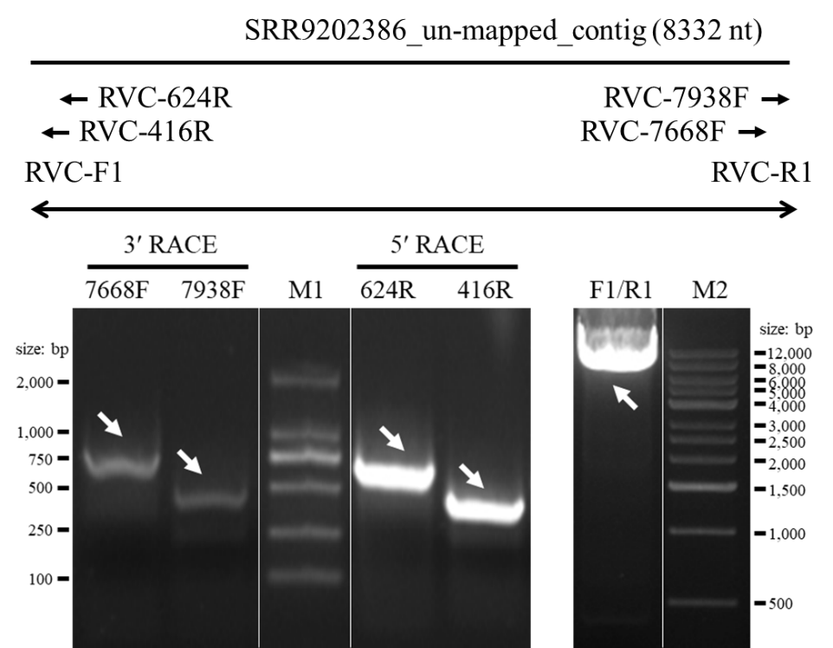
Supplementary Fig. 1. The sketch diagram of amplification of the full genome of RVC (right) and the RACE amplification (left).

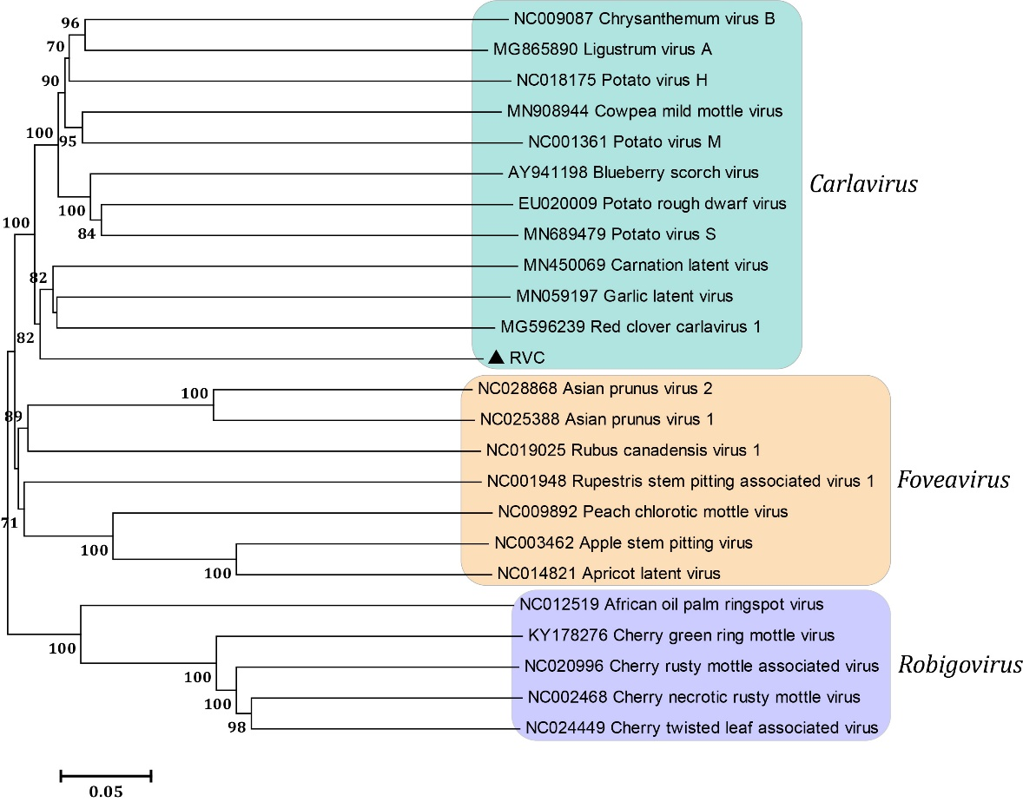
Supplementary Fig. 2. Phylogenetic relationship of the RVC with other members of the subfamily Quinvirinae, in family Betaflexiviridae. The tree was constructed based on the replication protein nucleotide sequences by the neighbor-joining method with 1000 bootstrap replicates. RVC sequenced in this study is highlighted by the black triangle (accession no. MZ049538). The branch values lower than 70% are hidden.

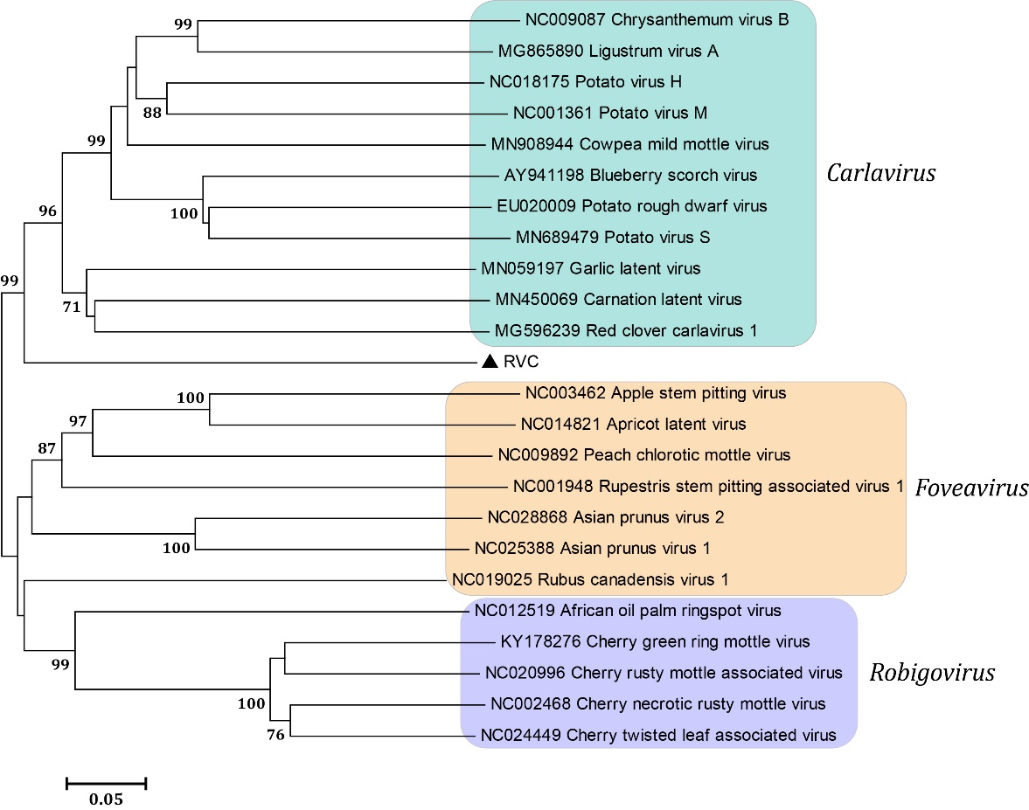
Supplementary Fig. 3. Phylogenetic relationship of the RVC with other members of the subfamily Quinvirinae, in family Betaflexiviridae. The tree was constructed based on the coat protein nucleotide sequences by the neighbor-joining method with 1000 bootstrap replicates. RVC sequenced in this study is highlighted by the black triangle (accession no. MZ049538). The branch values lower than 70% are hidden.

