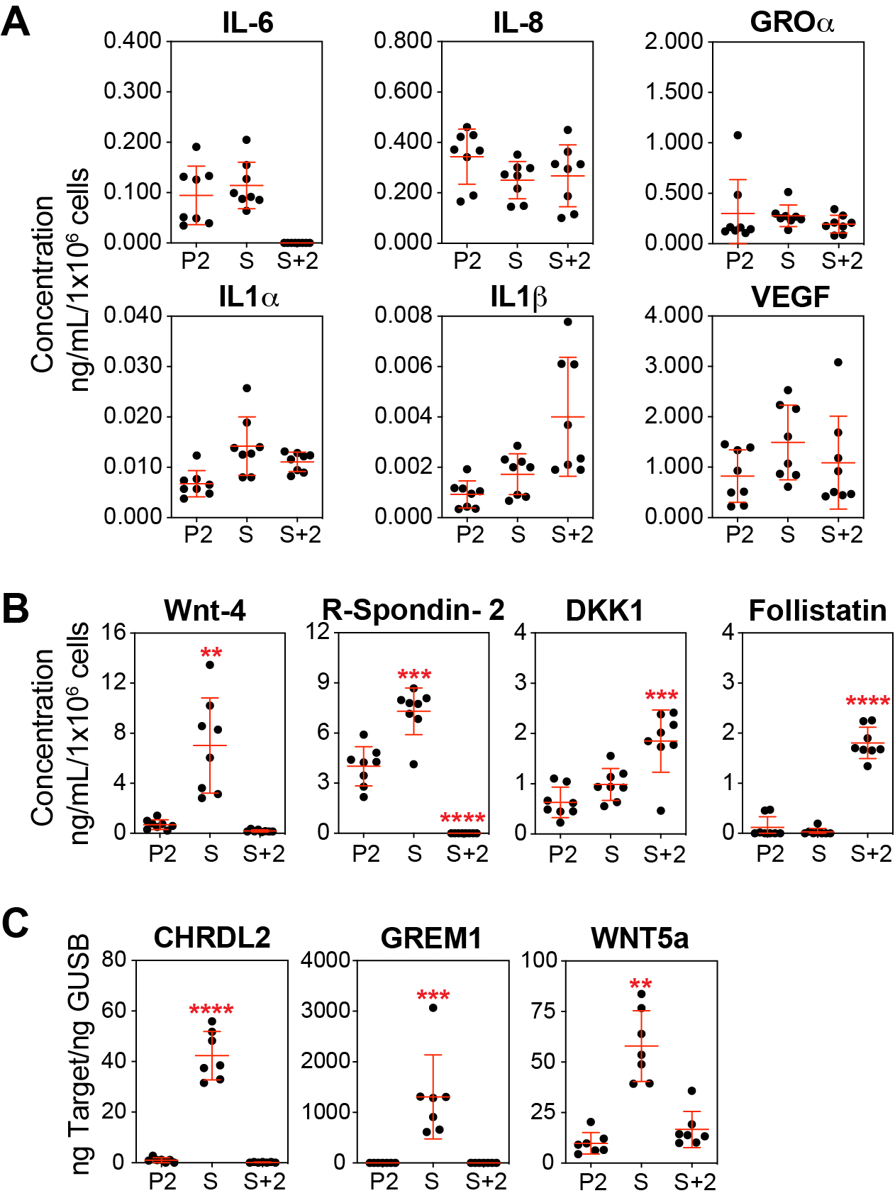

Supplemental Fig. 1: Secretome analysis of HMEC. (A) Sandwich ELISA kits were used to determine the concentrations of IL-6, IL-8, GRO, IL-1α, IL-1β, and VEGF based on standard curves. Equal numbers of cells were harvested from P2, S, and S+2 cultures and cultured in basal medium (without supplements) for 24 hours. Concentrations were normalized to the final cell number. (B) Same as A, for Wnt-4, R-Spondin-2, DKK1, and Follistatin. (C) For CHRDL2, GREM1, and WNT5A, for which sandwich ELISA kits were unavailable, expression was analyzed by qPCR using cDNA produced from P2, S, and S+2 cells.

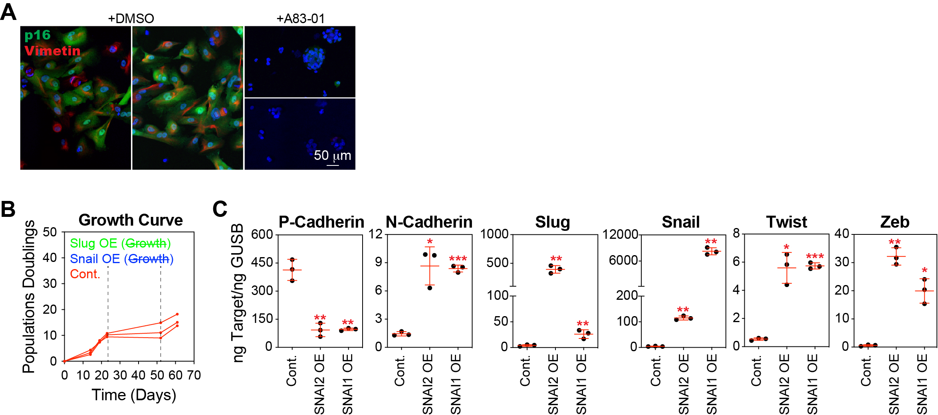

Supplemental Fig. 2: Growth Arrest induced by Snail or Slug overexpression. (A) Representative images of P3 basal epithelial cells treated with 500 nM A83-01 or DMSO, immunostained with antibodies against p16 and vimentin and counterstained with DAPI. (B) Basal epithelial cells (P1) were transduced with lentiviral constructs containing Slug, Snail or GFP (control). After selection (1 μg/mL puromycin), Snail overexpressing (OE), Slug OE, and control cells were expanded in MEGM medium. At each passage, cells were counted to produce a growth curve of cumulative population doubling over time. Only control cells could be passaged; Snail OE and Slug OE were completely growth-arrested following selection. A second set of transduced basal epithelial cells was generated and collected immediately after selection. (C) Expression of P-cadherin, N-cadherin, Slug, Snail, Twist, and Zeb and was analyzed by qPCR using cDNA produced from basal epithelial cells transduced with Snail OE, Slug OE, or control vectors.

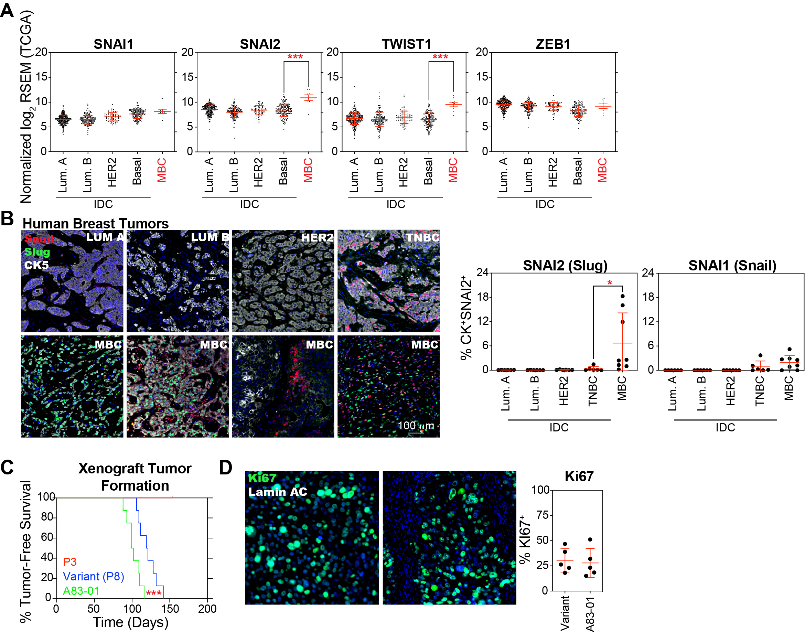
Supplemental Fig. 3: Higher levels of Slug were characteristic of MBCs. (A) Using TCGA data accessed through https://www.cbioportal.org, we analyzed the expression levels of Snail (SNAI1), Slug (SNAI2), Twist (TWIST1), and Zeb (ZEB1) in bulk RNA-sequencing data from eight metaplastic breast cancer cases compared to invasive ductal carcinoma cases separated into major intrinsic subtypes. (B) FFPE sections from 24 cases of invasive ductal carcinoma (six from each subtype) and eight cases of metaplastic breast cancer were subjected to multiplexed immunohistochemical analysis for Snail, Slug, and cytokeratin 5 (CK5). Quantification was performed using QuPath software, and cells were segmented and classified based on intensity thresholds determined from unstained control slides for each individual marker. (C) Kaplan-Meier analysis of P3 basal epithelial cells (red), variant basal epithelial cells (blue), and A83-01-treated basal epithelial cells (green). The x-axis represents time (days), and the y-axis represents the proportion of tumor-free mice. Eight mice per group, Statistical analysis of tumor formation rates between the variant and A83-01 groups was performed using the log-rank test for trend (D) Variants and A83-01-treated oncogenically transformed basal epithelial cells (4 × 10⁶) were injected subcutaneously with 50% Matrigel into 8-to 12-week-old female NSG mice. Tumors formed over a period of 3-6 months. A83-01 was not administered to mice. FFPE sections from five tumors were subjected to multiplexed immunohistochemical analysis for Ki67. Human-specific lamin A/C was used to identify the tumor cells. Quantification was performed using QuPath software, and cells were segmented and classified based on intensity thresholds determined from unstained control slides for each individual marker.
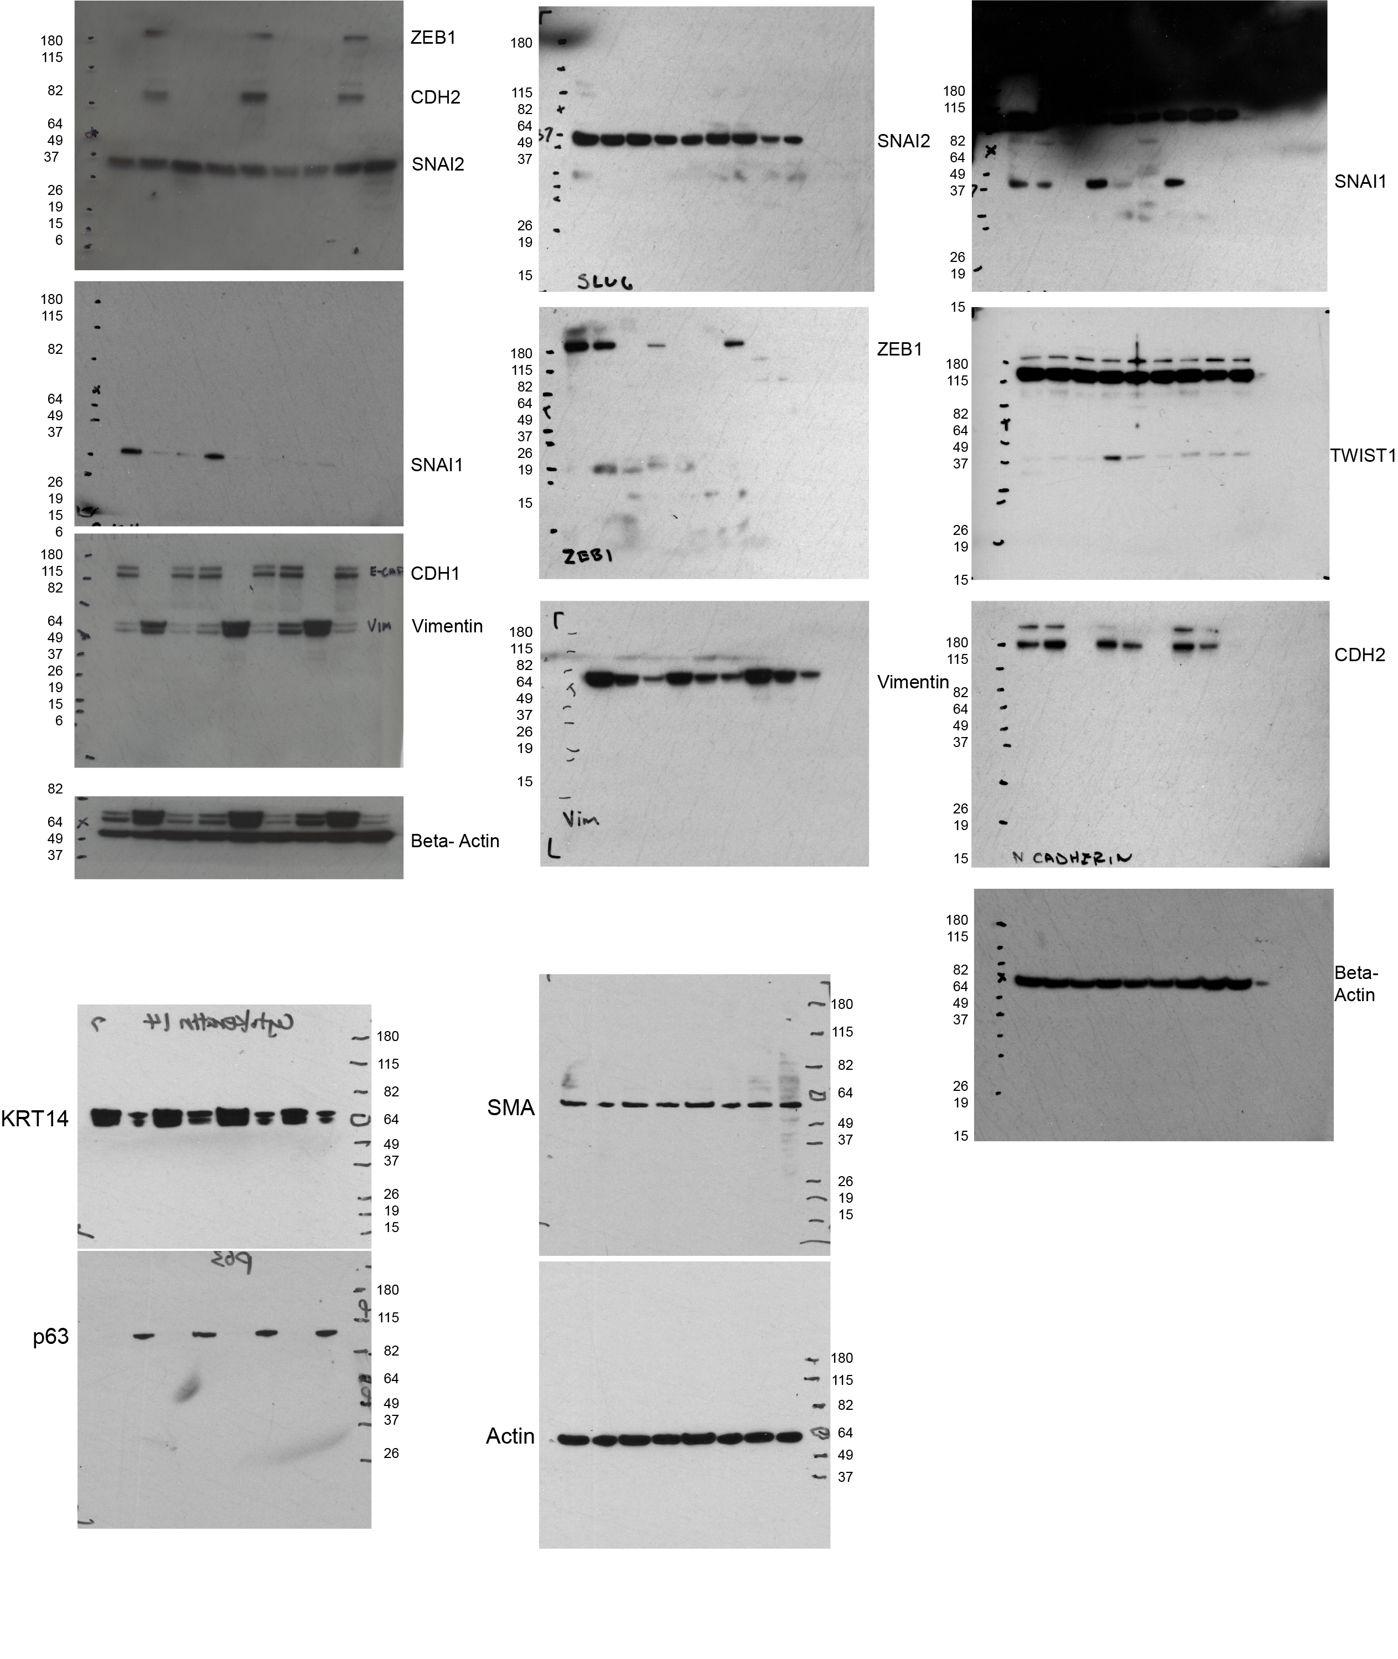Supplemental Fig. 4: Full western blots. Western blots were developed using X-ray Film to visualize chemiluminescence.

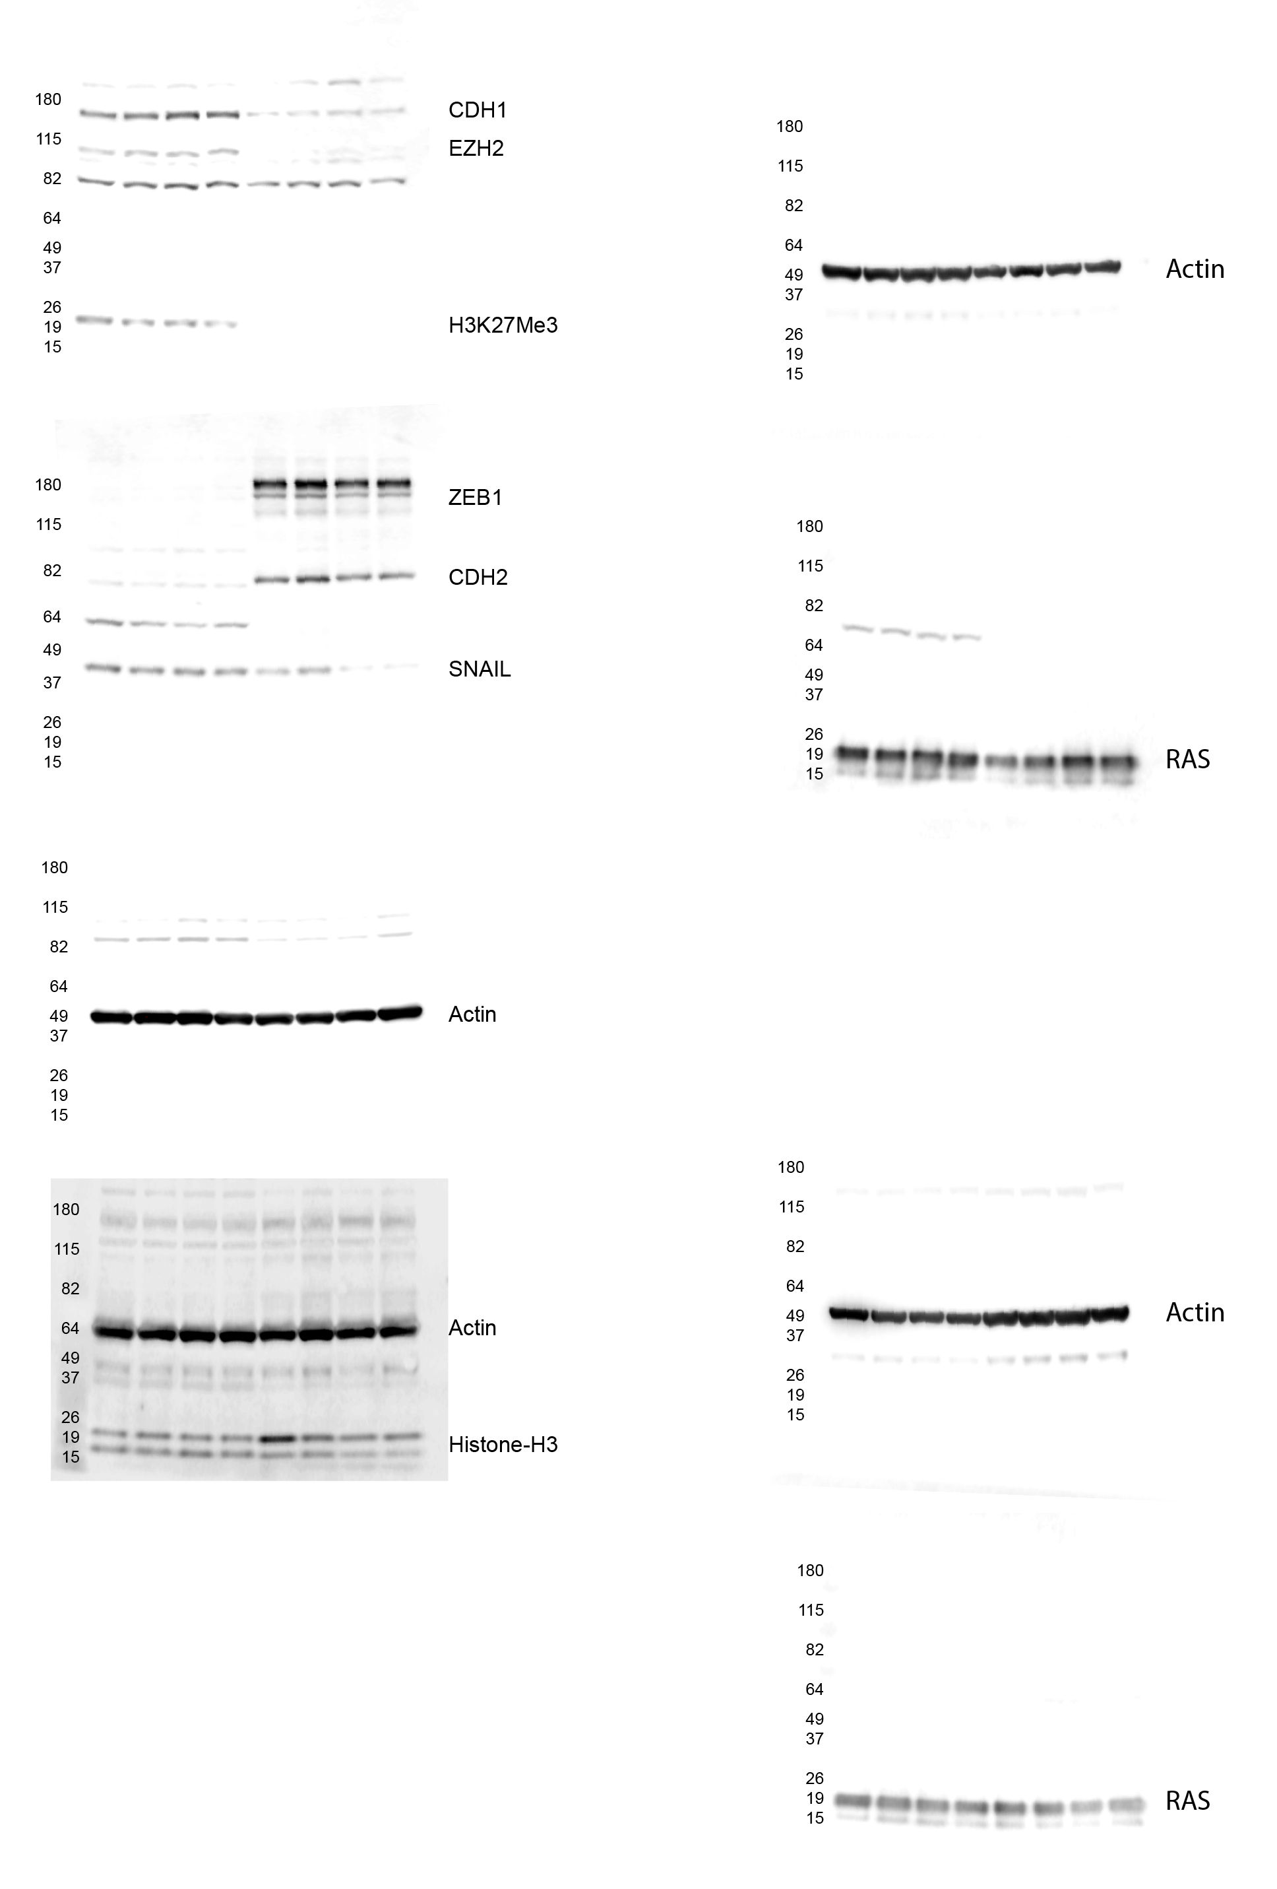Supplemental Fig. 5: Full western blots. Western blots were developed using digital imaging to visualize the chemiluminescence.

