Parkinson’s disease is characterized by vitamin B6-dependent inflammatory kynurenine pathway dysfunction

Edward N. Wilson^{1,2,3,*}, Jacob Umans¹, Michelle S. Swarovski¹, Paras S. Minhas¹, Øivind Midttun⁴, Arve Ulvik⁴, Marian Shahid-Besanti¹, Patricia Linortner¹, Siddhita D. Mhatre¹, Qian Wang¹, Divya Channappa^{1,5}, Nicole K. Corso¹, Lu Tian⁶, Carolyn A. Fredericks⁷, Geoffrey A. Kerchner⁸, Edward D. Plowey⁵, Brenna Cholerton¹, Per M. Ueland⁴, Cyrus P. Zabetian^{9,10}, Nora E. Gray¹¹, Joseph F. Quinn^{11,12}, Thomas J. Montine⁵, Sharon J. Sha^{1,2}, Frank M. Longo^{1,2}, David A. Wolk¹³, Alice Chen-Plotkin¹³, Victor W. Henderson^{1,2}, Tony Wyss-Coray^{1,2,3}, Anthony D. Wagner^{14,2}, Elizabeth C. Mormino^{1,2}, Nima Aghaeepour^{6,15,16,17}, Kathleen L. Poston^{1,2,3,18} & Katrin I. Andreasson^{1,2,3,19,*}

¹Neurology & Neurological Sciences, Stanford University, Stanford, CA, 94305, USA
²Wu Tsai Neurosciences Institute, Stanford University, Stanford, CA, USA
³The Phil & Penny Knight Initiative for Brain Resilience, Stanford University, Stanford, CA, USA
⁴Bevital, Bergen, Norway
⁵Pathology, Stanford University, Stanford, CA, USA
⁶Biomedical Data Science and Statistics, Stanford University, Stanford, CA, USA
⁷Neurology, Yale University, New Haven, CT, USA
⁸Pharma Research and Early Development, F. Hoffmann-La Roche, Ltd., Basel, Switzerland
⁹VA Puget Sound Health Care System, Seattle, WA
¹⁰Neurology, University of Washington, Seattle, WA
¹¹Neurology, Oregon Health & Sciences University, Portland, OR
¹²Neurology, Portland VA Medical Center, Portland, OR
¹³Neurology, University of Pennsylvania, Philadelphia, PA
¹⁴Psychology, Stanford University, Stanford, CA, USA
¹⁵Anesthesiology, Perioperative and Pain Medicine, Stanford University, Stanford, CA, 94305, USA
¹⁶Neonatal & Developmental Medicine, Department of Pediatrics, Stanford University, Stanford, CA, 94305, USA
¹⁷Biomedical Informatics, Stanford University, Stanford, CA, 94305, USA
¹⁸Neurosurgery, Stanford University, Stanford, CA, 94305, USA
¹⁹Chan Zuckerberg Biohub, San Francisco, CA 94158

*Correspondence should be addressed to: enwilson@stanford.edu & kandreas@stanford.edu

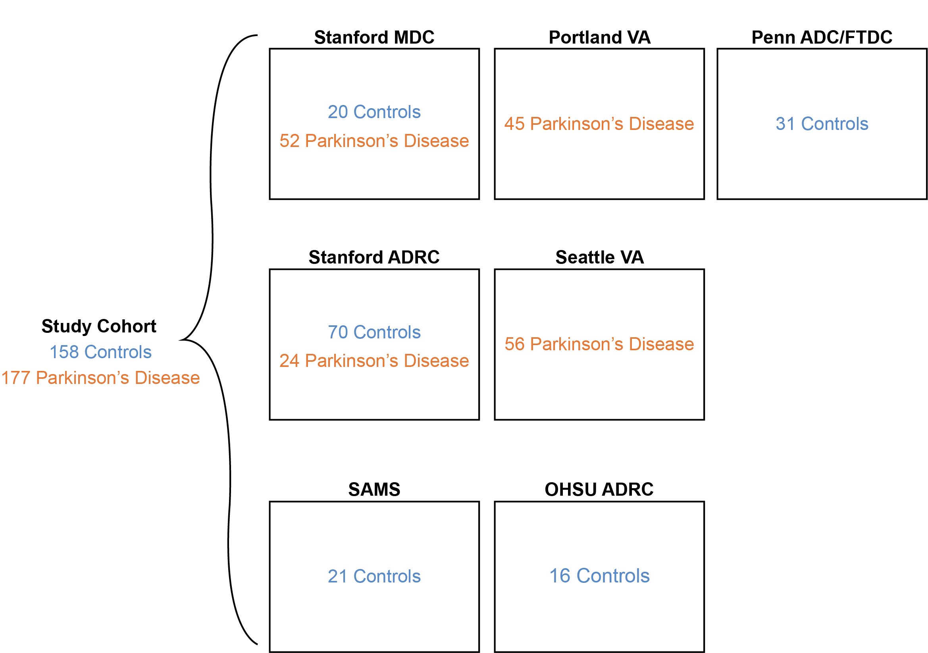

Supplementary Fig. 1: Multicenter study of control participants and Parkinson’s disease participants.

The combined study cohort consisted of a total of 158 control and 177 Parkinson’s disease participants. Number of participants and diagnostic group are indicated for each recruiting research center. This multicenter study included participants from 1) the Stanford Movement Disorders Clinic (Stanford MDC); 2) the Stanford Alzheimer’s Disease Research Center (Stanford ADRC); 3) the Stanford Aging and Memory Study (SAMS); 4) the VA Puget Sound Health Care System/University of Washington (Seattle VA); 5) the VA Portland Medical Center (Portland VA); 6) the Oregon Health & Science University Layton Aging and Alzheimer’s Disease Research Center (OHSU ADRC); 7) the University of Pennsylvania Alzheimer’s Disease Center (Penn ADC); and 8) the University of Pennsylvania Frontal Temporal Dementia Center (Penn FTDC). Demographic information on the study participants is included in Table 1.

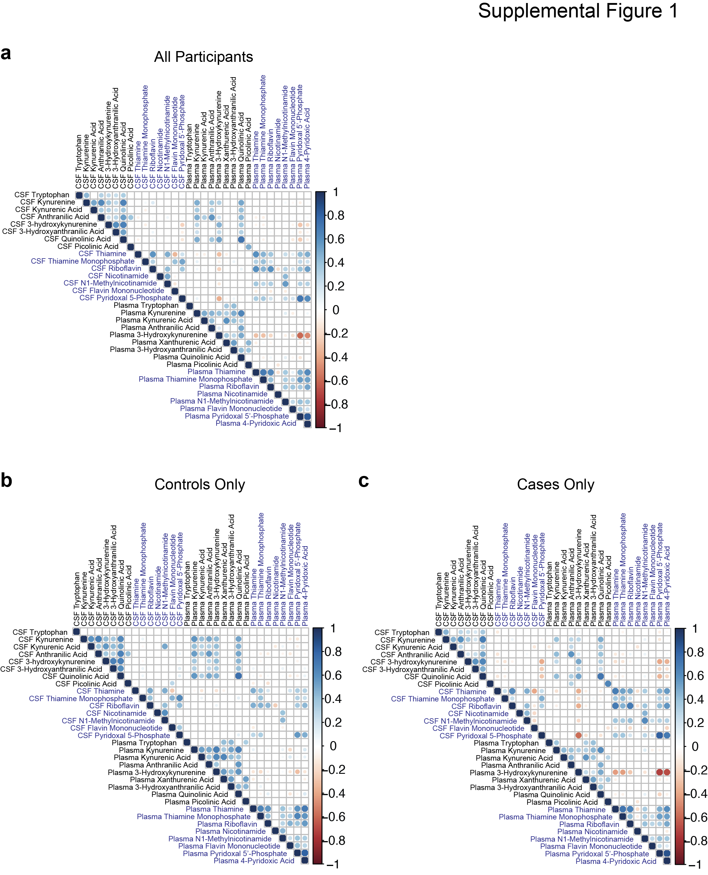

Supplementary Fig. 2: Correlation Between CSF and Plasma Metabolic Pools.

(a) Correlation matrix showing associations between CSF and plasma metabolites (black text) and related B-vitamins (blue text) in all participants. Significant correlations are shown with the circle size indicating the P-value of the correlation and color indicating size and direction of the β-estimate.
(b) Correlation matrix showing association between CSF and plasma metabolites (black text) and related B-vitamins (blue text) in control participants. Significant correlations are shown with the circle size indicating the P-value of the correlation and color indicating size and direction of the β-estimate.

(c) Correlation matrix showing association between CSF and plasma metabolites (black text) and related B-vitamins (blue text) in PD cases. Significant correlations are shown with the circle size indicating the P-value of the correlation and color indicating size and direction of the β-estimate.

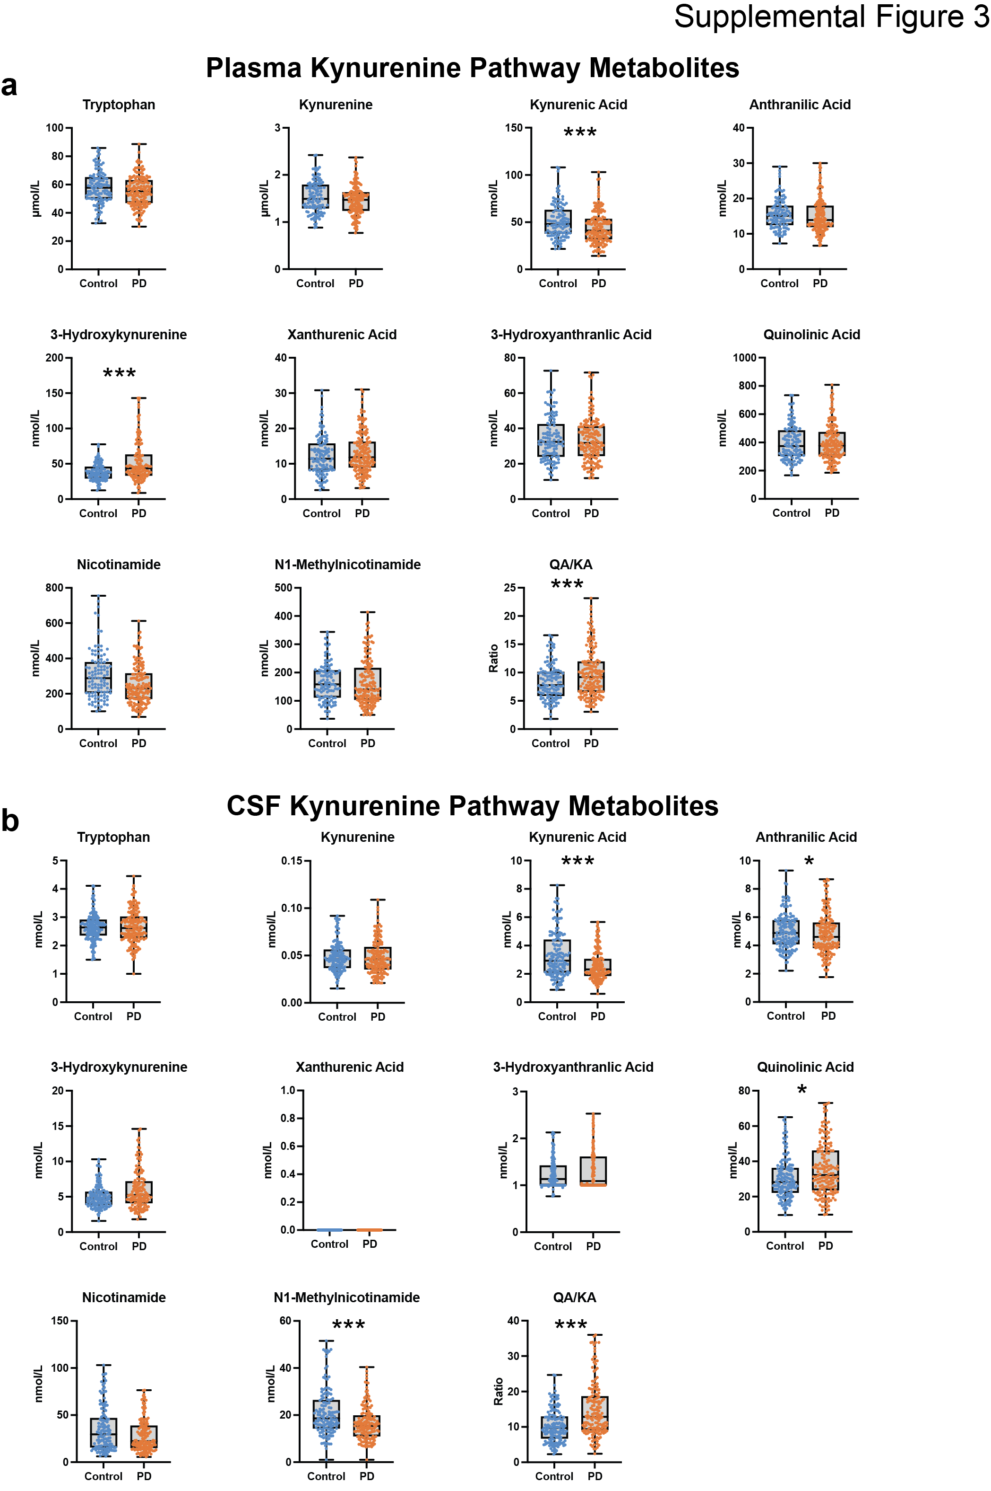

Supplementary Fig. 3: KP changes in plasma and CSF metabolite pools in Parkinson’s disease.

(a) Concentrations of plasma kynurenine pathway metabolites in control and PD participants. *P < 0.05 and ***P < 0.001 using ANCOVA including age and sex as covariates.

(b) Concentrations of CSF kynurenine pathway metabolites between control and PD participants. *P < 0.05 and ***P < 0.001 using ANCOVA including age and sex as covariates.
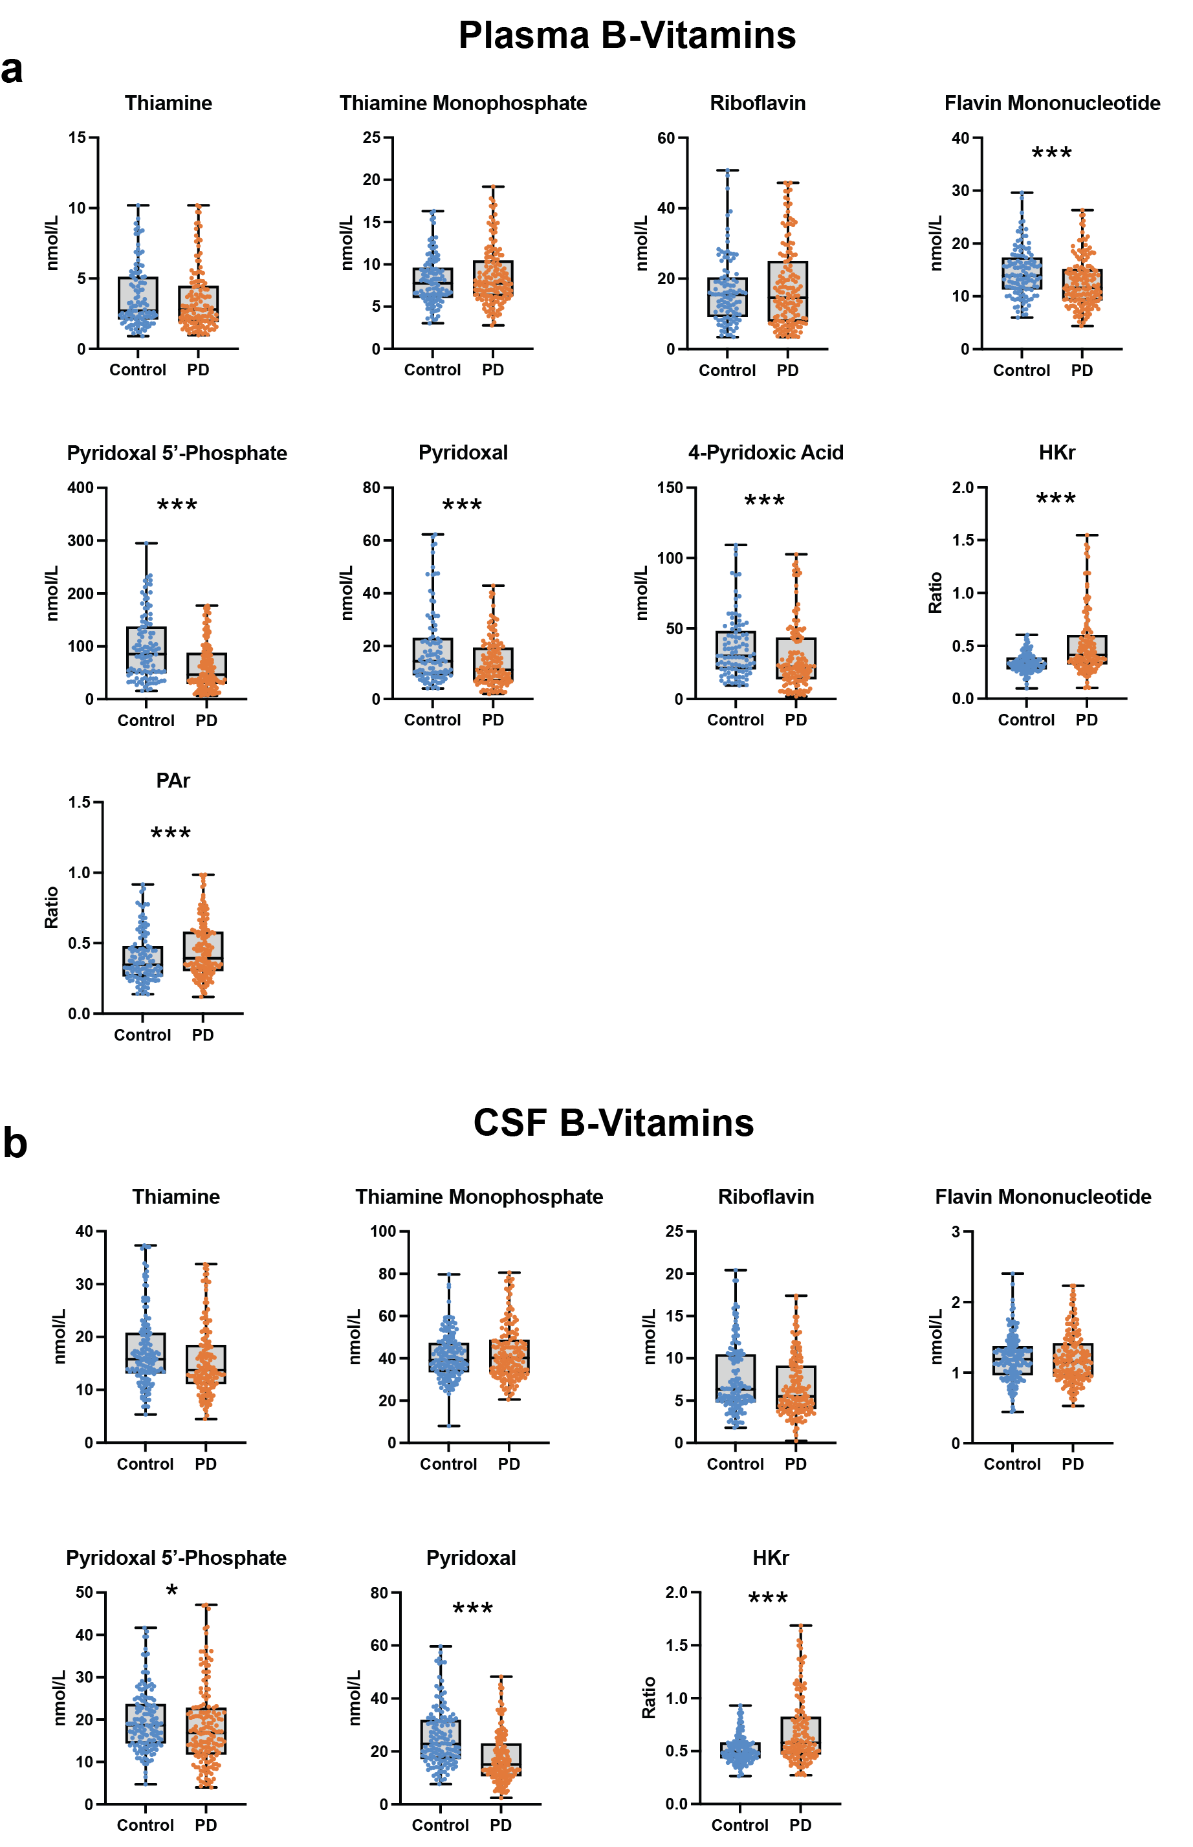

Supplementary Fig. 4: Vitamin B deficiency in plasma and CSF pools in Parkinson’s disease.

(a) Concentrations of plasma B-vitamins in control and PD participants. ***P < 0.001 using ANCOVA including age and sex as covariates. Abbreviations: HKr: HK ratio; PAr: PAr Index.

(b) Concentrations of CSF B-vitamins between control and PD participants. *P < 0.05 and ***P < 0.001 using ANCOVA including age and sex as covariates. Abbreviations: HKr: HK ratio.

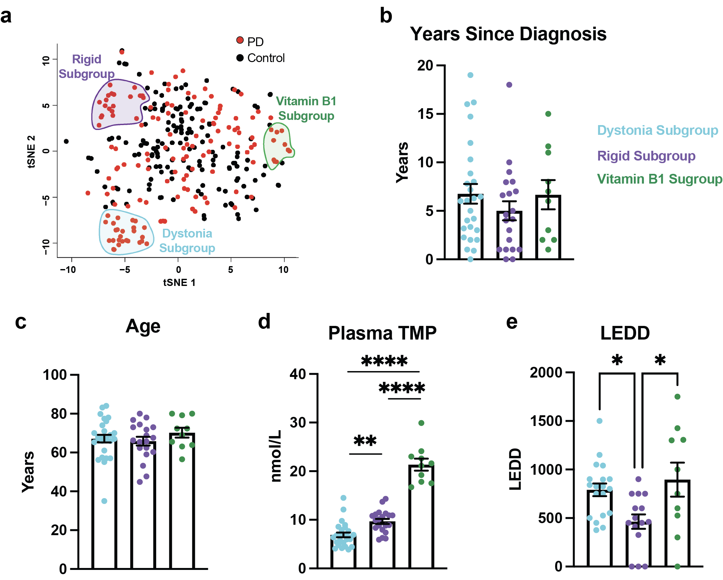

Supplementary Fig. 5: Features of the PD clinical subgroups

(a) tSNE clustering of the natural classes of the entire study population by blood and CSF metabolomic data uncovered three subgroups of PD participants. Control participants: black circles. PD participants: red circles. Three distinct clusters of PD participants are circled. Dystonia Subgroup: cyan, Rigid Subgroup: purple, Vitamin B1 Subgroup: green.

(b) Mean years since diagnosis across the PD clinical subgroups. Group differences were assessed using one-way ANOVA with Tukey’s post hoc test for pairwise comparisons.

(c) Mean age (years) across the PD clinical subgroups. Group differences were assessed using one-way ANOVA with Tukey’s post hoc test for pairwise comparisons.

(d) Plasma thiamine monophosphate (TMP) across the PD clinical subgroups. Group differences were assessed using one-way ANOVA with Tukey’s post hoc test for pairwise comparisons. **P < 0.01, ****P < 0.0001.

(e) Mean levodopa equivalent daily dose (LEDD) in PD participants according to subgroups. Group differences were assessed using one-way ANOVA with Tukey’s post hoc test for pairwise comparisons. *P < 0.05.

