Appendices
Appendix 1: Questionnaire

I) Gender
1. Male
2. Female
3. Prefer not to say.
4. Non-Binary/ Other
II) Age
1. 18-24
2. 25-34
3. 35-44
4. 45+
III) Are your livelihood activities or occupation related to water resources?
1. Yes
2. No
IV) What is your occupation?
V) Place of Residence
1. Mudzingadzi
2. Chinfura
3. 25 de Junho
4. Bairro 4
5. 16 de Junho
6. Samora Machel
7. Bairro 2
8. Centro Hipico
9. Nhamadjesa
10. Nhamatsane
11. Vila Nova
12. Tambara 2
13. Bairro 1
14. Trangapasso
15. Herois Mocambicanos
16. Josina Machel
17. Liberdade
18. 7 de Abril
19. Soalpo
20. Bloco 9
21. 1 de Maio
22. Francisco Manhanga
23. Piloto
24. Nhauriri
25. 5 Congresso
26. 25 de Setembro
27. 3 de Fevereiro
28. Bairro 5
29. Citembwe
VI) How Long have you lived in this place?
1. Less than a year
2. 1 – 5 years
3. 5 – 10 years
4. More than 10 years
VII) Do you have access to potable water?
1. Yes
2. No
VIII) If you have, how do you access it?
1. A tap at our house
2. A tap at a neighbour’s house
3. A community distribution point
4. Other
IX) Do you have access to other sources of water, if so choose the ones you use?
1. A borehole inside your home
2. A protected well
3. Non-protected well
4. Community borehole
5. River or lake
6. None
X) Do you do any form of water treatment to the water from other sources before use?
1. Yes
2. No
3. Maybe
4. Not applicable
XI) How would you rate the current water supply in Chimoio?
1. Excellent
2. Good
3. Fair
4. Bad
5. Very bad
XII) Do you face water supply stress?
1. Yes
2. No
XIII) On average, how many hours a day do you have uninterrupted water supply?
1. Less than 6 hours
2. About 6 to 12 hours
3. About 12 to 18 hours
4. About 18 to 24 hours
5. Never (No access)
XIV) Do you sometimes go for more than 24 hours without water supply?
1. Yes
2. No
XV) If so how does unavailability of water affect your household? Choose the ones that apply to you.
1. Not affected
2. Moderately affected.
3. Extremely affected.
XVI) How do you cope with water stress
1. Use an alternative source.
2. Buy water.
3. Walk long distances in search of water.
4. Wait for the potable water to be available.
5. Store water in tanks and in containers.
6. Harvest rainwater for other uses.
XVII) What is the main source of water you use for daily activities?
1. Tap water (municipal supply)
2. Bottled water
3. Borehole/ well water
4. Harvested stormwater.
5. Other
XVIII) Have you ever experienced flooding?
1. Yes
2. No
XIX) If you have experienced flooding, how did it affect you?
1. Flooding on roads which cut access to other areas.
2. Flooding in the yard which lasted for days.
3. Flooding inside the house with loss of property
4. Not affected
XX) How satisfied are you with the quality of the potable water?
1. Very satisfied
2. Satisfied
3. Neutral
4. Unsatisfied
5. Very unsatisfied
6. Not applicable (No access)
XXI) What factors influence your perception of the quality of water?
1. Odour
2. Colour
3. Taste
4. Presence of contaminants
5. Water pressure
6. Availability at peak hours
7. Other
XXII) How do you deal with poor water quality?
1. Report to the authorities.
2. Boil before using.
3. Buy bottled water for drinking.
4. Nothing
XXIII) How do you rate the price you pay for water?
1. Very expensive
2. Expensive
3. Fair
4. Cheap
5. Very cheap
6. Not applicable (Use free source)
XXIV) How would you rate the reliability of FIPAG’s water supply infrastructure in your area?
1. Very reliable
2. Reliable
3. Neutral
4. Unreliable
5. Very unreliable
XXV) Have you experienced any leaks or damages in the water distribution system in your neighbourhood?
1. Yes
2. No
3. Not sure
XXVI) Are you aware of any ongoing water infrastructure improvement projects in Chimoio?
1. Yes
2. No
XXVII) Have you received information from local authorities about water conservation practices?
1. Yes
2. No
XXVIII) How frequently do you practice water conservation at home?
1. Always
2. Often
3. Sometimes
4. Rarely
5. Never
XXIX) What water conservation methods do you use, if any? (Select all that apply)
1. Repairing leaks immediately
2. Using water-efficient appliances (e.g., low-flow faucets, efficient washing machines)
3. Collecting and using rainwater
4. Watering plants during off-peak hours
5. None

XXX) How involved are you in matters concerning water supply in Chimoio?
1. Always
2. Often
3. Sometimes
4. Rarely
5. Never
XXXI) Have you ever taken part in any meeting with the local authorities concerning water supply and management?
1. Yes
2. No
XXXII) Is the public in general consulted on matters concerning water supply or distribution before any decision is made?
1. Yes
2. No
3. Not sure
Appendix 2: Interview Guides
A: Interview with AdRC
This interview will be conducted for the research project "Adopting an Integrated Water Management System as a solution to water scarcity: Potentialities and Challenges in Chimoio, Mozambique".
The information from the interviews will be used for the academic purposes of a PhD study by Shylet Tsoca. Your consent and willingness to answer questions are mostly sought, and I (Shylet Tsoca) would like to express my gratitude in advance for your time and contribution to the outcome of the survey.
Background and Overview:
1. Can you indicate the name of the organisation you represent, your gender, role, or functions in the organisation?
2. Can you provide an overview of the current state of water supply and management in the city of Chimoio?
3. What are the main sources of water for the city and how are they managed?
Water Availability and Sustainability:
4. What is the current availability of water in the city of Chimoio and how does it compare to demand?
5. What measures are in place to ensure the long-term sustainability of water supply and what challenges or concerns do you have in this regard?
6. Are you familiar with the concept of IWRM and what is your view?
7. What emergency response plans are in place in the event of a water supply interruption or contamination event? Is there a backup water source or an agreement with neighbouring districts?
8. How does the city communicate with residents during water-related emergencies?
9. How does the city prepare for and respond to drought conditions or other climate-related challenges?
10. Are there contingency plans in place for water scarcity during extreme weather events?
11. Does the city often experience flooding? How to remedy this situation and how do you deal with rainwater?
12. What are the city's long-term goals and plans for water supply and management?
13. How do these goals align with broader environmental and sustainability goals? Are there any innovative projects or technologies to consider for the future?
Infrastructure and Distribution:
14. How is water distribution infrastructure maintained and upgraded to meet growing demands? What percentage of the population is covered by tap water?
15. Are there any plans to expand or improve the water distribution network?
16. How do you address issues such as leak detection and water loss in the distribution system?
Water Quality, Recycling and Treatment:
17. How is the quality of drinking water controlled and maintained?
18. What water treatment processes are in place to ensure safe and clean drinking water? Have you recently faced any water quality challenge incidents?
19. Are there efforts to promote rainwater harvesting, recycling, and water reuse in the city? How will you ensure the safety and quality of this water?
20. What industries or sectors are actively involved in water recycling practices?
Population Engagement and Education:
21. What initiatives or programs are in place to engage the community in water conservation and sustainable practices?
22. Is local knowledge and the cultural value of all population groups referred to before decisions are made around water-related issues?
23. How to educate the public about the importance of water conservation and responsible water use?
24. Are there incentives for residents and businesses to reduce their water consumption?
25. Is there free and meaningful participation of local people, the private sector, women, NGOs, etc., in issues related to water supply, sanitation, drainage and flooding?
26. How do you collaborate with other government agencies, NGOs, or private entities to improve water supply and management? Do local government and political leadership promote sustainability and water resilience as priorities in decision-making?
27. Are there any partnerships or joint initiatives focused on water sustainability? Do you regularly meet with the public to discuss water-related issues?
Water Prices and Affordability:
28. How is the price of water set in Chimoio and how are the tariffs determined?
29. Is the environmental and economic aspect of water understood by local people and what measures are taken to ensure that water remains accessible to all residents?
30. Are there assistance programs for low-income families?

B: Interview with the Municipality of Chimoio
Policy and Planning:
1. What are the key policies and regulations governing water resource management in Chimoio?
2. Can you discuss any recent initiatives or projects aimed at improving water resource management in your area?
Water Infrastructure and Distribution:
3. What is the current state of our municipal water infrastructure?
4. How does the municipality ensure equitable access to water resources across different communities and neighbourhoods?
5. Are there any plans to upgrade or expand the water distribution systems to meet growing demands?
6. Is there a wastewater treatment plant in Chimoio?
Water Quality and Pollution Control:
7. What measures are in place to monitor and maintain water quality in our rivers, lakes, and groundwater sources?
Water Conservation and Efficiency:
8. What strategies does the municipality employ to promote water conservation and efficiency among residents, businesses, and industries?
9. How does the municipality handle drought conditions or water scarcity events?
Community Engagement and Education:
10. How does the municipality engage with local communities especially women and stakeholders on water management issues, and how does it get feedback from residents on water issues?
11. Are there educational programs or outreach initiatives to raise awareness about water conservation and environmental stewardship?
Climate Change Adaptation
12. What steps has the municipality taken to assess and mitigate the impacts of climate change on our water resources?
13. Are there resilience-building measures in place to address extreme weather events, and is there infrastructure in place to facilitate storm water collection for later use?
Funding and Resource Allocation:
14. What sources of funding does the municipality rely on for water infrastructure projects and maintenance?
15. Are there opportunities for public-private partnerships or grant funding to support water-related projects?
Data Collection and Monitoring:
16. What mechanisms are used to collect and analyse data on water availability, usage, and quality?
17. How frequently are water resource monitoring systems updated, and how is the data utilized for decision-making?
18. Are there efforts to improve data transparency and accessibility for stakeholders and the public?

C: Interview with the local Government

1. Can you provide an overview of the current water management practices and infrastructure in Chimoio or Manica Province
2. What specific challenges are you facing in terms of water availability, quality, and sustainability?
3. How does the local government collaborate with relevant stakeholders such as environmental agencies, community groups including women, and industries to address water management issues?
4. Can you describe any recent initiatives or projects aimed at promoting sustainable water management in our area?
5. What is your knowledge and views regarding IWRM?
6. Considering that a large part of the population rely on groundwater (Boreholes and wells), how does the local government monitor and assess water usage, conservation efforts, and pollution levels within the community?
7. What policies or regulations are in place to ensure responsible water usage and conservation by residents, businesses, and agricultural activities?
8. How does the local government integrate climate change considerations into water management planning and decision-making processes?
9. Are there any partnerships or collaborations with neighbouring municipalities or regional authorities to address shared water management challenges?
10. How does the local government engage with the public to raise awareness about water conservation and sustainable practices?
11. What plans or strategies are in place to ensure long-term sustainability and resilience of the local water resources in the face of future challenges and population growth?

Appendix 3: Ethics Approval
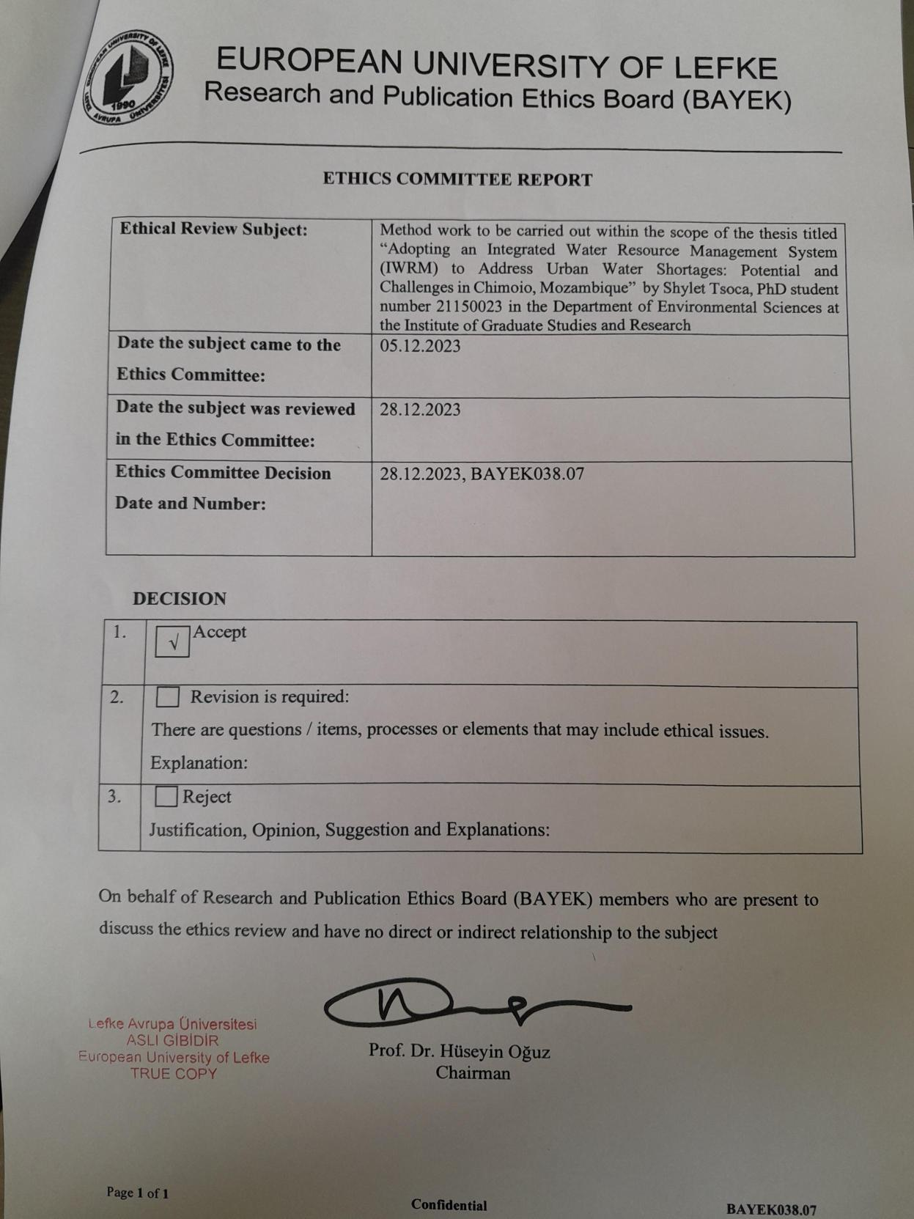

Appendix 4: Participant’s Consent Form


Adopting an Integrated Water Resource Management System (IWRM) to address urban water shortages: Potential and Challenges in Chimoio, Mozambique Consent Form

Please tick the appropriate boxes |  |  | Yes | No
Taking Part in the Project
I have full understanding of the project and all the information has been explained to me. (If you will answer No to this question please do not proceed with this consent form until you are fully aware of what your participation in the project will mean.)
I have been given the opportunity to ask questions about the project.
I agree to take part in the project. I understand that taking part in the project will include completing a questionnaire, being interviewed, and being recorded (audio).
I understand and voluntarily agree to take part in the research and I am free to withdraw at any moment and that there will be no consequences if I choose to withdraw.
Use of information
I understand my personal details such as name, phone number, address, and email address etc. will not be revealed to people outside the project.
I understand and give consent to the use of my words in publications, reports, web pages, and other research outputs. My identity and name however will not be mentioned unless I specifically request this.
I understand and agree to the use of the data I will provide by other authorised researchers with the guarantee of keeping my identity confidential.
I understand and agree to the use of the data by the researcher in publications, reports, web pages, and other research outputs, only if they agree to preserve the confidentiality of the information as requested in this form.
Legal use of Information by the Researcher
I agree to assign the copyright I hold in any materials generated as part of this project to the researcher.
Name of participant: | Signature | Date
Name of Researcher: | Signature | Date

