Appendix
- EPKQ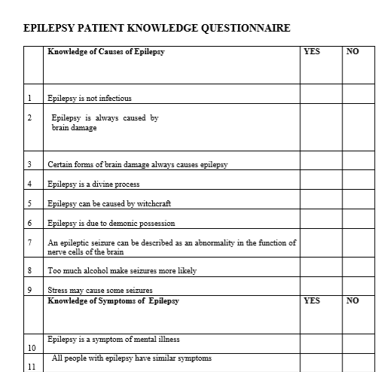

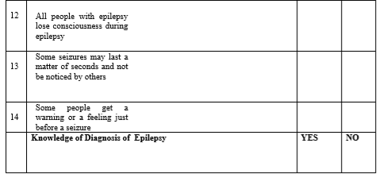
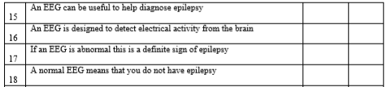

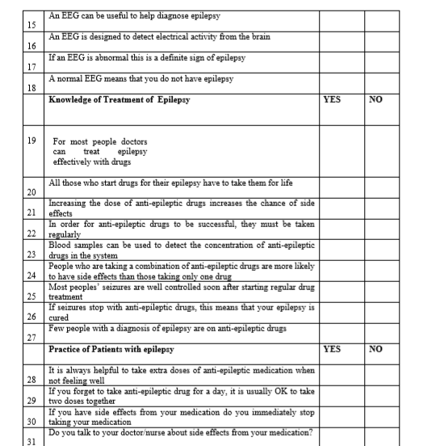

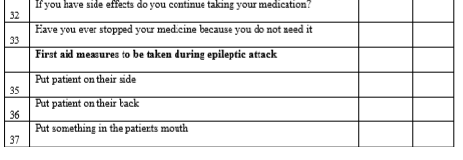
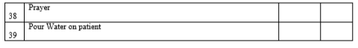

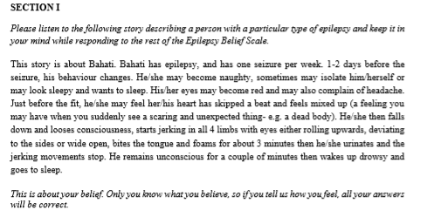
B. Kilifi Epilepsy Beliefs and attitude scale

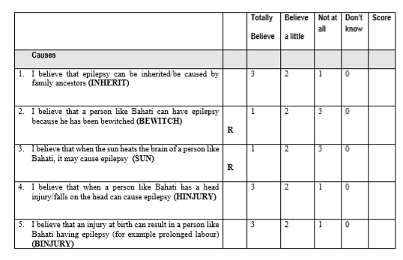

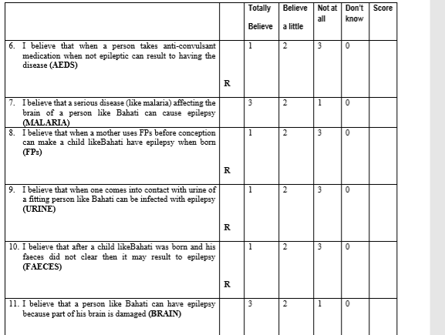
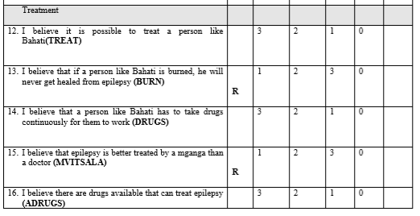
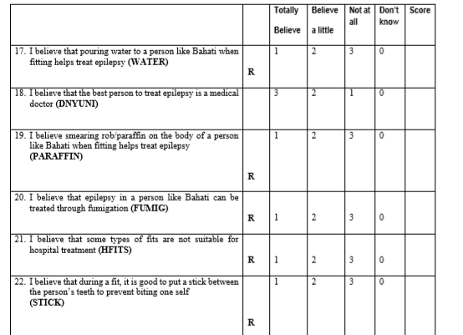
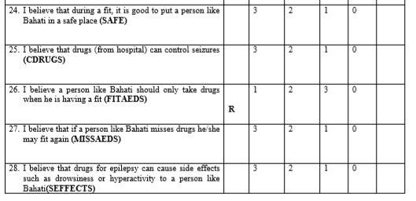
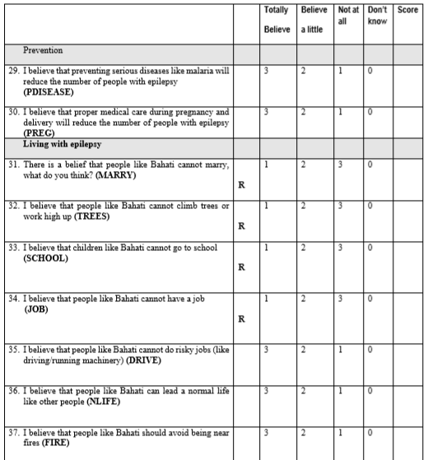
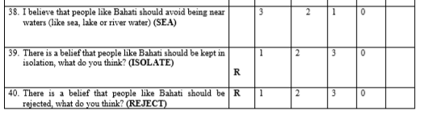
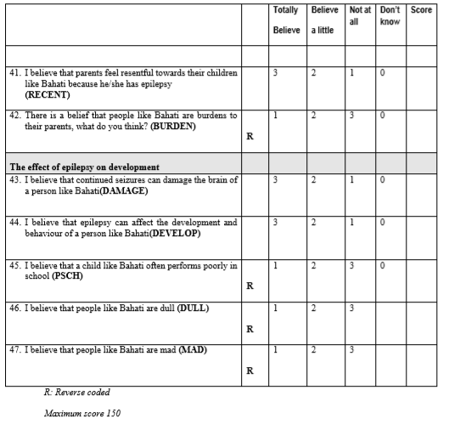
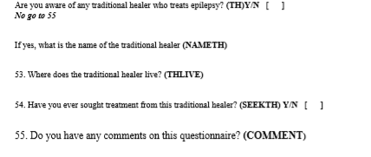
C. Data collection Sheet

- Patient Socio-demographic character
- Age
- Gender | Male Female
- Occupation | Unemployed Employed  Student Housewife  Retired Others
- Marital Status | Single Married  Divorced Widowed
- Educational level | No formal education Primary  Secondary University  Postgraduate
- Reproductive history (if female) | No history  History of contraceptive use  Current use of contraceptives  Children parity
- Income | Low income  Moderate income  High income
- Disease Characteristics
- Age of first seizure attack:
- Disease duration:
- Do you know the pattern of your seizure? | Yes No
- If yes, it is: | Partial simple Partial complex  Generalized Unidentified
- Do you know the type of your seizure? | Yes No
- If yes, it is: | Tonic Clonic Absence  Atonic Myoclonic  Unidentified
- Are you being treated by a medical doctor? | Yes No
- Are you taking a medical treatment? | Yes No
- If yes, how many medications do you take? | None  Only one  More than one
- Current seizure medication (s) name (s):
- Duration of current treatment:
- Compliance assessment
- Do you know that you should take regular treatment for your disease? | Yes No
- Do you take your current medication properly? | Yes No
- If no, why not? | Financial problems  Inaccessible medications  Due to side effects  Just forgetting sometimes  Others
- Why are you not treated by a medical treatment? (If you are not) | Medication never prescribed  Medication d/c due to SE  Medication d/c after remission
- Did you benefit from your current medication? | Yes No
- If yes, epilepsy had | Decreased in frequency  Stopped
- If epilepsy had stopped, what is the duration of remission?
- What is the frequency of seizure attack after taking the current medication? | 0  1  2  3  4
- Seizure Control
- What is the number of seizures: | In the last month:
- What is the number of seizures: | In the last 3 months:
- What is the number of seizures: | In the last 6 months:
- What is the number of seizures: | In the last year:
- Do you attend regular follow up at your clinic? | Yes No
- Knowledge of treatment
- Do you agree that epilepsy is a treatable condition? | Yes No  (10 pts) (0 pt)
- Do you know that epilepsy is treatable with modern drugs? | Yes No  (10 pts) (30 pts)
- Can faith healers treat epilepsy | Yes No  (10 pts) (0 pt)
- Knowledge of diagnosis
- Do you know how seizure is diagnosed? | Can’t be diagnosed (0 pt)  I don’t Know (1 pt)  Blood test ( 2spt)  Signs and symptoms ( 3 pts)  Electroencephalogram ( 4 pts)
- Do you know the cause of your disease? | No (0 pt)  Due to supernatural power (5 pts)  Caused by severe hunger (10 pts)  Infection (15 pts)  Caused by increased stress or anger (20 pts)  Psychological disorder (25 pts)r  Mental disease (30 pts)  Hereditary disease (35 pts)  Disease of the brain (40 pts(
- Is epilepsy contagious? | Yes No  (0 pt) (10 pts)
- Attitude
- Can a person with epilepsy take up a job? | Yes No  (25 pts) (0pt )
- Can person with epilepsy marry? | Yes No  (25 pts) (0pt)
- Can a person with epilepsy have children | Yes No  (25 pts) (0pt)
- Are you discriminated by people? | Yes No  (0 pt) (25 pts)
- Knowledge of the cause of relapses
- What do you think the cause the breakthrough Seizure is? | I don’t Know (0pt)  Infection and inflammation (1pt)  Disease progression (2 pts)  Medication overdose (3 pts)  SE of treatment (4 pts)  Medication failure (5pts)  Medication non-compliance (6pts)
- Practice
- What you will do during an epileptic attack | Nothing done (0pt)  Smell a shoe (15pts)  Put key in the hands (30pts)  Put spoon or cloth in your mouth (40pts)  Praying (45 pts)  Take away from dangerous site (75 pts)  Positioning you (90 pts)  Go to the hospital (100 pts)

D. Scores assumption
Knowledge of causes
The cause is | I don’t know  0 | Supernatural power  5 | Hunger  10 | Infection  15 | Depression and anger  20 | Psychological disorder  25 | Mental  Illness  30 | Genetic  35 | Neurons  Disturbances  40
Can epilepsy be contagious | Yes  0  points | No  10 points
Maximum: 50
knowledge of causes: Poor 0-25 moderate: 30-40 Good :45-50

Knowledge of treatment
Epilepsy can be treated | Yes  (10 points) | No  ( 0 point)
Epilepsy can be treated with medication | Yes  (10 points) | No  (0 point)
Epilepsy can be treated with traditional healers | Yes  (0 point) | No  (20points)
Maximum score: 30 points
Knowledge of treatment: Poor 0 -10 moderate 20 Good 40

Knowledge of diagnosis
Epilepsy is diagnosed | Can’t be diagnosed  (O point) | I don’t know  (1 point) | Blood tests  (2points) | Based on signs and symptoms  (3 points) | EEG  (4 points)
Max score: 4
Knowledge of diagnosis: 0-1 poor 2 moderate 3-4 good

 | Knowledge of cause of the relapse
Relapse may be due |  | I don’ know  (0 point) | Infection and inflammation  (1 point) | Disease progression  (2 points) | Medication overdose  (3 points) | Medication SE  (4 points) | Medication failure  (5 points) | Medication  Noncompliance  (6 points)
Max score: 6 points
Knowledge of the cause of relapse: poor 0-1 moderate 2-4 Good 5-6

