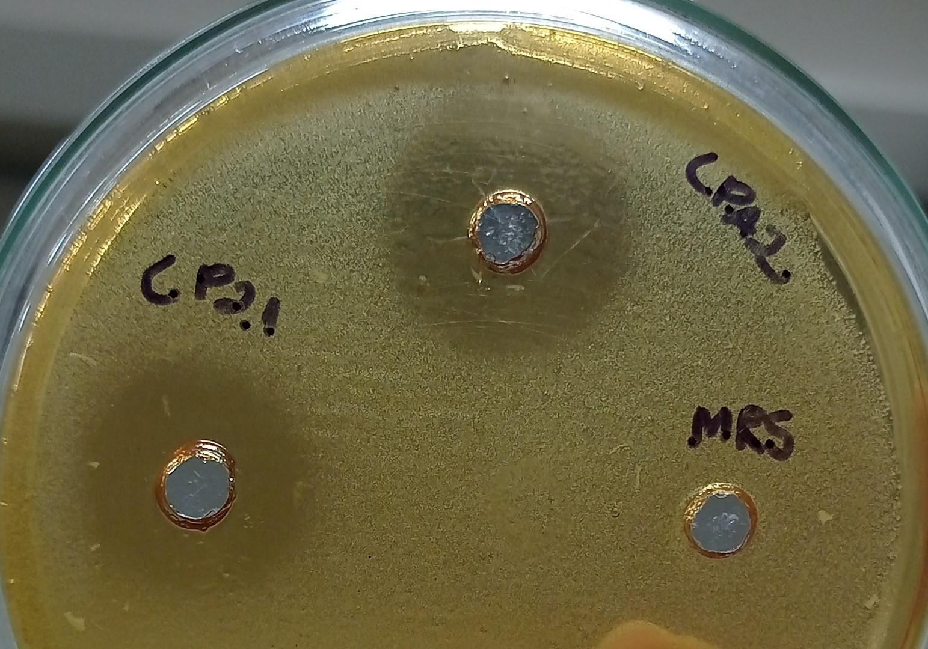
Figure 1: Assessment of antimicrobial activity by diffusion in semi-solid agar. After 24 hours of incubation, LPA2 formed a 17 mm inhibition halo in E.coli culture and LP2.1 formed a 12 mm one. The MRS control did not form an inhibition halo.

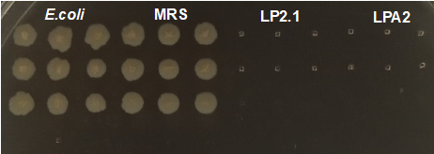
Figure 2: Plating the contents of the microplate wells on a Mueller-Hinton agar plate. The inhibitory effect of LPA2 and LP2.1 on E.coli has a microbicidal character.

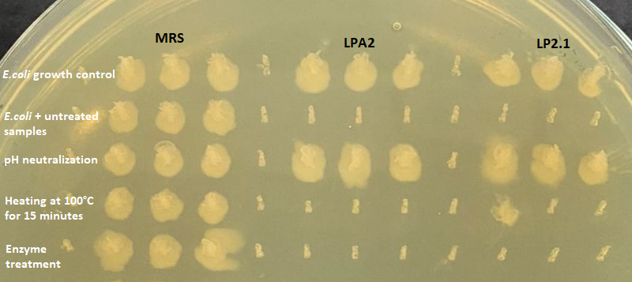
Figure 3: Assessment of the inhibitory effect of LPA2 and LP2.1, with and without treatment. After neutralizing the pH of the lactobacilli supernatant, the inhibitory effect was suspended, and it was possible to observe microbial growth in the Petri dish. After heating to 100°C and enzymatic treatment, it was not possible to observe microbial growth in the Petri dish, thus demonstrating that the inhibitory effect of the supernatants was preserved even after the respective treatments.

