Tele-Neurological Assessment for the Level, Severity, and Completeness of Spinal Cord Injury (TNASCI)
You will soon undergo an assessment evaluating your sensory perception, motor function, and anorectal function. Please respond honestly to ensure an accurate clinical analysis. A summary of your assessment will be provided upon completion.
Section 1 Sensory assessment
Using the body chart below, indicate how your skin feels in different areas by selecting Normal, Abnormal, or Absent.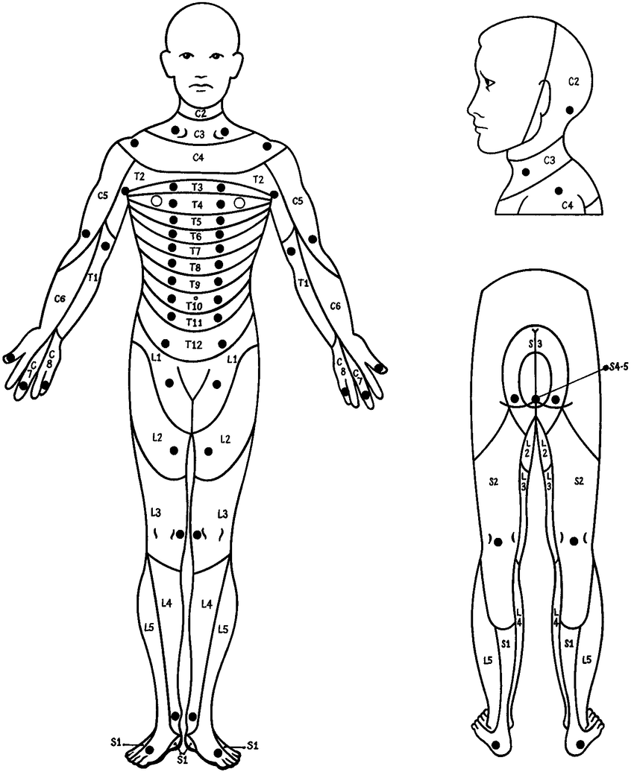
right
left
Sensory function | Description
Normal | The sensation should feel similar to what you normally experience on both sides of your cheeks. You should also be able to distinguish between sharp and dull stimuli or light touch when your skin is touched.
Abnormal | The sensation may feel stronger or weaker than what you would normally experience on both sides of your cheeks, or you might be unable to distinguish between sharp and dull stimuli or light touch.
Absent | No sensation is felt at all when touched.
- Please evaluate the "sensory function" you experience in each area of your skin (both right and left sides), starting from the head and moving down to the toes. Identify and indicate the transition points where sensation changes from "normal" to "abnormal" or "absent" across different areas of your skin.
Table 1 Cut-off points between skin areas with different sensory function
Cut-off point | Right | Left
Transition points between “normal” and “abnormal”. | (example C2–3/L3–4) | (example C2–3/L3–4)
Transition points between “abnormal” and “absent”.
No “abnormal” skin sensation No “absent” skin sensation

- Please reassess the "sensory function" you perceive in a specific area of your skin and confirm that the information we requested accurately reflects your actual sensation.
Assessor’s script: On your right/left side, how would you describe the sensory function of the skin at the [specific area a–d]... is it "normal," "abnormal," or "absent"?
(Appendix 1: description of “Key Sensory Points” for each specific skin area)
Sensory assessment summary:
The lowest skin area with “normal” sensory function on both sides of the body is at …………………………………………..(a level)
Left………………………..…… Right..........……..……………….
Use the information from Table 1 to verify the sensory function of specific skin areas as follows: "a" represents the lowest skin area with "normal" sensory function, "b" indicates the highest skin area with "abnormal" sensory function adjacent to "a", "c" represents the lowest skin area with "abnormal" sensory function, and "d" denotes the highest skin area with "absent" sensory function.
Table 2 Recheck of the sensory function of specific skin areas
Time 1 |  |  |  |  | Time 2
Sensory function of specific skin areas | Right |  | Left |  | Sensory function of specific skin areas | Right |  | Left
a |  | normal  abnormal  absent |  | normal  abnormal  absent | a |  | normal  abnormal  absent |  | normal  abnormal  absent
a |  | normal  abnormal  absent |  | normal  abnormal  absent | a |  | normal  abnormal  absent |  | normal  abnormal  absent
b |  | normal  abnormal  absent |  | normal  abnormal  absent | b |  | normal  abnormal  absent |  | normal  abnormal  absent
b |  | normal  abnormal  absent |  | normal  abnormal  absent | b |  | normal  abnormal  absent |  | normal  abnormal  absent
c |  | normal  abnormal  absent |  | normal  abnormal  absent | c |  | normal  abnormal  absent |  | normal  abnormal  absent
c |  | normal  abnormal  absent |  | normal  abnormal  absent | c |  | normal  abnormal  absent |  | normal  abnormal  absent
d |  | normal  abnormal  absent |  | normal  abnormal  absent | d |  | normal  abnormal  absent |  | normal  abnormal  absent
d |  | normal  abnormal  absent |  | normal  abnormal  absent | d |  | normal  abnormal  absent |  | normal  abnormal  absent

Section 2 Information for motor examination
Use the chart below to evaluate your motor function.
Grade | Description
0 | No movement and no muscle twitch.
1 | No movement but some muscle twitch witnessed.
2 | Full active range of motion when performed in the horizontal plane.
3 | Full active range of motion when performed in the vertical plane (as shown in the pictures).
4 | Full active range of motion when performed against some resistance.
5 | Full active range of motion when performed against full resistance.

Please reassess the strength grade you perceive for each key muscle and verify that the information provided accurately represents your actual motor function.
Note: If the patient can perform the action shown in the picture, assess for grades 3–5. If the patient is unable to perform the action, assess for grades 0–2. When reassessing for grade 2, the assessor should describe the full active range of motion with gravity eliminated for each key muscle to the patient.
Level | Starting position and action | Right | Left
C5 | Starting position: straighten your arm and face your palm upward.  Action: bend your elbow.  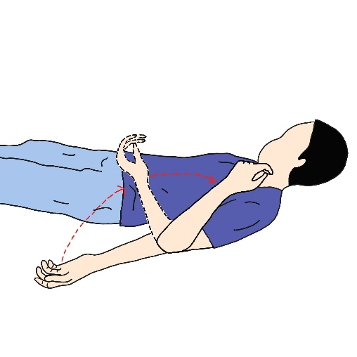
C6 | Starting position: face your palm downward.  Action: bend your wrist backward.  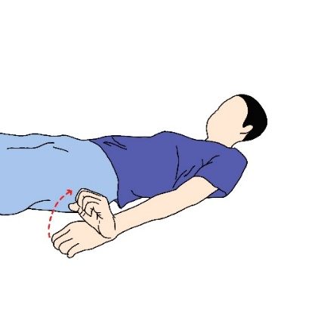
C7 | Starting position: lift your shoulder, bend your elbow, and put your palm on your shoulder.  Action: straighten your arm up toward the ceiling.  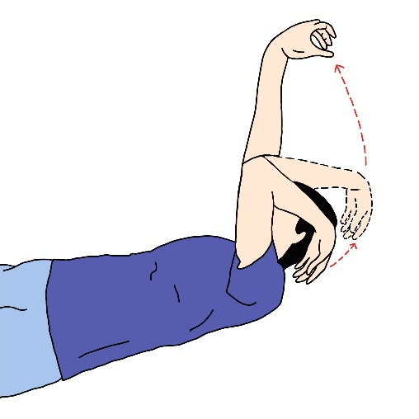
C8 | Starting position: open your hand.  Action: bend your middle finger.  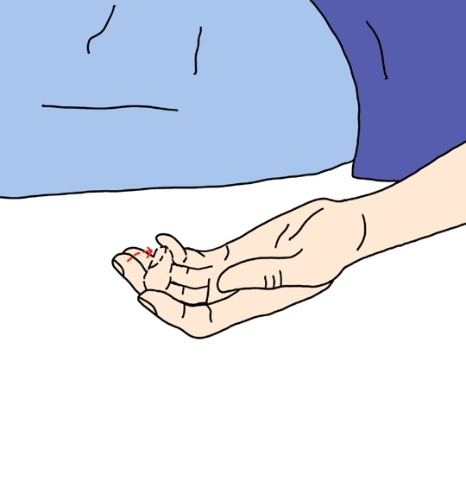
T1 | Starting position: open and straighten your hand with closed fingers.  Action: spread your fingers apart.  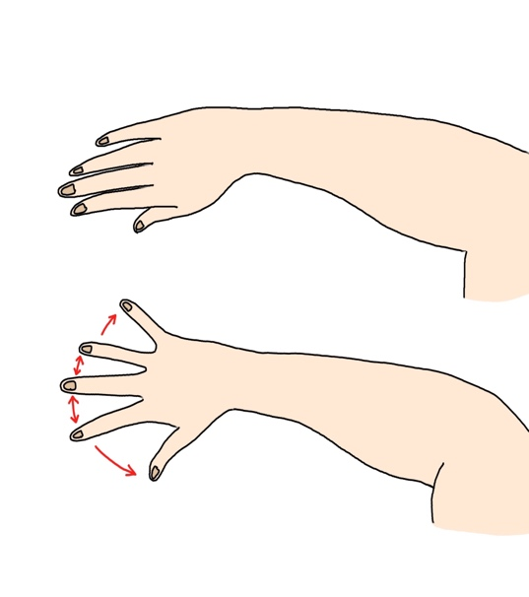
L2 | Starting position: lie on your back and straighten your hip.  Action: bend your hip to your torso.  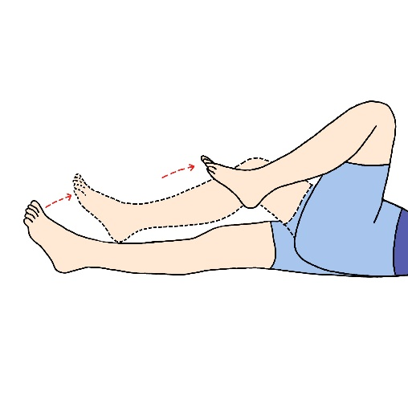
L3 | Starting position: bend your knee.  Action: straighten out your knee.  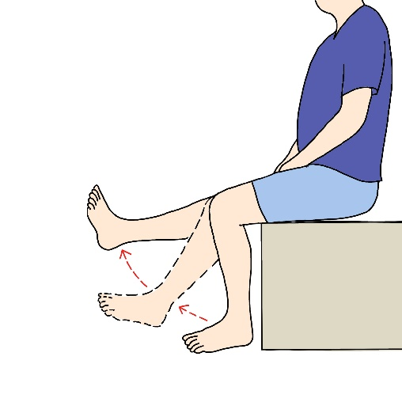
L4 | Starting position: natural position.  Action: bend your ankle upward.  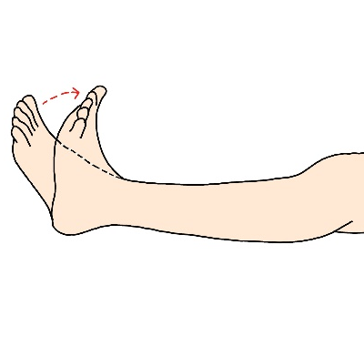
L5 | Starting position: natural position.  Action: pull your big toe up.  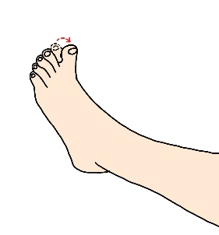
S1 | Starting position: natural position.  Action: press your foot down.  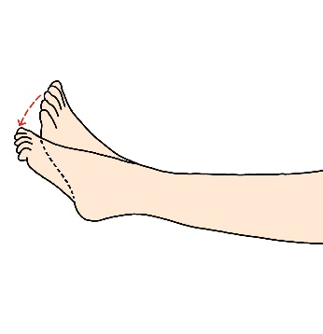

Section 3 Anorectal function
Question | Answer
Do you have any sensation of touch around your anus? | Normal  Abnormal  Absent
When inserting a finger or performing anal care, do you feel any pressure inside your rectum? | Yes  No  Unsure
Can you consciously tighten the muscles around your anus to control passing gas or prevent stool leakage? | Yes  No  Unsure

Section 4 Results summary
Neurological level | Right | Left
Sensory
Motor
Neurological level of injury …………………………………
Completeness of injury Complete Incomplete
ASIA Impairment Scale ……………………………………..
Zone of partial preservation | Right | Left
Sensory
Motor

Appendix
Key Sensory Points (to accommodate section 2)
C2 | The skin behind the ear (approximately 1 inch behind)
C3 | The skin above the collar bone (midline of each side)
C4 | The skin on the upper-front part of the shoulder
C5 | The skin on the outer part of the elbow crease
C6 | The skin on the back of the thumb
C7 | The skin on the back of the middle finger
C8 | The skin on the back of the little finger
T1 | The skin of the elbow
T2 | The skin at the armpit
T3 | The skin 2 inches above the nipple | Consider an imaginary vertical line running through the center of both collarbones.
T4 | The skin next to the nipple (inner part)
T5 | The skin between the nipple and the xiphisternum
T6 | The skin next to the xiphisternum
T7 | The skin slightly under the xiphisternum
T8 | The skin between the xiphisternum and the belly button
T9 | The skin slightly above the belly button
T10 | The skin next to the belly button
T11 | The skin slightly under the belly button
T12 | The skin on the groin crease
L1 | The skin over the top of the upper thigh
L2 | The skin over the top of the mid-thigh
L3 | The skin inside the thigh near the knee
L4 | The skin over the inside of the ankle
L5 | The skin on top of the foot around the middle toe area
S1 | The skin under the sole of the foot
S2 | The skin behind the knee
S3 | The skin under the buttocks
S4/5 | The skin around the anus

