Additional file 1: Fig. S1 FRK enzyme activity in the transgenic poplars (OE#1, OE#4 and OE#9) leaves overexpressing MdFRK2. Bars represent the mean value ± SE (n ≥3). An asterisk indicates a significant difference at P ≤0.05.

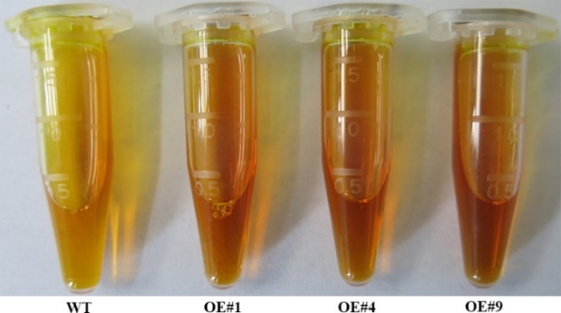
Additional file 2: Fig. S2 SUSY activity in stems of transgenic poplars (OE#1, OE#4 and OE#9) overexpressing MdFRK2. SUSY, sucrose synthase

Additional file 3: Table S1 Phenotypic characteristics of the transgenic poplars (OE#1, OE#4 and OE#9) overexpressing MdFRK2
phenotypes Index | WT | OE#1 | OE#4 | OE#9
Height (cm) | 108.25±1.82 | 108.5±1.83 | 108.25±1.75 | 108.24±1.73
Stem diameter (mm) | 6.16±0.24 | 6.7±0.26 | 6.22±0.25 | 6.52±0.26

Additional file 2: Table S2 Primers used in this study
Name/Accession no | Sequence (5’-3’) | Purpose
qPtrCWINV2 | F: TCAACGATCCAAATGGGCCT | Quantitative expression of PtrCWINV2
qPtrCWINV2 | R: GGGCTCACCATTTGGGAGAA | Quantitative expression of PtrCWINV2
qPtrSUSY1 | F: ACGTGCTCTTACTCGTGTCC | Quantitative expression of PtrSUSY1
qPtrSUSY1 | R: CGCCTGCCAATGTTTTCCTG | Quantitative expression of PtrSUSY1
qPtrFRK1 | F: CATCAGCTGAGGCTGCTAGG | Quantitative expression of PtrFRK1
qPtrFRK1 | R: ATACCGGCAACCTTCTGACC | Quantitative expression of PtrFRK1
qPtrFRK2 | F: ACTGATCGTGAGCTTCGGTG | Quantitative expression of PtrFRK2
qPtrFRK2 | R: CGCCGACTTTCCTCCTAGTC | Quantitative expression of PtrFRK2
qPtrHxK1 | F: ATTTCCGGTCTTCGCACCTT | Quantitative expression of PtrHxK2
qPtrHxK1 | R: CAGACATGTGAGGCGTCCTT | Quantitative expression of PtrHxK2
MdActin | F: GGACAGCGAGGACATTCAGC | Real-time PCR of actin as a reference gene in apple plants
MdActin | R: CTGACCCATTCCAACCATAACA | Real-time PCR of actin as a reference gene in apple plants
PtrActin | F: CCCATTGAGCACGGTATTGT | Real-time PCR of actin as a reference gene in poplar plants
PtrActin | R: TACGACCACTGGCATACAGG | Real-time PCR of actin as a reference gene in poplar plants

