Supplementary Information for
Collective quantum coherence and subband redistribution in artificially assembled nanotube arrays

Xiaosong Deng^{1,5}, Weili Li^{2,5}, Xiaohan Cheng¹, Zixuan Zhang³, Guanhua Long¹, Chenwei Fan¹, Chuanhong Jin³, Yanning Zhang², Ning Kang^{1,4*}, and Zhiyong Zhang^{1*}
¹Key Laboratory for the Physics and Chemistry of Nanodevices and Center for Carbon-based Electronics, School of Electronics, Peking University, Beijing 100871, China.
²Institute of Fundamental and Frontier Sciences, University of Electronic Science and Technology of Chengdu 610054, China.
³State Key Laboratory of Silicon Materials, School of Materials Science and Engineering, Zhejiang University, Hangzhou 310027, China.
⁴Hefei National Laboratory, Hefei 230088, China.
⁵These authors contributed equally: Xiaosong Deng, Weili Li.

*Correspondence to: E-mail: (N. K.) nkang@pku.edu.cn; (Z. Z.) zyzhang@pku.edu.cn

This file includes:
Supplementary Figures 1-10
Supplementary Table 1
Supplementary Discussions 1-3
Supplementary References

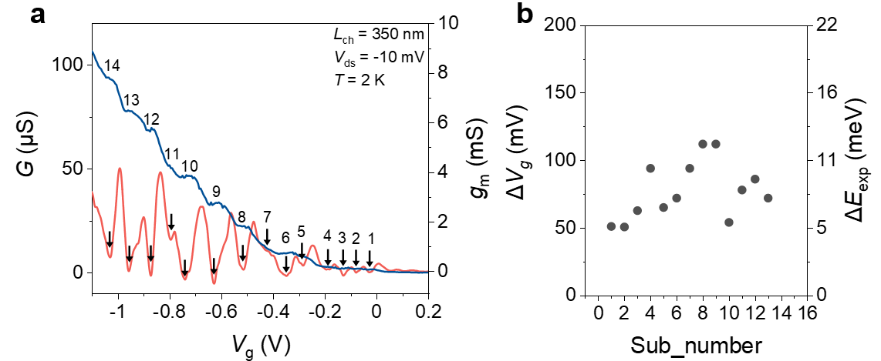
Fig. S1. Subband separations of a device based on A-CNT films. a, A transfer curve and transconductance curve at 2 K. The black arrows are the minima of the transconductance and the numbers are the subband orders, indicating the position of each subband. b, Subband separations as the function of subband number, extracted from a. ∆E_{exp} is calculated from the ∆V_{g} by the equation (1). The data from the same device of Fig.1.
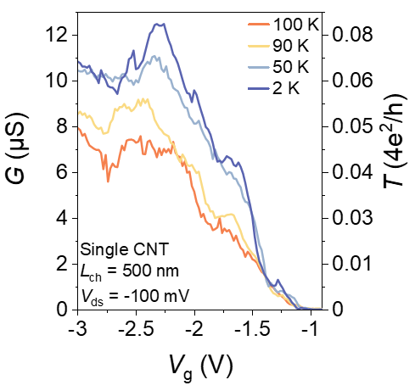
Fig. S2. Transfer curves at various temperatures of a device based on a single CNT. The single CNT is separated from the A-CNT films. The conductance increases with decreasing temperature, demonstrating the quasi-ballistic transport. Non-perfect contact leads to non-perfect transmission.
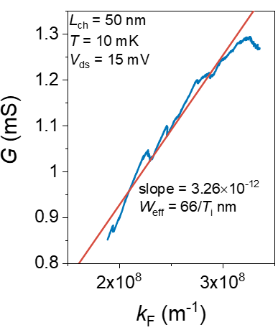
Fig. S3. Conductance as a function of the Fermi wave number. The red line is a fit using the equation (2) in the ballistic regime. The effective width of the constriction can be obtained from the slope of fitting.
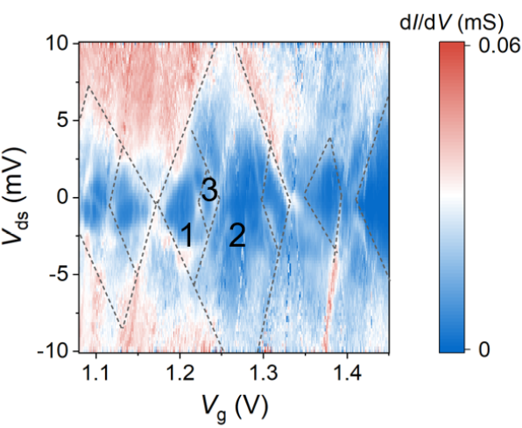
Fig. S4. Differential conductance as a function of V_{g} and V_{ds}, showing the nested diamonds with different sizes. The charge energies change from 2.1 to 11.5 meV.

Supplementary Discussions 1. Geometric size of the quantum dot.
The constant-interaction model¹ gives the addition energy, $E_{add}=E_{c}+∆ϵ$, where $E_{c}=e^{2}/C$ is the charge energy, C is the total capacitance and $∆ϵ$ is the energy difference between adjacent levels. It is reasonable to ignore $∆ϵ$ in multi-electron regime. Then, the total capacitance can be obtained from $E_{c}$. The gate capacitance $C_{g}=e/{∆V}_{g}$ can be extracted from the width of diamonds. Finally, the geometric size of the quantum dot is calculated by $S=C_{ox}/C_{g}≈L_{ch}×W_{qd}$, where $C_{ox}=ε_{0}ε_{r}/t_{ox}$=1.77×10⁻² F/m² by flat capacitance approximation here ($ε_{0}$ is the vacuum permittivity, $ε_{r}≈10$ is the relative permittivity of HfO₂ obtained from the empirical value, and $t_{ox} ≈5 nm$ is the thickness of the gate oxide). The parameters of representative diamonds of Figure S4 are summarized in the Table S1.

Table S1 Parameters of representative diamonds in Fig. S4
diamond | ${∆V}_{g}$ (mV) | $E_{c}$ (meV) | $C_{g}$ (F) | C (F) | S (nm²) | W_{qd} (nm)
1 | 74.7 | 5.2 | 2.14e⁻¹⁸ | 3.01e⁻¹⁷ | 121 | 2.4
2 | 159.4 | 11.5 | 1.00e⁻¹⁸ | 1.39e⁻¹⁷ | 56.7 | 1.1
3 | 24.7 | 2.1 | 6.48e⁻¹⁸ | 7.62e⁻¹⁷ | 366 | 7.3

There is an underestimation of $W_{qd}$, considering that the actual length of QDs is smaller than $L_{ch}$. Moreover, a greater lateral extension can be obtained by a round shape of QDs. Consequently, we capture the formation of the large sizes of QDs based on multiple-CNT coherence, since the average diameter of CNTs is 1.45 nm. The observation demonstrates that the wave function of the electron in a QD extends to multiple CNTs.
The intertube coupling can be controlled by the gate voltage, causing the smaller spatial scale than that in subband regime. The same result is observed in our other work.
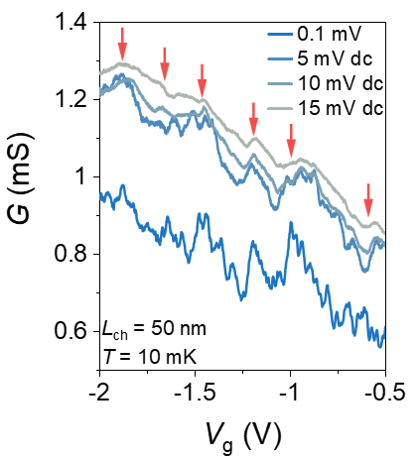
Fig. S5. Transfer curves at various biases of a device based on A-CNT films. Red arrows indicate the positions of subband. The curve with 0.1 mV is measured by the lock-in ac technology, while others are measured by the dc technology. Obvious interference appears in the curve with 0.1 mV, demonstrating the ballistic realization.
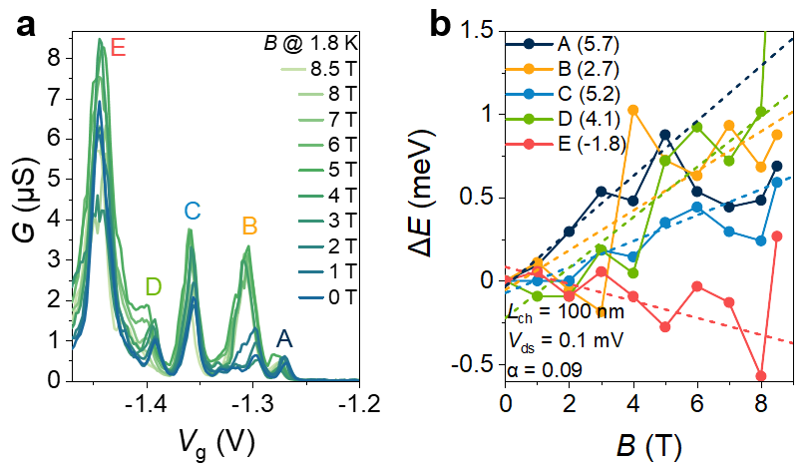
Fig. S6. Magnetic field dependence of the discrete levels in the QD regime. a, Transfer curves as a function of V_{g} at various magnetic fields. Peaks indicate the resonance transport through the discrete levels of the QDs, marked by the colored letters. b, The shifts of the conductance peak in a as a function of magnetic fields. ∆E is obtained by the equation (1). Dashed lines are the fitting of Zeeman equation (S1).

Supplementary Discussions 2. Level shifts induced by magnetic field.
The discrete levels in QD can shift with a perpendicular magnetic field due to the Zeeman effect^{2,3}. The contribution of orbital magnetic moment can be neglected without parallel magnetic field. Thus, the Zeeman shift is given by
$$\begin{aligned}{∆E}_{z}=\frac{1}{2}g_{s}μ_{B}B_{⊥}\#\left(S1\right)\end{aligned}$$
where $g_{s}$ is the spin g factor and $μ_{B}$ is the Bohr magneton. We fit the level shifts in Fig. S6a and the results are shown in Fig. S6b. $g_{s}$ is obtained from 1.8 to 5.7, close to that of single CNTs.

Supplementary Discussions 3. DFT simulation of A-CNT system
The DFT calculations are performed using ab initio methods as implemented by Vienna ab initio Simulation Package (VASP)⁴ using the projector augmented wave (PAW)⁵. The electronic exchange-correlation interactions were modeled within the generalized gradient approximation with the Perdew–Burke–Ernzerhof functional (GGA-PBE)^{4,6}. The long-range van der Waals interactions were included using the semiempirical DFT-D3 method^{7,8}. A plane wave energy cutoff of 500 eV is used with k-meshes of 1× 1 × 11 and 3 × 1 × 11 for 1D CNTs and 2D A-CNTs system, respectively. Both the lattice parameter and atom coordinates are fully relaxed, until the energy is converged at 10⁻⁶ eV and the force is converged at 0.02 eV/Å for the geometry optimization. The (19,0) CNT is used to model the single CNT with a 1.5 nm diameter similar to the experiment, which lattice parameter is 4.28 Å and the energy band gap is 0.46 eV. The 1D CNTs and 2D A-CNTs system is modeled as a 3D lattice in which the distances of CNTs at lattice aperiodic direction are chosen to be more than 10 Å so that there is negligible interaction between aperiodic CNTs in the periodic lattice. To clarify the change of electron coupling in 2D A-CNTs with the inter-tube interaction, lattice strain was applied at the non-transport direction in array system. The strain-driven changes of intertube spacing and system energy are in Fig. S7. The intertube spacing is defined as the distance between two tubes. The strain energy (E_{str.}) is defined as:
$$E_{str.}=E_{tot.}-E_{tot.(str.)}$$
Here, the $E_{tot.}$ is the total energy of 2D A-CNT, $E_{tot.(str.)}$ is the total energy of 2D A-CNT under strain. The strain dependence of band structure is in Fig. S8. In Fig. S8, the E_{vx} is defined as the sequencing of the energy band under fermi energy, example the E_{v1-2} is the sub energy between the first and second energy. While to evaluate the interactions between the tubes bundle, the 2-tubes bundle and 3-tubes bundle models are established, and the electron levels are shown in Fig. 3c. Considering all the calculated models here, the subband structure is summarized in Fig. S9, which demonstrates the obvious difference between the subband in single CNT and that in A-CNT systems. A denser number of subbands and smaller subband separations arise, namely subband redistribution.

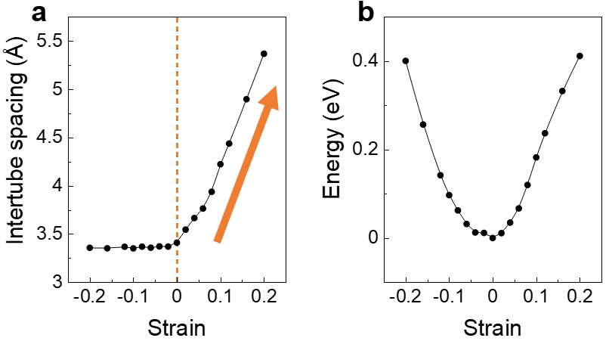
Fig. S7. Strain-driven changes of intertube spacing (a) and system energy (b) in DFT simulation of A-CNT system.

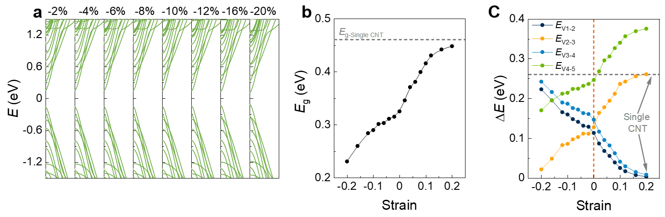
Fig. S8. Strain dependence of band structure. a, Band structures of A-CNT films with negative strain. b, Energy gap of A-CNT films as a function of strain. Dotted line marks the energy gap of a single CNT. c, Subband separations of the first five subbands of the valence band as a function of strain, extracted from Fig. 3b and a. Dotted gray line marks the subband separation of the first subband of single CNT.

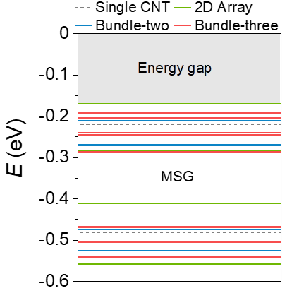
Fig. S9. Subband summary of DFT simulations. Data is extracted from Fig. 3a and 3b.
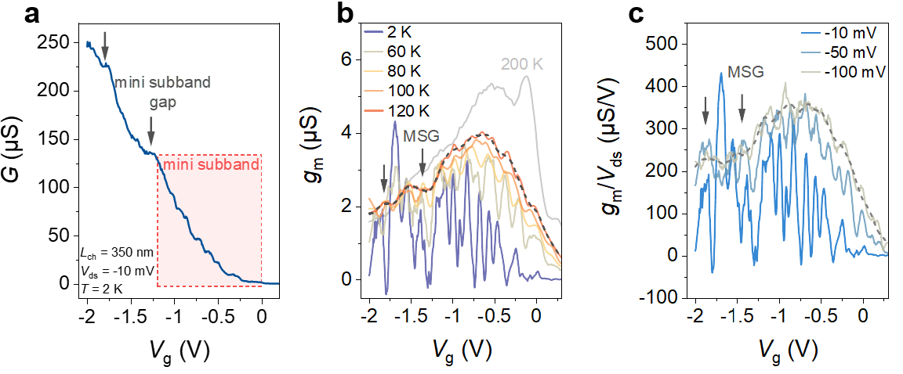
Fig. S10. Mini subband gap in a device based on A-CNT films. a, Transfer curves at 2 K. Black arrows mark the position of mini subband gap (MSG) with a larger energy scale, compared with the normal subband. Red region is the mini subband occupancy shown in Fig. 1d. Temperature b and bias c dependence of MSG demonstrate the larger energy scale of MSG. The characteristics of MSG can be sustained up to 200 K or 100 mV after that of mini subband occupancy disappears. The data from the same device of Figure 1.

Supplementary References
1 Kouwenhoven, L. P., Austing, D. G. & Tarucha, S. Few-electron quantum dots. Rep. Prog. Phys. 64, 701-736 (2001).
2 Jarillo-Herrero, P., Sapmaz, S., Dekker, C., Kouwenhoven, L. P. & van der Zant, H. S. J. Electron-hole symmetry in a semiconducting carbon nanotube quantum dot. Nature 429, 389-392 (2004).
3 Jespersen, T. S. et al. Gate-dependent spin-orbit coupling in multielectron carbon nanotubes. Nat. Phys. 7, 348-353 (2011).
4 Kresse, G. & Furthmuller, J. Efficient iterative schemes for ab initio total-energy calculations using a plane-wave basis set. Phys. Rev. B 54, 11169-11186 (1996).
5 Blochl, P. E. Projector augmented-wave method. Phys. Rev. B 50, 17953-17979 (1994).
6 Perdew, J. P., Burke, K. & Ernzerhof, M. Generalized gradient approximation made simple. Phys. Rev. Lett. 78, 1396-1396 (1997).
7 Grimme, S., Antony, J., Ehrlich, S. & Krieg, H. A consistent and accurate ab initio parametrization of density functional dispersion correction (DFT-D) for the 94 elements H-Pu. J. Chem. Phys. 132, 154104 (2010).
8 Grimme, S., Ehrlich, S. & Goerigk, L. Effect of the damping function in dispersion corrected density functional theory. J. Comput. Chem. 32, 1456-1465 (2011).

