Supplementary Figure 1: Patient distribution and treatment exposure

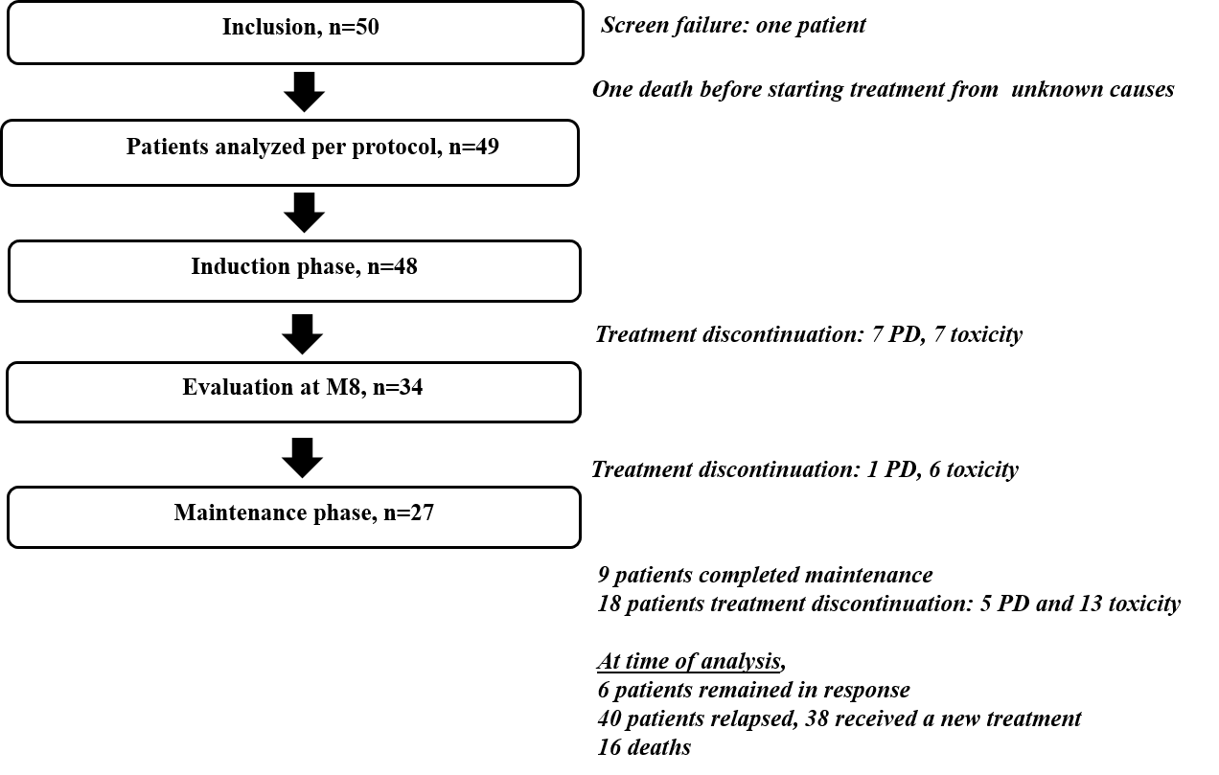
PD: progressive disease

Supplementary Table 1: Baseline characteristics of enrolled patients (n=49)
Median (interquartile range) and percentages computed on the whole sample of 49 patients are reported unless specified

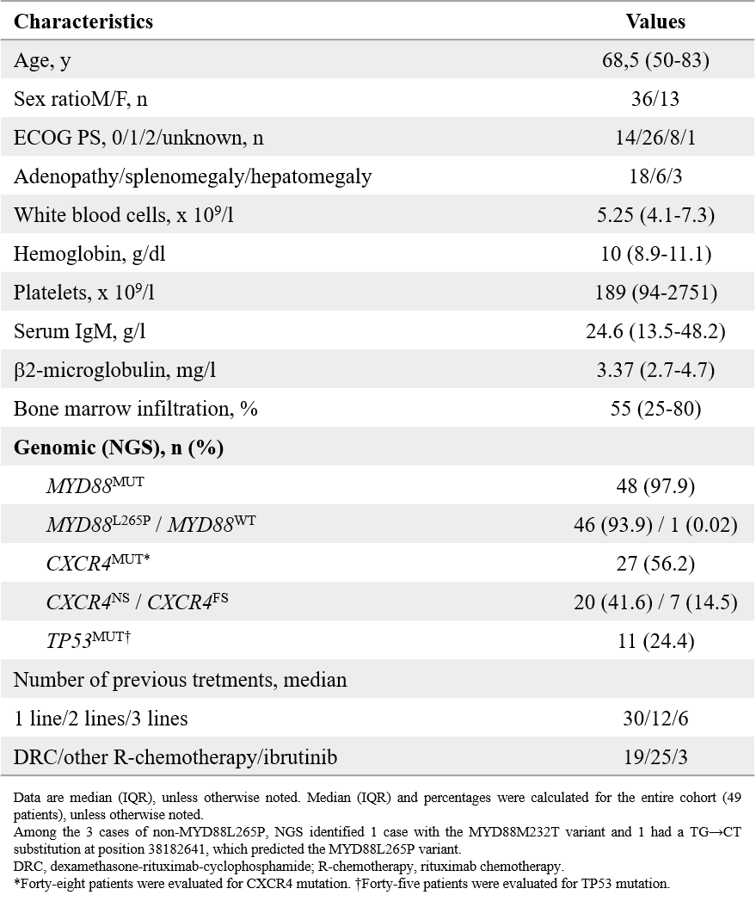
Gene mutation analysis Next-generation sequencing (NGS) was performed centrally on DNA extracted from cells following Ficoll-Paque gradient centrifugation of BM samples collected at inclusion using the Ion PGM Torrent platform (Thermo Fisher Scientific). The custom gene panel included MYD88, CXCR4, TP53, BTK, and PLCG2. A mean coverage of 2000 to 25003 was obtained for all targeted regions, allowing analysis of subclonal variation with a limit of detection of 0.8%.21 In addition, droplet digital PCR was used to screen MYD88L265P and CXCR4S338X variants, with a limit of detection of 0.05%, according to the manufacturer’s recommendations (Bio-Rad).

