Permafrost degradation reverses warming-induced earlier vegetation green-up
Boyi Liang¹, Jian Wang^{2,3}, Chris Huntingford⁴, Hongyan Liu^{5,}*, Elizabeth L. Cressey⁶, Chongyang Xu⁷, Liang Shi^{8,9}, Lu Wang¹⁰, Jing Cao¹¹, Yang Qi¹², Zong Wang¹, Jia Wang¹, Timothy A. Quine⁶

1. College of Forestry, Precision Forestry Key Laboratory of Beijing, Beijing Forestry University, Beijing 100083, China.
2. The Key Laboratory of Land Surface Pattern and Simulation, Institute of Geographical Sciences and Natural Resources Research, Chinese Academy of Sciences, Beijing, 100101, China.
3. University of the Chinese Academy of Sciences, Beijing, 100049, China.
4. UK Centre for Ecology and Hydrology, Wallingford, Oxfordshire, UK
5. College of Urban and Environmental Sciences, Institute of Ecology and Institute of Carbon Neutrality, Peking University, Beijing, 100871, China.
6. Geography, College of Life and Environmental Sciences, University of Exeter, Exeter, EX4 4RJ, UK.
7. Faculty of Agriculture, Food and Environment, The Hebrew University of Jerusalem, Rehovot, 7610001, Israel.
8. Key Laboratory of Ecosystem Network Observation and Modeling, Institute of Geographic Sciences and Natural Resources Research, Chinese Academy of Sciences, Beijing, 100101, China.
9. National Ecosystem Science Data Center, Beijing, 100101, China.
10. Key Laboratory for Agro‐Ecological Processes in Subtropical Region, Institute of Subtropical Agriculture, Chinese Academy of Sciences, Changsha, China.
11. State Key Laboratory of Environmental Criteria and Risk Assessment, State Environmental Protection Key Laboratory of Regional Eco-process and Function Assessment, Chinese Research Academy of Environmental Sciences, Beijing, 100012, China.
12. College of JunCao Science and Ecology, Fujian Agriculture and Forestry University, Fuzhou 350002, China.
*Corresponding author: Hongyan Liu (lhy@urban.pku.edu.cn)
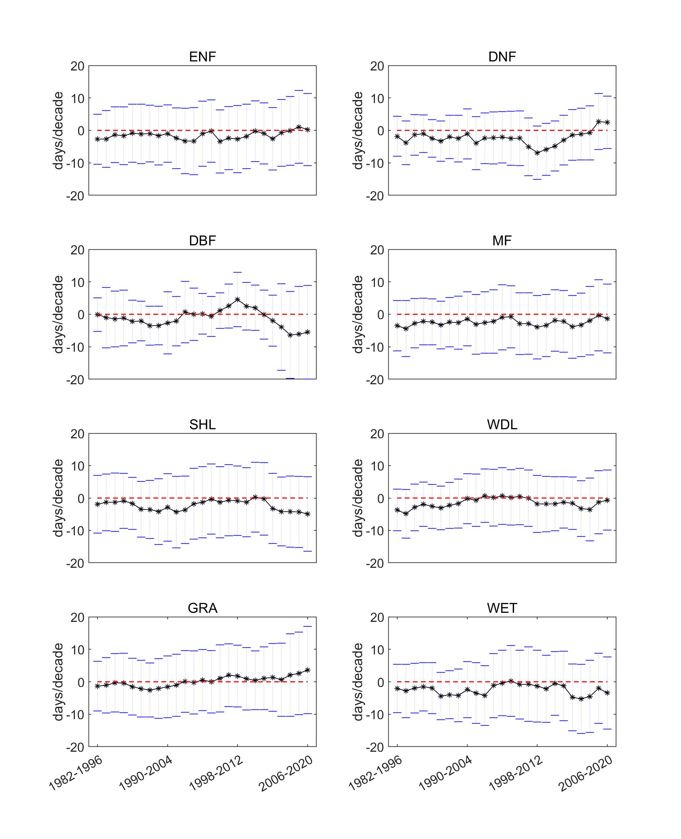
Figure S1 Temporal variation of green-up date (GUD) slope in different biomes, including evergreen needleleaf forests (ENF), deciduous needleleaf forests (DNF), deciduous broadleaf forests (DBF), mixed forests (MF), shrublands (SHL), woodlands (WDL), grasslands (GRA), and permanent wetlands (WET). The asterisk represents the average of the slope for each 15-years moving window.

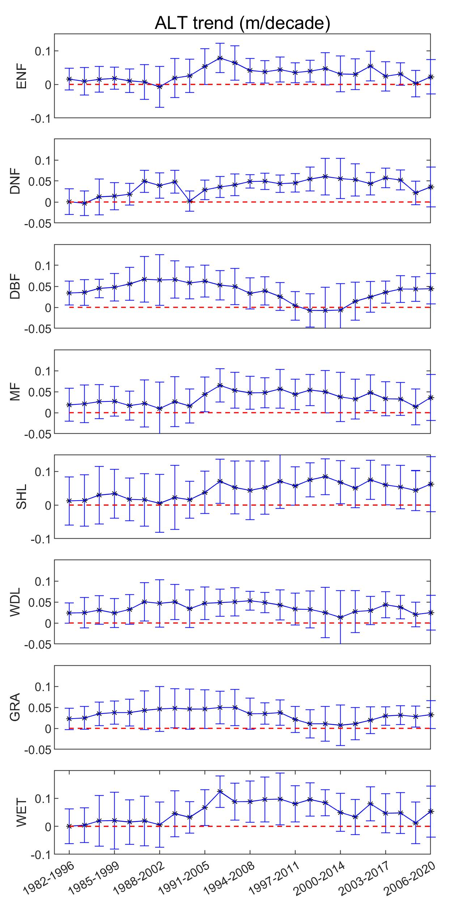
Figure S2 Temporal variation of ALT slope in the different biomes; where ENF denotes evergreen needleleaf forests, DNF – deciduous needleleaf forests, DBF – deciduous broadleaf forests, MF – mixed forests, SHL – shrublands, WDL – woodlands, GRA – grasslands, and WET – permanent wetlands. The asterisk represents the average of the slope for each 15-years moving window.

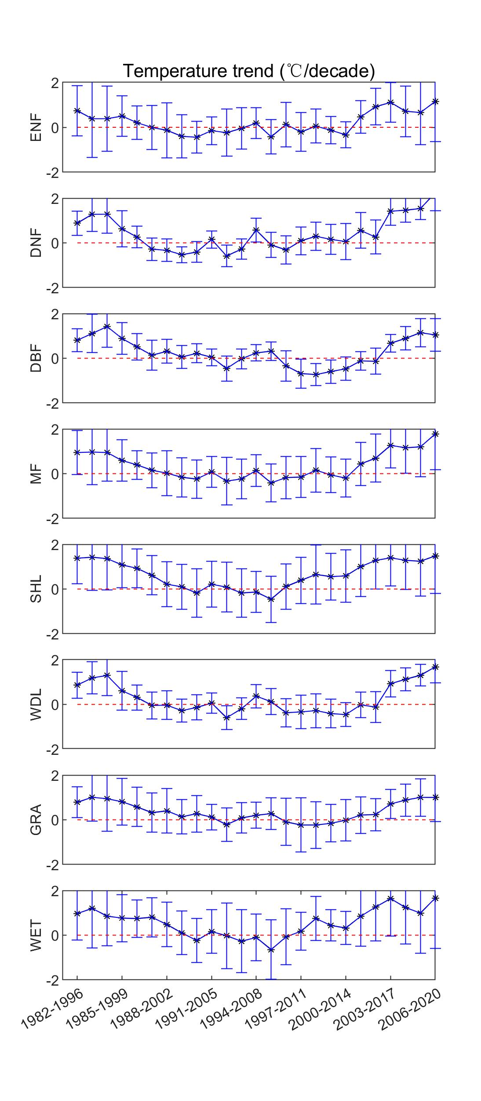
Figure S3 Temporal variation of temperature slope in different biomes; where ENF denotes evergreen needleleaf forests, DNF – deciduous needleleaf forests, DBF – deciduous broadleaf forests, MF – mixed forests, SHL – shrublands, WDL – woodlands, GRA – grasslands, and WET – permanent wetlands. The asterisk represents the average of the slope for each 15-years moving window.

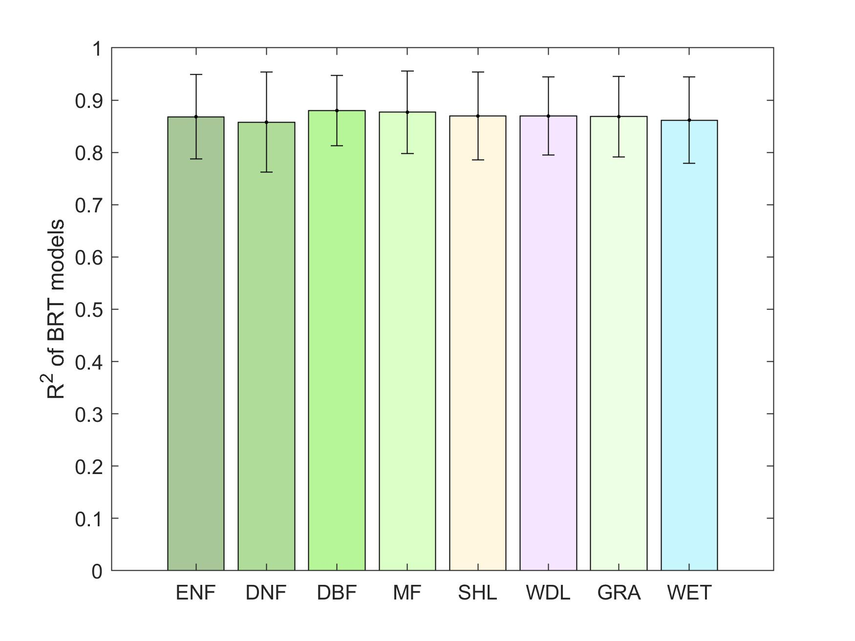
Figure S4 Determination coefficient (R²) of boosted regression tree (BRT) models in the different biomes; where ENF denotes evergreen needleleaf forests, DNF – deciduous needleleaf forests, DBF – deciduous broadleaf forests, MF – mixed forests, SHL – shrublands, WDL – woodlands, GRA – grasslands, and WET – permanent wetlands.
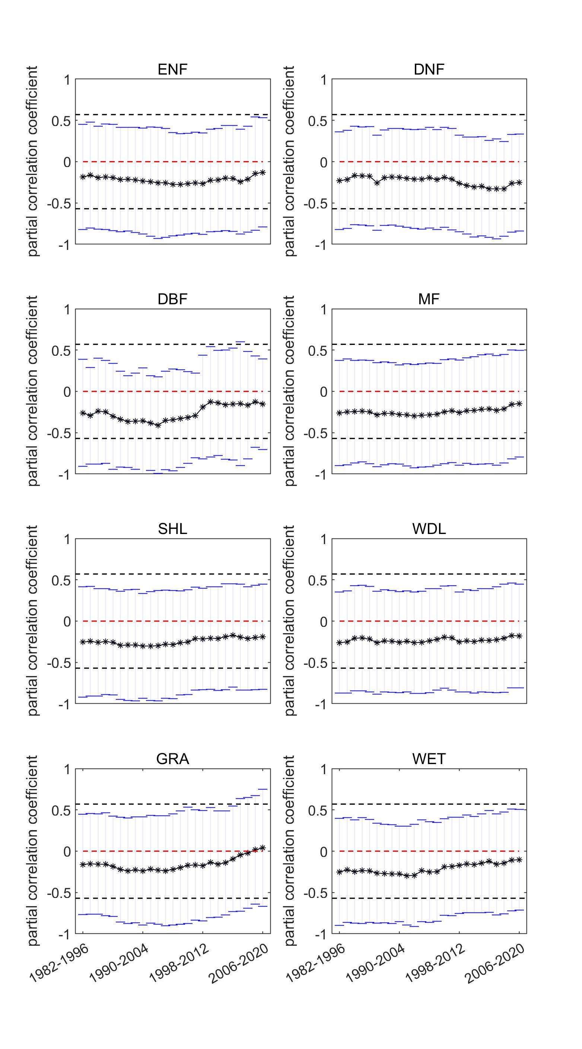
Figure S5 Temporal variation of partial correlation coefficient (within range of two standard deviations, black dashed lines denote the threshold of partial correlation coefficients with a significance level of <0.1) in different biomes; where ENF denotes evergreen needleleaf forests, DNF – deciduous needleleaf forests, DBF – deciduous broadleaf forests, MF – mixed forests, SHL – shrublands, WDL – woodlands, GRA – grasslands, and WET – permanent wetlands. The asterisk represents the average of the slope for each 15-years moving window.

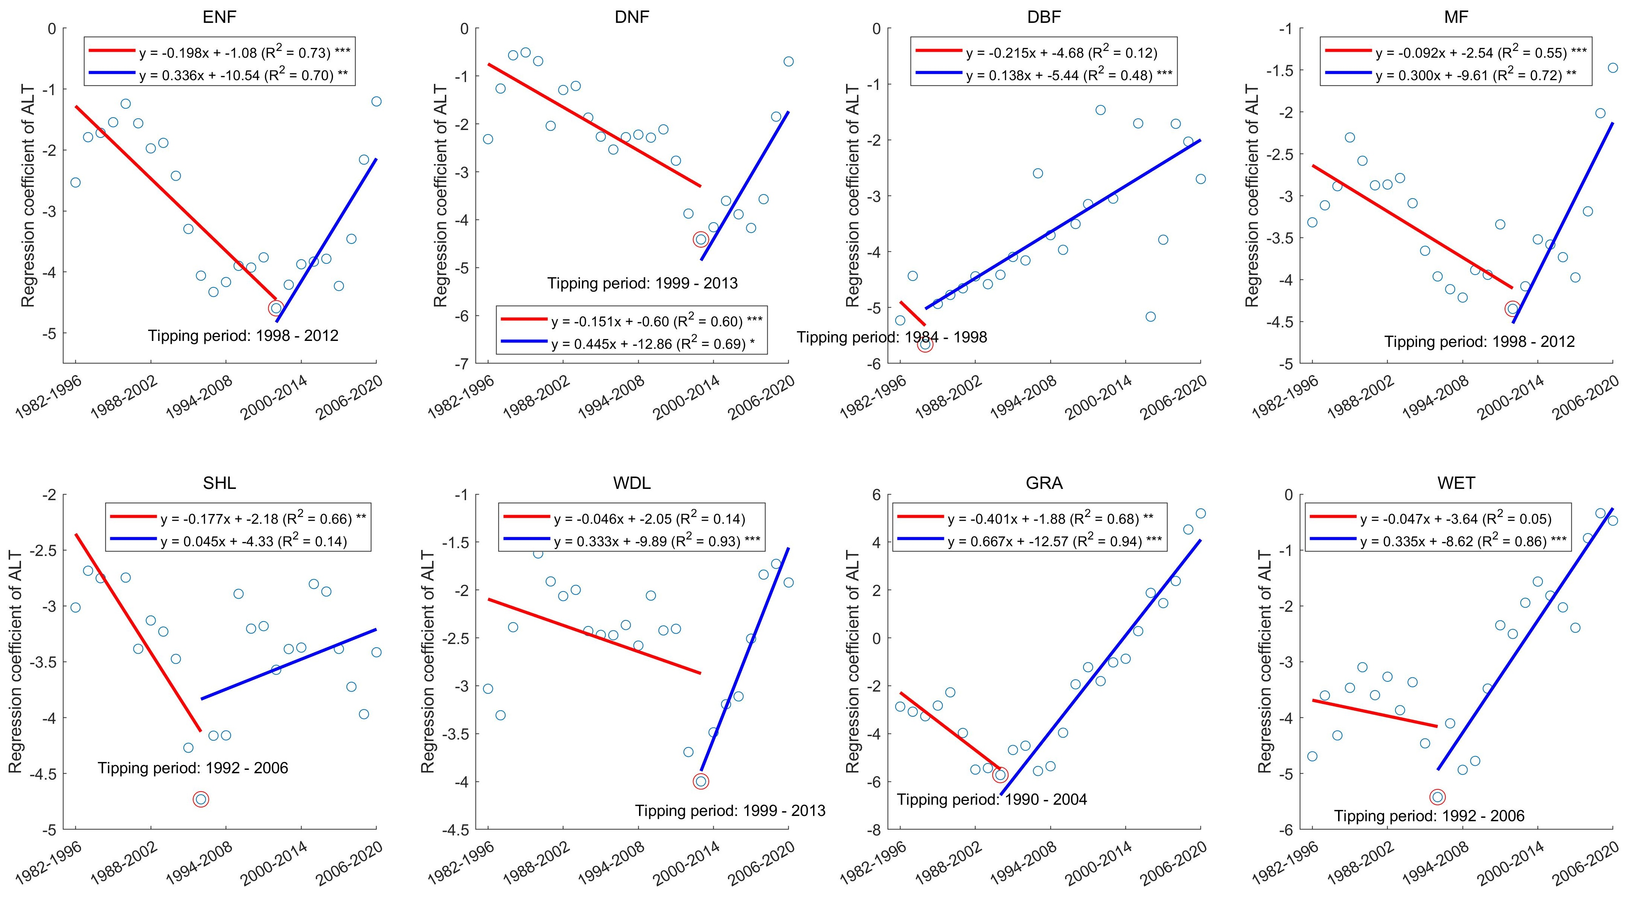
Figure S6 Regression coefficients for active layer thickness (ALT) from partial least squares regression (PLSR) in different biomes. The circle mark represents the average of the coefficient for each 15-years moving window. Identifying the period with maximum value of regression coefficients as the tipping period and the linear regression for the time periods before (red) and after (blue) the period, respectively. Where ENF denotes evergreen needleleaf forests, DNF – deciduous needleleaf forests, DBF – deciduous broadleaf forests, MF – mixed forests, SHL – shrublands, WDL – woodlands, GRA – grasslands, and WET – permanent wetlands.
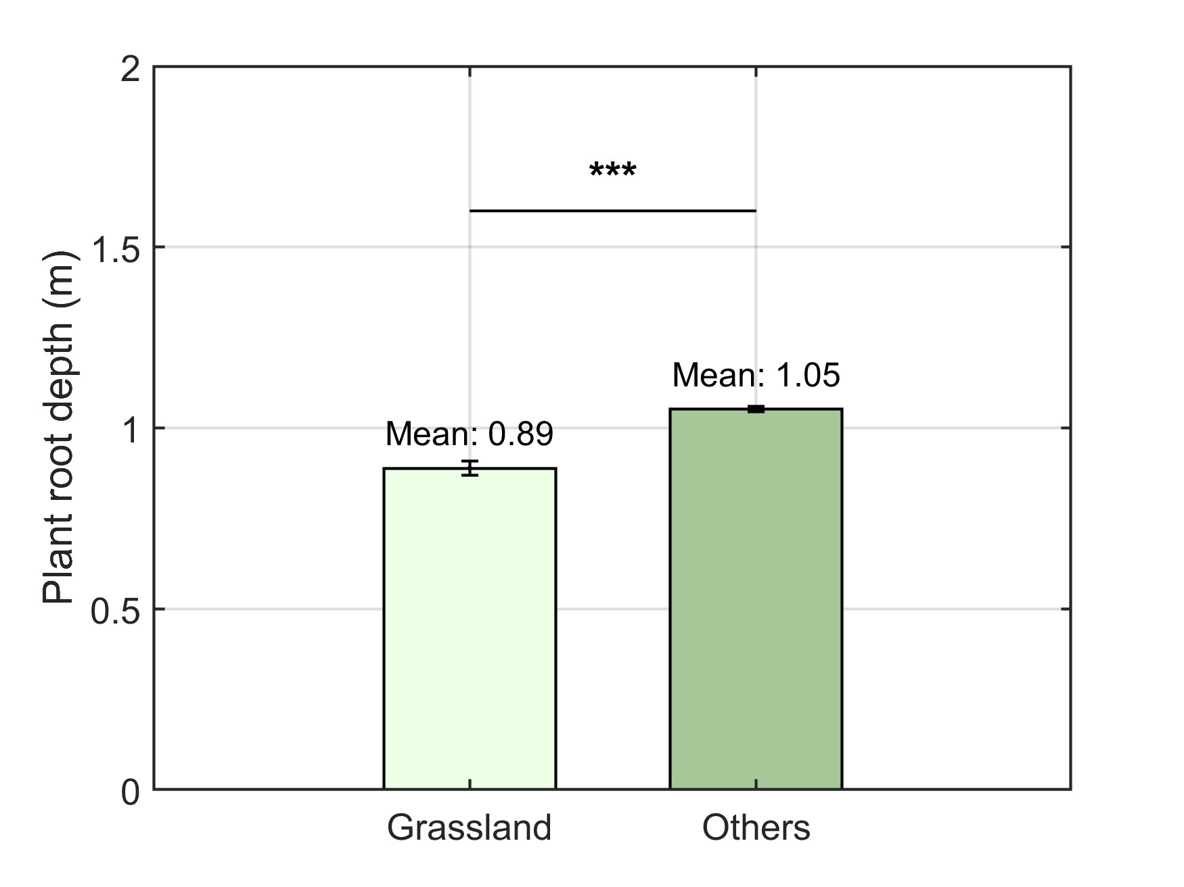
Figure S7 Difference of root depth between grasslands and other biomes by Kruskal-Wallis test (***: P<0.001).
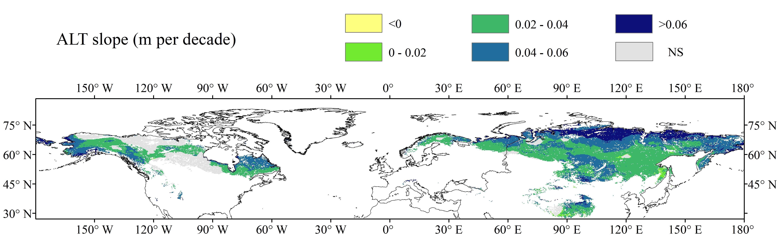
Figure S8 Active layer thickness (ALT) slope in the Northern Hemisphere permafrost region. NS represents nonsignificant.

