Table 1. Different termites’ species colony size in deadwood logs brought to the laboratory from different understudy-sites.
Study areas | Plots/Transect | Dead wood  log size (cm³) | Species | Workers | Soldiers | Alates | Larvae | Nymphs | Eggs | Colony size | Termites per (cm³)
Bagh-e-Jinnah | Transect 1 | 890.00 | O. obesus | 80 | 25 | 17 | 8 | 23 | + | 153 | 0.35
Bagh-e-Jinnah | Transect 1 | 890.00 | M. obesi | 48 | 20 | 10 | 2 | 5 | ̶ | 85 | 0.35
Bagh-e-Jinnah | Transect 1 | 890.00 | H. indicola | 34 | 22 | 10 | — | 4 | ̶ | 70 | 0.35
Bagh-e-Jinnah | Transect 2 | 354.00 | H. indicola | 28 | 13 | 10 | — | — | ̶ | 53 | 0.35
Bagh-e-Jinnah | Transect 2 | 354.00 | O. obesus | 45 | 25 | 5 | — | — | ̶ | 75 | 0.35
Bagh-e-Jinnah | Transect 3 | 231.00 | C. heimi | 33 | 28 | — | 5 | 14 | ̶ | 80 | 0.35
Canal Vegetation | Transect 1 | 5520.00 | O. obesus | 608 | 234 | 101 | 34 | 76 | + | 1053 | 0.44
Canal Vegetation | Transect 1 | 5520.00 | C. heimi | 450 | 135 | 25 | 35 | 120 | ̶ | 785 | 0.44
Canal Vegetation | Transect 1 | 5520.00 | H. indicola | 287 | 102 | 78 | 14 | 35 | ̶ | 516 | 0.44
Canal Vegetation | Transect 2 | 3960.00 | C. heimi | 682 | 323 | 30 | 52 | 83 | ̶ | 1170 | 0.44
Canal Vegetation | Transect 2 | 3960.00 | O. obesus | 428 | 172 | 25 | 20 | 55 | + | 500 | 0.44
Canal Vegetation | Transect 3 | 849.00 | O. obesus | 130 | 63 | — | 17 | 31 | + | 241 | 0.44
Canal Vegetation | Transect 3 | 849.00 | M. obesi | 40 | 23 | — | — | 17 | ̶ | 80 | 0.44
Race-Course Park | Transect 1 | 402.00 | O. obesus | 170 | 33 | -— | 7 | 10 | ̶ | 221 | 0.45
Race-Course Park | Transect 2 | 348.00 | O. obesus | 65 | 19 | 21 | 9 | 18 | ̶ | 132 | 0.45
Race-Course Park | Transect 3 | 90.00 | H. indicola | 15 | 10 | — | — | 7 | ̶ | 33 | 0.45
Model Town Park | Transect 1 | 444.00 | O. obesus | 112 | 64 | — | 12 | 21 | ̶ | 209 | 0.41
Model Town Park | Transect 2 | 345.00 | O. obesus | 54 | 35 | 11 | 4 | 16 | ̶ | 120 | 0.41
Model Town Park | Transect 3 | 231.00 | O. obesus | 46 | 29 | 8 | 5 | 12 | ̶ | 97 | 0.41
Jallo forestry | Transect 1 | 1050.00 | O. obesus | 321 | 100 | 75 | 12 | 35 | + | 543 | 0.37
Jallo forestry | Transect 2 | 744.00 | O. obesus | 149 | 77 | 38 | 10 | 24 | + | 298 | 0.37
Jallo forestry | Transect 3 | 222.00 | O. obesus | 66 | 26 | — | — | 20 | ̶ | 112 | 0.37
FC College Botanical Garden | Transect 1 | 897.00 | O. obesus | 162 | 59 | 35 | 12 | 18 | ̶ | 286 | 0.36
FC College Botanical Garden | Transect 1 | 897.00 | C. heimi | 86 | 24 | ---- | ---- | 14 | ̶ | 124 | 0.36
FC College Botanical Garden | Transect 2 | 162.00 | H. indicola | 26 | 20 | — | — | — | ̶ | 46 | 0.36
FC College Botanical Garden | Transect 3 | 465.00 | C. heimi | 74 | 30 | — | — | 9 | + | 113 | 0.36
Present = +; Absent = —
Table 2. Feeding preference of different termite species in Bagh-e-Jinnah, Canal vegetation, Race-Course vegetation, Model Town Park, Jallo forestry and F. C. College.
Plant species | H. indicola | O. obesus | M. obesi | C. heimi
Acacia nilotica (keekar) | ̶ | + | + | ̶
Acacia catechu (katha) | ̶ | ̶ | ̶ | ̶
Acacia modesta (phulai) | ̶ | ̶ | ̶ | ̶
Aegle marmelos (Bel) | + | + | + | ̶
Ailanthus excels (ailanthus) | + | + | + | +
Albizzia porecera (white siris) | ̶ | + | ̶ | ̶
Albizzia lebbeck (black siris) | ̶ | + | ̶ | ̶
Alstonia scholaris (shaitan) | ̶ | + | + | ̶
Artocarpus integrifolia (kathal) | ̶ | ̶ | ̶ | ̶
Azadirachta indica (Neem) | ̶ | + | ̶ | ̶
Bambus spp. (Bamboo) | ̶ | ̶ | ̶ | ̶
Bauhinia variegata (Kachnaar) | ̶ | + | ̶ | ̶
Bombax malabaricum (Simal) | ̶ | ̶ | ̶ | ̶
Broussonetia papyrifera (Mulberry) | ̶ | + | + | ̶
Butea frondosa (Dhaak) | ̶ | + | ̶ | ̶
Callistemon citrinus (Bottle brush) | ̶ | + | ̶ | ̶
Cassia fistula (Amaltas) | ̶ | + | ̶ | ̶
Chukrasia tabularis (chukrassia) | ̶ | ̶ | ̶ | ̶
Cinnammom camphora (kafoor) | ̶ | + | ̶ | ̶
Citharexylum sipnosum (fiddle wood) | ̶ | ̶ | ̶ | ̶
Cordial obliqua (lasura) | ̶ | + | ̶ | ̶
Crataeva religiosa (Burna) | ̶ | + | + | ̶
Dalbergia sissoo (Shisham) | ̶ | + | + | ̶
Delonix regia (gold mohr) | ̶ | + | + | ̶
Erythrina suberosa (gul-e-nishtar) | ̶ | ̶ | ̶ | ̶
Eucalyptus citriodora (sufeda) | ̶ | ̶ | ̶ | ̶
Ficus spp. | ̶ | + | + | ̶
Grevellia robusta (Silver oak) | ̶ | + | ̶ | ̶
Gleditsia triacathos (Honey locust) | ̶ | ̶ | ̶ | ̶
H. adenophyllum (Nag phali) | ̶ | + | + | ̶
J. mimosifolia (gul-el-neelum) | ̶ | + | + | ̶
Lagerstroemia tomentosa | + | + | + | ̶
Magnifera indica (Aam) | ̶ | + | ̶ | ̶
Melia azedarach (Bakain) | ̶ | + | + | ̶
Morus alba (shehtoot) | + | + | ̶ | +
Parkinsonia aculeata (parkinsonia) | ̶ | + | ̶ | ̶
Phylllanthus emblica (Amla) | ̶ | ̶ | ̶ | ̶
Pinus roxburghii (Pinus) | ̶ | + | ̶ | +
Platanus orientalis (Chinar) | ̶ | ̶ | ̶ | ̶
Polyathia longifolia (Ulta Ashok) | ̶ | ̶ | ̶ | ̶
Populus euramericana (Poplar) | + | + | + | +
Prosopis juliflora (Jand) | ̶ | + | + | ̶
Pterospermum acerifolium (kanak champa) | ̶ | + | ̶ | ̶
Putanjivia roxburghii (putajan) | ̶ | + | ̶ | ̶
Sapium sebiferum (Makhan Charbi) | ̶ | + | ̶ | ̶
Tectona grandis (Teak) | ̶ | ̶ | ̶ | ̶
Ziziphus spp. (beri) | ̶ | + | + | ̶
Tarmindus indica (imli) | ̶ | + | ̶ | ̶
Salix tetrasperma (laila) | ̶ | + | + | ̶
Populus eumericana | + | + | + | +
Eucalyptus camaldulensis | ̶ | + | ̶ | ̶
Salix babylonica | ̶ | + | + | ̶
Syzygium cumini | ̶ | ̶ | ̶ | ̶
Magnifera indica | + | + | + | ̶
Ficus spp. | ̶ | + | + | ̶
Beoussonetia papyrifera | + | + | + | ̶
Jacaranda mimosifolia | ̶ | + | + | ̶
Bauhinia variegata | ̶ | + | ̶ | ̶
Erythrina subrosa | ̶ | ̶ | ̶ | ̶
Alstonia scholaris | ̶ | + | + | ̶
Melia azedarach | + | + | + | ̶
Butea monosperma | + | + | + | +
Cassia fistula | ̶ | ̶ | ̶ | ̶
Delonix regia | ̶ | + | ̶ | ̶
Putranjive roxburghii | ̶ | + | + | ̶
Bambusa vulgaris | ̶ | + | + | ̶
Azadirachta indica | ̶ | + | ̶ | ̶
Morus alba | ̶ | + | + | +
Dalbergia sissoo | ̶ | + | + | ̶
Melia azedarach | ̶ | + | ̶ | ̶
Erythrina subrosa | ̶ | ̶ | ̶ | ̶
Pinus roxburghii | ̶ | + | + | ̶
Ficus spp. | ̶ | + | ̶ | ̶
Cassia fistula | ̶ | + | + | ̶
Callistemon citrinus | ̶ | + | + | ̶
Populus diltoides | + | + | + | +
Grevellia robusta | ̶ | ̶ | ̶ | ̶
Eucalyptus spp. | ̶ | + | ̶ | ̶
Jacaranda mimosifolia | ̶ | + | ̶ | ̶
Hibiscus rosa | ̶ | + | + | ̶
Morus alba | ̶ | + | ̶ | +
Cassia fistula | ̶ | + | + | ̶
Dalbergia sissoo | ̶ | + | + | ̶
Albizia procera | ̶ | + | + | ̶
Syzygium cumini | ̶ | ̶ | ̶ | ̶
Bambusa vulgaris | ̶ | + | + | ̶
Salix babylonica | ̶ | + | + | ̶
Populus eumericana | + | + | + | +
Butea monosperma | ̶ | + | + | +
Morus alba | ̶ | ̶ | ̶ | +
Azadirachta indica | ̶ | + | + | ̶
Thuja occidentalis | + | + | + | ̶
Alstonia scholaris | ̶ | + | + | ̶
Syzgym cumini | ̶ | ̶ | ̶̶ | ̶
Beoussonetia papyrifera | + | + | + | ̶
Albizia lebbeck | ̶ | + | ̶̶ | ̶
Dalbergia sissoo | + | + | + | ̶
Bottle palm trees | ̶ | + | + | ̶
Ficus spp | + | + | ̶ | +
Bauhinia variegata | ̶ | + | + | ̶

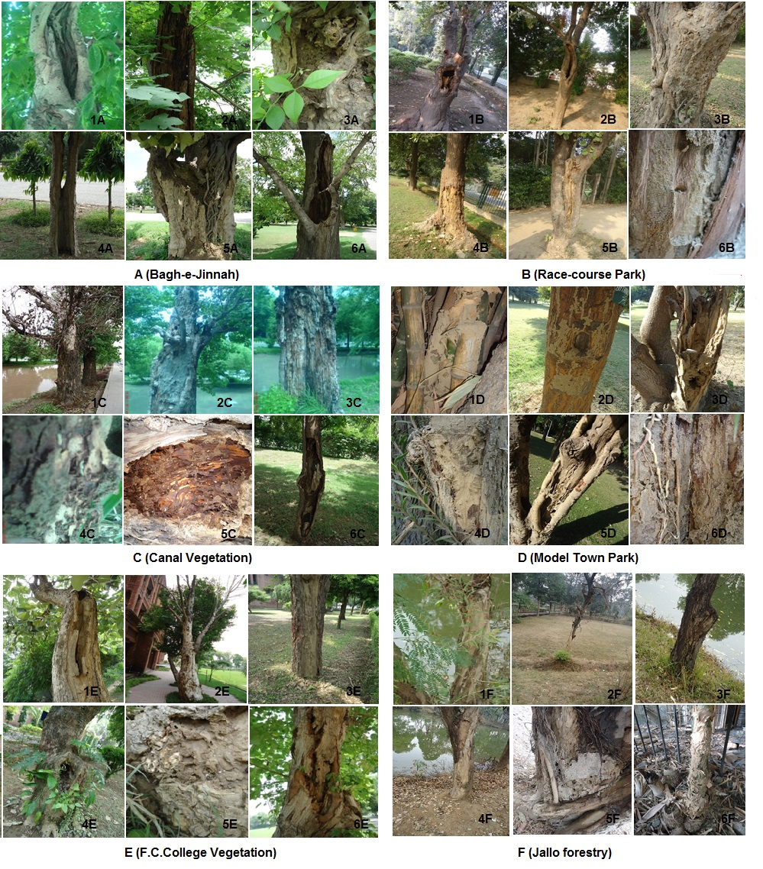
Figure 1. Trees attacked by termite in Bagh-e-Jinnah (A) were 1A (C. fistula), 2A (B. papyrifera), 3A (E. marmelos), 4A (L. tomentosa), 5A (H. adenphyllum), 6A (A. excela); in location B (Race-course Park) 1B (M. azedarach), 2B (P. roxburghii), 3B (B. monosperma), 4B (E. suberosa), 5B (B. variegata), 6B (D. regia); in location C (Canal vegetation) 1C and 2C (P. eumericana), 3C (S. tetrasperma), 4C (S. babylonica), 5C (Dead log of P. eumericana), 6C (B. papyrifera); in location D (Model town Park) 1D (B. vulgaris), 2D (P. roxburghii), 3D (M. alba), 4D (C. citrinus), 5D (C. fistula), 6D (D. sisoo); in location E (F.C. College) 1E (B. monosperma), 2E (P. euramericana), 3E (D. sissoo), 4E (Ficus spp), 5E (T. occcidentaalis), 6E (B. papyrifera); and in location F (Jallo forestry) 1F (C. citrinus), 2F (M. azedarach), 3F (P. deltoides), 4F (C. fistula), 5F (Ficus spp) and 6F (B. vulgaris).

