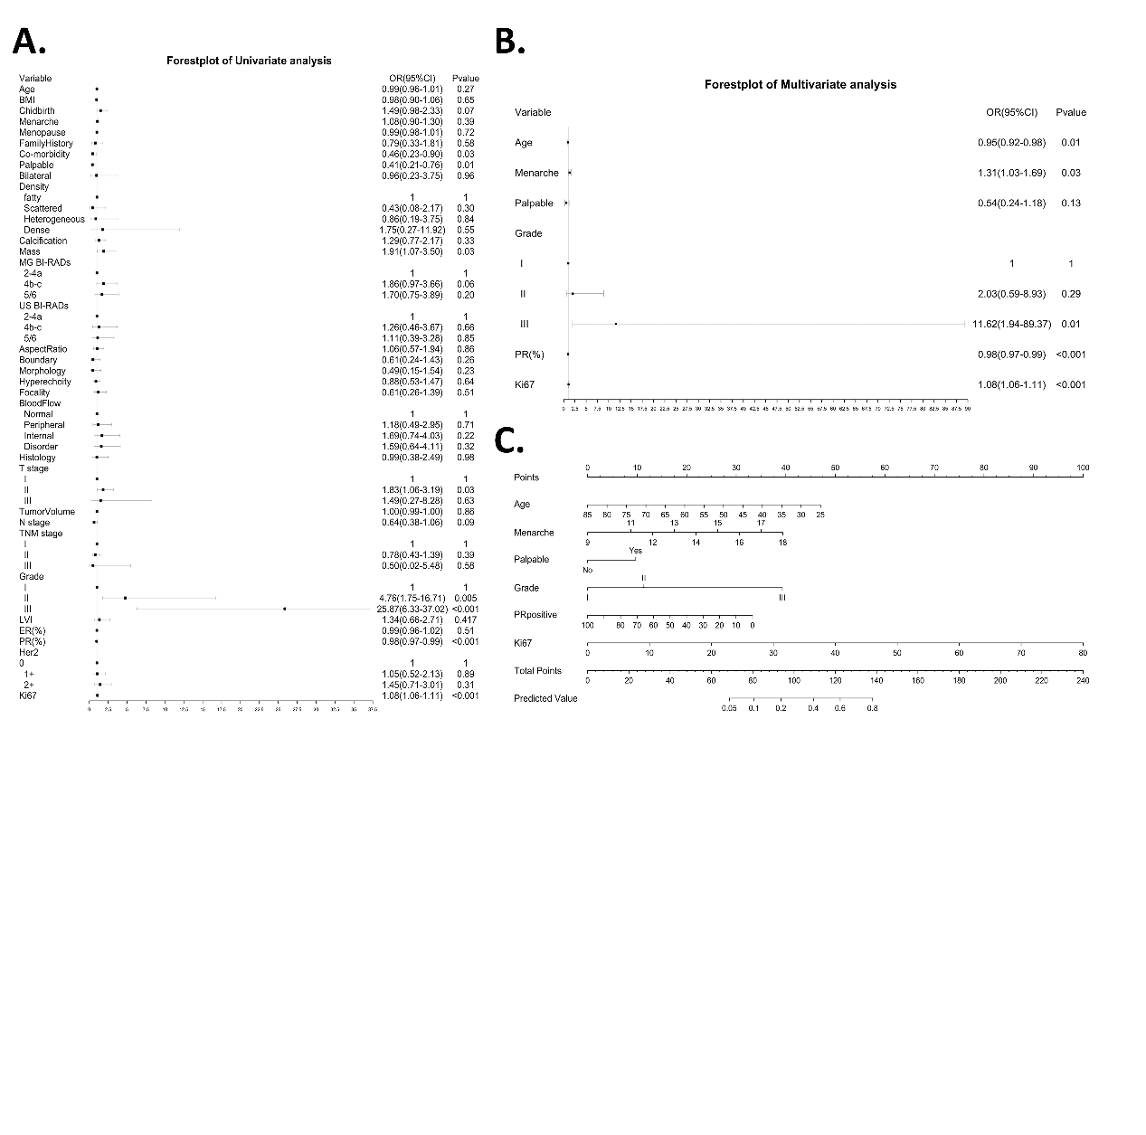
Supplementary Figure 1. The selection of the variables to construct the nomogram model without separating LN+ patients from LN- patients.
A. The forest plot exhibited the univariate analysis of the risk factors.
B. The forest plot exhibited the multivariate analysis of the risk factors.
C. The nomogram incorporating of age, menarche, palpable, grade, PR positivity and Ki67 for predicting 70-GS risk for LN+ patients was constructed.

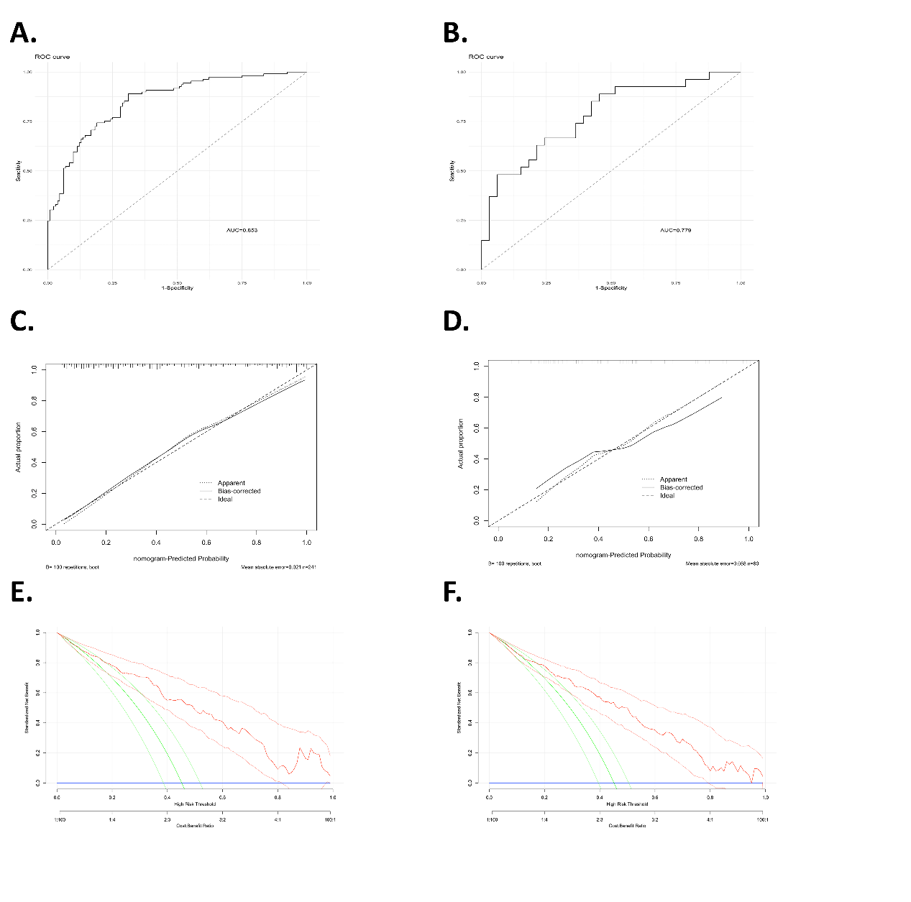
Supplementary Figure 2. Validation of the nomogram model to predict 70-GS risk without separating LN+ patients from LN- patients.
A-B. The ROC curve of the nomogram model in the train cohort (N=241) and the test cohort (N=60).
C-D. The calibration curve of the nomogram model in the train cohort (N=241) and the test cohort (N=60).
E-F. The DCA of the nomogram model in the train cohort (N=241) and the test cohort (N=60).

