Supplementary Information for the manuscript

Key drivers of large scale changes in North Atlantic atmospheric and oceanic circulations and their predictability

Buwen Dong¹*, Yevgeny Aksenov², Ioana Colfescu³, Ben Harvey¹, Joël Hirschi², Simon Josey², Hua Lu⁴, Jenny Mecking², Marilena Oltmanns², Scott Osprey⁵, Jon Robson¹, Stefanie Rynders², Len Shaffrey¹, Bablu Sinha², Rowan Sutton¹, and Antje Weisheimer⁵
¹National Centre for Atmospheric Science, Department of Meteorology, University of Reading, Reading, UK
²National Oceanography Centre, Southampton, UK
³University of St Andrews, St Andrews, UK
⁴British Antarctic Survey, Cambridge, UK
⁵Atmosphere, Ocean and Planetary Physics, University of Oxford, Oxford, UK

*Corresponding author address: Buwen Dong, National Centre for Atmospheric Science, Department of Meteorology, University of Reading, Reading, RG6 6BB. UK. E-mail: b.dong@reading.ac.uk
- Supplementary Figures S1-S4

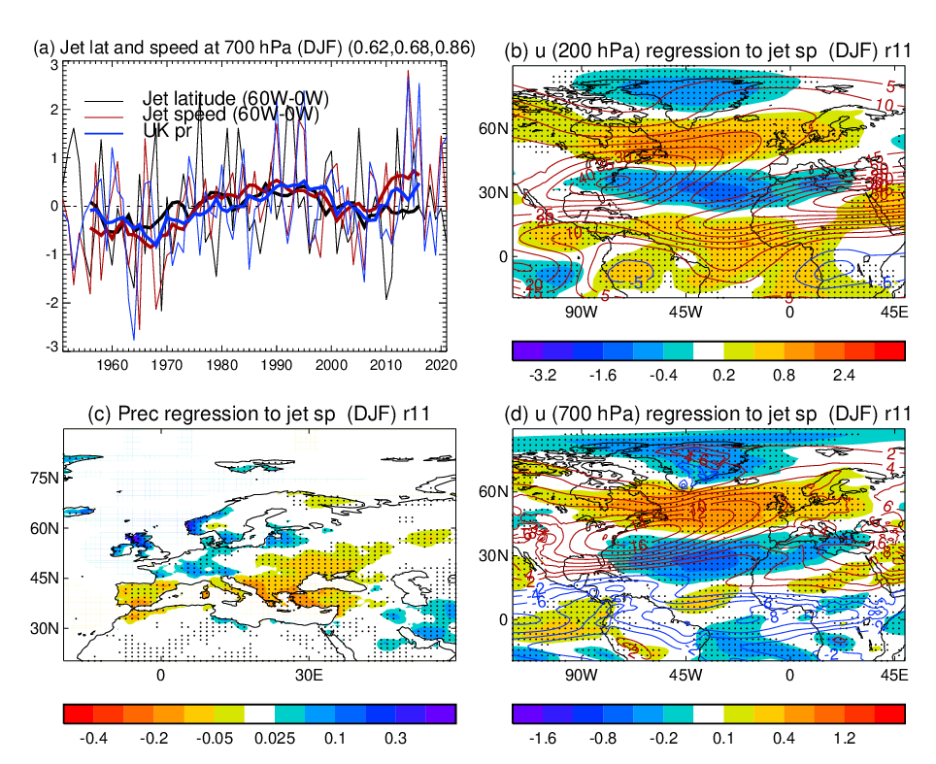
Supplementary Fig. S1: (a) Normalized (by standard deviation of interannual variability) time series of jet latitude, jet speed indices, based on ERA5 reanalysis (Hersbach et al. 2020) at 700 hPa over the North Atlantic and UK precipitation index,based on CRUTS4.06 data set (Harris et al. 2014) in DJF with thick lines representing low frequency (11 year running mean) variations. Jet latitude and jet speed indices are defined as the latitude of maximum zonal wind averaged over (60ºW-0) and the corresponding maximum zonal wind speed at 700 hPa. The UK precipitation index is defined as the area averaged precipitation over the land region (51-59ºN, 6ºW-0). (b, c, d) Spatial patterns of 200 hPa zonal wind, precipitation, and 700 hPa zonal wind in DJF regressed to the normalized low frequency variations of jet speed index in DJF. Contours (b and d) show climatology and dots (b, c, d) highlight regions where regressions are statistically significant at the 10% level based on the two-tailed Student’s t test.

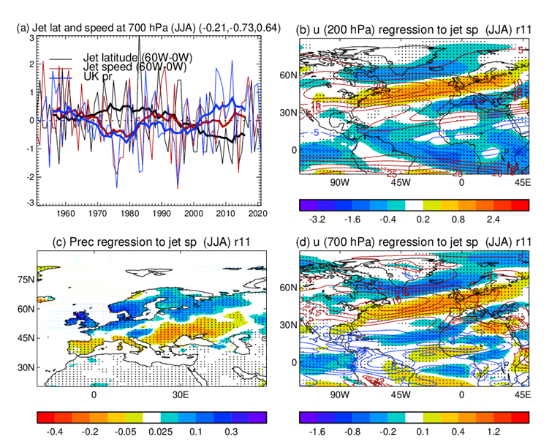
Supplementary Fig. S2: As Fig, S1 but for JJA.
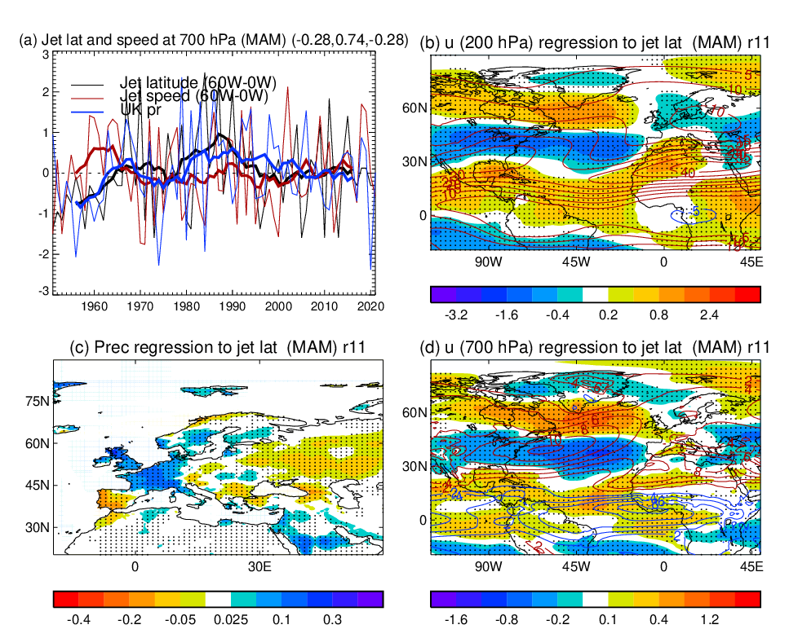
Supplementary Fig. S3: As Fig, S1 but for MAM. (b, c, d) Spatial patterns of 200 hPa zonal wind, precipitation, and 700 hPa zonal wind in MAM regressed to the normalized low frequency variations of jet speed latitude in MAM.
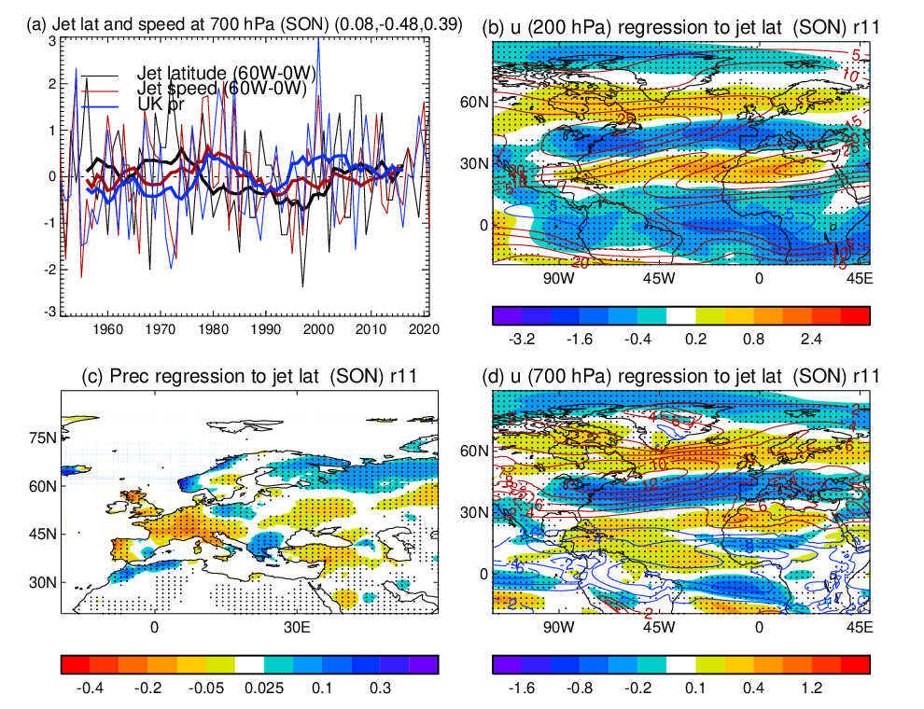
Supplementary Fig. S4: As Fig. S1 but for SON.

