Supplementary Material
Contrasting dynamic behaviour of six lake-terminating glaciers draining the Vatnajökull Ice Cap and links to bedrock topography
Nathaniel R. Baurley¹, Amelia Andrews¹, Benjamin Robson^{2*}, Sherif Attia³, Kirk Martinez³, Jane K. Hart¹
¹ Geography and Environmental Science, University of Southampton, Southampton, United Kingdom
² Department of Earth Science, University of Bergen, Bergen, Norway
³Electronics and Computer Science, University of Southampton, Southampton, United Kingdom
*Correspondence:
Benjamin Robson
benjamin.robson@uib.no
TABLE S1 List of imagery sources, type, year(s) acquired and their use in this study.
Imagery Source | Sensor Type | Years Acquired | Utilisation
Landsat 7 ETM+ | Optical | 2008, 2010, 2012 | Lake Area and Frontal Position Change
Landsat 8 OLI/TIRS | Optical | 2016 | Lake Area and Frontal Position Change
Sentinel-2 | Optical | 2018, 2020 | Lake Area and Frontal Position Change
TerraSAR-X | SAR | 2008, 2010, 2012, 2016, 2018, 2020 | Velocity Analyses

TABLE S2 Acquisition date of each of the TerraSAR-X image pairs used in this study to calculate glacier velocity. Time between each pair is also shown.
Image Date for t = 1 | Image Date for t = 2 | Time Between Image Pairs
15th August 2008 | 26th August 2008 | 11 days
26th August 2008 | 6th September 2008 | 11 Days
2nd September 2010 | 13th September 2010 | 11 Days
7th September 2010 | 18th September 2010 | 11 Days
26th July 2012 | 17th August 2012 | 22 Days
21st October 2012 | 12th November 2012 | 22 Days
28th May 2016 | 19th June 2016 | 22 Days
29th July 2018 | 31st August 2018 | 33 Days
13th July 2020 | 4th August 2020 | 22 Days

TABLE S3 Acquisition date of each of the optical images used to measure changes in ice front position and proglacial lake area.
Optical Satellite Sensor | Image Date
Landsat 7 ETM+ | 12th August 2008
Landsat 7 ETM+ | 25th August 2010
Landsat 7 ETM+ | 17th October 2012
Landsat 8 OLI/TIRS | 1st October 2016
Sentinel-2 | 26th October 2018
Sentinel-2 | 13th October 2020
TABLE S4 Processing parameters used in SNAP to produce high-resolution velocity rasters of each glacier.
Glacier | Grid Azimuth Spacing (pixels) | Grid Range Spacing (pixels) | Registration Window Width/Height | Max. Velocity (m d⁻¹) | Cross-Correlation Threshold
Breiðamerkurjökull | 20 | 20 | 256 x 256 | 5 | 0.01
Fjallsjökull | 20 | 20 | 256 x 256 | 4 | 0.01
Kvíárjökull | 20 | 20 | 256 x 256 | 4 | 0.01
Skaftafellsjökull | 60 | 60 | 512 x 512 | 1.5 | 0.01
Svínafellsjökull | 60 | 60 | 256 x 256 | 1.5 | 0.01

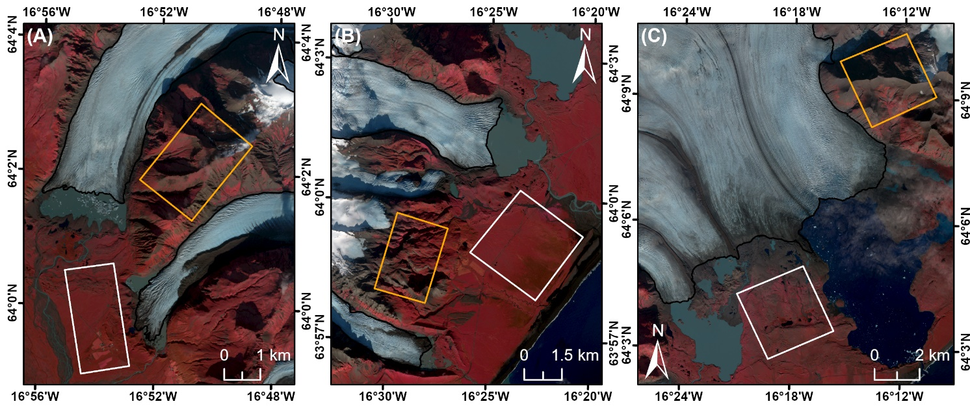
FIGURE S1 Location of the stable ground areas at (A) Skaftafellsjökull and Svínafellsjökull, (B) Fjallsjökull and Kvíárjökull and (C) Breiðamerkurjökull, that were used to determine the stochastic error of the velocity measurements. The different coloured boxes represent areas of “flat” (white) and “steep” (orange) stable ground. Glacier outlines as before. Background in each panel is a Sentinel-2 false-colour acquisition from 13/10/2020.

TABLE S5 Results of the uncertainty assessment to quantify digitisation error for the analyses undertaken in this study. Note that for all proglacial lakes the standard error is <1% of the original measured value.
Proglacial Lake | Year | Original Measured Area (km²) | Mean Repeat Area (km²) | Standard Error (± km²)
Jökulsárlón | 2012 | 23.784 | 23.781 | 0.0018
 | 2016 | 25.999 | 25.996 | 0.0014
 | 2020 | 27.598 | 27.594 | 0.0011
Breiðárlón | 2012 | 5.510 | 5.507 | 0.0013
 | 2016 | 5.475 | 5.476 | 0.0012
 | 2020 | 5.759 | 5.758 | 0.0010
Fjallsárlón | 2012 | 3.110 | 3.109 | 0.0016
 | 2016 | 3.623 | 3.620 | 0.0013
 | 2020 | 3.768 | 3.767 | 0.0011
Kvíárjökulslón | 2012 | 0.601 | 0.603 | 0.0012
 | 2016 | 0.604 | 0.605 | 0.0011
 | 2020 | 0.665 | 0.664 | 0.0010
Svínafellsjökull | 2012 | 0.256 | 0.254 | 0.0014
 | 2016 | 0.323 | 0.326 | 0.0012
 | 2020 | 0.486 | 0.485 | 0.0010
Skaftafellsjökull | 2012 | 0.784 | 0.776 | 0.0017
 | 2016 | 1.162 | 1.163 | 0.0012
 | 2020 | 1.710 | 1.709 | 0.0010

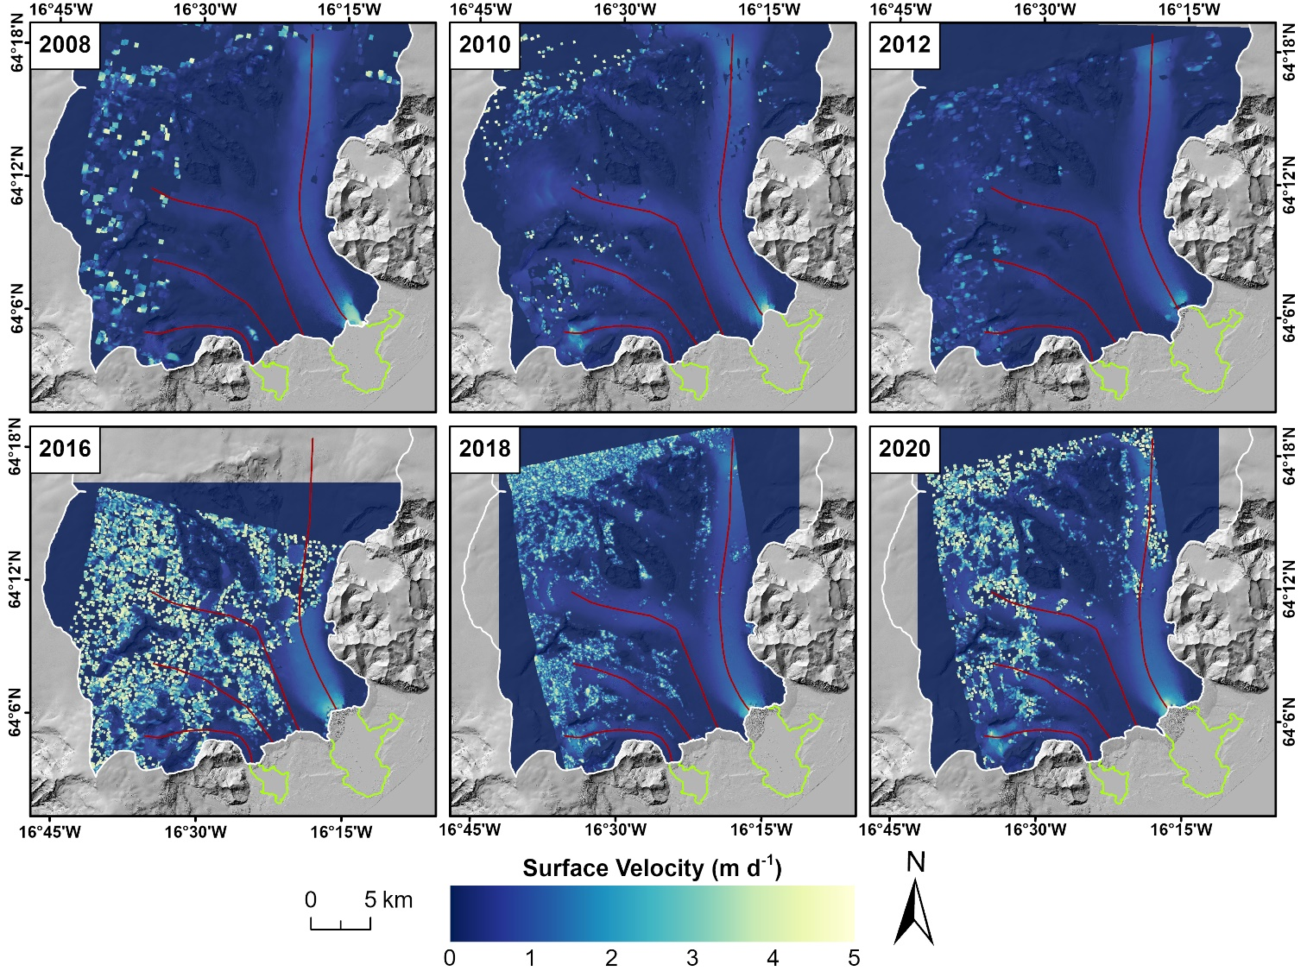
FIGURE S2 Velocity grids for Breiðamerkurjökull, calculated through offset tracking on pairs of TerraSAR-X images for the period 2008-2020. All grids are shown at 15% transparency overlaid on a hillshade of the LiDAR DEM of Iceland from 2016. Glacier centrelines (deep red), glacier outlines (white), and lake areas (light green) for each year are shown for reference.

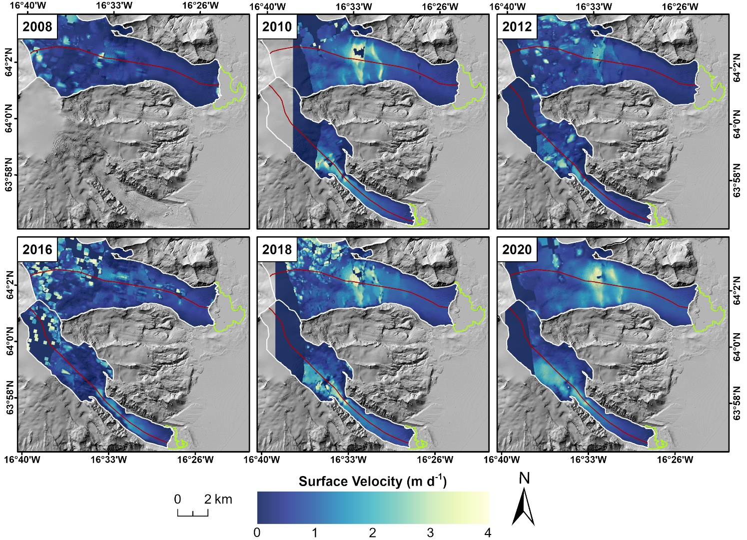
FIGURE S3 Velocity grids for Fjallsjökull and Kvíárjökull, calculated through offset tracking on pairs of TerraSAR-X images for the period 2008-2020 (Fjallsjökull) and 2010-2020 (Kvíárjökull). All grids are shown at 15% transparency overlaid on a hillshade of the LiDAR DEM of Iceland from 2016. Glacier centrelines (deep red), glacier outlines (white), and lake areas (light green) for each year are shown for reference.

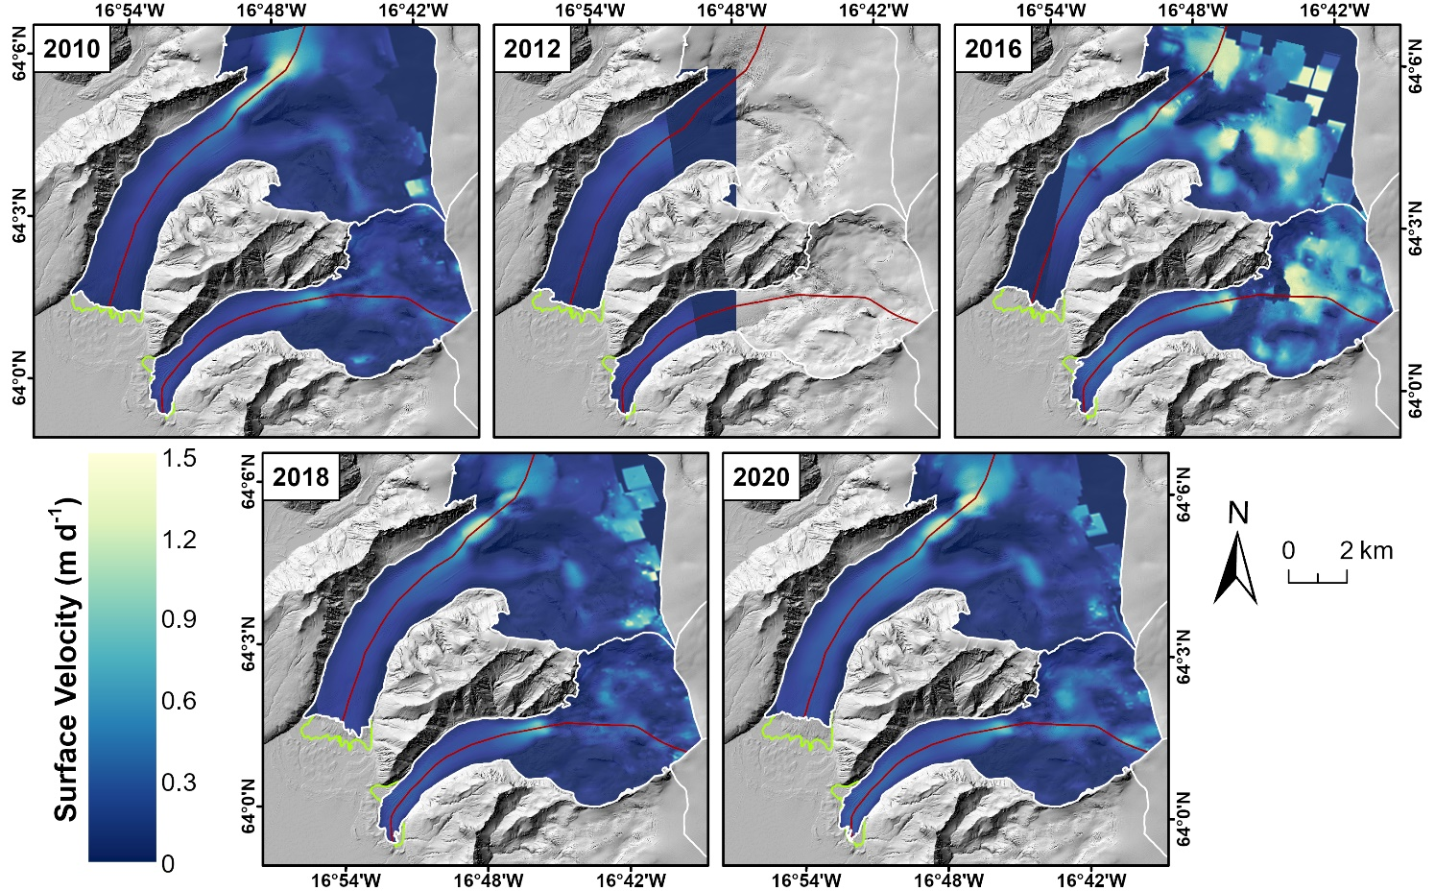
FIGURE S4 Velocity grids for Svinafellsjokull and Skaftafellsjökull, calculated through offset tracking on pairs of TerraSAR-X images for the period 2010-2020. All grids are shown at 15% transparency overlaid on a hillshade of the LiDAR DEM of Iceland from 2016. Glacier centrelines (deep red), glacier outlines (white), and lake areas (light green) for each year are shown for reference.
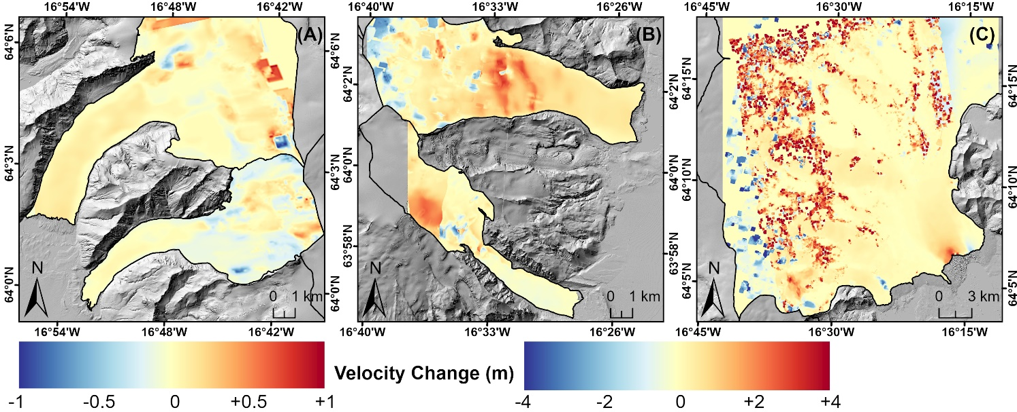
FIGURE S5 Change in velocity at (A) Skaftafellsjökull & Svínafellsjökull, (B) Fjallsjökull & Kvíárjökull and (C) Breiðamerkurjökull. Panels (B) and (C) share the same legend. 2020 glacier outlines are shown in black. Background in each panel is a hillshade of the LiDAR DEM of Iceland from 2016.
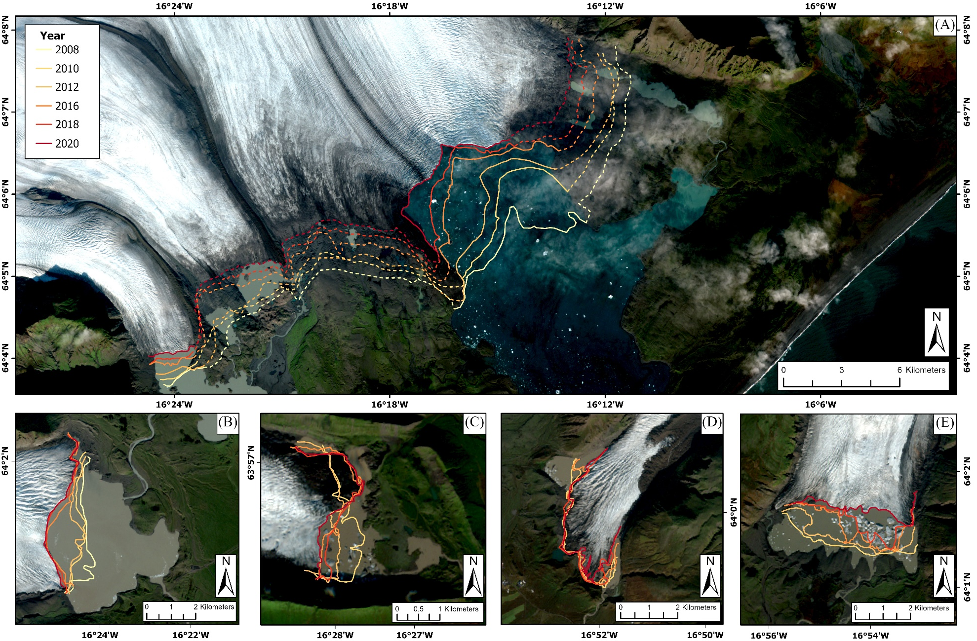
FIGURE S6 Change in the frontal position of (A) Breiðamerkurjökull and (B) Fjallsjökull for the period 2008-2020, and of (C) Kvíárjökull, (D) Svínafellsjökull and (E) Skaftafellsjökull for the period 2010-2020. The thick and dashed lines in (A) relate to the aqueous- and land-terminating margins, respectively. Background in each panel is a Sentinel-2 acquisition (3, 2, 1 RGB) from 13/10/2020.
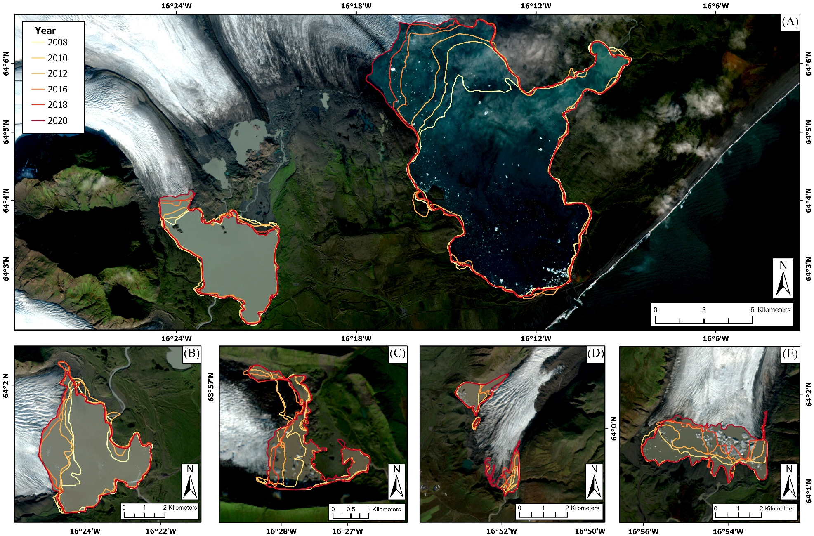
FIGURE S7 Change in proglacial lake area for (A) Jökulsárlón, Breiðárlón, and (B) Fjallsárlón for the period 2008-2020, and for (C) Kvíárjökulslón, (D) Svínafellsjökull and (E) Skaftafellsjökull for the period 2010-2020. Background in each panel is a Sentinel-2 acquisition (3, 2, 1 RGB) from 13/10/2020.
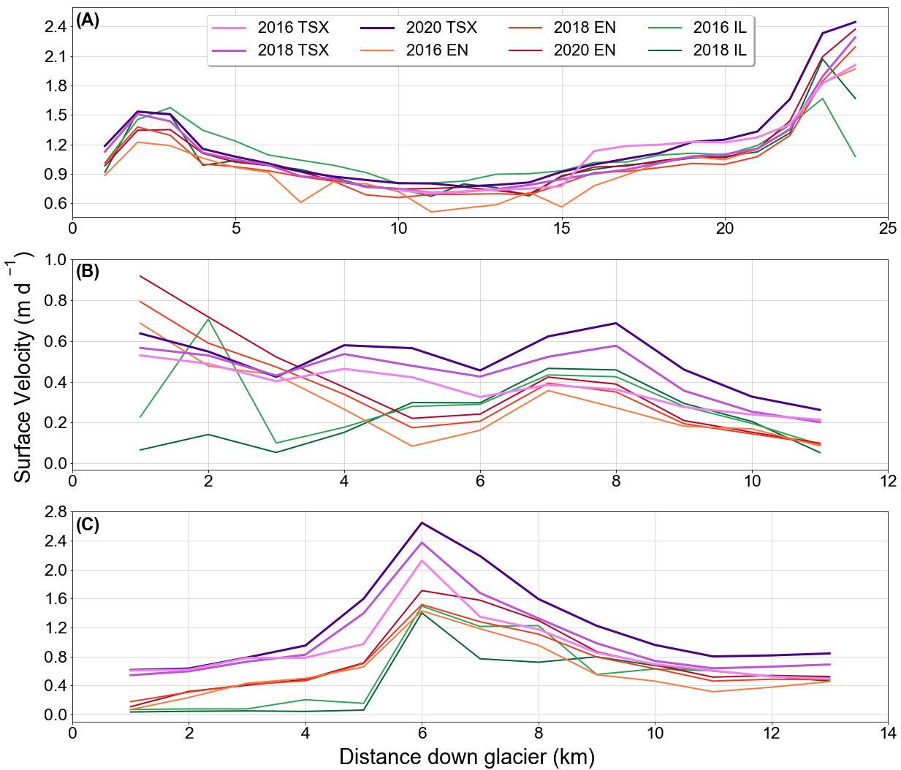
FIGURE S8 Comparison between the velocity profiles generated in this study (pink/purple lines) and those generated from the ENVEO Icelandic velocity dataset (orange/red lines, Wuite et al., 2022) and NASA ITS_LIVE dataset (green lines, Gardner et al., 2024) for the (A) eastern and (B) Western A arms of Breiðamerkurjökull, and (C) Fjallsjökull. Note how there are a larger number of erroneous points and outliers in both the ENVEO and ITS_LIVE datasets (but particularly the latter) due to their coarse resolution when compared to the high resolution TerraSAR-X imagery used in this study.

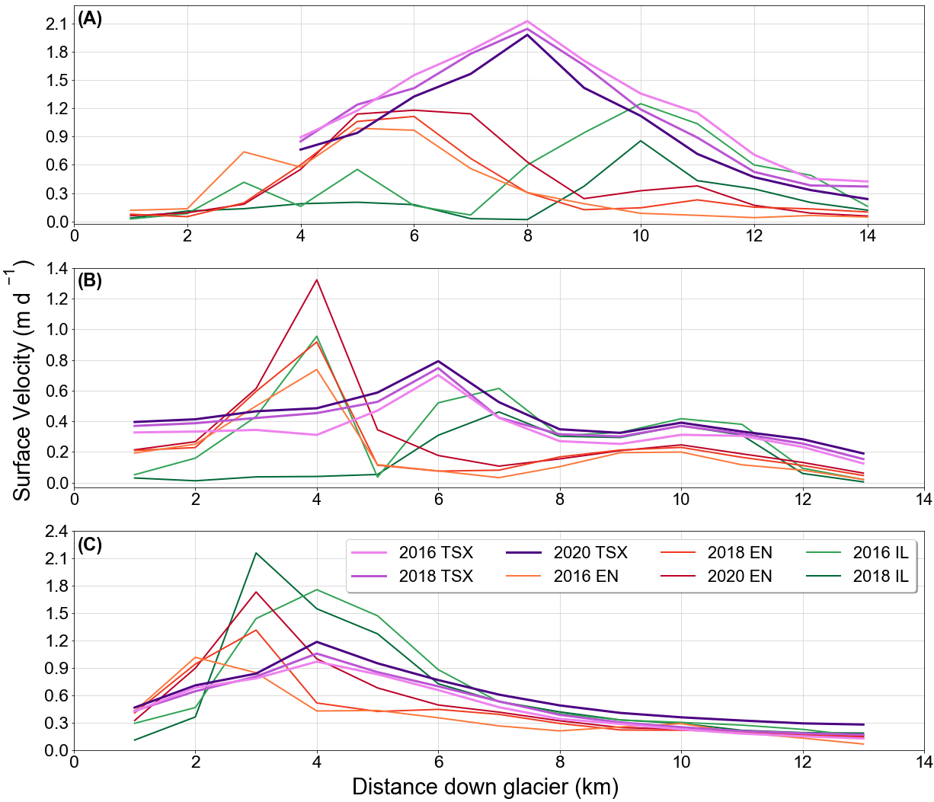
FIGURE S9 Comparison between the velocity profiles generated in this study (pink/purple lines) and those generated from the ENVEO Icelandic velocity dataset (orange/red lines, Wuite et al., 2022) and NASA ITS_LIVE dataset (green lines, Gardner et al., 2024) for (A) Kvíárjökull (B) Svínafellsjökull and (C) Skaftafellsjökull. Note how there are a larger number of erroneous points and outliers in both the ENVEO and ITS_LIVE datasets (but particularly the latter) due to their coarser resolution when compared to the high resolution TerraSAR-X imagery used in this study.
TABLE S6 Comparison between digitised proglacial lake areas and calculated rates of proglacial lake growth from this study and those reported by Guðmundsson et al. (2019) for the year 2018. Note the slight variation in the rates of proglacial lake growth reported in both studies, which is due to our rates being calculated over a much shorter period. Despite this, both sets of data still show very close agreement.
 | 2018 Lake Area (km²) |  | Growth Rate (km² a⁻¹)
Lake | This Study | Guðmundsson et al. (2019) | This Study | Guðmundsson et al. (2019)
Jökulsárlón | ~26.9 | ~27 | ~0.63* | ~0.6 (1991-2018)
Breiðárlón | ~5.8 | ~5.9 | ~0.03* | No data
Fjallsárlón | ~3.81 | ~3.7 | ~0.13* | ~0.1 (1994-2018)
Kvíárjökulslón | ~0.61 | ~0.65 | ~0.02† | ~0.02 (2001-2018)
Svínafellsjökull | ~0.42 | ~0.38 | ~0.03† | ~0.02 (2000-2018)
Skaftafellsjökull | ~1.36 | ~1.3 | ~0.09† | ~0.07 (2002-2018)
*For the period 2008-2018; †For the period 2010-2018.

TABLE S7 Detail on how the surface profiles shown in Figures 6-8 of the manuscript were derived.
Profile | Method
2010 | The flowlines shown in Figure 1 were extracted from the LiDAR DEM of Iceland and adjusted to the 2010 terminus positions to give the 2010 surface profiles.
2020 | The elevation change dataset of Hugonnet et al. (2021) was then used to calculate the 2020 surface profiles. First, the flowlines shown in Figure 1 were extracted from the relevant elevation change raster for each glacier (these are the same rasters used in the elevation change analysis detailed in Section 3.3). Next, as the elevation change data is given in meters per year, we needed to convert it to the total elevation change over the whole period (i.e., by multiplying each data point along each flowline by 10). This new data could then be subtracted from the 2010 surface profiles and adjusted using the 2020 terminus positions to give the 2020 surface profiles.
2030 | To calculate the 2030 surface profiles, we first subtracted the 2010-2020 elevation change data (calculated in the previous step) from the 2020 surface profiles. We then used the retreat rate that we calculated in Section 3.2. to estimate the terminus position of each glacier in 2030. These data sources were then combined to give the 2030 surface profiles. Although this analysis assumes that the rate of surface thinning and frontal retreat will remain constant between 2020-2030, it is likely that both will increase over the next 10 years. As such, the 2030 surface profiles are likely to be underestimates. However, because we only require an estimate of the position and thickness of each glacier in 2030, the impact of this on our analysis and subsequent discussion is likely to be minimal.

