Appendix

Appendix A

List of the 67 stimuli organized by syllabic structure and initial phoneme (p-t-k)
Disyllabic | prata | prouchi | ploussou | krapa | kroufou | klafi | trapa
 | praka | proussi | plouti | krati | krouti | klata | trafa
 | prassa | trafi | trachi | prati | krouchi | klati | tracha
 | prafa | proutou | ploussi | krapi | kroussou | klacha | trapi
 | pracha | proufou | ploufi | krassa | kroufi | klapa | plouki
 | krafa | prouchou | plouchi | krafi | krouchou | klapi | proufi
 | prafi | proukou | plouchou | krata | kroutou | klafa | ploutou
 | prachi | proussou | ploukou | krassi | kroussi | klachi | prassi
 | praki | prouti | ploufou | prouki
Monosyllabic | pra | prou | plou | kra | krou | kla | tra
Appendix B

Table with the results of our best nested model: RT ~ (1 | subject) + (1 | stimuli) + speechmode + taskorder + syllabic structure + speechmode:taskorder

 | Estimate | Std. error | Degree of freedom | t-value | p-value
Standard speech | 555.842 | 20.003 | 24.469 | 27.788 | <.001***
Speech mode loud | 15.988 | 3.295 | 7356.339 | 4.852 | <.001***
Taskorder Standard First | 55.243 | 28.214 | 24.210 | 1.568 | .13
Length monosyllabic | 4.430 | 4.396 | 27.942 | 1.008 | .322
Loud * Standard First | -13.092 | 4.737 | 7363.254 | -2.764 | .005**

Appendix C

Table with the results of our best nested model: RT ~ (1 | subject) + speechmode + taskorder + syllabic structure + speechmode:taskorder

 | Estimate | Std. error | Degree of freedom | t-value | p-value
Standard speech | 661.674 | 34.718 | 24.165 | 19.058 | <.001***
Speechmode whispered | -1.375 | 3.744 | 7860.05 | -0.367 | .713
Taskorder Standard First | -54.177 | 49.083 | 24.132 | -1.104 | .281
Length monosyllabic | 6.410 | 2.820 | 7860.024 | 2.273 | .023*
Whispered * Standard First | 35.315 | 5.310 | 7860.036 | 6.651 | <.001***

Appendix D

Results of the TCT for experiment 1 and experiment 2 with no period of topographic inconsistency across experiments.

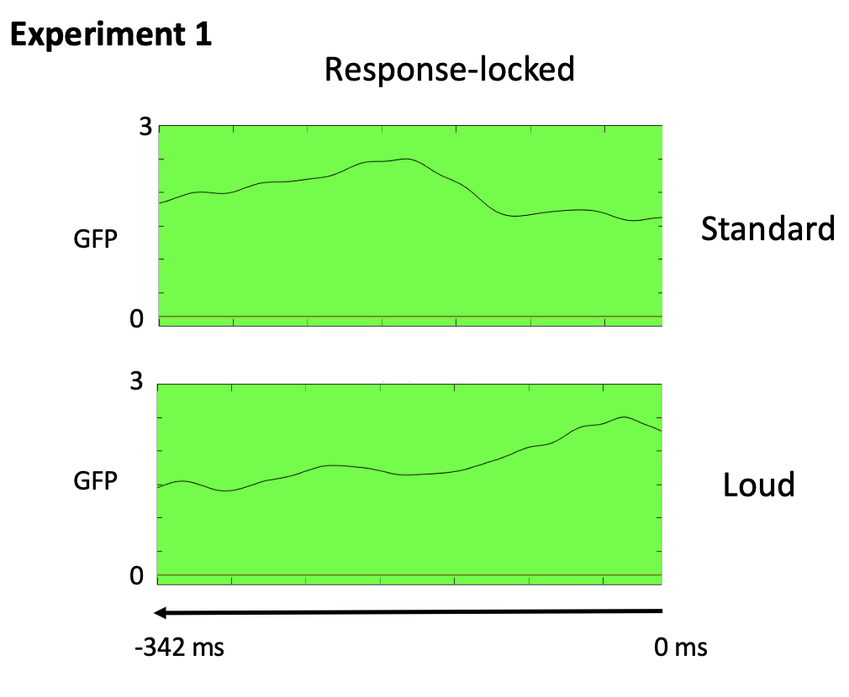
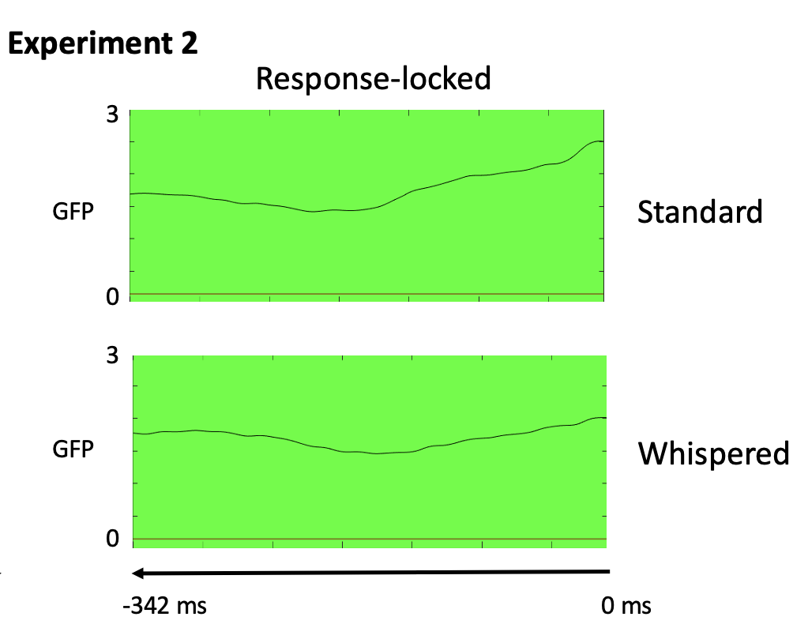

Appendix E

Appendix E
Results of the non-parametric Friedman test for response-locked microstates maps for experiment 1 on the Area under curve (AUC) and the duration (DUR).
 | Parameters | Mean Standard | Mean Loud | X² | Degrees of freedom | Adjusted p-value (BH)
Map A | AUC | 318.533 | 240.24 | 8.167 | 1 | .004*
 | DUR | 181.84 | 125.531 | 9.783 | 1 | .004*
Map B | AUC | 56.273 | 70.258 | 0 | 1 | 1
 | DUR | 71.26 | 79.79 | 0.182 | 1 | 1
Map C | AUC | 33.51 | 89.85 | 4.55 | 1 | .033*
 | DUR | 88.16 | 135.931 | 8.901 | 1 | .06

Appendix F
 | Parameters | Mean Standard | Mean  Whispered |  |  | X² | Degrees of freedom | Adjusted p-value (BH)
Map a | AUC | 199.47 | 209 |  |  | 0.182 | 1 | 1
 | DUR | 147.8 | 143.731 |  |  | 0 | 1 | 1
Map b | AUC | 51.71 | 51.125 |  |  | 0.73 | 1 | .79
 | DUR | 59.48 | 60.29 |  |  | 0 | 1 | 1
Map c | AUC | 183.91 | 151.253 |  |  | 2.579 | 1 | .22
 | DUR | 133.981 | 137.231 |  |  | 0.53 | 1 | .47
Results of the non-parametric Friedman test for the response-locked microstates maps for experiment 2 on the area under curve (AUC) and the duration (DUR).

