Supplementary figures
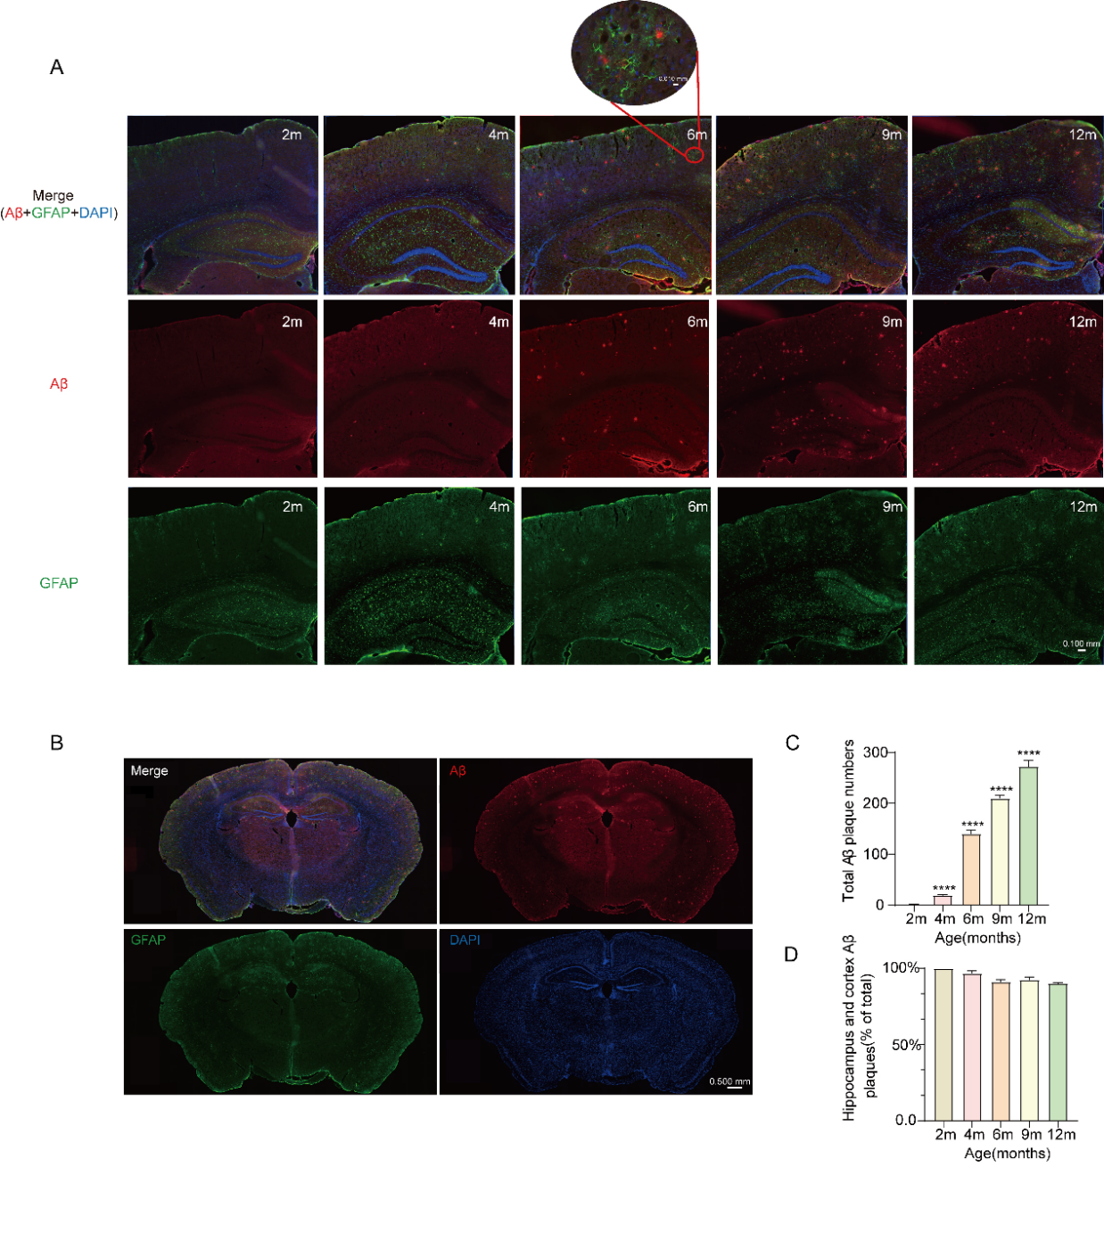
Fig S1. Immunofluorescence staining of Aβ and astrocytes in AD mice at different ages
A Representative immunofluorescence images of hippocampus and cortex from AD model mice at five time points, showing Aβ (6E10, yellow) and reactive astrocytes (GFAP, green). Enlarged areas highlight reactive astrocytes surrounding Aβ plaques.
B Representative immunofluorescence image of a whole brain section from a 12-month-old AD mouse.
C One-way ANOVA and Dunnett’s multiple comparisons of Aβ plaque counts in brain sections of AD model mice at five time points, n=3, with *** indicating p < 0.001 compared to 2m.
D Percentage of Aβ plaques located in the hippocampus and cortex relative to all detected Aβ plaques.

Fig S2. Temporal and functional analysis of RNA-seq data of astrocytes.
A UpSet plot showing the number of upregulated or downregulated differentially expressed genes (DEGs) in astrocytes from AD mice compared to controls at different time points (2m, 4m, 6m, 9m, 12m). The left bar chart represents the total number of DEGs at each time point. The matrix layout below indicates specific intersections of time points, with connected dots representing the shared DEGs among those time points. The top bar chart indicates the size of each intersection set, representing the number of shared DEGs.
B GO-BP pathways for DEGs, with each node representing a GO term. Nodes are colored by time point, and their size reflects the number of genes in each term. Nodes are connected based on similarity scores (Jaccard + Overlap score > 0.375).
C qPCR validation of the top 6 genes intersecting between Profile 5 genes and downregulated DEGs at 6 months, n=4, T-test, ns indicates p > 0.05, * indicates p < 0.05.
D RNA-seq FPKM values for the top 6 genes intersecting between Profile 5 genes and downregulated DEGs at 6 months , n=3, T-test, ns indicates p > 0.05, * indicates p < 0.05.
E On the left, gray lines represent the expression changes of 416 genes in Profile 10, with the red line indicating the mean expression change. On the right, the top five GO-BP enriched pathways for Profile 10 genes are shown.
F On the left, gray lines represent the expression changes of 416 genes in Profile 16, with the red line indicating the mean expression change. On the right, the top five GO-BP enriched pathways for Profile 16 genes are shown.

Fig S3. Correlation analysis of proteomic and transcriptomic data in 6-month-old astrocytes
A Pearson correlation of fold changes between transcriptomic and proteomic data. The x-axis represents fold changes at the RNA level, and the y-axis represents fold changes at the protein level. Red dots indicate genes with significant changes in both RNA and protein levels. Green dots represent genes with significant changes in protein levels but minor changes in RNA levels. Purple dots indicate genes with significant changes in RNA levels but minor changes in protein levels. Gray dots denote genes with no significant changes in either RNA or protein levels.
B Venn diagram showing the overlap of genes upregulated at both RNA and protein levels.
C Venn diagram showing the overlap of genes downregulated at both RNA and protein levels.
D Fold change plot of genes related to fatty acid metabolism that are downregulated at both RNA and protein levels at 6 months. The y-axis represents the expression ratio of AD to WT.
E GO-MF pathway analysis of genes upregulated at both RNA and protein levels.
F GO-MF pathway analysis of genes downregulated at both RNA and protein levels.

Fig S4. Spatial metabolomics related figures.
A Positioning of samples on the slides for spatial metabolomics, with the first slide consisting of AD3, WT2, and AD1, and the second slide consisting of WT3, AD2, and WT1.
B UMAP visualization of spatial metabolomics sample distribution (left: pre-correction data, right: data corrected for batch effects).
C Representative image of the mouse brain atlas used for reference, sourced from Allen Brain Atlas.
D Immunofluorescence images of adjacent sections stained for the astrocyte marker GFAP.

Supplementary tables
Table S1. Characteristics of NHANES participants, 2011–2014
 |  | Sex
Characteristic | Overall, N = 2502 (100%)¹ | female, N = 1299 (55%)¹ | male, N = 1203 (45%)¹
Age group
60-69 years | 1,258 (52%) | 659 (51%) | 599 (54%)
70-79 years | 698 (27%) | 353 (27%) | 345 (28%)
80+ years | 546 (20%) | 287 (22%) | 259 (18%)
Race
Non-Hispanic White | 1,261 (80%) | 669 (79%) | 592 (81%)
Non-Hispanic Black | 584 (8.3%) | 296 (9.0%) | 288 (7.5%)
Other Hispanic | 243 (3.7%) | 134 (3.9%) | 109 (3.3%)
Mexican American | 210 (3.4%) | 99 (3.1%) | 111 (3.7%)
Other/multiracial | 204 (4.9%) | 101 (4.8%) | 103 (5.0%)
BMI group
Underweight(<18.5) | 34 (1.4%) | 23 (1.7%) | 11 (1.1%)
Normal(18.5 to <25) | 617 (25%) | 328 (28%) | 289 (23%)
Overweight(25 to <30) | 861 (35%) | 375 (31%) | 486 (41%)
Obese(30 or greater) | 958 (38%) | 559 (40%) | 399 (36%)
Alq group
1-5 drinks/month | 1,218 (48%) | 539 (44%) | 679 (53%)
5-10 drinks/month | 115 (5.2%) | 45 (4.7%) | 70 (5.8%)
10+ drinks/month | 393 (20%) | 132 (14%) | 261 (27%)
Non-drinker | 776 (27%) | 583 (37%) | 193 (15%)
Smoke group
Current smoker | 294 (9.9%) | 126 (9.0%) | 168 (11%)
Former smoker | 972 (40%) | 376 (32%) | 596 (50%)
Never smoker | 1,236 (50%) | 797 (59%) | 439 (39%)
Education attainment
Less Than 9th Grade | 249 (5.3%) | 112 (4.7%) | 137 (6.1%)
9-11th Grade | 344 (10%) | 189 (11%) | 155 (9.5%)
High School Grad/GED | 594 (22%) | 320 (25%) | 274 (20%)
Some College or AA degree | 715 (31%) | 414 (35%) | 301 (27%)
College Graduate or above | 600 (31%) | 264 (25%) | 336 (38%)
Age (years) | 68.0 (63.0, 74.0) | 68.0 (63.0, 75.0) | 68.0 (63.0, 74.0)
PIR | 3.13 (1.72, 5.00) | 2.82 (1.57, 4.96) | 3.58 (1.98, 5.00)
BMI | 28 (25, 32) | 28 (24, 33) | 28 (25, 31)
Waist (cm) | 102 (92, 111) | 98 (90, 108) | 105 (97, 114)
Total calories | 1,787 (1,407, 2,254) | 1,602 (1,254, 1,941) | 2,122 (1,691, 2,598)
SFA (gm/day) | 21 (15, 30) | 19 (13, 26) | 25 (18, 34)
MUFA (gm/day) | 24 (17, 32) | 21 (15, 28) | 29 (21, 38)
PUFA (gm/day) | 15 (10, 21) | 13 (9, 18) | 17 (12, 23)
CERAD1 | 5.00 (4.00, 6.00) | 5.00 (4.00, 6.00) | 5.00 (4.00, 6.00)
CERAD2 | 7.00 (6.00, 8.00) | 7.00 (6.00, 9.00) | 7.00 (6.00, 8.00)
CERAD3 | 8.00 (7.00, 9.00) | 8.00 (7.00, 9.00) | 8.00 (7.00, 9.00)
CERAD total (3 Recall trials) | 20.0 (17.0, 23.0) | 21.0 (18.0, 24.0) | 19.0 (16.0, 22.0)
CERAD delay recall | 7.00 (5.00, 8.00) | 7.00 (5.00, 8.00) | 6.00 (4.00, 8.00)
Animal fluency | 18.0 (14.0, 22.0) | 18.0 (14.0, 21.0) | 18.0 (14.0, 22.0)
DSST | 54 (42, 64) | 55 (43, 67) | 51 (40, 61)
¹median (IQR) for continuous; n (%) for categorical

Table S2. Median (25th, 75th percentiles) score on cognitive tests
Median (25th, 75th percentiles) score on cognitive tests, by quartile of SFAT
Characteristic | Q1, N = 651 (25%)¹ |  |  | Q2, N = 610 (25%)¹ |  |  |  | Q3, N = 607 (25%)¹ | Q4, N = 634 (25%)¹ | p-value²
SFAT | 0.28 (0.25, 0.30) |  |  |  | 0.33 (0.32, 0.35) |  |  | 0.38 (0.37, 0.39) | 0.43 (0.42, 0.46) | <0.001
Animal Fluency | 19.0 (15.0, 22.0) |  | 18.0 (14.0, 22.0) |  |  |  | 18.0 (14.0, 22.0) |  | 17.0 (14.0, 20.0) | <0.001
CERAD1 |  | 5.00 (4.00, 6.00) |  |  |  | 5.00 (4.00, 6.00) |  | 5.00 (4.00, 6.00) | 5.00 (4.00, 6.00) | <0.001
CERAD2 |  | 7.00 (6.00, 8.00) |  |  |  | 7.00 (6.00, 8.00) |  | 7.00 (6.00, 9.00) | 7.00 (6.00, 8.00) | 0.025
CERAD3 |  | 8.00 (7.00, 9.00) |  |  |  | 8.00 (7.00, 9.00) |  | 8.00 (7.00, 9.00) | 8.00 (7.00, 9.00) | 0.002
CERAD total |  | 21.0 (18.0, 23.0) |  |  |  | 20.0 (17.0, 23.0) |  | 21.0 (18.0, 24.0) | 19.0 (16.0, 22.0) | 0.001
CERAD delay recall |  | 7.00 (5.00, 8.00) |  |  |  | 6.00 (5.00, 8.00) |  | 7.00 (5.00, 8.00) | 6.00 (5.00, 8.00) | 0.015
DSST |  | 54 (43, 65) |  |  |  | 54 (42, 64) |  | 54 (41, 65) | 50 (40, 62) | 0.026

Median (25th, 75th percentiles) score on cognitive tests, by quartile of PFAT
Characteristic | Q1, N = 646 (25%)¹ | Q2, N = 634 (25%)¹ | Q3, N = 580 (25%)¹ | Q4, N = 642 (25%)¹ | p-value²
PFAT | 0.17 (0.15, 0.19) | 0.22 (0.21, 0.23) | 0.27 (0.26, 0.28) | 0.32 (0.30, 0.36) | <0.001
Animal Fluency | 17.0 (14.0, 21.0) | 17.0 (14.0, 21.0) | 19.0 (15.0, 22.0) | 19.0 (14.2, 22.0) | 0.006
CERAD1 | 5.00 (4.00, 6.00) | 5.00 (4.00, 6.00) | 5.00 (4.00, 6.00) | 5.00 (4.00, 6.00) | 0.012
CERAD2 | 7.00 (6.00, 8.00) | 7.00 (6.00, 8.00) | 8.00 (6.00, 9.00) | 7.00 (6.00, 8.00) | <0.001
CERAD3 | 8.00 (6.82, 9.00) | 8.00 (7.00, 9.00) | 8.00 (7.00, 9.00) | 8.00 (7.00, 9.00) | <0.001
CERAD total | 19.0 (17.0, 22.0) | 20.0 (17.0, 23.0) | 21.0 (18.0, 24.0) | 20.0 (17.0, 23.0) | 0.001
CERAD delay recall | 6.00 (5.00, 8.00) | 6.00 (5.00, 8.00) | 7.00 (5.00, 8.00) | 7.00 (5.00, 8.00) | <0.001
DSST | 51 (39, 63) | 52 (41, 63) | 54 (43, 65) | 54 (43, 66) | 0.049

Median (25th, 75th percentiles) score on cognitive tests, by quartile of MFAT
Characteristic | Q1, N = 604 (25%)¹ | Q2, N = 630 (25%)¹ | Q3, N = 623 (25%)¹ | Q4, N = 645 (25%)¹ | p-value²
MFAT | 0.34 (0.33, 0.35) | 0.38 (0.37, 0.38) | 0.41 (0.40, 0.41) | 0.44 (0.43, 0.47) | <0.001
Animal Fluency | 18.0 (14.5, 21.0) | 17.0 (14.0, 21.0) | 18.0 (14.0, 22.0) | 18.0 (14.0, 22.0) | 0.4
CERAD1 | 5.00 (4.00, 6.00) | 5.00 (4.00, 6.00) | 5.00 (4.00, 6.00) | 5.00 (4.00, 6.00) | 0.6
CERAD2 | 7.00 (6.00, 8.00) | 7.00 (6.00, 8.00) | 7.00 (6.00, 8.00) | 7.00 (6.00, 8.00) | >0.9
CERAD3 | 8.00 (7.00, 9.00) | 8.00 (7.00, 9.00) | 8.00 (7.00, 9.00) | 8.00 (7.00, 9.00) | 0.5
CERAD total | 20.0 (17.0, 23.0) | 20.0 (17.0, 23.0) | 20.0 (17.0, 23.0) | 20.0 (17.0, 23.0) | >0.9
CERAD delay recall | 7.00 (5.00, 8.00) | 6.00 (5.00, 8.00) | 6.00 (5.00, 8.00) | 7.00 (5.00, 8.00) | 0.9
DSST | 54 (43, 64) | 53 (41, 63) | 52 (42, 63) | 54 (42, 66) | 0.4
¹Median (IQR)
²Kruskal-Wallis test for complex survey samples
Table S3. RT-qPCR primer sequence
gene name | primer | sequence
Clu | forward | GCTGCTGATCTGGGACAATG
 | reverse | ACCTACTCCCTTGAGTGGACA
Mfge8 | forward | CCGCGTCTGGTGACTTCTG
 | reverse | TCCTCTCTCAGTCTCATTGCAC
Gstm5 | forward | TCCAAGTCTATGGTTCTGGGTT
 | reverse | CCACAGATGTACCGTTTCTCCT
Htra1 | forward | TAGCGACGCCAAGACCTACA
 | reverse | TGACGCAAACTGTTGGGATCT
Tmem212 | forward | ACAGGATGGAGCGTTTGGATT
 | reverse | CACGGCTTCCCACAAGTGT
Fabp7 | forward | GGACACAATGCACATTCAAGAAC
 | reverse | CCGAACCACAGACTTACAGTTT

