Periodontal pathogen Fusobacterium nucleatum promotes ulcerative colitis by ferroptosis-mediated gut barrier disruption
Xiaoyue Zhang^{1,2}, Shouzheng Cheng^{1,2}, Shuze Chen^{1,2}, Qiuhao Wang^{1,2}, Jeiyu Zhou^{1,2}, Hui Wang^{1,2}, Lei Cheng^{1,3}, Lei Zhao^{1,2*}

¹：State Key Laboratory of Oral Diseases & National Center for Stomatology & National Clinical Research Center for Oral Diseases, West China Hospital of Stomatology, Sichuan University, Chengdu 610041, Sichuan, China.
²：Department of Periodontics, West China School & Hospital of Stomatology, Sichuan University, Chengdu, China.
³：Department of Operative Dentistry and Endodontics, West China School & Hospital of Stomatology, Sichuan University, Chengdu, China.

*: Corresponding author

Correspondence Author:
Prof. Lei Zhao, Department of Periodontics, West China Hospital of Stomatology, Sichuan University, Chengdu, China. Tel: +86 28 85503489; Fax: +86 28 85582167; Email: Zhaolei@scu.ed.cn ; ORCID iD: 0000-0003-4077-533X

Supplementary Table 1. Disease activity index (DAI) score
Weight loss (%) |  | Stool consistency | Blood in feces | score
0 | Normal |  | Absence | 0
1-5 |  |  |  | 1
5-10 | Loose |  | Presence | 2
10-15 |  |  |  | 3
>15 | Diarrhea |  | Gross bleeding | 4

Supplementary Table 2. List of primers
Gene | Sequence 5’-3’
[human]GAPDH | F: GACCACAGTCCATGCCATCAC
[human]GAPDH | R: GTCCACCACCCTGTTGCTGTA
[human]FTH1 | F: ATCTGGCTTGGCGGAATAT
[human]FTH1 | R: TCAAAGACAACACCTGGGTA
[human]GPX4 | F: GAGGCAAGACCGAAGTAAACTAC
[human]GPX4 | R: CCGAACTGGTTACACGGGAA
[human]ACSL4 | F: CATCCCTGGAGCAGATACTCT
[human]ACSL4 | R: TCACTTAGGATTTCCCTGGTCC
[mice]ZO-1 | F: CAACATACAGTGACGCTTCACA
[mice]ZO-1 | R: CACTATTGACGTTTCCCCACTC
[mice]CLDN-1 | F: CCTCCTGGGAGTGATAGCAAT
[mice]CLDN-1 | R: GGCAACTAAAATAGCCAGACCT
[mice]GPX4 | F: GCCTGGATAAGTACAGGGGTT
[mice]GPX4 | R: CATGCAGATCGACTAGCTGAG
[mice]ACSL4 | F: CCACACTTATGGCCGCTGTT
[mice]ACSL4 | R: GGGCGTCATAGCCTTTCTTG
[mice]FTH1 | F: TGAAGCTGCAGAACCAACGAGG
[mice]FTH1 | R: GCACACTCCATTGCATTCAGCC
[mice]β-actin | F: GGCTGTATTCCCCTCCATCG
[mice]β-actin | R: CCAGTTGGTAACAATGCCATGT

Supplementary Table 3. Primers of F.nucleatum
sequence
F- | GATCGTGACTTCACTGAAGCACTTTACATTCCGAAAAACGTCATCGTGCACACAGAATTGCTGGATCAGACTCTCGGTCCATTGTCCAATATTCCCCACTGCTGCCTCCCGTAGGAGTAAGGGCCGTGTCTCAGTCCCCTTGTGGCCAAA
R- | CAAATTCACGGGAGGAGCAGTGGGGATATTGGACAATGGACCGAGAGTCTGATCCAGCAATTCTGTGTGCACGATGACGTTTTTCGGAATGTAAAGTGCTTTCAGTTGGGAAGAAAAAAATGACGGTACCAACAGAAGAAGTGACGGCTAAAAAAG
Supplementary Figure 1
More gene copies of F. nucleatum 16S rDNA could be detected in the colon of the UF group mice. The qPCR product from the experimental group was 98%-100% identical to the F. nucleatum ATCC25586 standard sequence compared to the NCBI GenBank database.
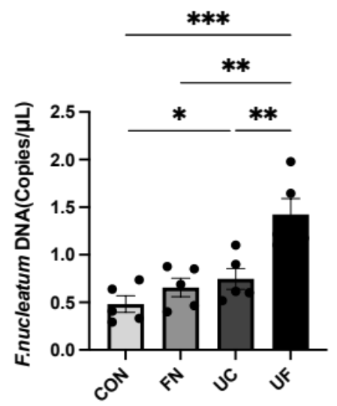
Figure S1. Absolute quantitative qPCR analysis of gene copy number of F. nucleatum 16S rDNA in colon tissue (n = 5). All data represent the mean ± SEM. *P<0.05, **p<0.01, ***P<0.001, ****p<0.0001, by one-way ANOVA, followed by a post-hoc test.

Supplementary Figure 2
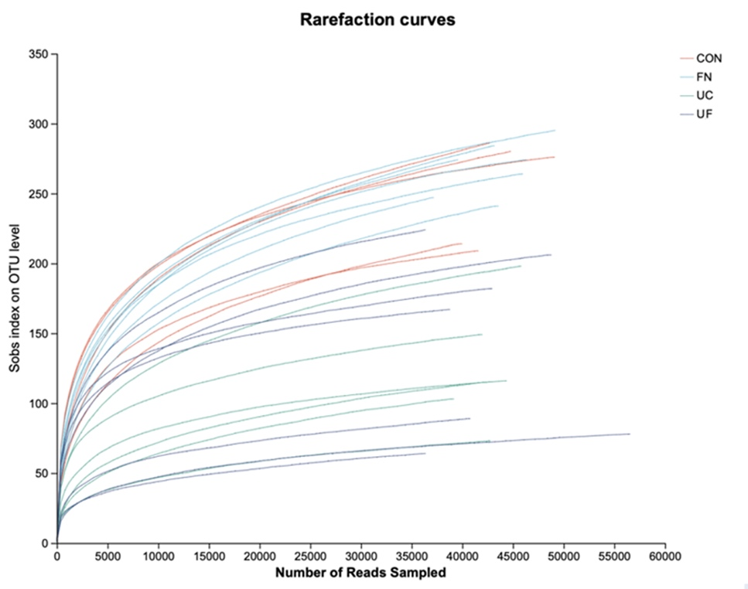
Figure S2. The rarefaction curves in four groups. The curves flattened, and the sequencing data reached saturation, enabling coverage of most of the species.

Supplementary Figure 3
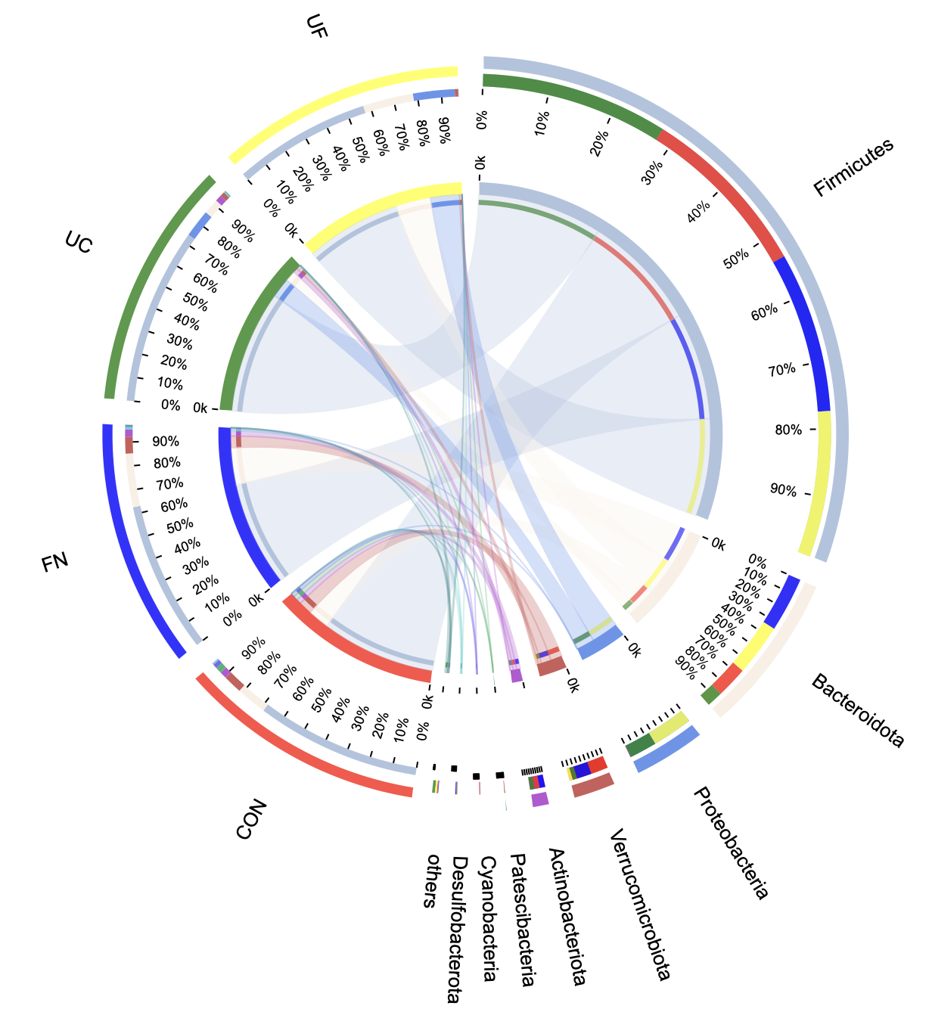
Figure S3. The distribution of dominant species in each group and the distribution of each dominant species in different samples were reflected by visualizing circle plots.

Supplementary Figure 4
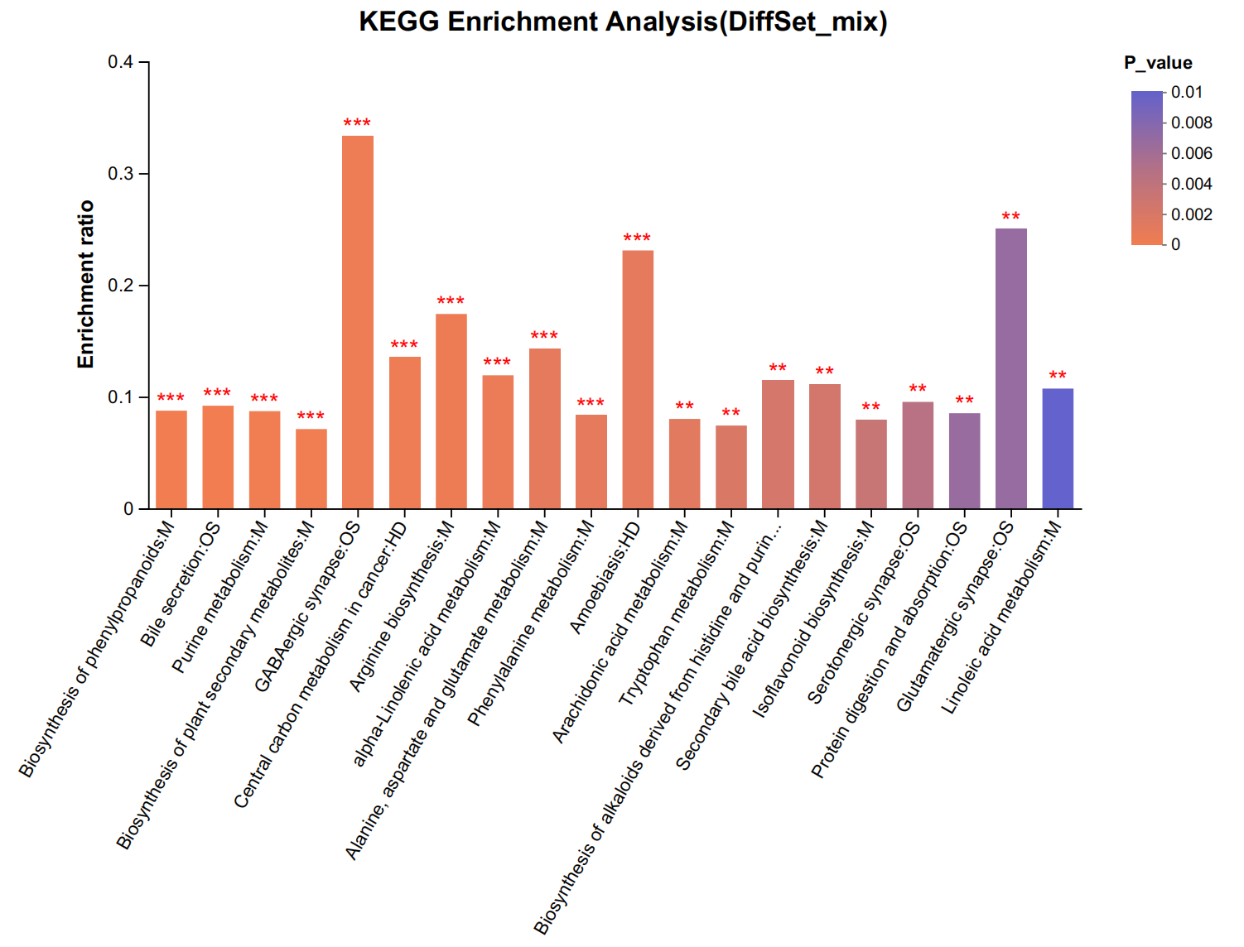
Figure S4. A hypergeometric distribution algorithm was utilized to obtain pathways significantly enriched in metabolite-concentrated metabolites.

Supplementary Figure 5
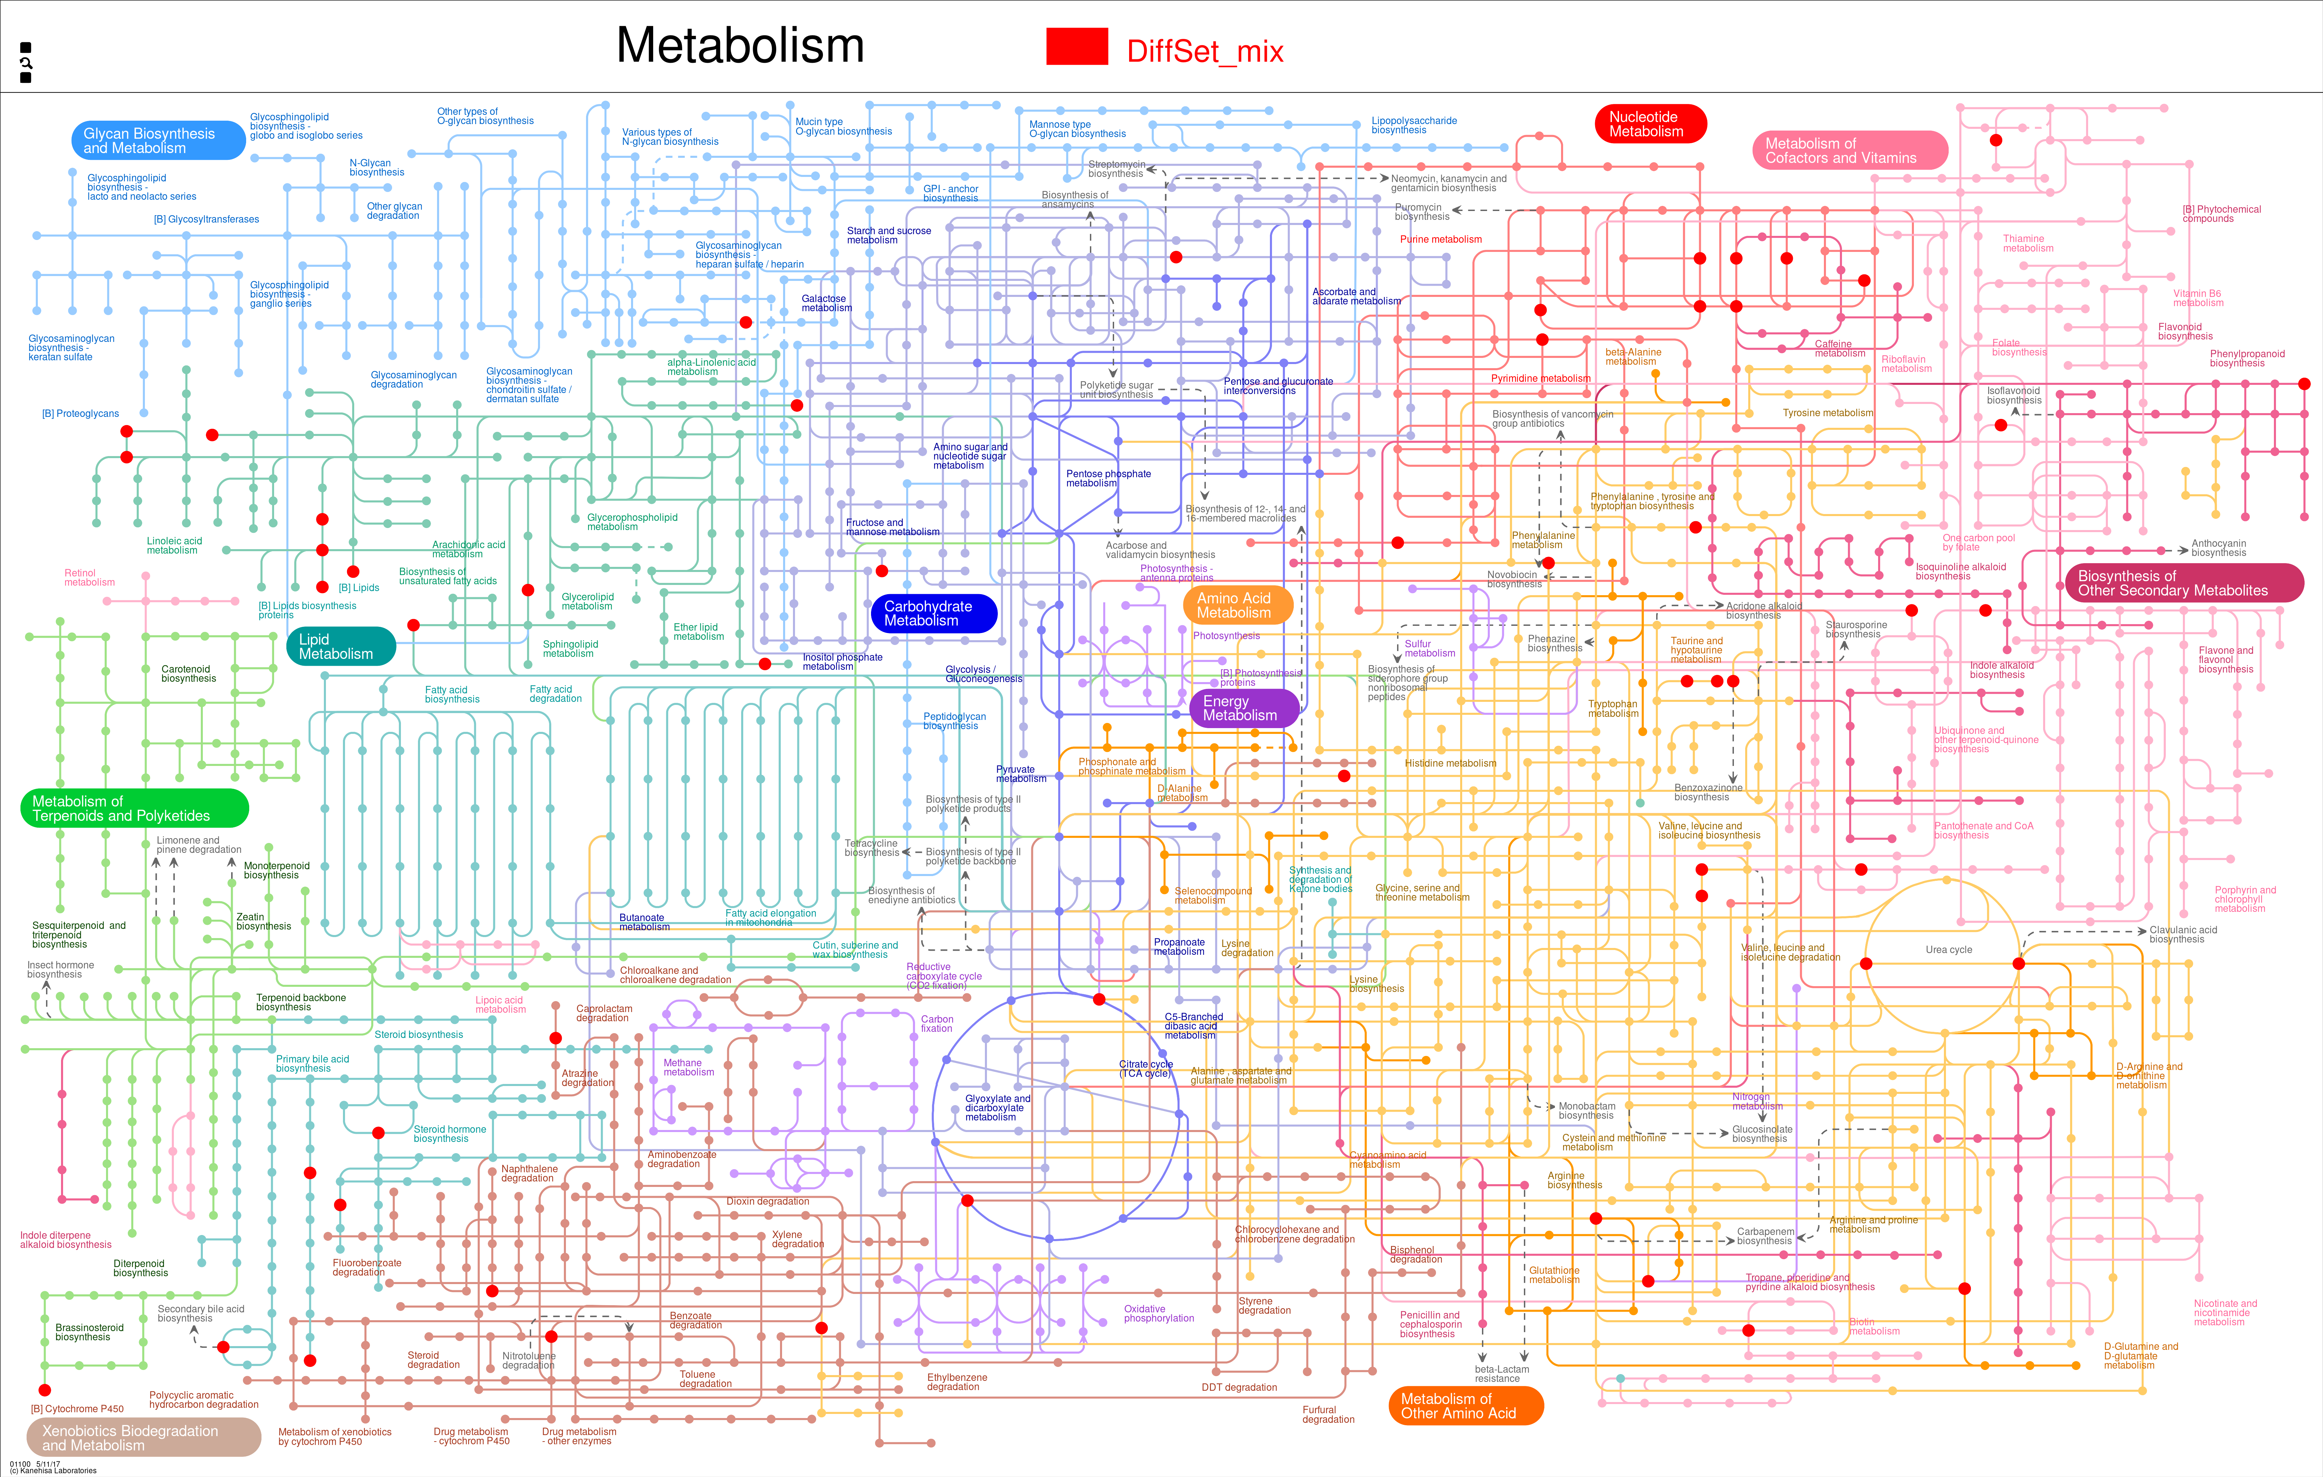
Figure S5. Visualize metabolic pathways using iPath 3.0 (http://pathways.embl.de) to view metabolic pathway information for an entire biological system. The nodes in the graph represent different compounds and the boundaries represent different enzymatic reactions.

Supplementary Figure 6
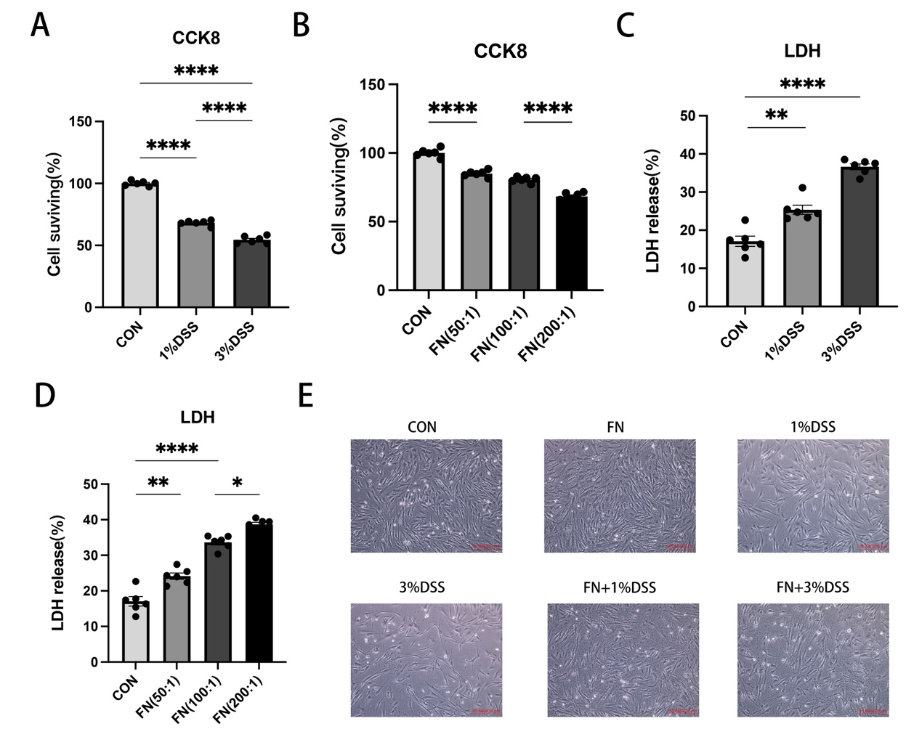
Figure S6. (A-D) Determination of appropriate DSS concentration and MOI values for F.nucleatum infections using CCK-8 (A, B) and LDH (C, D) experiments. 5%,8%,10%DSS induced total cell death (n=6). (E) CCD-841 cell morphology under the light microscope (scale: 50μm). All data represent the mean ± SEM. *P<0.05, **p<0.01, ***P<0.001, ****p<0.0001, by one-way ANOVA, followed by a post-hoc test.

Supplementary Figure 7
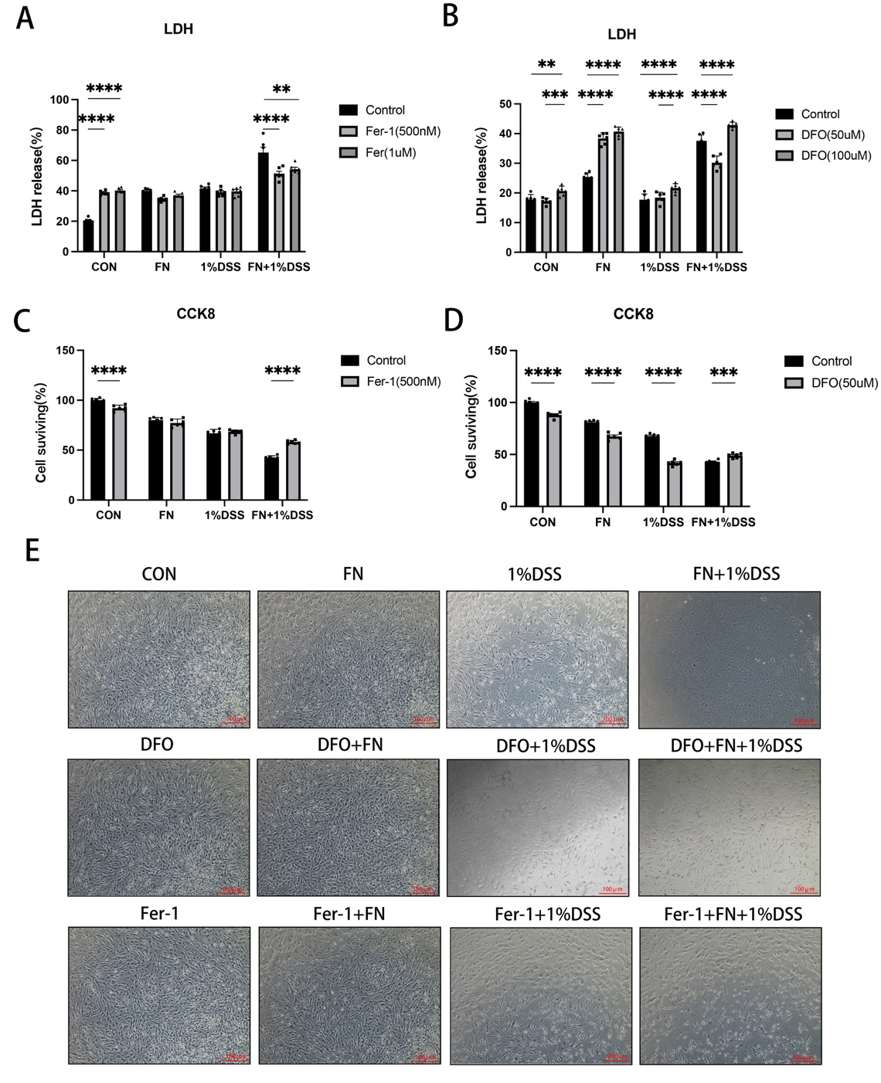
Figure S7. (A, B) Determination of appropriate Fer-1 and DFO concentrations using LDH and CCK-8 experiments (n=6). (C) CCD-841 cell morphology under the light microscope (scale: 100μm). Fer-1 is more effective than DFO. All data represent the mean ± SEM. *P<0.05, **p<0.01, ***P<0.001, ****p<0.0001, by 2way ANOVA, followed by a post-hoc test.
Supplementary Figure 8
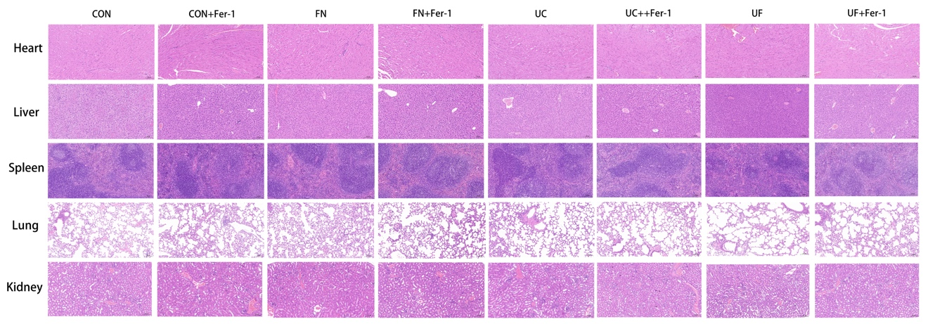
Figure S8. H&E Staining of Heart, Liver, Spleen, Lung, and Kidney demonstrates safety of Fer-1 in vivo.

