Unlocking Pan-Cancer Detection with Phenyl-β-D-Glucuronide Like Exogenous Agent and Induced Breath Analysis for Non-Invasive Early Discovery

CONTENTS
Supplementary methods
- Details of Mouse breath sample extraction and collection
- Details of sensor fabrication and sample gas blending approaches
- Pharmacokinetics analysis of in vivo samples by LCMS/MS

Supplementary results
- Characterization of the chemical structure for the intermediate and synthesized phenyl-β-D-glucuronide
- Bio-compatibility of phenyl-β-D-glucuronide
- Phenol sensor fabrication and characterization
- Characterization of handheld breath-analyzer
- Impact of environmental factor and confounding diseases

Supplementary figures
- Pathway of synthesizing phenyl-β-D-glucuronide (Supplementary Fig. 1)
- Molecular structure and functional group analysis of intermediate (Supplementary Fig. 2)
- Molecular structure and functional group analysis of synthesized phenyl-β-D-glucuronide (Supplementary Fig. 3)
- Chemical properties of phenyl-β-D-glucuronide (Supplementary Fig. 4)
- Analysis of phenol level in breath sample (Supplementary Fig. 5)
- Pharmacokinetics properties of phenyl-β-D-glucuronide (Supplementary Fig. 6)
- Phenol sensor fabrication and characterization (Supplementary Fig. 7)
- Schematic diagram of the circuit board for handheld breath-analyzer (Supplementary Fig. 8)
- Characterization of handheld breath-analyzer (Supplementary Fig. 9)
- Tissue images for different mouse model (Supplementary Fig. 10)
- Impact of studied confounding diseases (Supplementary Fig. 11)

Supplementary tables
- Chemical list
- Source of tumor cell lines that are referred in the research
SUPPLEMENTARY METHODS
Details of mouse breath sample extraction and collection
- Mouse breath sample extraction (Supplementary Video 1)
The exhaled breath extraction apparatus enriches volatile organic compounds (VOCs) from mouse exhaled breath onto an solid-phase microextraction (SPME) fiber for the analysis of exhaled breath composition relative content before and after mouse administration. The extraction apparatus consists of a large glass container with a volume of approximately 400 mL. The bottleneck is sealed with a sealing gasket, silicone plug and fixing clip to ensure airtightness. Prior to using, the device is cleaned and dried. Cleanliness and airtightness tests are conducted initially. In the cleanliness test, high-purity nitrogen gas was introduced into the glass container, sealed for 1 hour, and then the gas adsorbed on the SPME fiber was analyzed by GCMS. The composition of the adsorbed substances was compared with a blank SPME fiber to ensure that the glass container does not generate any impurity gases. In the airtightness test, the sealed glass container is injected with gas and performed a soap bubble test. No bubbles are produced at any part of the glass container, and the piston of the syringe returns to its original position after release, indicating good sealing performance of the setup.
At the first step, placing mouse into the glass container for breath sample extraction. The entire glass container was then placed in a constant temperature environment at 25°C and sealed for 1 hour, with oxygen supplementation every 15 minutes. Using a glass syringe through a silicone plug, inject 10 mL of pure oxygen (99.9%). After 1 hour of sealing, insert a 75 μm Car/PDMS extraction fiber into the glass container through the silicone plug, exposing the black extraction fiber of SPME. The extraction was carried out for 30 minutes in a constant temperature environment at 25°C, and oxygen supplementation was performed periodically following the above process.
- Mouse breath sample collection (Supplementary Video 2)
The mouse breath sample collection apparatus is used to collect the mouse's exhaled breath into a gas bag for later breath readout recording. In this study, a breath sample collection glass apparatus was built which includes a 500 mL sandblasted glass syringe, silicone tubing, and a Tedlar gas bag. The glass syringe is employed to collect the mouse's exhaled breath. Before starting the experiment, glass syringe is thoroughly cleaned to remove any potential impurities and sealed with silicone tubing, making it convenient to supplement oxygen when collecting breath from the mouse. The Tedlar gas bag, used for collecting and storing gas, is thoroughly dried and washed three times with high-purity nitrogen gas to remove impurities adsorbed on the inner wall of the bag.
In the gas collection apparatus, both oxygen bag and sampling bag were connected to the syringe through a silicone tube, and the gas volume was directly estimated according to syringe's scale. The overall cleanliness and sealing are tested. For cleanliness testing, high-purity nitrogen gas was introduced into the glass syringe and the sampling bag. After sealing for 1h, the gas from both was separately adsorbed using an extraction fiber. Gas components are then analyzed by GCMS through headspace injection and the results are compared with the analysis of a blank extraction fiber. In the sealing test, 500mL of gas was injected into the syringe, and the silicone tubing in the device is clamped. The gas collection syringe was placed vertically for 1 hour. The scale position of the piston remains at 500mL, confirming the good sealing performance of the device.
Place the targeted mouse into the glass syringe, push the piston to the 450mL mark, connect the other end of the silicone tubing attached to the gas outlet to the oxygen bag, and seal with a clamp. The entire apparatus is placed in a 25°C environment, and every 15min, the sealed clamp and the gas bag switch, and move the piston to supplement 10 mL of oxygen. After 1h of sealing, removing the oxygen bag, connect an empty sampling bag, and slowly push the gas from the syringe into the sampling bag by pushing the piston. Ensure sufficient space for the mouse during this process. After the gas collection, remove the mouse and place it in a regular mouse cage immediately.

Details of sensor fabrication and sample gas preparation
- Sensor preparation process
YSZ-based electrochemical phenol sensor fabrication processes are as follows:
1) Binder preparation: mix turpentine alcohol and ethyl cellulose in a ratio of 94:6 by mass to prepare a turpentine alcohol slurry;
2) Preparation of reference electrode: grind a mixture of turpentine alcohol slurry and manganese dioxide powder in a mass ratio of 1.2:1 using an agate mortar to obtain a reference electrode slurry. Coat the reference electrode slurry onto the reference electrode lead based on yttria-stabilized zirconia;
3) Preparation of counter electrode: Coat platinum slurry onto the counter electrode wire;
4) Forming reference and counter electrodes: The sensor are first dried at 130°C for 4 hours and then placed in a muffle furnace for sintering. The sintering temperature profile was as follows: ramp up from room temperature to 1400°C at a rate of 3°C/min, hold at 1400°C for 2 hours, and then naturally cool to room temperature after the sintering process;
5) Preparation of the sensing electrode: grind a mixture of turpentine alcohol slurry and chromium oxide powder in a mass ratio of 1:1 using an agate mortar to obtain a sensing electrode slurry. Coat the sensing electrode slurry onto the lead of the sensing electrode;
6) Forming sensing electrode: the sensor are first dried at 130°C for 4 hours and placed in a muffle furnace for sintering. The sintering temperature profile is as follows: ramp up from room temperature to 1050°C at a rate of 3°C/min, hold at 1050°C for 2 hours, and then naturally cool to room temperature after the sintering process.
(2) Details of sample gas preparation
The testing system mainly consists of the sensor, quartz testing chamber, digital multimeter, power supply, gas cylinders, and a gas distribution system. The gas distribution system has nine interfaces, which can be connected to nine gas cylinders (replaceable) through pressure-reducing valves. The gas switches and flow direction were controlled by two-way/three-way valves in the pipeline. The gas flow rate was controlled by seven mass flow controllers (MFC) arranged in the pipeline. The real-time flow was adjusted and monitored by the Muti-Digital MFC software on the computer. The digital multimeter was connected to the computer through an I/O interface transmission line, and the Agilent signal acquisition software was used to collect and display the response curve of the sensor in real time. The entire system can dynamically configure gases of different concentrations and compositions, exposing the sensor to the atmosphere of the test gas to achieve real-time collection of response signals.
To align with real-world application scenarios, the sensor was exposed to a simulated air environment, and the response signal in this environment was considered as the baseline state for the sensor. The main principle of sensor testing relies on the redox reactions at the interface, directly correlated with the concentration of oxygen. In air, the primary factor affecting the sensor response signal is the concentration of oxygen. Therefore, the simulated air contains 21% oxygen, with the rest being nitrogen. Additionally, when diluting samples of different concentrations or creating gas mixtures, it is essential to ensure that the final oxygen concentration in the gas is 21%. For dilution, three gases are used: the original test gas, 50% oxygen, and air. The total gas flow rate was maintained at 100 sccm, and the proportions of different gases in the mixture were controlled by the gas flow rates. This was achieved through mass flow controllers to adjust the gas concentration, with the calculation formula as follows:
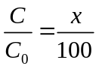
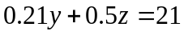
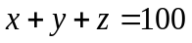
Where C₀ is the original concentration of the test gas, C is the target concentration of the test gas; x, y, and z represent the actual gas flow rates of the test gas, air, and oxygen, respectively. Based on the above principal formula, the numerical values of the flow rates for the three required gases during gas dilution can be obtained as follows:
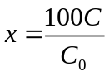
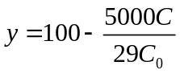
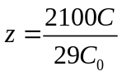

Pharmacokinetics study of in vivo samples by UPLCMS/MS
Electrospray ionization UPLC-MS/MS analysis was carried out using an AB Sciex 4000 triple quadrupole mass spectrometry instrument with a Waters ACQUITY UPLC I-Class/Xevo TQD UPLC system. Chromatographic separation was achieved at 40°C using a reversed phase column ACQUITY UPLC BEH C18 Column (2.1mm × 100mm, 1.7μm). The analyte was eluted from the column using an isocratic flow of Mobile Phase A (acetonitrile) and Mobile Phase B (0.1% formic acid aqueous solution) for 4 min. The flow rate and injection volume were 0.4mL/min and 5µL, respectively. Phenyl-β-D-glucuronide in plasma and aqueous solution were detected by multiple reaction monitoring (MRM) in the positive ion mode, quantified by the ion transition m/z 268.97 → 175.01 for phenyl-β-D-glucuronide and 325.98 → 291.07 for midazolam internal standard. The ionspray voltage and source temperature were 3kV and 600°C, respectively. Decluttering, entrance and exit potentials were 86.0, 10.0, and 6.0V, respectively. Curtain gas, ion source gas 1, ion source gas 2, and collision gas were set to 30, 30, 45, and 6 psi, respectively. The collision energies for quantitation ions for phenyl-β-D-glucuronide, internal standard were 10 and 26 eV, respectively.
Area ratio of all calibration curve standards and quality control samples were corrected for blank area ratio from mean of triplicate Blank + IS samples. These area ratios were further used to back calculate the concentrations of calibration curve standards and quality control samples. Further study sample concentrations were also calculated using excel for back calculation of active drug.

SUPPLEMENTARY RESULTS
Characterization of the chemical structure for the intermediate and synthesized phenyl-β-D-glucuronide
Synthetic pathway for the large-scale production of the phenyl-β-D-glucuronide is shown in Supplementary Figure 1.
- Analysis of molecular structure and functional group of the intermediate
Chemical structure of intermediate was verified through NMR, IR and MS spectra which were described as fellow:
¹H NMR (400 MHz, Chloroform-d) δ 7.35 – 7.24 (m, 3H), 7.13 – 7.00 (m, 2H), 7.00 – 6.96 (m, 1H), 5.40 – 5.35 (m, 1H), 5.35 – 5.24 (m, 2H), 5.15 (d, J = 7.1 Hz, 1H), 4.23 – 4.13 (m, 1H), 3.73 (s, 3H), 2.09 – 1.99 (m, 9H) (Supplementary Figure 2a);
¹³C NMR (101 MHz, Chloroform-d) δ 170.13, 169.35, 169.24, 166.89, 156.72 , 129.63, 123.54, 117.09, 99.23, 77.23 , 72.70, 71.90, 71.10 , 69.15 , 52.98 , 20.63 , 20.53 (Supplementary Figure 2b);
IR (neat, cm⁻¹): 2951, 1759, 1597, 1492, 1438, 1381, 1296, 1222, 1080, 1045, 914, 767, 694. (Supplementary Figure 2c)
MS ESI: 428.1 [M+NH₄]⁺ (Supplementary Figure 2d).
- Analysis of molecular structure and functional group of the synthesized phenyl-β-D-glucuronide
NMR, IR and MS data for the synthesized phenyl-β-D-glucuronide are:
¹H NMR (400 MHz, D₂O) δ 7.44 (t, J = 7.7 Hz, 2H), 7.24 – 7.15 (m, 3H), 5.22 – 5.16 (m, 1H), 4.03 (dd, J = 6.4, 3.7 Hz, 1H), 3.72 – 3.61 (m, 3H) (Supplementary Figure 3a);
¹³C NMR (101 MHz, D₂O) δ 174.19, 156.54, 129.96, 123.45, 116.71, 100.15, 75.57 , 75.24 , 72.72 , 71.54 (Supplementary Figure 3b);
IR (neat, cm⁻¹): 3502, 3456, 2900, 1743, 1600, 1492, 1415, 1226, 1080, 752, 690, 636 (Supplementary Figure 3c);
MS ESI: 288.1 [M+NH₄]⁺ (Supplementary Figure 3d).
Bio-compatibility of phenyl-β-D-glucuronide
Cell viability of phenyl-β-D-glucuronide solution (diluted with phosphate buffer saline, PBS solution) was verified on human gastric mucosal epithelial cells by standard cell-counting kit 8 (CCK-8) analysis. Figure 3a implies that the cell viability remains at 92.3% even the exogenous agent concentration up to 500μg/mL, indicating negligible cytotoxicity against cells incubated with phenyl-β-D-glucuronide solution. Then, body weight of the healthy mice that dosed without (control group) or with 200μg/kg phenyl-β-D-glucuronide were compared. The similarity of body weight for all groups at different investigation period implies that dosing phenyl-β-D-glucuronide did not cause any notable toxic side-effects (Figure 3b). Hematoxylin Eosin (H&E) stained sections of major organs (heart, liver, spleen, lung, kidney) for both healthy and tumor bearing mice that subjected to phenyl-β-D-glucuronide treatment also exhibit unapparent pathological changes (Figure 3c). Finally, the bio-compatibility of phenyl-β-D-glucuronide was additionally investigated by the detailed parameters of hematology, including alanine transaminase level (ALT), albumin level (ALB), blood urea nitrogen level (BUN), creatinine level (CRE), triglyceride level (TG), cholesterol level (CHO), high density lipoprotein level (HDL), aspartate transaminase level (AST), white blood cell count (WBC), red blood cell count (RBC), haemoglobin level (HGB) and platelet count (PLT). As shown in Figure 3d that negligible changes were observed between these two groups. Moreover, animal testing reports of acute systemic toxicity test and the maximization test for sensitization reveal that extract solution of phenyl-β-D-glucuronide did not cause acute systemic toxicity and/or skin allergic reaction (Supplementary Reports for acute systemic toxicity test and the maximization test). In sum, all these aforementioned preliminary toxicology test results validate good bio-compatibility of the phenyl-β-D-glucuronide like exogenous agent.

Phenol sensor fabrication and characterization
At the first step, gas adsorption capability of various metallic oxides was compared to screen out the phenol adsorption preferred sensing material so as to detect phenol with high specificity. Volatile compounds (VOCs, e.g. acetone, styrene, hexanal, ethanol, n-butanol, ethylbenzene) that can be primary found in human exhaled breath are selected as the interference gases in this research and an automatic gas blending system was built for supplying VOCs at certain concentration (Supplementary Figure 7a). As shown in Supplementary Figure 7b, among all the examined metallic oxides that exposed to various studied VOCs, relative larger frequency shift for phenol was purely observed for Cr₂O₃. Because large frequency shift suggests the high affinity to specific gas species, Cr₂O₃ is deduced that preferred to capture phenol molecular against other examined VOCs. In other words, Cr₂O₃ could be a good candidate for phenol tracking. To prove our speculation, a compact yttria stabilized zirconia (YSZ) based electrochemical gas sensor that comprised of Cr₂O₃ sensing electrode (SE), platinum counter electrode (Pt-CE) and Mn-based reference electrode (RE) was fabricated, whilst its operating parameters (i.e. fabrication and operating temperature) were also optimized (Figure 5a,b and Supplementary Figure 7c). Optimal response magnitude to 0.6ppm phenol was demonstrated at the fabrication and operational temperature of 1050ºC and 450ºC, respectively. After that, sensing behavior of the sensor was thoroughly characterized at the optimal operating parameters. In summary, the developed sensor gave high specificity to phenol against other examined VOCs (Figure 5c, d). Linear relationship between the response signal and phenol concentration was further confirmed (Figure 5e and Supplementary Figure 7d, e). Besides, 90% response/recovery time of the sensor is roughly estimated to be 37s/41s (Supplementary Figure 7f), the acceptable response/recovery speed is beneficial to the rapid monitoring of breath marker. Furthermore, the sensor show satisfactory response stability and breath moisture resistance when detecting phenol (Supplementary Figure 7g, h). Such impressive sensing characteristics imply the practicability of tracking induced phenol-based breath marker at trace amount.

Characterization of handheld breath-analyzer
Figure 5f and Supplementary Figures 8, 9a-c illustrate the handheld breath-analyzer, featuring the integrated YSZ-based electrochemical phenol sensor. These figures also provide a comprehensive overview of the device's operational diagram and the process of breath sample collection. Data shown in Supplementary Figure 9d suggests the identical results for the breath-analyzer and GCMS. In other words, our developed breath-analyzer demonstrated high accuracy in recording data. To evaluate the sensing characteristics, breath signal for different samples was recorded by the breath-analyzer and further compared (Figure 5g). After dosing phenyl-β-D-glucuronide, apparent increment in breath signal is solely observed for breath sample derived from gastric tumor bearing mice. This suggests our proposed breath-analyzer would be helpful to realizing the pre-warning of potential cancer risk. Note that the variation of breath signal is primary contributed by the administration of phenyl-β-D-glucuronide, because the solvent (i.e. PBS) that utilized for preparing phenyl-β-D-glucuronide solution gives negligible impact on breath signal (Supplementary Figure 9e, f).

Impact of environmental factor and confounding diseases
It should be noted that all mice released strong body odor during testing and the experimental results weren't affected by odor because of the high selectivity to phenol-based breath marker for the proposed breath analyzer, suggesting minimal impact of environmental factor on cancer risk pre-warning. Impact of confounding diseases has also been investigated to confirm the high specify of phenyl-β-D-glucuronide-like exogenous agent as the tumor probe. In the pilot study, mice that were suffering with acute G.U., ovalbumin (OVA) induced asthma, carbon tetrachloride (CCl₄) induced hepatic fibrosis, dextran sulfate sodium (DSS) induced colitis and B6-hBAFF induced L.N. were selected as the research objects since these diseases are frequently found in stomach, respiratory tract, liver, colon and kidney. All these mouse model were directly purchased from Gempharmatech Co. Ltd (P. R. China) and confirmed by histological analysis (Supplementary Figure 10). As shown in Supplementary Figure 11, after administrated with phenyl-β-D-glucuronide, minor response difference was observed for healthy mice and mice suffered with the aforementioned diseases when compared with that of the tumor bearing mice, such as gastric tumor bearing mice (n = 4 for each). This means that phenyl-β-D-glucuronide is relatively insensitive to these studied confounding diseases.

SUPPLEMENTARY FIGURES
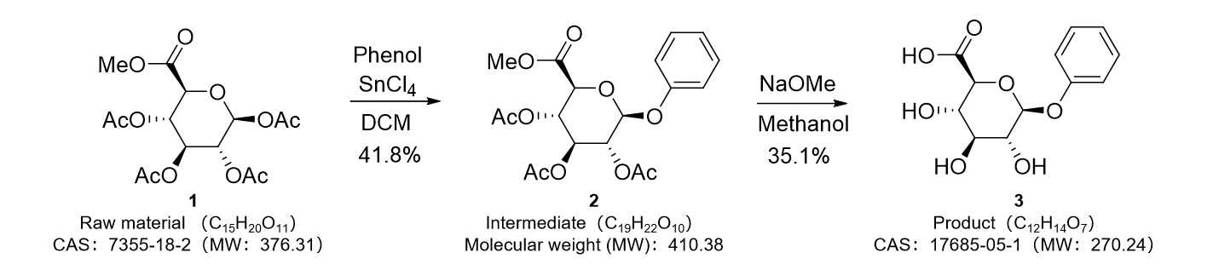
Supplementary Figure 1. Pathway of synthesizing phenyl-β-D-glucuronide. The phenyl-β-D-glucuronide was obtained via two steps pathway with 35.1% yield.

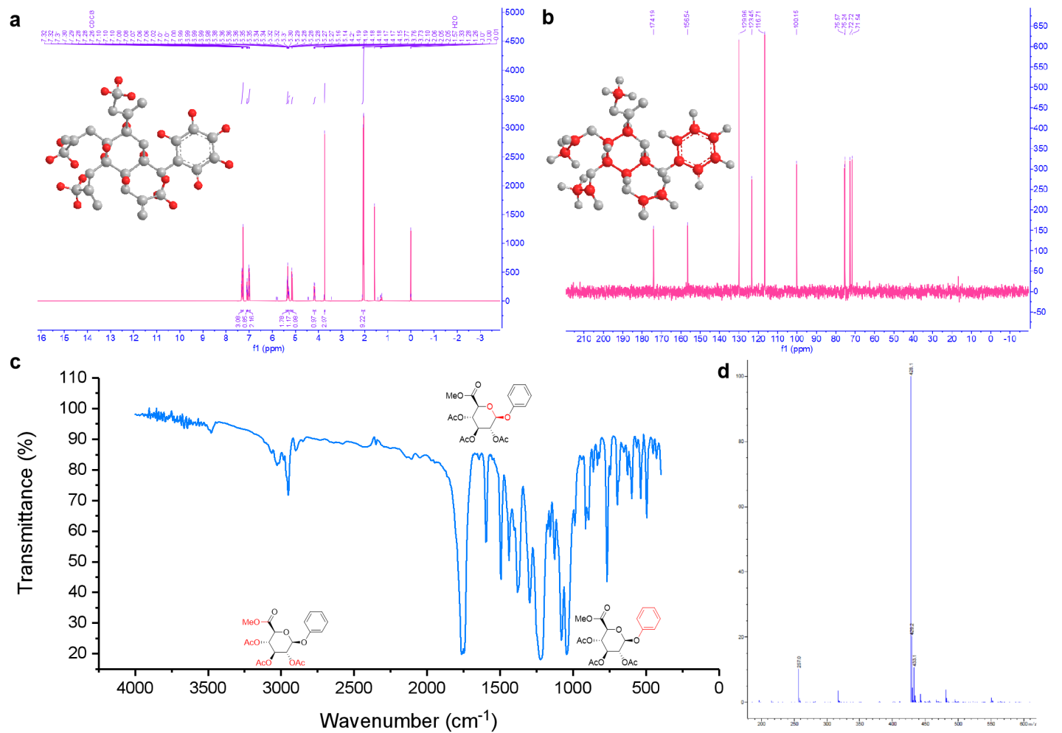
Supplementary Figure 2. Analysis of the molecular structure and functional group of the intermediate. a, HMR and b, CNMR spectra of the intermediate. ¹H NMR (400 MHz, Chloroform-d) δ 7.35 – 7.24 (m, 3H), 7.13 – 7.00 (m, 2H), 7.00 – 6.96 (m, 1H), 5.40 – 5.35 (m, 1H), 5.35 – 5.24 (m, 2H), 5.15 (d, J = 7.1 Hz, 1H), 4.23 – 4.13 (m, 1H), 3.73 (s, 3H), 2.09 – 1.99 (m, 9H). ¹³C NMR (101 MHz, Chloroform-d) δ 170.13, 169.35, 169.24, 166.89, 156.72, 129.63, 123.54, 117.09, 99.23, 77.23, 72.70, 71.90, 71.10, 69.15, 52.98, 20.63, 20.53. c, FT-IR spectra and d, MS for the intermediate. IR (neat, cm⁻¹): 2951, 1759, 1597, 1492, 1438, 1381, 1296, 1222, 1080, 1045, 914, 767, 694. MS ESI: 428.1 [M+NH₄]⁺.
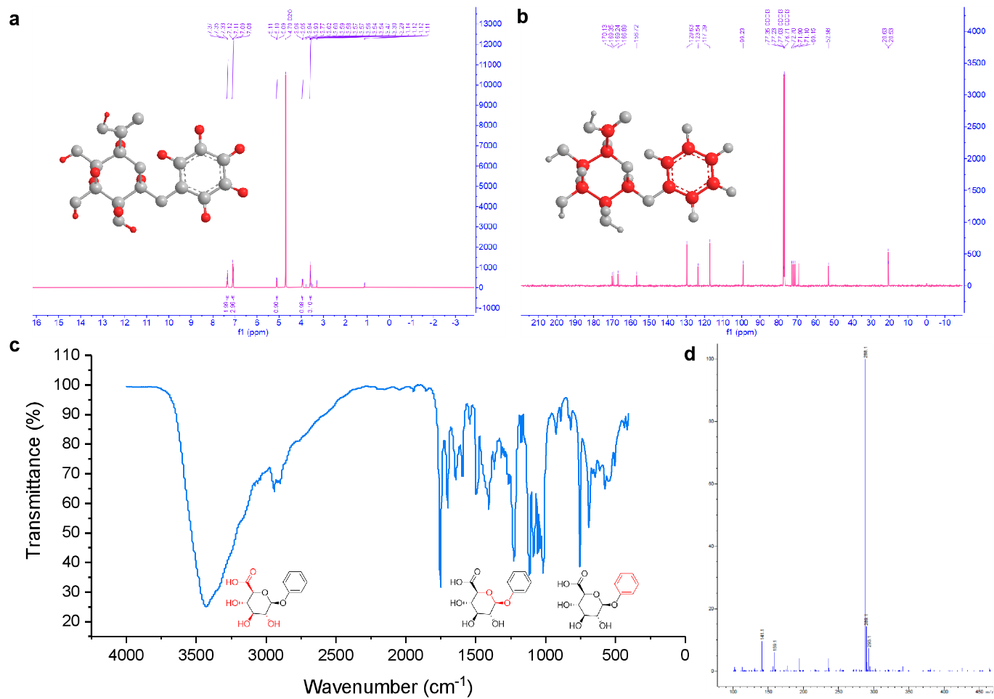
Supplementary Figure 3. Analysis of the molecular structure and functional group of the synthesized phenyl-β-D-glucuronide. a, HMR and b, CNMR spectra of the synthesized phenyl-β-D-glucuronide. ¹H NMR (400 MHz, D₂O), δ 7.44 (t, J = 7.7 Hz, 2H), 7.24 – 7.15 (m, 3H), 5.22 – 5.16 (m, 1H), 4.03 (dd, J = 6.4, 3.7 Hz, 1H), 3.72 – 3.61 (m, 3H). ¹³C NMR (101 MHz, D₂O) δ 174.19, 156.54, 129.96, 123.45, 116.71, 100.15, 75.57, 75.24, 72.72, 71.54. c, FT-IR spectra and d,MS for the synthesized phenyl-β-D-glucuronide. IR (neat, cm⁻¹): 3502, 3456, 2900, 1743, 1600, 1492, 1415, 1226, 1080, 752, 690, 636. MS ESI: 288.1 [M+NH₄]⁺.
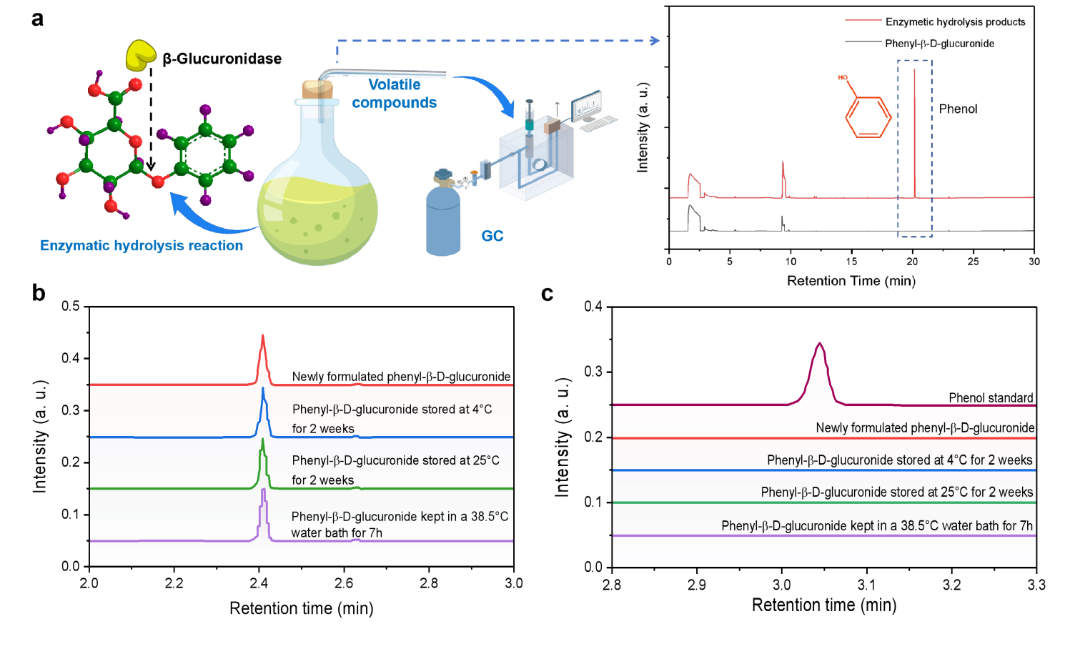
Supplementary Figure 4. Chemical properties of phenyl-β-D-glucuronide. a, GC spectra of the compounds in upper gas phase derived from phenyl-β-D-glucuronide and its enzymatic hydrolysis products. Vaporized phenol is solely found in the upper gas phase of the sample containing enzymatic hydrolysis products. b, UPLC-MS-PDA (at 280nm) spectra phenyl-β-D-glucuronide solutions under different treatment. The similar peak area suggests the phenyl-β-D-glucuronide solution are stable under the aforementioned treatment. c, Comparison of peak intensity for phenol vapor standard and upper vapor components of phenyl-β-D-glucuronide solutions under different treatment. No obvious phenol peak observed for the treated phenyl-β-D-glucuronide solutions further indicates good stability of phenyl-β-D-glucuronide solutions. These results imply that the release of phenol is entirely derived from the enzymatic hydrolysis reaction, since it is experimentally evidenced that phenyl-β-D-glucuronide remained stable without decomposition for 2 weeks when stored at 4ºC and for 7 hours kept at 38.5ºC.
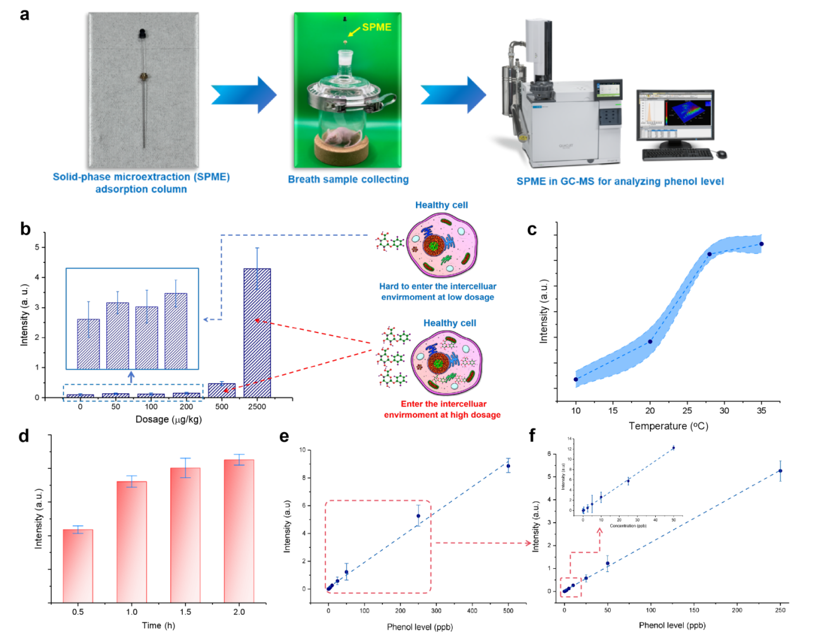
Supplementary Figure 5. Analysis of phenol level in exhaled breath. a, Illustration of extracting and analyzing phenol-based breath marker in breath sample. b, Variation of the induced phenol level in breath sample derived from health mice (n = 5 for each administration), at the phenyl-β-D-glucuronide dosage in the range of 0-2500μg/kg. A minimal background signal of phenol in exhaled breath of healthy mice was found at the phenyl-β-D-glucuronide dosage up to 200 μg/kg, suggesting the optimal dosage is around 200μg/kg. c, Impact of mouse incubator temperature during sampling on phenol level. The gastric tumor bearing mice (n = 5) was administrated with 200μg/kg of phenyl-β-D-glucuronide. It can be deduced that the optimal incubator temperature is 28ºC. d, Dependence of the induced phenol level in breath sample on the sampling time, after the mice were administrated with 200μg/kg exogenous agent and kept at the incubator temperature of 28ºC (n = 5). Phenol level in exhaled breath almost reached the maximum value at 1h. Dependence of GC peak intensity on phenol level in the range of e, 0-500ppb and f, 0-250ppb, inset: 0-50ppb.
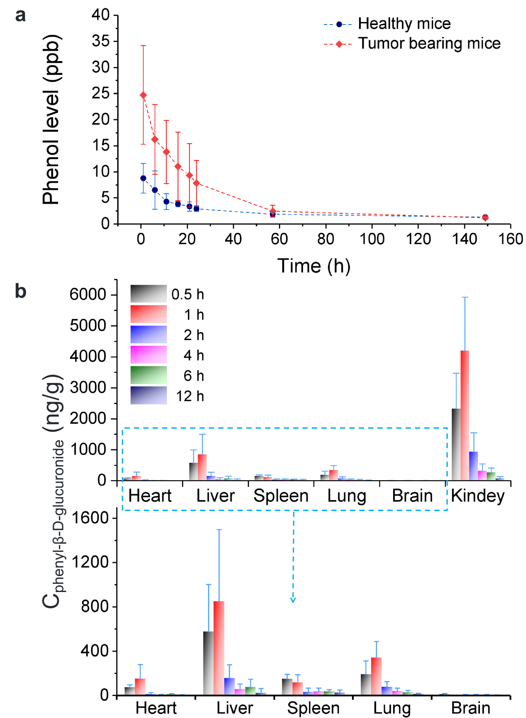
Supplementary Figure 6. Pharmacokinetics properties of phenyl-β-D-glucuronide. a, Mean phenol concentration-time profile in exhaled breath following a single intravenous administration (2mg/kg) of phenyl-β-D-glucuronide in mice (n = 4). b, Concentration (mean ± SD) levels of phenyl-β-D-glucuronide in rat tissues at 0.5, 1, 2, 4, 6 and 12 h, after intragastric (20 mg/kg) administration (n = 5).
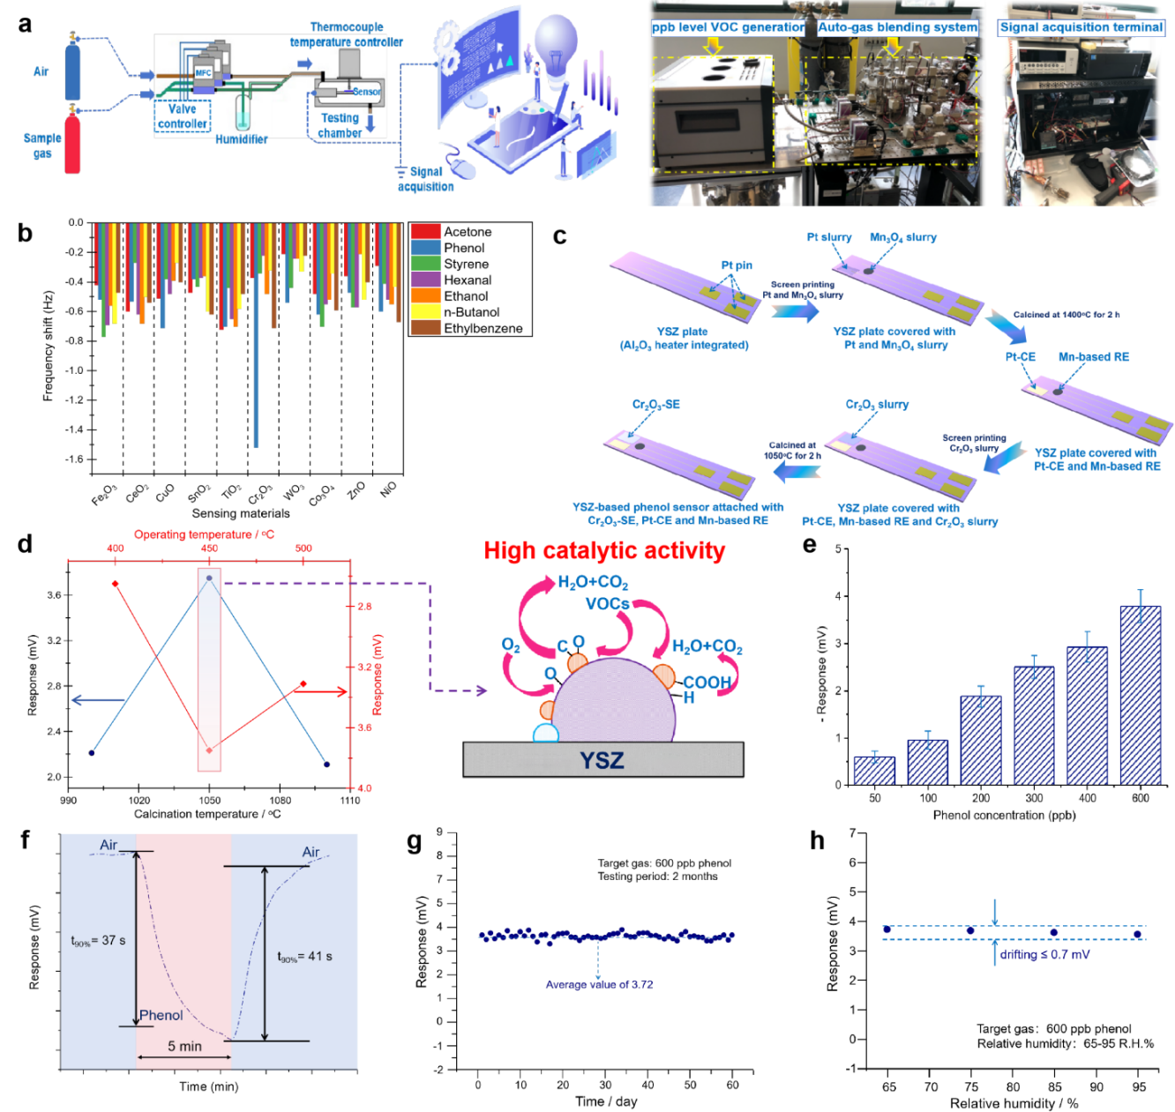
Supplementary Figure 7. Fabrication and characterization of phenol sensor. a, Illustration and photographic image of the auto-gas blending system for for providing VOCs at pre-set concentration. b, Comparison of the gas adsorption capacity for various metallic oxide-based sensing materials towards acetone, phenol, styrene, hexanal, ethanol, n-hexane and ethylbenzene. c, Schematic view of fabricating YSZ-based phenol sensor. d, Impact of calcination and operating temperature on sensing characteristics of the YSZ-based phenol sensor utilizing Cr₂O₃-SE, Pt-CE and Mn-based RE. e, Step response of the sensor to phenol in the range of 50-600 ppb. f, 90% response/recovery time of the developed sensor. g, Long term stability of the sensor. h, Impact of ambient humidity on response behavior.
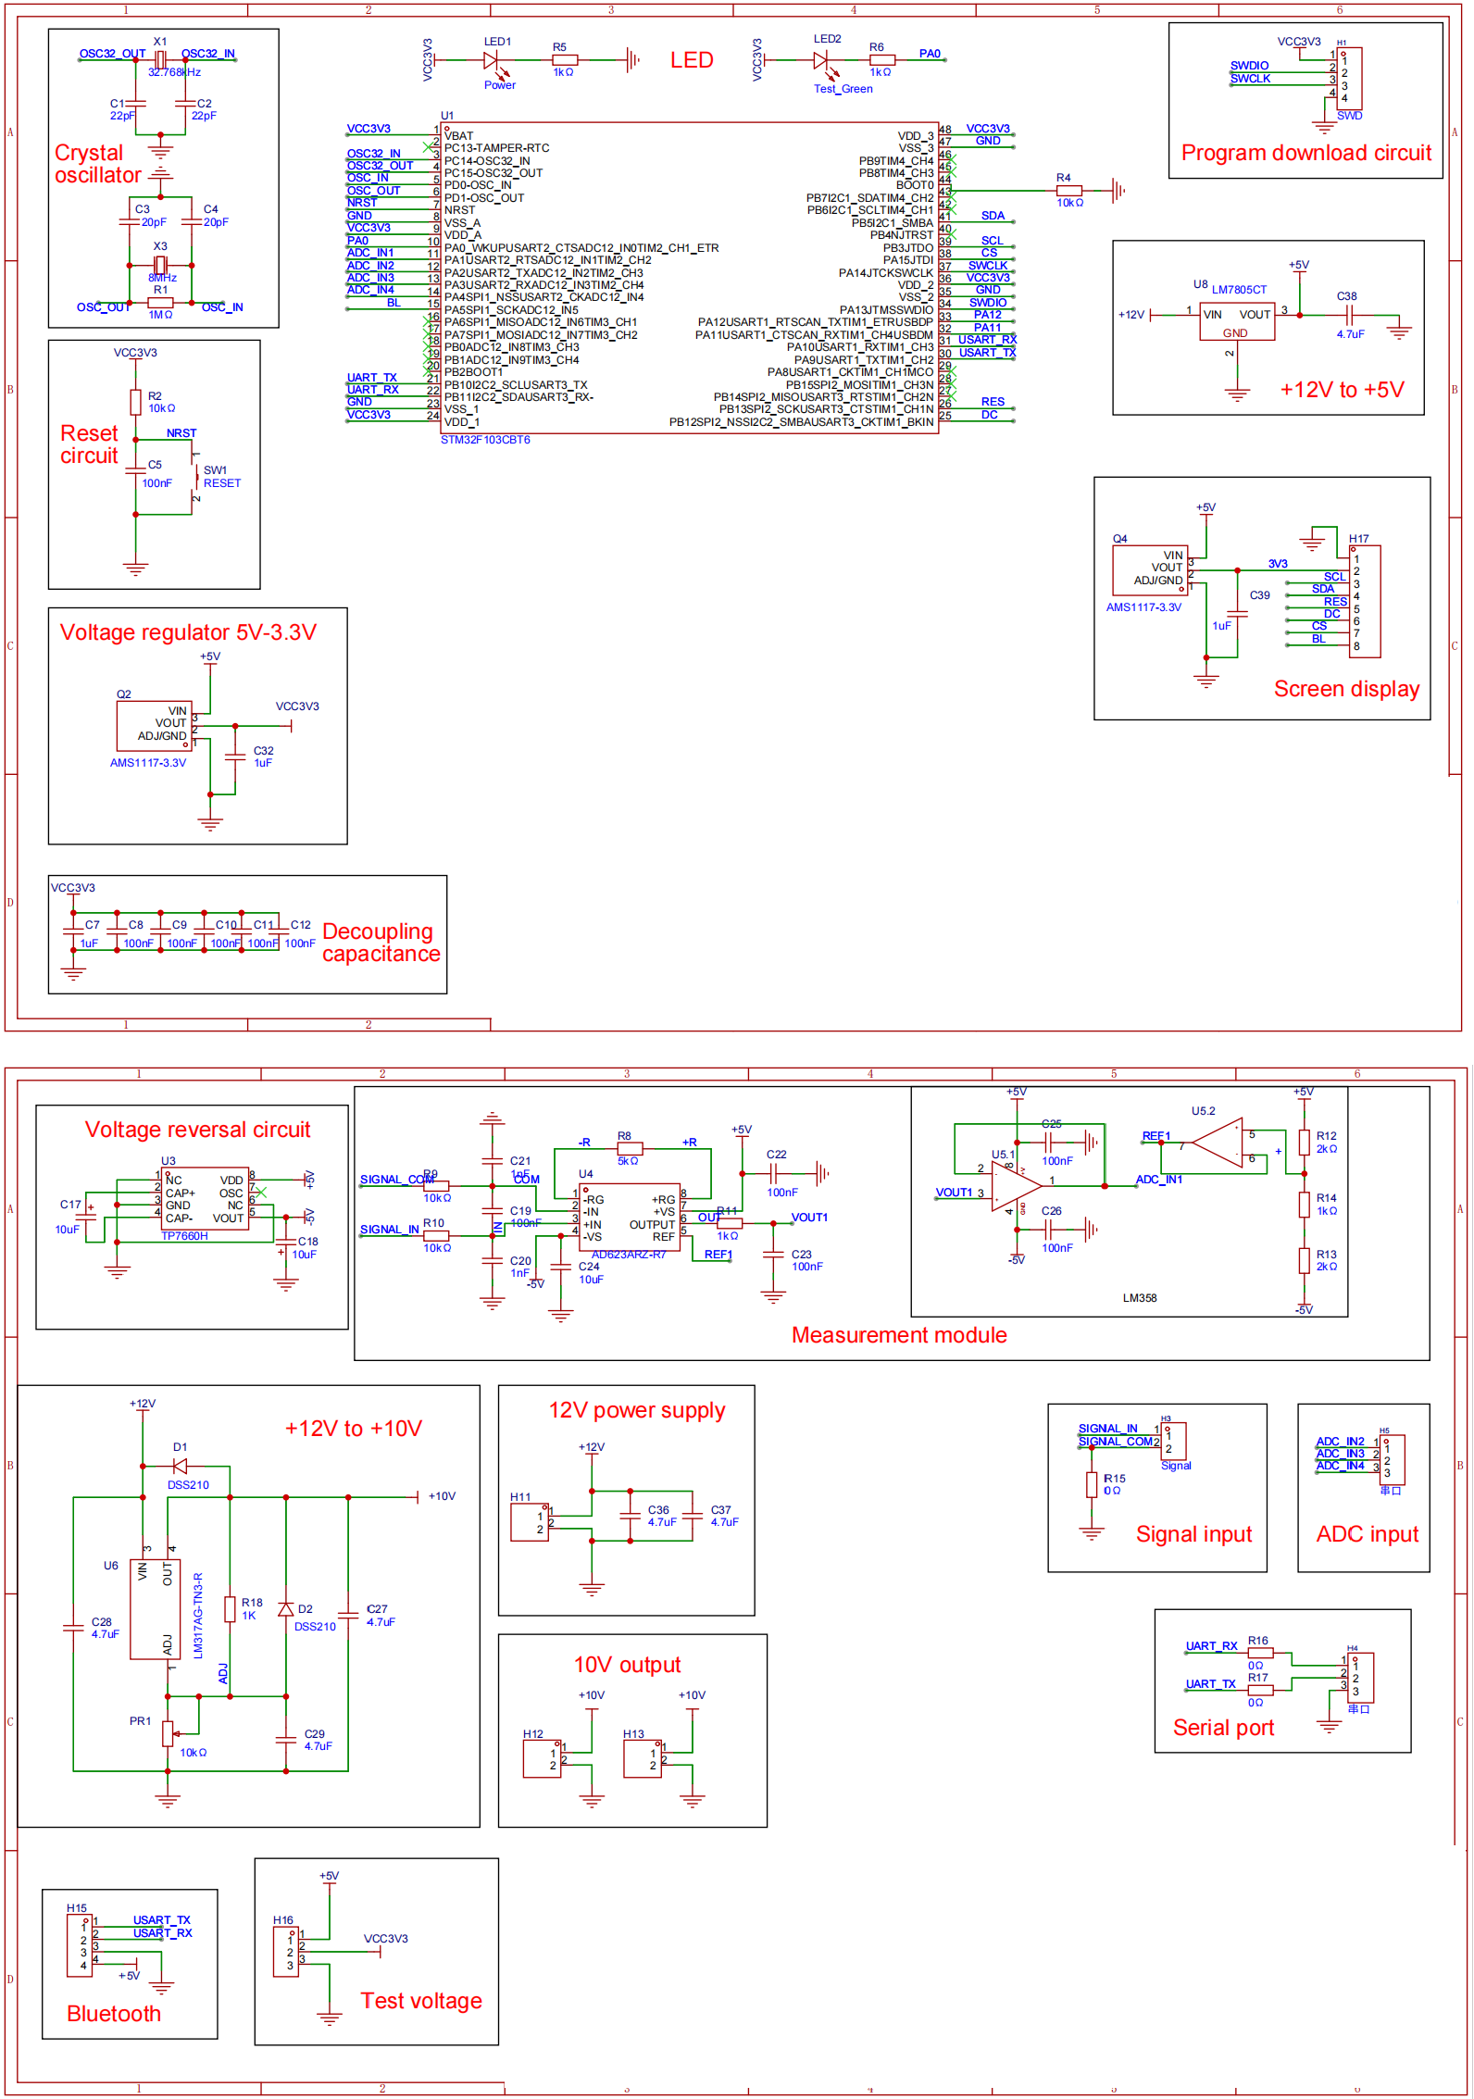
Supplementary Figure 8. Schematic diagram of the circuit board for the handheld breath-analyzer.
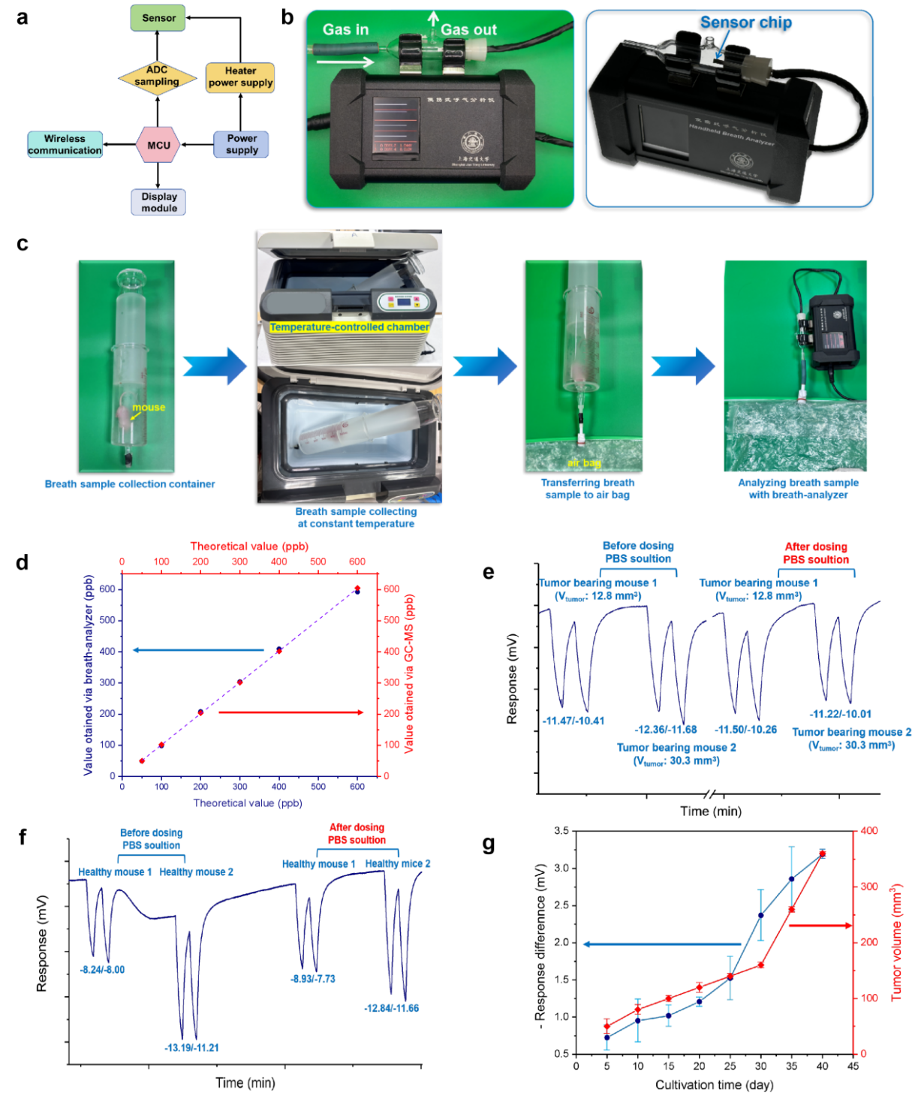
Supplementary Figure 9. Characterization of handheld breath-analyzer. a, Operating diagram of the handheld breath-analyzer. b, Sample gas transmission path and location of the electrochemical phenol sensor in the breath-analyzer. c, Illustration of tracking the level of induced phenol in breath sample that derived from healthy or tumor-bearing mice through the handheld breath-analyzer. d, Data deviation for the phenol level recorded by commercial GC-MS and proposed breath-analyzer. Variation of the breath signal for the breath sample derived from e, healthy or f, tumor-bearing mice, after tail injecting PBS solution. The minor difference in response signal suggests negligible impact of PBS administration on breath signal. g, Increment of response difference and tumor volume on cultivation time.
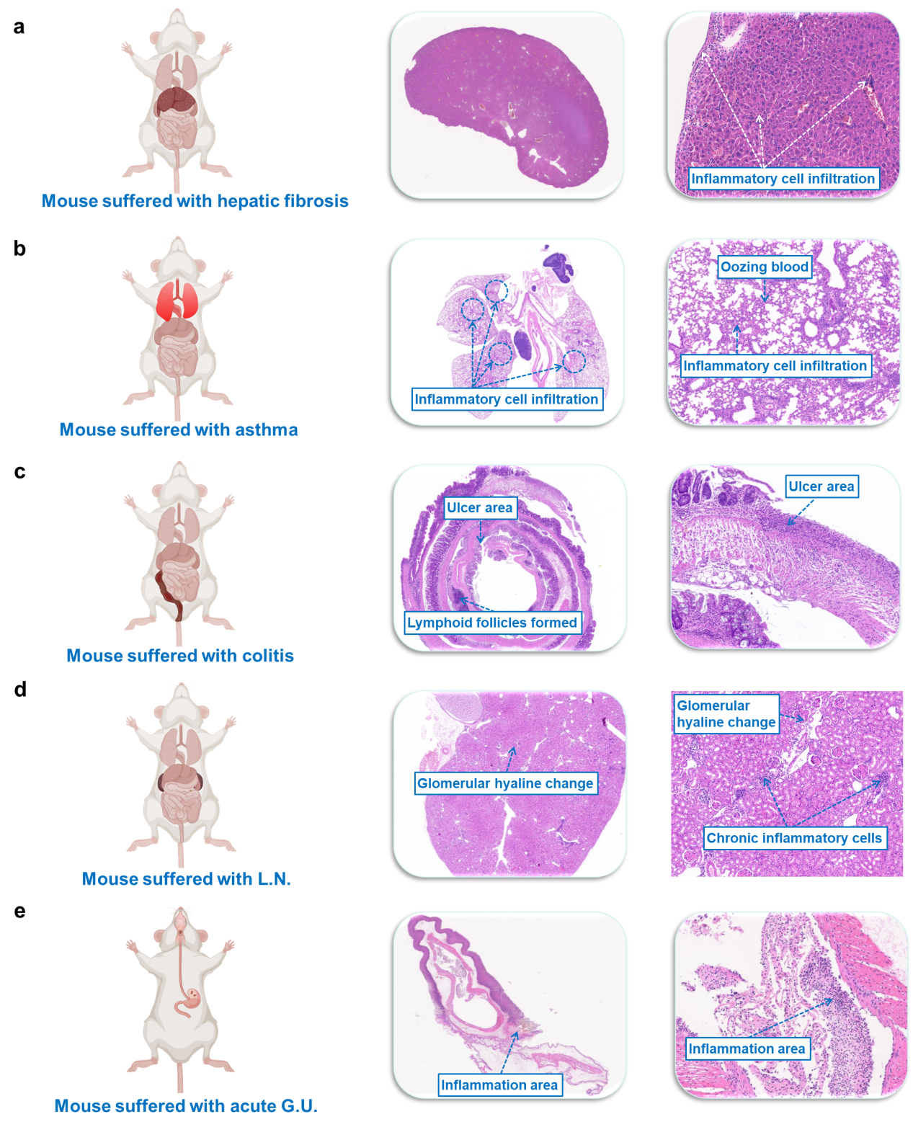
Supplementary Figure 10. Tissue images for different mouse model. Hematoxylin-eosin staining (H&E) images for tissues derived from the mice suffered with a, hepatic fibrosis; b, asthma; c, colitis; d, lupus nephritis (L.N.); e, actuate ulcer (G.U.).
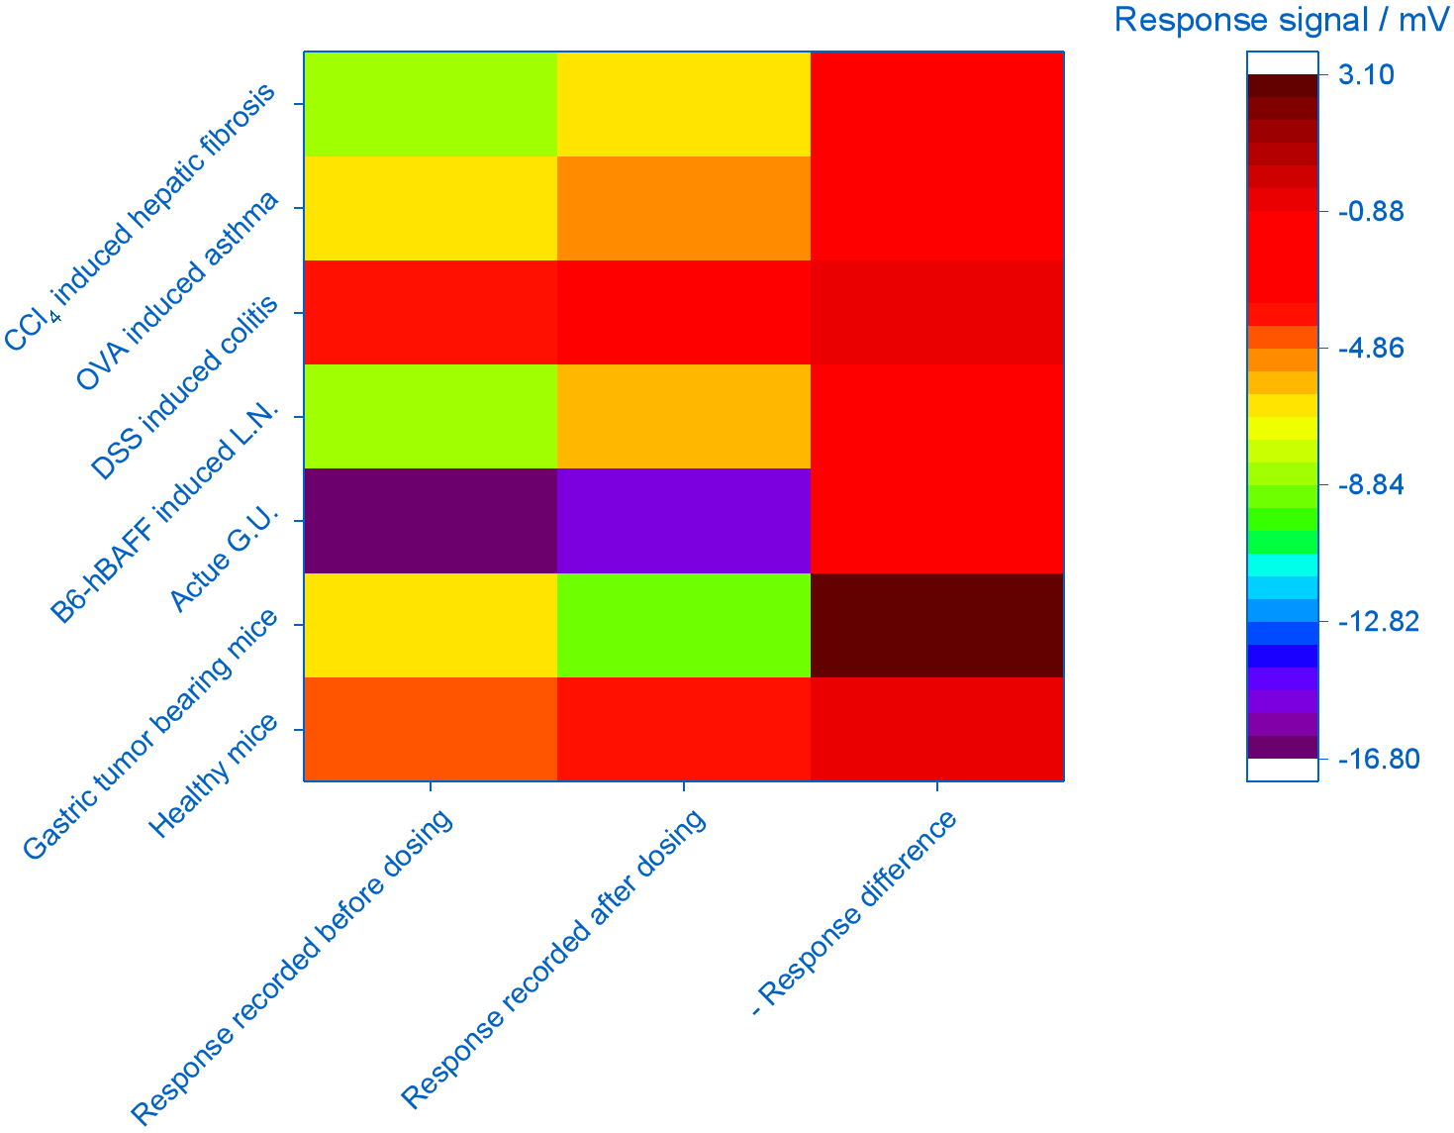
Supplementary Figure 11. Impact of studied confounding diseases. After administration with phenyl-β-D-glucuronide, apparent response difference is solely found for gastric tumor bearing mice when compared with that of the healthy mice and mice suffered with acute G.U., OVA induced asthma, CCl₄ induced hepatic fibrosis, dextran sulfate sodium DSS induced colitis and B6-hBAFF induced L.N. (n = 4 for each mouse model, "Response difference" = "Response signal recorded after dosing" - "Response signal recorded before dosing").

SUPPLEMENTARY TABLES

Supplementary Table 1. Chemical list for the research
Chemicals | Purity | Supplier
Phenol | ≥ 99.5% | Macklin (P. R. China)
Phenyl-β-D-glucuronide | ≥ 96% | Sigma-Aldrich (USA)
β-glucuronidase | N/A | Sigma-Aldrich (USA)
Bovine serum albumin | N/A | ChromatoPur (USA)
High glucose culture medium (DMEM) | N/A | Hyclone (USA)
PBS solution | N/A | Hyclone (USA)
Fetal bovine serum (FBS) | N/A | Hyclone (USA)
α-Terpineol | 98% | Macklin (P. R. China)
Ethyl cellulose | N/A | Aladdin (P. R. China)
Mn₃O₄ | ≥ 98% | Aladdin (P. R. China)
Cr₂O₃ | ≥ 98% | Aladdin (P. R. China)
Fe₂O₃ | ≥ 98% | Aladdin (P. R. China)
CeO₂ | ≥ 98% | Aladdin (P. R. China)
CuO | ≥ 98% | Aladdin (P. R. China)
SnO₂ | ≥ 98% | Aladdin (P. R. China)
TiO₂ | ≥ 98% | Aladdin (P. R. China)
WO₃ | ≥ 98% | Aladdin (P. R. China)
Co₃O₄ | ≥ 98% | Aladdin (P. R. China)
ZnO | ≥ 98% | Aladdin (P. R. China)
NiO | ≥ 98% | Aladdin (P. R. China)

Supplementary Table 2. Source of tumor cell lines referred in the research
Cancer type | Name of cell lines | Derived from human or mouse
Gastric cancer | MGC-803 | Human
Lung cancer | A549-Luc | Human
Liver cancer | Huh7-Luc | Human
Colorectal cancer | HCT116-Luc | Human
Breast cancer | MDA-MB-231-Luc | Human
Renal carcinoma | Renca-Luc | Mouse

