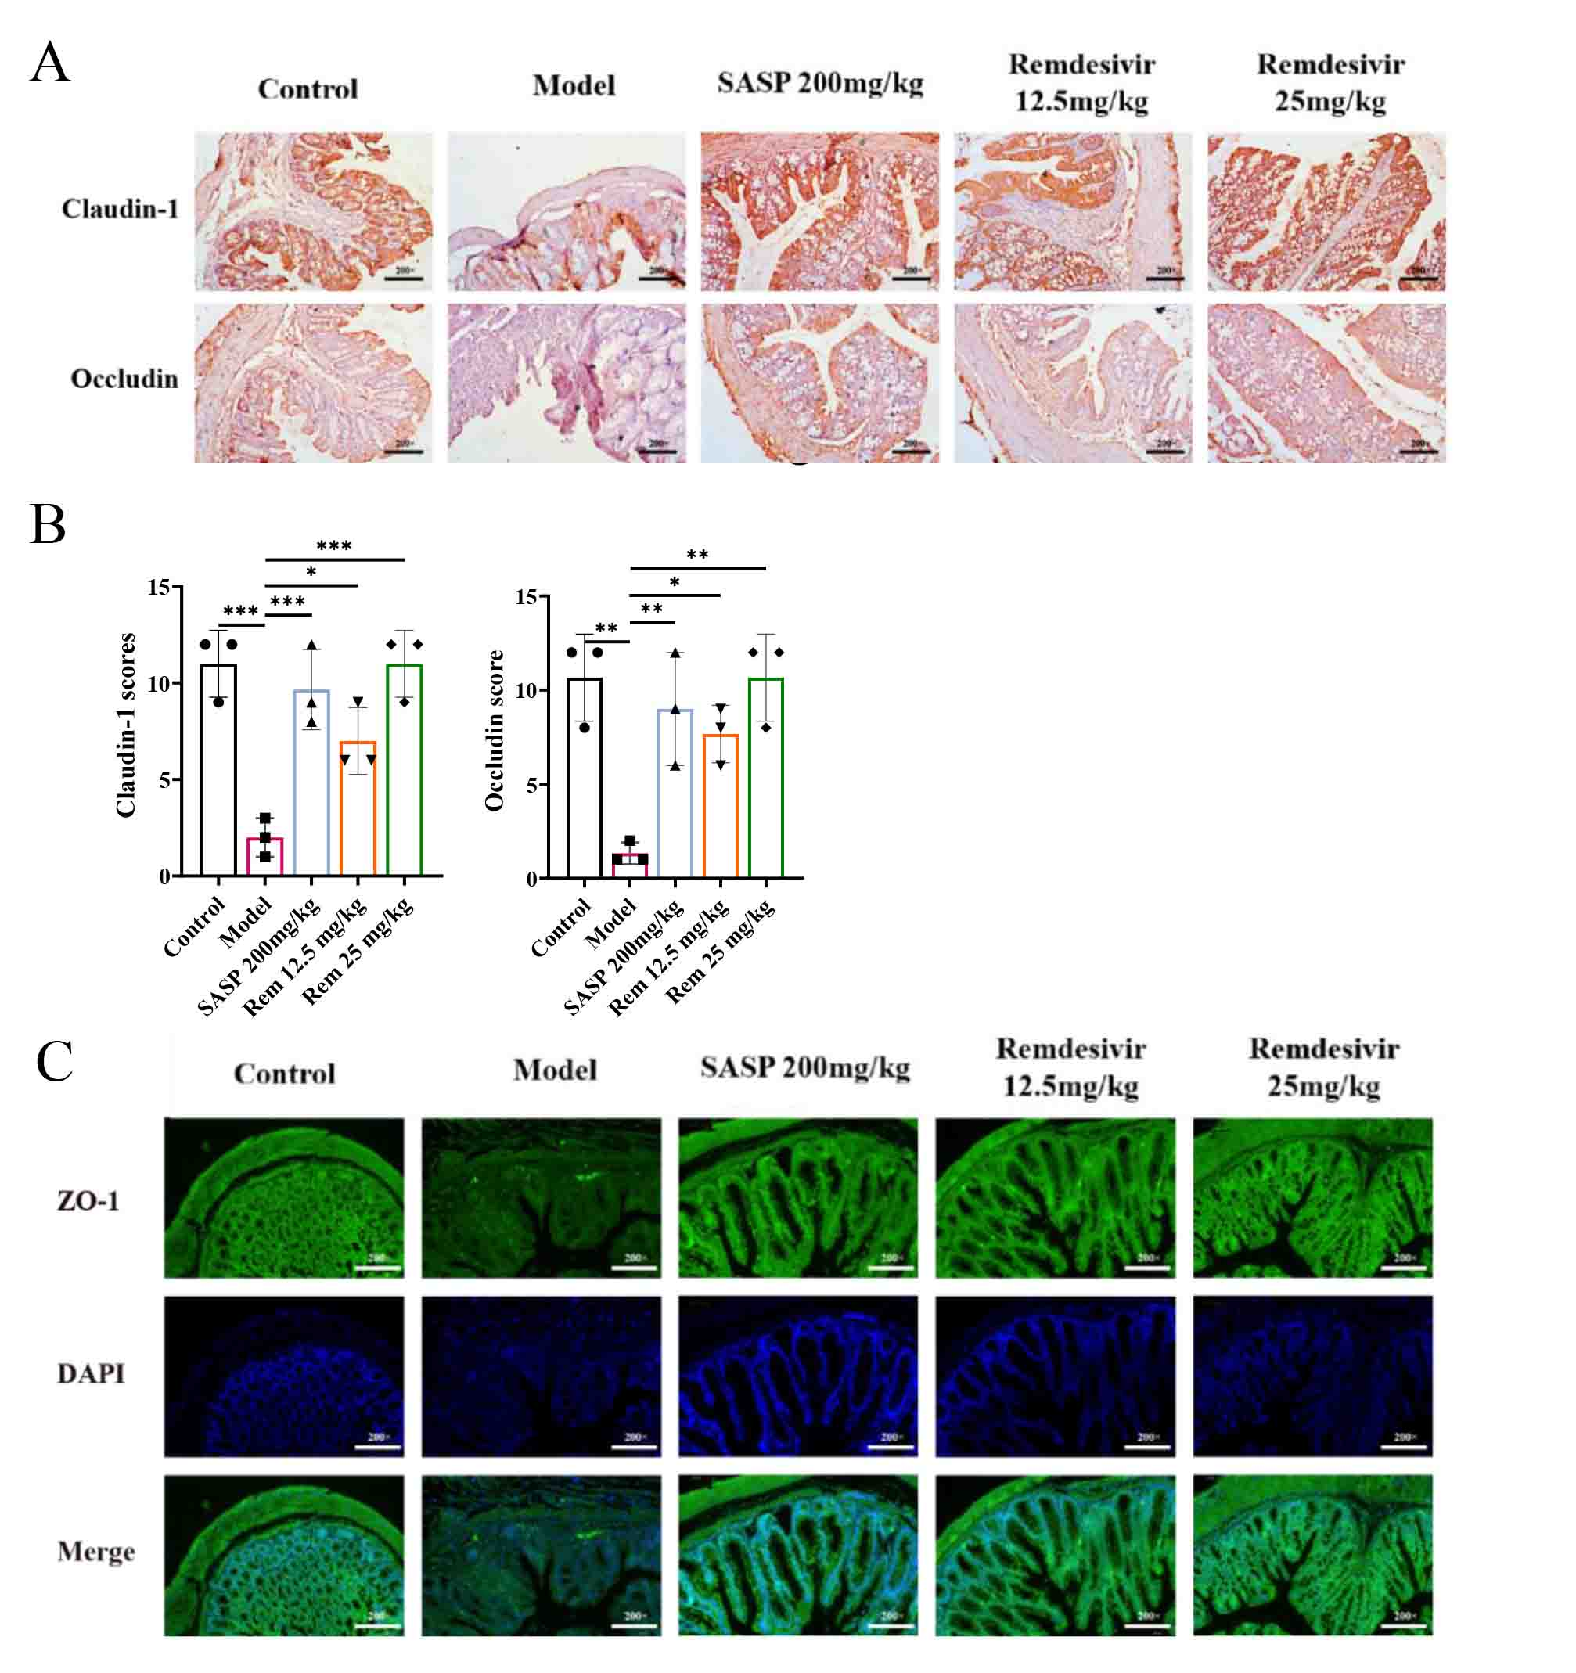
Supplementary figure 1. Remdesivir mitigates epithelial barrier damage in mice with experimental colitis. A. B. Immunohistochemical experiments revealed the expression of Claudin-1 and Occludin in the colonic tissues of mice in each group. C. Immunofluorescence experiments revealed the expression of ZO-1 in the colonic tissues of mice in each group. *P<0.05，**P<0.01，***P<0.001.

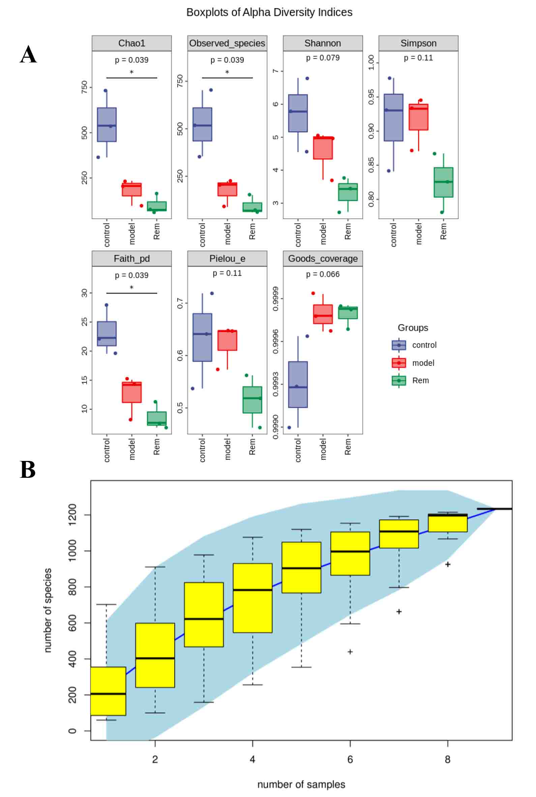
Supplementary figure 2. A. Alpha diversity index group box plot. B. Specaccum species accumulation curve chart.

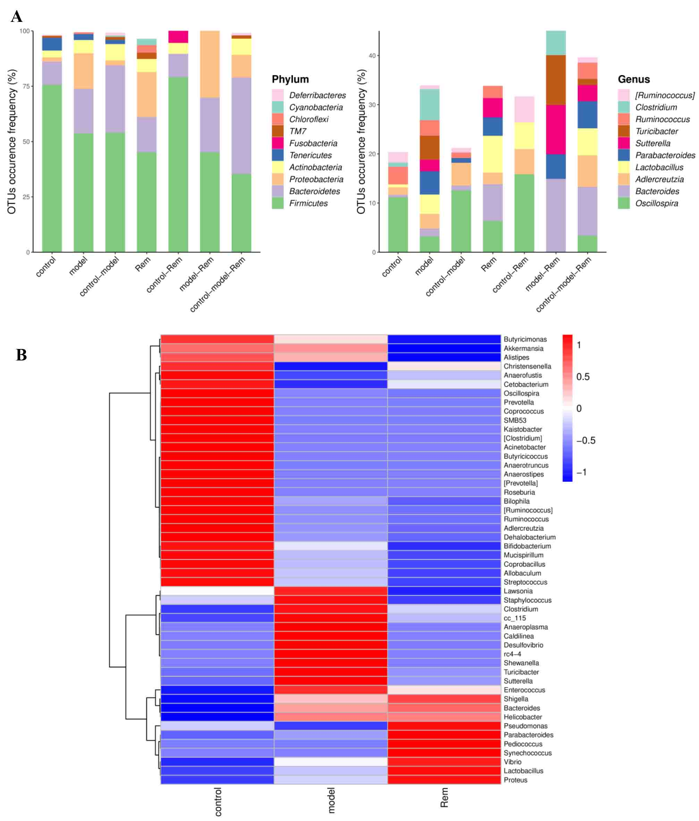
Supplementary figure 3. A. Venn diagram showing the count of ASVs/OTUs in different regions as a bar chart. B. Species composition heatmap at the genus level for species clustering.

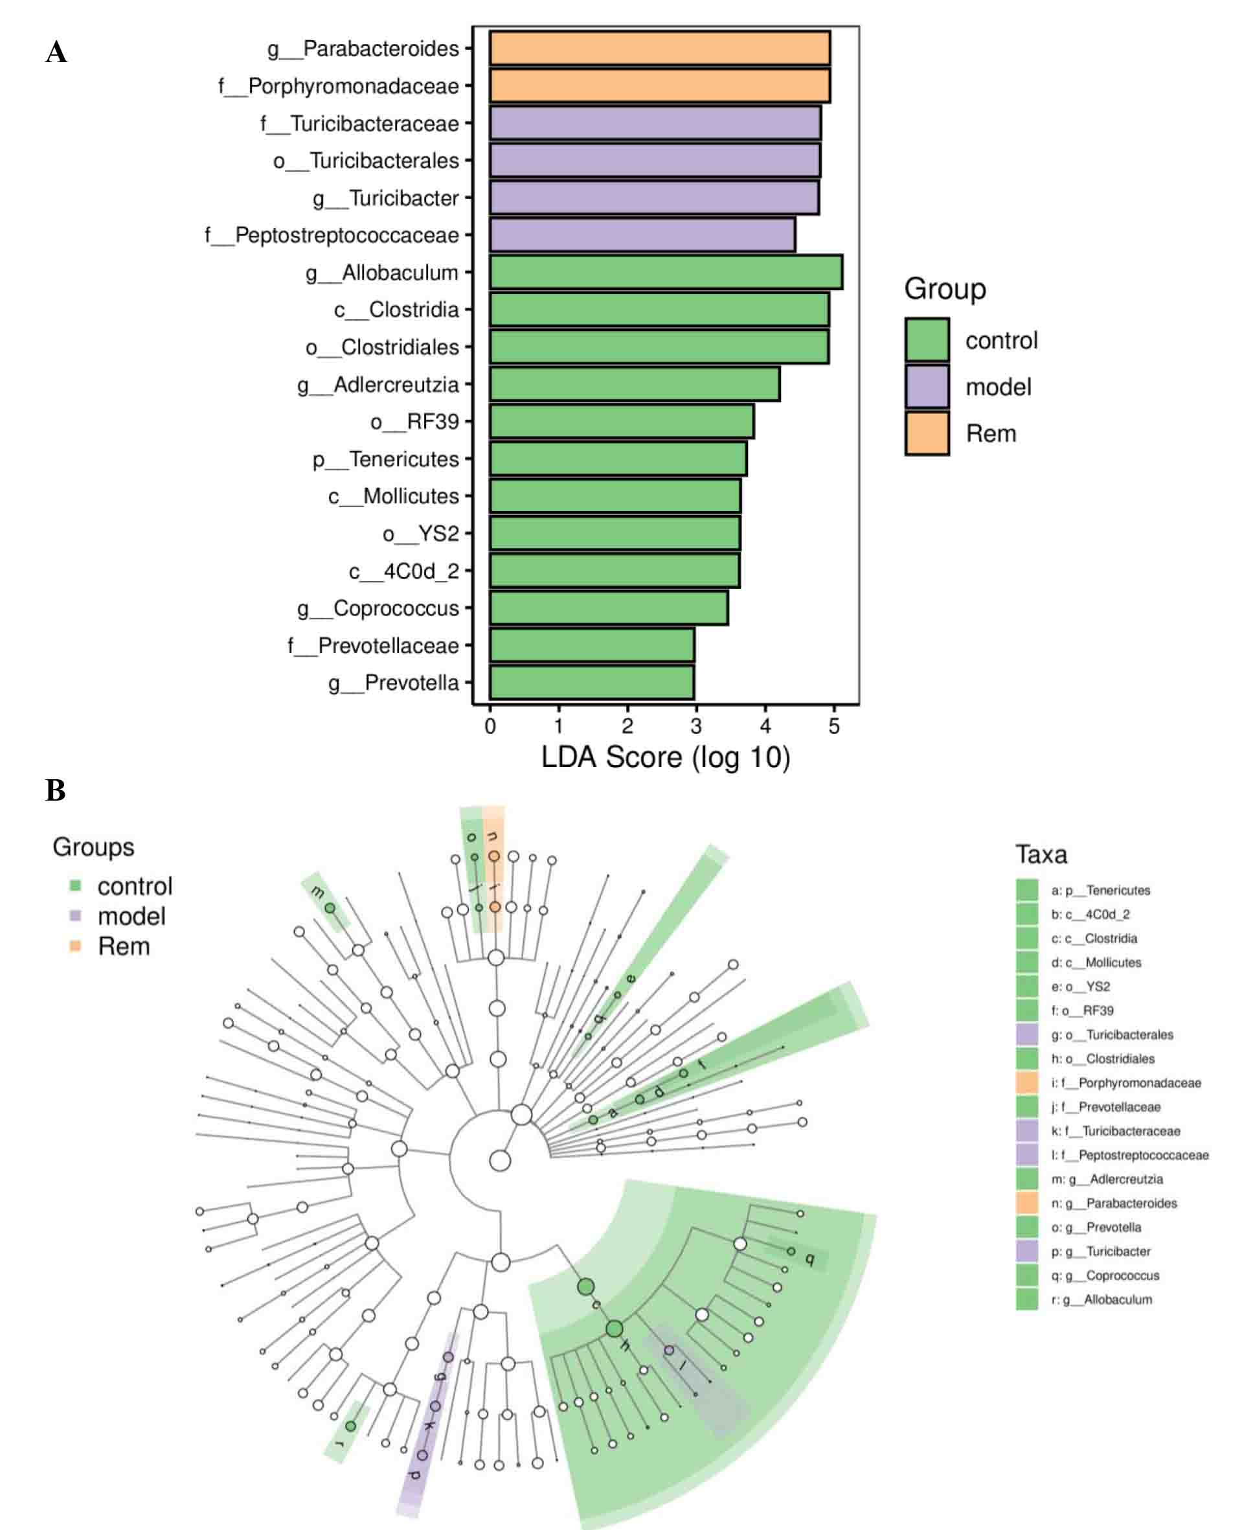
Supplementary figure 4. A. Indicator species' LDA effect size bar chart. B. Tree-based differential classification unit chart for intergroup comparison.

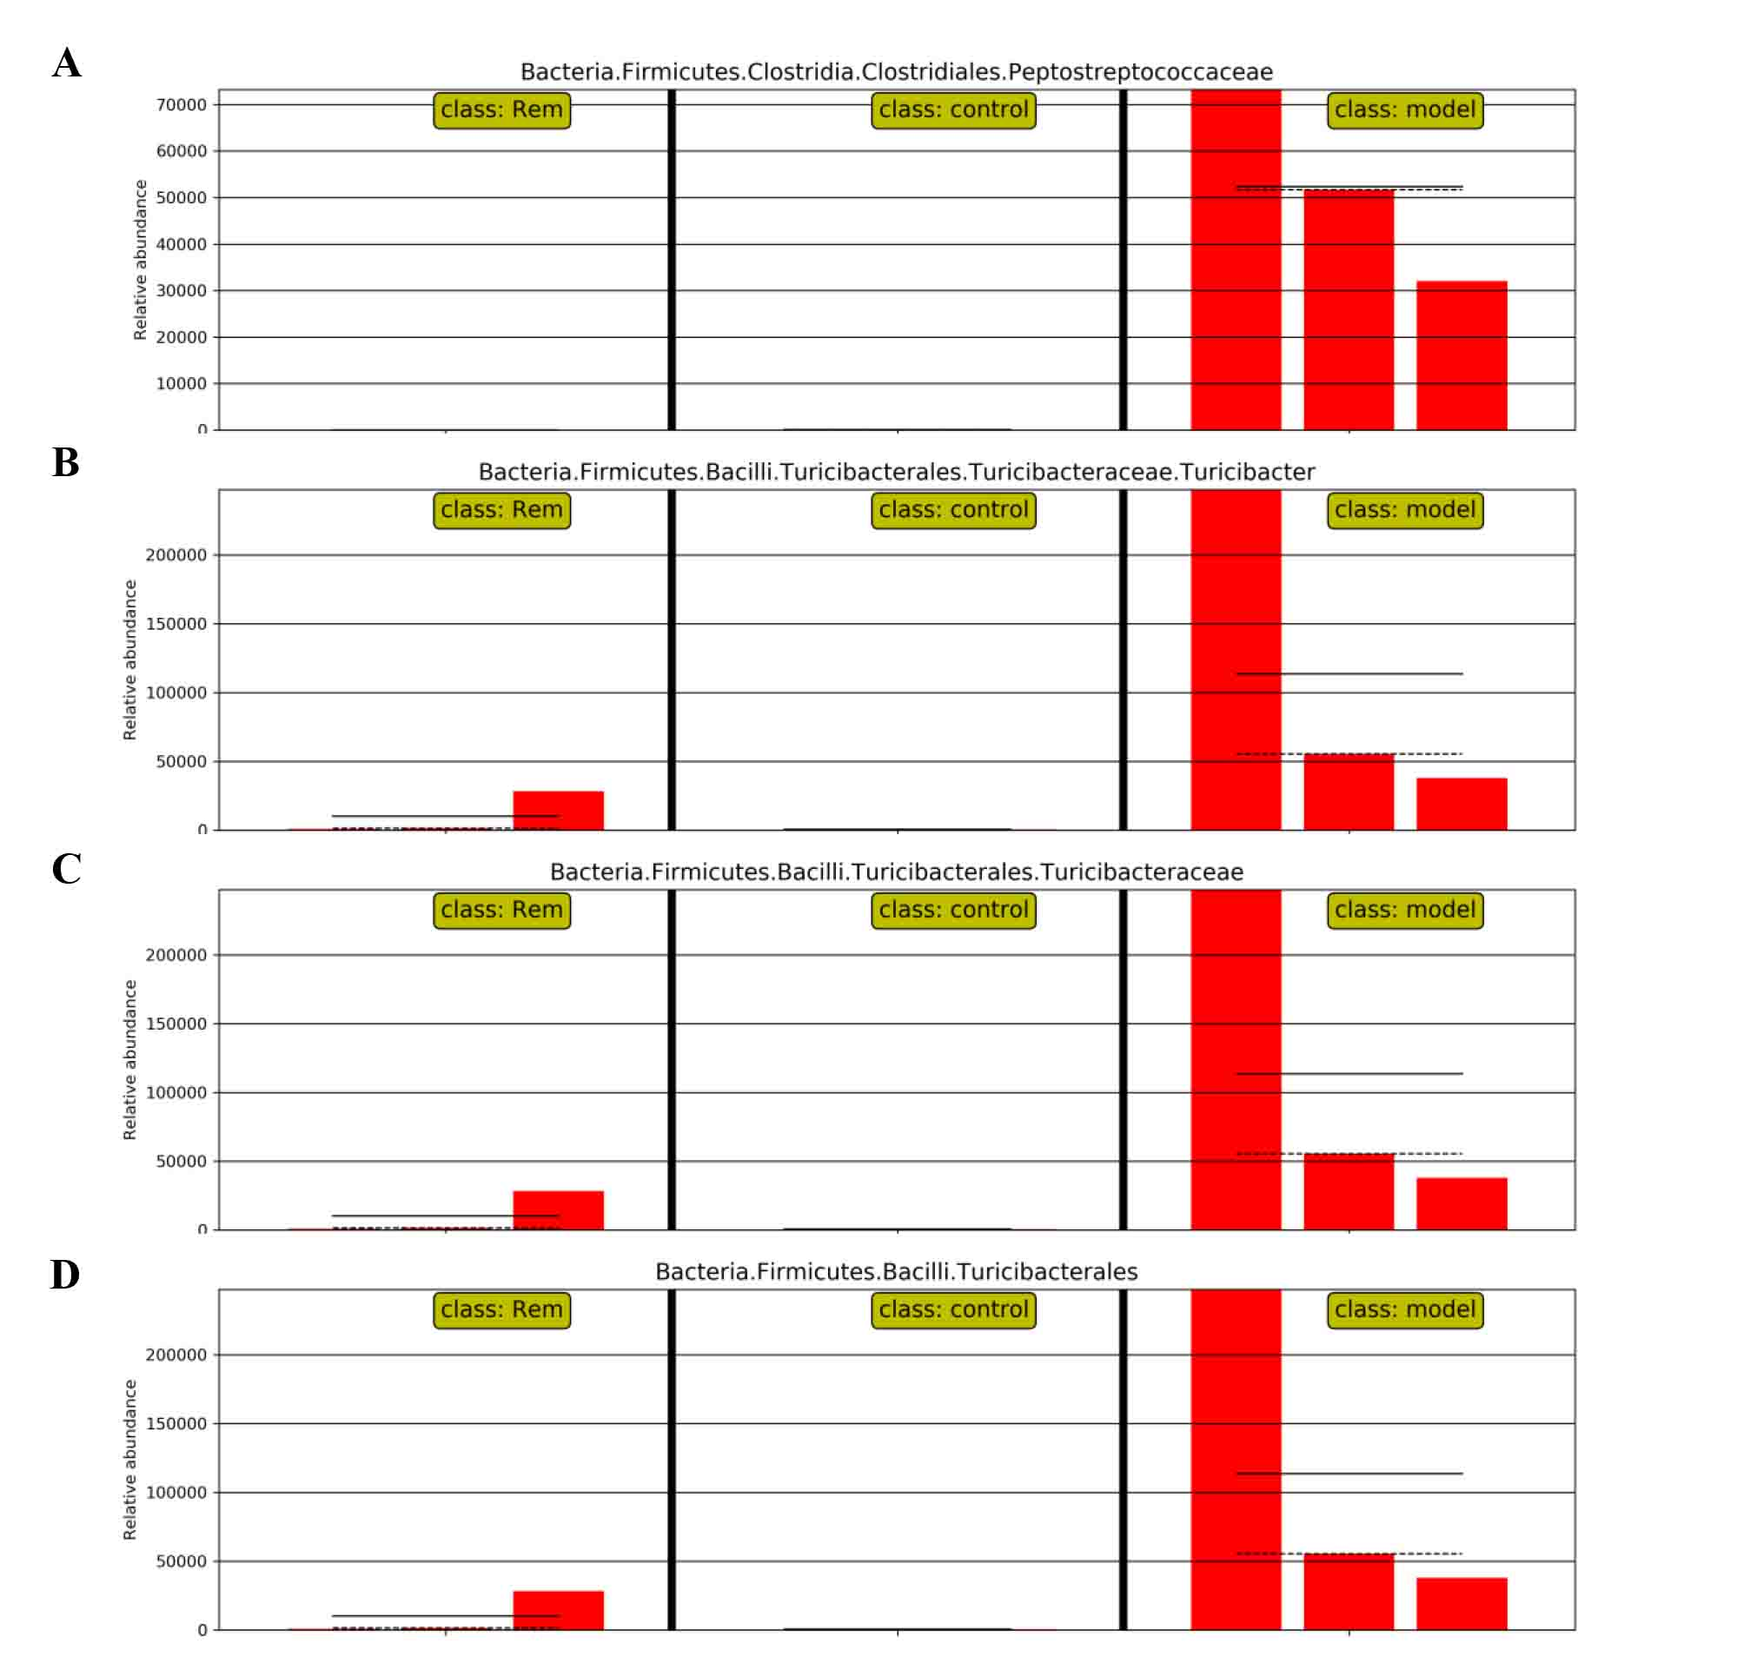
Supplementary figure 5. A-D. Relative abundance distribution of indicator species across different groups.

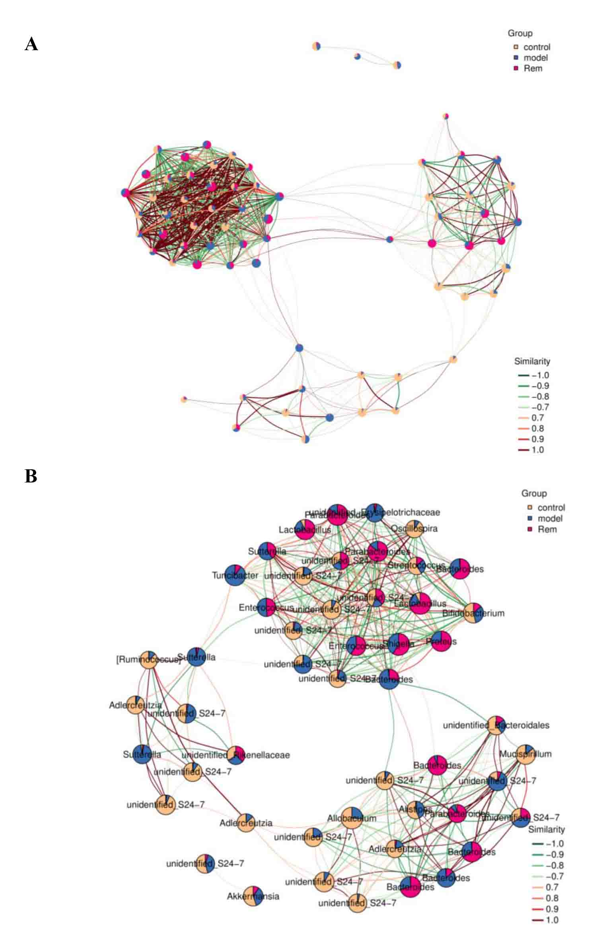
Supplementary figure 6. A. B. Association analysis between microbial members in different groups.

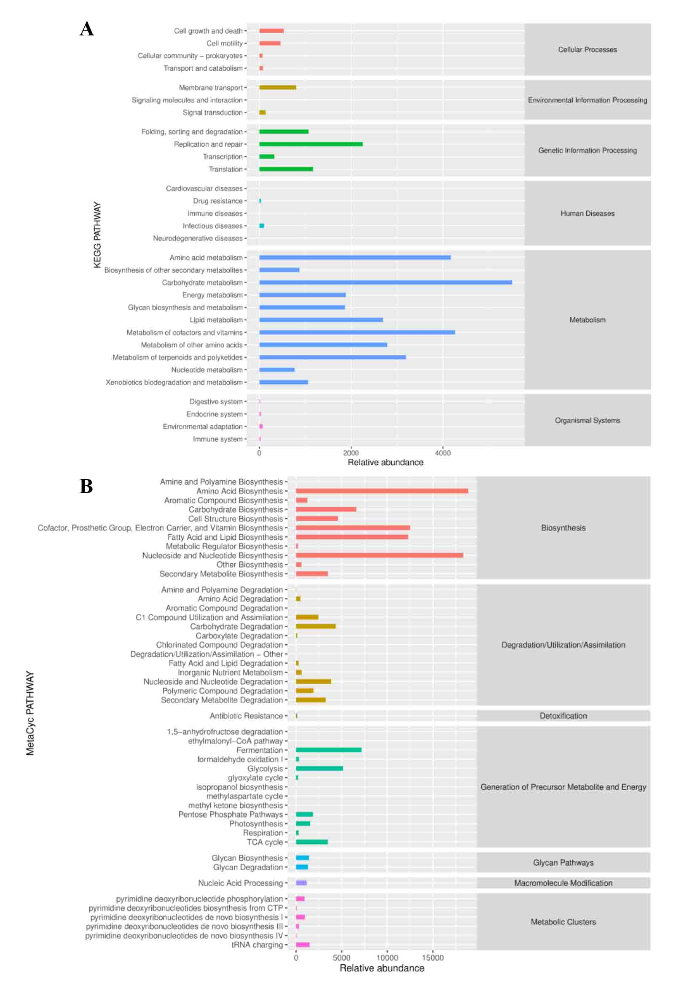
Supplementary figure 7. A. B. MetaCyc and KEGG secondary pathway enrichment for all samples
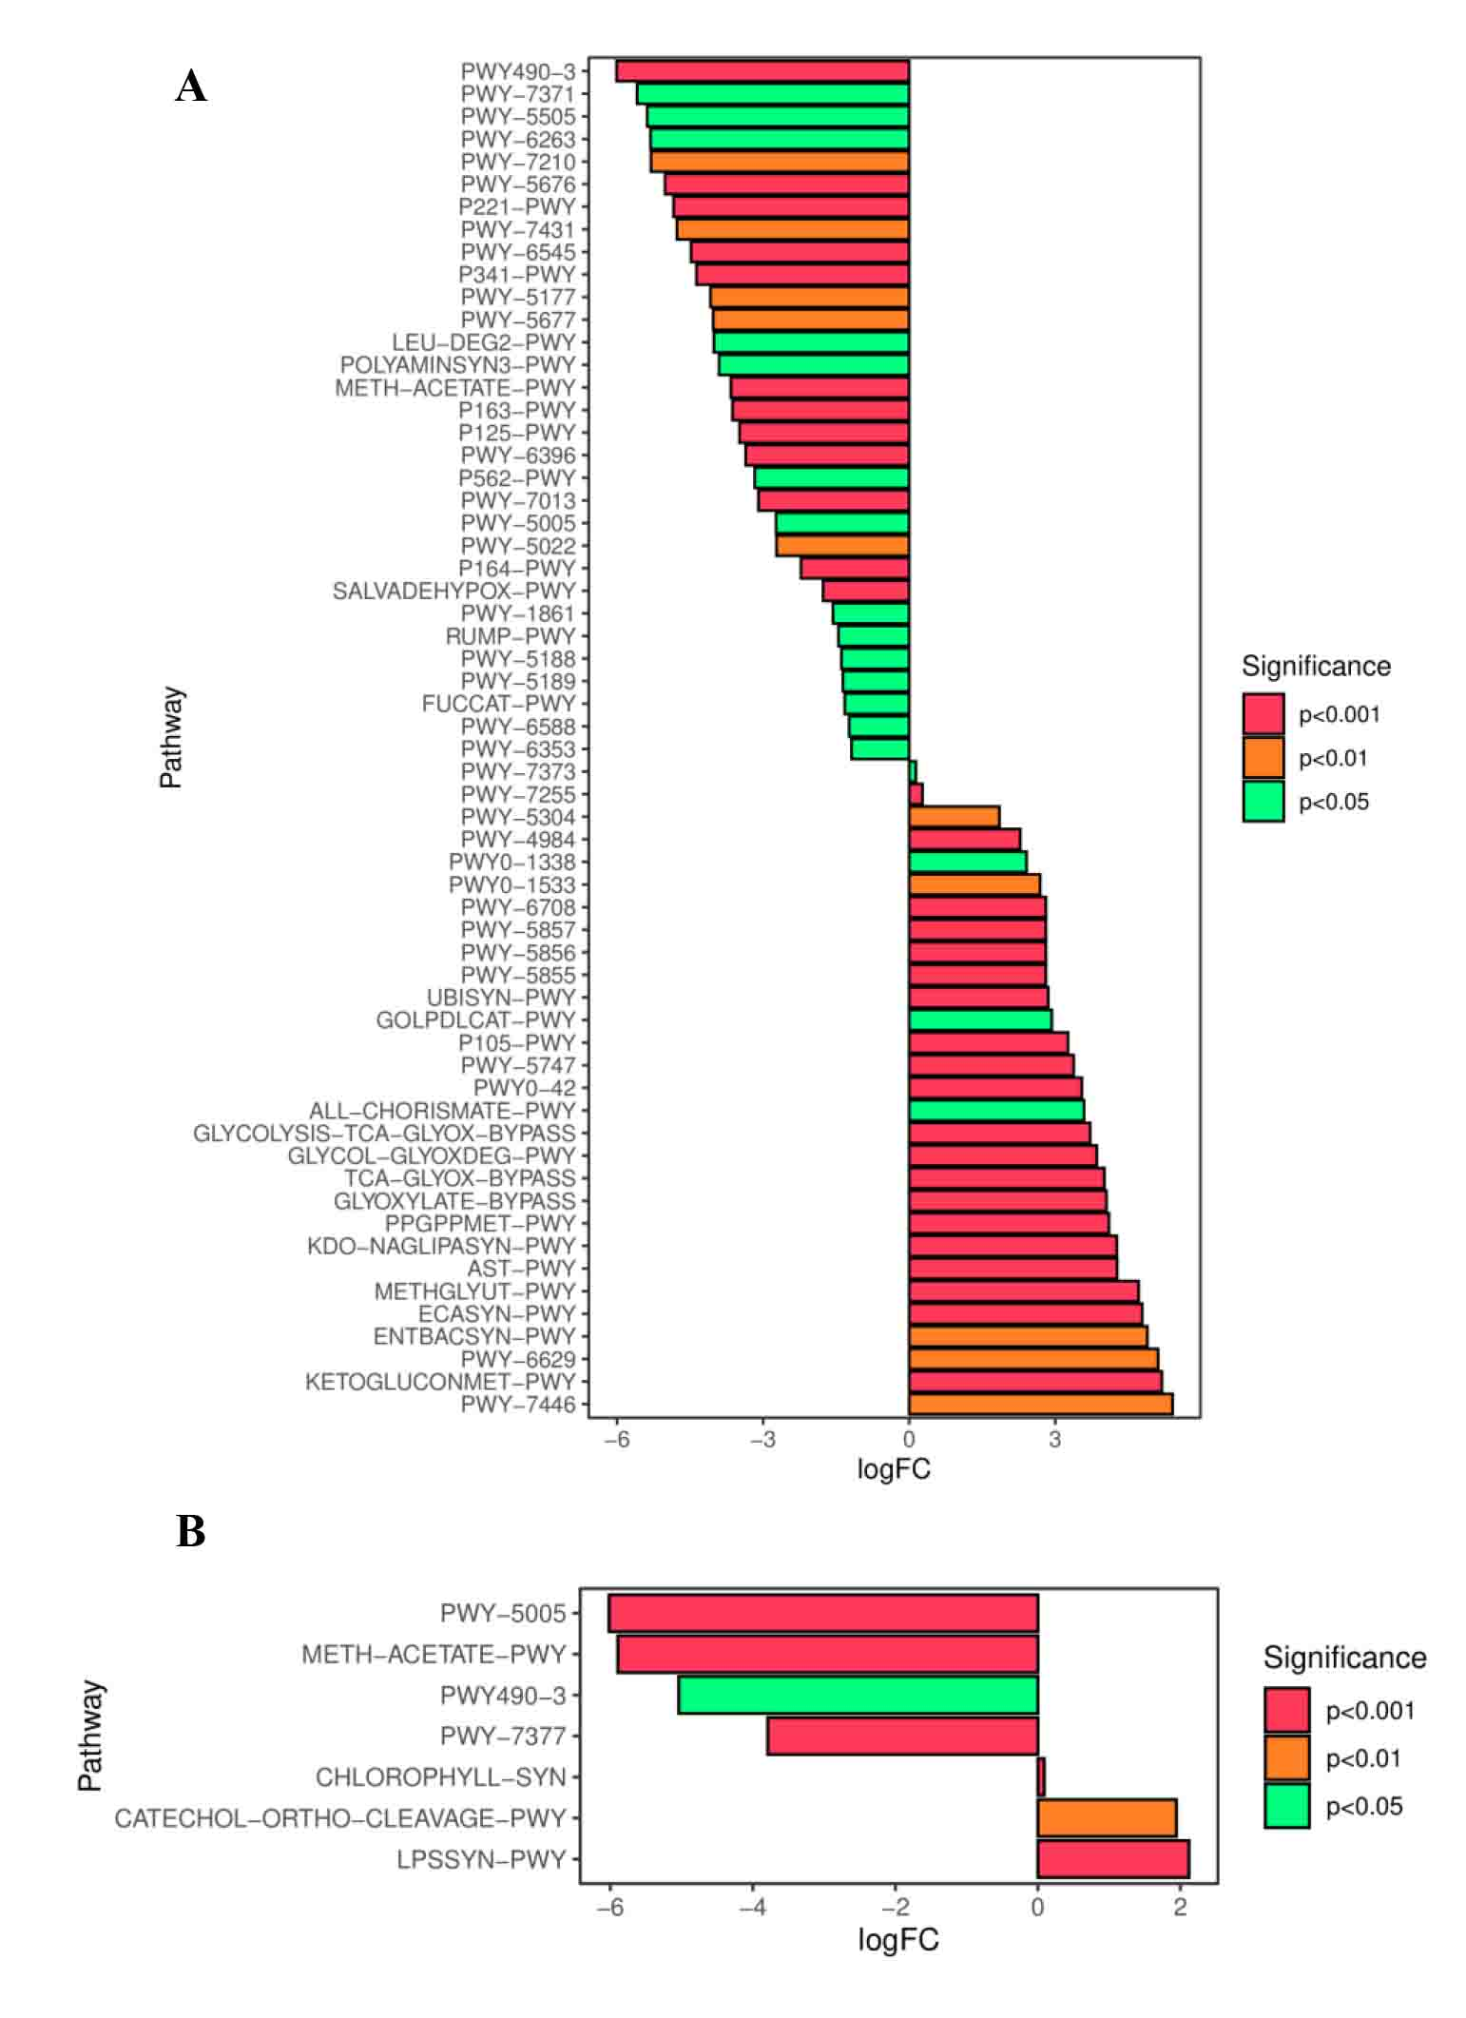
Supplementary figure 8. A. The significantly different KEGG metabolic pathways between the control group and the remdesivir group. B. The significantly different KEGG metabolic pathways between the model group and the remdesivir group.

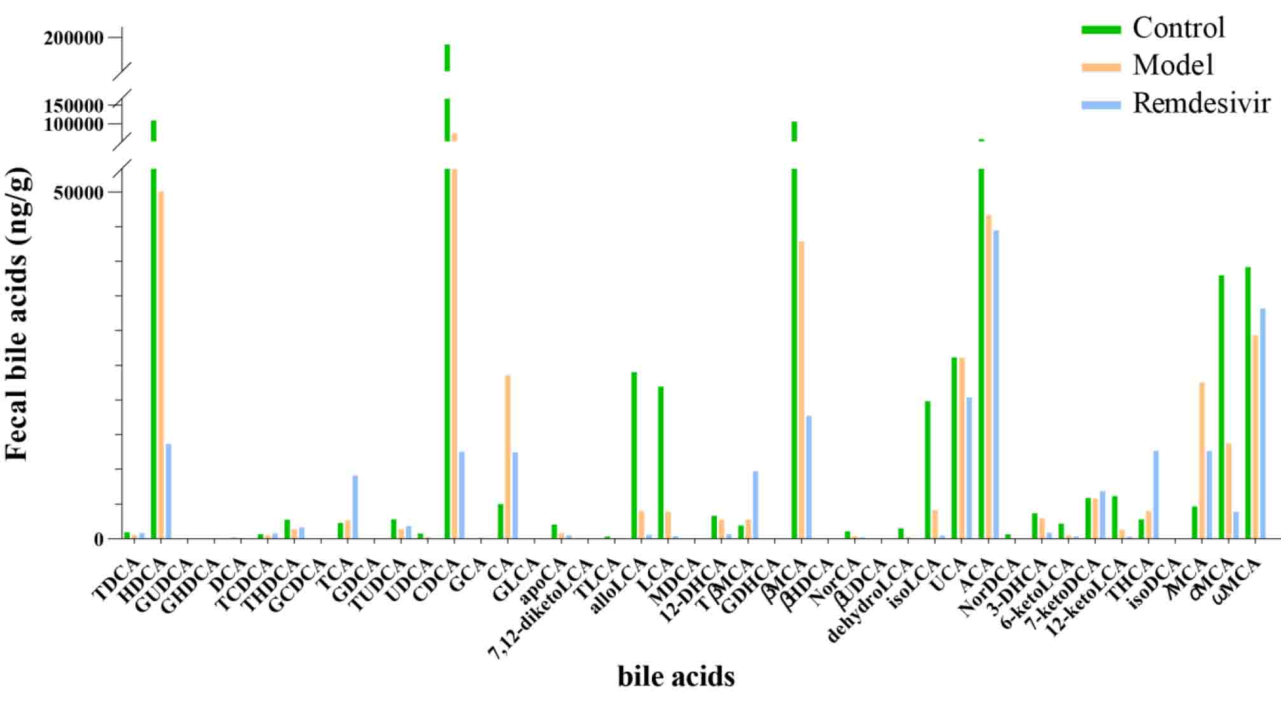
Supplementary figure 9. Quantitative analysis of 43 bile acids in fecal samples from mice in different groups.

