Supplementary Information
Comprehensive Mapping of Binding Hot Spots of SARS-CoV-2 RBD-specific Neutralizing Antibodies for Tracking Immune Escape Variants
Chunyan Yi^{1#}, Xiaoyu Sun^{1#}, Yixiao Lin^{2#}, Chenjian Gu^{3#}, Longfei Ding², Xiao Lu^{1,7}, Zhuo Yang¹, Yaguang Zhang¹, Liyan Ma¹, Wangpeng Gu¹, Aidong Qu⁴, Xu Zhou⁴, Xiuling Li⁴, Jianqing Xu², Zhiyang Ling^{1*}, Youhua Xie^{3*}, Hongzhou Lu^{2*}and Bing Sun^{1,5,6*}
¹ State Key Laboratory of Cell Biology, Shanghai Institute of Biochemistry and Cell Biology, Center for Excellence in Molecular Cell Science, Chinese Academy of Sciences, Shanghai 200031, China.
² Shanghai Public Health Clinical Center, Shanghai Medical College, Fudan University, Shanghai 201508, China.
³ Key Laboratory of Medical Molecular Virology (MOE/MOH), Department of Medical Microbiology and Parasitology, School of Basic Medical Sciences, Shanghai Institute of Infectious Diseases and Biosecurity, Shanghai Medical College, Fudan University, Shanghai 200032, China.
⁴ Shanghai Institute of Biological Products Co., Ltd, Shanghai 200052, China.
⁵School of Life Science and Technology, ShanghaiTech University, 100 Haike Road, Shanghai 201210, China.
⁶ University of Chinese Academy of Sciences, Beijing 100049, China.
# These authors contributed equally to this study.
* Corresponding author

Supplementary Tables (Supplementary Tables 1, 2 and 4 are supplied as independent spreadsheets.)
Supplementary Table 1 | In vitro binding and neutralizing activity of RBD-specific mAbs
Supplementary Table 2 | Sequence analysis of RBD-specific mAbs
Supplementary Table 4 | The information of epitope targeted by RBD-specific mAbs

Supplementary Table 3 | hmAb panel percent binding to alanine mutants.
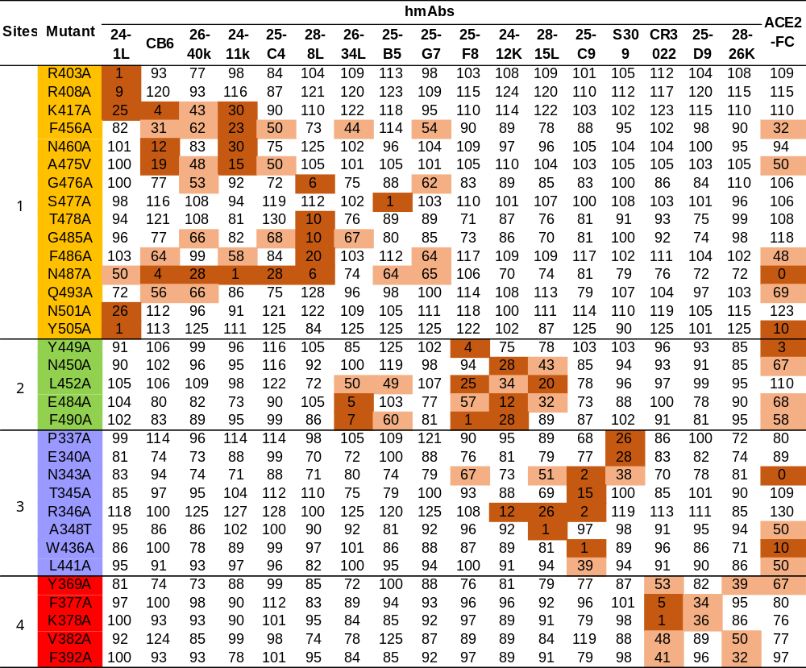

Coloring corresponds to the reactivity to each RBD mutant relative to WT with ≤ 30% dark orange, 30±70% light salmonand and ≥ 70% white.

Supplementary Table 5 | human mAb panel percent binding to natural RBD mutants.
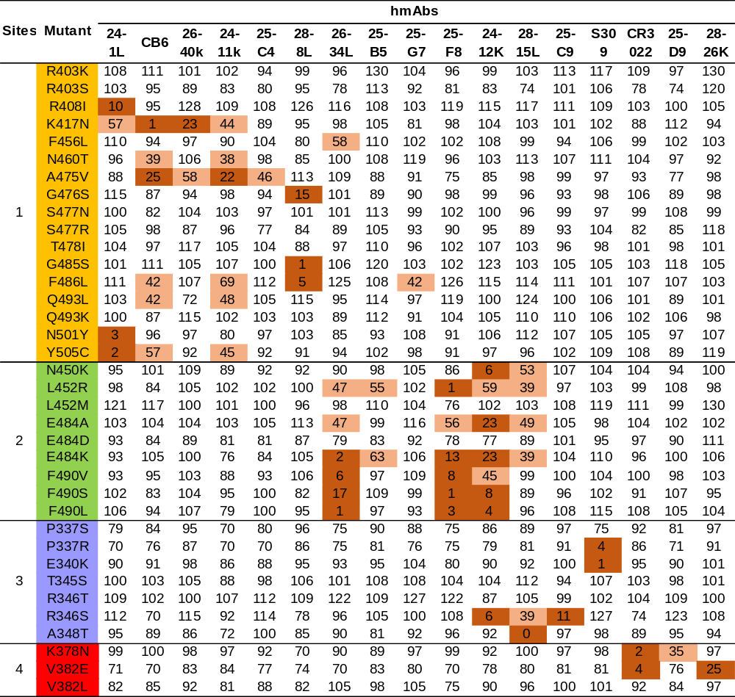

Coloring corresponds to the reactivity to each RBD mutant relative to WT with ≤ 30% dark orange, 30±70% light salmonand and ≥ 70% white.

Supplementary Fig. 1 | Binding kinetics of RBD -specific mAbs with RBD from SARS-CoV-2 and SARS-CoV were measured by the Octet Red instrument. a, Binding kinetics of purified recombinant mAbs with SARS-CoV-2 RBD. b, Binding kinetics of cross-reactivity mAbs with SARS-CoV RBD. Blue curves are the experimental trace, and red curves are the best global fits to the data used to calculate the KD. The lines represent 3.125 nM, 6.25 nM, 12.5 nM, 25 nM, 50 nM and 100 nM concentrations of RBD. The data were double reference subtracted and fit using a 1:1 binding model.

Supplementary Fig. 2 | Binding kinetics of purified recombinant RBD mutants with ACE2-FC were measured by BIAcore 8K. The lines represent 6.25 nM, 12.5 nM, 25 nM, 50 nM, 100 nM, and 200 nM nM concentrations of RBD mutants and wild type. The data were double reference subtracted and fit using a 1:1 binding model. WT, wild type RBD.

