Table legends:
Table S1 Characteristics and heavy metal content of the soil sample.

Table S1 Characteristics and heavy metal content of the soil sample.
 | Cd (mg/kg) | Ni (mg/kg) | Cr (mg/kg) | Pb (mg/kg) | Zn (mg/kg)
NBSV※ | 0.097 | 27 | 61 | 27 | 74
Soil sample | 1.36 | 95.3 | 203.1 | 109.9 | 165.3
※The national soil background [1].

Figure legends:
Fig. S1 The morphological characteristics (a) and Gram staining (b) of strains Y3, Y4 and Y5.
Fig. S2 Phylogenetic trees of Y3, Y4 and Y5 strains based on 16S rDNA sequences.
Fig. S3 The growth curves of strains Y3 (a), Y4 (b) and Y5 (c) under Ni stress (μg/mL) in 60 h.
Fig. S4 The growth curves of strains Y3 (a), Y4 (b) and Y5 (c) under Cd metal stress (μg/mL) in 60 h.
Fig. S4 The growth curves of strains Y3 (a), Y4 (b) and Y5 (c) under combined stress of Ni and Cd in 60 h.
Fig. S5 The quantitative estimation of EPS production. Values are the means ± standard errors of three replicates. Error bars depict standard errors and different letters above the bars show statistically significant different values (p < 0.05) according to ANOVA followed by the Duncan’s test.
Fig. S6 The germination rate of rice seeds under different combined concentration. Values are the means ± standard errors of three replicates. Error bars depict standard errors and different letters above the bars show statistically significant different values (p < 0.05) according to ANOVA followed by the Duncan’s test.
Fig. S7 Effect of the strains on germination rate under different conditions (Control: treated with water, N: non-inoculation). Values are the means ± standard errors of three replicates. Error bars depict standard errors and different letters above the bars show statistically significant different values (p < 0.05) according to ANOVA followed by the Duncan’s test.
Fig. S8 Effect of the strains on uptake of (a) Ni and (b) Cd by rice seedling. Values are the means ± standard errors of three replicates. Error bars depict standard errors and different letters above the bars show statistically significant different values (p < 0.05) according to ANOVA followed by the Duncan’s test.
Fig. S9 The cluster analysis of all parameters in rice plants (Control: treated with water, N: non-inoculation). Values are the means ± standard errors of three replicates. Error bars depict standard errors and different letters above the bars show statistically significant different values (p < 0.05) according to ANOVA followed by the Duncan’s test.

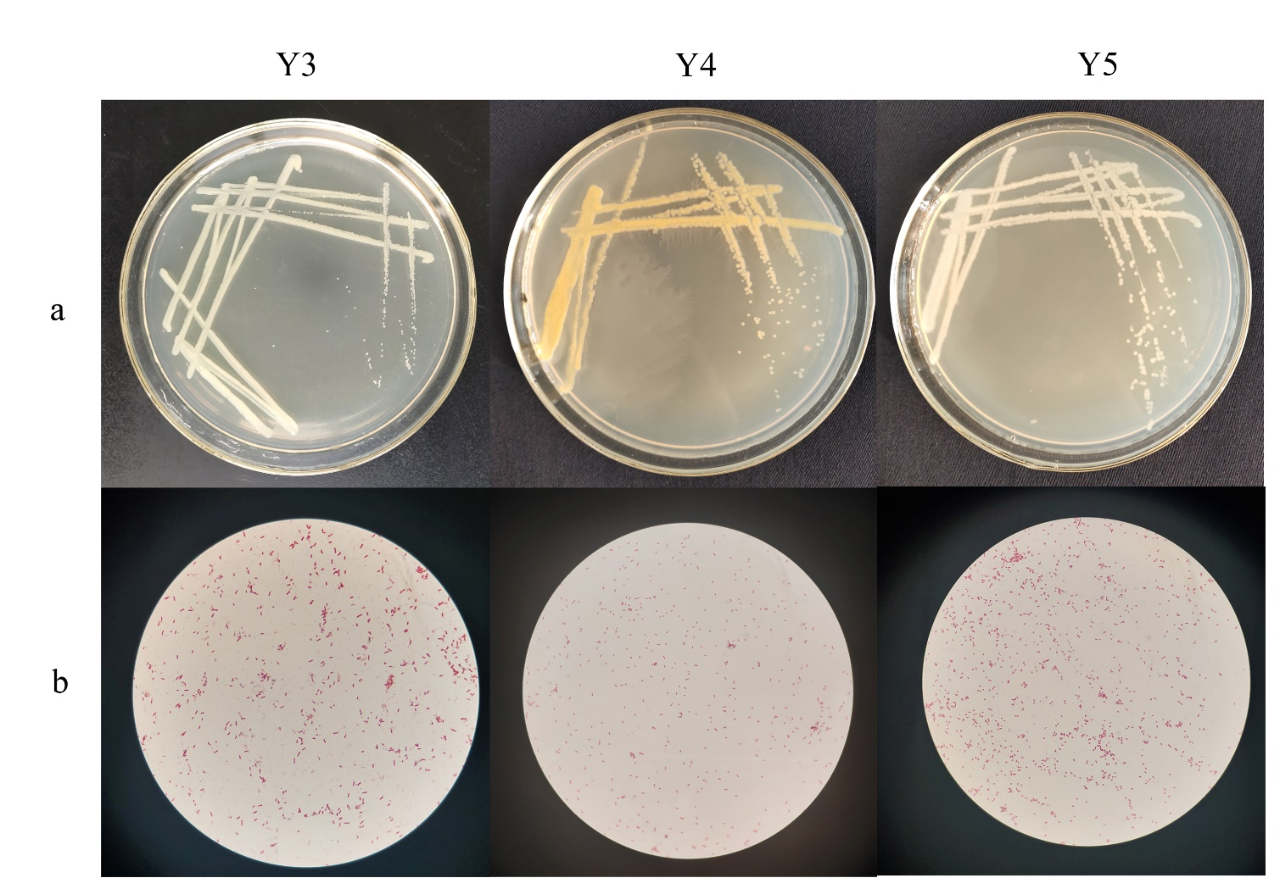
Fig. S1

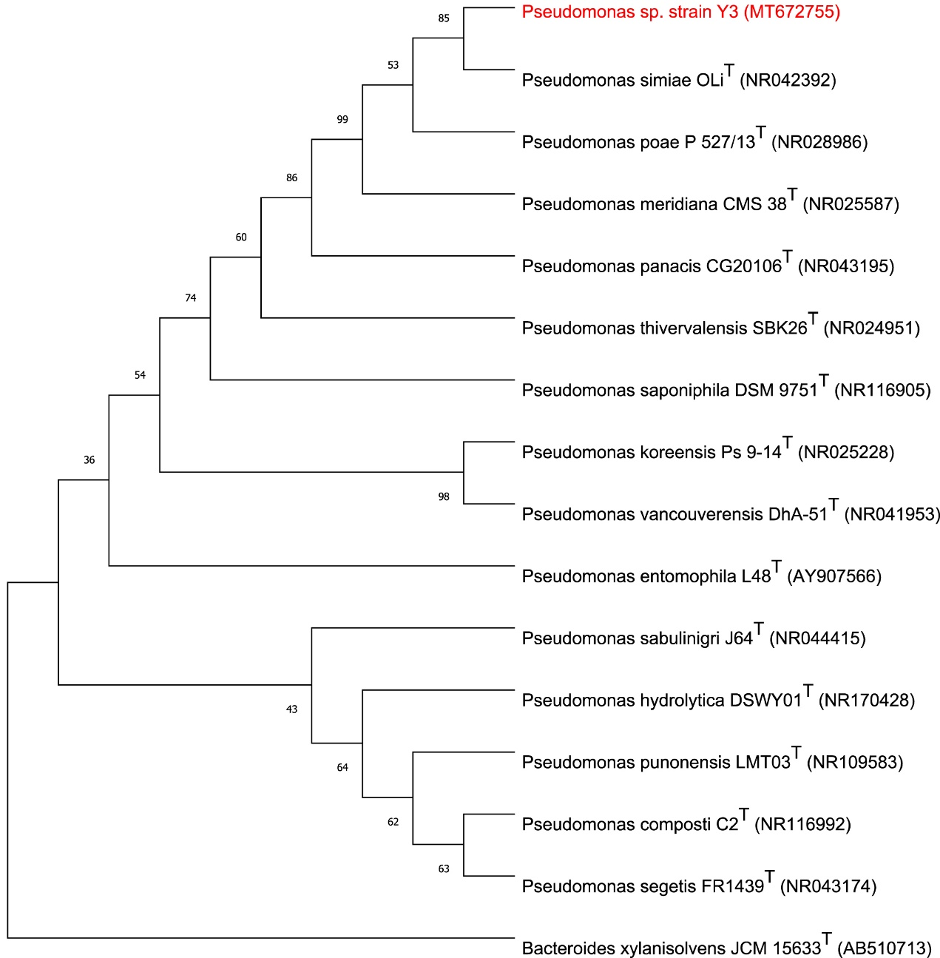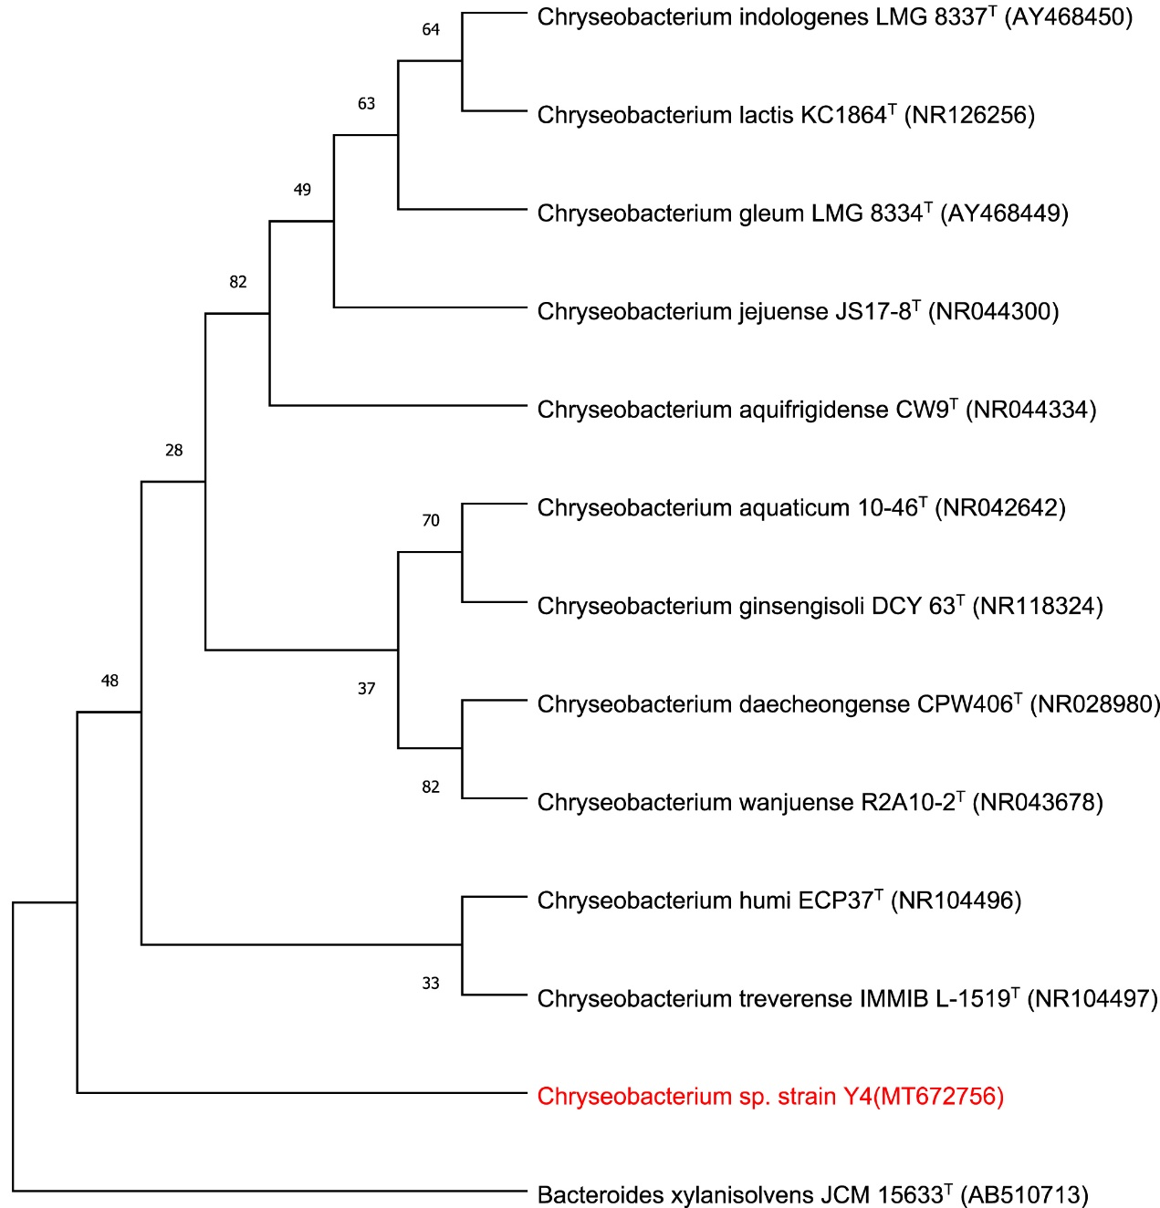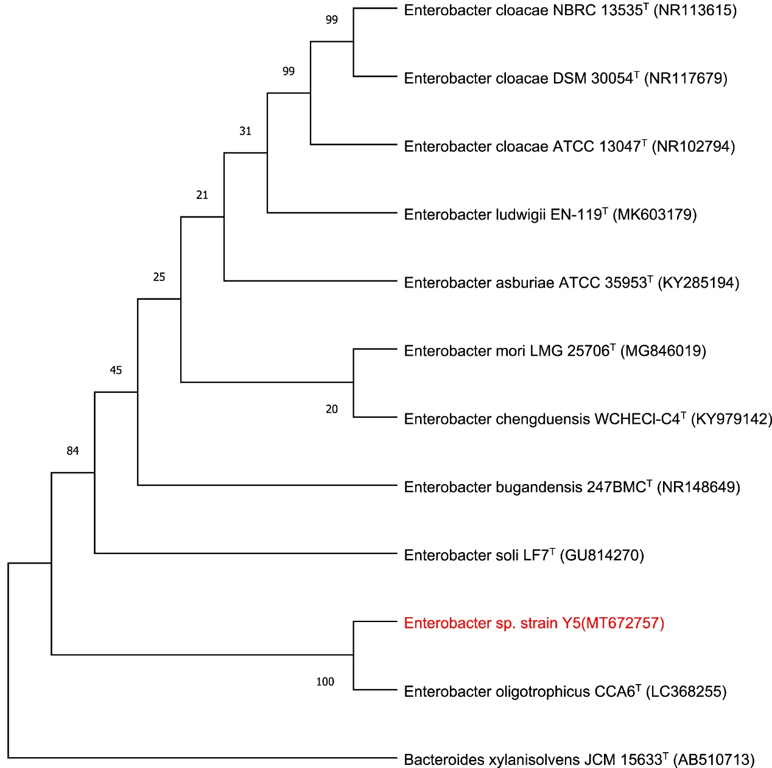
Fig. S2

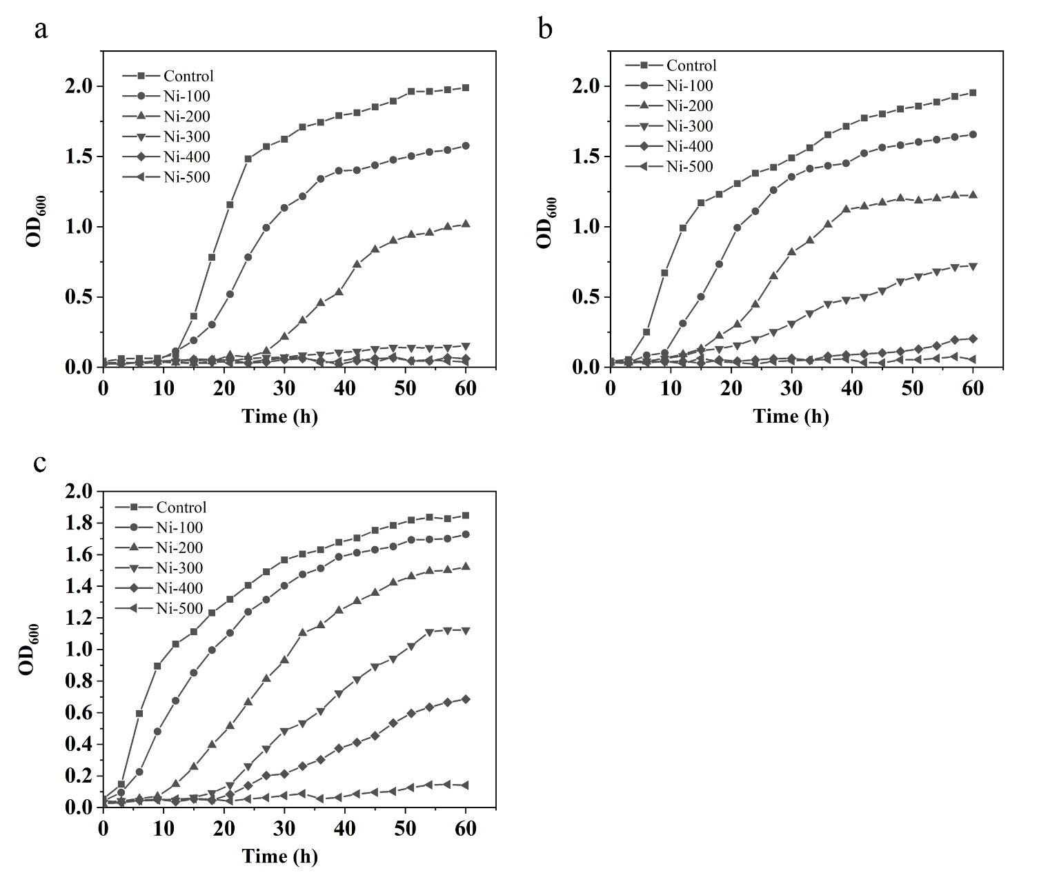
Fig. S3

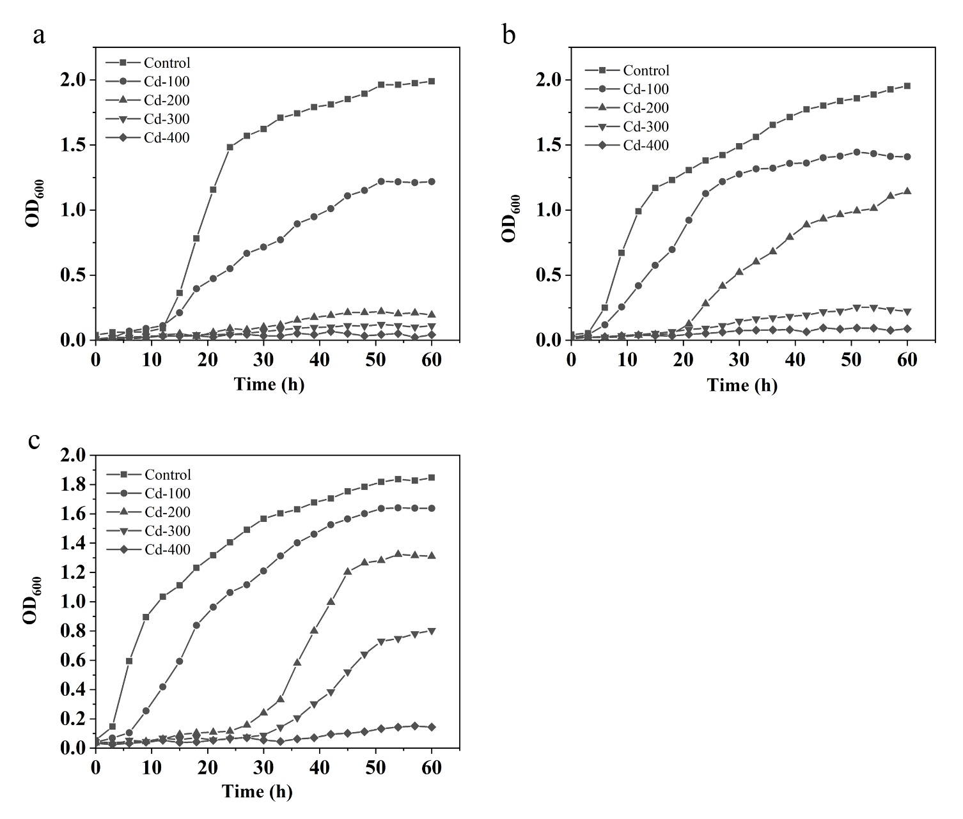
Fig. S4

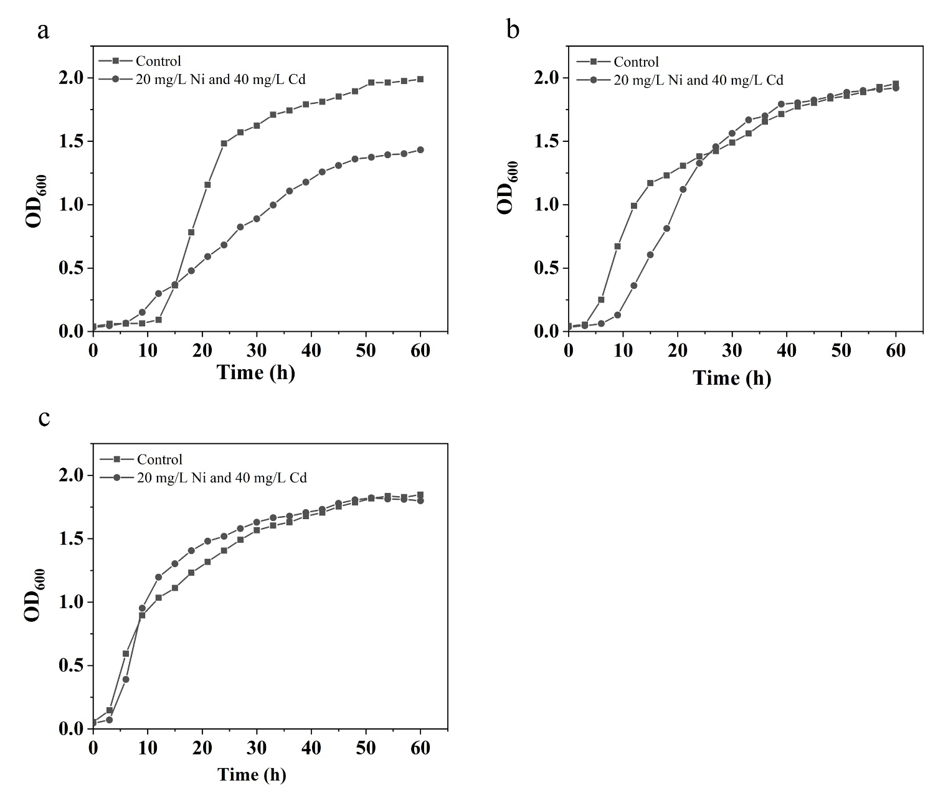
Fig. S5

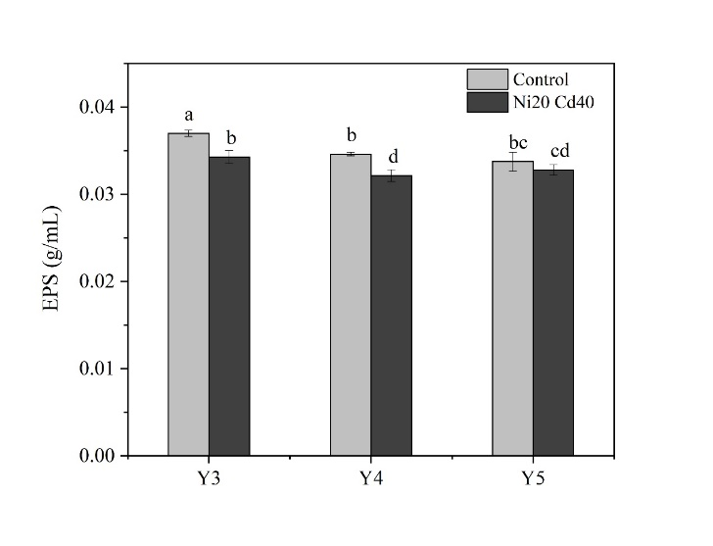
Fig. S6

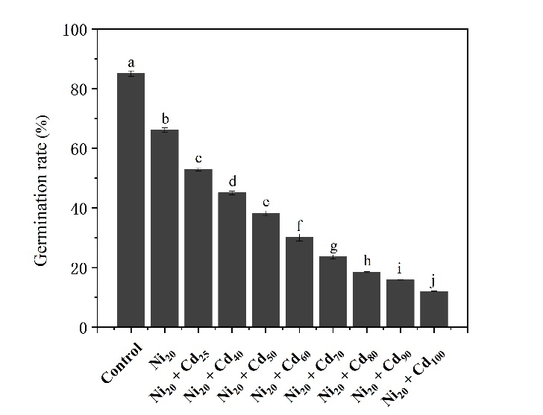
Fig. S7

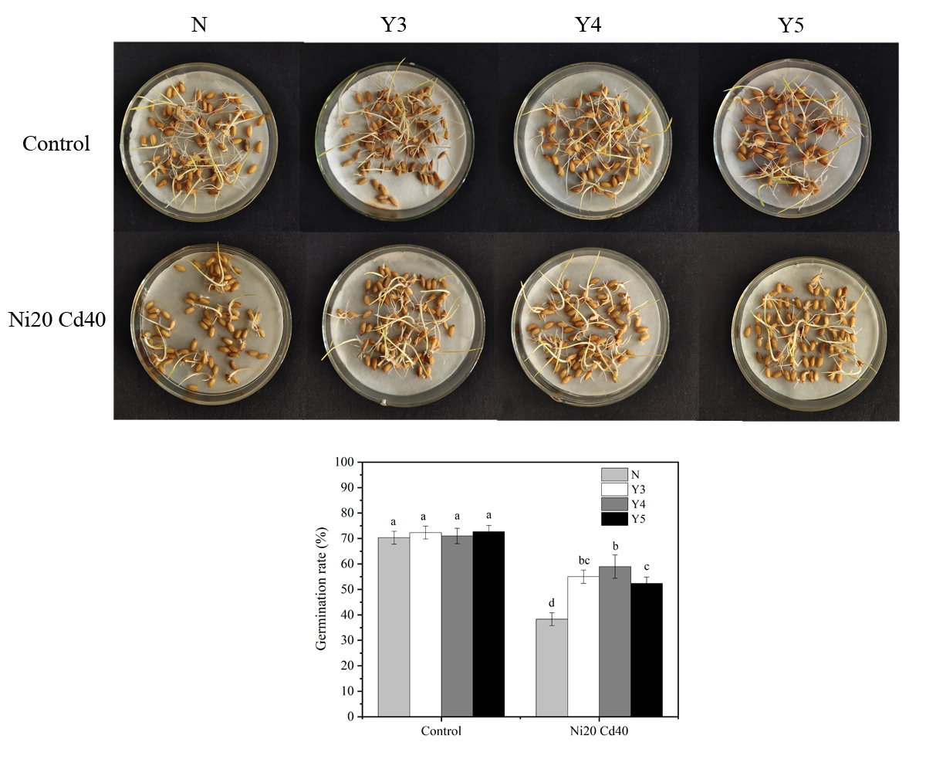
Fig. S8

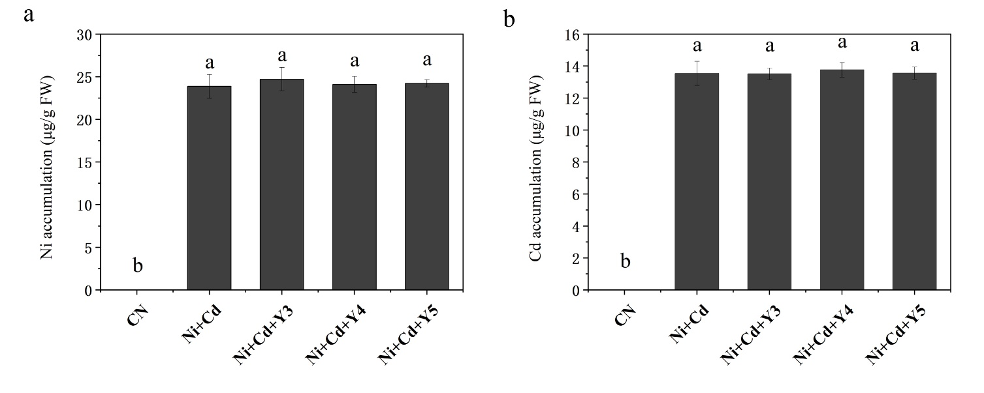
Fig. S9

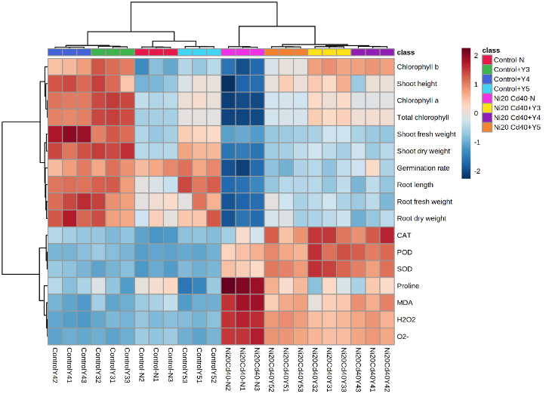
Fig. S10

References
1. Chen J, Wei F, Zheng C, Wu Y, Adriano DC (1991) Background concentrations of elements in soils of China. Water, Air, and Soil Pollution 57 (1):699-712. doi:10.1007/BF00282934

