Additional file 1
Table S1. The results of RNA quality inspection
Sample ID | Concentration (ng/μl) | Vol. (μl) | Total weight | OD260/280 | RIN value
J9_S1_1 | 554 | 32 | 17.728 | 2.083 | 10
J9_S1_2 | 264 | 32 | 8.448 | 2.063 | 7.5
J9_S1_3 | 634 | 32 | 20.288 | 2.099 | 9.5
J9_S2_1 | 1014 | 32 | 32.448 | 2.069 | 10
J9_S2_2 | 618 | 32 | 19.776 | 2.06 | 9.6
J9_S2_3 | 564 | 32 | 18.048 | 2.089 | 9.5
J9_S3_1 | 258 | 32 | 8.256 | 2.026 | 10
J9_S3_2 | 584 | 32 | 18.688 | 2.071 | 9.7
J9_S3_3 | 156 | 32 | 4.992 | 2.067 | 9.7
J9_S4_1 | 282 | 32 | 9.024 | 2.062 | 9.9
J9_S4_2 | 568 | 32 | 18.176 | 2.073 | 9.6
J9_S4_3 | 590 | 32 | 18.88 | 2.034 | 9.8
J9_S5_1 | 638 | 32 | 20.416 | 2.085 | 9.7
J9_S5_2 | 534 | 32 | 17.088 | 2.054 | 9.2
J9_S5_3 | 514 | 32 | 16.448 | 2.056 | 9.4
J9_S6_1 | 522 | 32 | 16.704 | 2.055 | 9.4
J9_S6_2 | 730 | 32 | 23.36 | 2.074 | 9.8
J9_S6_3 | 606 | 32 | 19.392 | 2.075 | 9.6
P50_S1_1 | 450 | 32 | 14.4 | 2.045 | 9.6
P50_S1_2 | 532 | 32 | 17.024 | 2.078 | 9.8
P50_S1_3 | 458 | 32 | 14.656 | 2.045 | 9.8
P50_S2_1 | 360 | 32 | 11.52 | 2.045 | 8.8
P50_S2_2 | 964 | 32 | 30.848 | 2.06 | 10
P50_S2_3 | 430 | 32 | 13.76 | 2.048 | 9.7
P50_S3_1 | 448 | 32 | 14.336 | 2.018 | 9.4
P50_S3_2 | 1386 | 32 | 44.352 | 2.069 | 10
P50_S3_3 | 742 | 32 | 23.744 | 2.084 | 10
P50_S4_1 | 532 | 32 | 17.024 | 2.046 | 9.4
P50_S4_2 | 1256 | 32 | 40.192 | 2.066 | 10
P50_S4_3 | 394 | 32 | 12.608 | 2.118 | 9.6
P50_S5_1 | 678 | 32 | 21.696 | 2.055 | 9.8
P50_S5_2 | 1330 | 32 | 42.56 | 2.091 | 10
P50_S5_3 | 794 | 32 | 25.408 | 2.057 | 10
P50_S6_1 | 654 | 32 | 20.928 | 2.07 | 9.7
P50_S6_2 | 752 | 32 | 24.064 | 2.066 | 10
P50_S6_3 | 516 | 32 | 16.512 | 2.064 | 10
J9_CK_1 | 256 | 32 | 8.192 | 2.098 | 10
J9_CK_2 | 204 | 32 | 6.528 | 2.04 | 10
J9_CK_3 | 138 | 32 | 4.416 | 2.219 | 7.7
J9_A1_1 | 572 | 32 | 18.304 | 2.058 | 10
J9_A1_2 | 470 | 32 | 15.04 | 2.08 | 10
J9_A1_3 | 270 | 32 | 8.64 | 2 | 10
J9_A2_1 | 786 | 32 | 25.152 | 2.102 | 10
J9_A2_2 | 805 | 32 | 25.76 | 2.086 | 10
J9_A2_3 | 196 | 32 | 6.272 | 2.042 | 7.7
J9_A3_1 | 210 | 32 | 6.72 | 2.037 | 10
J9_A3_2 | 414 | 32 | 13.248 | 2.125 | 9.8
J9_A3_3 | 480 | 32 | 15.36 | 2.118 | 10
J9_A4_1 | 136 | 32 | 4.352 | 1.857 | 10
J9_A4_2 | 68 | 32 | 2.176 | 2.125 | 9.4
J9_A4_3 | 56 | 32 | 1.792 | 2 | 9.5
P50_CK_1 | 128 | 32 | 4.096 | 2.161 | 8
P50_CK_2 | 304 | 32 | 9.728 | 2.054 | 10
P50_CK_3 | 196 | 32 | 6.272 | 2.13 | 9.1
P50_A1_2 | 640 | 32 | 20.48 | 2.08 | 10
P50_A1_3 | 500 | 32 | 16 | 2.066 | 10
P50_A2_1 | 342 | 32 | 10.944 | 1.988 | 10
P50_A2_2 | 575 | 32 | 18.4 | 2.026 | 10
P50_A2_3 | 710 | 32 | 22.72 | 2.076 | 10
P50_A3_1 | 485 | 32 | 15.52 | 2.04 | 10
P50_A3_2 | 492 | 32 | 15.744 | 2.05 | 9.8
P50_A3_3 | 338 | 32 | 10.816 | 1.988 | 9.9
P50_A4_1 | 48 | 32 | 1.536 | 2.182 | 9.4
P50_A4_2 | 52 | 32 | 1.664 | 2.167 | 8.8
P50_A4_3 | 60 | 32 | 1.92 | 1.7 | 9

Additional file 2
Table S2. Illumina sequencing data quality of S-test
Sample ID | bases | error rate | Q20 | Q30 | GC pct
J9_S1_1 | 6.77G | 0.03 | 96.43 | 94.83 | 45.92
J9_S1_2 | 7.63G | 0.03 | 95.89 | 94.14 | 45.33
J9_S1_3 | 6.93G | 0.03 | 96.08 | 90.38 | 45.71
J9_S2_1 | 7.47G | 0.03 | 96.55 | 95 | 46.85
J9_S2_2 | 6.12G | 0.04 | 94.32 | 89.14 | 46.56
J9_S2_3 | 8.88G | 0.03 | 96.19 | 90.65 | 46.27
J9_S3_1 | 7.72G | 0.03 | 95.48 | 90.35 | 46.11
J9_S3_2 | 6.93G | 0.03 | 96.15 | 94.46 | 46.26
J9_S3_3 | 6.39G | 0.03 | 96.16 | 90.58 | 45.53
J9_S4_1 | 6.45G | 0.03 | 96.57 | 95.01 | 45.84
J9_S4_2 | 6.72G | 0.03 | 96.42 | 94.83 | 46.47
J9_S4_3 | 7.28G | 0.03 | 95.26 | 90.18 | 46.26
J9_S5_1 | 6.87G | 0.03 | 96.3 | 94.66 | 46.43
J9_S5_2 | 7.0G | 0.03 | 94.73 | 89.68 | 46.1
J9_S5_3 | 6.43G | 0.03 | 95.09 | 90.18 | 45.85
J9_S6_1 | 7.28G | 0.03 | 96.32 | 94.69 | 46.97
J9_S6_2 | 6.78G | 0.03 | 96.47 | 91.16 | 46.13
J9_S6_3 | 6.43G | 0.03 | 94.97 | 90.01 | 47.06
P50_S1_1 | 6.75G | 0.03 | 95.44 | 90.51 | 45.98
P50_S1_2 | 8.42G | 0.03 | 96.49 | 94.92 | 46.24
P50_S1_3 | 8.02G | 0.03 | 96.4 | 94.8 | 45.7
P50_S2_1 | 6.87G | 0.03 | 95.56 | 90.61 | 46.33
P50_S2_2 | 9.06G | 0.03 | 96.44 | 94.86 | 47.24
P50_S2_3 | 7.77G | 0.03 | 96.54 | 94.99 | 46.91
P50_S3_1 | 8.75G | 0.03 | 96.34 | 94.71 | 47.42
P50_S3_2 | 7.48G | 0.03 | 96.5 | 94.95 | 47.72
P50_S3_3 | 7.7G | 0.03 | 96.05 | 94.32 | 47.13
P50_S4_1 | 8.98G | 0.03 | 96.49 | 94.92 | 46.8
P50_S4_2 | 6.97G | 0.03 | 96.14 | 90.59 | 47.06
P50_S4_3 | 9.01G | 0.03 | 96.37 | 94.76 | 45.7
P50_S5_1 | 7.78G | 0.03 | 96.57 | 95.02 | 47.28
P50_S5_2 | 8.09G | 0.03 | 96.5 | 94.93 | 46.8
P50_S5_3 | 7.37G | 0.03 | 95.53 | 90.48 | 47.23
P50_S6_1 | 6.69G | 0.03 | 96.53 | 94.97 | 47.16
P50_S6_2 | 7.21G | 0.03 | 96.55 | 94.99 | 46.76
P50_S6_3 | 6.79G | 0.03 | 95.31 | 90.15 | 47.1

Additional file 3
Table S3. Illumina sequencing data quality of A-test
Sample ID | clean bases | error rate（%） | Q20（%） | Q30（%） | GC pct
J9_CK_1 | 7.3G | 0.03 | 94.91 | 89.55 | 43.97
J9_CK_2 | 8.63G | 0.03 | 96.83 | 91.71 | 44.06
J9_CK_3 | 6.96G | 0.03 | 94.55 | 89.44 | 44.06
J9_A1_1 | 8.36G | 0.03 | 95.4 | 90.05 | 46.24
J9_A1_2 | 6.07G | 0.03 | 94.96 | 90.01 | 45.65
J9_A1_3 | 7.28G | 0.03 | 95.15 | 89.93 | 45.12
J9_A2_1 | 7.97G | 0.03 | 94.78 | 89.76 | 46.4
J9_A2_2 | 7.51G | 0.03 | 95.98 | 90.24 | 45.89
J9_A2_3 | 6.81G | 0.04 | 93.9 | 88.58 | 45.92
J9_A3_1 | 7.43G | 0.03 | 94.71 | 89.67 | 46.18
J9_A3_2 | 6.67G | 0.03 | 94.86 | 89.87 | 46.36
J9_A3_3 | 8.83G | 0.03 | 95.95 | 90.18 | 46.48
J9_A4_1 | 7.03G | 0.03 | 95.69 | 89.63 | 44.98
J9_A4_2 | 8.21G | 0.03 | 96.2 | 94.56 | 46.07
J9_A4_3 | 6.54G | 0.03 | 96.16 | 94.49 | 46.25
P50_CK_1 | 7.07G | 0.03 | 94.96 | 89.64 | 43.83
P50_CK_2 | 5.9G | 0.03 | 94.71 | 89.64 | 43.95
P50_CK_3 | 7.03G | 0.03 | 96.55 | 95.01 | 44.09
P50_A1_1 | 8.48G | 0.03 | 95.6 | 90.37 | 45.59
P50_A1_2 | 6.58G | 0.03 | 94.84 | 89.84 | 45.86
P50_A1_3 | 7.44G | 0.03 | 96.53 | 94.96 | 45.19
P50_A2_1 | 7.7G | 0.03 | 96.24 | 90.75 | 46.97
P50_A2_2 | 6.99G | 0.03 | 95.26 | 90.22 | 47.4
P50_A2_3 | 6.42G | 0.03 | 96.24 | 90.77 | 47.03
P50_A3_1 | 6.87G | 0.03 | 95.58 | 90.82 | 47.29
P50_A3_2 | 7.89G | 0.03 | 96.47 | 94.89 | 47.81
P50_A3_3 | 8.13G | 0.03 | 96.62 | 95.09 | 47.26
P50_A4_1 | 7.08G | 0.03 | 96.21 | 94.55 | 47.84
P50_A4_2 | 8.18G | 0.03 | 96.16 | 94.51 | 46.97
P50_A4_3 | 8.51G | 0.03 | 96.47 | 94.89 | 47.58

Additional file 4
Figure S1. Result of the sample repeatability test

Additional file 5
Figure S2. The stacked histogram of gene expressionin of the different sunflowers varieties. a Seeds in the sowing period; b Oil accumulation in the developing seed

Additional file 6
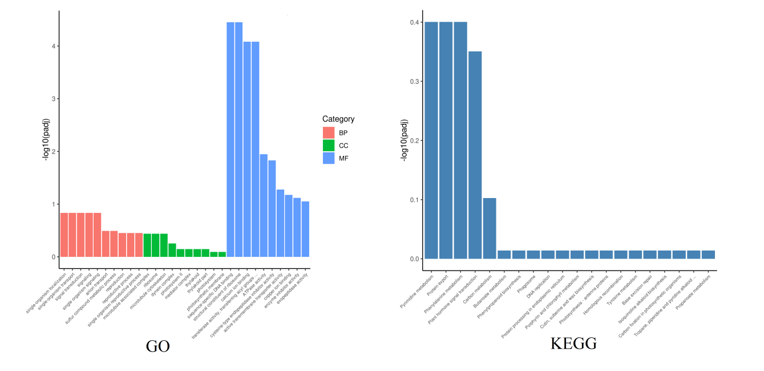
Figure S3. a The results of All-Unigene GO Classification; b The results of All-Unigene KEGG Classification

Additional file 7
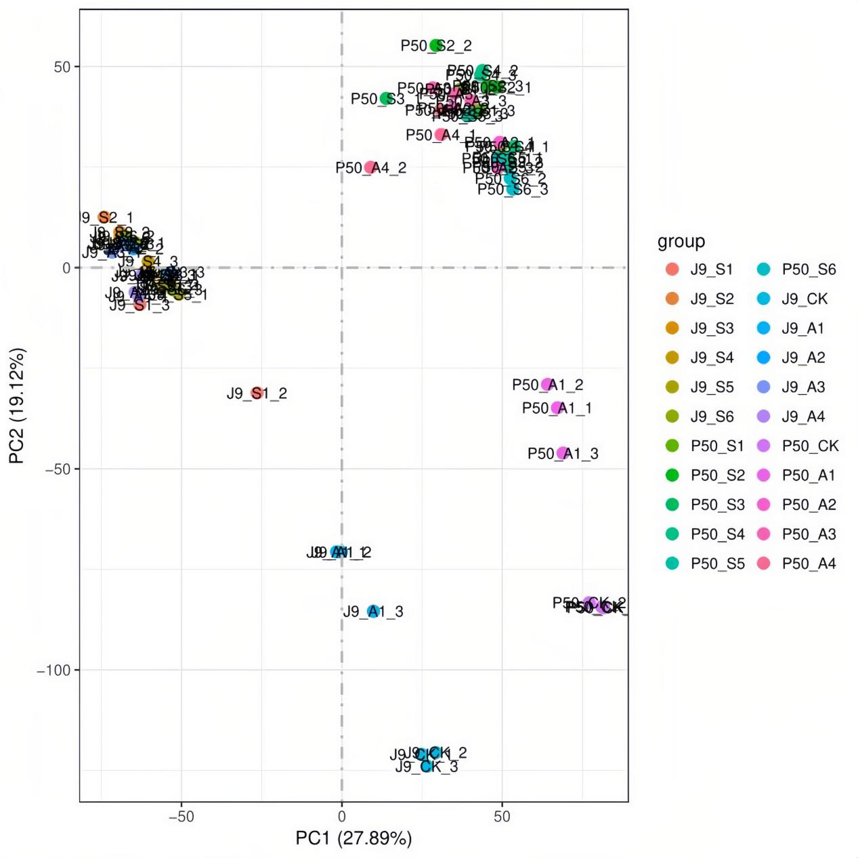
Figure S4. Principal component analysis of samples

Additional file 8
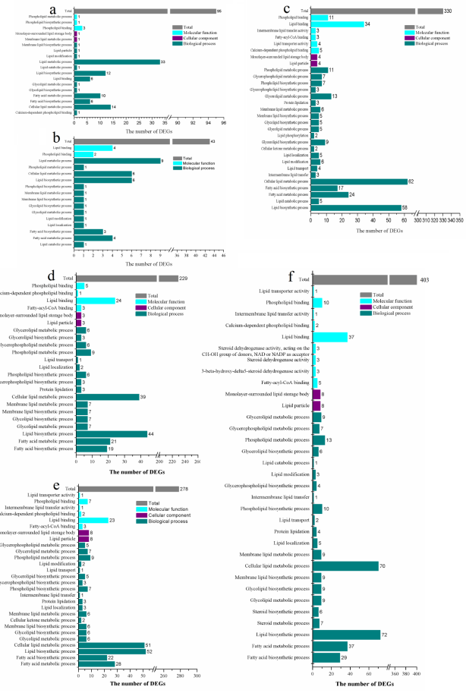
Figure S5. Mapping results of specifically expressed DEGs under the GO terms, a. J9 GO terms in S-test, b. P50 GO terms in S-test, c. J9 GO terms in A-test, d. P50 GO terms in A-test, e. J9 and I P50 co express GO terms in A-test, f. J9 and P50 specifically express GO terms among varieties

Additional file 9
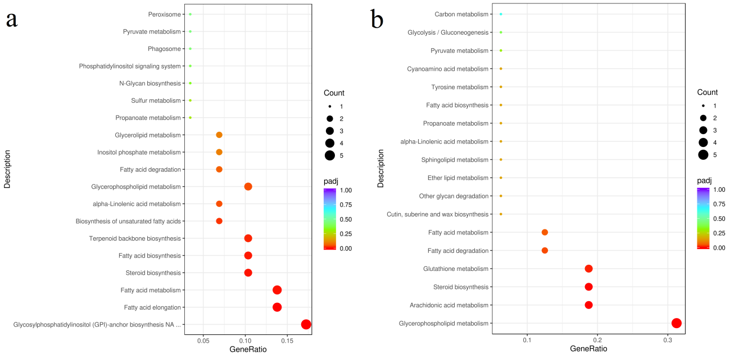
Figure S6. Functional distribution of DEGs annotated by KEGG

