Supplementary Materials for
Skyrmion nanodomains in ferroelectric-antiferroelectric solid solutions
Weijie Zheng, Xingyue Ma, Zhentao Pang, Yifeng Ren, Hongying Chen, Jibo Xu, Chunyan Zheng, Jianyi Liu, Xiaohui Liu, Yu Deng, Yuefeng Nie, Di Wu, Laurent Bellaiche, Yurong Yang, and Zheng Wen

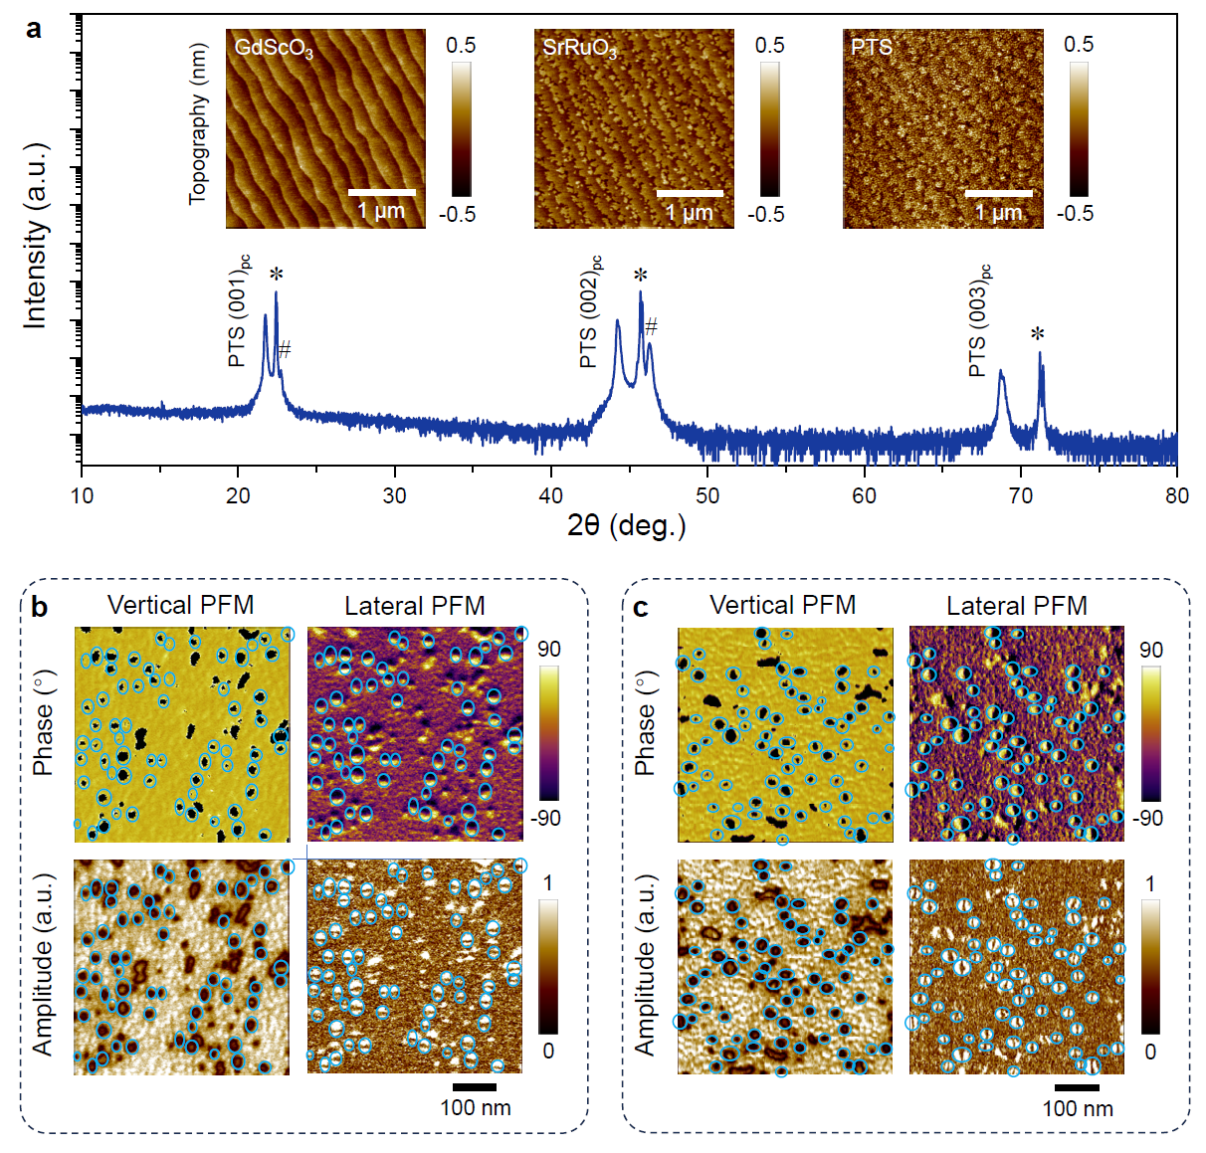
Figure S1. Skyrmion nanodomains in PTS thin films. (a) XRD pattern of the PTS/SrRuO₃/GdScO₃ thin-film heterostructure, where the * and # symbols denote the Bragg reflections of the (001)_{pc}-oriented GdScO₃ substrate and the SrRuO₃ bottom electrode, respectively. The insets show AFM surface topographies of the GdScO₃ substrate, the SrRuO₃ bottom electrode, and the PTS thin film, respectively. Vector PFM images of the PTS/SrRuO₃/GdScO₃ for (b) α = 0° and (c) α = 90°.
We also grew thin-film form of the PTS solid solution by pulsed laser deposition. As shown in the XRD pattern in Figure S1a, the 80 nm-thick PTS thin film is epitaxial on the (001)_{pc}-oriented GdScO₃ substrate buffering with SrRuO₃ bottom electrode. The insets in Figure S1a show the AFM surface topographies. Both the SrRuO₃ and PTS layers have atomically-smooth step-like surfaces mimicking the GdScO₃ substrate, suggesting high-quality layer-by-layer growth. The domain configurations are measured by vector PFM, as shown in Figure S1b and c. One can find in the VPFM and LPFM images that the centre-convergent skyrmionic textures with the core polarization downwards are formed in the upward-polarized matrix. The domain walls of the skyrmion nanodomains are always following the cantilever. For α = 0°, the domain walls are horizontal (Figure S1b) while the walls are changed to vertical when the sample is rotated by 90° (Figure S1c).

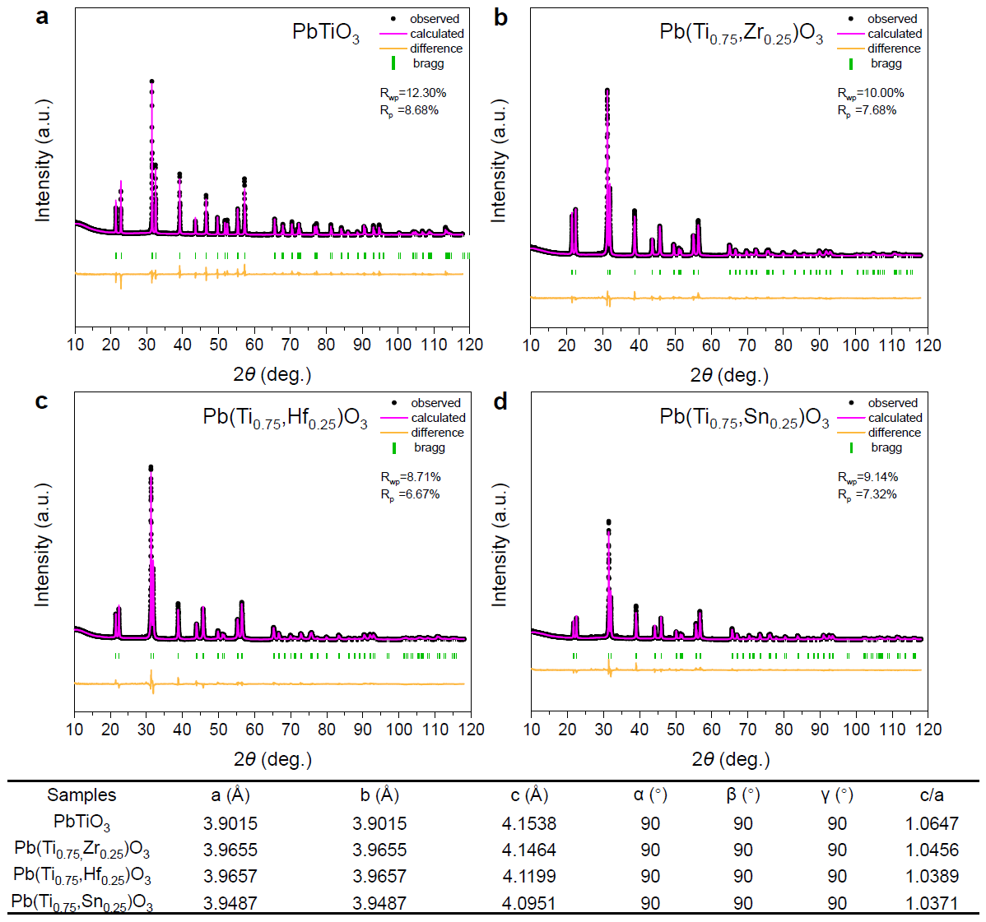
Figure S2. XRD characterizations of the FE-AFE solid solutions. (a) PbTiO₃, (b) Pb(Ti_{0.75}Zr_{0.25})O₃ (PTZ_{x=0.25}), (c) Pb(Ti_{0.75}Hf_{0.25})O₃ (PTH_{x=0.25}), and (d) Pb(Ti_{0.75}Sn_{0.25})O₃ (PTS_{x=0.25}). The XRD θ-2θ patterns are analyzed by the Rietveld refinement and the extracted lattice parameters are listed in the table.
Figure S2 shows XRD characterizations of PbTiO₃, PTZ_{x=0.25}, PTH_{x=0.25}, and PTS_{x=0.25} solid-solution ceramics. After analysis by the Rietveld refinement technique using a tetragonal structure, the lattice parameters of the solid solutions can be extracted from the θ-2θ scans, as listed in the table in Figure S2. One can find that the tetragonality (c/a) of the PbTiO₃ is reduced by the substitution of the orthorhombic antiferroelectric components. At the same antiferroelectric concentration of x = 0.25, the PbSnO₃ substitution exhibits the strongest effect on the lattice distortion for lowering the tetragonality.
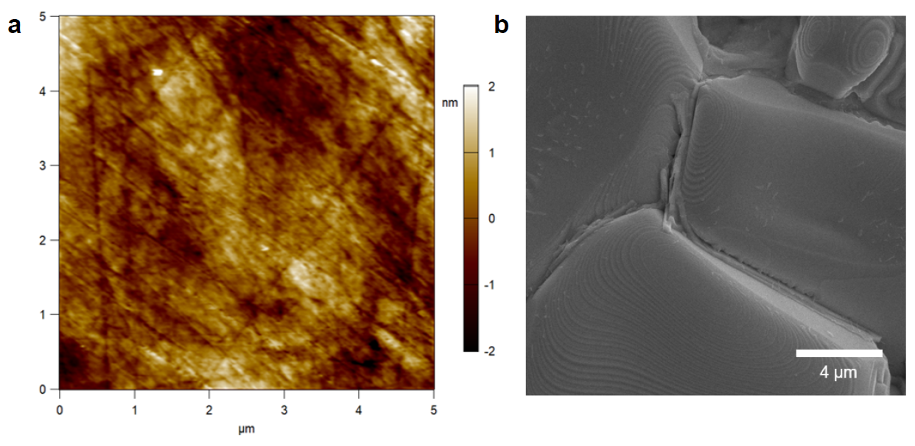
Figure S3. (a) AFM surface topography of the polished PTS_{x=0.25} ceramic. (b) SEM topography of the ceramic to show the grain size.
Figure S3a shows an AFM surface topography of the polished PTS_{x=0.25} ceramic. The root-mean-square roughness calculated over the area of 5.0 × 5.0 μm² is only ~0.6 nm, which is good for eliminating the influence of surface topography on the piezoresponse signals in the PFM measurements. As shown in Figure S3b, the grain size of the PTS_{x=0.25} ceramic is more than 10 μm.

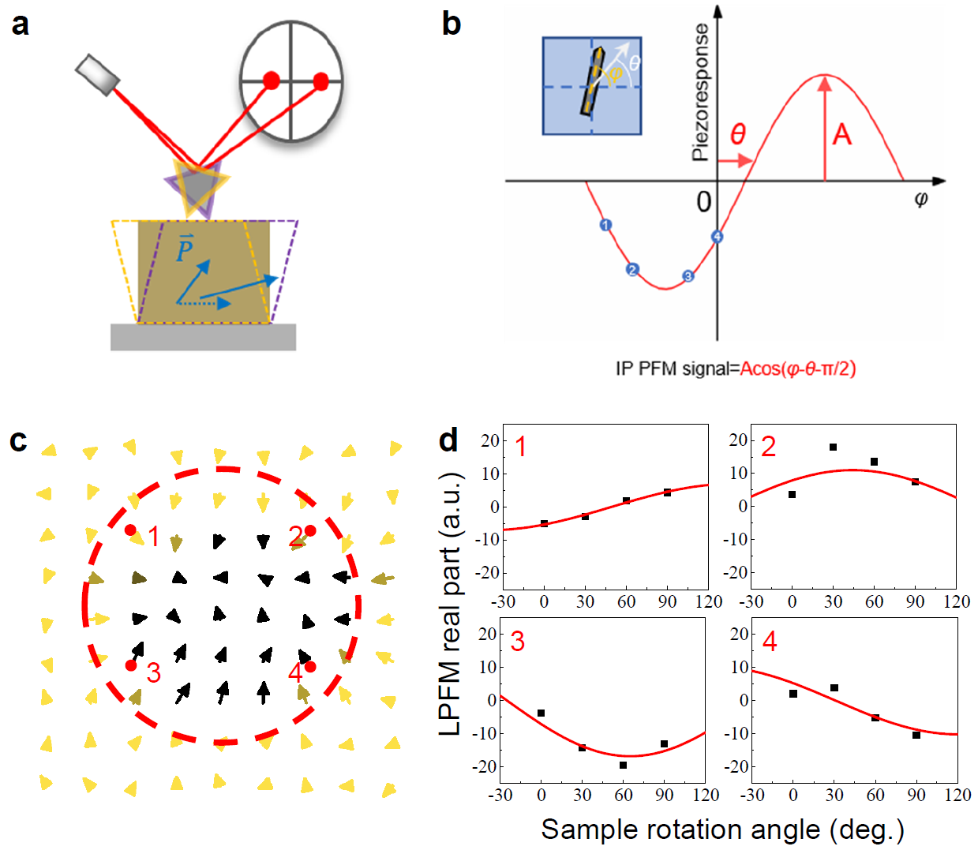
Figure S4. Construction of an in-plane (IP) piezoresponse vector map. (a) Schematic of the LPFM measurement. LPFM detects the torsional motion of the cantilever to sense the IP oscillations of the underneath sample. (b) The amplitude and phase signals of the fitting curve, which determine the amplitude and direction of the IP piezoresponse vector. LPFM real part signal was collected experimentally as a function of tip orientation angle φ and then the amplitude and the phase delay were determined by trigonometric curve fitting. (c) IP piezoresponse vector map for a center-convergent dipole textures in the PTS_{x=0.25} solid solution. (d) The trigonometric curve fitting for four representative points that are denoted as red spots in (c).

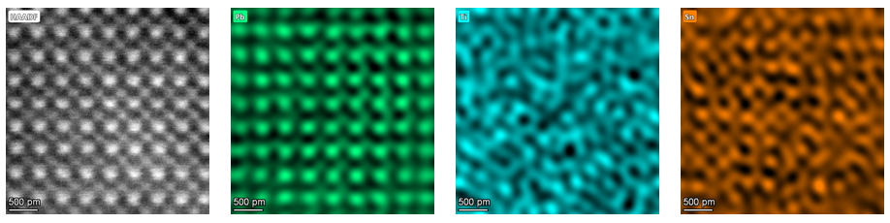
Figure S5. HAADF image and corresponding energy dispersion spectra of Pb, Ti, and Sn elements of the PTS_{x=0.25} ceramic. The Pb, Ti, and Sn ions are uniform in the PTS solid solution.

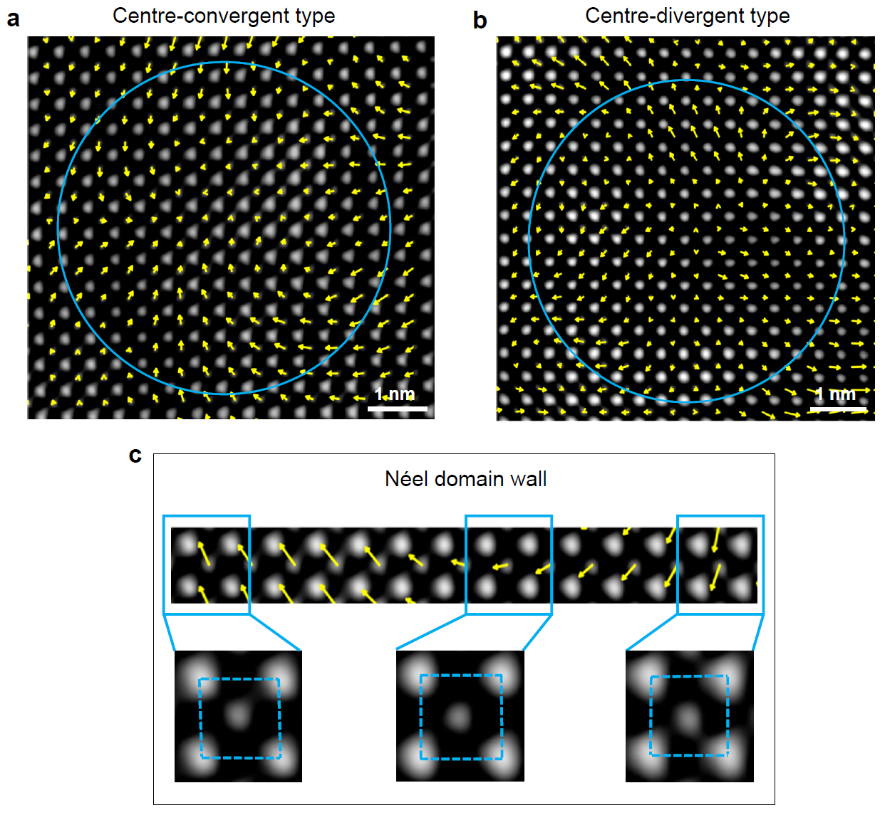
Figure S6. HAADF images with overlays of polar displacement vectors for demonstrating (a) the centre-convergent and (b) the centre-divergent skyrmionic textures of the PTS_{x=0.25} solid solution. (c) Lattice distortion of the Néel domain wall.

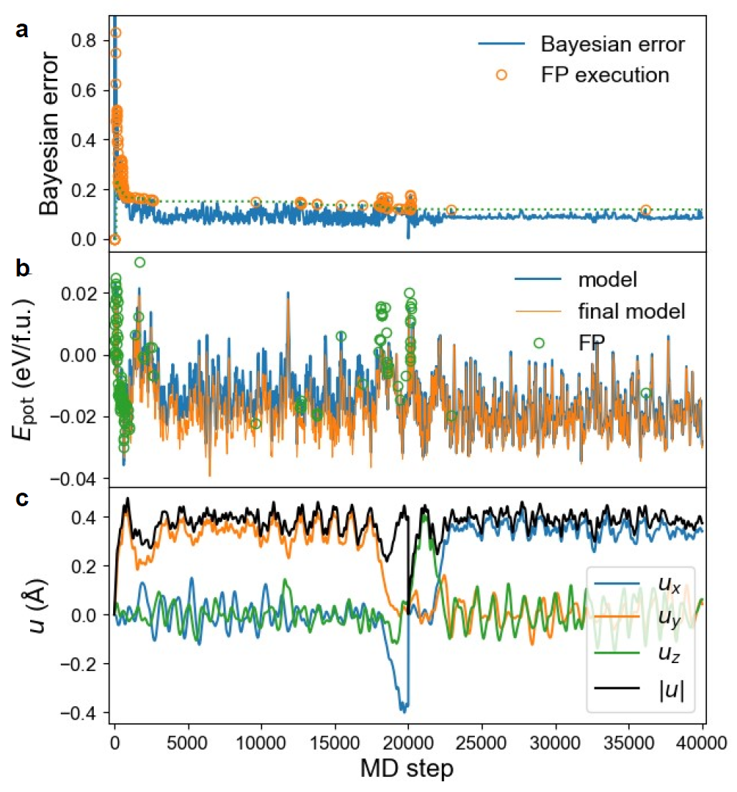
Figure S7. Active learning of the effective Hamiltonian for PTS_{x=0.25}. (a) Bayesian error, (b) potential energy, and (c) local dipolar mode in the first 40000 steps of active learning process. The dashed line in (a) denotes the threshold to perform first-principles calculations. The blue and orange lines in (b) denote the potential energy predicted by the effective Hamiltonian model during the fitting process and using the parameters obtained after the fitting, respectively. The open circles in (b) denote the potential energy obtained from the first-principles calculations.
Figure S7 shows the active learning process of determining effective Hamiltonian parameters for PTS_{x=0.25} at first 40000 MD steps. Here, the active learning is performed on $2×2×2$ supercell of the perovskite unit-cell (40 atoms). The Bayesian error (Figure S7a) exhibits a sharp drop at the beginning of fitting, with first principles calculations called frequently. After about 5000 steps, the Bayesian error threshold (Figure S7a) remains basically unchanged, and first-principles calculations are less frequently called, indicating that the fitting is approaching convergence. The potential energy values predicted by the effective Hamiltonian are close to those obtained from first principles calculations (Figure S7b). The local dipolar mode (Figure S7c) shows one nonzero average value during the whole fitting process, characterizing a macroscopic tetrahedral ferroelectric phase.

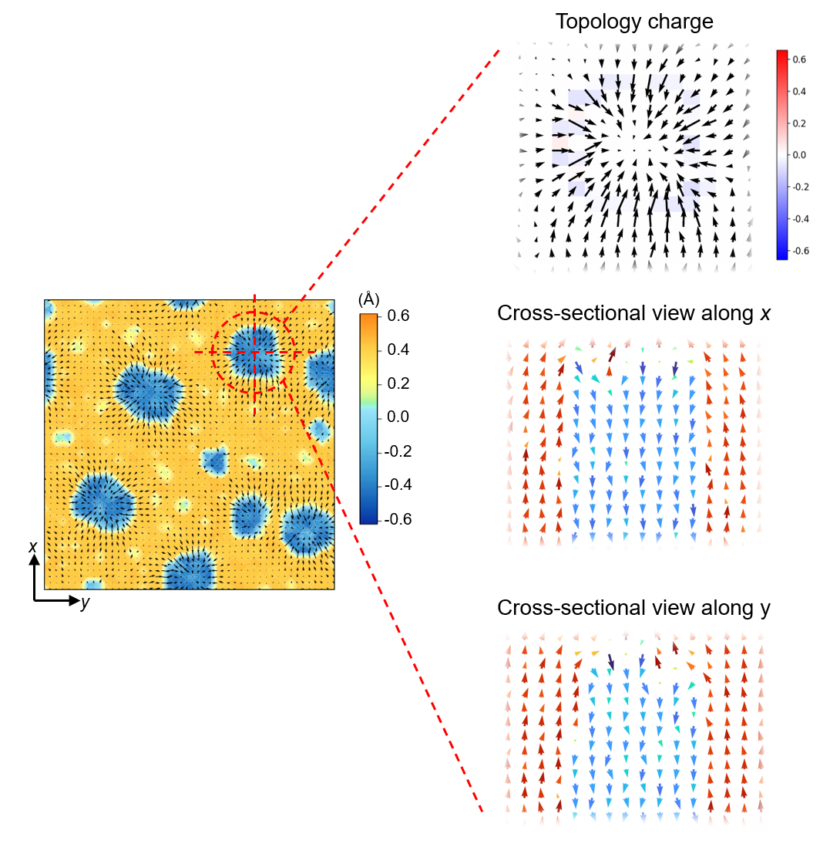
Figure S8. Topology charge density and cross-sectional views along x and y directions of the selected skyrmion in the simulated domain configuration of PTS_{x=0.25} (the left panel).

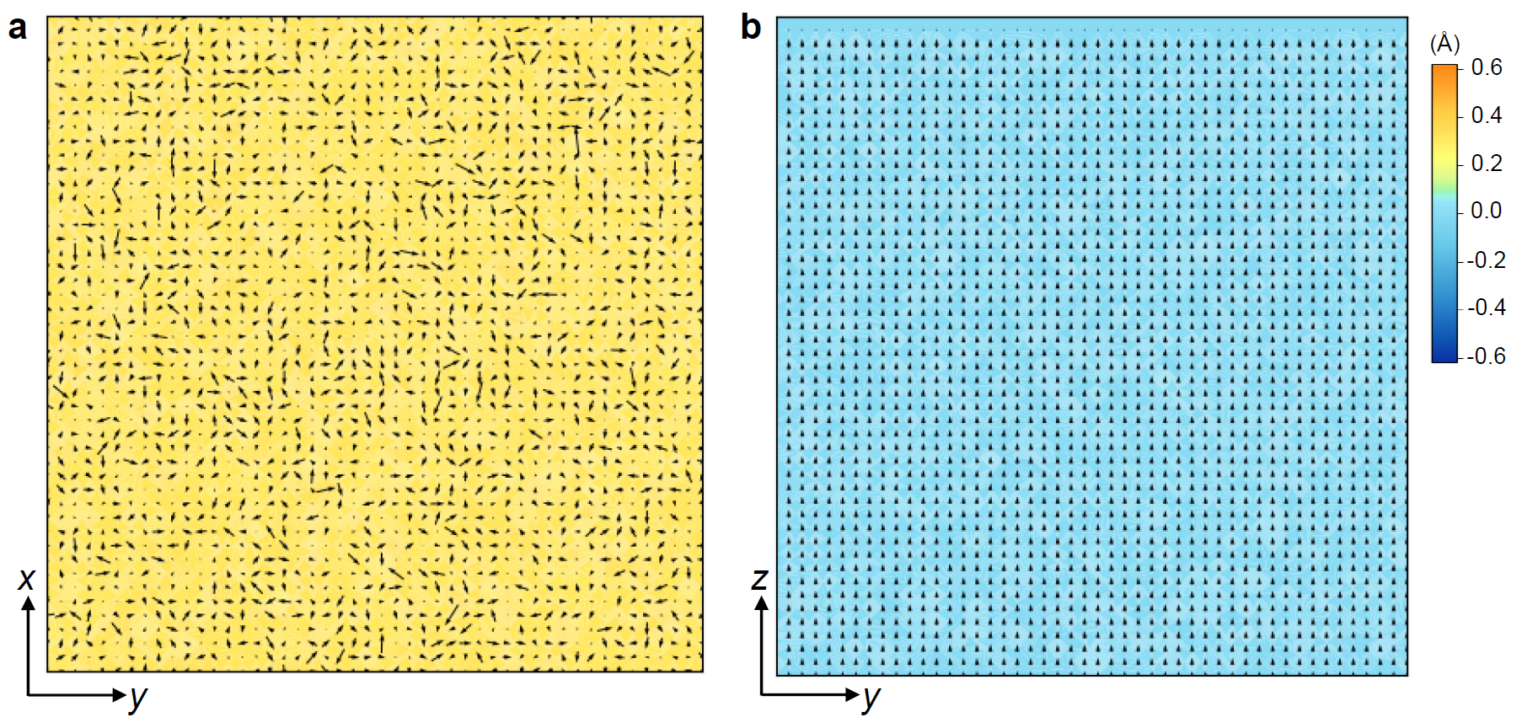
Figure S9. Effective Hamiltonian simulation of PbTiO₃. Domain configurations of (a) top (x-y plane) and (b) cross-sectional (y-z plane) views.
Figure S9 shows effective Hamiltonian simulations of PbTiO₃ in quasi-bulk supercell. In Figure S9a, only yellow color contrast is observed, suggesting that PbTiO₃ is in single domain with the polarization pointing upward along the [001] direction. As shown in the cross-sectional view, parallel arrangement of the dipoles can be observed (Figure S9b).

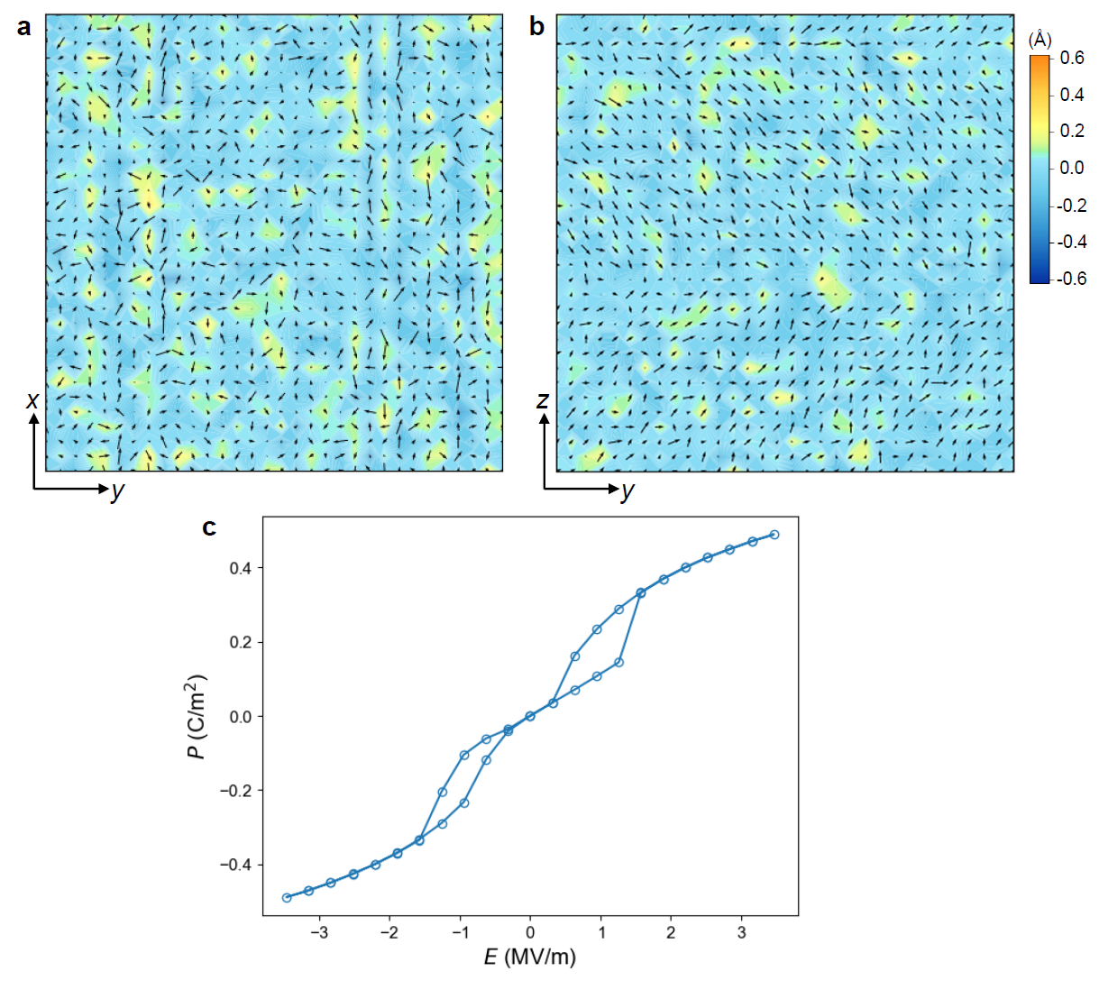
Figure S10. Effective Hamiltonian simulation of PbSnO₃. Domain configurations of (a) top (x-y plane) and (b) cross-sectional (y-z plane) views, as well as (c) the simulated antiferroelectric P-E hysteresis loop.
Figure S10a and b show simulated domain configurations of PbSnO₃, in which non-collinear dipole arrangements are observed in the top and cross-sectional views. By applying voltage on the supercell along the pseudocubic [111] direction, PbSnO₃ exhibits an antiferroelectric polarization-electric field (P-E) hysteresis loop.

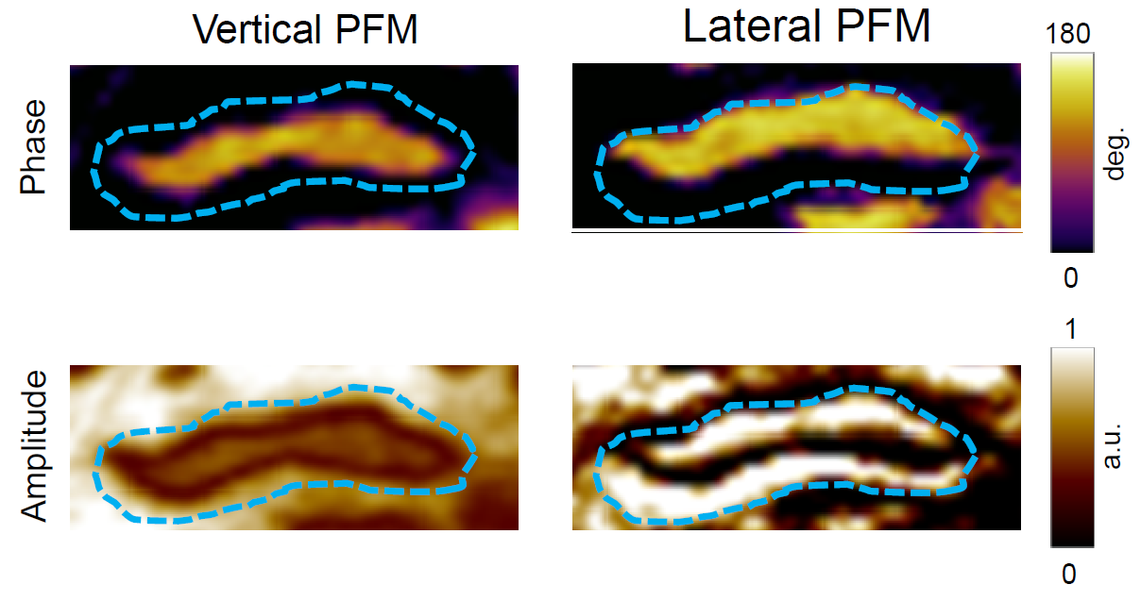
Figure S11. Zoom-in view of the PFM images of Néel-type labyrinthine domains of the PTS_{x=0.08} ceramic.
Figure S11 shows the VPFM and LPFM for a labyrinthine domain of the PTS_{x=0.08} ceramic. One can find the half-yellow-half-purple contrast in the LPFM with the domain wall being parallel with the cantilever. In addition, the LPFM area of the labyrinthine domain is larger than that of the VPFM. These features are similar to that of the skyrmionic texture in the main texture (Figure 2d and e), suggesting that the labyrinthine domain may be regarded as an elongated skyrmionic texture.

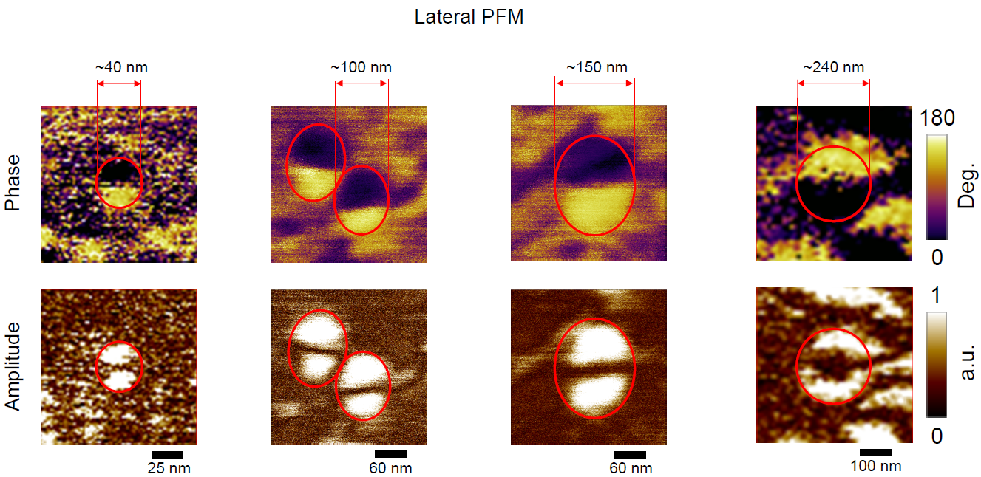
Figure S12. LPFM images for the polar skyrmionic textures of different sizes.
In PFM measurements, we have observed that the skyrmion nanodomains can be stabilized with a lateral size from ~40 to ~150 nm. For skyrmions smaller than 40 nm, clear dipole textures cannot be detected because of the limitation of the tip diameter, which is about 30 nm. In fact, the skyrmion textures can be stabilized in smaller size of about several nanometers, as demonstrated by STEM (Figure S6). For skyrmions larger than 150 nm, one can find that the core expands and the topological texture cannot be maintained, as demonstrated for a lateral size of ~240 nm.

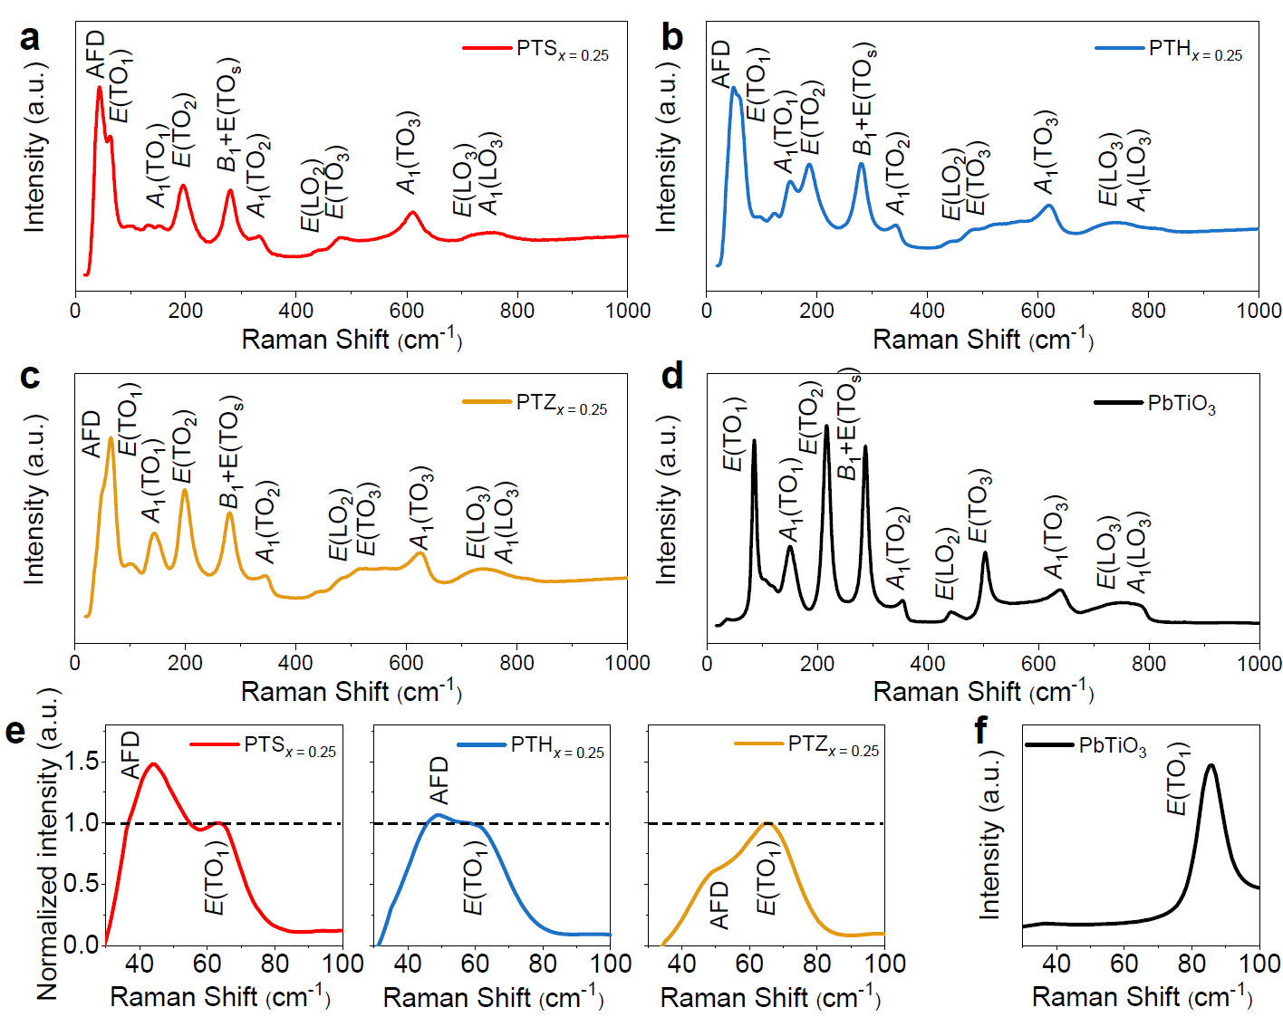
Figure S13. Raman spectra of the (a) PTS_{x=0.25}, (b) PTH_{x=0.25}, (c) PTZ_{x=0.25}, and (d) PbTiO₃ ceramics. Enlarged views of the Raman spectra in 30 ~ 100 cm⁻¹ region for (e) the PTS_{x=0.25}, PTH_{x=0.25}, and PTZ_{x=0.25} solid solutions with the intensity of E(TO₁) mode normalized to 1.0 and (f) the PbTiO₃.
The AFD distortions can appear in the Raman spectra (Figure S13). As a matter of fact and as reported previously, the AFD mode appears at ~45 cm⁻¹, on the left side of the E(TO₁) mode.^{[1]} For clarity, we show the enlarged views of the Raman spectra in the 30 ~ 100 cm⁻¹ region in Figure S13e and S13f, respectively, for PTS_{x=0.25}, PTH_{x=0.25}, and PTZ_{x=0.25} solid solutions, as well as for PbTiO₃. In Figure S13e, the intensities of the E(TO₁) modes are normalized to 1.0, as indicated by the horizontal dashed lines, in order to facilitate the comparison. As shown in this Figure, at the same antiferroelectric concentration of x = 0.25, PTS_{x=0.25} exhibits the strongest AFD mode intensity. Furthermore, the AFD mode intensity decreases successively from PTS_{x=0.25} to PTH_{x=0.25} and then PTZ_{x=0.25}. For PbTiO₃, there is no AFD mode. These results suggest that the substitution of PbSnO₃ can result in the strongest AFD distortion (the oxygen octahedral tilting) in the solid solutions.

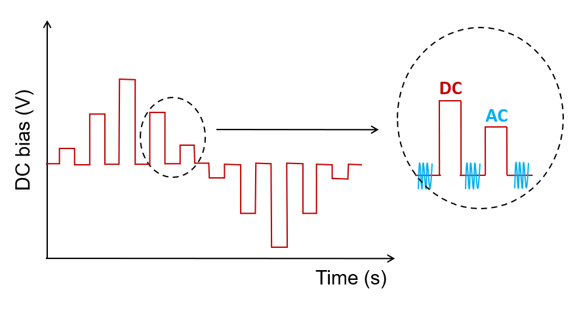
Figure S14. Test waveform for the PFM hysteresis loops.
Figure S14 shows test waveform applied on the conductive tip for the PFM hysteresis loops. Here, we adopted the off-field mode, in which the DC bias is applied to pole the sample and then the polarization is read by the AC voltage (at DC = 0 V) following each DC bias. Therefore, the PFM hysteresis loops shown in Figure 5a and Figure S15 are the remanent polarizations of the samples.

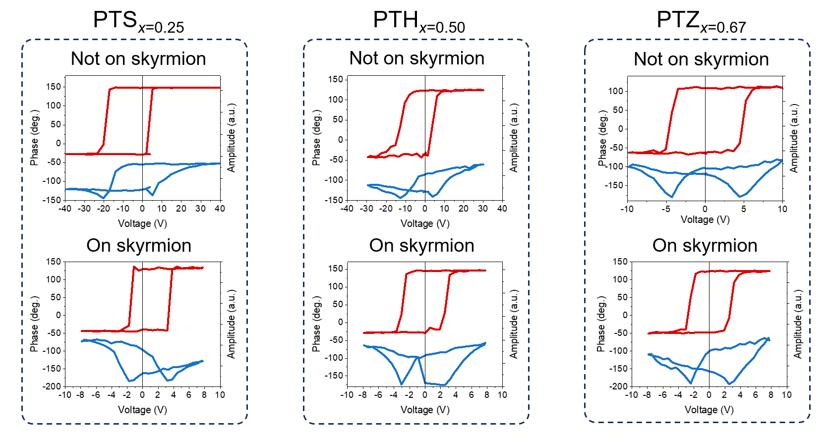
Figure S15. PFM hysteresis loops of the PTS_{x=0.25}, PTH_{x=0.50}, and PTZ_{x=0.67} ceramics. Top, the “not on skyrmion” case; bottom, the “on skyrmion” case.
Figure S15 shows PFM phase (red) and amplitude (blue) hysteresis loops of the PTS_{x=0.25}, PTH_{x=0.50}, and PTZ_{x=0.67} ceramics for both the “not on skyrmion” and “on skyrmion” cases. One can find that, with the skyrmionic textures, the imprint effects are reduced and the coercive voltages are lowered. In the PFM hysteresis measurements, the coercive voltages are determined by the amplitude minima of the butterfly-type amplitude loops. The extracted values are plotted in Figure 5b in the main text.

References
- Buixaderas, E. et al. Compositional behavior of Raman-active phonons in Pb(Zr,Ti)O₃ ceramics. Phys. Rev. B 91, 014104 (2015).

