Supplemental Material
Cardiogenic Necrotizing Enterocolitis in Infants with Congenital Heart Disease: A Systematic Review and Meta-Analysis

Supplemental Figure 1:
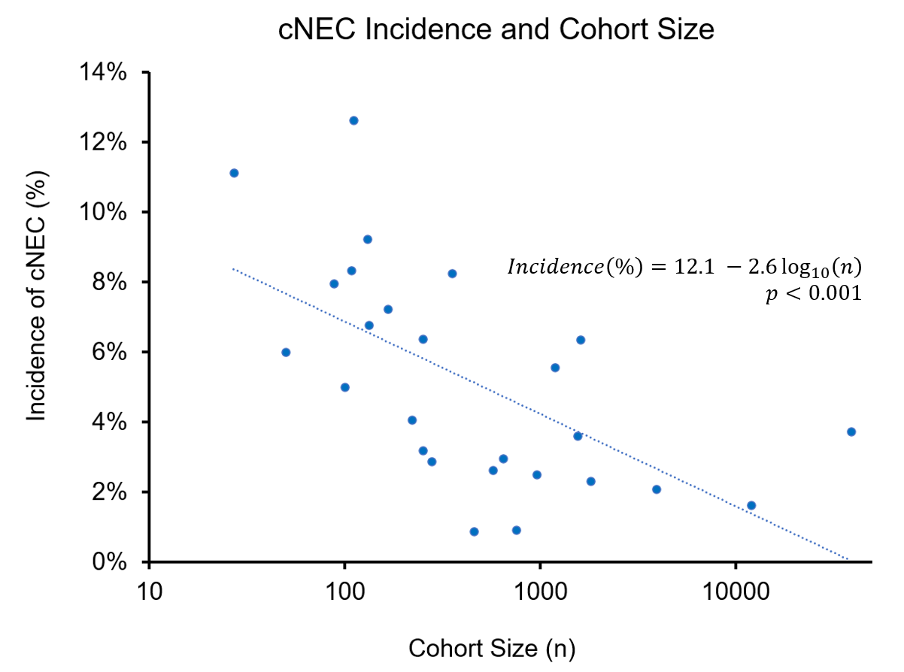
Relationship between cohort size and prevalence of NEC. Note, x-axis is on a base-10 logarithmic scale.

Supplemental Figure 2: Forest plot of Cardiogenic NEC incidence in Single Ventricle patients
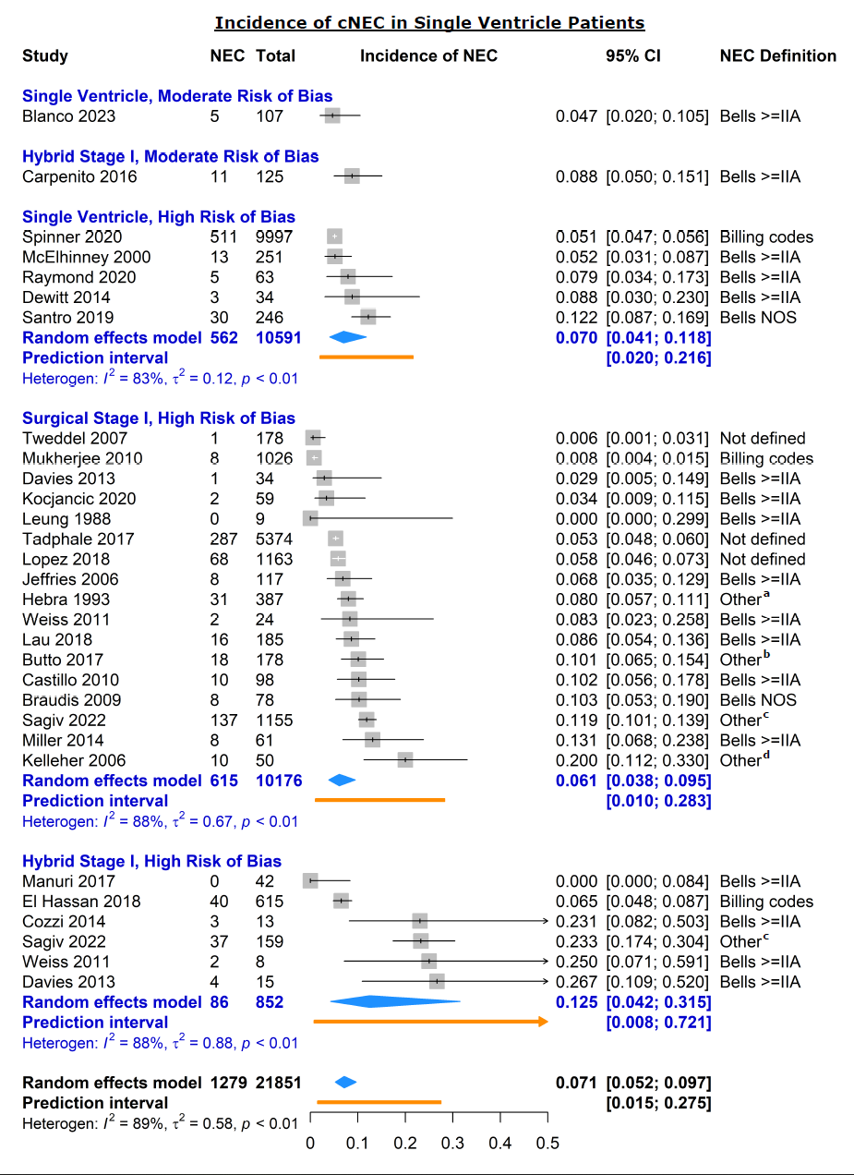
Individual (squares) and pooled (diamonds) estimates of incidence of cardiogenic NEC in infants with single ventricles. ªTwo of three: clinical, radiographic, or pathologic signs of NEC; ^{b}Clinical findings which required antibiotics or abdominal surgery; ^{c}Differed by registry site; ^{d}Clinical or radiographic findings requiring NPO
Supplemental Figure 3: Forest plot of Cardiogenic NEC incidence by cardiac lesion in term infants
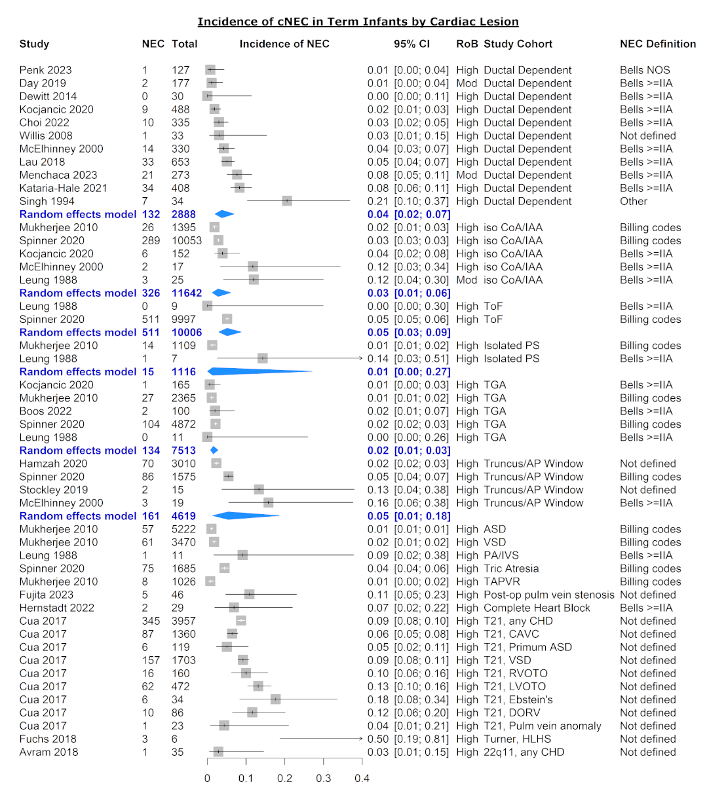
Individual (squares) and pooled (diamonds) estimates of incidence of cardiogenic NEC in all or term infants by cardiac anomaly excluding single ventricles. RoB, risk of bias; CoA, coarctation of aorta; IAA, interrupted aortic arch; ToF, Tetralogy of Fallot; PS, pulmonary stenosis; TGA, transposition of the great arteries; AP, aortopulmonary; ASD, atrial septal defect; VSD, ventricular septal defect; PA, pulmonary atresia; IVS, intact ventricular septum; TAPVR, total anomalous pulmonary venous return; CHD, congenital heart disease; CAVC, common atrioventricular canal; RVOTO, right ventricular outflow tract obstruction; LVOTO; left ventricular outflow tract obstruction; DORV, double outlet right ventricle; HLHS, hypoplastic left heart syndrome; (1) clinical and radiographic signs (including distended small bowel loops)
Supplemental Figure 4: Forest plot of cardiogenic NEC incidence in premature infants stratified by risk of bias
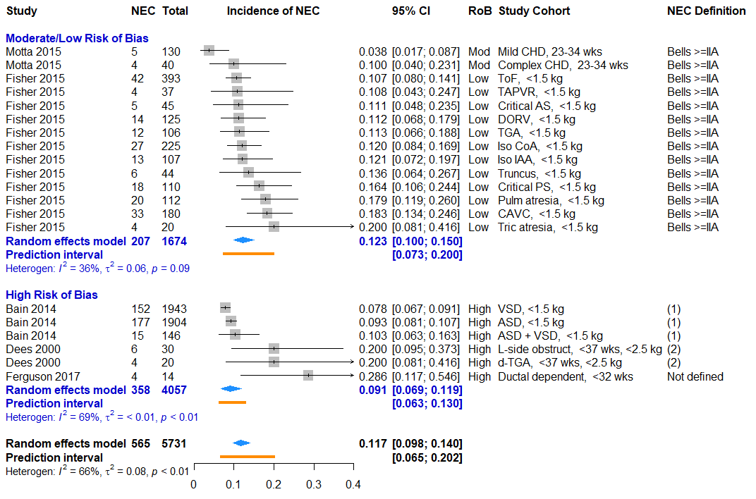
Supplemental Figure 3: Individual (squares) and pooled (diamonds) estimates of incidence of cardiogenic NEC in premature infants by cardiac anomaly excluding single ventricles. RoB, risk of bias; CHD, congenital heart disease; wks, gestational age in weeks; kg, birth weight in kilograms. Complex CHD excludes isolated atrial and ventricular septal defects. (1), Internal administrative database; (2), each of: clinical signs, x-ray findings, and required antibiotics or NPO

Supplemental Table 1: Hospital Length of Stay by NEC in CHD patients stratified by outcome metric (median vs mean LOS)
 | NEC |  | No NEC
Study | Median LOS (IQR)  days | n | Median LOS (IQR)  days | n | Difference  (days)
Del Castillo 2010 | 55 (34, 83) | 17 | 21 (16, 36) | 81 | 34
Luce 2011 | 35 (8, 49) | 8 | 19 (9, 100) | 65 | 16
Lopez 2018 | 55 (39, 74) | 57 | 28 (21, 42) | 171 | 27
Schuchardt 2018 | 53 (36, 93) | 16 | 10 (6, 23) | 217 | 43
Spinner 2020 | 54 (NR) | 1,448 | 18 (not reported) | 37,322 | 36
Chanthong 2010 | 10 (NR) | 66 | 5 (not reported) | 1119 | 5
 |  |  |  |  | 30.5 (10.5-39.5)
 | Mean LOS (SD)  days |  | Mean LOS (SD)  days |  | Difference  (days)
McElhinney 2000 | 36 (22) | 21 | 19 (14) | 622 | 17
Jeffries 2006 | 59 (36) | 9 | 29 (32) | 96 | 30
Davies 2013 | 89.5 (54.2) | 11 | 39.6 (26.7) | 49 | 49
Miller 2014 | 31.6 (36.4) | 30 | 22.7 (7.6) | 50 | 8.9
Pham 2022 | 66.6 (44.7) | 21 | 40.6 (42.9) | 50 | 26.0
 |  |  |  |  | 21.1 (12.1, 30.0)
NR, not reported.

Supplemental Methods 1: Search Logic for Medline and Embase databases
Medline search strategy:
Search: ((infant) AND ((((((((congenital heart disease) OR (congenital heart defect)) OR ((cardiology service, hospital[MeSH Terms]) OR (cardiology hospital services[MeSH Terms]))) OR (cardiovascular surgical procedure[MeSH Terms])) OR (cardiopulmonary bypass)) OR (extracorporeal circulation[MeSH Terms])) OR (hemodynamics[MeSH Terms])) OR ((((((treatment out[MeSH Terms]) OR (postoperative complication[MeSH Terms])) OR (intensive care units, pediatric[MeSH Terms])) OR (intensive care, neonatal[MeSH Terms]))) AND ((cardiovascular disease[MeSH Terms]) OR (heart[MeSH Terms]))))) AND ((((((necrotizing enterocolitis) OR (gastrointestinal hemorrhage)) OR (hematochezia)) OR (splanchnic circulation[MeSH Terms])) OR (intestinal mucosa[MeSH Terms])) OR (((spectroscopy, near infrared[MeSH Terms]) OR (occult blood[MeSH Terms])) AND (((somatic) OR (gastrointestinal tract[MeSH Terms])) OR (gastrointestinal disease[MeSH Terms])))) Sort by: Publication Date
(((("infant"[MeSH Terms] OR "infant"[All Fields]) OR "infants"[All Fields]) OR "infant s"[All Fields]) AND ((((((((("congenit heart dis"[Journal] OR (("congenital"[All Fields] AND "heart"[All Fields]) AND "disease"[All Fields])) OR "congenital heart disease"[All Fields]) OR (((("heart defects, congenital"[MeSH Terms] OR (("heart"[All Fields] AND "defects"[All Fields]) AND "congenital"[All Fields])) OR "congenital heart defects"[All Fields]) OR (("congenital"[All Fields] AND "heart"[All Fields]) AND "defect"[All Fields])) OR "congenital heart defect"[All Fields])) OR ("cardiology service, hospital"[MeSH Terms] OR "cardiology service, hospital"[MeSH Terms])) OR "cardiovascular surgical procedures"[MeSH Terms]) OR (("cardiopulmonary bypass"[MeSH Terms] OR ("cardiopulmonary"[All Fields] AND "bypass"[All Fields])) OR "cardiopulmonary bypass"[All Fields])) OR "extracorporeal circulation"[MeSH Terms]) OR "hemodynamics"[MeSH Terms]) OR ((("postoperative complications"[MeSH Terms] OR "intensive care units, pediatric"[MeSH Terms]) OR "intensive care, neonatal"[MeSH Terms]) AND ("cardiovascular diseases"[MeSH Terms] OR "heart"[MeSH Terms])))) AND ((((((((("necrotising enterocolitis"[All Fields] OR "enterocolitis, necrotizing"[MeSH Terms]) OR ("enterocolitis"[All Fields] AND "necrotizing"[All Fields])) OR "necrotizing enterocolitis"[All Fields]) OR ("necrotizing"[All Fields] AND "enterocolitis"[All Fields])) OR ((("gastrointestinal haemorrhage"[All Fields] OR "gastrointestinal hemorrhage"[MeSH Terms]) OR ("gastrointestinal"[All Fields] AND "hemorrhage"[All Fields])) OR "gastrointestinal hemorrhage"[All Fields])) OR (((("gastrointestinal hemorrhage"[MeSH Terms] OR ("gastrointestinal"[All Fields] AND "hemorrhage"[All Fields])) OR "gastrointestinal hemorrhage"[All Fields]) OR "haematochezia"[All Fields]) OR "hematochezia"[All Fields])) OR "splanchnic circulation"[MeSH Terms]) OR "intestinal mucosa"[MeSH Terms]) OR (("spectroscopy, near-infrared"[MeSH Terms] OR "occult blood"[MeSH Terms]) AND (((((("diploidy"[MeSH Terms] OR "diploidy"[All Fields]) OR "somatic"[All Fields]) OR "somatically"[All Fields]) OR "somatics"[All Fields]) OR "gastrointestinal tract"[MeSH Terms]) OR "gastrointestinal diseases"[MeSH Terms])))
Translations
infant: "infant"[MeSH Terms] OR "infant"[All Fields] OR "infants"[All Fields] OR "infant's"[All Fields]
congenital heart disease: "Congenit Heart Dis"[Journal:__jid101256510] OR ("congenital"[All Fields] AND "heart"[All Fields] AND "disease"[All Fields]) OR "congenital heart disease"[All Fields]
congenital heart defect: "heart defects, congenital"[MeSH Terms] OR ("heart"[All Fields] AND "defects"[All Fields] AND "congenital"[All Fields]) OR "congenital heart defects"[All Fields] OR ("congenital"[All Fields] AND "heart"[All Fields] AND "defect"[All Fields]) OR "congenital heart defect"[All Fields]
cardiology service, hospital[MeSH Terms]: "cardiology service, hospital"[MeSH Terms]
cardiology hospital services[MeSH Terms]: "cardiology service, hospital"[MeSH Terms]
cardiovascular surgical procedure[MeSH Terms]: "cardiovascular surgical procedures"[MeSH Terms]
cardiopulmonary bypass: "cardiopulmonary bypass"[MeSH Terms] OR ("cardiopulmonary"[All Fields] AND "bypass"[All Fields]) OR "cardiopulmonary bypass"[All Fields]
extracorporeal circulation[MeSH Terms]: "extracorporeal circulation"[MeSH Terms]
hemodynamics[MeSH Terms]: "hemodynamics"[MeSH Terms]
postoperative complication[MeSH Terms]: "postoperative complications"[MeSH Terms]
intensive care units, pediatric[MeSH Terms]: "intensive care units, pediatric"[MeSH Terms]
intensive care, neonatal[MeSH Terms]: "intensive care, neonatal"[MeSH Terms]
cardiovascular disease[MeSH Terms]: "cardiovascular diseases"[MeSH Terms]
heart[MeSH Terms]: "heart"[MeSH Terms]
necrotizing enterocolitis: "necrotising enterocolitis"[All Fields] OR "enterocolitis, necrotizing"[MeSH Terms] OR ("enterocolitis"[All Fields] AND "necrotizing"[All Fields]) OR "necrotizing enterocolitis"[All Fields] OR ("necrotizing"[All Fields] AND "enterocolitis"[All Fields])
gastrointestinal hemorrhage: "gastrointestinal haemorrhage"[All Fields] OR "gastrointestinal hemorrhage"[MeSH Terms] OR ("gastrointestinal"[All Fields] AND "hemorrhage"[All Fields]) OR "gastrointestinal hemorrhage"[All Fields]
hematochezia: "gastrointestinal hemorrhage"[MeSH Terms] OR ("gastrointestinal"[All Fields] AND "hemorrhage"[All Fields]) OR "gastrointestinal hemorrhage"[All Fields] OR "haematochezia"[All Fields] OR "hematochezia"[All Fields]
splanchnic circulation[MeSH Terms]: "splanchnic circulation"[MeSH Terms]
intestinal mucosa[MeSH Terms]: "intestinal mucosa"[MeSH Terms]
spectroscopy, near infrared[MeSH Terms]: "spectroscopy, near-infrared"[MeSH Terms]
occult blood[MeSH Terms]: "occult blood"[MeSH Terms]
somatic: "diploidy"[MeSH Terms] OR "diploidy"[All Fields] OR "somatic"[All Fields] OR "somatically"[All Fields] OR "somatics"[All Fields]
gastrointestinal tract[MeSH Terms]: "gastrointestinal tract"[MeSH Terms]
gastrointestinal disease[MeSH Terms]: "gastrointestinal diseases"[MeSH Terms]

EMBASE search strategy:
('infant'/exp OR 'infant' OR 'infants'/exp OR 'infants')

AND
((‘congenital heart disease’/exp OR (‘congenital’ AND ‘heart’ AND ‘disease’) OR ‘congenital heart disease’ OR ((‘heart’ AND ‘defects’) AND ‘congenital’) OR ‘congenital heart defect’ OR ((‘congenital’ AND ‘heart’) AND ‘defect’))
OR ‘cardiology service’/exp OR ‘cardiovascular surgery’/exp
OR ((‘cardiopulmonary bypass’/exp OR (‘cardiopulmonary’ AND ‘bypass’) OR ‘cardiopulmonary bypass’)))

AND
((‘necrotizing enterocolitis’ OR ‘necrotizing enterocolitis’/exp OR (‘enterocolitis’ AND ‘necrotizing’) OR ‘necrotizing enterocolitis’ OR (‘necrotizing’ AND ‘enterocolitis’))
OR (‘gastrointestinal haemorrhage’ OR ‘gastrointestinal hemorrhage’/exp OR (‘gastrointestinal’ AND ‘hemorrhage’))
OR (‘haematochezia’ OR ‘hematochezia’ OR ‘splanchnic blood flow’/exp))

Supplemental Methods 2: Search Logic for Medline and Embase databases

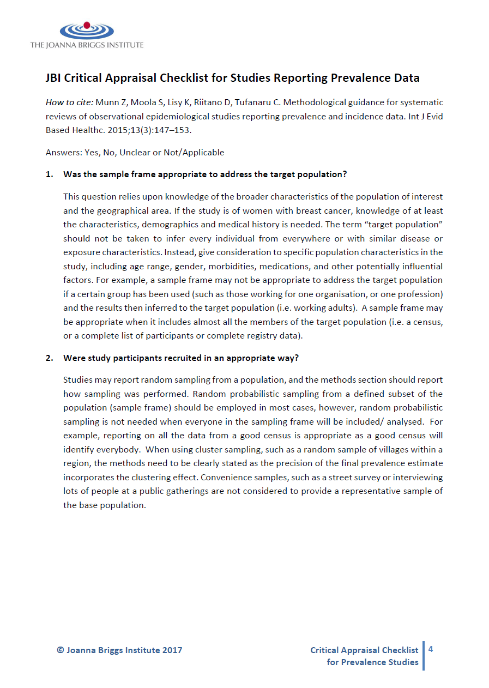
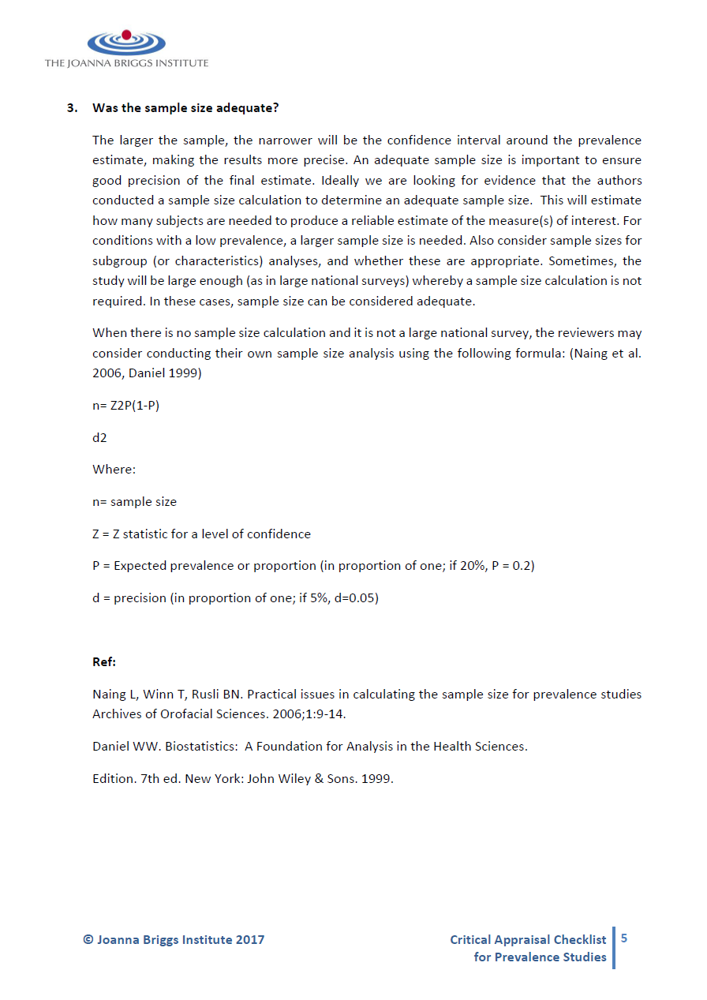
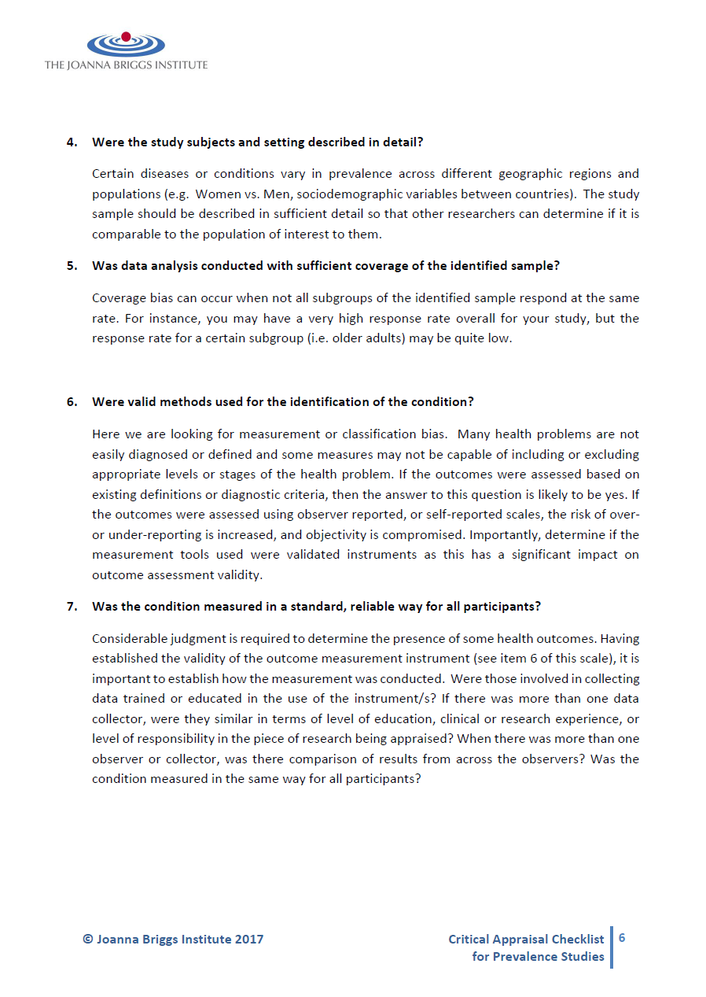
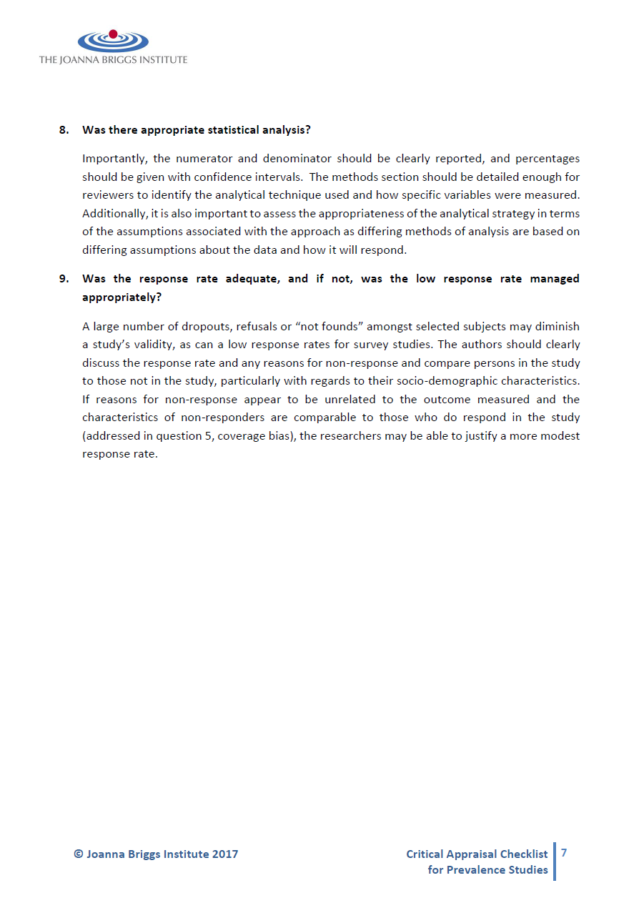
Supplemental Methods 3: Newcastle-Ottawa Risk of Bias Assessment Tool

NEWCASTLE - OTTAWA QUALITY ASSESSMENT SCALE
COHORT STUDIES

Note: A study can be awarded a maximum of one star for each numbered item within the Selection and Outcome categories. A maximum of two stars can be given for Comparability

Selection
1) Representativeness of the exposed cohort
a) truly representative of the average _______________ (describe) in the community 
b) somewhat representative of the average ______________ in the community 
c) selected group of users eg nurses, volunteers
d) no description of the derivation of the cohort
2) Selection of the non exposed cohort
a) drawn from the same community as the exposed cohort 
b) drawn from a different source
c) no description of the derivation of the non exposed cohort
3) Ascertainment of exposure
a) secure record (eg surgical records) 
b) structured interview 
c) written self report
d) no description
4) Demonstration that outcome of interest was not present at start of study
a) yes 
b) no
Comparability
1) Comparability of cohorts on the basis of the design or analysis
a) study controls for _____________ (select the most important factor) 
b) study controls for any additional factor  (This criteria could be modified to indicate specific control for a second important factor.)
Outcome
1) Assessment of outcome
a) independent blind assessment 
b) record linkage 
c) self report
d) no description
2) Was follow-up long enough for outcomes to occur
a) yes (select an adequate follow up period for outcome of interest) 
b) no
3) Adequacy of follow up of cohorts
a) complete follow up - all subjects accounted for 
b) subjects lost to follow up unlikely to introduce bias - small number lost - > ____ % (select an adequate %) follow up, or description provided of those lost) 
c) follow up rate < ____% (select an adequate %) and no description of those lost
d) no statement

CODING MANUAL FOR COHORT STUDIES

SELECTION

- Representativeness of the Exposed Cohort

Item is assessing the representativeness of exposed individuals in the community, not the representativeness of the sample of women from some general population. For example, subjects derived from groups likely to contain middle class, better educated, health oriented women are likely to be representative of postmenopausal estrogen users while they are not representative of all women (e.g. members of a health maintenance organisation (HMO) will be a representative sample of estrogen users. While the HMO may have an under-representation of ethnic groups, the poor, and poorly educated, these excluded groups are not the predominant users users of estrogen).

Allocation of stars as per rating sheet

- Selection of the Non-Exposed Cohort

Allocation of stars as per rating sheet

- Ascertainment of Exposure

Allocation of stars as per rating sheet

- Demonstration That Outcome of Interest Was Not Present at Start of Study

In the case of mortality studies, outcome of interest is still the presence of a disease/ incident, rather than death. That is to say that a statement of no history of disease or incident earns a star.

COMPARABILITY

- Comparability of Cohorts on the Basis of the Design or Analysis

A maximum of 2 stars can be allotted in this category
Either exposed and non-exposed individuals must be matched in the design and/or confounders must be adjusted for in the analysis. Statements of no differences between groups or that differences were not statistically significant are not sufficient for establishing comparability. Note: If the relative risk for the exposure of interest is adjusted for the confounders listed, then the groups will be considered to be comparable on each variable used in the adjustment.
There may be multiple ratings for this item for different categories of exposure (e.g. ever vs. never, current vs. previous or never)
Age = , Other controlled factors =

OUTCOME

- Assessment of Outcome

For some outcomes (e.g. fractured hip), reference to the medical record is sufficient to satisfy the requirement for confirmation of the fracture. This would not be adequate for vertebral fracture outcomes where reference to x-rays would be required.
- Independent or blind assessment stated in the paper, or confirmation of the outcome by reference to secure records (x-rays, medical records, etc.)
- Record linkage (e.g. identified through ICD codes on database records)
- Self-report (i.e. no reference to original medical records or x-rays to confirm the outcome)
- No description.

- Was Follow-Up Long Enough for Outcomes to Occur

An acceptable length of time should be decided before quality assessment begins (e.g. 5 yrs. for exposure to breast implants)

- Adequacy of Follow Up of Cohorts

This item assesses the follow-up of the exposed and non-exposed cohorts to ensure that losses are not related to either the exposure or the outcome.

Allocation of stars as per rating sheet

