New estimates and synthesis of chromosome number, ploidy level and genome size variation in Allium sect. Codonoprasum: a step towards understanding the hitherto unresolved diversification and evolution of the section
Kobrlová L., Jandová M., Vojtěchová K., Šafářová L., Duchoslav M.

Figure S1. Mitotic metaphase chromosomes of the studied taxa of A. sect. Codonoprasum.
A. A. aetnense (2n = 2x = 16, population ID 22/58, Sicily, Passopisciaro); B. A. carinatum subsp. carinatum (2n = 2x = 16, population ID 11/53, Slovakia, Velké Leváre); C. A. carinatum subsp. carinatum (2n = 3x = 24, population ID 08/12A, Slovenia, Postojna); D. A. carinatum subsp. pulchellum (2n = 2x = 16, population ID 15/48, Serbia, Nova Varoš); E. A. dentiferum (2n = 4x =32, population ID 23/01, Crete, Pano Saktouria); F. A. dentiferum (2n = 5x = 40, population ID 10/11A, Italy, San Germano). Bar = 20 μm. Photographs by Lucie Kobrlová.

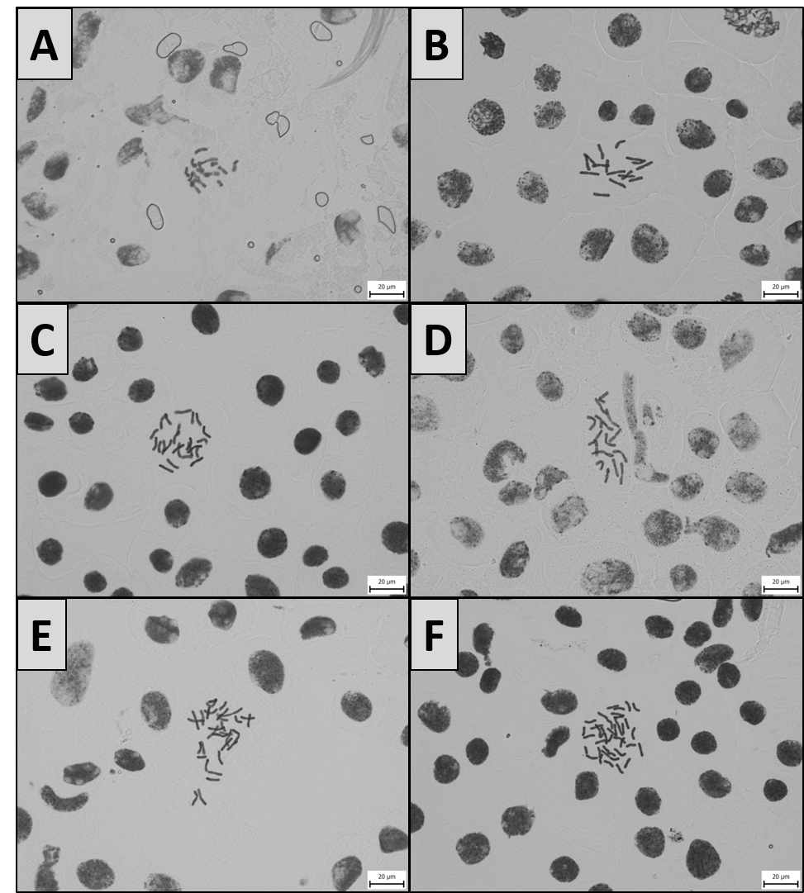
G. A. daninianum (2n = 2x = 16, population ID 23/162, Israel, Haifa); H. “A. dentiferum-pallens” (2n = 4x = 32, population ID 23/179, Spain, Órgiva); I. A. flavum subsp. flavum (2n =2x = 16, population ID 04/23, Slovakia, Plešivec); J. A. flavum subsp. flavum (2n =4x = 32, population ID 14/101, Bulgari, Kokayane); K. A. flavum subsp. tauricum (2n = 4x = 32, population ID 15/308, Ukraine, Novokairy); L. A. garbarii (2n = 2x = 16, population ID 22/04, Italy, Crotone). Bar = 20 μm. Photographs by Lucie Kobrlová and Alena Fišerová.

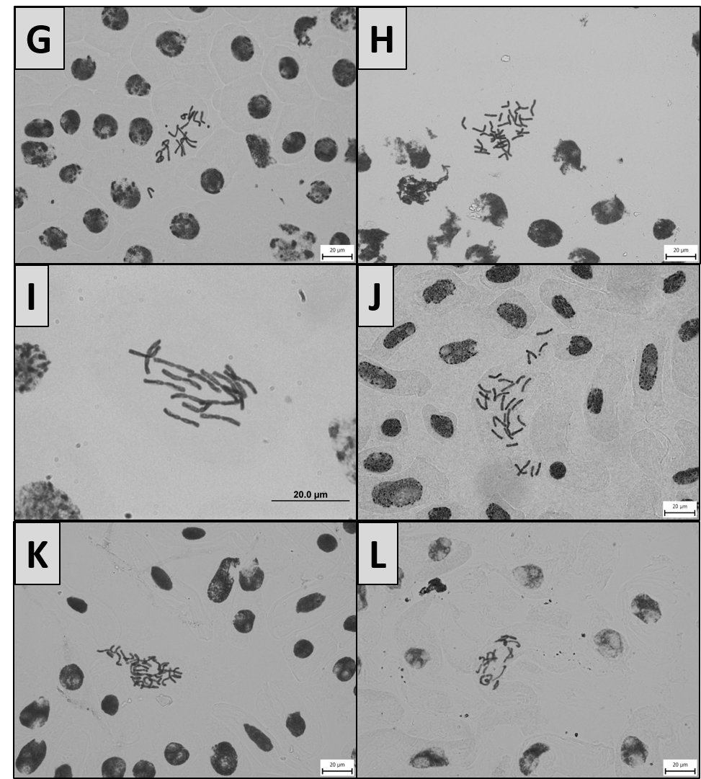

M. A. hermoneum (2n = 4x = 32, population ID 23/171, Israel, Majdal Shams); N. A. karsianum (2n = 2x = 16, population ID 19/117, Georgia, Ušguli); O. A. kunthianum (2n = 2x = 16, population ID 23/137, Georgia, Samcche-Džavachetie); P. A. melanantherum (2n = 3x = 24, population ID 14/56A, Bulgaria, Rilski Manastir); Q. A. oporinanthum (2n = 4x = 32, population ID 12/62B, Spain, La Roca del Vallès); R. A. pallens (2n = 4x = 32, population ID 22/40, Italy, Altamura). Bar = 20 μm. Photographs by Lucie Kobrlová.

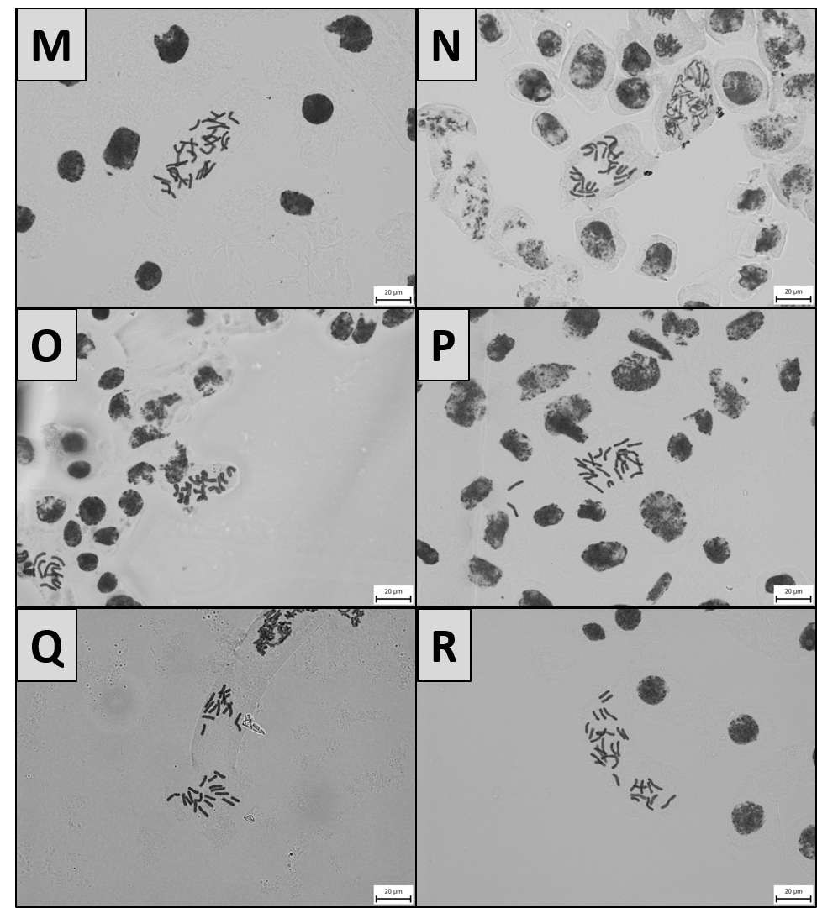

S. A. rhodopeum (2n = 2x = 16, population ID 17/134, Greece, Thiva); T. A. rupestre (2n = 2x = 14 (x = 7), population ID 13/60, Georgia, Chvabiani); U. A. rupestre (2n = 3x = 21 (x = 7), population ID 12/04A, Ukraine, Nikita); V. A. rupestre (2n = 4x = 28 (x = 7), population ID 13/65, Georgia, Kvabiskhevi); W. A. rupestre (2n = 3x = 24 (x = 8), population ID 18/32, Georgia, Didgoori); X. A. telmatum (2n = 4x = 32, population ID 15/42B, Croatia, Nin). Bar = 20 μm. Photographs by Lucie Kobrlová and Michaela Jandová.

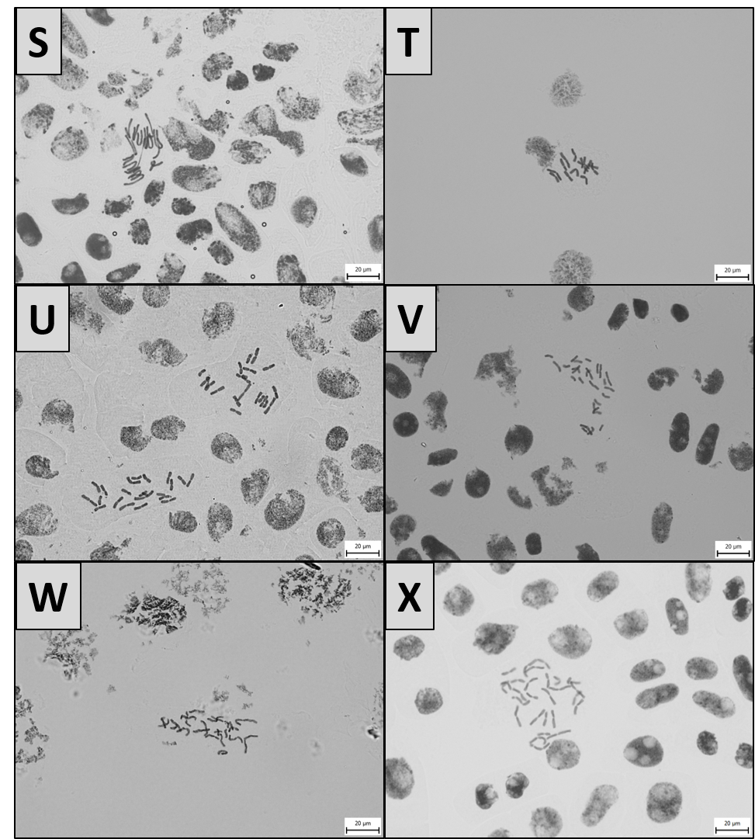

Y. A. tenuiflorum (2n = 2x = 16, population ID 23/190B, Croatia, Pula, Verudela); Z. A. valdesianum (2n = 2x = 16, population ID 23/175, Spain, Monachil). Bar = 20 μm. Photographs by Lucie Kobrlová.

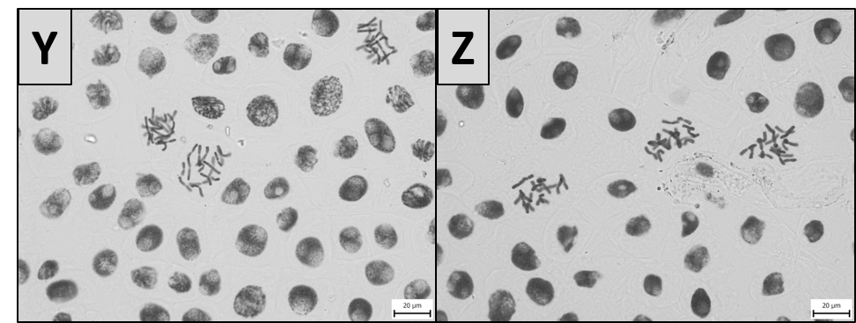

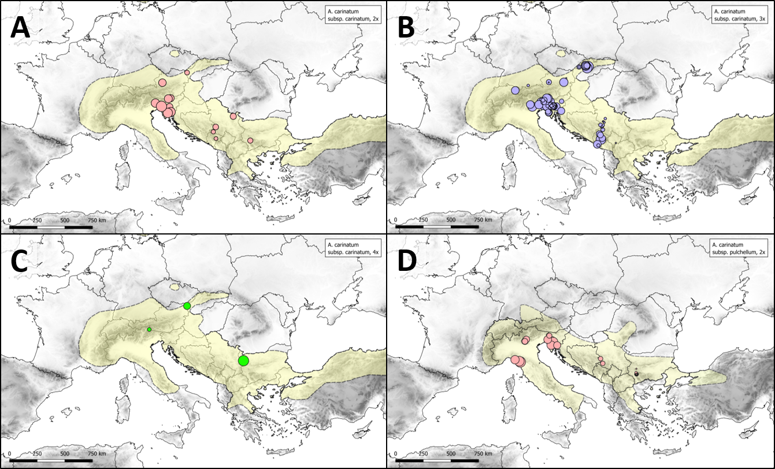
Figure S2. Variation in RGS for ploidy levels of particular taxa of A. sect. Codonoprasum with a wider distribution range. Circle sizes are proportional to RGS values within each taxon only. The original RGS values for particular ploidies/taxa used in the maps are given in Table S1. The approximate range of a given taxon is shown in light yellow. A. Allium carinatum subsp. carinatum (2n = 2x), B. Allium carinatum subsp. carinatum (2n = 3x), C. Allium carinatum subsp. carinatum (2n = 4x), D. Allium carinatum subsp. pulchellum (2n = 2x), E. Allium dentiferum (2n = 4x), F. Allium dentiferum (2n = 5x), G. Allium “dentiferum-pallens” (2n = 4x), H. Allium pallens (2n = 4x), I. Allium flavum subsp. flavum (2n = 2x), J. Allium flavum subsp. flavum (2n = 4x), K. Allium flavum subsp. tauricum (2n = 2x), L. Allium flavum subsp. tauricum (2n = 4x).
