Supplementary information for
Defect-mediated exciton localization and relaxation in CVD-grown monolayer MoS₂

Jiafan Qu,^{1†} Yadong Wei,^{2†} Liang Zhao,¹ Ruoxi Tan,¹ Weiqi Li,³ Hongyan Shi,^{1,4} Yueling Zhang,⁵ Jianqun Yang,² Bo Gao^{1,4*} and Xingji Li^{2*}

¹Institute of Modern Optics, School of Physics, Key Laboratory of Micro-Nano Optoelectronic Information System, Ministry of Industry and Information Technology, Key Laboratory of Micro-Optics and Photonic Technology of Heilongjiang Province, Harbin Institute of Technology, Harbin 150001, China
²Technology Innovation Center of Materials and Devices for Extreme Environment, School of Materials Science and Engineering, Harbin Institute of Technology, Harbin 150001, China
³School of Physics, Harbin Institute of Technology, Harbin 150001, China
⁴Collaborative Innovation Center of Extreme Optics, Shanxi University, Taiyuan 030006, China
⁵State Key Laboratory for Animal Disease Control and Prevention, Harbin Veterinary Research Institute, Chinese Academy of Agricultural Sciences, Harbin 150069, China

*Corresponding author: gaobo@hit.edu.cn, lxj0218@hit.edu.cn
†These authors contributed equally to this work

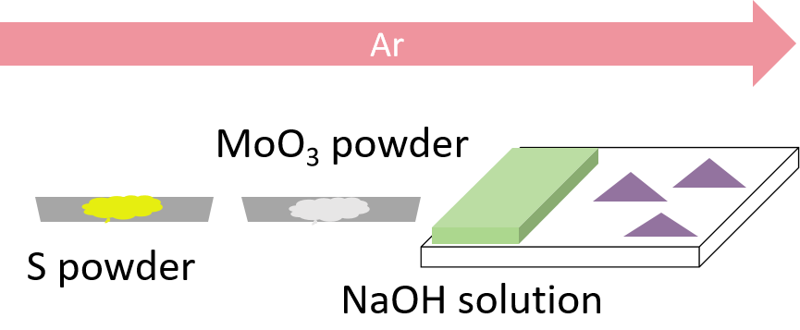
Supplementary Figure 1: Schematic illustration for the growth of monolayer MoS₂ with high n-type doping and a large quantity of defects.
NaOH-promoted CVD method has been well developed to grow high sulfur vacancy defect concentration and high n-type doping monolayer 2D materials under atmospheric pressure in our group. For growing MoS₂ in this study, MoO₃ (Sigma-Aldrich) and pure sulfur (Sinopharm) were used. 3mol/L NaOH (Sigma-Aldrich) aqueous solution was coated onto one edge of the Si/SiO₂ growth substrate (Resemi) using a pipette and evenly spread into a strip approximately 2 mm wide. Then, the substrate was placed face down above an alumina crucible containing 1 mg of MoO₃ powder, followed by loading in the center of the tube furnace. A firebrick crucible filled with 20 mg of sulfur powder was placed upstream in the quartz tube outside the tube furnace. Before growth, the whole airtight CVD system was purged with 300 sccm argon (Ar) for 4 min. The furnace was heated to 680 °C at a rate of 34 °C/min. The deposition was carried out for 12 min at atmospheric pressure under a constant Ar gas flow of 60 sccm. During growth, the sulfur powder was kept at temperature around 180 °C using an independent heating apparatus. After deposition, the furnace was cooled down to room temperature rapidly under 120 sccm of Ar.

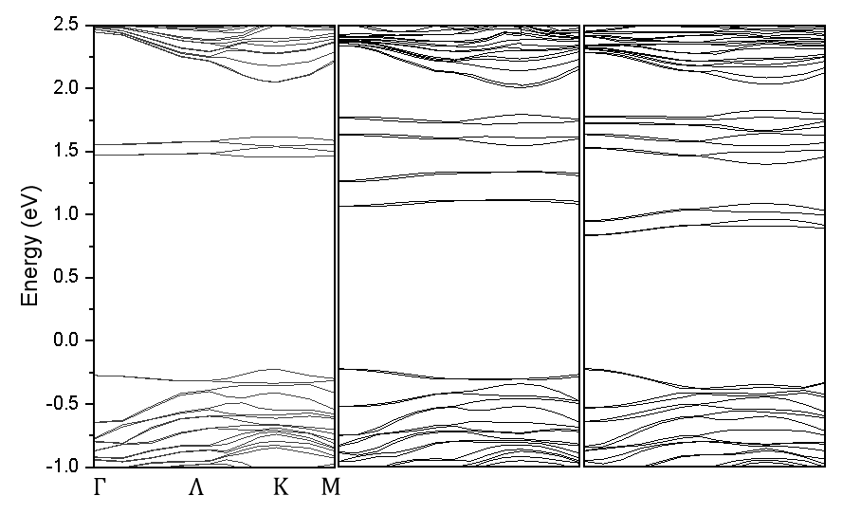
c)
a)
b)
Supplementary Figure 2: Density functional theory simulated the band structure of monolayer MoS₂ with a) 3% b) 6% and c) 9% S-vacancy defects.
It can be observed that several new bands have appeared between the conduction band and the valence band, which are formed because of defects. With the increase of defects, the quantity of defect levels correspondingly increases. Similar results are reported previously¹.

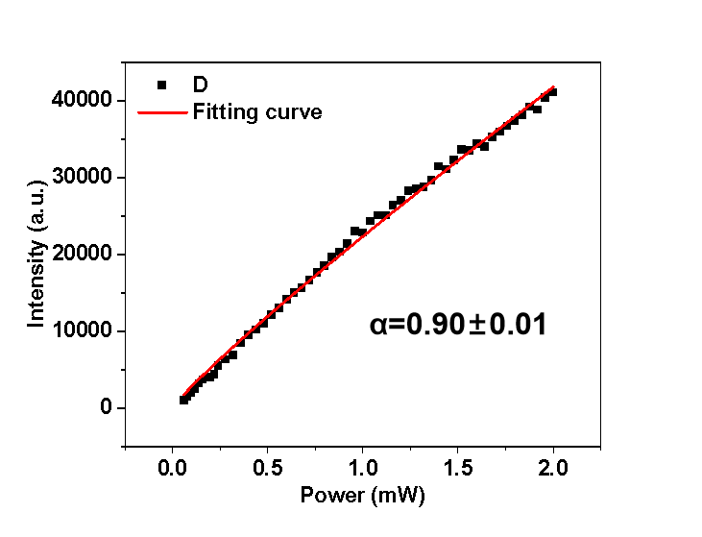
Supplementary Figure 3: Integrated photoluminescence intensity (I) of defect PL (measured at 2K) as a function of the laser power (P).
The PL intensity shows a power law dependence on the laser excitation power.
$$I∝P^{α}$$
$α<1$ suggests the recombination of electrons in defect levels and holes in valence band shown in Figure 3c (orange arrow), which also called free to bound transition^{2, 3}. As the excitation power increases, the defect PL exhibits a sublinear increase, further indicating the blocking effect of limited defect energy levels in capturing excitons. With increasing excitation power, the number of excitons rises, while the number of defect energy levels remains finite. Once the defect energy levels are continuously filled with captured electrons, the Pauli exclusion principle impedes the capture of subsequent electrons. This means that the concentration of excitons (proportional to the excitation light intensity) is not proportional to the number of electrons on defect levels (proportional to the defect PL intensity) that can recombine with holes, but instead follows a sublinear relationship.
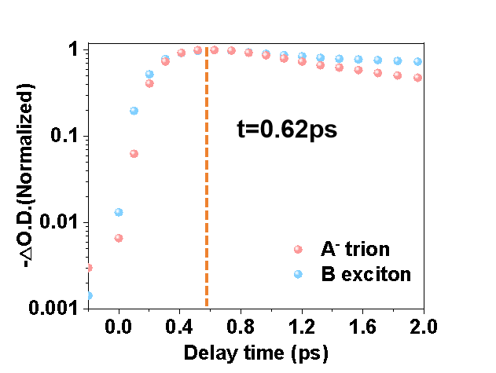

Supplementary Figure 4: Normalized decay curves of A⁻ trions and B excitons from 0 ps to 2.0 ps. It can be observed that the generation time of both A⁻ trions and B excitons is ~0.62 ps.
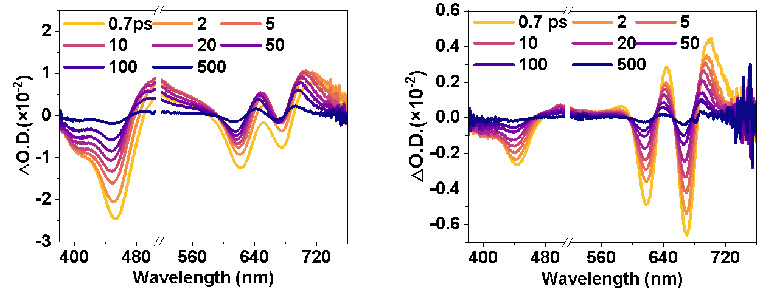
b)
a)

Supplementary Figure 5: Transient absorption spectra of monolayer MoS₂ under (a) 515 nm and (b) 343 nm pump with different delay time.

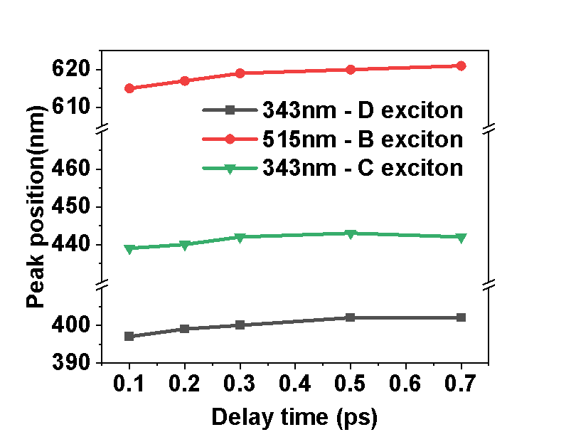
Supplementary Figure 6: Bleaching peak position of B/C/D excitons as a function of delay time under 343 nm and 515 nm pump.

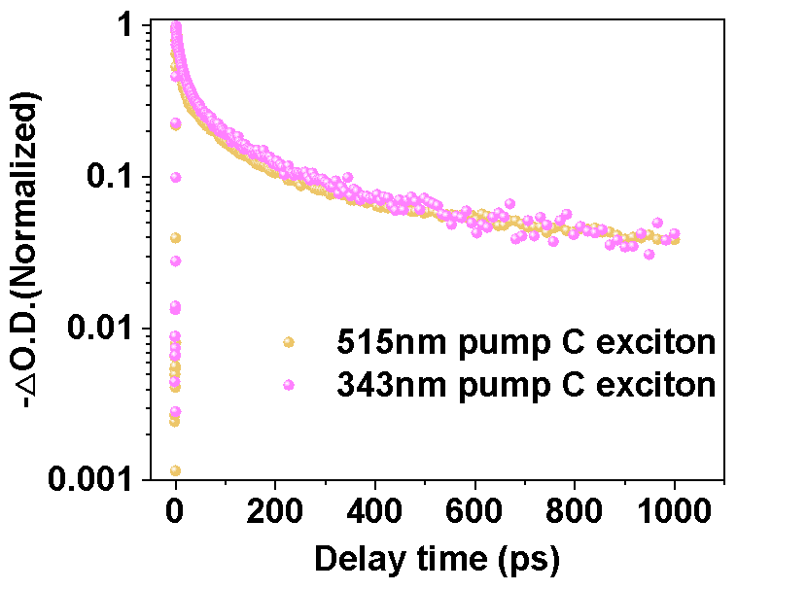
Supplementary Figure 7: Normalized decay curves of C excitons under 515 nm and 343 nm pump.

Supplementary References
1.Bussolotti F, Yang J, Kawai H, Wong CPY, Goh KEJ. Impact of S-vacancies on the charge injection barrier at the electrical contact with the MoS₂ monolayer. ACS nano 15, 2686-2697 (2021).
2.Schmidt T, Lischka K, Zulehner W. Excitation-power dependence of the near-band-edge photoluminescence of semiconductors. Physical Review B 45, 8989 (1992).
3.Kaplan D, et al. Excitation intensity dependence of photoluminescence from monolayers of MoS₂ and WS₂/MoS₂ heterostructures. 2D Materials 3, 015005 (2016).

