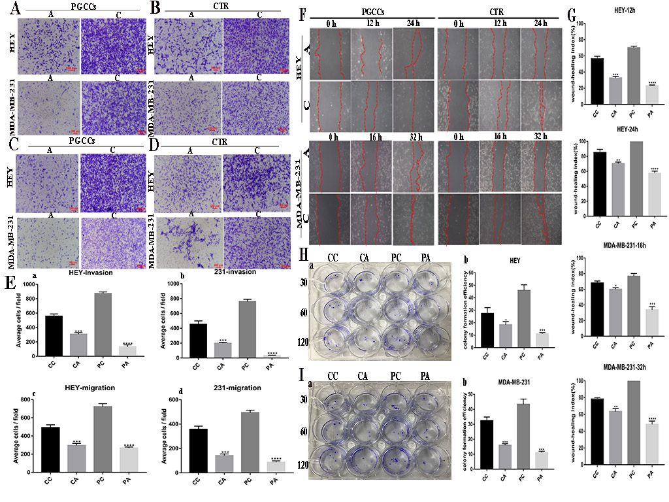
Figure S1. Migration, invasion, and proliferation abilities of HEY and MDA-MB-231 cells before and after differentiation
(A) Transwell invasion ability assay showing the migration capacity of HEY and MDA-MB-231 polyploid giant cancer cells (PGCCs) with daughter cells at different times, before and after differentiation (100×). (B) Transwell invasion ability assay showing the migration capacity of HEY and MDA-MB-231 control cells at different times, before and after differentiation (100×). (C) Transwell migration assay at different times in HEY and MDA-MB-231 PGCCs with daughter cells before and after differentiation (100×). (D) Transwell migration assay at different times in HEY and MDA-MB-231 control cells before and after differentiation (100×). (E) Column diagram showing the transwell efficiency in HEY and MDA-MB-231 control and PGCCs with daughter cells before and after differentiation. (F) Wound-healing assays for HEY and MDA-MB-231 control and PGCCs with daughter cells before and after differentiation. (G) Wound-healing index in HEY and MDA-MB-231 control and PGCCs with daughter cells before and after differentiation. (H) Plate cloning assay in HEY cells. (a) Proliferation ability in HEY control and PGCCs with daughter cells before and after differentiation. (b) Column diagram showing the colony formation efficiency between 30, 60, and 120 cells. (I) Plate cloning assay in MDA-MB-231 cells. (a) Proliferation ability in MDA-MB-231 control and PGCCs with daughter cells before and after differentiation. (b) Column diagram showing the colony formation efficiency between 30, 60, and 120 cells.
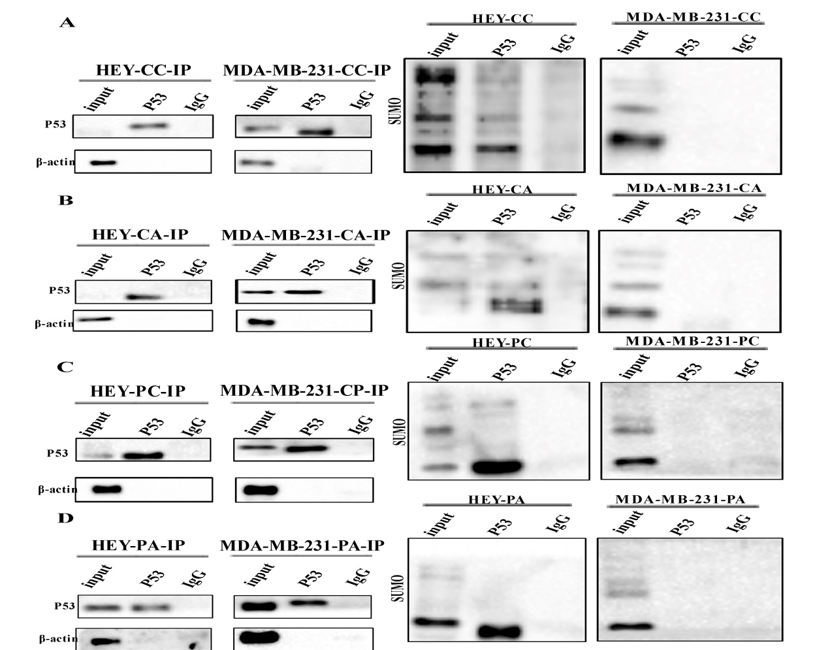
Figure S2. SUMO-P53 expression in adipogenic differentiation of HEY and MDA-MB-231 cells
(A)-(D) Total lysates of HEY and MDA-MB-231 control and polyploid giant cancer cells (PGCCs) with daughter cells before and after adipogenic differentiation were immunoprecipitated with anti-p53 and immunoblotted with anti-SUMO. (A) control cells before adipogenic differentiation. (B) control cells after adipogenic differentiation. (C) PGCCs with daughter cells before adipogenic differentiation. (D) PGCCs with daughter cells after adipogenic differentiation.

