Dynamics of Southern Hemisphere Super Gyre Response to External Forcings

Jianyu Liu¹, Yiyong Luo¹, Fukai Liu¹, and Jason Yang²

¹Frontier Science Center for Deep Ocean Multispheres and Earth System (FDOMES) and Physical Oceanography Laboratory, College of Oceanic and Atmospheric Sciences, Ocean University of China, Qingdao 266100, China

²Department of Geography and Meteorology, Ball State University, Muncie, IN 47306, USA

Corresponding author: Yiyong Luo (yiyongluo@ouc.edu.cn)

Contents of this file
Figure S1 to S9

Introduction
This supporting information file provides nine figures (Figure S1-S9) with information which are not shown in the main article.
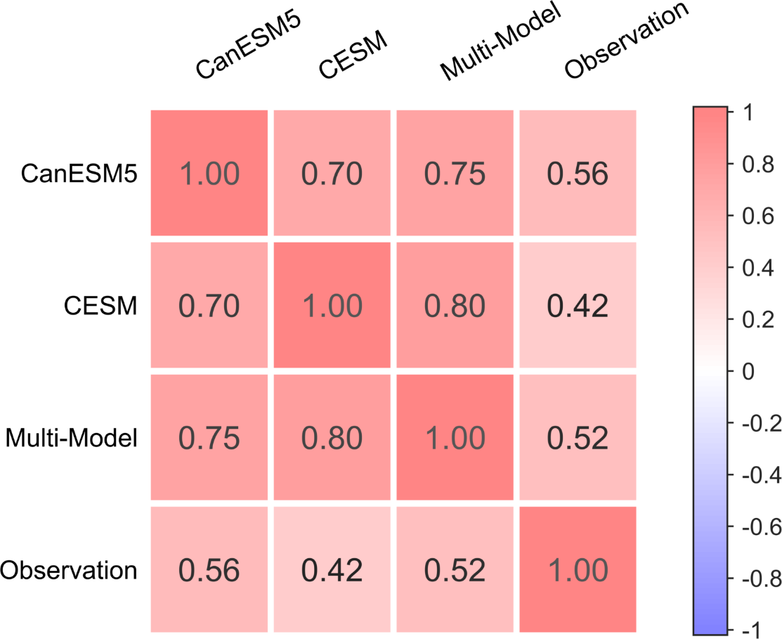
Fig. S1. The correlation coefficient heat map of the observation and the models (CanESM5, CESM, and multi-model ensembles) for the linear trend of sea surface height in the Southern Hemisphere region (0-360°E,0–60°S). Note that the linear trends are calculated during 1993-2020 for the observation and during 1955-2020 for the models.
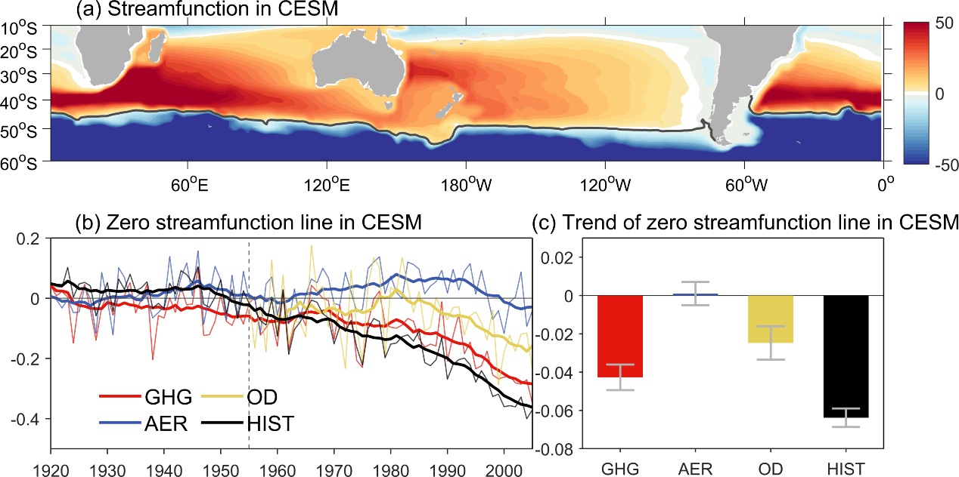
Fig. S2. Same as Fig. 3 except from CESM ensemble and the linear trends (latitude/decade) are calculated during 1955-2005.
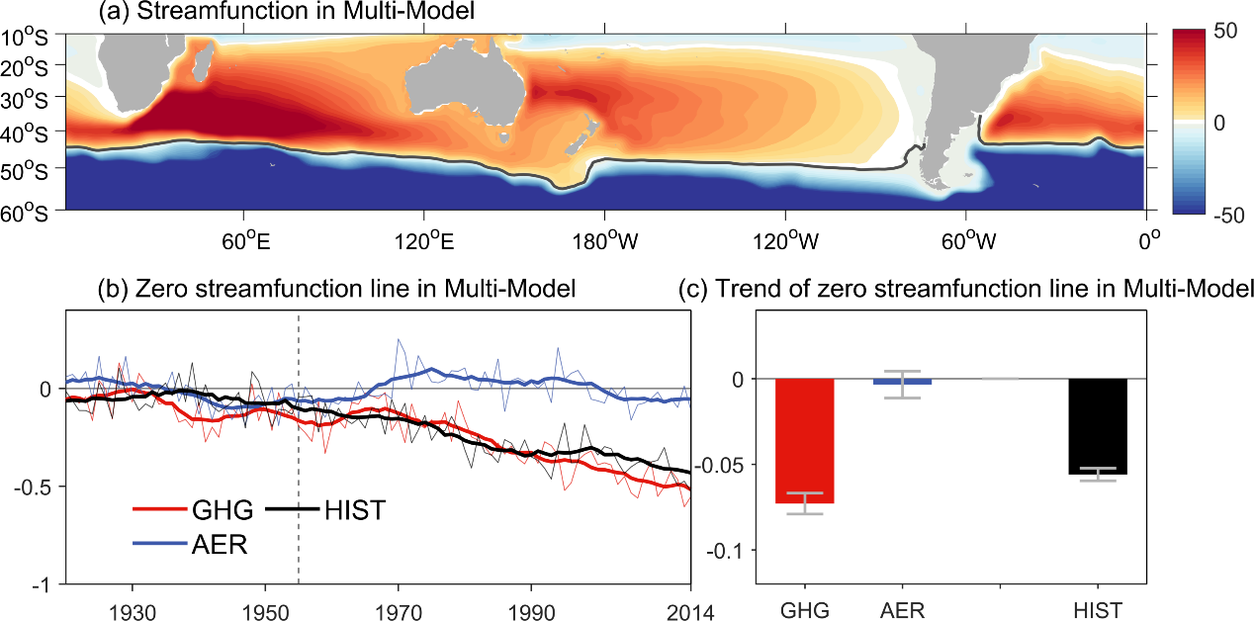
Fig. S3. Same as Fig. 3 except from multi-model ensemble and excluding the OD-only simulation.
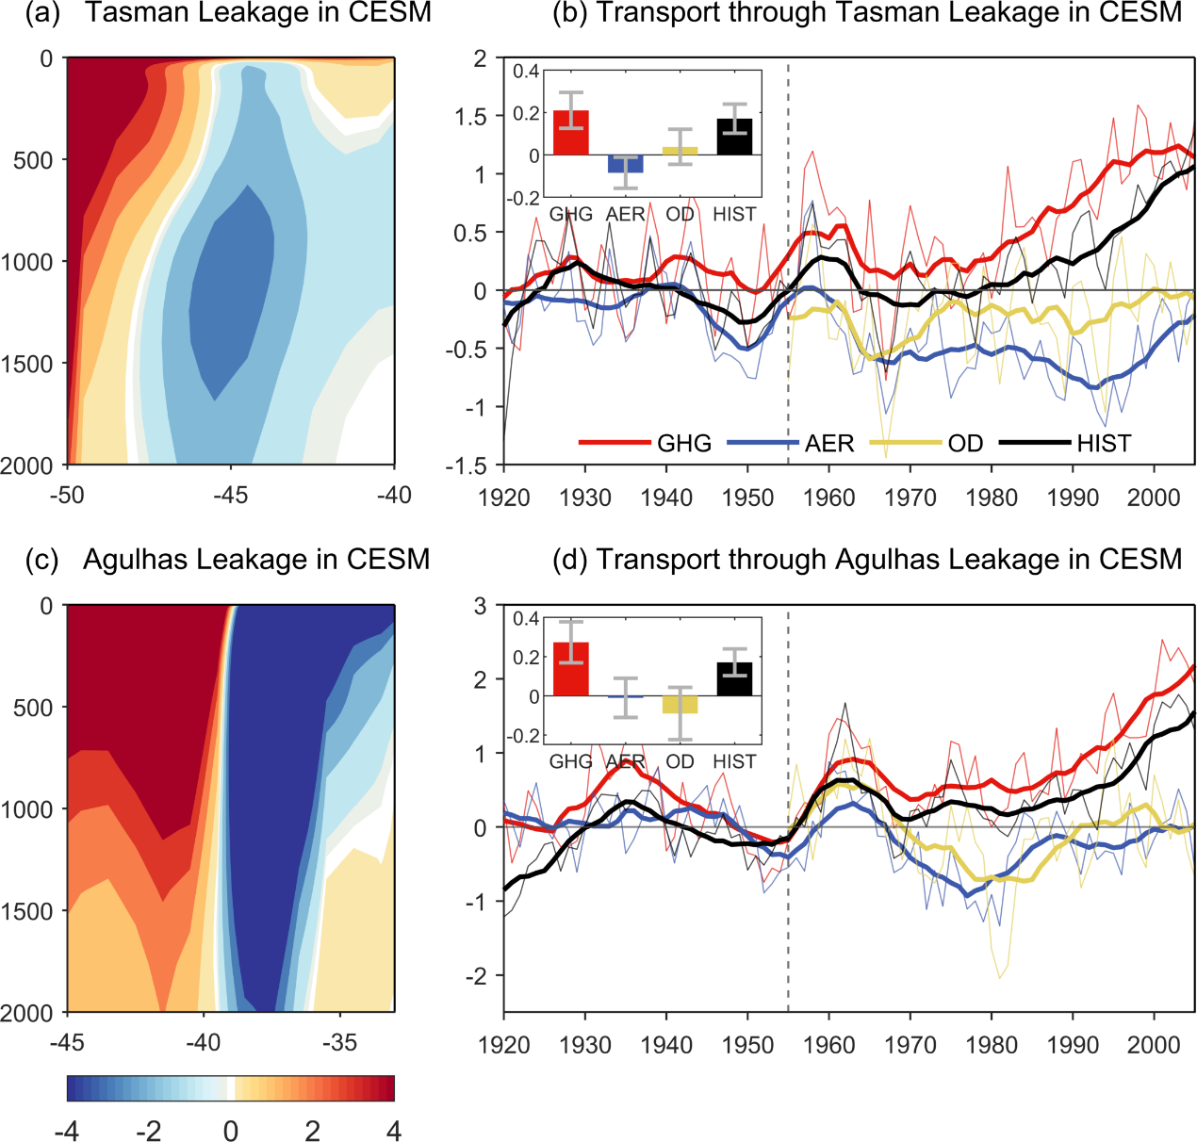
Fig. S4. Same as Figs. 4b-c&e-f except from CESM ensemble and the linear trends (Sv/decade) are calculated during 1955-2005.
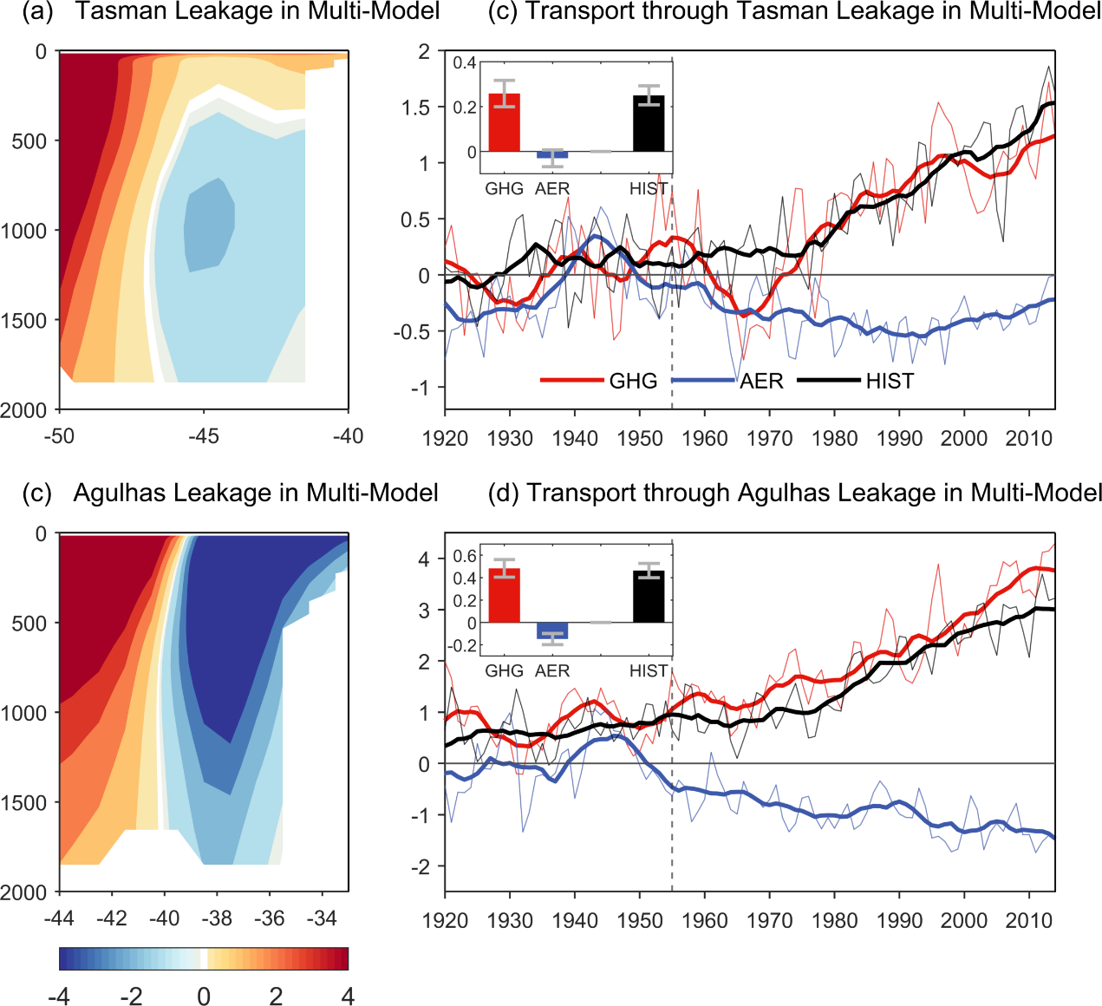
Fig. S5. Same as Figs. 4b-c&e-f except from multi-model ensemble and excluding the OD-only simulation.

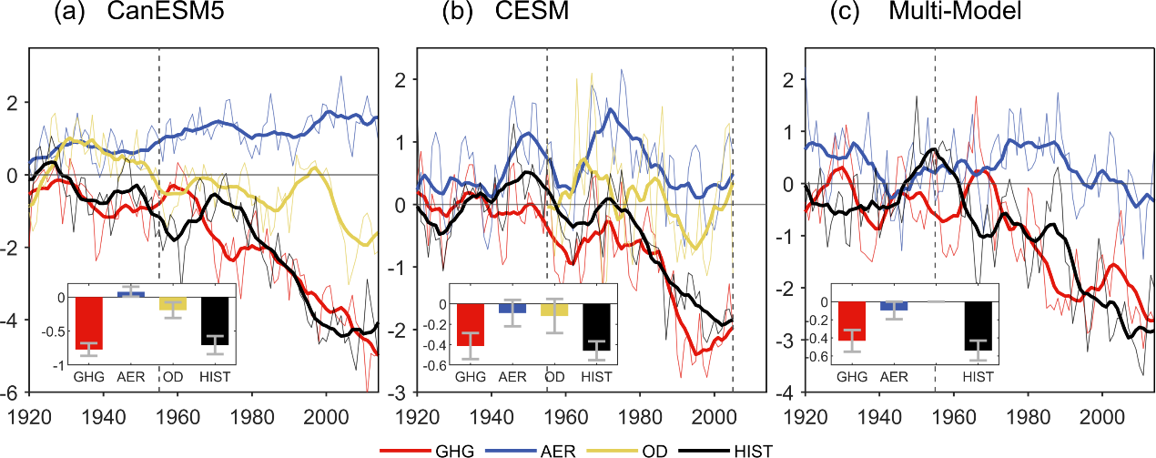
Fig. S6. Time series of changes in transport (Sv) for the flow along the Tasman Front in the historical simulations (black lines and bars) and the contributions from GHG (red lines and bars), AER (blue lines and bars), and OD (yellow lines and bars) forcings from (a) CanESM5 ensemble during 1920-2014, (b) CESM ensemble during 1920-2005, and (c) multi-model ensemble during 1920-2014. The bold lines represent the results of 10-year running mean. The bars in each panel show linear trends (Sv/decade) in transport for the flow along the Tasman Front during 1955-2014 (2005 for CESM), and the error bars are the 95% confidence interval of these trends.
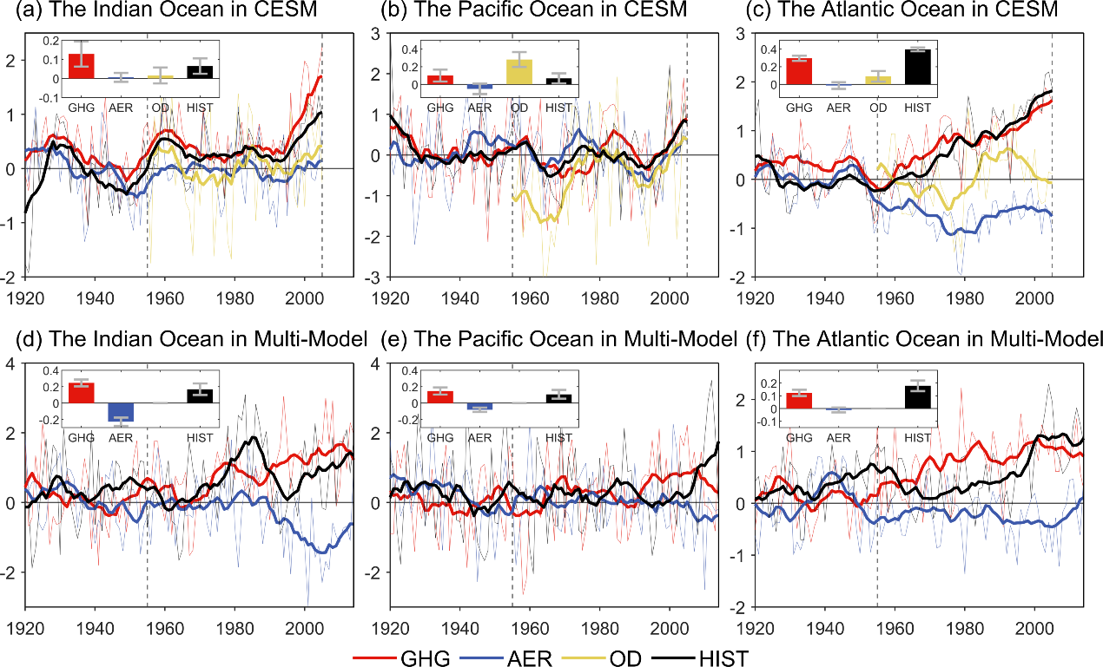
Fig. S7. Same as Fig. 5 except (a-c) from CESM and the linear trends (Sv/decade) are calculated during 1955-2005, and except (d-f) from multi-model ensemble and excluding the OD-only simulation.
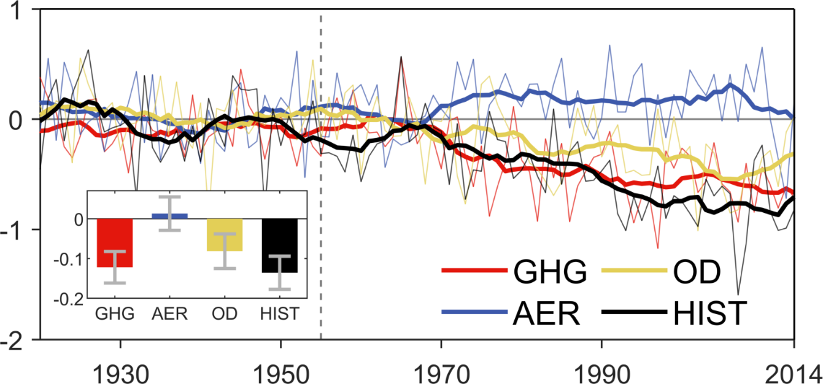
Fig. S8. Time series of change in zonal mean zero wind stress curl line (latitude) from CanESM5 ensemble in the historical simulation (black lines and bar) and the contributions from GHG (red lines and bar), AER (blue lines and bar), and OD (yellow lines and bar) forcings from 1920 to 2014. The bold lines represent the results of 10-year running mean. The bars in panel show linear trends (latitude/decade) in zonal mean zero wind stress curl line changes during 1955-2014, and the error bars are the 95% confidence interval of these trends.
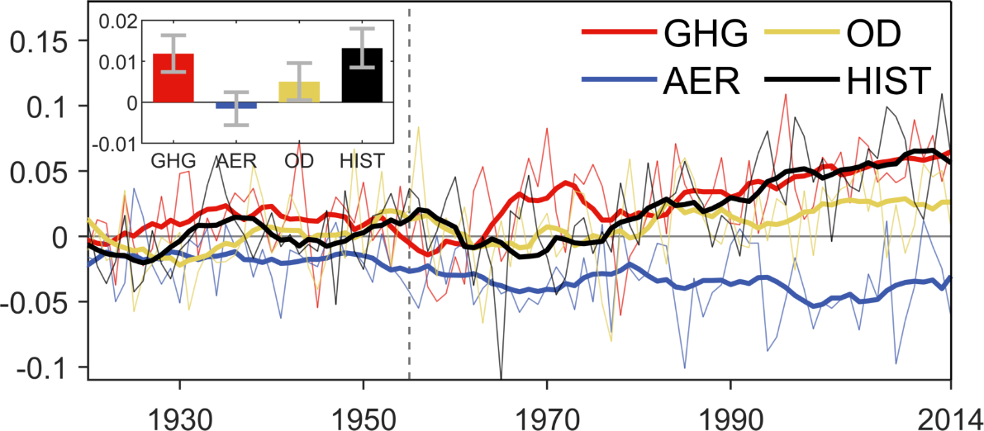
Fig. S9. Time series of change in wind stress curl (${10}^{-7}Nm^{-3}$) from CanESM5 ensemble in the South Pacific region (20-50°S, 180-280°E) in the historical simulation (black lines and bar) and the contributions from GHG (red lines and bar), AER (blue lines and bar), and OD (yellow lines and bar) forcings from 1920 to 2014. The bold lines represent the results of 10-year running mean. The bars in panel show linear trends (${10}^{-7}Nm^{-3}$/decade) in wind stress curl changes during 1955-2014, and the error bars are the 95% confidence interval of these trends.

