Ion Sequential Therapy Aligned With Pathological Changes Enhances Cardiac Function After Myocardial Infarction
Supporting Information
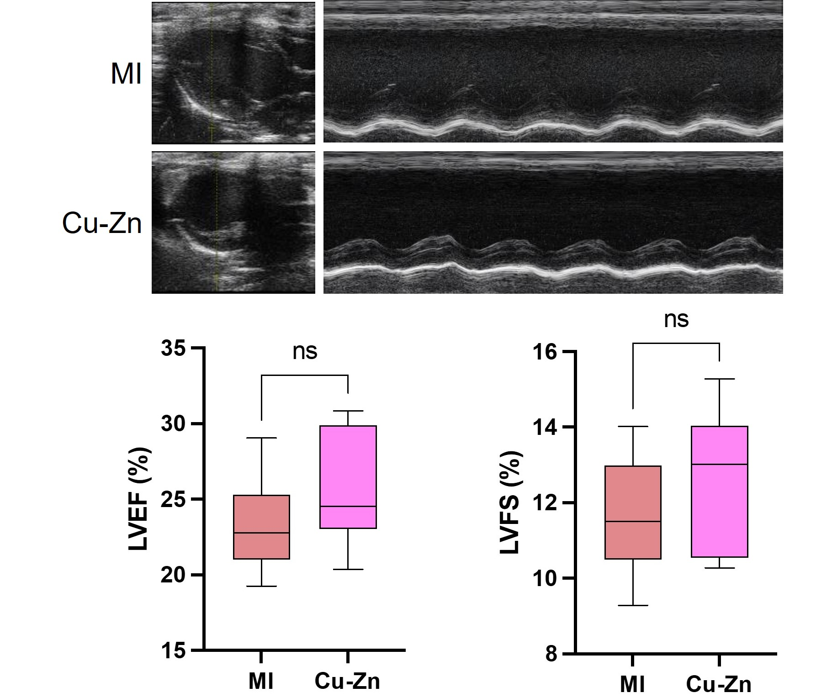
Figure S1. Echocardiographic assessment of LVEF and LVFS in rats 28 days post-myocardial infarction with Cu-Zn ion sequential therapy.

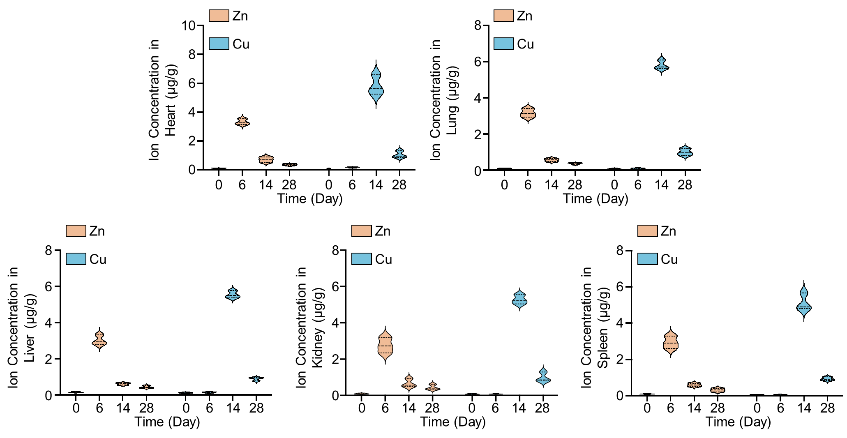
Figure S2. Zn and Cu ions change trends in heart, lung, liver, kidney, and spleen after Zn-Cu ion sequential therapy via tail vein injection for myocardial infarction.

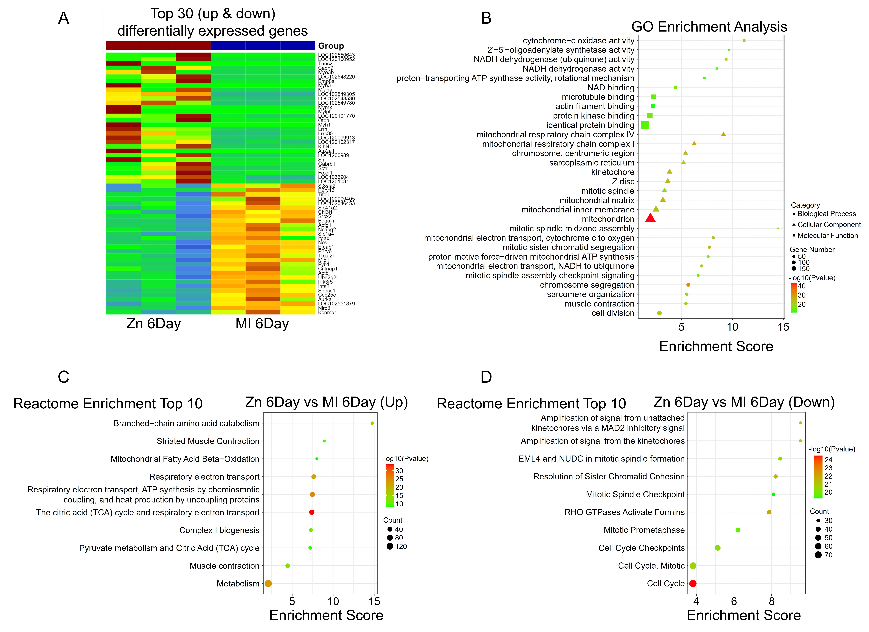
Figure S3. (A) Heatmap analysis of differentially expressed genes (DEGs) after 6 days of Zn ion therapy for myocardial infarction. (B) GO enrichment analysis of DEGs after 6 days of Zn ion therapy for myocardial infarction. (C) Top 10 reactome enrichment results for upregulated DEGs after 6 days of Zn ion therapy for myocardial infarction. (D) Top 10 reactome enrichment results for downregulated DEGs after 6 days of Zn ion therapy for myocardial infarction.

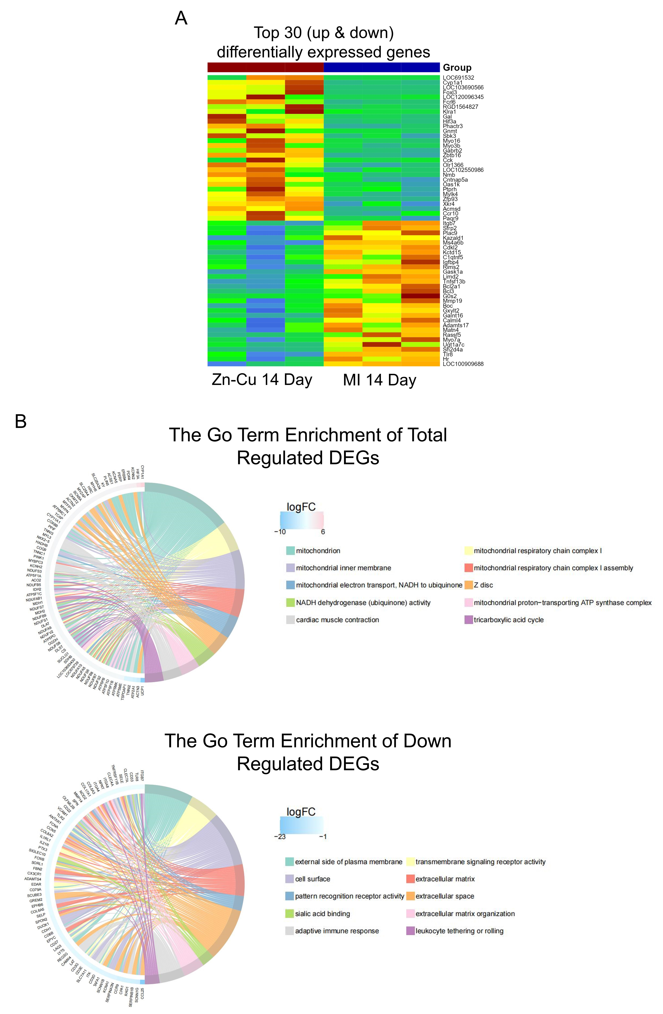
Figure S4. (A) Heatmap analysis of differentially expressed genes (DEGs) between the Zn-Cu 14-day group and the MI 14-day group. (B) GO enrichment analysis of total DEGs and down regulated DEGs comparing the Zn-Cu 14-day group to the MI 14-day group.

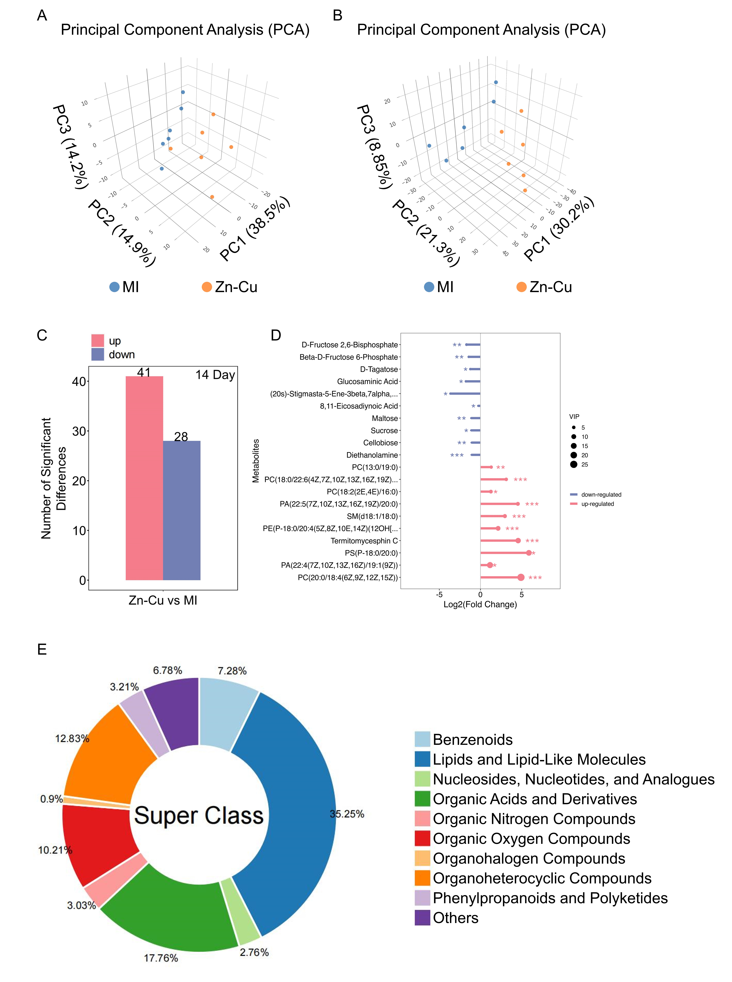
Figure S5. (A) Metabolomics comparison between the Zn-Cu ion sequential group and the MI group presented on the PCA-GCMS platform. (B) Metabolomics comparison between the Zn-Cu ion sequential group and the MI group presented on the PCA-LCMS platform. (C) The number of differential metabolites between the Zn-Cu ion sequential group and the MI group at 14 days. There are a total of 69 metabolites, of which 41 metabolites increased significantly, and 28 metabolites decreased significantly. (D) Metabolite profiling comparing the Zn-Cu 14-day group to the MI 14-day group. (E) Metabolomic analysis between the Zn-Cu ion sequential group and the MI group at 14 days. Lipids and lipid-like molecules accounted for 35.25%.

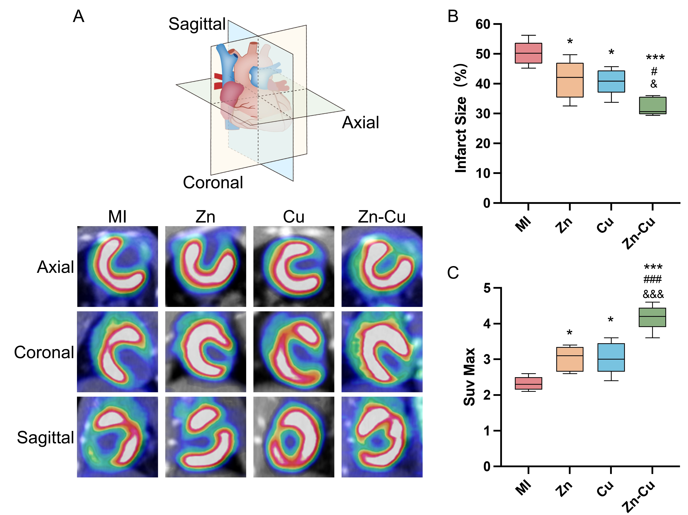
Figure S6. Zn-Cu Ion Sequential Therapy via Tail Vein Injection Enhances Cardiac Metabolic Capability. (A) Representative PET-CT image of the heart after 28 days of ion therapy administered via tail vein injection. (B, C) Assessment of infarct size and cardiomyocyte metabolic capability by PET-CT on day 28 post-myocardial infarction.
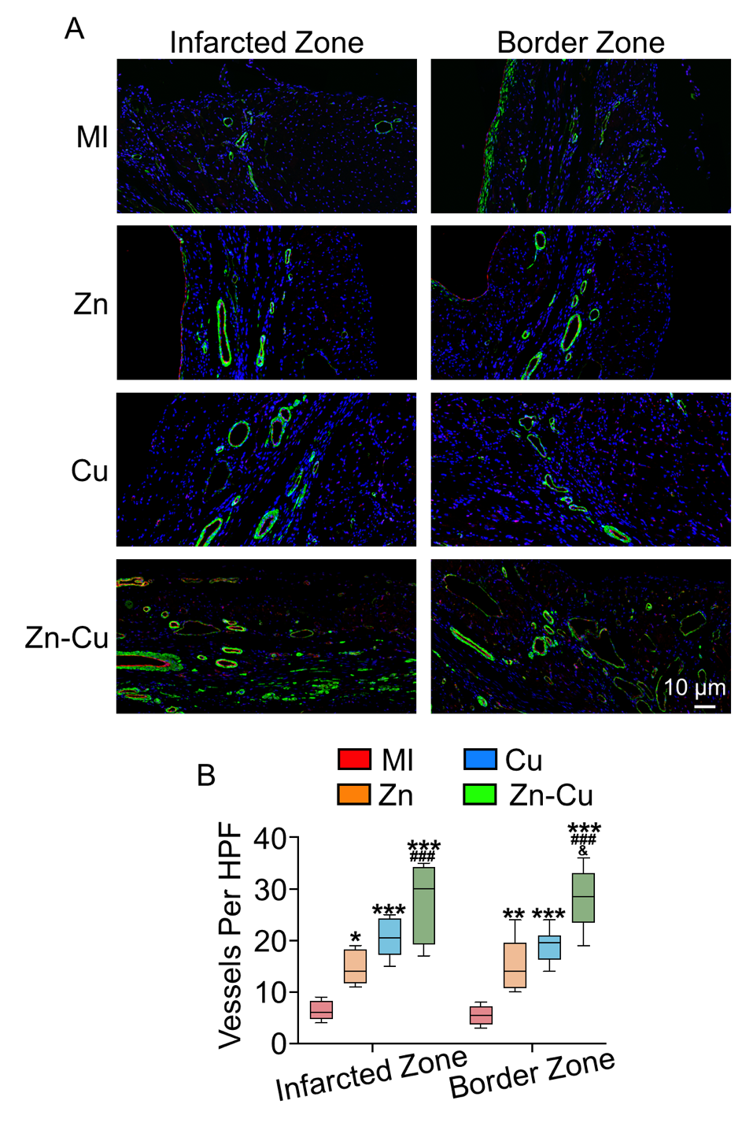
Figure S7. Zn-Cu Ion Sequential Therapy via Tail Vein Injection Promotes Angiogenesis. (A) Immunofluorescence staining of arterioles and capillaries in the infarcted and border zones, with α-SMA (green), CD31 (red), and DAPI (blue). (B) Quantitative analysis of arteriolar and capillary immunostaining, revealing vascularization improvements. ***p < 0.001, **p < 0.01, and *p < 0.05 compared to the MI group; ###p < 0.001, ##p < 0.01, and #p < 0.05 compared to the Zn group; &&&p < 0.001, &&p < 0.01, and &p < 0.05 compared to the Cu group.
Figure S8. Zn-Cu Ion Sequential Therapy via Tail Vein Injection Regulates Collagen Deposition. (A) Immunofluorescence of type III and type I collagen in myocardial tissue after ion therapy. (B) Quantitative analysis of the type III/type I collagen ratio according to immunofluorescence images. (C) Sirius red staining of type III and type I collagen in myocardial tissue after ion therapy. (D) Quantitative analysis of the type III/type I collagen ratio according to Sirius red. ***p < 0.001, **p < 0.01, and *p < 0.05 compared to the MI group; ###p < 0.001, ##p < 0.01, and #p < 0.05 compared to the Zn group; &&&p < 0.001, &&p < 0.01, and &p < 0.05 compared to the Cu group.
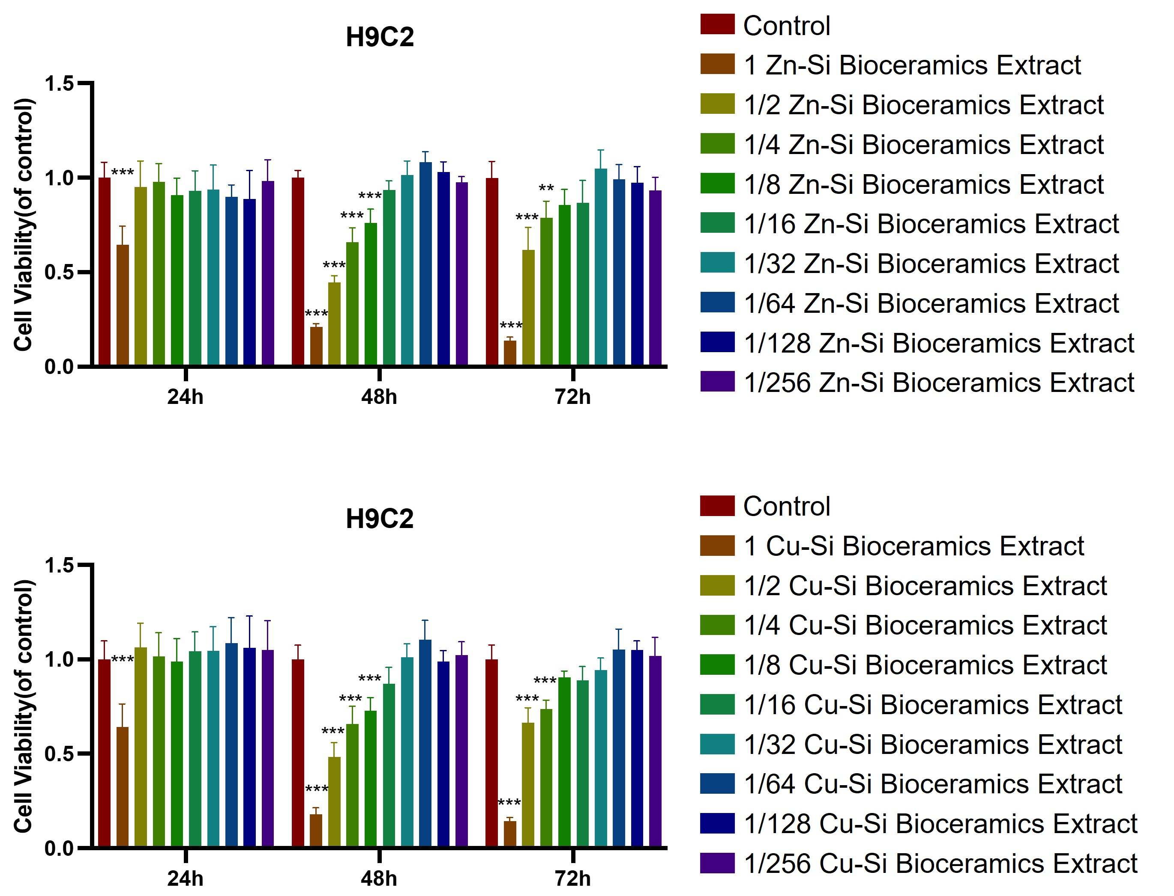
Figure S9. The effect of Zn-Si and Cu-Si bioceramic extracts on cardiomyocyte (H9C2) viability, ***p < 0.001, **p < 0.01, and *p < 0.05 compared to the Control group.

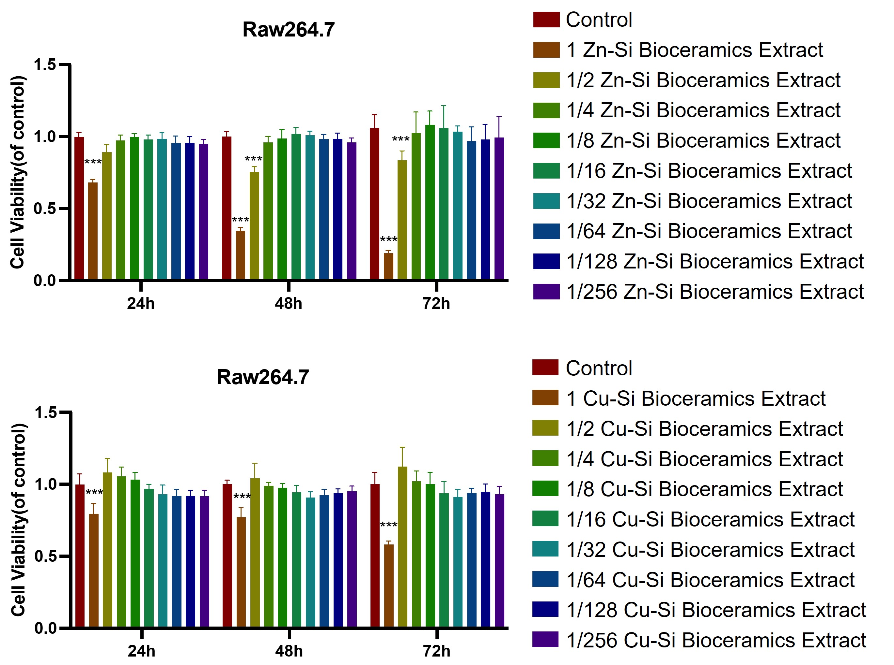
Figure S10. The effect of Zn-Si and Cu-Si bioceramic extracts on macrophages (Raw264.7) viability, ***p < 0.001, **p < 0.01, and *p < 0.05 compared to the Control group.

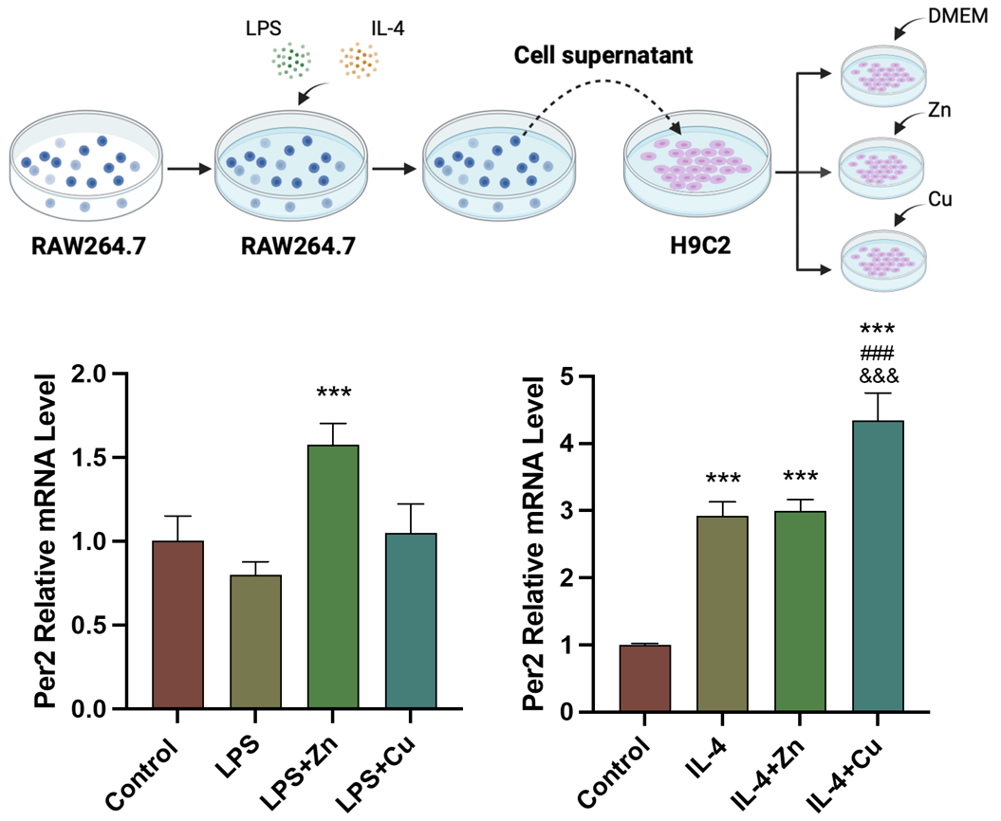
Figure S11. Zn-Cu ion sequential therapy promotes the up-regulation of Per2 in cardiomyocytes mediated by macrophages. The co-culture of Zn with M1 macrophages leads to the up-regulation of Per2, and the co-culture of Cu with M2 macrophages leads the up-regulation of Per2.

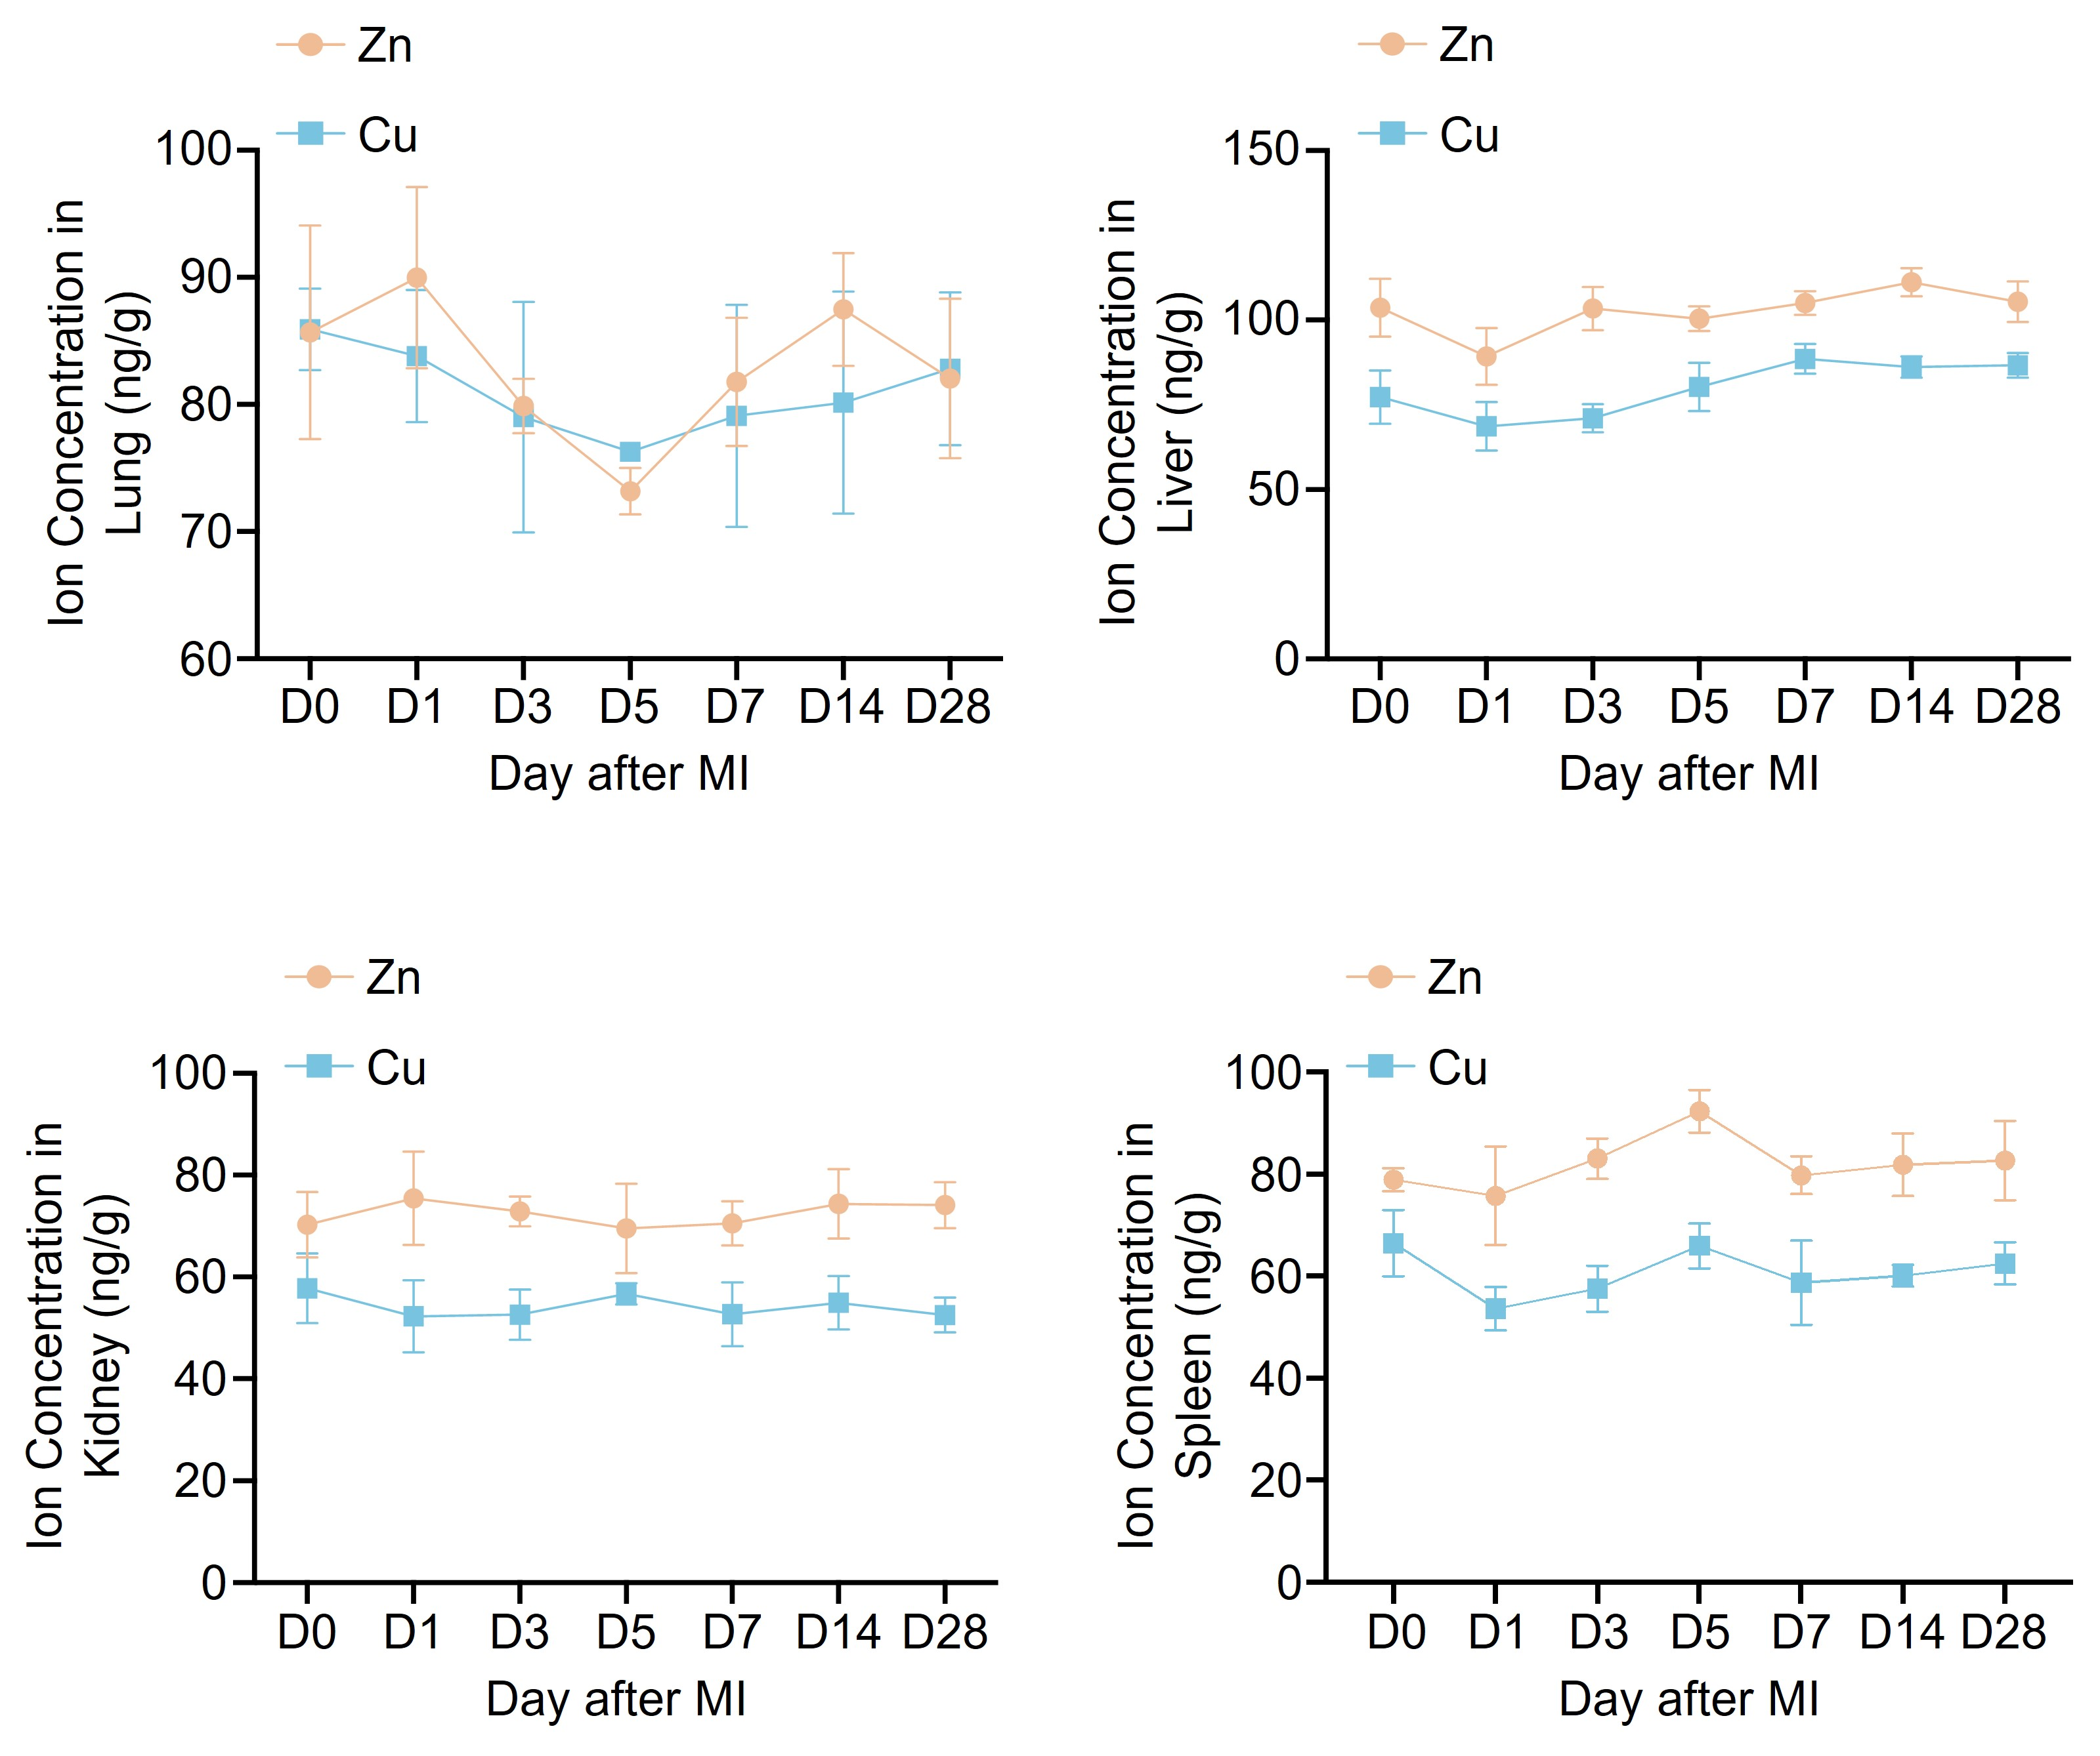
Figure S12. Zn and Cu ions change trends in lung, liver, kidney, and spleen after myocardial infarction.

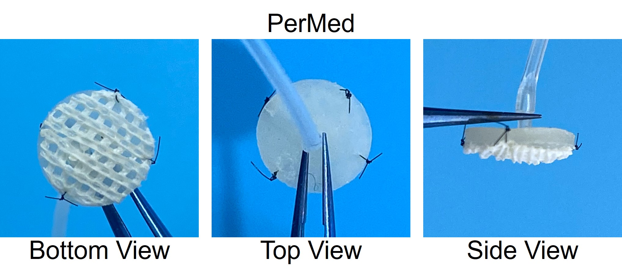
Figure S13. The optical photo images of PerMed.

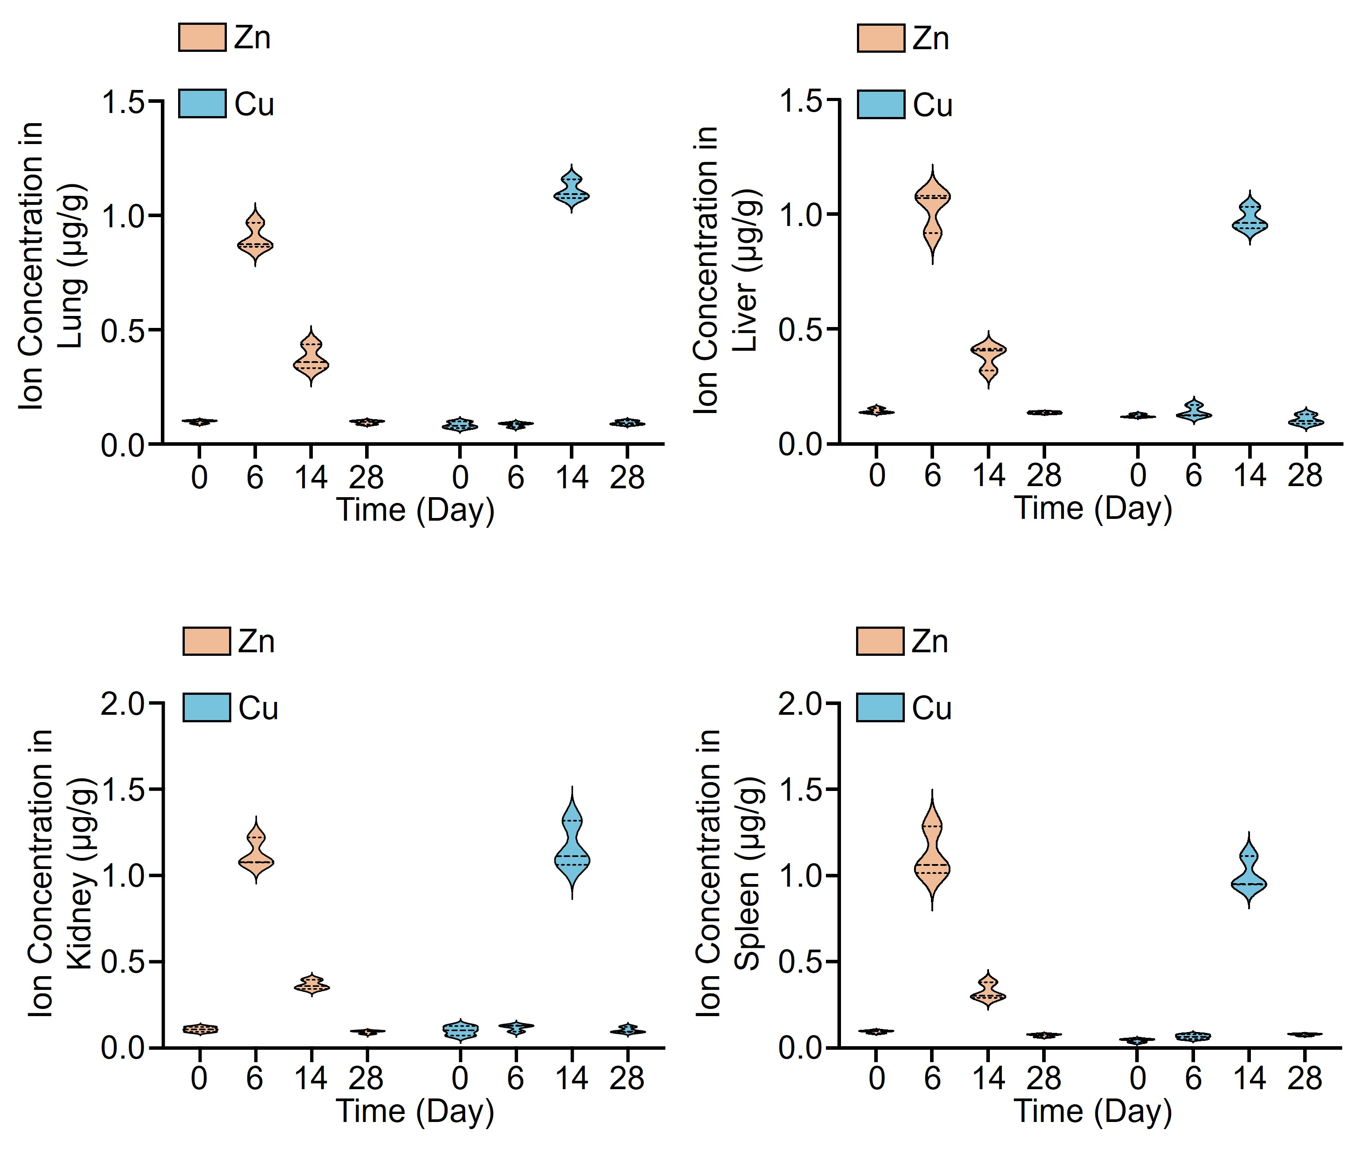

Figure S14. Zn and Cu ions change trends in lung, liver, kidney, and spleen after in situ Zn-Cu ion sequential therapy for myocardial infarction using PerMed.

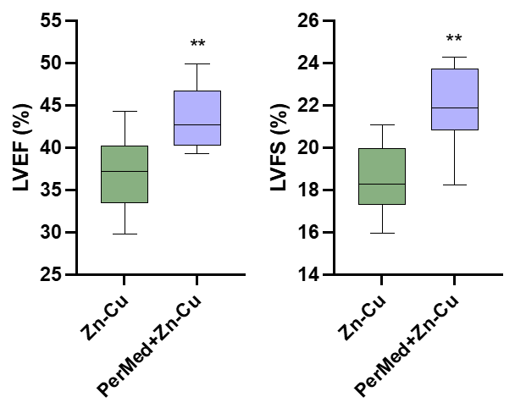
Figure S15. Echocardiographic assessment (LVEF, LVFS) of cardiac function in rats treated with Zn-Cu ions sequential via tail vein versus in situ sequential PerMed+Zn-Cu therapy. ***p < 0.001, **p < 0.01 and *p < 0.05 compared with Zn-Cu group.

Movie S1. The PerMed was interfaced with the infarcted myocardial region of rats to carry out sequential Zn-Cu ion therapy.

Table S1. Primer sequence
 | Forward primer (5'-3') | Reverse primer (5'-3')
Per2 | GCAGGCAGCAGTGATACAAGTC | CCTGCAAGACGTACTTAATGAACTG
Bmal1 | GAGGCGTCGGGACAAAATGA | GCTTCTGTGTATGGGTTGGTGG
Cry1 | TGGAGGAGCTCGGTTTTGATAC | CAGGGAGTTTGCATTCATTCG
GAPDH | CTGGAGAAACCTGCCAAGTATG | GGTGGAAGAATGGGAGTTGCT

Table S2. Antibody
Antibody | Company | Cat. No. | Application | Dilution
CD31 | Abcam | ab64543 | IF | 1:100
α-SMA | Abcam | ab5694 | IF | 1:100
α-actinin | Sigma | A7811 | IF | 1:500
Collagen I | Abcam | ab270993 | IF | 1:100
Collagen III | Abcam | ab184993 | IF | 1:100
Per2 | Thermo Fisher | PA5-89045 | WB | 1:1000

