Supplementary Material
eTable1 Comparison summary of participants' characteristics between multiple imputation, non-multiple imputation, and all adult participants data [mean (SE) / n (%)], weighted.ª
Characteristics | Multiple imputation  (Final analysis data) | Non-multiple imputation | All adult participants
Characteristics | n = 23163 | n = 23163 | n = 39749
Gender
Male | 11,143 (47.7) | 11,143 (47.7) | 19,250 (48.1)
Female | 12,020 (52.3) | 12,020 (52.3) | 20,499 (51.9)
Age (years)
< 40 | 7,742 (34.9) | 7,742 (34.9) | 13,467 (36.7)
40-64 | 9,903 (46.7) | 9,903 (46.7) | 16,580 (44.8)
≥ 65 | 5,518 (18.4) | 5,518 (18.4) | 9,702 (18.5)
Race
Non-Hispanic White | 10,898 (71.3) | 10,898 (71.3) | 16,543 (66.7)
Non-Hispanic Black | 4,806 (10.4) | 4,806 (10.4) | 8,600 (11.4)
Mexican American | 3,462 (7.5) | 3,462 (7.5) | 6,213 (8.5)
Other Hispanic | 2,038 (4.7) | 2,038 (4.7) | 3,823 (5.6)
Other/Multiracial | 1,959 (6.1) | 1,959 (6.1) | 4,570 (7.8)
Education
Less than high school | 5,294 (14.9) | 5,294 (14.9) | 10,090 (16.3)
High school | 5,317 (22.5) | 5,317 (22.5) | 9,102 (23.3)
Some college | 6,935 (31.9) | 6,935 (31.9) | 11,561 (31.2)
College or above | 5,617 (30.7) | 5,617 (30.7) | 8,996 (29.2)
Marital Status
Married/living with partner | 14,116 (65.2) | 14,116 (65.2) | 23,479 (63.2)
Widowed/divorced/separated | 5,050 (18.1) | 5,050 (18.1) | 9,001 (18.6)
Never married | 3,997 (16.7) | 3,997 (16.7) | 7,269 (18.2)
Poverty Income Ratio (PIR)
Poor | 4,647 (13.1) | 4,647 (13.1) | 7,703 (14.4)
Not poor | 18,516 (86.9) | 18,516 (86.9) | 28,229 (85.6)
Drinking Status
Non-drinker | 6,526 (23.0) | 6,515 (23.0) | 8,615 (23.5)
1-5 drinks/month | 11,514 (50.1) | 11,512 (50.1) | 14,565 (49.6)
5-10 drinks/month | 1,829 (9.4) | 1,826 (9.4) | 2,318 (9.5)
10+ drinks/month | 3,294 (17.5) | 3,287 (17.5) | 4,148 (17.3)
Smoking Status
Never smoker | 12,643 (54.7) | 12,637 (54.7) | 22,080 (55.3)
Former smoker | 5,888 (25.7) | 5,885 (25.7) | 9,504 (24.4)
Current smoker | 4,632 (19.6) | 4,630 (19.6) | 8,130 (20.3)
Sleeping Time (hours)
≤ 6 | 8,933 (35.7) | 7,543 (35.7) | 11,082 (36.5)
7-8 | 12,452 (57.1) | 10,508 (57.3) | 15,083 (56.3)
≥ 9 | 1,778 (7.2) | 1,488 (7.0) | 2,280 (7.3)
Physical Activities
Inactive | 11,380 (42.8) | 11,378 (42.8) | 20,640 (45.0)
Moderate | 6,418 (29.6) | 6,418 (29.6) | 10,152 (27.9)
Vigorous | 5,365 (27.6) | 5,365 (27.6) | 8,957 (27.0)
Body Mass Index (BMI)
Underweight | 333 (1.4) | 332 (1.4) | 616 (1.6)
Normal | 6,190 (28.2) | 6,138 (28.2) | 10,291 (28.4)
Overweight | 7,688 (33.3) | 7,626 (33.3) | 12,416 (32.8)
Obese | 8,952 (37.1) | 8,873 (37.1) | 14,296 (37.2)
Diabetes
Yes | 4,216 (14.0) | 3,827 (23.4) | 6,766 (24.3)
No | 18,947 (86.0) | 8,837 (76.6) | 14,136 (75.7)
Hypertension
Yes | 4,122 (14.9) | 348 (28.4) | 657 (32.4)
No | 19,041 (85.1) | 739 (71.6) | 1,204 (67.6)
Perceived Health
Fair or poor | 5,245 (16.5) | 5,245 (16.5) | 8,401 (17.8)
Good | 9,253 (38.7) | 9,252 (38.7) | 13,986 (39.2)
Very good | 6,474 (33.7) | 6,474 (33.7) | 9,077 (32.3)
Excellent | 2,191 (11.1) | 2,191 (11.1) | 3,180 (10.7)
Dietary Inflammatory Index (DII)
Anti-inflammatory | 5,884 (28.4) | 5,884 (28.4) | 6,728 (28.3)
Pro-inflammatory | 17,279 (71.6) | 17,279 (71.6) | 20,019 (71.7)
Work Status
Working | 12,485 (61.5) | 12,485 (61.5) | 21,115 (61.0)
Not working | 10,678 (38.5) | 10,678 (38.5) | 18,627 (39.0)
Depression
With depression | 2,004 (7.4) | 2,004 (7.4) | 3,171 (8.0)
Without depression | 21,159 (92.6) | 21,159 (92.6) | 31,143 (92.0)
Notes: PIR = poverty income ratio; BMI = body mass index; DII = dietary inflammatory index.
ª Depressed adults with a PHQ-9 score ≥ 10, while non depressed adults with a PHQ-9 score < 10. Mean ± standard deviation was used to describe continuous variables, and number (constituent ratio [%]) was used to describe categorical variables. The percentages, means, and standard deviations were derived by applying the full sample 2 year Mobile Examination Center (MEC) exam weight provided in the National Health and Nutrition Examination Survey (NHANES).

eTable2 The association of DII, work status, work types, and shift work with depression, using data of multiple imputation, non-multiple imputation, and all adult participants.ª
Independent Variables | OR (95CI%)
Independent Variables | Multiple imputation  (Final analysis data) | Non-multiple imputation | All adult participants
Dietary Inflammatory Index (DII)
Anti-inflammatory | Reference | Reference | Reference
Pro-inflammatory | 1.30 (1.10, 1.55)** | 1.31 (1.10, 1.56)** | 1.17 (1.02, 1.35)*
Work Status
Not Working | Reference | Reference | Reference
Working | 0.46 (0.40, 0.53)*** | 0.46 (0.40, 0.53)*** | 0.50 (0.44, 0.56)***
Work Types
Not working | Reference | Reference | Reference
Private employee | 0.45 (0.38, 0.52)*** | 0.45 (0.38, 0.52)*** | 0.50 (0.44, 0.56)***
Government employee | 0.50 (0.37, 0.68)*** | 0.49 (0.36, 0.67)*** | 0.48 (0.37, 0.61)***
Self-employed | 0.52 (0.35, 0.77)** | 0.51 (0.35, 0.75)*** | 0.54 (0.39, 0.74)***
Unpaid family business or farm | 0.59 (0.16, 2.18) | 0.61 (0.17, 2.19) | 1.02 (0.45, 2.33)
Shift Work
Not working | Reference | Reference | Reference
Regular daytime | 0.45 (0.38, 0.53)*** | 0.45 (0.39, 0.52)*** | 0.48 (0.42, 0.54)***
Evening/Night | 0.58 (0.40, 0.83)** | 0.45 (0.32, 0.63)*** | 0.53 (0.39, 0.72)***
Rotating shift | 0.43 (0.28, 0.65)*** | 0.53 (0.36, 0.77)*** | 0.47 (0.35, 0.63)***
Another schedule | 0.52 (0.36, 0.76)*** | 0.45 (0.31, 0.66)*** | 0.67 (0.51, 0.89)**
Notes: CI = confidence interval; PIR = poverty income ratio; BMI = body mass index; DII = dietary inflammatory index.
ª The analysis in this table was benchmarked to the model 3 in the table 2, all models were adjusted for gender, age, education, race, marital status, PIR, drinking status, smoking status, sleeping time, physical activities, BMI, diabetes, hypertension, and self-reported perceived health. *** p <0.001; **p<0.01; *p<0.05.

eTable3 The moderating effect of work status, work types, and shift work on the association between DII and depression, using propensity score matching (PSM) method.ª
Moderating Effect | Independent Variables | β (95CI%) |  |  | P-value ^{b}
Moderating Effect |  | Model 1 | Model 2 | Model 3 | P-value ^{b}
Interaction | DII × Work Status |  |  |  | <0.001
Slope analysis | Not Working | 0.41 (0.35, 0.48)*** | 0.28 (0.21, 0.34)*** | 0.13 (0.07, 0.19)***
Slope analysis | Working | 0.22 (0.15, 0.29)*** | 0.08 (0.02, 0.15)* | -0.03 (-0.09, 0.04)
Interaction | DII × Work Types |  |  |  | <0.001
Slope analysis | Not working | 0.41 (0.35, 0.48)*** | 0.28 (0.21, 0.34)*** | 0.13 (0.07, 0.19)***
Slope analysis | Private employee | 0.25 (0.18, 0.33)*** | 0.11 (0.04, 0.19)** | -0.01 (-0.08, 0.06)
Slope analysis | Government employee | 0.18 (0.01, 0.35)* | 0.05 (-0.12, 0.22) | -0.06 (-0.22, 0.09)
Slope analysis | Self-employed | 0.05 (-0.16, 0.25) | -0.05 (-0.25, 0.16) | -0.05 (-0.24, 0.14)
Slope analysis | Unpaid family business or farm | 0.26 (-0.87, 1.39) | 0.20 (-0.90, 1.31) | 0.08 (-0.94, 1.11)
Interaction | DII × Shift Work |  |  |  | <0.001
Slope analysis | Not working | 0.41 (0.35, 0.48)*** | 0.28 (0.21, 0.34)*** | 0.13 (0.07, 0.19)***
Slope analysis | Regular daytime | 0.19 (0.11, 0.27)*** | 0.05 (-0.03, 0.13) | -0.06 (-0.13, 0.01)
Slope analysis | Evening/Night | 0.23 (0.00, 0.45)* | 0.09 (-0.13, 0.30) | -0.01 (-0.21, 0.19)
Slope analysis | Rotating shift | 0.32 (0.08, 0.55)** | 0.20 (-0.03, 0.43) | 0.15 (-0.06, 0.37)
Slope analysis | Another schedule | 0.33 (0.10, 0.55)** | 0.21 (-0.01, 0.43) | 0.07 (-0.13, 0.28)
Notes: CI = confidence interval; PIR = poverty income ratio; BMI = body mass index; DII = dietary inflammatory index.
ª The analyzes were benchmarked to the models in the table 3. The PHQ-9 score and DII were set as continuous variables, workforce participation was set as categorical variable, including work status, work types, and shift work, for this moderating effect model. Model 1 was unadjusted. Model 2 was adjusted for gender, age, education, race, marital status, and PIR. Model 3 was adjusted for gender, age, education, race, marital status, PIR, drinking status, smoking status, sleeping time, physical activities, BMI, diabetes, hypertension, and self-reported perceived health. *** p <0.001; **p<0.01; *p<0.05. In the propensity score matching (PSM) method, caliper value was set to 0.05, and 12500 of the 23163 original observations were successfully matched. ^{b} P-value of the interaction effect of DII with work status, work types, and shift work in the model 3 was reported here.

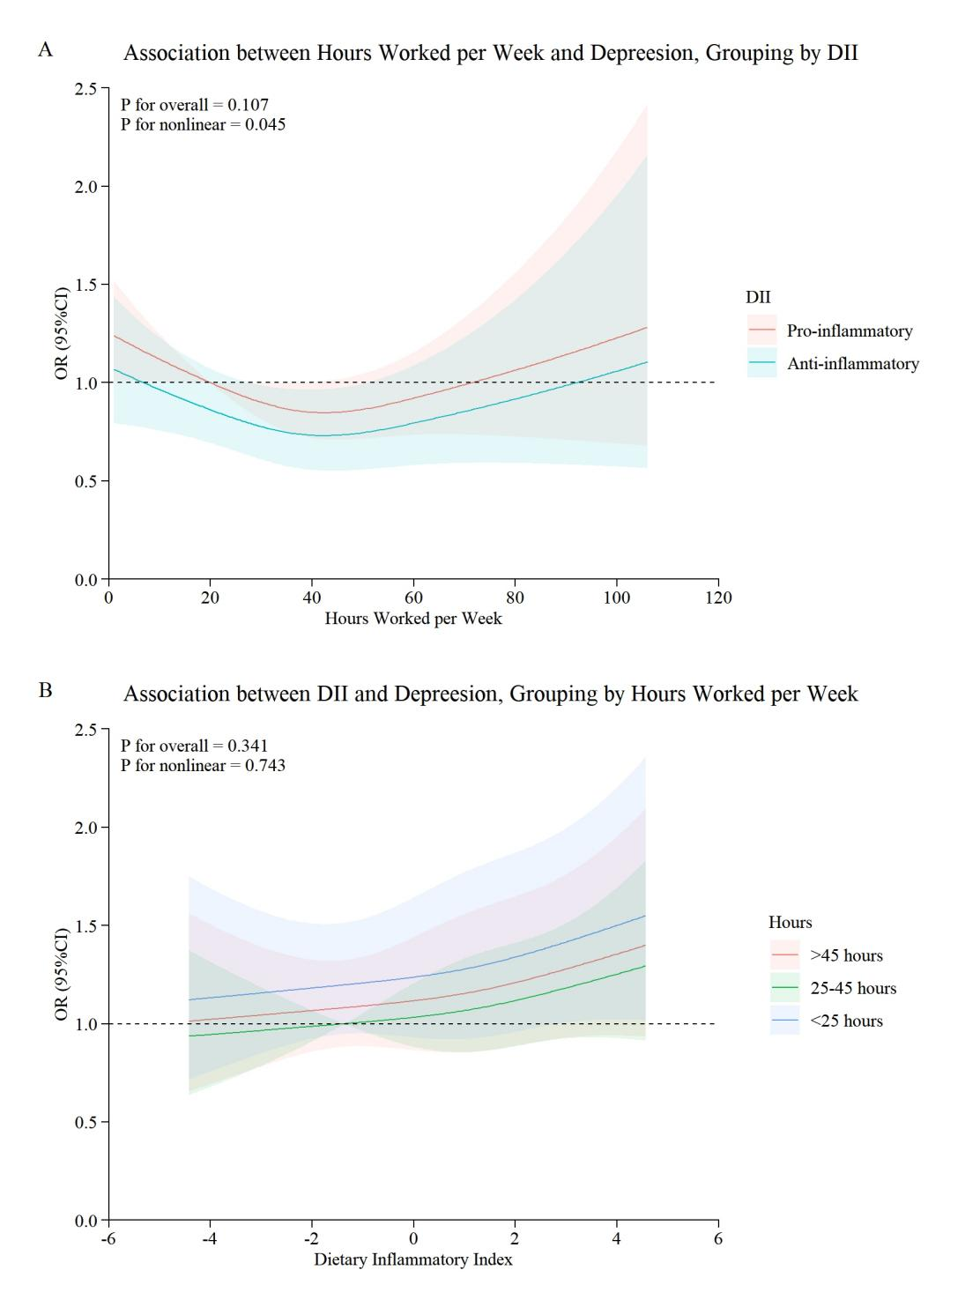
eFig1. The restricted cubic spline (RCS) for the association of DII and hours worked per week with depression at different levels.
Notes: The data of non-multiple imputation was used. (A) Non-linearity of hours worked per week with depression, grouping by DII. The solid red and green lines represent estimates of the adjusted OR coefficients for the pro-inflammatory diet (DII ≥ 0) and anti-inflammatory diet (DII < 0) groups, the shadow represents 95% confidence intervals, and the reference OR value was set to 1 (dashed black line). (B) Linearity of DII with depression, grouping by hours worked peer week. The solid blue, green, and red lines represent estimates of the adjusted OR coefficients for the <25 hours, 25-45 hours, and >45 hours groups, the shadow represents 95% confidence intervals, and the reference OR value was set to 1 (dashed black line). In this two RCS for binary logistic regression models, PHQ-9 score was divided into two categories: depression with a score ≥ 10, while no depression with a score < 10. Both models were adjusted for: gender, age, education, race, marital status, PIR, drinking status, smoking status, sleeping time, physical activities, BMI, diabetes, hypertension, and self-reported perceived health. PIR = poverty income ratio; BMI = body mass index; DII = dietary inflammatory index.
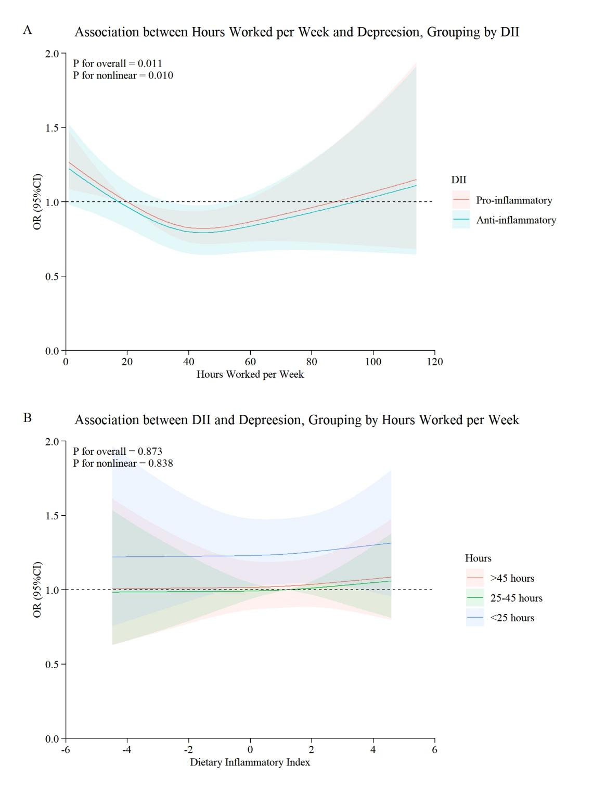
eFig2. The restricted cubic spline (RCS) for the association of DII and hours worked per week with depression at different levels.
Notes: The data of all adult participants was used. (A) Non-linearity of hours worked per week with depression, grouping by DII. The solid red and green lines represent estimates of the adjusted OR coefficients for the pro-inflammatory diet (DII ≥ 0) and anti-inflammatory diet (DII < 0) groups, the shadow represents 95% confidence intervals, and the reference OR value was set to 1 (dashed black line). (B) Linearity of DII with depression, grouping by hours worked peer week. The solid blue, green, and red lines represent estimates of the adjusted OR coefficients for the <25 hours, 25-45 hours, and >45 hours groups, the shadow represents 95% confidence intervals, and the reference OR value was set to 1 (dashed black line). In this two RCS for binary logistic regression models, PHQ-9 score was divided into two categories: depression with a score ≥ 10, while no depression with a score < 10. Both models were adjusted for: gender, age, education, race, marital status, PIR, drinking status, smoking status, sleeping time, physical activities, BMI, diabetes, hypertension, and self-reported perceived health. PIR = poverty income ratio; BMI = body mass index; DII = dietary inflammatory index.

