Supporting Information
Development and utilization of a fluorescence sensor for Zn²⁺ detection
Xiujuan Li^{1,2}, Tinghuan Gao ¹, Shoucheng Wang ², Qing Zhang ¹, Siyu Chen¹, Xinchao Wang ^{1,3*}, Qianqian Liu ^{1*}
¹Heze Univeristy, Heze, Shangdong, 274015, China.
²Heze Vocational College, Heze Shangdong, 274015, China.
³Key Laboratory of Targeted Diagnosis and Treatment of Cancer diseases of Heze, Heze, Shangdong, 274015, China)

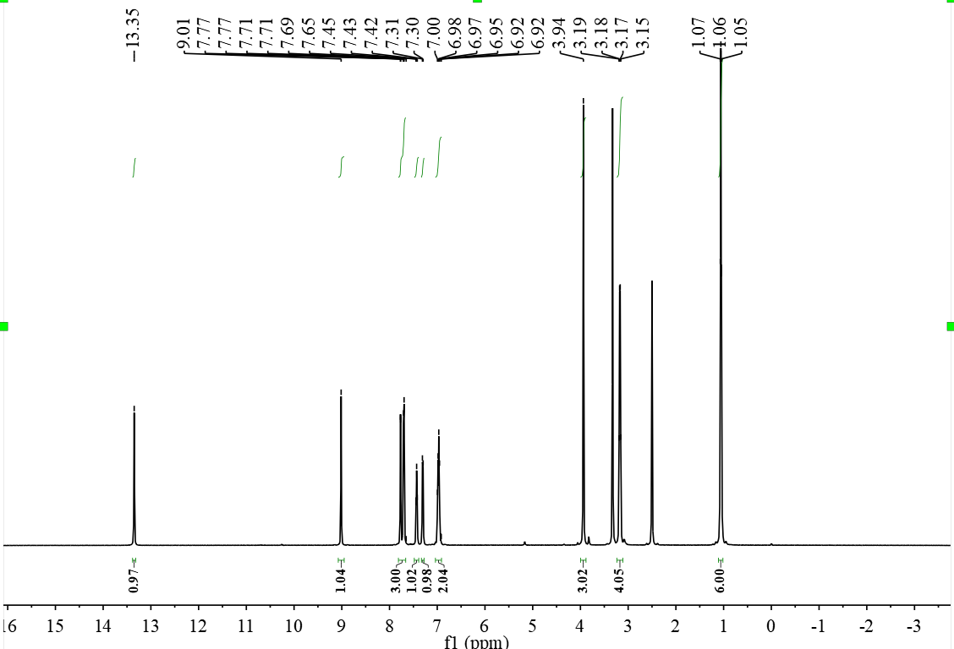
Fig S1.¹H NMR (400 MHz, DMSO-d₆): Spectra of Probe-Zn

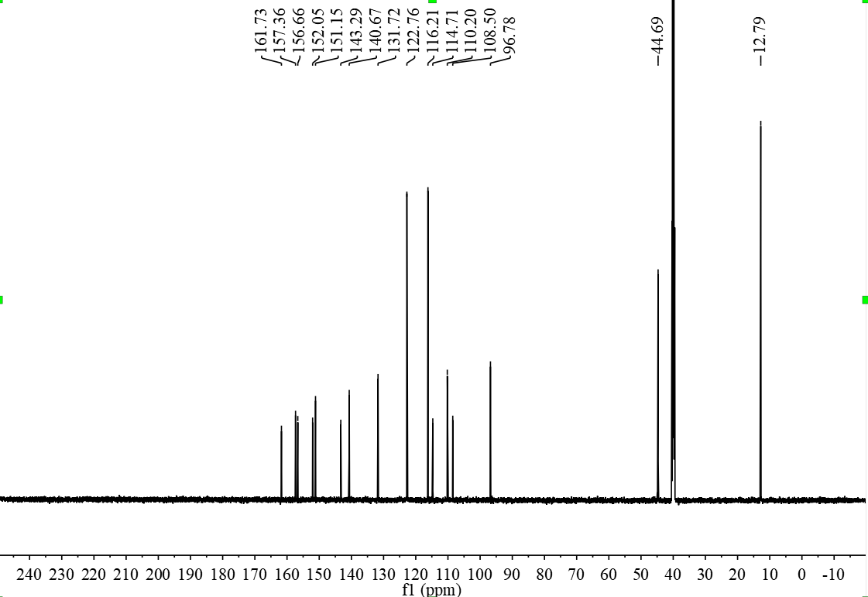
Fig S2.¹³C NMR (100 MHz, DMSO-d₆): Spectra of Probe-Zn

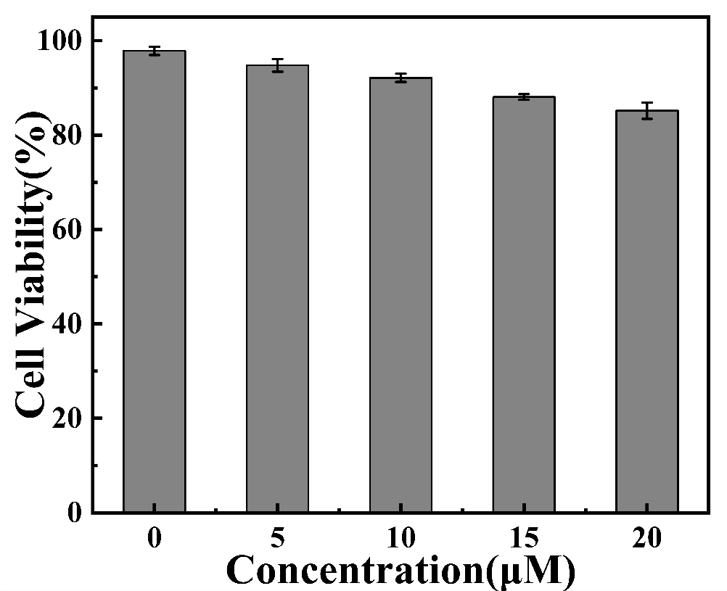
Figure S3 Cell viability assay for HeLa cells treated with different concentrations of Probe-Zn.

