Supplementary Information

Further characterization of lipase B from Ustilago maydis expressed in Pichia pastoris: a member of “Candida antarctica lipase B like” superfamily

Marcela Robles-Machuca ^{1,2}, Tania Diaz-Vidal ¹, M. Angeles Camacho-Ruiz ^{1,3}, Raúl B. Martínez-Pérez ^{1,4}, Martha Martin del Campo ^{1,3}, Juan Carlos Mateos-Díaz ¹, Jorge A. Rodríguez ^{1*}

¹ Unidad de Biotecnología Industrial, Centro de Investigación y Asistencia en Tecnología y Diseño del Estado de Jalisco A.C., 45019, Zapopan, Jal., Mexico
² Present Address: Unidad de Tecnología de alimentos, Secretaría de investigación y posgrado, Universidad Autónoma de Nayarit, 63000, Tepic, Nay., México
³ Present Address: Laboratorio de Investigación en Biotecnología, Departamento de Fundamentos del Conocimiento, Centro Universitario del Norte, Universidad de Guadalajara, 46200, Colotlán, Jal., México
⁴ Present Address: Departamento de Biotecnología y Ciencias Alimentarias, Instituto Tecnológico de Sonora, 85137 Ciudad Obregón, Mexico

* Corresponding author: jrodriguez@ciatej.mx (J.A. Rodríguez). Tel.: +52 1 3345 5200 ext. 2108.

Supplementary Tables

Supplementary Table 1 Purification table of rUMLB and rCALB lipases produced in P. pastoris. The lipase activity was assessed using the PHIBLA method (Camacho-Ruiz et al., 2015) [14] with TG (4:0) as substrate, at 37 °C for 15 min.
Step | Total activity (U) | Total protein (mg) | Specific activity ª (U mg⁻¹) | Purification fold | Yield (%)
rUMLB
Cell-free culture | 1108 | 28.7 | 38.5 | 1.0 | 100.0
Precipitation with NH₂SO₄ (3 mol L⁻¹) | 62.1 | 1.56 | 39.7 | 1.2 | 30.6
Butyl-Sepharose | 330.6 | 4.9 | 66.6 | 1.7 | 13.5
rCALB
Cell-free culture | 32088 | 389.6 | 82.4 | 1.0 | 100.0
Precipitation with NH₂SO₄ (2.5 mol L⁻¹) | 20857 | 215.3 | 96.3 | 1.2 | 65.0
Butyl-Sepharose | 5900 | 53.7 | 109.8 | 2.3 | 18.4
ª Activity measured in microplate assay

Supplementary Table 2 Molecular weights and experimental mass of purified lipases expressed in P. pastoris.
Enzyme | Theoretical mass (Da) | Experimental Mass  (Da) | Mass difference (Da) | N-glycosylation putative sites *
rCALB | 33022 | 35862 | 2840 | N74
rUMLB | 33191 | 38618 | 5427 | N44, N75
* NetNGlyc 1.0 Server

Supplementary Figures

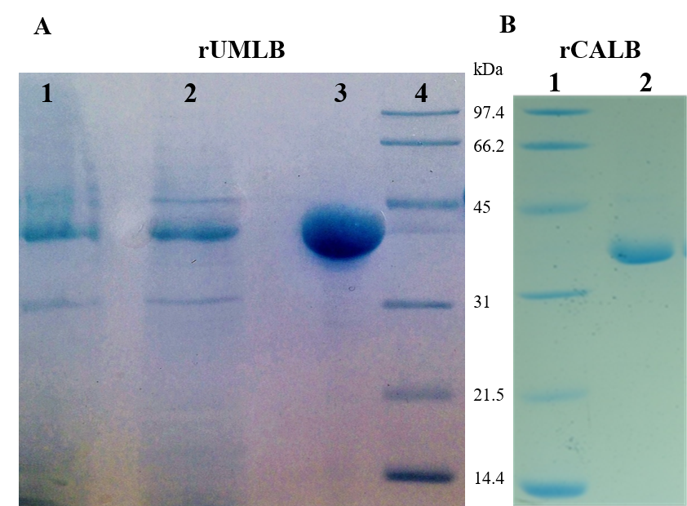
Supplementary Fig. 1 SDS-PAGE (12 %) gel under reducing conditions, using Coomassie brilliant blue to stain the proteins for A) rUMLB and B) rCALB. In A) Line 1: proteins in free medium cell culture; line 2: ammonium sulfate precipitation, line 3: purified rUMLB fraction eluted from Butyl-sepharose, line 4: low range Bio Rad molecular weight marker. In B) Line 1: low range Bio Rad molecular weight marker; line 2: purified rCALB fraction eluted from Butyl-sepharose.

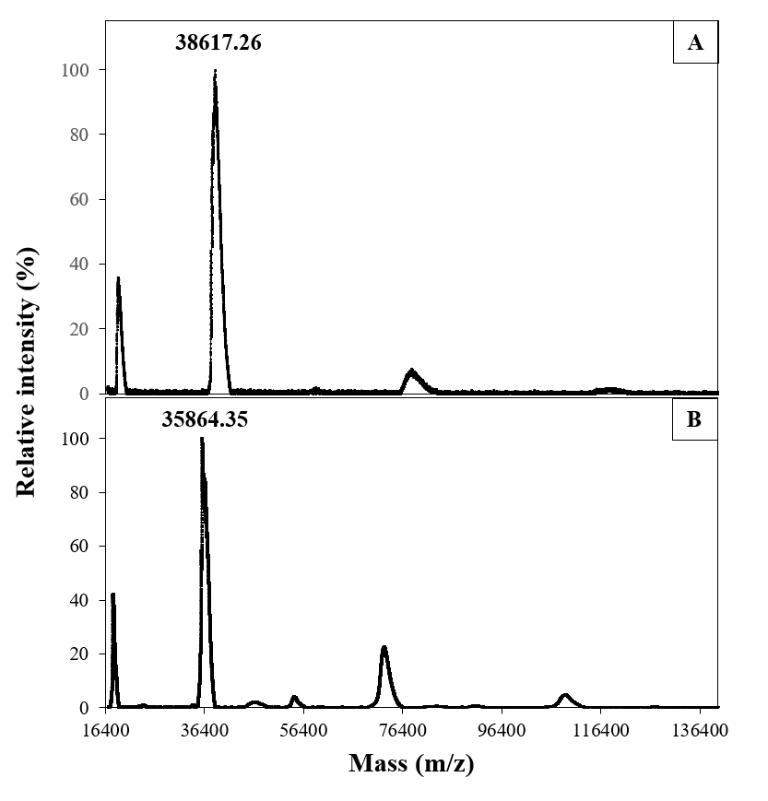
Supplementary Fig. 2 Mass spectra of pure rUMLB (A) and rCALB (B) proteins obtained by MALDI-TOF analysis. Mass spectra were acquired using a MALDI-TOF (Microflex Biotyper, Bruker) equipment in linear positive mode. Ions were accelerated with an extraction voltage of 25 kV, and each spectrum was generated by performing at least 300 successive laser shots. Intensity values were normalized.

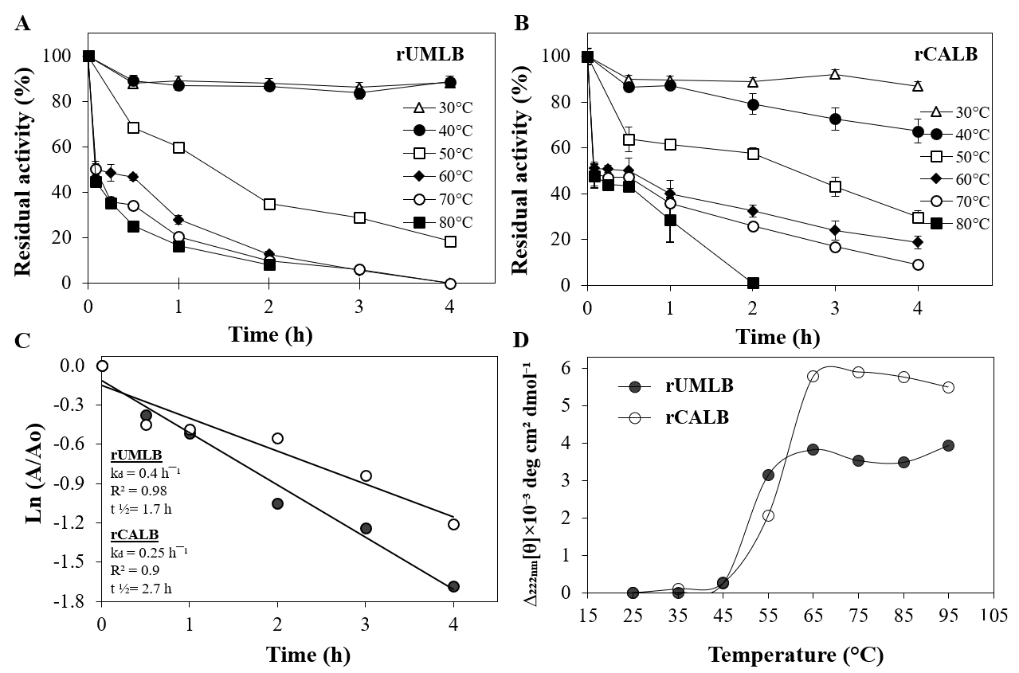
Supplementary Fig. 3 Thermostability of A) rUMLB and B) rCALB determined by measuring the residual activity of each enzyme using the PHIBLA method with TG(4:0) as substrate after incubation for 4 h at various temperatures. The activity of non-incubated enzyme was used as the control (100 %). C) The half-life at 50 °C of rUMLB (filled circle) and rCALB (empty circle) was determined from the natural logarithm of the residual activity versus incubation time. D) Boltzmann fitting profiles of two parameters for rUMLB (filled circle) and rCALB (empty circle) depending on the jump in the residual molar ellipticity at 222 nm were determined by Circular Dichroism (CD). All values represent the average of three independent assays.

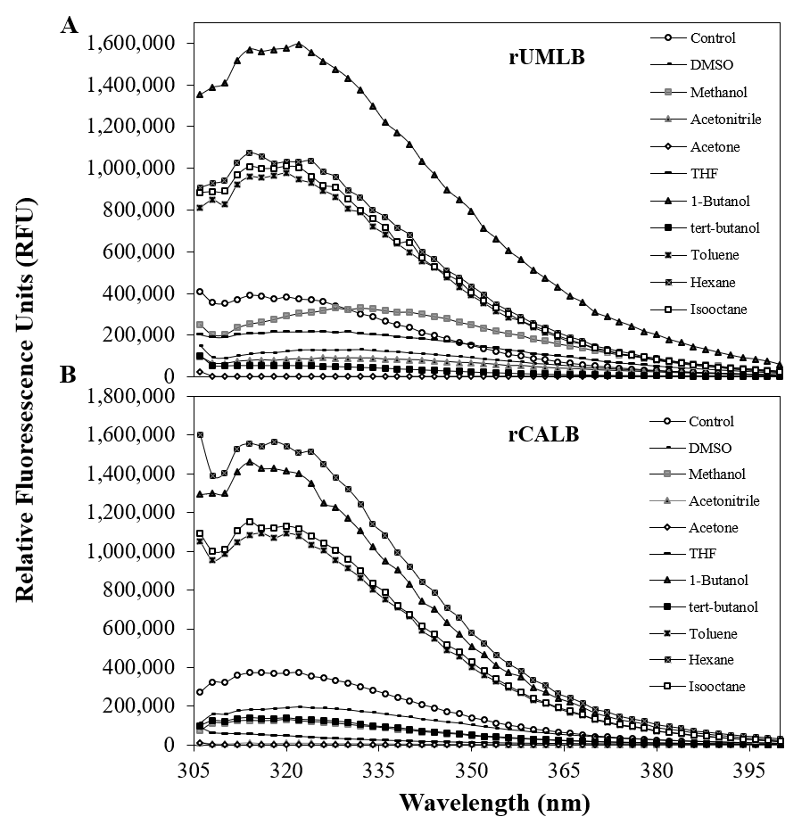
Supplementary Fig. 4 Fluorescence spectra of 75 µg of A) rUMLB and B) rCALB in various solvents: dimethyl sulfoxide, methanol, acetonitrile, acetone, tetrahydrofuran, 1-butanol, tert-butanol, toluene, hexane, and isooctane. The relative fluorescence units (RFU) were obtained after subtracting the blank samples consisting in enzyme in 2.5 mmol L⁻¹ MOPS (pH 7.2). Values represent the average of three independent assays.

Supplementary Fig. 5 Amino acid sequence alignment of UMLB and CALB proteins. The catalytic triad in both enzymes is highlighted with a yellow rectangle and the catalytic Serine is market with a yellow star. Alignment was generated by using ESPRIPT 3.0 tool (https://espript.ibcp.fr/).

