Appendix
Scanners Utilized | Either a 1.5T Acheiva or 1.5T Ingenia scanner (Philips Medical System, Best, the Netherlands) or a 1.5T Aera scanner (Siemens Healthineers, Erlangen, Germany)
Sequence Parameters  Slice Thickness (mm)  Interslice Gap  Repetition Time (ms)  Echo Time (ms)  Acquisition Matrix  Heart Phases | 6-10  0  2.6-3.5  1.3-1.8  108-200 x 101-185  25-30
Table 4. Supplemental CMR Methods
Sequence parameters for balanced steady state free precession sequences used in analysis

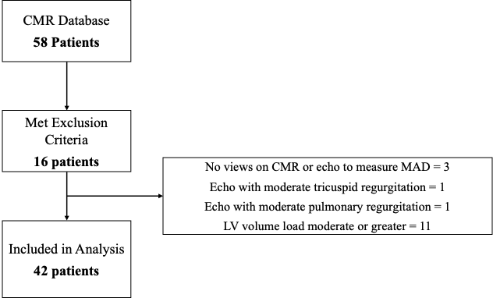
Figure 4: Flowchart of Patient Inclusion to Study Group

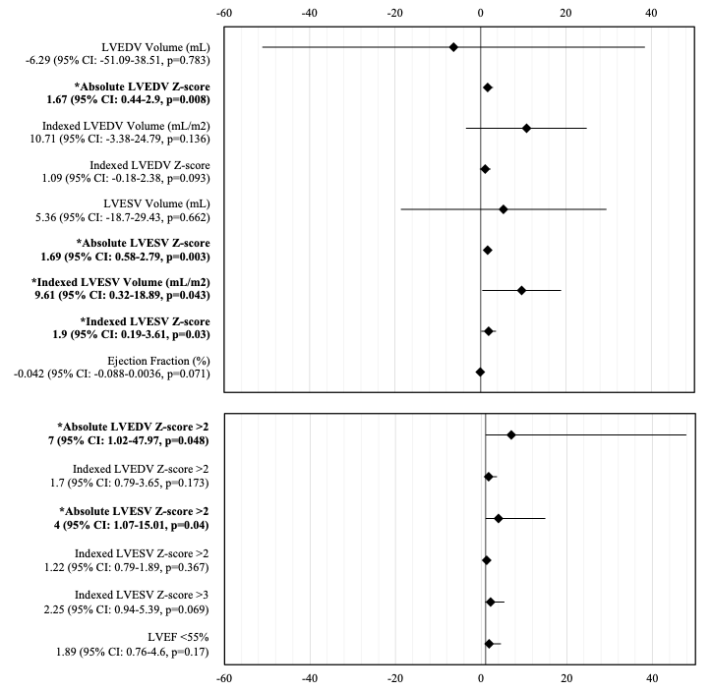
Figure 5. Risk Ratios and Confidence Intervals for Univariable MAD Association with LV volumes and Z-scores
Generalized linear modeling utilized to assess MAD association with continuous variables and log-binomial logistic regression was utilized to assess the association with categorical variables. Null value for continuous variables marked at zero and for categorical variables at 1. LVEDV: LV end-diastolic volume, LVESV: LV end-systolic volume, LVEF: LV ejection fraction; MAD: Mitral annular disjunction

