New insights into the structure of cellulose in plant cell walls
Rosalie Cresswell¹, Parveen Kumar Deralia², Yoshihisa Yoshimi², Steven P. Brown¹, Ray Dupree¹, Paul Dupree²
1, Department of Physics, University of Warwick, Coventry CV4 7AL, UK;
2, Department of Biochemistry, University of Cambridge, Hopkins Building, The Downing Site, Tennis Court Road, Cambridge CB2 1QW, UK;
Corresponding authors: Ray Dupree¹, Paul Dupree²

Supporting Information
Contents
- SI Figure 1: 30 ms ¹³C 2D CP PDSD MAS NMR spectrum of poplar wood.
- SI Figure 2: Glucose environments are common to cellulose from different plant lineages.
- SI Figure 3: TEM images of hCNFs of poplar wood.
- SI Figure 4: Comparison of the neutral carbohydrate region of ¹³C 1D CP MAS spectrum of Poplar wood and xylanase-treated hCNFs of poplar wood.
- SI Figure 5: Cellulose of poplar wood maintains its structure in the fibrillation process to form hCNFs.
- SI Figure 6: The C1-C3, C4-C3 region of the 30 ms ¹³C 2D CP PDSD MAS NMR of the environments a and c from the xylanase treated hCNFs of poplar wood compared to the NMR chemical shift positions of the two Iβ cellulose glucose units.
- SI Figure 7: Similar water proximity of the three domain 2 surface glucose environments of cellulose.
- SI Figure 8: Calculating the interior to surface ratio and relative amounts of glucose environment b versus core environments.
- SI Figure 9: Cellulose fibril surface glucose environments in domain 2 are as well ordered as the glucose environments in domain 1 that include the fibril core.
- SI Table 1: Comparing the cellulose Iα and Iβ ¹³C NMR chemical shifts from Brouwer and Mikolajewski²¹ with the Domain 1 cellulose shifts from xylanase treated hCNFs of poplar wood.
- SI Table 2: The linewidths of glucose environments in cellulose are comparable in domain 1 and domain 2.
- SI Table 3 Experimental parameters
- Estimating the relative amounts of the different cellulose environments

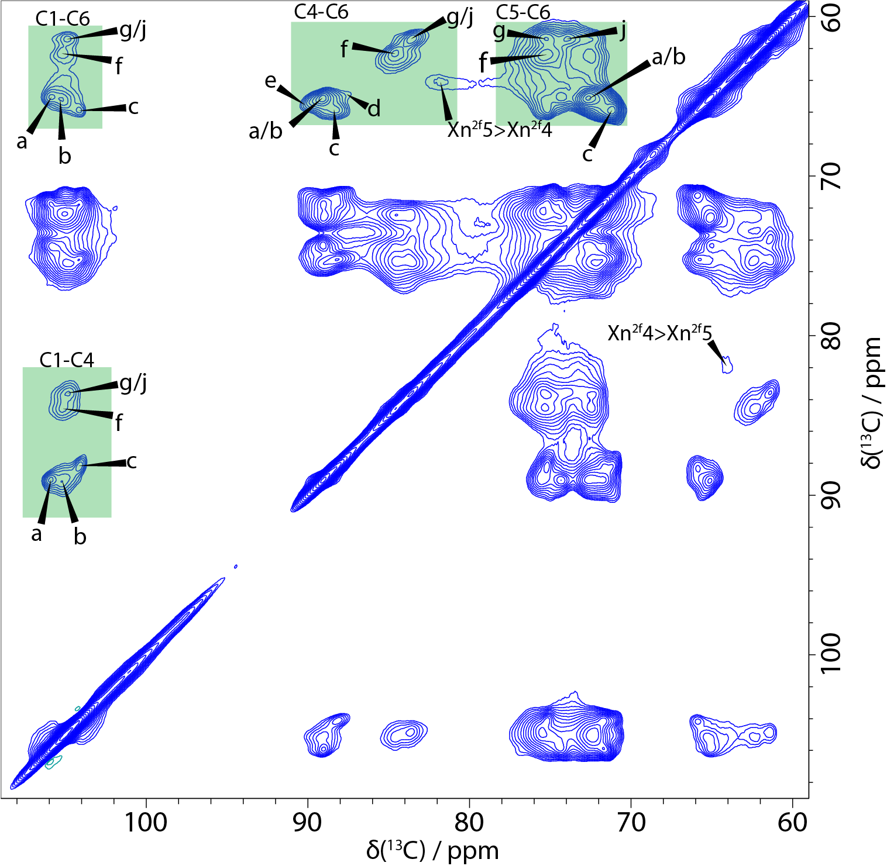
SI Figure 1: 30 ms ¹³C 2D CP PDSD MAS NMR spectrum of poplar wood. The main regions where different glucose environments in cellulose can be resolved have been highlighted in green. The spectrum was recorded at a ¹³C Larmor frequency of 251.4 MHz and a MAS frequency of 12.5 kHz.

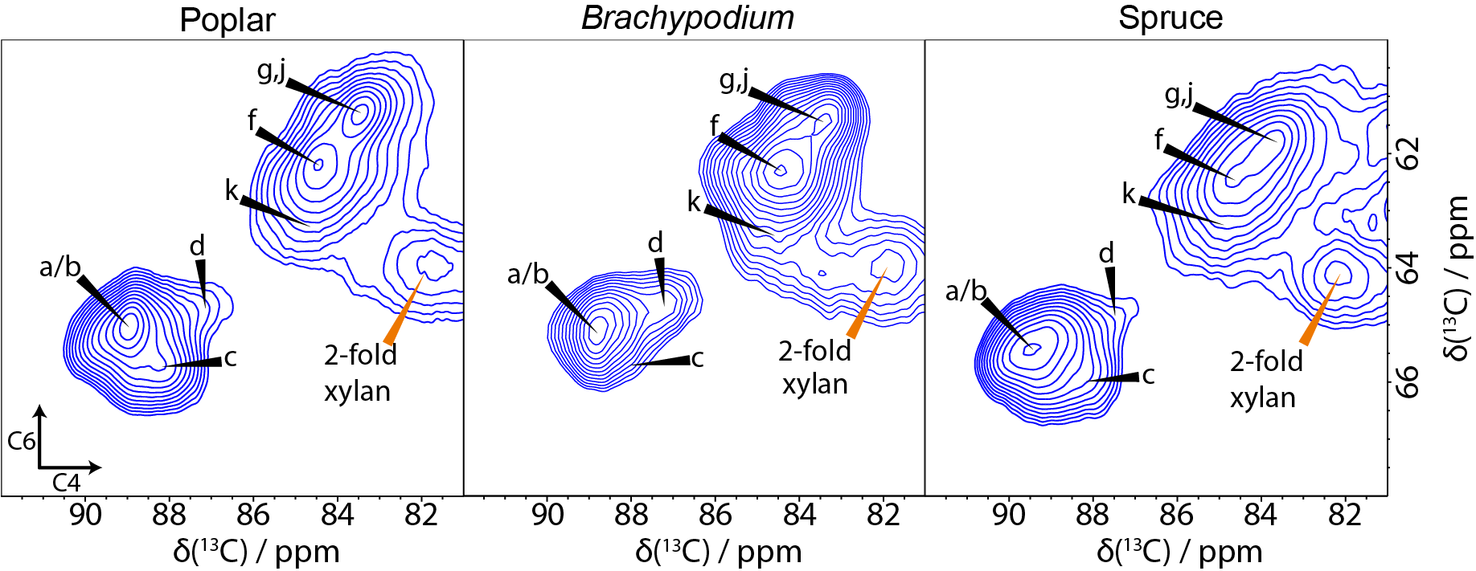
SI Figure 2: Glucose environments are common to cellulose from different plant lineages. A comparison of the C4-C6 region of 30 ms ¹³C 2D CP PDSD MAS NMR spectra of poplar wood (a eudicot), Brachypodium mature leaves (a monocot) and Spruce wood (a gymnopserm) with common glucose environments labelled. The spectra were recorded as in SI Figure 1.

SI Figure 3: TEM images of hCNFs of poplar wood.

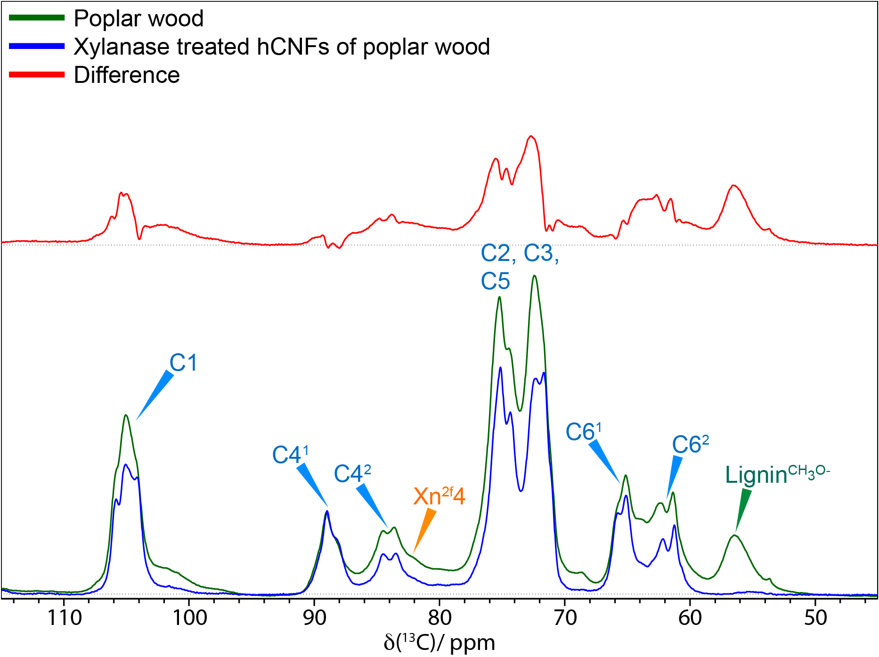
SI Figure 4: Comparison of the neutral carbohydrate region of ¹³C 1D CP MAS NMR spectrum of Poplar wood and xylanase-treated hCNFs of poplar wood. The comparison (normalised to C4 at 89 ppm) shows the difference in the 1D CP spectrum when hemicellulose and lignin have been removed. It is clear the production of hCNFs results in the removal of most of a broad background signal. Spectra were recorded as in SI Figure 1.

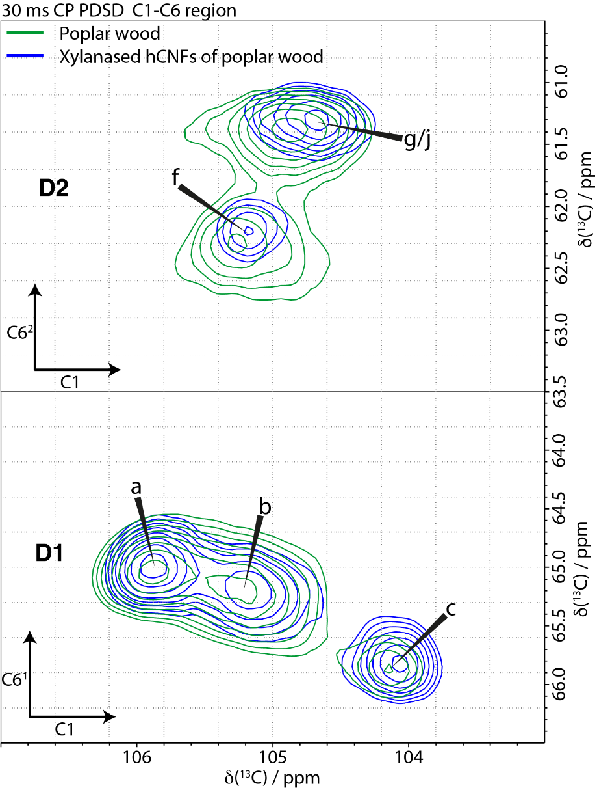
SI Figure 5: Cellulose of poplar wood maintains its structure in the fibrillation process to form hCNFs. Comparison of the C1-C6 region of a 30 ms ¹³C 2D CP PDSD MAS NMR spectrum of poplar wood (green) and xylanase-treated hCNFs of poplar wood (blue). Spectra were recorded as in SI Figure 1.

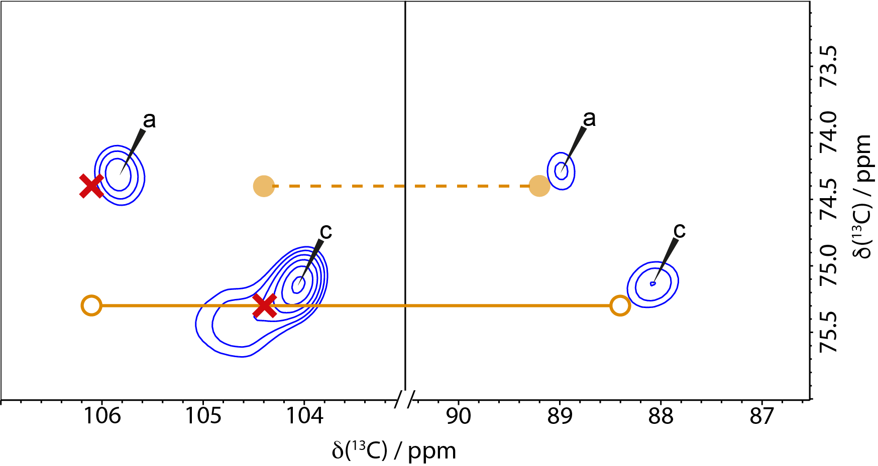
SI Figure 6: The C1-C3 and C4-C3 regions of a 30 ms ¹³C 2D CP PDSD MAS NMR spectrum showing the environments a and c from the xylanase treated hCNFs of poplar wood compared to the NMR shift positions of the two Iβ cellulose glucose units. Circles are the Kono et al. assignment^{19,20} with chemical shifts corrected by Brouwer and Mikolajewski.²¹ The crosses indicate where the peaks would be if the C1 assignment were switched, as determined in this work, showing a and c closely match the corrected assignments for cellulose Iβ. Spectra were recorded as in SI Figure 1.

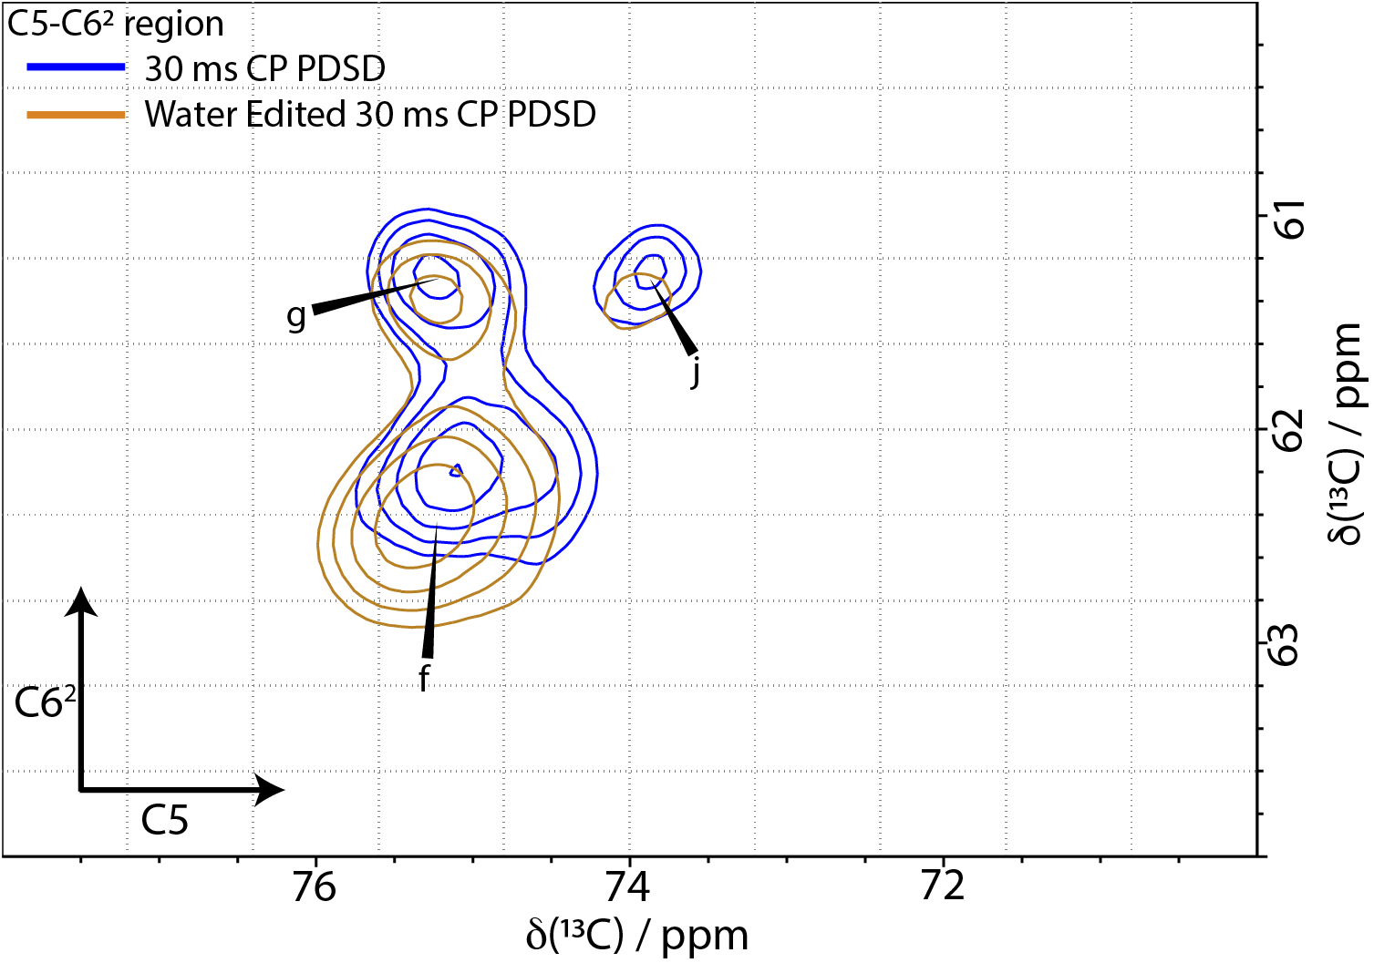
SI Figure 7: Similar water proximity of the three domain 2 surface glucose environments of cellulose. The domain 2 C5-C6 spectral regions of xylanase treated hCNFs of poplar wood is shown, comparing the standard 30 ms ¹³C CP PDSD MAS NMR spectrum (blue) with the water-edited 30 ms ¹³C CP PDSD MAS NMR spectrum (brown). Spectra were recorded as in SI Figure 1.

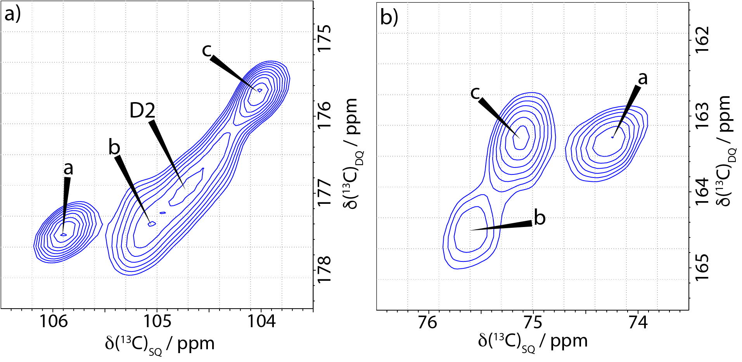
SI Figure 8: Calculating the interior to surface ratio and relative amounts of glucose environment b versus core environments a and c. a) The C1 part of the C1-C2 cross peak region of a ¹³C 2D CP refocussed INADEQUATE MAS NMR spectrum which resolves fibril core sites a and c, allowing integration of the core environments separately from surface environments (b and domain 2). b) The C3 part of the region for the C3-C4 cross peaks of domain 1 in the CP refocussed INADEQUATE spectrum are used to estimate the relative amounts of surface environment b compared to fibril core environments a and c. Spectra were recorded as in SI Figure 1.

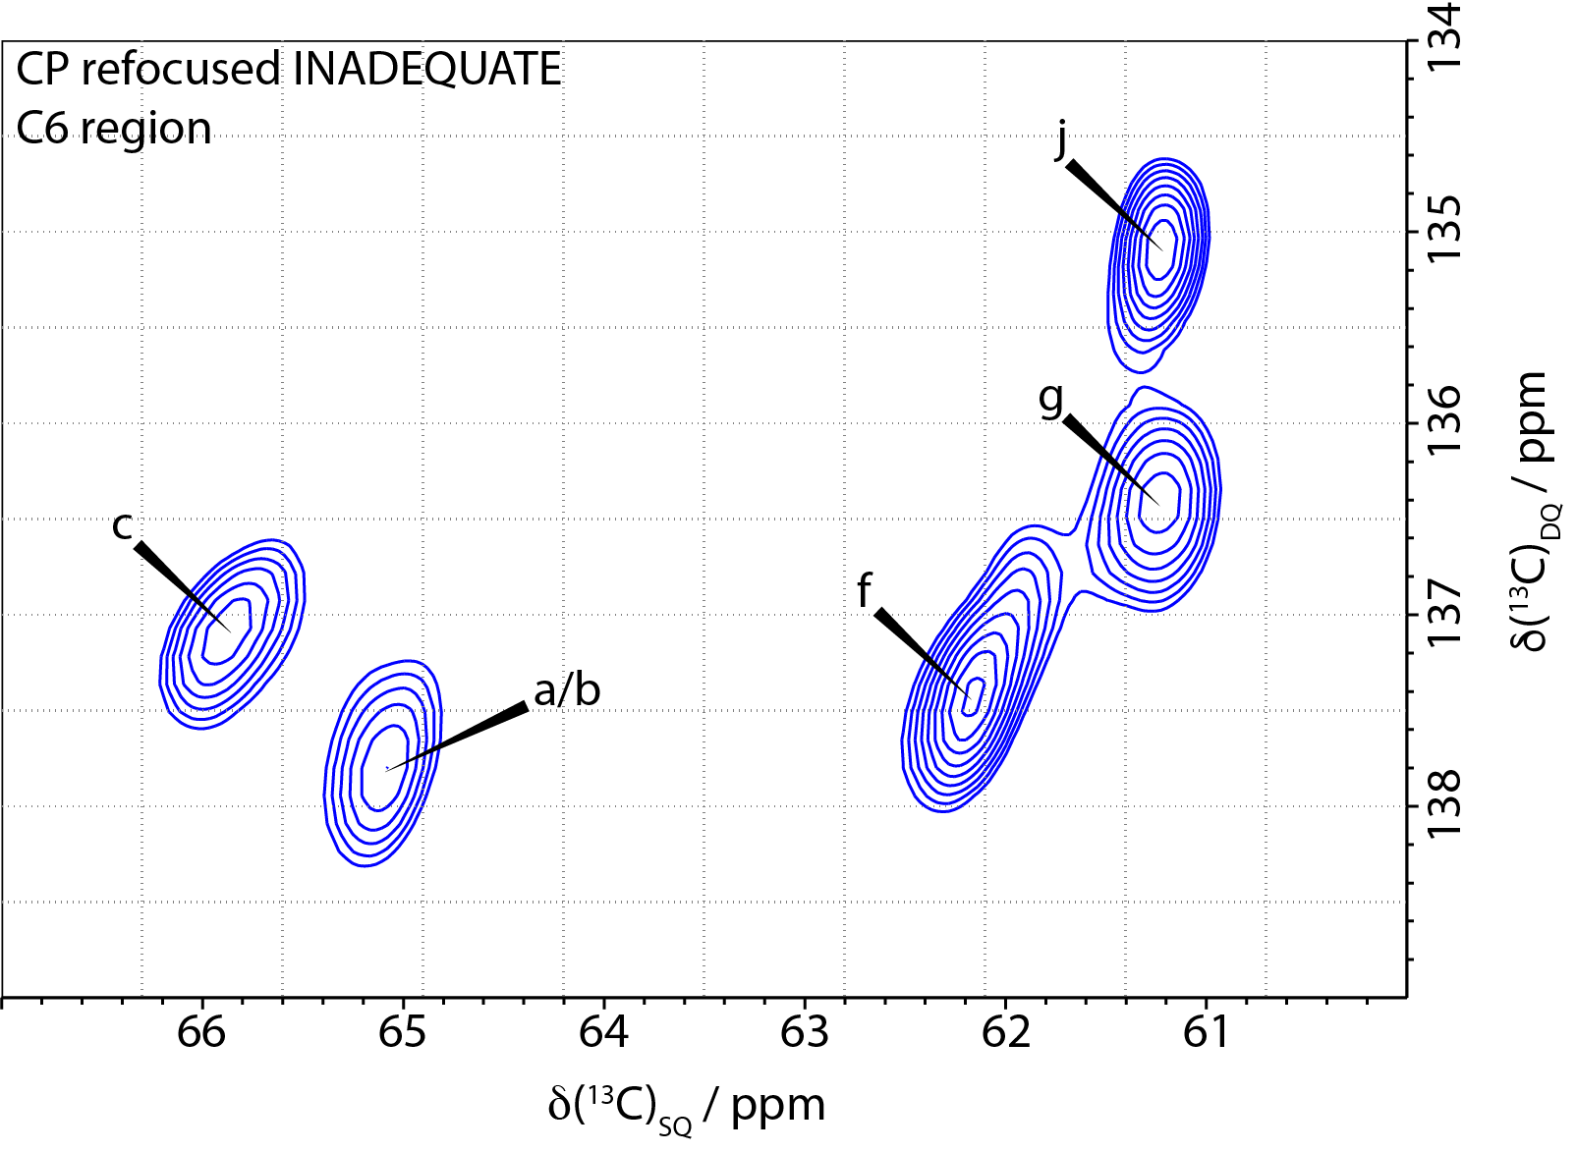
SI Figure 9: Cellulose fibril surface glucose environments in domain 2 are as well ordered as the glucose environments in domain 1 that include the fibril core. C6 region of the ¹³C 2D CP refocused INADEQUATE MAS NMR spectrum of xylanase treated hCNFs of poplar wood. The linewidths of the main domain 2 surface environments (f, g, j) are comparable to those of domain 1 (a, b, c) indicating significant (and similar) local order of the domain 2 glucose residues that lie on the fibril surface. Spectra were recorded as in SI Figure 1.

 | C1 | C2 | C3 | C4 | C5 | C6
Cellulose Iα
Glucose Unit 1 (Down) | 105.6 | 72.2 | 74.6 | 89.4 | 73.1 | 65.7
Glucose Unit 2 (Up) | 105.5 | 71.2 | 75.1 | 90.3 | 71.3 | 65.8
Cellulose Iβ (Brouwer)
Glucose Unit 1 (Centre) | 106.1 | 71.7 | 75.3 | 88.4 | 71.4 | 66.0
Glucose Unit 2 (Origin) | 104.4 | 71.7 | 74.4 | 89.2 | 72.9 | 65.2
Cellulose Iβ (Corrected)
Glucose Unit 1 (Centre) | 104.4 | 71.7 | 75.3 | 88.4 | 71.4 | 66.0
Glucose Unit 2 (Origin) | 106.1 | 71.7 | 74.4 | 89.2 | 72.9 | 65.2
Native plant cellulose
a (Origin) | 105.8 | 71.7 | 74.3 | 89.0 | 72.5 | 65.0
b | 105.2 | 72.6 | 75.5 | 89.1 | 72.6 | 65.2
c (Centre) | 104.1 | 71.8 | 75.2 | 88.1 | 71.2 | 65.8

SI Table 1: Comparison of Iα and Iβ cellulose ¹³C chemical shifts as given by Brouwer and Mikolajewski²¹ with the cellulose domain 1 a, b and c chemical shifts, and the cellulose Iβ chemical shifts with the C1 shifts corrected.

Cellulose glucose environments | Linewidth C6 region CP INADEQUATE
a + b | 0.57 ppm
c | 0.49 ppm
f | 0.57 ppm
g | 0.46 ppm
j | 0.41 ppm

SI Table 2: The linewidths of glucose environments in cellulose are comparable in domain 1 and domain 2. Comparison of the linewidths of the different environments in the C6 region of the ¹³C CP INADEQUATE MAS NMR spectrum of the xylanase treated hCNFs of poplar wood given in SI Fig. 9. The peak labelled a+b has a larger linewidth as it has two components that are ~0.2 ppm different in their NMR shift. Site f has a similar width to the peak for sites a + b and is elongated suggesting it could also be two environments which have yet to be resolved.

sample | experiment | Recycle  Delay  (s) | Echo/  Mixing time (ms) | SW  (F₂)  (kHz) | SW  (F₁)  (kHz) | Acq  (F₂)  (ms) | Acq.  (F₁)  (ms) | Number  co-added  FIDs
Poplar  wood | 1D CP | 2 | - | 100 |  | 20 | - | 256
Poplar  wood | 1D DP | 2 | - | 100 |  | 25 | - | 256
Poplar  wood | 1D DP | 20 | - | 100 |  | 25 | - | 128
Poplar  wood | 2D CP refocussed  INADEQUATE | 2 | 2.24 | 59 | 37.5 | 20 | 6.67 | 128
Poplar  wood | 2D CP PDSD | 2 | 30 | 75 | 37.5 | 25 | 8.2 | 64
Xylanase treated  hCNFs  of poplar  wood | 1D CP | 2 | - | 100 |  | 20 | - | 256
Xylanase treated  hCNFs  of poplar  wood | 1D DP | 2 | - | 100 |  | 25 | - | 256
Xylanase treated  hCNFs  of poplar  wood | 1D DP | 20 | - | 100 |  | 25 | - | 128
Xylanase treated  hCNFs  of poplar  wood | 2D CP refocussed  INADEQUATE | 2 | 2.24 | 59 | 37.5 | 25 | 6.7 | 128
Xylanase treated  hCNFs  of poplar  wood | 2D CP PDSD | 2 | 30 | 75 | 37.5 | 25 | 7.3 | 80
Xylanase treated  hCNFs  of poplar  wood | 2D CP PDSD | 2 | 200 | 75 | 37.5 | 25 | 5.1 | 80
Xylanase treated  hCNFs  of poplar  wood | 2D CP PDSD | 2 | 400 | 75 | 37.5 | 25 | 5.5 | 80
Xylanase treated  hCNFs  of poplar  wood | 2D Water edited  CP PDSD | 2 | 0.32-2/  30 | 75 | 37.5 | 25 | 4.8 | 576

SI Table 3 Experimental solid-state NMR parameters

Estimating the relative amounts of the different cellulose glucose residue environments

Estimates of the relative amount of core fibril, a+c, and of domain 1 environment b were made from integration of the ¹³C CP refocussed INADEQUATE spectrum of xylanased hCNFs of poplar wood (Fig. 5 and SI Figure 8) complemented by analysis of 1D ¹³C CP (SI Fig 4) and quantitative ¹³C DP MAS NMR spectra. Whilst ¹³C CP INADEQUATE is not strictly quantitative, in the present case where all the carbons compared have very similar shifts and environments, we feel the uncertainties are no larger than those arising from analysing the data. Differences in local motion could affect the relative intensities, however two CP refocussed INADEQUATE experiments were run on a very similar sample where the echo spacing was reduced from 2.24 ms to 0.96 ms. This changed the signal by a factor of more than 2 but the relative amounts of core (sites a and c) to surface (b+f+g+j), where one would expect maximum differences in motion, changed by less than 5%. Using the C1 region (see SI Fig. 8a) the ratio of core to surface was 0.50 for the longer echo spacing (our normal data-taking value) and 0.53 for the shorter. From the C3 region (SI fig. 8b) b was found to be ~0.7 of a and c, which is consistent with a simulation of the 1D spectrum.
Note that because of the small number of chains in a fibril there are very limited possibilities for the ratio of b to core. For instance, if there are 3 cores (a=c=3) and b could be 1, 2 or 3 chains then b/a = 1/3, 2/3 (as we find) or 1. Similarly the possible values for the core-to surface ratio is limited by the small number of chains in the fibril.

