Supplementary tables and figures
Table S1: Village distribution into districts

District | Village
Central (1) | Lerala, Sefophe, Maunatlala, Ramokgonami, Mmadinare, Shoshong, Nkange, Sebina, Mathangwane, Mandunyane, Gumare, Rakops, Sefhare, Tsetsebjwe, Nata
South East (2) | Otse
Ngamiland (3) | Gweta, Shakawe
North East (4) | Masunga, Tati_siding
Kgatleng (5) | Bokaa, Oodi
Kweneng (6) | Letlhakeng, Lentsweletau, Metsimotlhabe
Southern (7) | Ranaka, Digawana, Molapowabojang, Mmankgodi, Mmathethe
Notes. Annotation of districts is as follows: Central=1, South East=2, Ngamiland=3, North East=4, Kgatleng=5, Kweneng=6, Southern=7

Table S2: Geographical characteristics of the subtrees in the HIV-1 Botswana phylogeny
 |  | Districts (%) |  |  |  |  |  |  | Partition combinations of p-values
Gene | Partition ID | Central | Kgatleng | Kweneng | Ngamiland | North East | South East | Southern | p -value
gag | 1 | 50.8 | 0.5 | 8.7 | 9 | 11.7 | 0.8 | 12 | (1&2) <.020
gag | 2 | 54.9 | 0.4 | 6.4 | 11.7 | 13.6 | 0.6 | 7.9 | (1&2) <.020
gag | 3 | 51.6 | 0.4 | 4.3 | 13.1 | 12.5 | 0.9 | 11.2
pol | 1 | 57.6 | 0.4 | 6.3 | 11.9 | 13.4 | 0.3 | 7.2 | (1&2) <.001
pol | 2 | 52.7 | 0.3 | 7.2 | 9.3 | 13.6 | 0.8 | 12.3 | (1&2) <.001
pol | 3 | 49.7 | 0.9 | 5.3 | 16.1 | 12 | 1.4 | 11.2
Notes. Data were analysed using Anova, then with the Tukey test. The p-values pertain to the comparison of partition combinations and only the significant values (p<.05) from the Tukey test are shown. Data points are displayed in percentages (%).
Table S3: Treestructure partitions at different α sensitivities
 | Gag |  |  |  |  |  | Pol
α sensitivity | 0.01 |  | 0.05 |  | 0.1 |  | 0.01 |  | 0.05 |  | 0.1
Partition | CGR | Total | CGR | Total | CGR | Total | CGR | Total | CGR | Total | CGR | Total
1 | 241 | 1156 | 241 | 1156 | 241 | 1156 | 34 | 1760 | 34 | 1760 | 34 | 1760
2 | 312 | 2265 | 293 | 2265 | 312 | 2265 | 414 | 2757 | 244 | 1790 | 244 | 1790
3 | 283 | 1529 | 302 | 1529 | 283 | 1529 |  |  | 170 | 967 | 170 | 967
Notes. Treestructure was run with α sensitivities 0.01-0.1 for detecting partitions. Total sequence counts are inclusive of CGRs.

 |  |  |  |  |  |  |  | Districts
Gene | Partition ID | Alpha cutoff | Total sequences | Female (%) | Male (%) | Age (mean) | Sample Date (mean) | South East (%) | Southern (%) | p-value (partitions)
gag | 1 | 0.01 | 1309 | 67.5 | 28.4 | 40.3 | 2016.2 | 0.8 | 12 | (1&2) <.002
gag | 2 |  | 2508 | 70.5 | 27.3 | 39.9 | 2016.2 | 0.6 | 8
gag | 3 |  | 1675 | 67.5 | 28.6 | 39.6 | 2016.2 | 1 | 11.1
pol | 1 | 0.01 | 1865 | 70.8 | 28.3 | 40 | 2016.2 | 0.3 | 7.2 | (1&2) <.000
pol | 2 |  | 3099 | 70.1 | 28.4 | 39.9 | 2016.2 | 1 | 11.9
gag | 1 | 0.1 | 2508 | 70.5 | 27.3 | 39.9 | 2016.2 | 0.6 | 8 | (1&2) <.002
gag | 2 |  | 1309 | 67.5 | 38.4 | 40.3 | 2016.2 | 0.8 | 12
gag | 3 |  | 1675 | 67.5 | 28.6 | 39.6 | 2016.2 | 1 | 11.1
pol | 1 | 0.1 | 1865 | 70.8 | 28.1 | 40 | 2016.2 | 0.3 | 7.2 | (1&2) <.000
pol | 2 |  | 2022 | 71.4 | 27.1 | 39.6 | 2016.2 | 0.8 | 12.3
pol | 3 |  | 1077 | 67.6 | 31.0 | 40.4 | 2016.3 | 1.4 | 11.2 | (1&3) <0.008
Table S4: Demographic characteristics of three partitions in the HIV-1 gag and pol phylogenies with different α cutoffs for tree partitioning.

Notes. The demographic characteristics (sex and CGR) were compared among different partitions by Pearson χ² using raw numbers except age, mean partition sample dates and districts, which were analysed using ANOVA. The significant values were further analysed with Bonferroni post hoc to show which groups in each partition were significant. After ANOVA analysis on districts, the Tukey test was used to show significant p- values comparing the distribution of districts across gene partitions as shown in bold excluding the non-significant values.

Table S5: Clinical characteristics of three partitions in the HIV-1 gag and pol phylogenies with different sensitivities.
 |  |  | Stage of infection (%) |  | p-value | Treatment status (%) |  | p-value
Gene | Alpha cutoff | Partition ID | chronic | recent |  | No | Yes
gag | 0.01 | 1 | 90.5 | 9.5 |  | 22 | 78
gag |  | 2 | 91.8 | 8.2 |  | 17.6 | 82.4 | <.002
gag |  | 3 | 88.9 | 11.1 |  | 22.3 | 77.7
pol | 0.01 | 1 | 92.4 | 7.6 | <.001 | 16.4 | 83.6 | <.000
pol |  | 2 | 88.9 | 11.1 | <.001 | 22.4 | 77.6 | <.000
gag | 0.1 | 1 | 91.8 | 8.2 |  | 17.6 | 82.4 | <.002
gag |  | 2 | 90.5 | 9.5 |  | 22.0 | 78.0
gag |  | 3 | 88.9 | 11.1 |  | 22.3 | 77.7
pol | 0.1 | 1 | 92.4 | 7.6 | <.002 | 16.4 | 83.6 | <.002
pol |  | 2 | 88.9 | 11.1 |  | 21.7 | 78.3
pol |  | 3 | 88.8 | 11.2 |  | 23.7 | 76.3 | <.020

Notes. Categorical variables were compared across partitions by the Pearson χ² using raw numbers. Significant values were further analysed with Bonferroni post hoc to show which groups in each partition were significant. p-values below 0.05 are shown in bold.

Annotation of Districts for Tukey Analysis
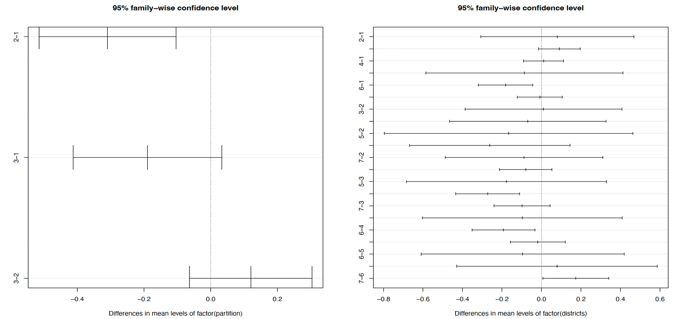
Figure S1: The Tukey analysis plot for association between districts and partitions in gag.
A
B

Plot A shows the difference in the distribution of districts between pairs of partitions. Plot B shows the difference in partition membership based between pairs of districts. In plot A, partition 1 vs. 2 the distribution does not contain 0 in its confidence interval. Similarly, for plot B showing districts, Southern and Kweneng (6 vs 7), have confidence interval that does not contain 0, (p<0.012) indicating the Southern district is over-represented in partition 1.

Figure S2: Estimated effective population size though time for three partitions in the Botswana gag and pol HIV-1 phylogenies.
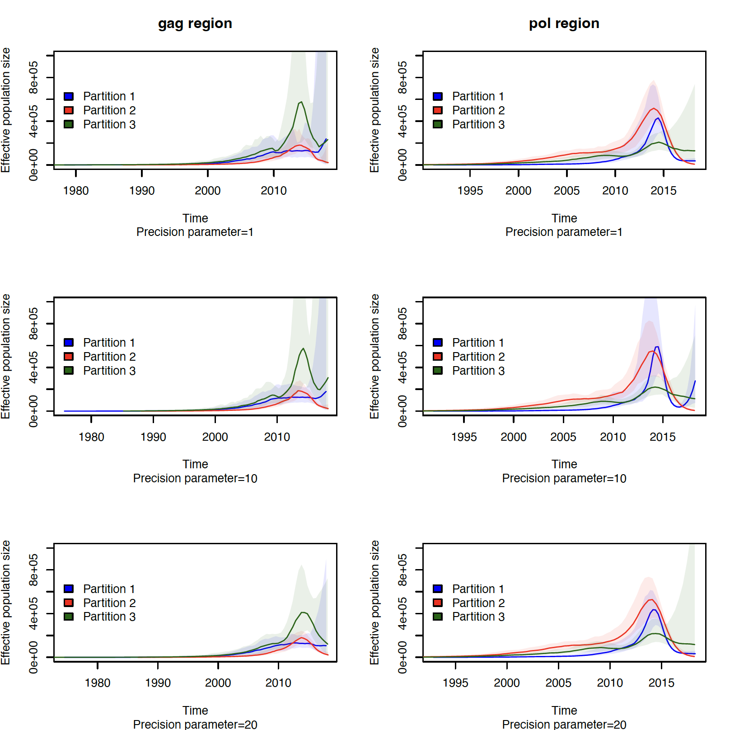
τ= 20
τ= 1

The N_{e}(t) was estimated using the mlesky method with precision parameter τ= 1, 20 respectively.

Figure S3: Estimated effective population size though time for three partitions in the Botswana gag and pol HIV-1 phylogenies with different α sensitivities.
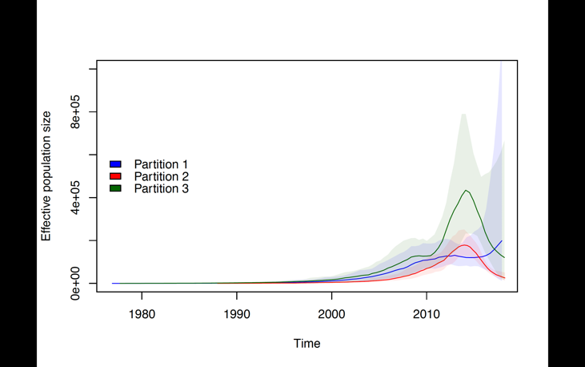
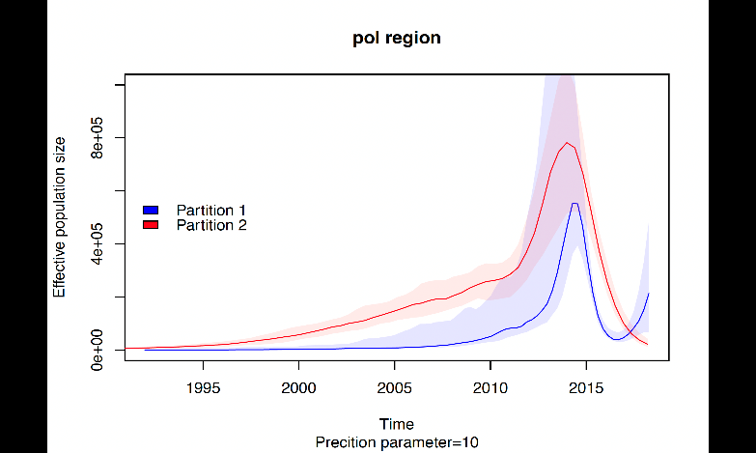
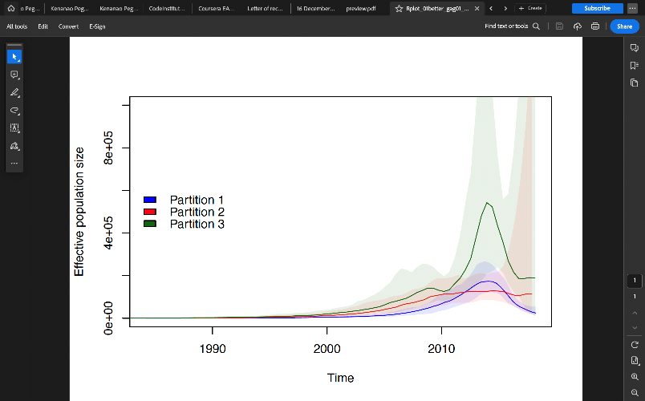
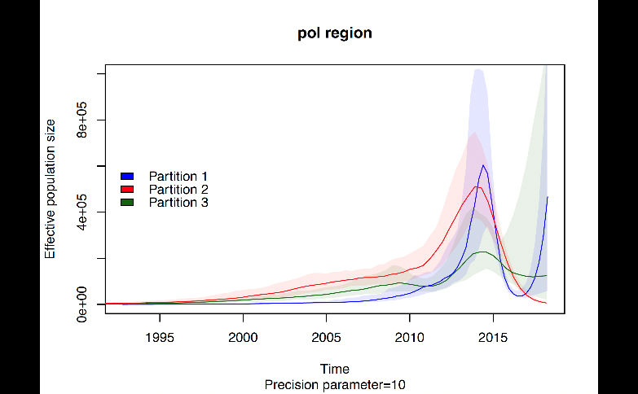
α = 0.01
α = 0.1
gag region
pol region

The N_{e}(t) was estimated using the mlesky method with precision parameter τ= 10. In gag partition 1 and 2 swap when mlesky is analysed at the different sent sensitivity while pol phylogeny shows only two partitions in α =0.01.

