Appendix A
Survey Materials for Community Members Sample

[High containment laboratories] do research pertaining to animals and highly contagious animal-borne pathogens that may result in human fatalities and have no treatments for the subjects who may contract these contagions. Due to the dangerous pathogens contained within the [high containment] laboratory, strict and extensive safety procedures are necessary for the facility to start basic functioning. [High containment] laboratories undergo numerous safety inspections administered by the Federal Select Agent Program. The potential hazards of a [high containment] laboratory could be detrimental to the research team and surrounding community given the dangerous quality of these pathogens, such as an outbreak of Ebola or Nipah.
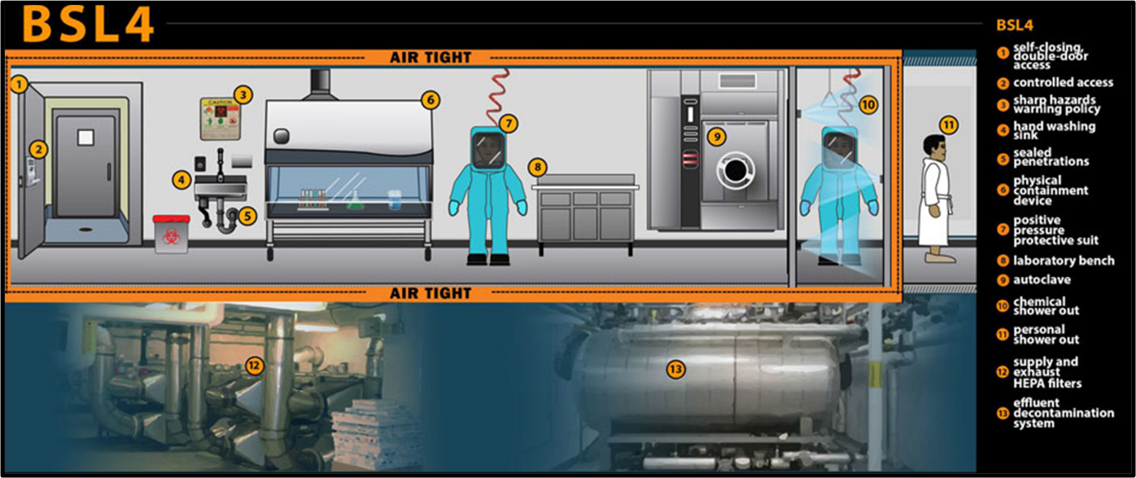

Psychological safety refers to the sense of well-being and confidence individuals experience in a social environment when they feel secure and confident in sharing their opinions, ideas, and questions without fear of negative consequences from their team members or supervisor. In the workplace, this includes promoting a shared sense of safety and an organizational culture that promotes individual expression, taking constructive interpersonal risks, and effectively managing change. When there is trust and no fear of being judged, people tend to share their mistakes or failures. Psychological safety has a direct impact on employee efficiency and performance. For example, it can reduce errors and accidents at work.
The following are examples of items from psychological safety scales and behaviors associated with high psychological safety.
- Example survey items (rated on a 7-point scale ranging from “Very Inaccurate” to “Very Accurate”): If you make a mistake on this team, it is often held against you.
- Members of this team are able to bring up problems and tough issues.
- It is difficult to ask other members of this team for help.
Example behaviors:
- Members express mutual respect.
- Unconventional ideas are encouraged.
- Members listen to and are receptive of negative feedback.

Figure A1. Incidence analysis focused on corrective action
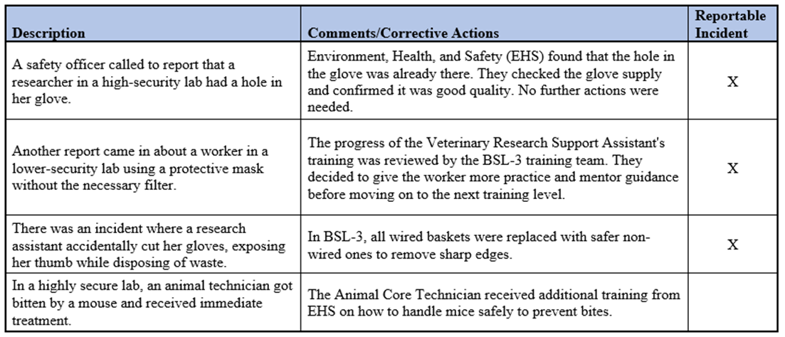

Figure A2. Incidence analysis focused on risks and root cause identification
