SUPPLEMENTARY FIGURES
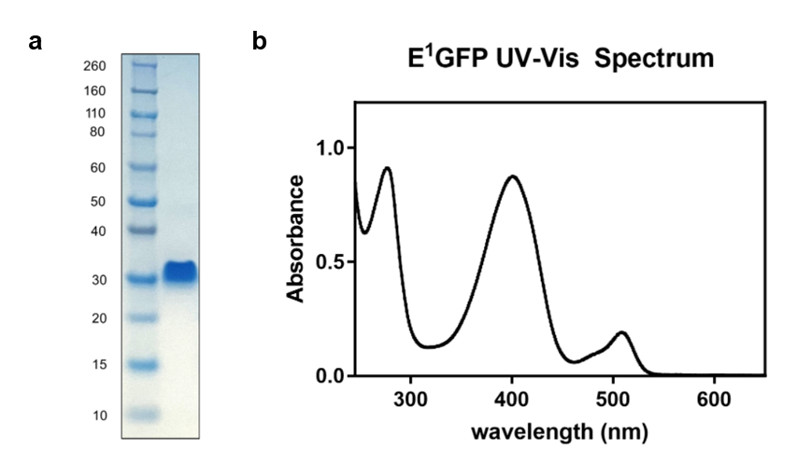
Figure S1: Purification and characterization of recombinant E¹GFP. (a) SDS-PAGE of purified recombinant E¹GFP. (b) Absorption spectrum of E¹GFP.

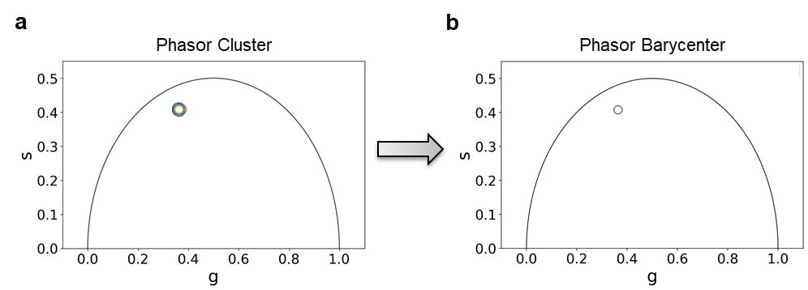
Figure S2: Phasor analysis. Phasor cluster (a) and extracted phasor barycenter (b) of recombinant E¹GFP incubated in buffer with pH equal to 6.26. Cumulative analysis of three replicates.

