A
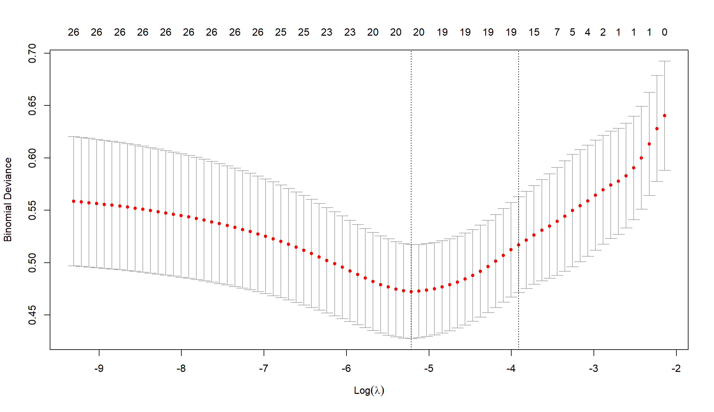
B
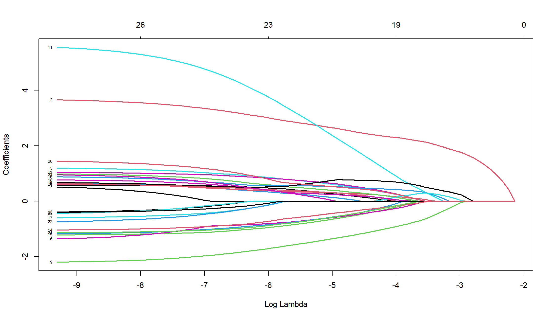
Supplementary Figure 1. Results of LASSO analysis. A. The tuning parameters (log λ) of severe RP-related factors were selected to cross-verify the error curve. According to the minimal criterion and 1-se criterion, perpendicular imaginary lines were drawn at the optimal value. B. The LASSO coefficient profile of severe RP-related factors and perpendicular imaginary line were drawn at the value chosen by 10-fold cross-validation.

