Quantum Long Short-Term Memory for Drug Discovery

Liang Zhang²*, Yin Xu¹, Mohan Wu¹, Liang Wang¹ and Hua Xu¹*

Table S1. The avg score of QLSTM and LSTM models was evaluated on BACE, BBBP, SIDER, BCAP37 and T-47D five datasets.
 | 2 | 4 | 8 | 12
Quantum LSTM | 0.744 | 0.771 | 0.780 | 0.795
Classical LSTM | 0.755 | 0.764 | 0.762 | 0.776

Table S2. The different noise levels comparison of QLSTM model with 0.01, 0.02 and 0.05.
 | 2 | 4 | 8 | 12
0.01 | 0.727 | 0.755 | 0.760 | 0.778
0.02 | 0.728 | 0.749 | 0.746 | 0.765
0.05 | 0.719 | 0.730 | 0.745 | 0.758

Figure S1. The QLSTM and LSTM models training loss on the BBBP dataset with 2, 4, 8, 12 qubits.
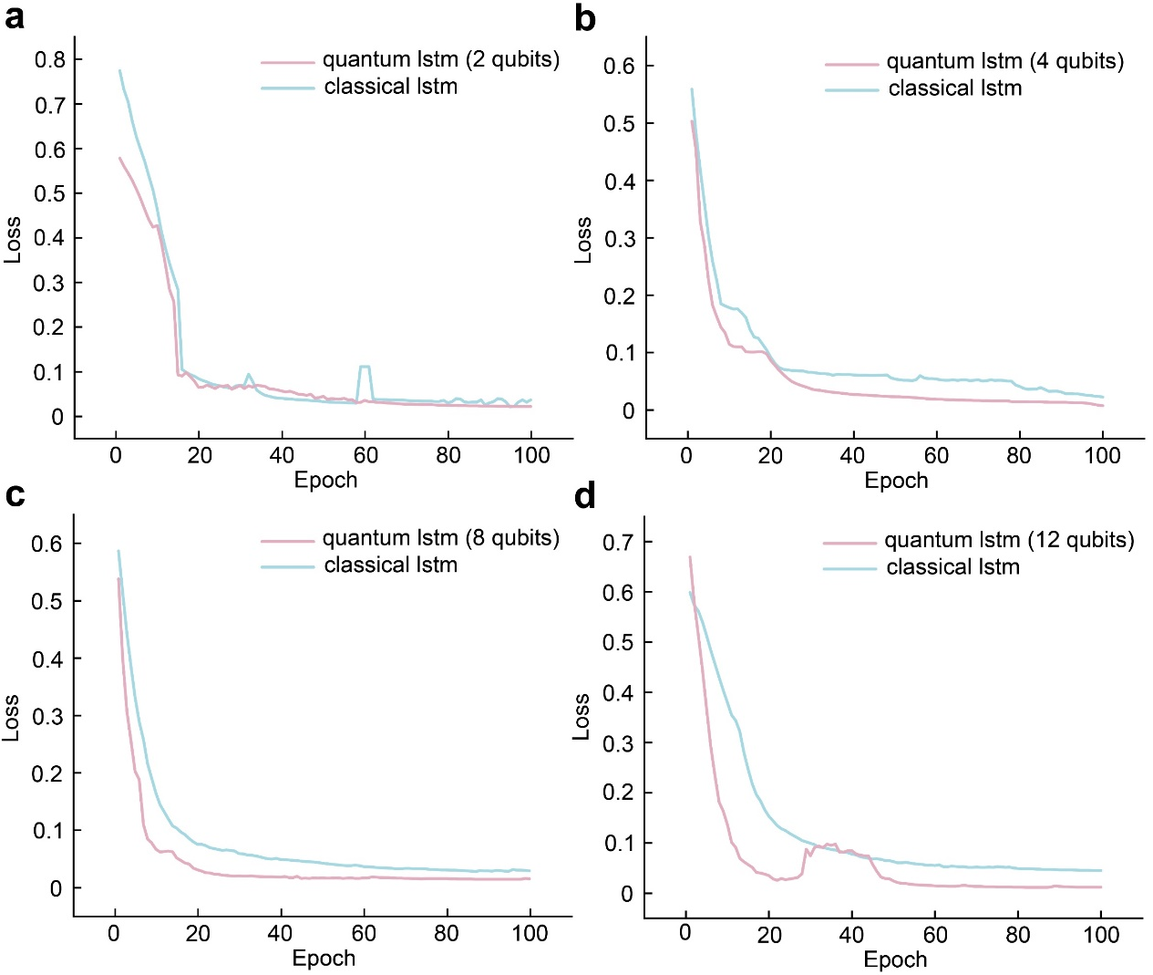
Figure S2. The QLSTM and LSTM models training loss on the SIDER dataset with 2, 4, 8, 12 qubits.
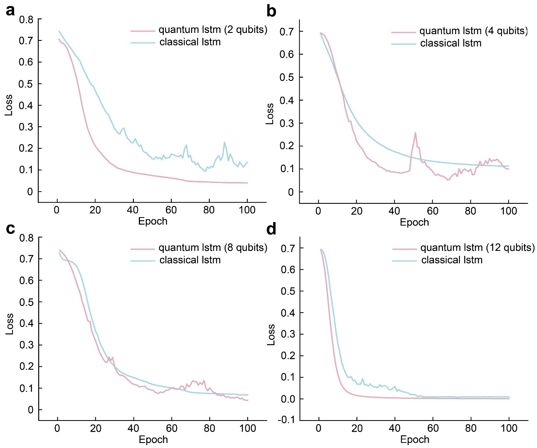

Figure S3. The QLSTM and LSTM models training loss on the BCAP37 dataset with 2, 4, 8, 12 qubits.
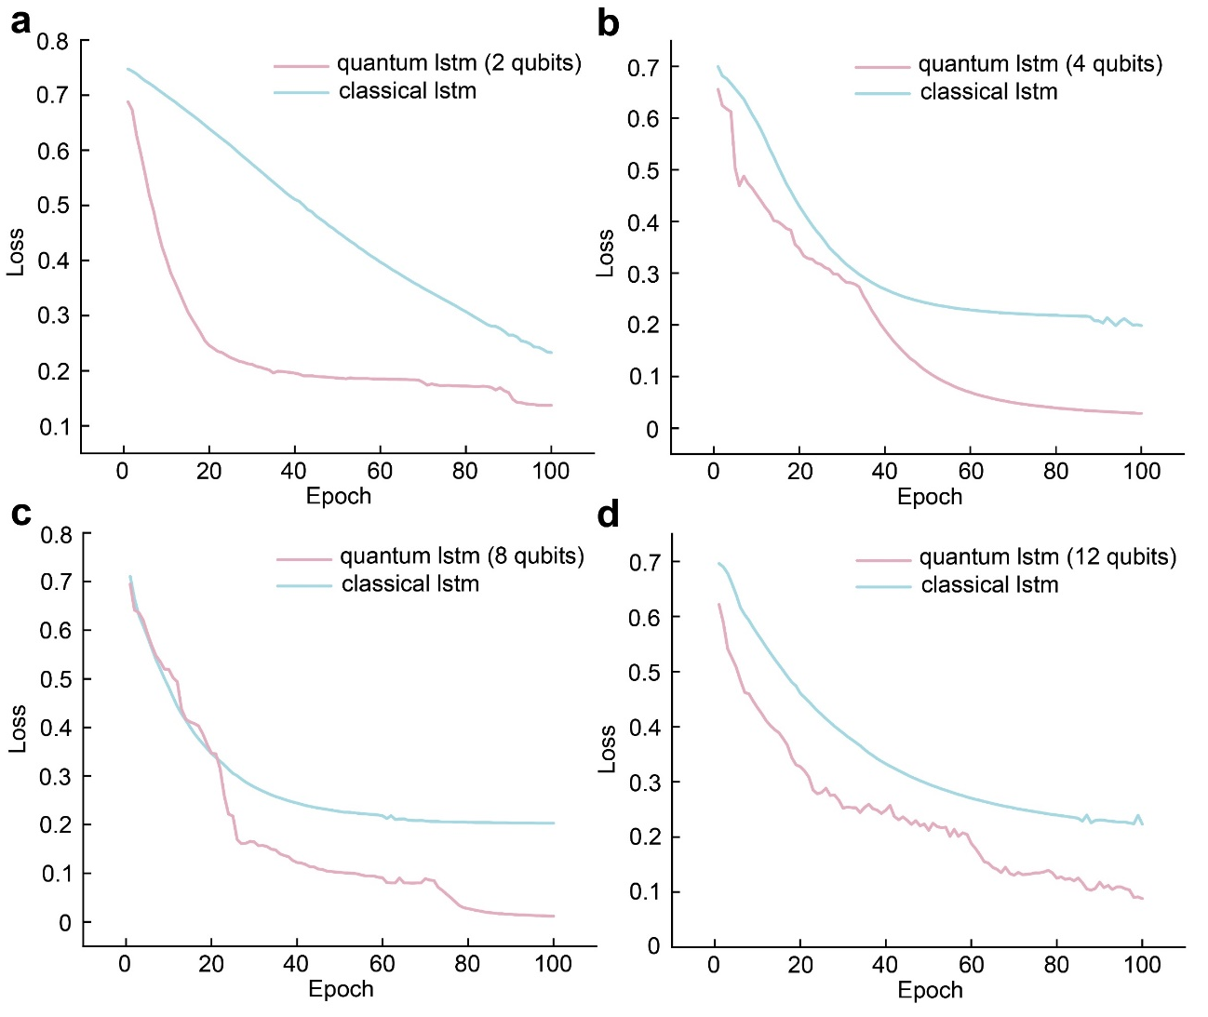

Figure S4. The QLSTM and LSTM models training loss on the T-47D dataset with 2, 4, 8, 12 qubits.
