Supplementary Information

Supplementary Table 1. Production cost mean (± Standard Error) in MXN/ha⁻¹ for field experiments and farmers' fields under different cropping systems in the semiarid region of Queretaro, Mexico.

Treatment | San Juan del Rio | Cadereyta | Farmers' fields
CT, MM | 8873.5 (687.6) | 8408 (444.3) | 6504.0 (374.2)
PB, MM | 8153.5 (749.5) | 7891.4 (558.9) | 7454.9 (469.1)
PWB, MO | 6947.9 (636.2) | 7643.6 (378.5) | -
PWB, MT | 7167.0 (690.8) | - | -
PB, MB | 7815.9 (783.9) | 8014.6 (283.6) | 7196.0 (503.1)

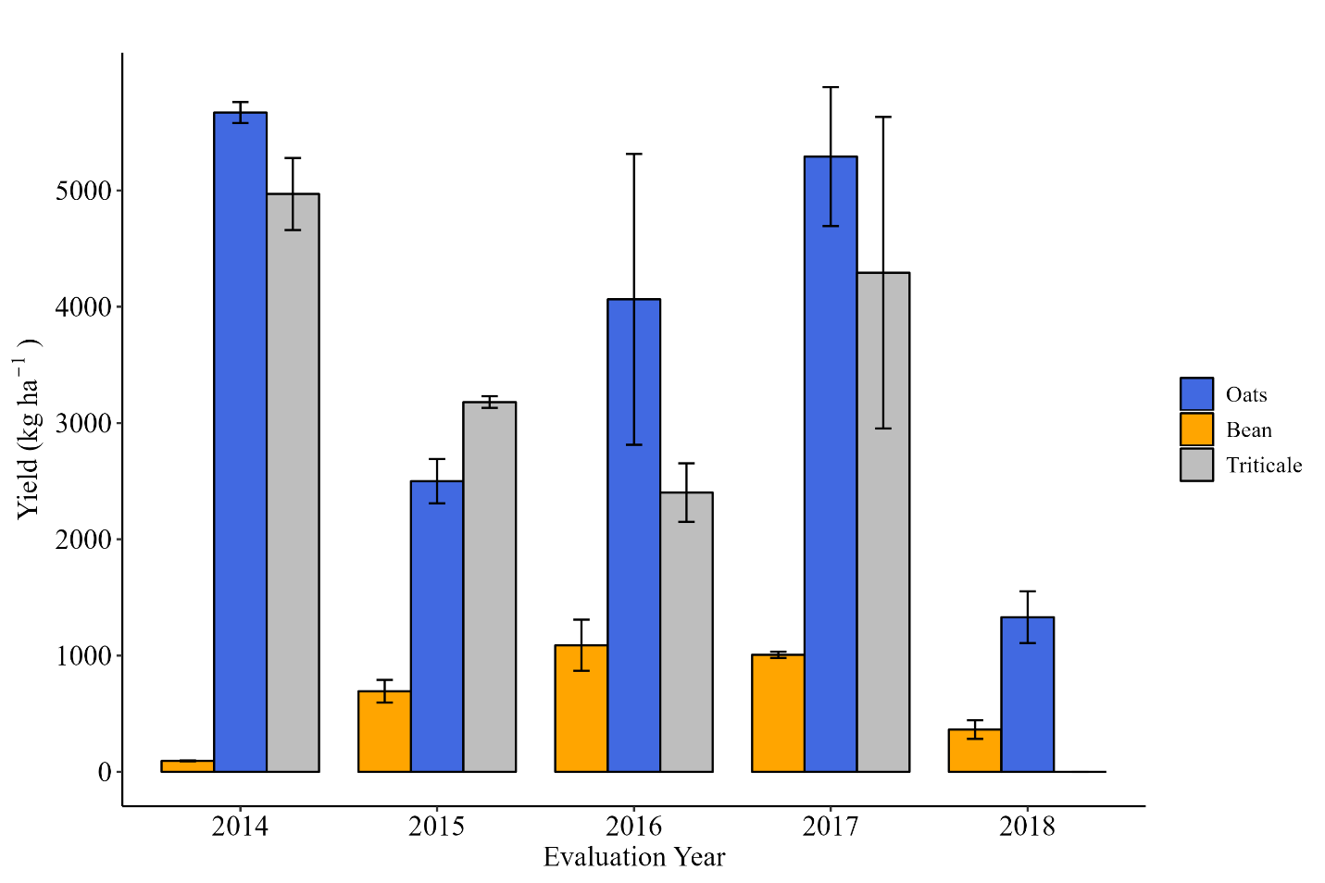
Supplementary Figure 1. Yield of grain or forage of rotation crops at San Juan del Rio site. The error bars represent the standard error of the mean.

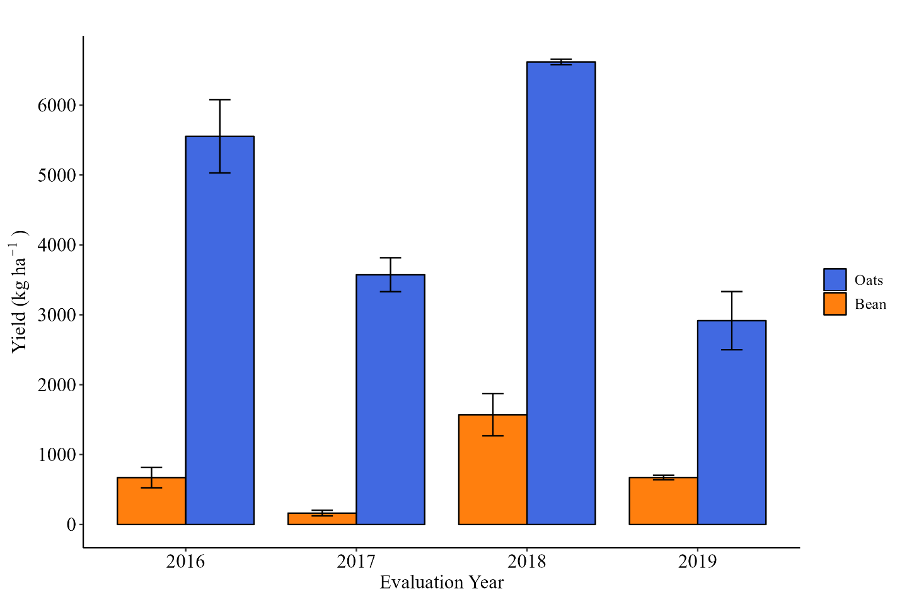
Supplementary Figure 2. Yield of grain or forage of rotation crops at Cadereyta site. The error bars represent the standard error of the mean.

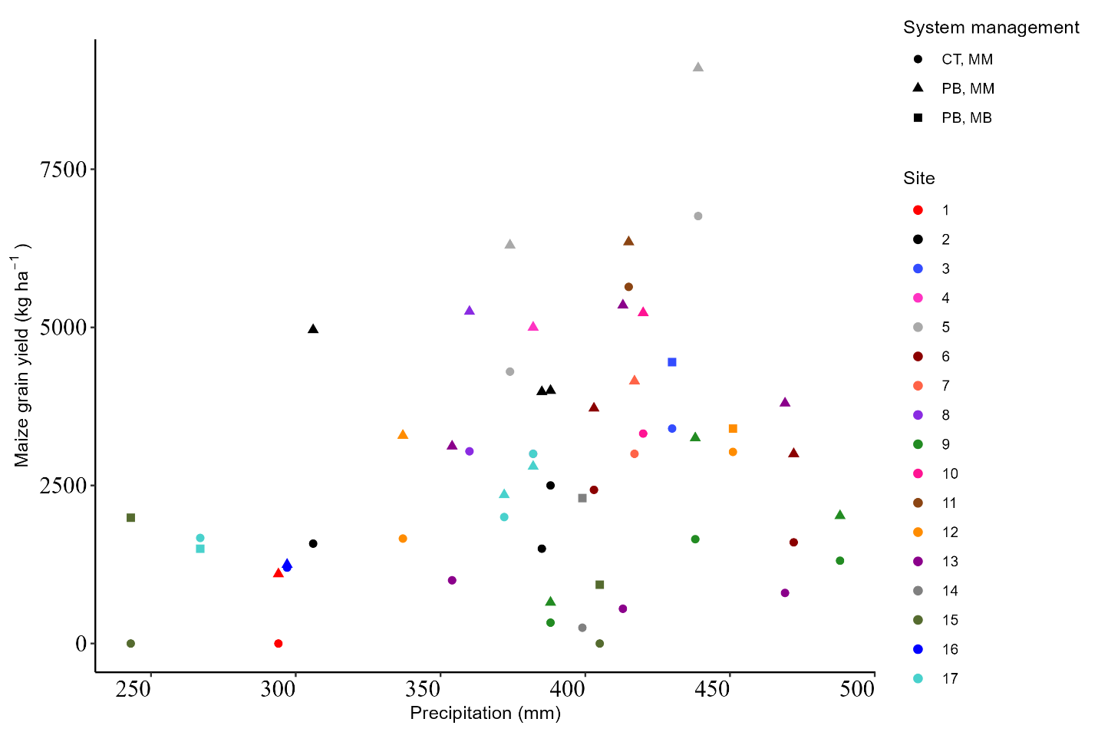
Supplementary Figure 3. Yield of maize grain at farmers' fields concerning precipitation during the growing season.

