Supplementary material
(A)
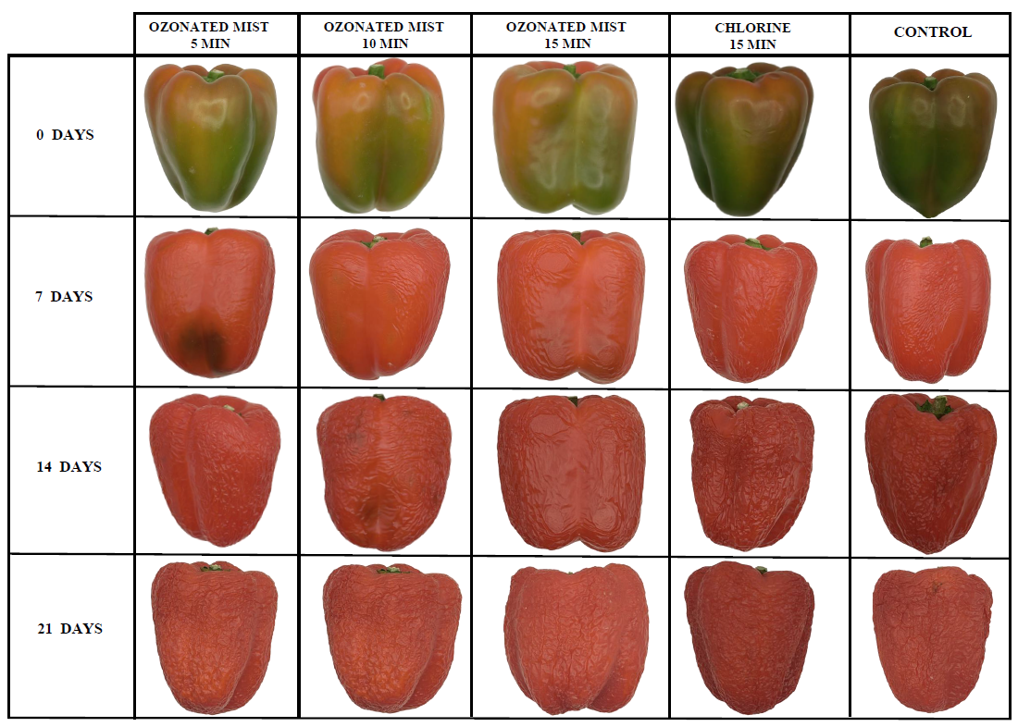
(B)
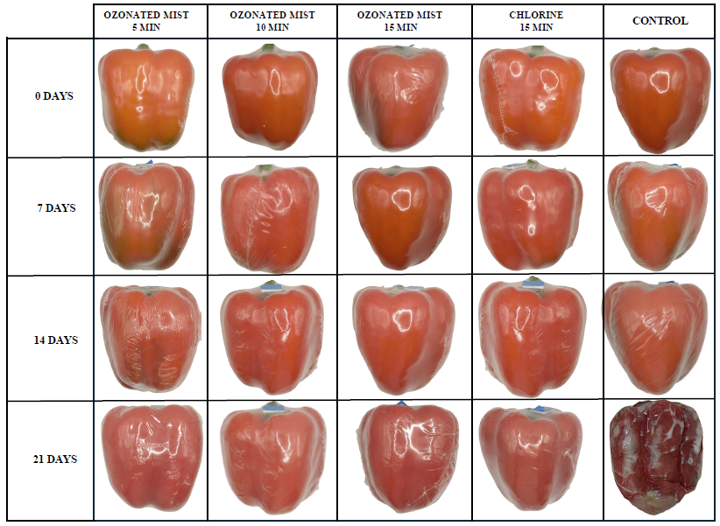
Figure 1. External appearance of bell peppers treated or not with ozonated mist and stored for 21 days at 25°C and 60% relative humidity.

