Supplementary Material

Video Communication, Blue Marble Awe, and Attitudes Toward Climate Change and Renewable Energy.

We include several supplementary materials: (1) descriptive statistics and correlation coefficients for the control variables; (2) the script used in each video and links to each video; (3) quotes illustrating positive and negative responses; (4) additional results from text analyses; (5) tables of results from regression analyses; (6) results from additional variables that were not included in the main text due to lack of space.

- Descriptive statistics and correlation coefficients for the control variables

We include descriptive statistics and correlation coefficients for the control variables in Table S1. Results from this table show that the correlations between the control variables are relatively weak, indicating that multicollinearity is not a significant problem in regression analyses.

 | Mean | S.D. | Age | Gender | Education | Black | Hispanic | Pol. or.
Age | 3.628 | 1.659 | 1
Gender | .529 | .499 | 0.004 | 1
Education | 2.835 | 1.192 | 0.266 | 0.056 | 1
Black | .112 | .315 | -0.150 | 0.108 | -0.019 | 1
Hispanic | .109 | .315 | -0.205 | 0.043 | -0.089 | -0.125 | 1
Pol. or. | 4.035 | 1.566 | -0.097 | 0.056 | 0.105 | 0.112 | 0.052 | 1
Table S1. Correlation coefficients for control variables.

- The script used in each video and links to each video.

Control: Blockchain Technology Video (2:35 minutes)
This video can be watched here (right click and choose “open hyperlink”).
Video script:
“Blockchains have been increasing in popularity but what is a block chain and why do people find them secure? Blockchain was invented by a person or a group of people using the name Satoshi Nakamoto in 2008, to serve as the public transaction ledger of the cryptocurrency bitcoin. A blockchain is a peer-to-peer software technology that acts as a secure distributed ledger that is completely open to anybody. It does this by recording and copying all transactions, and then crosschecking those transactions between all computers within the network. These transactions are stored in blocks, which contain 3 main parts. 1. Transaction data 2. A hash, and 3. The hash of a previous block. Blocks store all kinds of data on transactions such as the sender, receiver, and the amount being sent. Blocks also each contain a hash, which can be compared to a fingerprint. This hash uniquely identifies this block and its contents. It's important to note that a change in data within the block also changes the hash, making sure all changes are detected. The last main part of a block is that it contains the hash of previous blocks before it. This links those blocks together, creating a blockchain and is what makes it so secure. Any changes made to one block is made to all other blocks linked to it. If one of these blocks doesn’t match the hashes found in other blocks, then the system will not recognize it as a legitimate transaction. Because of this ability to detect attempts at altering transactions, many people have been turning to blockchain for their software operations. Companies are using blockchain technology for secure contracting, online voting, payroll services, and more. (Credits. Information: Simply Explained. Video/images: Simply Explained. Music: Jesse Gallagher)”

Treatment 1. Climate Change Video (2:36 minutes)
This video can be watched here (right click and choose “open hyperlink”).
Video script:
“Scientific evidence for warming of the climate system is unequivocal. The current warming trend is of particular significance because most of it is extremely likely to be the result of human activity since the mid 20th century and preceding at a rate that is unprecedented over millennia. This graph, based on the comparison of atmosphere samples contained in ice cores and more recent direct measurements, provides evidence that atmospheric carbon dioxide has increased since the industrial revolution. Ice cores drawn from Greenland, Antarctica, and tropical mountain glaciers show that Earth's climate responds to changes in greenhouse gas levels. Ancient evidence can also be found in tree rings, ocean sediments, coral reefs, and layers of sedimentary rocks. This ancient, or paleoclimate, evidence reveals that current warming is occurring roughly ten times faster than the average rate of ice-age recovery warming. Carbon dioxide from human activity is increasing more than 250 times faster than it did from natural sources after the last ice age. Carbon dioxide from human activity is increasing more than 250 times faster than it did from natural sources after the last ice age. The evidence for rapid climate change is compelling. Most of the warming occurred in the past 40 years, with the seven most recent years being the warmest. The ocean has absorbed much of this increased heat, with the top 100 meters of ocean showing warming of more than 0.6 degrees Fahrenheit since 1969. The Greenland and Antarctic ice sheets have decreased in mass. Data from NASA's Gravity Recovery and Climate Experiment show Greenland lost an average of 279 billion tons of ice per year between 1993 and 2019, while Antarctica lost about 148 billion tons of ice per year. Global sea level rose about 8 inches (20 centimeters) in the last century. The rate in the last two decades, however, is nearly double that of the last century and accelerating slightly every year. Since the beginning of the Industrial Revolution, the acidity of surface ocean waters has increased by about 30%. This increase is the result of humans emitting more carbon dioxide into the atmosphere and hence more being absorbed into the ocean.” (Credits. Information: BBC. Video/images: WWF-Australia, Sounds4sleeping, Quicksilver, Armadas, Primal Earth, Video footage of, Maha K, Drone snap, Jim Quiter, Royalty free video library, Peaceful scenes, Busy boy productions, Licet studios, KSDK news, The national news. Music: Jesse Gallagher)

Treatment 2. Solar PV Technology Video (2:29 minutes)
This video can be watched here (right click and choose “open hyperlink”).
“Solar panels produce electricity, without creating emissions, in the form of kilowatts. Although the manufacturing of solar panels produces some emissions, it is only the equivalent of around 40 grams of carbon dioxide per kilowatt hour. Compare this to fossil fuels like natural gas which emits around 500 grams, or coal which emits around 1000 grams. This shows great promise in solar energy as this technology is still new and becoming more and more efficient. This creates a snowball effect whereby, the more solar gets deployed, the cleaner it will become to produce even more. This makes solar one of the climate friendliest energy sources we have. Solar is quickly becoming a top choice for a clean, durable, and money saving source of power. Hundreds of large companies have chosen to go solar. It makes sense for businesses, and it makes sense for homeowners too. Going solar also helps the environment as it lowers the reliance on fossil fuels and reduces overall greenhouse gas emissions. It's practical, it's economical, it's better for the environment, and it's smart. With the right solar and storage system, your home can be protected from outages and from rising rates. Whether it's for environmental or financial reasons, solar energy is the better choice. Take control over when your energy works, where it comes from, and how much it costs. Here is how a well-designed all in one solar system can give you more energy independence, more control, more peace of mind, and more energy savings. During daylight hours, your solar panel produces clean electricity, which you use to power your home directly. Any excess you produce can flow back to the grid, which can provide a credit on your electric bill which helps pay for itself. You can also choose to add battery storage into your system and store that energy in your home for later use. Use it at night when your system isn’t producing electricity, to minimize peak time charges, or during an outage. All of this, while reducing carbon emissions and air pollution. Solar panels produce cleaner energy that helps protect the Earth’s atmosphere.” (Credits. Information: SunPower, DW Planet A. Video/images: Sean Doren, SunPower, Primal Earth, DW Planet A, J7 Videos and Music. Music: Jesse Gallagher)

Treatment 3: Blue Marble Video (2:46 minutes)
This video can be watched here (right click and choose “open hyperlink”).
Video script:
“The "Blue Marble" is an image of Earth from space taken by NASA satellites about 18,000 miles away from the Earth's surface. The Earth is a sphere with a roughly 8000-mile diameter and the thickness of the atmosphere is about 60 miles. The Earth's atmosphere is an extremely thin sheet of air extending from the surface of the Earth to the edge of space. In this picture, the atmosphere is a barely visible thin blue band between the surface and the blackness of space. If the Earth were the size of a basketball, the thickness of the atmosphere could be modeled by a thin sheet of plastic wrapped around the ball. When seeing the "Blue Marble" from space, many astronauts immediately sense the fragility of Earth as a vulnerable ball of life. Formerly significant worries vanish into thin air as an overwhelming urge to protect the Earth affects the astronauts. Here are a few quotes from them. Astronaut Ron Garan said, “When we look down at the Earth from space, we see this amazing, indescribably beautiful planet. It looks like a living, breathing organism, but it also, at the same time, looks extremely fragile. Anybody else who’s ever gone to space says the same thing because it really is striking and it’s really sobering to see this paper-thin layer and to realize that that little paper-thin layer is all that protects every living thing on Earth from death basically. and to realize that that little paper-thin layer is all that protects every living thing on Earth from death basically. From the harshness of space.” Astronaut James Irwin said, “As we got further and further away, the Earth diminished in size. Finally, it shrank to the size of a marble, the most beautiful you can imagine. That beautiful, warm, living object looked so fragile, so delicate, that if you touched it with a finger, it would crumble and fall apart. Seeing this has to change a man.” Astronaut Ulf Merbold said, “For the first time in my life I saw the horizon as a curved line. It was accentuated by a thin seam of dark blue light - our atmosphere. It was accentuated by a thin seam of dark blue light - our atmosphere. Obviously, this was not the ocean of air I had been told it was so many times in my life. I was terrified by its fragile appearance.”” (Credits. Information: NASA. Video/images: ISS images by Sean Doren. Music: Jesse Gallagher)

Treatment 4: Blue Marble and Climate Change Video (5:15 minutes)
This video can be watched here (right click and choose “open hyperlink”).
Video script:
“The "Blue Marble" is an image of Earth from space taken by NASA satellites about 18,000 miles away from the Earth's surface. The Earth is a sphere with a roughly 8000-mile diameter and the thickness of the atmosphere is about 60 miles. The Earth's atmosphere is an extremely thin sheet of air extending from the surface of the Earth to the edge of space. In this picture, the atmosphere is a barely visible thin blue band between the surface and the blackness of space. If the Earth were the size of a basketball, the thickness of the atmosphere could be modeled by a thin sheet of plastic wrapped around the ball. When seeing the "Blue Marble" from space, many astronauts immediately sense the fragility of Earth as a vulnerable ball of life. Formerly significant worries vanish into thin air as an overwhelming urge to protect the Earth affects the astronauts. Here are a few quotes from them. Astronaut Ron Garan said, “When we look down at the Earth from space, we see this amazing, indescribably beautiful planet. It looks like a living, breathing organism. But it also, at the same time, looks extremely fragile. Anybody else who’s ever gone to space says the same thing because it really is striking and it’s really sobering to see this paper-thin layer and to realize that that little paper-thin layer is all that protects every living thing on Earth from death basically. From the harshness of space.” Astronaut James Irwin said, “As we got further and further away, the Earth diminished in size. Finally, it shrank to the size of a marble, the most beautiful you can imagine. That beautiful, warm, living object looked so fragile, so delicate, that if you touched it with a finger, it would crumble and fall apart. Seeing this has to change a man.” Astronaut Ulf Merbold said, “For the first time in my life I saw the horizon as a curved line. It was accentuated by a thin seam of dark blue light - our atmosphere. Obviously, this was not the ocean of air I had been told it was so many times in my life. I was terrified by its fragile appearance.” Because of the fragility of Earth’s atmosphere, climate change is a significant threat. Scientific evidence for warming of the climate system is unequivocal. The current warming trend is of particular significance because most of it is extremely likely to be the result of human activity since the mid 20th century and preceding at a rate that is unprecedented over millennia. This graph, based on the comparison of atmosphere samples contained in ice cores and more recent direct measurements, provides evidence that atmospheric carbon dioxide has increased since the industrial revolution. Ice cores drawn from Greenland, Antarctica, and tropical mountain glaciers show that Earth's climate responds to changes in greenhouse gas levels. Ancient evidence can also be found in tree rings, ocean sediments, coral reefs, and layers of sedimentary rocks. Ancient evidence can also be found in tree rings, ocean sediments, coral reefs, and layers of sedimentary rocks. This ancient, or paleoclimate, evidence reveals that current warming is occurring roughly ten times faster than the average rate of ice-age recovery warming. Carbon dioxide from human activity is increasing more than 250 times faster than it did from natural sources after the last ice age. The evidence for rapid climate change is compelling. Most of the warming occurred in the past 40 years, with the seven most recent years being the warmest. The ocean has absorbed much of this increased heat, with the top 100 meters of ocean showing warming of more than 0.6 degrees Fahrenheit since 1969. The Greenland and Antarctic ice sheets have decreased in mass. Data from NASA's Gravity Recovery and Climate Experiment show Greenland lost an average of 279 billion tons of ice per year between 1993 and 2019, while Antarctica lost about 148 billion tons of ice per year. Global sea level rose about 8 inches (20 centimeters) in the last century. The rate in the last two decades, however, is nearly double that of the last century and accelerating slightly every year. Since the beginning of the Industrial Revolution, the acidity of surface ocean waters has increased by about 30%. This increase is the result of humans emitting more carbon dioxide into the atmosphere and hence more being absorbed into the ocean.” (Credits. Information: NASA, BBC. Video/images: Sean Doren, WWF-Australia, Sounds4sleeping, Quicksilver, Armadas, Primal Earth, Video footage of, Maha K, Drone snap, Jim Quiter, Royalty free video library, Peaceful scenes, Busy boy productions, Licet studios, KSDK news, The national news. Music: Jesse Gallagher)

Treatment 5. Blue Marble and Solar PV Video (5:15 minutes)
This video can be watched here (right click and choose “open hyperlink”).
Video script:
“The "Blue Marble" is an image of Earth from space taken by NASA satellites about 18,000 miles away from the Earth's surface. The Earth is a sphere with a roughly 8000-mile diameter and the thickness of the atmosphere is about 60 miles. The Earth's atmosphere is an extremely thin sheet of air extending from the surface of the Earth to the edge of space. In this picture, the atmosphere is a barely visible thin blue band between the surface and the blackness of space. If the Earth were the size of a basketball, the thickness of the atmosphere could be modeled by a thin sheet of plastic wrapped around the ball. When seeing the "Blue Marble" from space, many astronauts immediately sense the fragility of Earth as a vulnerable ball of life. Formerly significant worries vanish into thin air as an overwhelming urge to protect the Earth affects the astronauts. Here are a few quotes from them. Astronaut Ron Garan said, “When we look down at the Earth from space, we see this amazing, indescribably beautiful planet. It looks like a living, breathing organism. But it also, at the same time, looks extremely fragile. Anybody else who’s ever gone to space says the same thing because it really is striking and it’s really sobering to see this paper-thin layer and to realize that that little paper-thin layer is all that protects every living thing on Earth from death basically. From the harshness of space.” Astronaut James Irwin said, “As we got further and further away, the Earth diminished in size. Finally, it shrank to the size of a marble, the most beautiful you can imagine. That beautiful, warm, living object looked so fragile, so delicate, that if you touched it with a finger, it would crumble and fall apart. Seeing this has to change a man.” Astronaut Ulf Merbold said, “For the first time in my life I saw the horizon as a curved line. It was accentuated by a thin seam of dark blue light - our atmosphere. Obviously, this was not the ocean of air I had been told it was so many times in my life. I was terrified by its fragile appearance.” Because of the fragility of Earth’s atmosphere, many people are adopting environmentally friendly technologies such as solar photovoltaics. Solar panels produce electricity, without creating emissions, in the form of kilowatts. Although the manufacturing of solar panels produces some emissions, it is only the equivalent of around 40 grams of carbon dioxide per kilowatt hour. Compare this to fossil fuels like natural gas which emits around 500 grams, or coal which emits around 1000 grams. This shows great promise in solar energy as this technology is still new and becoming more and more efficient. This creates a snowball effect whereby, the more solar gets deployed, the cleaner it will become to produce even more. This makes solar one of the climate friendliest energy sources we have. Solar is quickly becoming a top choice for a clean, durable, and money saving source of power. Hundreds of large companies have chosen to go solar. It makes sense for businesses, and it makes sense for homeowners too. Going solar also helps the environment as it lowers the reliance on fossil fuels and reduces overall greenhouse gas emissions. It's practical, it's economical, it's better for the environment, and it's smart. With the right solar and storage system, your home can be protected from outages and from rising rates. With the right solar and storage system, your home can be protected from outages and from rising rates. Whether it's for environmental or financial reasons, solar energy is the better choice. Take control over when your energy works, where it comes from, and how much it costs. Here is how a well-designed all in one solar system can give you more energy independence, more control, more peace of mind, and more energy savings. During daylight hours, your solar panel produces clean electricity, which you use to power your home directly. Any excess you produce can flow back to the grid, which can provide a credit on your electric bill which helps pay for itself. You can also choose to add battery storage into your system and store that energy in your home for later use. Use it at night when your system isn’t producing electricity, to minimize peak time charges, or during an outage. All of this, while reducing carbon emissions and air pollution. Solar panels produce cleaner energy that helps protect the Earth’s atmosphere.” (Credits. Information: NASA, SunPower, DW Planet A. Video/images: Sean Doren, SunPower, Primal Earth, J7 Videos and Music, DW Planet A. Music: Jesse Gallagher)

Treatment 6. Blue Marble and Solar PV and Solar Ambassador Video (6:41 minutes)
This video can be watched here (right click and choose “open hyperlink”).
Video script:
“The "Blue Marble" is an image of Earth from space taken by NASA satellites about 18,000 miles away from the Earth's surface. The Earth is a sphere with a roughly 8000-mile diameter and the thickness of the atmosphere is about 60 miles. The Earth's atmosphere is an extremely thin sheet of air extending from the surface of the Earth to the edge of space. In this picture, the atmosphere is a barely visible thin blue band between the surface and the blackness of space. If the Earth were the size of a basketball, the thickness of the atmosphere could be modeled by a thin sheet of plastic wrapped around the ball. When seeing the "Blue Marble" from space, many astronauts immediately sense the fragility of Earth as a vulnerable ball of life. Formerly significant worries vanish into thin air as an overwhelming urge to protect the Earth affects the astronauts. Here are a few quotes from them. Astronaut Ron Garan said, “When we look down at the Earth from space, we see this amazing, indescribably beautiful planet. It looks like a living, breathing organism. But it also, at the same time, looks extremely fragile. Anybody else who’s ever gone to space says the same thing because it really is striking and it’s really sobering to see this paper-thin layer and to realize that that little paper-thin layer is all that protects every living thing on Earth from death basically. From the harshness of space.” Astronaut James Irwin said, “As we got further and further away, the Earth diminished in size. Finally, it shrank to the size of a marble, the most beautiful you can imagine. That beautiful, warm, living object looked so fragile, so delicate, that if you touched it with a finger, it would crumble and fall apart. Seeing this has to change a man.” Astronaut Ulf Merbold said, “For the first time in my life I saw the horizon as a curved line. It was accentuated by a thin seam of dark blue light - our atmosphere. Obviously, this was not the ocean of air I had been told it was so many times in my life. I was terrified by its fragile appearance.” Because of the fragility of Earth’s atmosphere, many people are adopting environmentally friendly technologies such as solar photovoltaics. Solar panels produce electricity, without creating emissions, in the form of kilowatts. Although the manufacturing of solar panels produces some emissions, it is only the equivalent of around 40 grams of carbon dioxide per kilowatt hour. Compare this to fossil fuels like natural gas which emits around 500 grams, or coal which emits around 1000 grams. This shows great promise in solar energy as this technology is still new and becoming more and more efficient. This creates a snowball effect whereby, the more solar gets deployed, the cleaner it will become to produce even more. This makes solar one of the climate friendliest energy sources we have. Solar is quickly becoming a top choice for a clean, durable, and money saving source of power. Hundreds of large companies have chosen to go solar. It makes sense for businesses, and it makes sense for homeowners too. Going solar also helps the environment as it lowers the reliance on fossil fuels and reduces overall greenhouse gas emissions. It's practical, it's economical, it's better for the environment, and it's smart. With the right solar and storage system, your home can be protected from outages and from rising rates. With the right solar and storage system, your home can be protected from outages and from rising rates. Whether it's for environmental or financial reasons, solar energy is the better choice. Take control over when your energy works, where it comes from, and how much it costs. Here is how a well-designed all in one solar system can give you more energy independence, more control, more peace of mind, and more energy savings. During daylight hours, your solar panel produces clean electricity, which you use to power your home directly. Any excess you produce can flow back to the grid, which can provide a credit on your electric bill which helps pay for itself. You can also choose to add battery storage into your system and store that energy in your home for later use. Use it at night when your system isn’t producing electricity, to minimize peak time charges, or during an outage. All of this, while reducing carbon emissions and air pollution. Solar panels produce cleaner energy that helps protect the Earth’s atmosphere. Because it's a low carbon form of energy, solar power has attracted the support of many people concerned with the fragility of the Earth’s atmosphere. One of those people is former astronaut Scott Kelly, who has partnered up with the company Sunrun to put solar panels on his home. Here is how he describes this partnership. So, the space station, the international space station, is powered by the sun. We have these eight giant solar rays that collect solar energy, uses that energy to operate all of our systems. For the last twenty years, I mean it’s worked great. Very reliable, and I am happy to take advantage of it here on Earth. People that have flown in space often refer to this as the orbital perspective. You recognize that there are challenges on this planet, and we need to take care of it, there is no planet B, we are not moving to Mars. It’s a very important thing to do whatever we can to reduce carbon emissions, and I’m happy that you know that SunRun has given me the opportunity to partner with them and put some solar power on my house. To be able to use that energy is something we should all strive to take advantage of. You know we are all a part of humanity together, you know one thing I learned at NASA, is that you know when we work together, and cooperate, we can do some remarkable things. (Credits. Information: NASA, SunPower, SunRun, DW Planet A, Scott Kelly. Video/images: Sean Doren, SunPower, SunRun, Primal Earth, J7 Videos and Music. Music: Jesse Gallagher).

- Quotes illustrating positive and negative responses

We include Tables S2 and S3 to illustrate how some respondents answered the questions “What are your thoughts after watching this video?”, “What are your feelings after watching this video?”, and “Would you say that you have learned anything from this video?” These tables show that some respondents had a positive reaction to the videos, while others had a negative reaction. We use these quotes for descriptive purposes.

Treatment | Positive response | Negative response
T1: Climate change video | “I'm left speechless. I didn't realize that the numbers were that high and that the percentage of increased warmth was anywhere near 30%. After watching this very informative video I want to learn more and do more to bring awareness to climate change.”  “My feeling before was we should do what it takes to achieve climate control, but not willing to sacrifice anything. After watching the video, it is clear that we must sacrifice the way we do things today.” | “The ideas presented are a one-sided effort to support climate change. They are constantly used by the eco extremists to push their global agenda.”  “Climate change propaganda relies on emotion more than facts. The ins and outs and particulars of what’s really going on are in serious question.”  “I think this is all to promote an agenda that honestly doesn’t hold water.”
T2: Solar PV video | “Wow! I loved the video and I think every new home built should have solar automatically. It made me more interested in getting some solar. The video was very informative.”  “Solar is important to keep our atmosphere clean. It produces less pollution than natural gas and coal. It’s ideal for homes to lower the cost of energy and be less reliant on energy from the grid.”  “I feel persuaded after watching this video. I might be going solar when I get a house.” | “I WAS TOTALLY MAD AND ALMOST QUIT LOOKING AT THIS LIE”  “I feel that fossil fuel and coal is the best way to move forward. A couple of years ago Texas was hit with a Winter Blast that hadn’t been seen in hundreds of years. Solar panels did not work, there wasn’t enough sunlight to generate electricity that was needed to keep people’s homes warm or anything else.”  “As I said, it's a biased presentation. Solar power does NOT make financial sense for most homeowners.”
T3: Blue marble video | “I am absolutely in awe of earth. Seeing earth in such a way makes life see more precious. I wish everyone can view this video.”  “I'm as awestruck as I was the first time I saw that image of Earth. It saddens and angers me that so many people regard our planet with ignorance or distain. I wish I could tell the Earth that I'm sorry we're not treating her very well.”  “Some transcendental awe and wonder. Humility before ethereal beauty.” | “The earth isn't fragile, GOD takes care of it, He created it.”  “I think that they are just shamming us and tricking us.”  “I take a Biblical view of the Earth. Man can do everything that he can to try and save it, but one day God is going to burn it all up and recreate it better than it has ever been. (2 Peter 3:5-9)”
T4: Blue marble and climate change video | “I didn't realize that the atmosphere was so thin. Climate change is more of a threat than I originally thought. It's beautiful to hear astronauts' desire to protect the earth.”  “I feel moved by the quotes from the astronauts. I feel a new responsibility to also protect the Earth. I feel nervous that climate change is ignored when it's such a big threat.”  “I feel very concerned, I wasn’t before I thought climate change was exaggerated. This video changed my mind.” | “I think climate change if one of the biggest propaganda stories in Earth's history. The climate is cyclical. The changes reported this century will be reversed in the next.”  “Half of the world's scientists say one thing and the other another .. I trust in God only.”  “There were some beautiful shots of the earth. But this video came off as propaganda. Where's the objectivity?”  “I think climate change is a hoax.”
T5: Blue marble and solar PV video | “My husband always talks about going solar and I scoffed at the idea. I’m going to tell him it’s time to go solar now.”  “This video was a wakeup. I'm 45 years old and never understood how fragile Earth's atmosphere is. I would recommend watching this video to anyone.”  “I never thought about how in pictures earth’s atmosphere looked fragile, I love the idea of using solar panels to help protect it better.”  “I feel like I never really thought about how fragile the earth’s atmosphere is until I watched this video, made me feel Insignificant and small and maybe I should step up and do my part.” | “A usual propaganda piece for the solar energy pyramid scheme that only Bernie Madoff would be proud of. Solar energy is neither more efficient nor is it cleaner than fossil fuels! Anyone who has studied this knows that! It takes a tremendous amount of mining and stripping of the earth to attain the minerals needed for solar energy and batteries. Secondly, the batteries are HIGHLY toxic to the earth and groundwater etc... Thirdly our grid demands MUCH more than solar panels or wind turbines can produce! This is a shame and a farce!”
T6: Blue marble, solar PV, and solar ambassador video | “The earth is a very fragile system. The atmosphere is very important and protects life on the planet. Saving our atmosphere will help save the planet. Solar energy is the safest energy source compared to fossil fuels and by using it more, we can help save the planet.”  “I did not realize how fragile the earth is. I feel that more people need to be made aware of these issues and help to protect the earth. I feel that people need to be educated in this matter.” | “This is a weak sales pitch. Given that we're already past the point of no return on climate change, saving a little greenhouse gas is negligible.”  “I feel a little misled because it was an ad disguised as an unbiased video.”  “My thoughts are God created the earth and it will stand for as long as he wants.”
Table S2. Quotes illustrating positive and negative responses to the question “What are your thoughts and feelings after watching this video?” for treatments 1-3.

Treatment | Positive response | Negative response
T1: Climate change video | “I have learned something from this video. I would say I learned that the evidence for climate change is strong and the main reason for climate change is human activity.”  “Yes, I have learned that the ice caps are melting at multiple times the speed that they would normally during warm periods. I also learned that climate change is “real” and backed by extensive science as shown.” | “Lies will never cease!”  “I learned nothing that I have not already heard. Propaganda which cannot be trusted. It is as trustworthy as our government.”
T2: Solar PV. | “Absolutely, I learned that solar is a renewable energy source and reduces reliance on fossil fuels. Also, you can receive a credit on your energy bill by having solar panels.”  “I didn't know about the different rates of emissions from fossil fuels, and coal before the video. Learning how much they produce, definitely makes me want to push others to looking into solar energy.” | “YES THAT SOLAR PANELS ARE USELESS AND TAKE MILLIONS OF ACRES TO HAVE THEM, SO WE NEED TO LEARN HOW TO COOK SOLAR PANELS TO EAT AS THERE WILL BE NO SPACE FOR CATTLE, SHEEP, PIGS.”
T3: Blue marble video | “The reality of how thin our atmosphere and how fragile life is on this planet.”  “Yes, I did not know the atmosphere was so small in comparison to the earth. Also, how beautifully earth looks for space.” | “That science is a joke.”  “I learned the atmosphere is fragile but not how to fix it or prevent it from getting worse. How long will it take before it will no longer protect the earth?”
T4: Blue marble and climate change | “I learned that our atmosphere is very fragile. I learned that global warming is real. I learned that we need to protect our earth and atmosphere better.”  “I know that climate change is bad, but I didn’t realize how bad. I also didn’t know that our atmosphere is paper thin.” | “I have learned that people continue to use this falsehood to control the people of the world.”  “Nothing, it is about the con job of global warning, and everything that I have ever heard about global warming and or global cooling is so farfetched and inaccurate I don't see how you can find anyone gullible enough to fall for the big lie.”
T5: Blue Marble and solar PV | “I learned more about how solar panels are made and how the emissions made when making them is less than the the ones fossil fuels emit. I also learned that the Earth's atmosphere is actually much thinner when looked at from space, which is different from what I thought how it looked like.”  “Yes, I was against to all this technology of solar panels and I didn’t know how important the solar panels are for our planet until today. This video has changed my mind.” | “I have learned a little, but I still think nuclear is the better form of energy.”
T6: Blue marble, solar PV and solar Ambassador | “Solar energy is the way of the future and fossil fuels along with other non-renewable ways of energy should be left in the past. The earth is our only home so we must make the best of it and make sure that it stays healthy and last long.”  “The fact that we can do something about helping earth out as far as energy is a great idea. There is such a strain on the environment we live in, and I didn’t know this until the astronauts made it clear to me. we take a lot of stuff for granted by being negligence in our ways.” | “Not to trust ‘the science’.”
Table S3. Quotes illustrating positive and negative responses to the question: “Would you say that you have learned anything from this video?”

- Additional results from text analyses

We include Figures S1-S6 to aid the interpretation of Figures 1 and 2 from the paper. These figures show the words mentioned most frequently in respondents’ answers to the question “What are your feelings after watching this video?” for treatments 1-6. Although figures S1-S6 do not show the association between words, they make it easier to see the ranking of the most frequently mentioned words described in the paper.

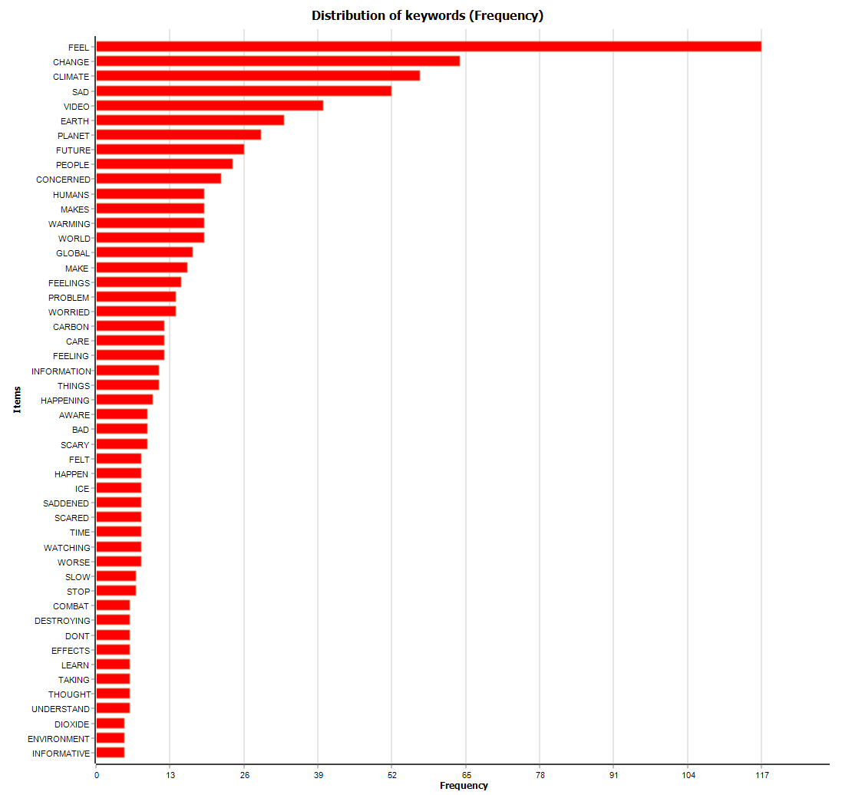
Figure S1. The words mentioned most frequently in answers to the question “What are your feelings after watching this video?” for the first treatment (T1 -climate change video).

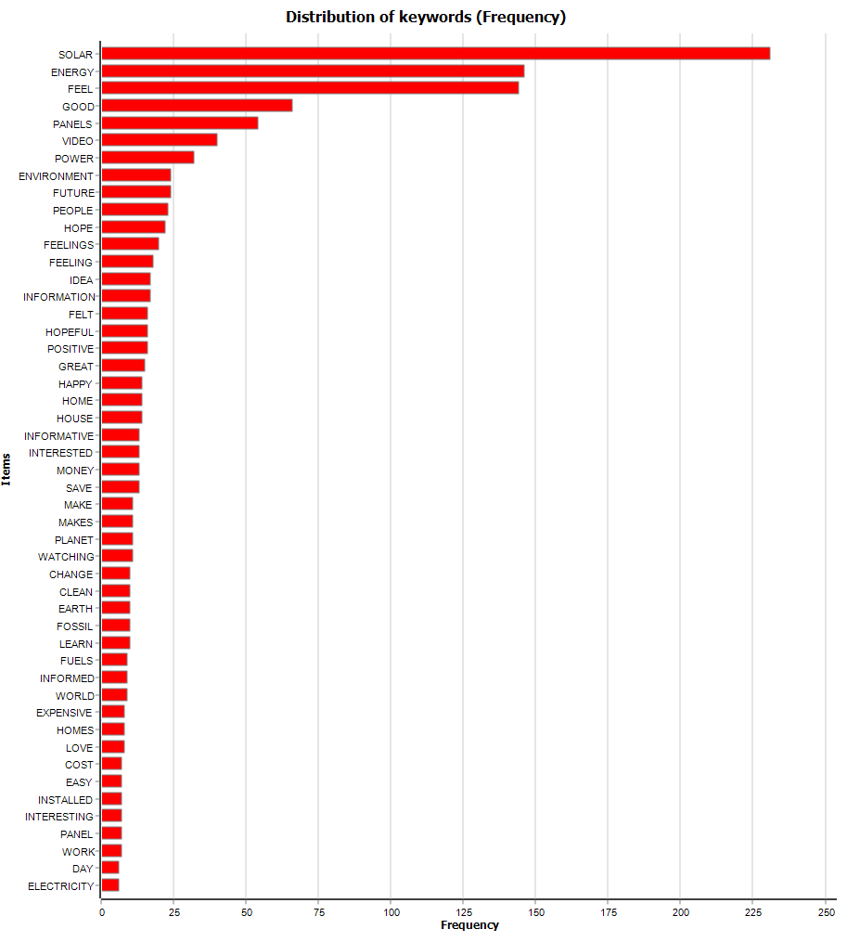
Figure S2. The words mentioned most frequently in answers to the question “What are your feelings after watching this video?” for the second treatment (T2 -solar PV video).
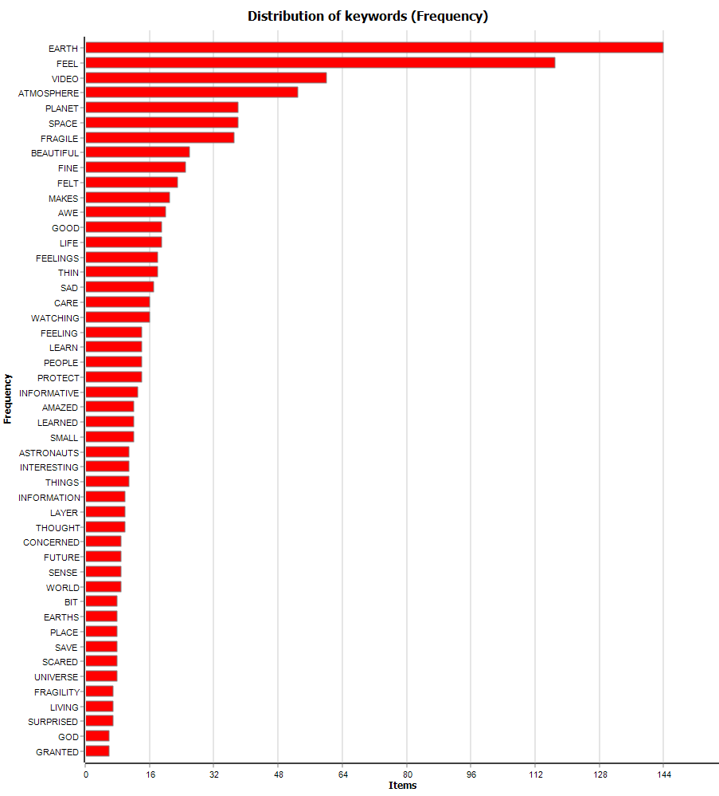
Figure S3. The words mentioned most frequently in answers to the question “What are your feelings after watching this video?” for the third treatment (T3 -blue marble video).
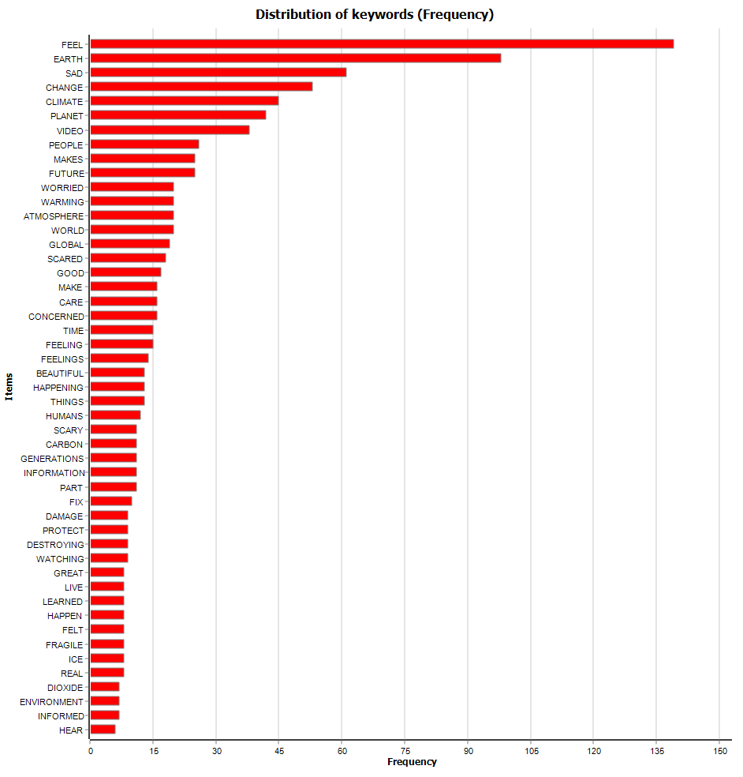
Figure S4. The words mentioned most frequently in answers to the question “What are your feelings after watching this video?” for the fourth treatment (T4 -blue marble and climate change video).

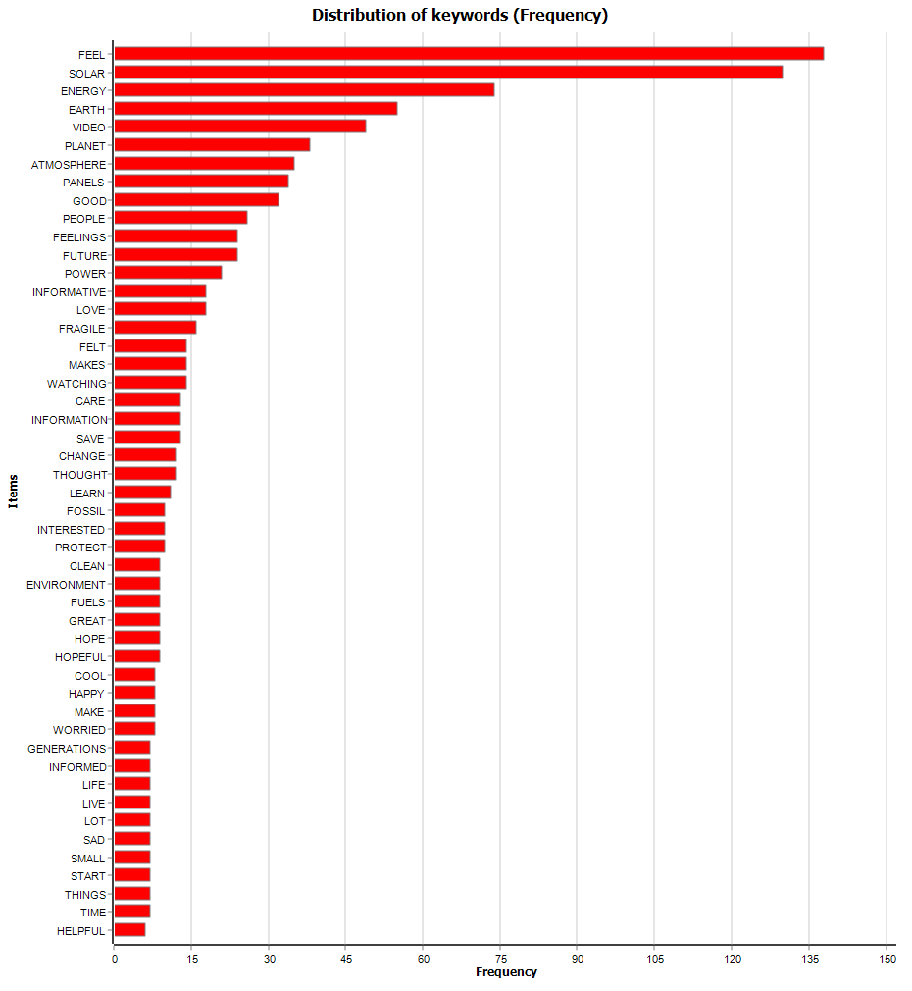
Figure S5. The words mentioned most frequently in answers to the question “What are your feelings after watching this video?” for the fifth treatment (T5 -blue marble and solar PV video).
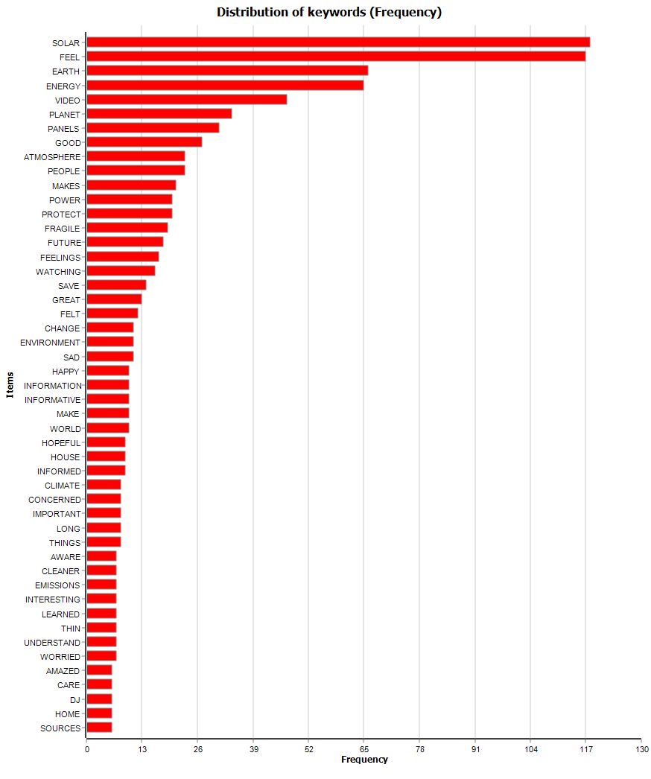
Figure S6. The words mentioned most frequently in answers to the question “What are your feelings after watching this video?” for the sixth treatment (T6 -blue marble, solar PV, and solar ambassador video).

- Tables of results from regression analyses.

We include Tables S4-S9 to show the complete results from ordered logistic regressions. These results include the odds ratios for treatments and control variables. The ordered logistic regressions were calculated in STATA/SE 17.0 using the ologit command, which fits the ordered logit model, also known as the proportional odds model.

 | CC human activity | CC pers. worry | Support solar | Plan install solar PV | Pay more for RE
T1: CC video | 1.742***  (.226) | 1.424**  (.180) | 1.159  (.146) | .976  (.124) | .862  (.107)
T2: SP video | 1.360*  (.167) | 1.188  (.142) | 1.607***  (.194) | 1.609***  (.194) | 1.007  (.121)
T3: BM video | 1.150  (.144) | 1.150  (.142) | 1.020  (.125) | 1.004  (.124) | .969  (.117)
T4: BM&CC video | 1.697***  (.216) | 1.572***  (.196) | 1.328*  (.165) | 1.215  (.152) | 1.304*  (.159)
T5: BM&SP video | 1.430**  (.181) | 1.325*  (.163) | 1.926***  (.242) | 1.428**  (.178) | 1.182  (.145)
T6: BM&SP&SA video | 1.634***  (.216) | 1.464**  (.188) | 2.006***  (.262) | 1.837***  (.238) | 1.529***  (.196)
Age | 1.031  (.023) | 1.029  (.022) | 1.053*  (.023) | .729***  (.016) | .861***  (.018)
Gender (woman) | 1.093  (.076) | 1.374***  (.093) | .863*  (.059) | .796**  (.054) | 1.050  (.070)
Education | 1.066*  (.032) | 1.074*  (.031) | 1.040  (.031) | 1.056  (.031) | 1.161***  (.033)
Race (Black) | .747**  (.082) | 1.185  (.130) | .805  (.089) | 1.229  (.136) | 1.224  (.130)
Race (Hispanic) | 1.077  (.123) | 1.436**  (.161) | .948  (.105) | 1.538***  (.171) | 1.201  (.131)
Political Orientation | 1.602***  (.039) | 1.542***  (.036) | 1.408***  (.033) | 1.130***  (.025) | 1.212***  (.026)
Nr. Obs.  Chi square | 2,846  450.39*** | 2,846  455.46*** | 2,846  292.16*** | 2,755  367.19*** | 2,846  216.28***
Table S4. This figure presents the effects of treatments and controls on: 1. CC human activity; 2. CC personal worry; 3. Support solar PV; 4. Plan install solar PV; 5. Pay more for RE. Note: *p < .05, **p < .01, ***p < .001.

 | CC human activity | CC human activity | CC human activity | CC human activity | CC human activity | CC human activity
T1: CC video | .746  (.230) | 1.743***  (.226) | 1.746***  (.227) | 1.744***  (.226) | 1.741***  (.226) | 1.741***  (.226)
T2: SP video | 1.360*  (.167) | 1.805*  (.495) | 1.361*  (.168) | 1.361*  (.168) | 1.360*  (.167) | 1.360*  (.167)
T3: BM video | 1.154  (.144) | 1.149  (.144) | 2.440**  (.711) | 1.149  (.144) | 1.150  (.144) | 1.150  (.144)
T4: BM&CC video | 1.696***  (.216) | 1.698***  (.217) | 1.699***  (.217) | 2.455**  (.717) | 1.697***  (.216) | 1.697***  (.216)
T5: BM&SP video | 1.422**  (.180) | 1.434**  (.182) | 1.439**  (.183) | 1.435**  (.182) | 1.360  (.378) | 1.430**  (.181)
T6: BM&SP&SA video | 1.637***  (.216) | 1.633***  (.216) | 1.631***  (.216) | 1.633***  (.216) | 1.634***  (.216) | 1.539  (.498)
T1XPO | 1.247**  (.092) | _ | _ | _ | _ | _
T2XPO |  | .930  (.057) | _ | _ | _ | _
T3XPO |  |  | .830**  (.053) | _ | _ | _
T4XPO |  |  |  | .910  (.060) | _ | _
T5XPO |  |  |  |  | 1.360  (.378) | _
T6XPO |  |  |  |  |  | 1.539  (.498)
Age | 1.030  (.023) | 1.030  (.023) | 1.032  (.023) | 1.030  (.023) | 1.031  (.023) | 1.031  (.023)
Gender (woman) | 1.095  (.076) | 1.094  (.076) | 1.090  (.076) | 1.099  (.076) | 1.094  (.076) | 1.093  (.076)
Education | 1.067*  (.032) | 1.066*  (.032) | 1.069*  (.032) | 1.066*  (.032) | 1.066*  (.032) | 1.066*  (.032)
Race (Black) | .754*  (.083) | .746**  (.082) | .748**  (.083) | .747**  (.082) | .747**  (.082) | .747**  (.082)
Race (Hispanic) | 1.079  (.124) | 1.072  (.123) | 1.081  (.124) | 1.080  (.124) | 1.077  (.124) | 1.076  (.123)
Political Orientation | 1.559***  (.040) | 1.622***  (.043) | 1.648***  (.044) | 1.624***  (.043) | 1.599***  (.042) | 1.599***  (.041)
Nr. Obs.  Chi square | 2,846  459.71*** | 2,846  451.71*** | 2,846  458.51*** | 2,846  452.36*** | 2,846  450.43*** | 2,846  450.43***
Table S5. This figure presents the effects of treatments, controls, and interaction effects on “Climate change human activity”. Note: *p < .05, **p < .01, ***p < .001.

 | CC per.  worry | CC per. worry | CC per. worry | CC per. worry | CC per. worry | CC per. worry
T1: CC video | 1.194**  (.079) | 1.424**  (.180) | 1.425**  (.180) | 1.425**  (.180) | 1.424**  (.180) | 1.424**  (.180)
T2: SP video | 1.188  (.142) | .902  (.052) | 1.188  (.142) | 1.189  (.142) | 1.187  (.142) | 1.188  (.142)
T3: BM video | 1.154  (.142) | 1.147  (.142) | 2.312**  (.671) | 1.147  (.142) | 1.152  (.142) | 1.150  (.142)
T4: BM&CC video | 1.573***  (.196) | 1.571***  (.196) | 1.571***  (.197) | .841**  (.053) | 1.572***  (.196) | 1.572***  (.196)
T5: BM&SP video | 1.319*  (.162) | 1.329*  (.164) | 1.331*  (.164) | 1.331*  (.164) | 1.023  (.281) | 1.325*  (.163)
T6: BM&SP&SA video | 1.468**  (.188) | 1.462**  (.188) | 1.461**  (.188) | 1.462**  (.188) | 1.465**  (.188) | 1.454  (.453)
T1XPO | 1.194**  (.079) | _ | _ | _ | _ | _
T2XPO |  | .902  (.052) | _ | _ | _ | _
T3XPO |  |  | .845**  (.053) | _ | _ | _
T4XPO |  |  |  | .841**  (.053) | _ | _
T5XPO |  |  |  |  | 1.023  (.281) | _
T6XPO |  |  |  |  |  | 1.001  (.069)
Age | 1.028  (.022) | 1.027  (.022) | 1.031  (.022) | 1.028  (.022) | 1.029  (.022) | 1.029  (.022)
Gender (woman) | 1.375***  (.093) | 1.375***  (.093) | 1.373***  (.093) | 1.382***  (.093) | 1.376***  (.093) | 1.374***  (.093)
Education | 1.075*  (.031) | 1.076*  (.031) | 1.076*  (.031) | 1.074*  (.031) | 1.076*  (.031) | 1.074*  (.031)
Race (Black) | 1.193  (.131) | 1.178  (.129) | 1.190  (.131) | 1.190  (.130) | 1.181  (.129) | 1.185  (.130)
Race (Hispanic) | 1.437***  (.161) | 1.427**  (.160) | 1.447***  (.162) | 1.453***  (.163) | 1.441***  (.162) | 1.436***  (.161)
Political Orientation | 1.506***  (.037) | 1.570***  (.040) | 1.580***  (.040) | 1.580***  (.040) | 1.527***  (.038) | 1.541***  (.038)
Nr. Obs.  Chi square | 2,846  462.70*** | 2,846  458.48*** | 2,846  462.48*** | 2,846  462.62*** | 2,846  456.57*** | 2,846  455.46***
Table S6. This figure presents the effects of treatments, controls, and interaction effects on “Climate change personal worry”. Note: *p < .05, **p < .01, ***p < .001.
 | Support solar PV | Support solar PV | Support solar PV | Support solar PV | Support solar PV | Support solar PV
T1: CC video | .591  (.173) | 1.159  (.146) | 1.159  (.146) | 1.159  (.146) | 1.159  (.146) | 1.159  (.145)
T2: SP video | 1.606***  (.194) | 2.410***  (.657) | 1.608***  (.195) | 1.607***  (.194) | 1.606***  (.194) | 1.606***  (.194)
T3: BM video | 1.023  (.125) | 1.018  (.125) | 1.764*  (.506) | 1.020  (.125) | 1.021  (.125) | 1.021  (.125)
T4: BM&CC video | 1.330*  (.165) | 1.328*  (.165) | 1.327*  (.165) | 1.504  (.436) | 1.328*  (.165) | 1.328*  (.165)
T5: BM&SP video | 1.919***  (.241) | 1.933***  (.243) | 1.934***  (.243) | 1.928***  (.242) | 1.762*  (.500) | 1.924***  (.241)
T6: BM&SP&SA video | 2.009***  (.262) | 2.006***  (.262) | 2.005***  (.262) | 2.006***  (.262) | 2.006***  (.262) | 1.660  (.526)
T1XPO | 1.182*  (.078) | _ | _ | _ | _ | _
T2XPO |  | .903  (.055) | _ | _ | _ | _
T3XPO |  |  | .875*  (.054) | _ | _ | _
T4XPO |  |  |  | .969  (.062) | _ | _
T5XPO |  |  |  |  | 1.023  (.067) | _
T6XPO |  |  |  |  |  | 1.047  (.075)
Age | 1.053*  (.023) | 1.052*  (.023) | 1.054*  (.023) | 1.053*  (.023) | 1.053*  (.023) | 1.053*  (.023)
Gender (woman) | .862*  (.059) | .864*  (.059) | .862*  (.059) | .864*  (.059) | .864*  (.059) | .864*  (.059)
Education | 1.041  (.031) | 1.041  (.031) | 1.042  (.031) | 1.040  (.031) | 1.040  (.031) | 1.040  (.031)
Race (Black) | .810  (.090) | .803*  (.089) | .804  (.089) | .806  (.089) | .804  (.089) | .806  (.089)
Race (Hispanic) | .946  (.105) | .944  (.105) | .946  (.105) | .949  (.106) | .948  (.106) | .947  (.105)
Political Orientation | 1.376***  (.034) | 1.432***  (.036) | 1.437***  (.036) | 1.414***  (.035) | 1.404***  (.035) | 1.400***  (.034)
Nr. Obs.  Chi square | 2,846  298.62*** | 2,846  294.90*** | 2,846  296.60*** | 2,846  292.39*** | 2,846  292.29*** | 2,846  292.59***
Table S7. This figure presents the effects of treatments, controls, and interaction effects on “Support solar PV”. Note: *p < .05, **p < .01, ***p < .001.

 | Plan install solar | Plan install solar | Plan install solar | Plan install solar | Plan install solar | Plan install solar
T1: CC video | .808  (.236) | .976  (.124) | .976  (.124) | .976  (.124) | .977  (.124) | .976  (.124)
T2: SP video | 1.609***  (.194) | 1.621  (.432) | 1.609***  (.194) | 1.609***  (.194) | 1.610***  (.194) | 1.609***  (.194)
T3: BM video | 1.004  (.124) | 1.004  (.124) | 1.164  (.332) | 1.004  (.124) | 1.003  (.124) | 1.004  (.124)
T4: BM&CC video | 1.215  (.152) | 1.215  (.152) | 1.216  (.152) | 1.283  (.373) | 1.216  (.152) | 1.215  (.152)
T5: BM&SP video | 1.426**  (.178) | 1.428**  (.178) | 1.429**  (.178) | 1.429**  (.178) | 1.918*  (.527) | 1.427**  (.178)
T6: BM&SP&SA video | 1.837***  (.238) | 1.837***  (.238) | 1.837***  (.238) | 1.837***  (.238) | 1.837***  (.238) | 1.591  (.488)
T1XPO | 1.048  (.068) | _ | _ | _ | _ | _
T2XPO |  | .998  (.058) | _ | _ | _ | _
T3XPO |  |  | .964  (.059) | _ | _ | _
T4XPO |  |  |  | .986  (.063) | _ | _
T5XPO |  |  |  |  | .927  (.058) | _
T6XPO |  |  |  |  |  | 1.035  (.070)
Age | .728***  (.016) | .729***  (.016) | .729***  (.016) | .729***  (.016) | .729***  (.016) | .729***  (.016)
Gender (woman) | .796***  (.054) | .796***  (.054) | .796***  (.054) | .797***  (.054) | .794***  (.054) | .797***  (.054)
Education | 1.056  (.031) | 1.056  (.031) | 1.056  (.031) | 1.056  (.031) | 1.055  (.031) | 1.055  (.031)
Race (Black) | 1.232  (.137) | 1.229  (.136) | 1.229  (.136) | 1.230  (.136) | 1.235  (.137) | 1.230  (.136)
Race (Hispanic) | 1.537***  (.171) | 1.538***  (.171) | 1.538***  (.171) | 1.539***  (.171) | 1.536***  (.171) | 1.539***  (.171)
Political Orientation | 1.123***  (.027) | 1.130***  (.028) | 1.136***  (.027) | 1.132***  (.027) | 1.142***  (.027) | 1.125***  (.027)
Nr. Obs.  Chi square | 2,846  367.71*** | 2,846  367.19*** | 2,846  367.53*** | 2,846  367.24*** | 2,846  368.64*** | 2,846  367.46***
Table S8. This figure presents the effects of treatments, controls, and interaction effects on “Plan install solar PV”. Note: *p < .05, **p < .01, ***p < .001.

 | Pay more for RE | Pay more for RE | Pay more for RE | Pay more for RE | Pay more for RE | Pay more for RE
T1: CC video | .526*  (.148) | .861  (.107) | .861  (.107) | .863  (.107) | .862  (.107) | .862  (.107)
T2: SP video | 1.006  (.120) | .834  (.227) | 1.007  (.121) | 1.007  (.121) | 1.007  (.121) | 1.007  (.121)
T3: BM video | .970  (.117) | .969  (.117) | .843  (.238) | .968  (.117) | .969  (.117) | .969  (.117)
T4: BM&CC video | 1.305*  (.159) | 1.305*  (.159) | 1.304*  (.159) | 2.248**  (.633) | 1.304*  (.159) | 1.304*  (.159)
T5: BM&SP video | 1.180  (.145) | 1.181  (.145) | 1.182  (.145) | 1.185  (.146) | 1.452  (.397) | 1.183  (.145)
T6: BM&SP&SA video | 1.532***  (.196) | 1.530***  (.196) | 1.530***  (.196) | 1.528***  (.196) | 1.529***  (.196) | 1.673  (.523)
T1XPO | 1.128  (.069) | _ | _ | _ | _ | _
T2XPO |  | 1.046  (.062) | _ | _ | _ | _
T3XPO |  |  | 1.033  (.063) | _ | _ | _
T4XPO |  |  |  | .877*  (.053) | _ | _
T5XPO |  |  |  |  | .950  (.057) | _
T6XPO |  |  |  |  |  | .978  (.066)
Age | .860***  (.018) | .862***  (.018) | .861***  (.018) | .860***  (.018) | .861***  (.018) | .861***  (.018)
Gender (woman) | 1.051  (.070) | 1.050  (.070) | 1.051  (.070) | 1.055  (.070) | 1.050  (.070) | 1.050  (.070)
Education | 1.162***  (.034) | 1.160***  (.033) | 1.160***  (.033) | 1.162***  (.033) | 1.160***  (.033) | 1.161***  (.033)
Race (Black) | 1.230  (.130) | 1.227  (.130) | 1.224  (.130) | 1.228  (.130) | 1.228  (.130) | 1.224  (.130)
Race (Hispanic) | 1.200  (.130) | 1.205  (.131) | 1.201  (.131) | 1.213  (.132) | 1.200  (.131) | 1.201  (.131)
Political Orientation | 1.191***  (.028) | 1.204***  (.028) | 1.206***  (.028) | 1.235***  (.029) | 1.221***  (.029) | 1.215***  (.028)
Nr. Obs.  Chi square | 2,846  220.11*** | 2,846  216.87*** | 2,846  216.57*** | 2,846  220.87*** | 2,846  216.98*** | 2,846  216.38***
Table S9. This figure presents the effects of treatments, controls, and interaction effects on “Pay more for renewable energy”. Note: *p < .05, **p < .01, ***p < .001.
- Results from additional variables that were not included in the main text.

We include Tables S10-S12 to show the results from ordered logistic regressions for two additional dependent variables (“ENGO recommend”, and “Solar company recommend”) that were not included in the main text due to lack of space.

We assessed respondents’ interest in recommending an environmental organization to friends and colleagues. The statement read “This environmental organization is an international movement of ordinary people working to end the age of fossil fuels and build a world of community-led renewable energy for all. This organization recognizes that the climate crisis is immense and that we must be daring and courageous in response. It embraces experiments and new solutions, recognizing that the crisis requires innovative ways of solving problems.” We asked respondents “How likely are you to recommend this environmental organization to a friend or colleague?” (labeled “ENGO recommend”, ranging from “0 percent likely” to “100 percent likely” in 10 points increments).

We assessed respondents’ interest in recommending a solar PV company to friends and colleagues. To create a realistic generic solar panel company, we described it using a statement that is very similar to the language used by an actual company on its websites. The statement read “This solar panel installer company is dedicated to making clean energy and storage accessible to everybody by designing all-in-one residential solutions.” We asked respondents “How likely are you to recommend this solar company to a friend or colleague?” (labeled “Solar c. recommend”, ranging from “0 percent likely” to “100 percent likely” in 10 points increments).

The results include the odds ratios for treatments and control variables. The ordered logistic regressions were calculated in STATA/SE 17.0 using the ologit command, which fits the ordered logit model, also known as the proportional odds model. Overall, the results from regression analyses using these additional dependent variables are similar to the results from regression analyses using the other dependent variables.

 | ENGO recommend | Solar c. recommend
T1: CC video | 1.326*  (.164) | 1.111  (.137)
T2: SP video | 1.435**  (.169) | 1.473**  (.175)
T3: BM video | 1.287*  (.158) | 1.128  (.136)
T4: BM&CC video | 1.544***  (.189) | 1.280*  (.156)
T5: BM&SP video | 1.642***  (.202) | 1.492**  (.184)
T6: BM&SP&SA video | 1.983***  (.248) | 1.717***  (.217)
Age | .920***  (.019) | .966  (.020)
Gender (woman) | 1.007  (.067) | .838**  (.055)
Education | 1.053  (.030) | 1.056  (.030)
Race (Black) | 1.329**  (.143) | 1.382**  (.151)
Race (Hispanic) | 1.494***  (.163) | 1.398**  (.153)
Political Orientation | 1.282***  (.028) | 1.255***  (.027)
Nr. Obs.  Chi square | 2,846  229.11*** | 2,846  183.32***
Table S10. This figure presents the effects of treatments and controls on: ENGO recommend; Solar company recommend. The values show odds ratios from ordered logistic regressions. Note: *p < .05, **p < .01, ***p < .001.

 | ENGO recommend | ENGO recommend | ENGO recommend | ENGO recommend | ENGO recommend | ENGO recommend
T1: CC video | .604  (.170) | 1.326*  (.164) | 1.327*  (.164) | 1.325*  (.164) | 1.326*  (.164) | 1.326*  (.164)
T2: SP video | 1.434**  (.169) | 1.610  (.421) | 1.436**  (.169) | 1.435**  (.169) | 1.436**  (.169) | 1.435**  (.169)
T3: BM video | 1.293*  (.159) | 1.286*  (.158) | 2.416**  (.712) | 1.288*  (.158) | 1.286*  (.158) | 1.288*  (.158)
T4: BM&CC video | 1.547***  (.189) | 1.544***  (.189) | 1.543***  (.189) | 1.446  (.413) | 1.544***  (.189) | 1.544***  (.189)
T5: BM&SP video | 1.636***  (.201) | 1.643***  (.202) | 1.646***  (.203) | 1.641***  (.202) | 2.054**  (.568) | 1.641***  (.202)
T6: BM&SP&SA video | 1.989***  (.249) | 1.982***  (.248) | 1.980***  (.248) | 1.983***  (.248) | 1.982***  (.248) | 1.962*  (.578)
T1XPO | 1.213**  (.076) | _ | _ | _ | _ | _
T2XPO |  | .972  (.055) | _ | _ | _ | _
T3XPO |  |  | .862*  (.054) | _ | _ | _
T4XPO |  |  |  | 1.015  (.063) | _ | _
T5XPO |  |  |  |  | .945  (.058) | _
T6XPO |  |  |  |  |  | 1.002  (.064)
Age | .918***  (.019) | .919***  (.019) | .921***  (.019) | .920***  (.019) | .920***  (.019) | .920***  (.019)
Gender (woman) | 1.008  (.067) | 1.006  (.067) | 1.006  (.067) | 1.006  (.067) | 1.005  (.067) | 1.007  (.067)
Education | 1.055  (.030) | 1.053  (.030) | 1.055  (.030) | 1.053  (.030) | 1.052  (.030) | 1.053  (.030)
Race (Black) | 1.342**  (.144) | 1.327**  (.143) | 1.329**  (.143) | 1.328**  (.143) | 1.334**  (.143) | 1.329**  (.143)
Race (Hispanic) | 1.492***  (.163) | 1.492***  (.163) | 1.495***  (.164) | 1.493***  (.163) | 1.491***  (.163) | 1.494***  (.163)
Political Orientation | 1.248***  (.029) | 1.289***  (.031) | 1.309***  (.031) | 1.280***  (.030) | 1.293***  (.031) | 1.282***  (.030)
Nr. Obs.  Chi square | 2,846  238.68*** | 2,846  229.35*** | 2,846  234.65*** | 2,846  229.17*** | 2,846  229.93*** | 2,846  229.11***
Table S11. This figure presents the effects of treatments, controls and interaction effects on: ENGO recommend. The values show odds ratios from ordered logistic regressions. Note: *p < .05, **p < .01, ***p < .001.

 | Solar PV c. recommend | Solar PV c. recommend | Solar PV c. recommend | Solar PV c. recommend | Solar PV c. recommend | Solar PV c. recommend
T1: CC video | .512*  (.142) | 1.111  (.137) | 1.111  (.137) | 1.111  (.137) | 1.111  (.137) | 1.111  (.137)
T2: SP video | 1.474***  (.175) | 1.713*  (.446) | 1.473***  (.175) | 1.473***  (.175) | 1.473***  (.175) | 1.473***  (.175)
T3: BM video | 1.135  (.137) | 1.127  (.136) | 1.347  (.379) | 1.128  (.136) | 1.125  (.136) | 1.128  (.136)
T4: BM&CC video | 1.284*  (.157) | 1.279*  (.156) | 1.279*  (.156) | 1.413  (.394) | 1.279*  (.156) | 1.280*  (.156)
T5: BM&SP video | 1.492**  (.184) | 1.493***  (.184) | 1.493***  (.184) | 1.493***  (.184) | 2.275**  (.620) | 1.492***  (.184)
T6: BM&SP&SA video | 1.727***  (.218) | 1.716***  (.217) | 1.715***  (.217) | 1.717***  (.217) | 1.713***  (.216) | 1.819*  (.546)
T1XPO | 1.212**  (.075) | _ | _ | _ | _ | _
T2XPO |  | .963  (.055) | _ | _ | _ | _
T3XPO |  |  | .958  (.058) | _ | _ | _
T4XPO |  |  |  | .976  (.059) | _ | _
T5XPO |  |  |  |  | .899  (.054) | _
T6XPO |  |  |  |  |  | .986  (.064)
Age | .965  (.020) | .966  (.020) | .966  (.020) | .966  (.020) | .966  (.020) | .966  (.020)
Gender (woman) | .838**  (.055) | .838**  (.055) | .838**  (.055) | .839**  (.055) | .836**  (.055) | .838**  (.055)
Education | 1.057  (.030) | 1.056  (.030) | 1.056  (.030) | 1.056  (.030) | 1.055  (.030) | 1.056  (.030)
Race (Black) | 1.393**  (.152) | 1.380**  (.150) | 1.382**  (.151) | 1.383**  (.151) | 1.392**  (.152) | 1.382**  (.151)
Race (Hispanic) | 1.396**  (.152) | 1.396**  (.152) | 1.399**  (.153) | 1.400**  (.153) | 1.394**  (.152) | 1.398**  (.153)
Political Orientation | 1.222***  (.028) | 1.263***  (.030) | 1.263***  (.030) | 1.259***  (.029) | 1.275***  (.030) | 1.257***  (.029)
Nr. Obs.  Chi square | 2,846  193.08*** | 2,846  183.74*** | 2,846  183.81*** | 2,846  183.48*** | 2,846  186.34*** | 2,846  183.36***
Table S12. This figure presents the effects of treatments, controls and interaction effects on Solar company recommend. The values show odds ratios from ordered logistic regressions. Note: *p < .05, **p < .01, ***p < .001.

