Supplemental Information

REDD1 expression in podocytes facilitates renal inflammation and pyroptosis in streptozotocin-induced diabetic nephropathy
Sunilkumar et al.

Table of Contents:

- Table S1: Antibody information
- Table S2: PCR oligonucleotide sequence
- Table S3: Descriptive statistical analysis
- Figure S1. Flow cytometry analysis of REDD1^{+/+} vs. REDD1^{-/-}
- Figure S2. Flow cytometry analysis of REDD1 fl/fl vs. REDD1 PodKO
- Unedited western blots
- Individual immunofluorescence channels

Table S1. Antibody list
Antibody list
Assay | Antibody | Source | Catalog # | Lot# | Dilution
Western blotting | REDD1 | ProteinTech | 10638-1-AP | 95508 | 1:500
Western blotting | NLRP3 | Invitrogen | PA5-79740 | ZE4324561 | 1:1000
Western blotting | phospho p65 NF-κB (Ser 536) | Cell Signaling | 3033 | 17 | 1:1000
Western blotting | p65 NF-κB | Cell Signaling | 8242 | 8 | 1:1000
Western blotting | CCL2/MCP-1 | Cell Signaling | 2029 | 2 | 1:1000
Western blotting | IL-1β | Cell Signaling | 12242 | 4 | 1:1000
Western blotting | Gasdermin D | Cell Signaling | 39754 |  | 1:1000
Western blotting | Cleaved Gasdermin D (Asp275) | Cell Signaling | 36425 | 4 | 1:1000
Western blotting | HA-tag | Cell Signaling | 3724 | 10 | 1:1000
Western blotting | Actin | Cell Signaling | 4970 | 19 | 1:1000
Western blotting | Lamin B | Santa Cruz | sc6216 | C1307 | 1:1000
Western blotting | GAPDH | Santa Cruz | sc-47724 | H1021 | 1:2000
Western blotting | Goat anti-Rabbit IgG h+l-HRP | Bethyl laboratories | A120-101 | 44 | 1:10000
Western blotting | Goat anti-mouse IgG h+l-HRP | Bethyl laboratories | A90-116 | 43 | 1:10000
Western blotting | Rabbit anti-goat IgG h+l-HRP | Bethyl laboratories | A50-100P | 29 | 1:10000
IF / IHC | REDD1 | ProteinTech | 10638-1-AP | 110532 | 1:250
IF / IHC | F4/80 | Cell Signaling | 30325 | 3 | 1:200
IF / IHC | NF-κB | Cell Signaling | 8242 | 8 | 1:500
IF / IHC | Cleaved Gasdermin D (Asp275) | Cell Signaling | 36425 | 4 | 1:500
IF / IHC | NLRP3 |  | PA5-79740 | ZE4324561 | 1:500
IF / IHC | Nephrin | R&D Biotech | AF3159 | CBIK0422122 | 1:500
IF / IHC | Donkey anti-Rabbit Alexa Fluor 647 | Jackson laboratories | 711-605-152 | 164324 | 1:500
IF / IHC | Donkey anti-goat Alexafluor 488 | Jackson laboratories | 705-546-147 | 122088 | 1:500
Flow Cytometry | APC-Cy 7 Rat anti-Mouse CD45 | BD Biosciences | 561037 | 3041708 | 1:100
Flow Cytometry | PerCP-Cy 5.5 Rat anti-Mouse CD11b | BD Biosciences | 561114 | 3079694 | 1:100
Flow Cytometry | Alexa Fluor 647 Rat anti-Mouse F4/80 | BD Biosciences | 565854 | 3115393 | 1:100
Flow Cytometry | PE Rat anti-Mouse CD86 | BD Biosciences | 561963 | 3145661 | 1:100
Flow Cytometry | Alexa Fluor 488 Rat anti-Mouse CD206 | BD Biosciences | 568807 | 2279205 | 1:100
Table S2. PCR oligonucleotide sequence
PCR primer list
Species | Target | Forward sequence (5' - 3') | Reverse sequence (5' - 3')
Mouse | Ccl2 | CACTCACCTGCTGCTACTCA | GCTTGGTGACAAAAACTACAGC
Mouse | Il1b | CACTACAGGCTCCGAGATCAAC | CCCCTGGAGATTGAGCTGTCTGC
Mouse | Nlrp3 | CTCCAACCATTCTCTGACCAG | ACA GATT GAA GTA AGG CCG G
Mouse | Gapdh | GGTGGTCTCCTCTGACTTCAACA | GTTGCTGTAGCCAAATTCGTTGT
Human | CCL2 | CATGAAAGTCTCTGCCGCCC | GGGCATTGATTGCATCTGGCTG
Human | IL1B | TCCGAGGCACAAGGCACAA | TGGCTGCTTCAGACACTTGAG
Human | NLRP3 | GACCCAGGGATGAGAGTGTTGT | CCCAACCACAATCTCCGAAT
Human | GAPDH | GTTGTCTCCTGCGACTTCA | TGCTGTAGCCGTATTCATTG
Human | CCL2 ChIP | CCTGGAAATCCACAGGATGC | CGAGAGTGCGAGCTTCAG

Table S3. Descriptive statistics
Figure # | Experimental Groups | Adjusted P Value
Figure 1B | Veh DG (n=4) vs. STZ DMSO (n=4) | 0.0002
Figure 1B | STZ DMSO (n=4) vs. STZ DG (n=3) | 0.0006
Figure 1D | Veh DG (n=4) vs. STZ DMSO (n=4) | <0.0001
Figure 1D | STZ DMSO (n=4) vs. STZ DG (n=3) | <0.0001
Figure 2A | REDD1+/+ Veh (n=4) vs. REDD1+/+ STZ (n=4) | 0.0108
Figure 2A | REDD1+/+ Veh (n=4) vs. REDD1-/- Veh (n=4) | 0.0004
Figure 2A | REDD1+/+ STZ (n=4) vs. REDD1-/- STZ (n=4) | <0.0001
Figure 2B | REDD1+/+ Blood glucose vs Urine ACR | <0.0001
Figure 2B | REDD1-/- Blood glucose vs Urine ACR | 0.085
Figure 2C | REDD1+/+ Veh (n=5) vs. REDD1+/+ STZ (n=6) | 0.0039
Figure 2C | REDD1+/+ STZ (n=6) vs. REDD1-/- STZ (n=5) | 0.0012
Figure 2D | REDD1+/+ Veh (n=5) vs. REDD1+/+ STZ (n=6) | <0.0001
Figure 2D | REDD1+/+ STZ (n=6) vs. REDD1-/- STZ (n=6) | <0.0001
Figure 2E | REDD1+/+ Veh (n=4) vs. REDD1+/+ STZ (n=5) | 0.0088
Figure 2E | REDD1+/+ STZ (n=5) vs. REDD1-/- STZ (n=5) | 0.0066
Figure 2F | REDD1+/+ Veh (n=5) vs. REDD1+/+ STZ (n=6) | <0.0001
Figure 2F | REDD1+/+ STZ (n=6) vs. REDD1-/- STZ (n=5) | <0.0001
Figure 3B | REDD1+/+ Veh (n=3) vs. REDD1+/+ STZ (n=3) | <0.0001
Figure 3B | REDD1+/+ STZ (n=3) vs. REDD1-/- STZ (n=3) | <0.0001
Figure 3D | REDD1+/+ Veh (n=4) vs. REDD1+/+ STZ (n=4) | 0.0466
Figure 3D | REDD1+/+ STZ (n=4) vs. REDD1-/- STZ (n=4) | 0.0588
Figure 3E | REDD1+/+ Veh (n=4) vs. REDD1+/+ STZ (n=4) | 0.0485
Figure 3E | REDD1+/+ STZ (n=4) vs. REDD1-/- STZ (n=4) | 0.0428
Figure 3F | REDD1+/+ Veh (n=4) vs. REDD1+/+ STZ (n=4) | 0.0025
Figure 3F | REDD1+/+ STZ (n=4) vs. REDD1-/- STZ (n=4) | 0.0092
Figure # | Experimental Groups | Adjusted P Value
Figure 4A | REDD1+/+ Veh (n=6) vs. REDD1+/+ STZ (n=6) | <0.0001
Figure 4A | REDD1+/+ STZ (n=6) vs. REDD1-/- STZ (n=6) | <0.0001
Figure 4C | CIHP WT OC (n=6) vs. CIHP WT HG (n=6) | <0.0001
Figure 4C | CIHP WT HG (n=6) vs. CIHP REDD1 KO HG (n=6) | <0.0001
Figure 4E | CIHP WT OC (n=6) vs. CIHP WT HG (n=6) | <0.0001
Figure 4E | CIHP WT HG (n=6) vs. CIHP REDD1 KO HG (n=6) | <0.0001
Figure 4F | IL1B_CIHP WT OC (n=4) vs. CIHP WT HG (n=4) | <0.0001
Figure 4F | IL1B_CIHP WT HG (n=4) vs. CIHP REDD1 KO HG (n=4) | <0.0001
Figure 4F | CCL2_CIHP WT OC (n=4) vs. CIHP WT HG (n=4) | 0.0022
Figure 4F | CCL2_CIHP WT HG (n=4) vs. CIHP REDD1 KO HG (n=4) | <0.0001
Figure 4G | CIHP WT OC (n=4) vs. CIHP WT HG (n=4) | <0.0001
Figure 4G | CIHP WT HG (n=4) vs. CIHP REDD1 KO HG (n=4) | <0.0001
Figure 4H | CIHP WT OC (n=3) vs. CIHP WT HG (n=3) | 0.0003
Figure 4H | CIHP WT OC (n=3) vs. CIHP REDD1 KO OC (n=3) | 0.0002
Figure 4H | CIHP WT HG (n=3) vs. CIHP REDD1 KO HG (n=3) | 0.0002
Figure 4I | CIHP WT OC (n=5) vs. CIHP WT HG (n=5) | 0.0278
Figure 4I | CIHP WT HG (n=5) vs. CIHP REDD1 KO HG (n=5) | 0.0234
Figure 4J | EV OC (n=4) vs. HA-REDD1 OC (n=4) | 0.001
Figure 4J | EV HG (n=4) vs. HA-REDD1 HG (n=4) | <0.0001
Figure 5B | CIHP WT OC (n=3) vs. CIHP WT HG (n=3) | <0.0001
Figure 5B | CIHP WT HG (n=3) vs. CIHP REDD1 KO HG (n=3) | <0.0001
Figure 5D | REDD1 fl/fl Blood glucose vs Urine ACR | 0.0043
Figure 5D | REDD1 podKO Blood glucose vs Urine ACR | 0.0834
Figure 5F | REDD1 fl/fl Veh (n=6) vs. REDD1 fl/fl STZ (n=6) | 0.0001
Figure 5F | REDD1 fl/fl STZ (n=6) vs. REDD1 podKO STZ (n=6) | <0.0001
Figure # | Experimental Groups | Adjusted P Value
Figure 5H | REDD1 fl/fl Veh (n=3) vs. REDD1 fl/fl STZ (n=3) | <0.0001
Figure 5H | REDD1 fl/fl STZ (n=3) vs. REDD1 podKO STZ (n=3) | 0.033
Figure 5I | REDD1 fl/fl Veh (n=3) vs. REDD1 fl/fl STZ (n=3) | 0.0087
Figure 5I | REDD1 fl/fl STZ (n=3) vs. REDD1 podKO STZ (n=3) | 0.01
Figure 6A | CIHP WT OC (n=4) vs. CIHP WT HG (n=4) | <0.0001
Figure 6A | CIHP WT HG (n=4) vs. CIHP REDD1 KO HG (n=4) | 0.0001
Figure 6B | CIHP WT OC (n=6) vs. CIHP WT HG (n=6) | <0.0001
Figure 6B | CIHP WT HG (n=6) vs. CIHP REDD1 KO HG (n=6) | <0.0001
Figure 6D | CIHP WT OC (n=6) vs. CIHP WT HG (n=6) | <0.0001
Figure 6D | CIHP WT HG (n=6) vs. CIHP REDD1 KO HG (n=6) | 0.0004
Figure 6E | CIHP WT OC (n=12) vs. CIHP WT HG (n=12) | <0.0001
Figure 6E | CIHP WT HG (n=12) vs. CIHP REDD1 KO HG (n=12) | <0.0001
Figure 6F | REDD1 fl/fl Veh (n=3) vs. REDD1 fl/fl STZ (n=3) | 0.0005
Figure 6F | REDD1 fl/fl STZ (n=3) vs. REDD1 podKO STZ (n=3) | 0.0012
Figure 6G | REDD1 fl/fl Veh (n=6) vs. REDD1 fl/fl STZ (n=6) | 0.0056
Figure 6G | REDD1 fl/fl STZ (n=6) vs. REDD1 podKO STZ (n=6) | 0.0094
Figure 6I | REDD1 fl/fl Veh (n=6) vs. REDD1 fl/fl STZ (n=6) | <0.0001
Figure 6I | REDD1 fl/fl STZ (n=6) vs. REDD1 podKO STZ (n=6) | <0.0001

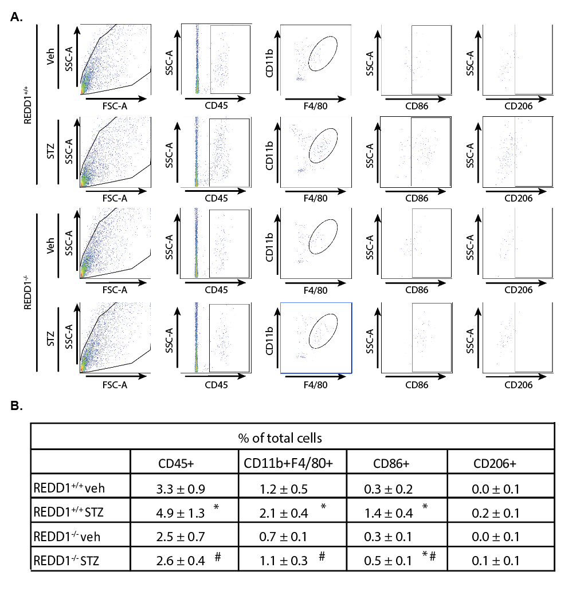

Figure S1. Flow cytometry analysis of REDD1^{+/+} vs. REDD1^{-/-}. Diabetes was induced in REDD1^{+/+} and REDD1^{-/-} mice by streptozotocin (STZ) administration. Non-diabetic control mice received vehicle (Veh). A, Representative flow cytometry plots show CD11b+F4/80+ macrophage populations within CD45+ leukocytes. The subpopulation of CD86+ and CD206+ cells among CD11b+F4/80+ macrophages are shown. B, The population of immune cells as a percent of total cells counted are tabulated. Values are presented as means ± SD (n = 3). Differences between groups were identified by two-way ANOVA. *, p < 0.05 versus Veh; #, p < 0.05 versus REDD1^{+/+}.

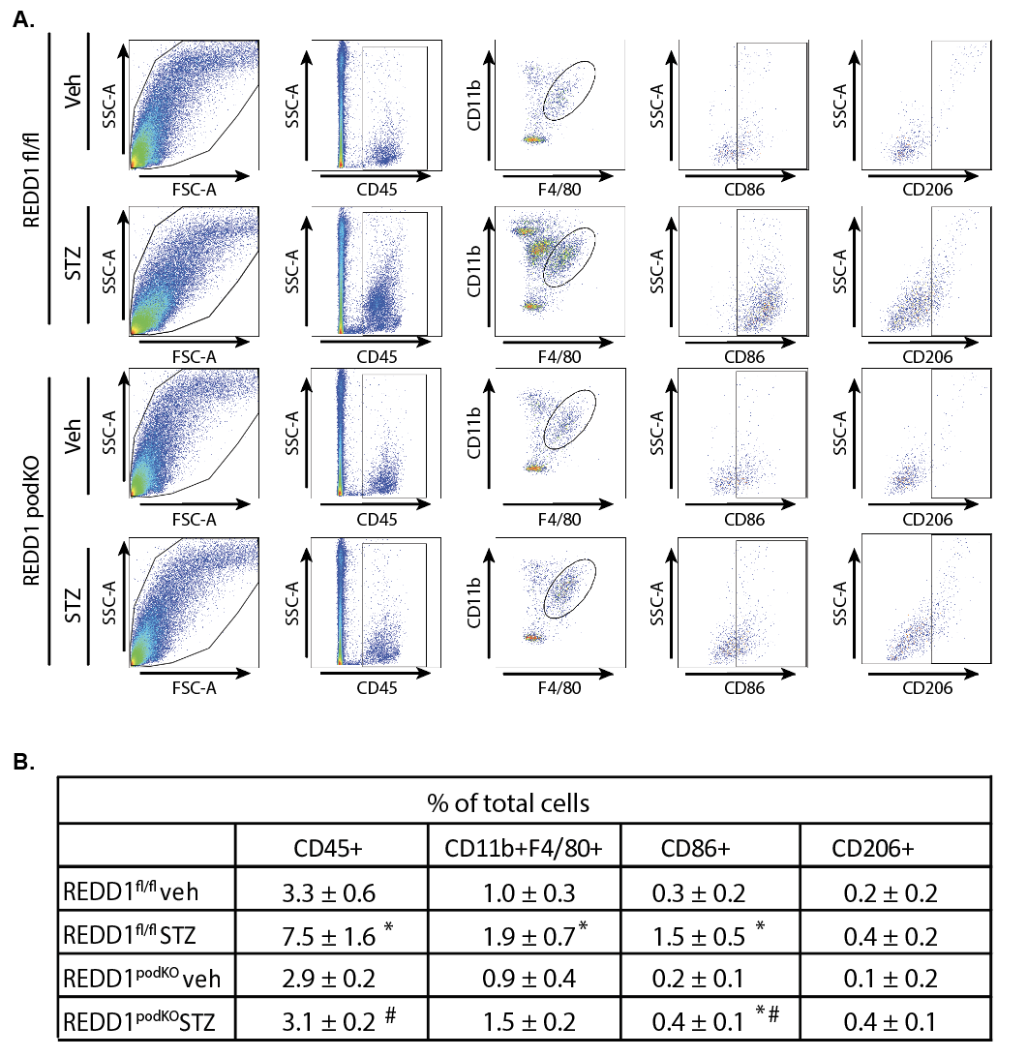

Figure S2. Flow cytometry analysis of REDD1^{fl/fl} vs. REDD1 podKO. REDD1^{fl/fl} and REDD1podKO mice were administered either streptozotocin (STZ) or a vehicle (Veh) control. A, Representative flow cytometry plots show CD11b+F4/80+ macrophage populations within CD45+ leukocytes. The subpopulation of CD86+ and CD206+ cells among CD11b+F4/80+ macrophages are shown. B, The population of immune cells as a percent of total cells counted are tabulated. Values are presented as means ± SD (n = 3). Differences between groups were identified by two-way ANOVA. *, p < 0.05 versus Veh; #, p < 0.05 versus REDD1^{fl/fl}.

Original western blot images-

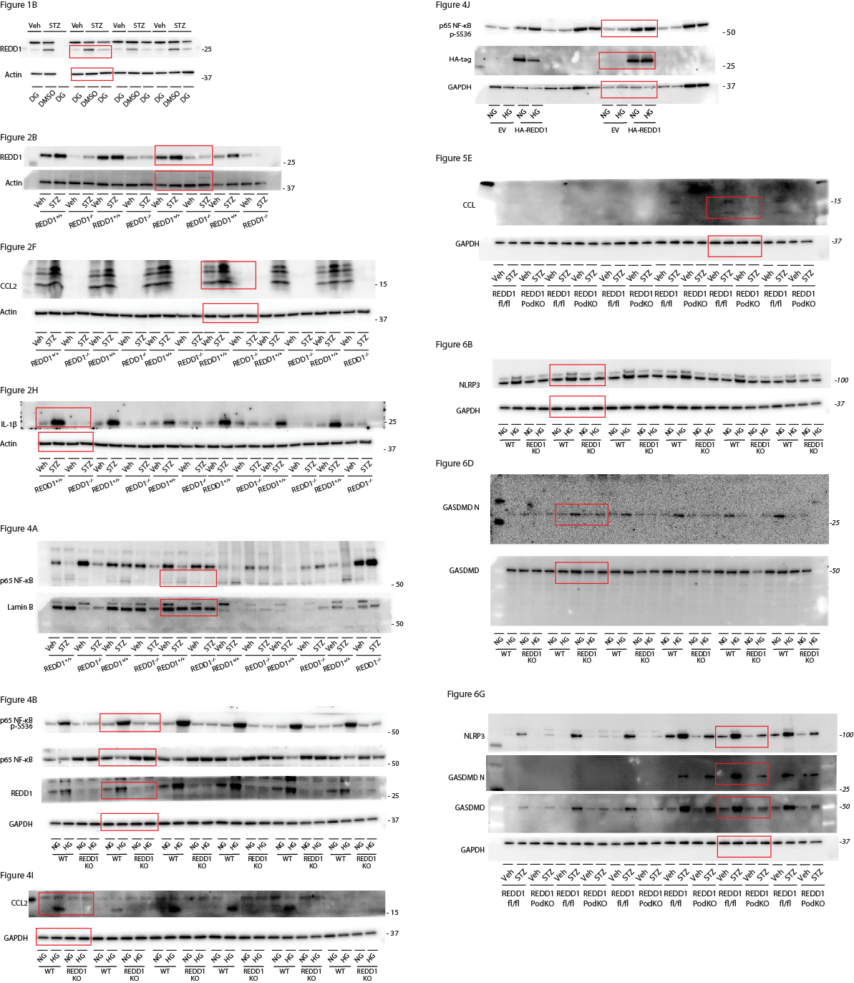
Immunofluorescence individual channels-

