Supplemental Material for Stark differences across flood risk zones in the Mississippi River floodplain landscape are revealed by an occupancy survey of Missouri swamp rabbits (Sylvilagus aquaticus)

Swamp Rabbit MaxEnt Model Creation
A swamp rabbit habitat model was crated for their range in Missouri and bordering counties of the surrounding states (Illinois, Kentucky, Tennessee, and Arkansas) using MaxEnt (). We incorporated basic layers and terrain variables including the the BioClim variables (https://www.worldclim.org/data/bioclim.html) which are often used to characterize the thermal and precipitation characteristics for species distribution models. We also selected variables with appropriate digital representation that have been related to swamp rabbit presence (Zollner et al. 2000, Scharine et al. 2011, Robinson et al. 2016, Crawford et al. 2018) including basal area, canopy cover, land cover, and those potentially related to standing water (elevation, inundation, and soil; Supplemental Table 1).
Models were 30-m resolution and projected under WGS 1984 UTM Zone 15. Presence points were obtained from Missouri’s Natural Heritage Database. We incorporated county boundaries for regions of sampling bias. Replicates of 15 were run using cross-validation as the replication type.
Representation of probability in the output is in logistic format. Only the full model was considered with no variable reduction. A strong habitat signal was achieved from the model (AUC = 0.961) and we considered probability values of 0.3 and above as habitat (Figure S1).

Supplemental Table 1: Continuous (Cont) and categorical (Cat) variables included a swamp rabbit habitat model.
Variables | Type
Bio1: Annual Mean Temperature [12–16 °C] | Cont
Bio2: Mean Diurnal Range (mean of monthly (max temp – min temp)) [10–14 °C] | Cont
Bio3: Isothermality ((Bio2/Bio7) * 100) [28–36%] | Cont
Bio4: Temperature Seasonality (standard deviation * 100) [864–1011 OR 8.64–10.11 °C] | Cont
Bio5: Max Temp of Warmest Month [30–34 °C] | Cont
Bio6: Min Temp of Coldest Month [-9–-2 °C] | Cont
Bio7: Temperature Annual Range (Bio5-Bio6) [36–40 °C] | Cont
Bio8: Mean Temperature of Wettest Quarter [12–23 °C] | Cont
Bio9: Mean Temp of Driest Quarter [-1–27 °C] | Cont
Bio10: Mean Temp of Warmest Quarter [23–27 °C] | Cont
Bio11: Mean Temp of Coldest Quarter [-1– 5°C] | Cont
Bio12: Annual Precipitation (sum of monthly ppt) [926–1341 mm] | Cont
Bio13: Precipitation of Wettest Month [102–137mm] | Cont
Bio14: Precipitation of Driest Month [39–91 mm] | Cont
Bio15: Precipitation Seasonality (Coefficient of Variation) [14–26%] | Cont
Bio16: Precipitation of Wettest Quarter [287–396 mm] | Cont
Bio17: Precipitation of Driest Quarter [146–279 mm] | Cont
Bio18: Precipitation of Warmest Quarter [234–317 mm] | Cont
Bio19: Precipitation of Coldest Quarter [146–342 mm] | Cont
Total Basal Area (TBA) 2012 | Cont
Percent Canopy Cover 2011 | Cont
National Land Cover Dataset (NLCD) 2011 – the 2016 NLCD is scheduled for release 12/2018 | Cat
Crop Data Layer (CDL) 2017 | Cat
Digital Elevation Model (DEM) for elevation | Cont
Slope derived from DEM | Cont
Aspect derived from DEM | Cont
Percent Inundated – from Gulf Coastal Plains and Ozarks LCC (avg. from 1983 to 2011) | Cont
Soils layers – soil particle size; soil order | Cat

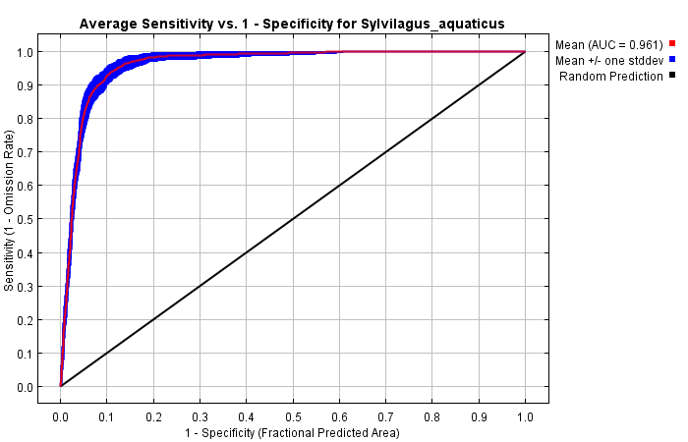
Figure S1 ROC curve for swamp rabbit habitat model

Figure S2. Relative importance of geospatial variables as ascertained but model improvement (gain) with the training set of locations. Canopy and landcover variables showed the greatest influence.
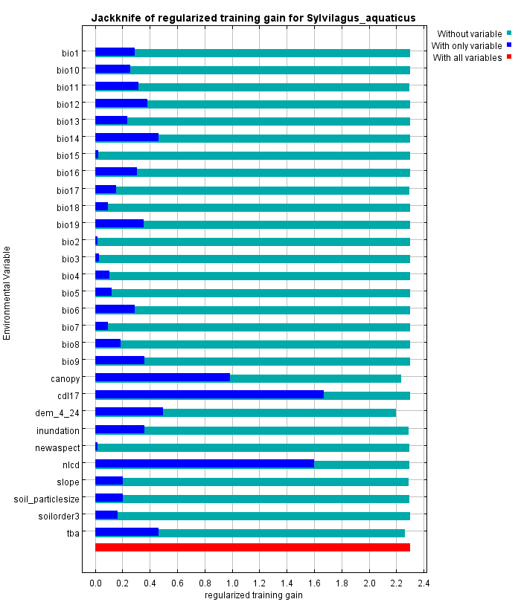

Figure S3: LDA histogram for swamp rabbit habitat patches

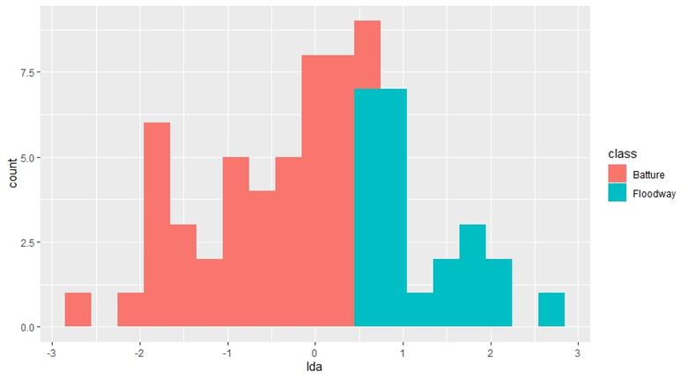

Table S2: All occupancy models considered for a latrine survey of swamp rabbits.
Model | Number of Parameters | AICc | DeltaAICc | Weight
p(2 Strata) Ψ(.) | 3 | 147.514 | 0.0000 | 0.2205
p(2 Strata) Ψ(LnArea) | 4 | 148.086 | 0.5720 | 0.1657
p(LnArea + 2 Strata) Ψ(.) | 4 | 148.782 | 1.2676 | 0.1170
p(2 Strata) Ψ(2 Strata) | 4 | 149.726 | 2.2123 | 0.0730
p(3 Strata) Ψ(.) | 4 | 149.749 | 2.2355 | 0.0721
p(LnArea + 2 Strata) Ψ(LnArea) | 5 | 150.328 | 2.8139 | 0.0540
p(3 Strata) Ψ(LnArea) | 5 | 150.397 | 2.8826 | 0.0522
p(LnArea + 2 Strata) Ψ(2 Strata) | 5 | 151.083 | 3.5694 | 0.0370
p(LnArea + 3 Strata) Ψ(.) | 5 | 151.085 | 3.5712 | 0.0370
p(2 Strata) Ψ(3 Strata) | 5 | 151.969 | 4.4553 | 0.0238
p(Survey Date) Ψ(2 Strata) | 4 | 151.980 | 4.4664 | 0.0236
p(3 Strata) Ψ(2 Strata) | 5 | 152.031 | 4.5166 | 0.0230
p(LnArea + 3 Strata) Ψ(LnArea) | 6 | 152.720 | 5.2058 | 0.0163
p(.) Ψ(2 Strata) | 3 | 152.822 | 5.3081 | 0.0155
p(LnArea + 2 Strata) Ψ(3 Strata) | 6 | 153.479 | 5.9652 | 0.0112
p(LnArea + 3 Strata) Ψ(2 Strata) | 6 | 153.483 | 5.9686 | 0.0112
p(LnArea) Ψ(2 Strata) | 4 | 153.924 | 6.4103 | 0.0089
p(Survey Date) Ψ(3 Strata) | 5 | 153.979 | 6.4648 | 0.0087
p(3 Strata) Ψ(3 Strata) | 6 | 154.313 | 6.7987 | 0.0074
p(.) Ψ(3 Strata) | 4 | 154.847 | 7.3327 | 0.0056
p(Obs) Ψ(2 Strata) | 4 | 154.970 | 7.4559 | 0.0053
p(LnArea + 3 Strata) Ψ(3 Strata) | 7 | 155.956 | 8.4417 | 0.0032
p(LnArea) Ψ(3 Strata) | 5 | 156.119 | 8.6050 | 0.0030
p(Obs) Ψ(3 Strata) | 5 | 157.069 | 9.5550 | 0.0019
p(Survey Date) Ψ(LnArea) | 4 | 158.359 | 10.8455 | 0.0010
p(.) Ψ(LnArea) | 3 | 158.719 | 11.2050 | 0.0008
p(LnArea) Ψ(.) | 3 | 160.354 | 12.8396 | 0.0004
p(LnArea) Ψ(LnArea) | 4 | 160.439 | 12.9249 | 0.0003
p(Obs) Ψ(LnArea) | 4 | 160.852 | 13.3383 | 0.0003
p(.) Ψ(.) | 2 | 163.196 | 15.6821 | 0.0001
p(Survey Date) Ψ(.) | 3 | 163.618 | 16.1042 | 0.0001
p(Obs) Ψ(.) | 3 | 165.379 | 17.8655 | 0.0000

Table S3 Rankings of occupancy models for swamp rabbit habitat patches in the Batture stratum
Model | Number of Parameters | AICc | DeltaAICc | Weight
p(Survey Date) Ψ(.) | 3 | 71.082 | 0.0000 | 0.3608
p(.) Ψ(.) | 2 | 71.848 | 0.7653 | 0.2461
p(Survey Date) Ψ(LnArea) | 4 | 73.567 | 2.4845 | 0.1042
p(.) Ψ(LnArea) | 3 | 73.713 | 2.6303 | 0.0968
p(Obs) Ψ(.) | 3 | 74.274 | 3.1920 | 0.0731
p(LnArea) Ψ(.) | 3 | 74.442 | 3.3594 | 0.0673
p(LnArea) Ψ(LnArea) | 4 | 76.323 | 5.2408 | 0.0263
p(Obs) Ψ(LnArea) | 4 | 76.376 | 5.2942 | 0.0256

Table S4 Rankings of occupancy models for swamp rabbit habitat patches in the Floodway/Ditch stratum
Model | Number of Parameters | AICc | DeltaAICc | Weight
p(Survey Date) Ψ(LnArea) | 4 | 158.359 | 0.0000 | 0.3293
p(.) Ψ(LnArea) | 3 | 158.719 | 0.3596 | 0.2751
p(LnArea) Ψ(.) | 3 | 160.354 | 1.9942 | 0.1215
p(LnArea) Ψ(LnArea) | 4 | 160.439 | 2.0794 | 0.1164
p(Obs) Ψ(LnArea) | 4 | 160.852 | 2.4928 | 0.0947
p(.) Ψ(.) | 2 | 163.196 | 4.8366 | 0.0293
p(Survey Date) Ψ(.) | 3 | 163.618 | 5.2588 | 0.0238
p(Obs) Ψ(.) | 3 | 165.379 | 7.0200 | 0.0098

