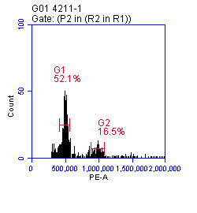
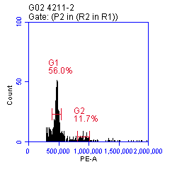
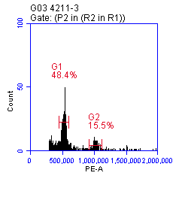
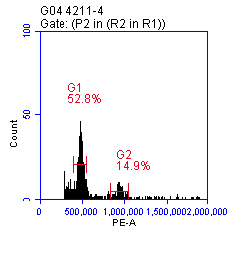
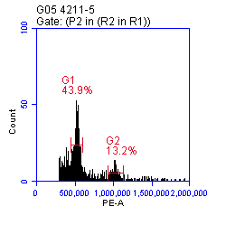
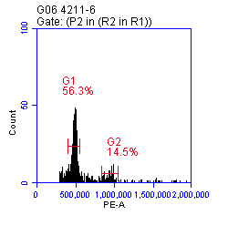
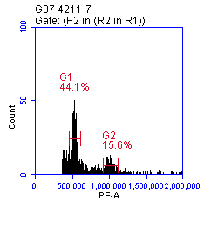
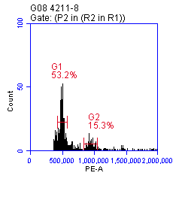
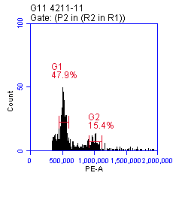
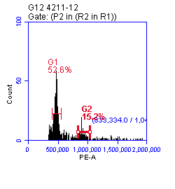
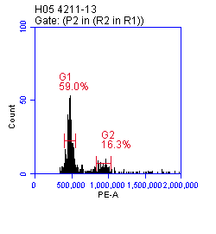
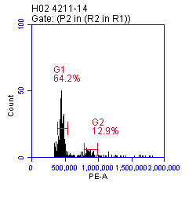

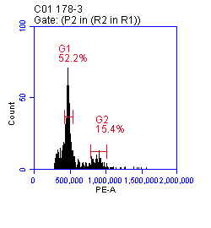
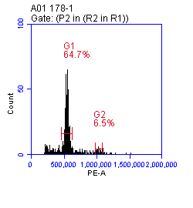
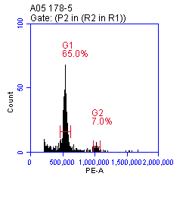
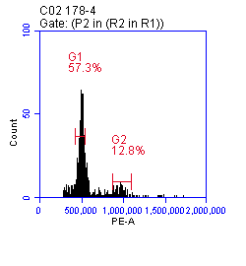
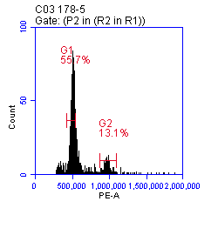
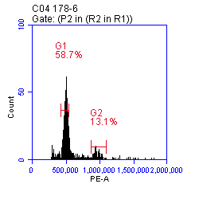
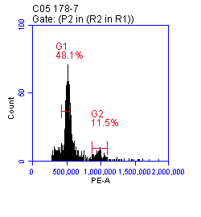
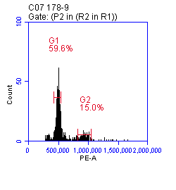
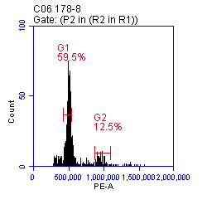
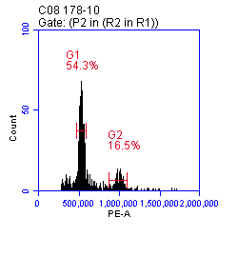
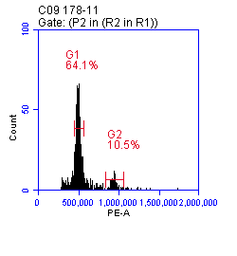
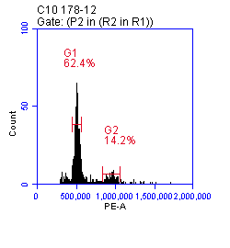
Supplementary Fig. 1 Flow cytometry ploidy maps of part of induced offspring 4211 and 178

Supplementary Table 1 Cytoplasmic primer sequences
Name | Forward primer (5'-3') | Reverse primer (5'-3')
MSS-2 | GAAGTTGAAAAAGGGAATGT | GATCAAGACGAGGAGTAGCT
MSS-4 | AGTATTTCGTTC ACCTTGGC | GCTTGGTGGAAAAGATCGTA
MSS-13 | TAGCGCTATCTTTCGGCCCT | ACCCGA AGGTCCTGGTCTCT
MSS-14 | GCTCGTTCGATTAAGCTCAA | GAATTCCTCTTTCATTGCGG
MSS-21 | GGATTATCCTGTGGTGTGGC | CACATGGTGGGTTTGTTGGA

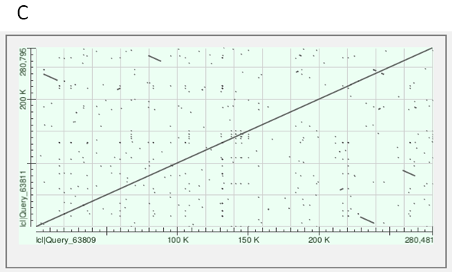
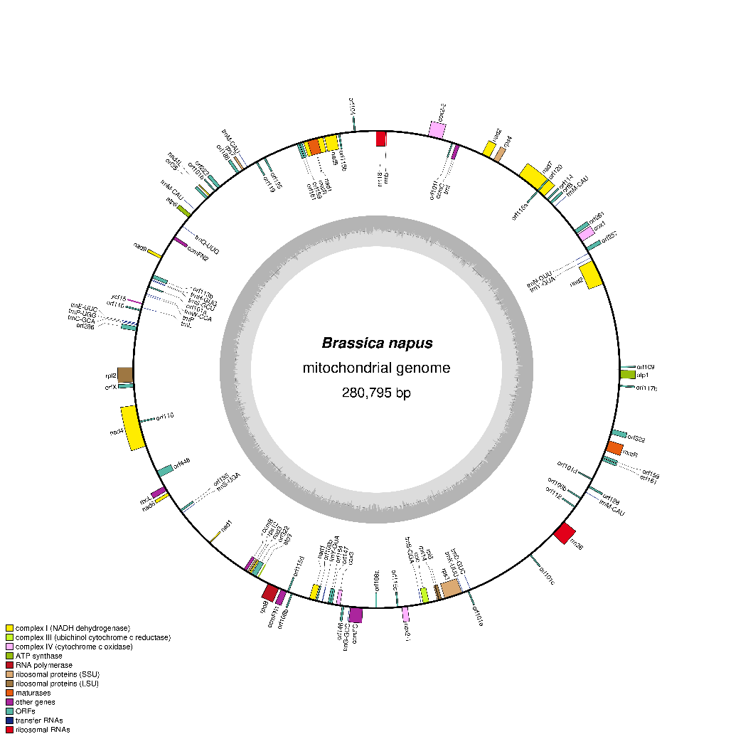
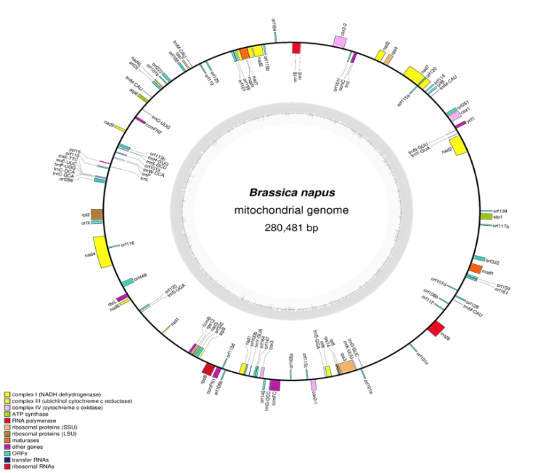
A
B
Supplementary Fig. 2 A Mitochondrial assembly annotation diagram of 4508A; B Mitochondrial assembly annotation diagram of 4211; C Linear comparison of 4508A and 4211C mitochondrial genomes

Supplementary Fig. 3 Sequence alignment of orf138 in induced fertile offspring

Supplementary Table 2 Sequence of molecular markers of restorer lines
Name | Forward primer (5'-3') | Reverse primer (5'-3')
BonJon | GATCCGATTCTTCTCCTGTTG | GCCTACTCCTCAAATCACTCT
OPF10 | AACTTTTTGTGTTTGATTTCTTGC | ACTCCTTCTAAACAAAACCAAACA
OPF20 | CCTTAGTTTAGTTGTAGGTGGTGG | AGAAACCGCTCAATTTTAACATAA
RMA05 | AAGCTCAGGCTCCTTCACCG | GGGAAGGAGATCCGGACTCA
RMA07 | CGGACTCTTTAGCTCCGCCA | CACCTCCTGTCGGCATCTCA
RMA09 | TTTTTCAATGCTTCTGTGCAG | GCACAAAATTACAATCAGCGC
RMB01 | ATTGTCGTTGTCGATGCATC | AGAAGAAGAAAGTGCCAAGCA
OPH03 | TCCACTCCTAGTTCACAATCTATTTT | TATACAAAATGTTGGAATACACAAGG
RME01 | TCCATTGCAGAATTCACCTG | TGTTTTCTTCGTCATGTCGG
RME04 | GGTCTCAGGTTTTGTGGGAG | GGTTCTCAAAGATTCCGAGG
RMC17 | TTTCCACACAAATCGGATTTAA | TGGCCAATGAAAGTTTACTGAT
RMC22 | GCTCTACGAGTGAGGATCAAAG | CACTTTCGGAATCCAAGCTC
OPC02 | CTGTAACTTTCAACCCAACTCGTAGAA | TTTTGGGGATTACTCTTCTTAGCTTTC
RMC28 | AGACCAAGAGGAAGCGTAGC | AAGAAACAACCCAGACTCCG
RMB12 | TGGACTAAGAAAGGGTCAGGTA | CGAAGAATCTCTACTCTGTTGT
RMC05 | TGCGAGTTTAATCCGGACGC | CCGCGTTATTCTGGTTCAGAGA
RMC08 | GAGGCGAAAACATAAACAAGG | ATCGCCAAAACTGTTTCAGG
RMC10 | TCCTGCAGTTTGAAATCCTTG | AAGTTTCCCCAAACCAACTTC
RMC14 | TTGACGGTTACCCAAAATACCG | TTGATTGCTTCACCCTCACCC
huifuxi23 | GGCTAGGGTTTGTGGATTCAA | CAAACTCACTCCTCCAAAACCT
huifuxi45 | TGGTCAACTCATCAGGCTC | GCCTCTAGGAGTAGTGAAGAAC
ScA14 | TCTGTGCTGGTGGGATGAAAG | TCTGTGCTGGCTACTTATTCATACAG
ScH03 | AGACGTCCACCATACC | AGACGTCCACTCCTAGTTC
SG34 | TATATTGTACCTTTGCCTCTTC | CTTTTCTTTTAGTTTTTGGTTT
PGIint | CAGCACTAATCTTGCGGTATG | CAATAACCCTAAAAGCACCTG
PGIol | TCATTTGATTGTTGCGCCTG | TGTACATCAGACCCGGTAGAAAA
CP148 | AATTTCTCCATCACAAGGACC | CTTCATTGACATCGGAAACTTCT
BnRfo-AS2 | CATGCTTCGATCTCGTCCTTTA | GGTAACAACATCAGGGTGGAGT

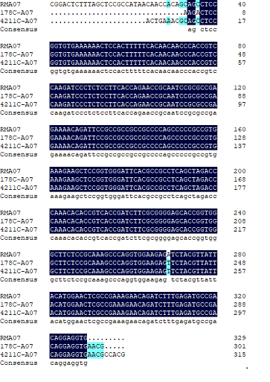
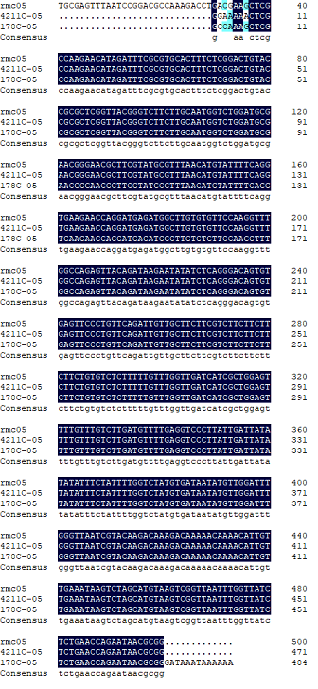

Supplementary Fig. 4 RMA07, RMC05 molecular marker sequencing alignment. In the figure, RMA07, RMC05 represent the original sequence of primers; 4211C and 178C represent the sequences amplified by primers in plants, respectively (display part of the molecular marker amplified sequence)

Supplementary Table 3 Primer sequence table
Name | Forward primer (5'-3') | Reverse primer (5'-3')
Bn09-1 | CATTTGGTTTGTCCGTGTGT | AGGGCGACAACCTCTTTCAAC
Bn09-2 | TCACATTAGTAAAACGATTGTCCAC | GATTGATTTTTTGGACTCCGTT
Bn09-3 | AATAGAGGGAGAGGATGAAAGAAC | AGCTACCTAACAGGTTTTGTTATAAAG

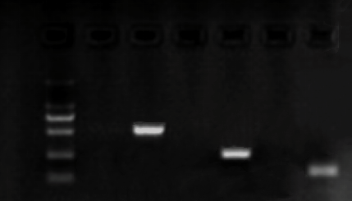
M 30 60 30 60 30 60
Bn09-1
Bn09-2
Bn09-3
500bp
250bp

Supplementary Fig. 5 Molecular marker electrophoresis map of F₂ generation. 30, 60 represent materials 4630-30, 4630-60 (part of the plant materials were displayed)

Supplementary Table 4 Statistical table of molecular marker results of F₂ generation
Serial number | Field code | Field test results | Bn09-1 | Bn09-2 |  | Bn09-3 | Serial number | Field code | Field test results | Bn09-1 | Bn09-2 | Bn09-3
1 | 4630-1 | F | + | + | + |  | 31 | 4630-31 | S | - | - | -
2 | 4630-2 | F | + | + | + |  | 32 | 4630-32 | F | + | + | +
3 | 4630-3 | S | - | - | - |  | 33 | 4630-33 | F | + | + | +
4 | 4630-4 | S | - | - | - |  | 34 | 4630-34 | S | - | - | -
5 | 4630-5 | F | + | + | + |  | 35 | 4630-35 | F | + | + | +
6 | 4630-6 | F | + | + | + |  | 36 | 4630-36 | F | + | + | +
7 | 4630-7 | F | + | + | + |  | 37 | 4630-37 | F | + | + | +
8 | 4630-8 | S | - | - | - |  | 38 | 4630-38 | F | + | + | +
9 | 4630-9 | F | + | + | + |  | 39 | 4630-39 | S | - | - | -
10 | 4630-10 | F | + | + | + |  | 40 | 4630-40 | F | + | + | +
11 | 4630-11 | S | - | - | - |  | 41 | 4630-41 | F | - | - | -
12 | 4630-12 | F | + | + | + |  | 42 | 4630-42 | S | - | - | -
13 | 4630-13 | S | + | - | - |  | 43 | 4630-43 | F | + | + | +
14 | 4630-14 | F | + | + | + |  | 44 | 4630-44 | S | - | - | -
15 | 4630-15 | F | + | + | + |  | 45 | 4630-45 | S | - | - | -
16 | 4630-16 | S | - | - | - |  | 46 | 4630-46 | S | - | - | -
17 | 4630-17 | F | + | + | + |  | 47 | 4630-47 | F | + | + | +
18 | 4630-18 | F | + | + | + |  | 48 | 4630-48 | F | + | + | +
19 | 4630-19 | F | + | + | + |  | 49 | 4630-49 | S | - | - | -
20 | 4630-20 | F | + | + | + |  | 50 | 4630-50 | F | + | + | +
21 | 4630-21 | S | - | - | - |  | 51 | 4630-51 | F | - | - | -
22 | 4630-22 | F | - | - | - |  | 52 | 4630-52 | F | - | - | -
23 | 4630-23 | F | - | - | - |  | 53 | 4630-53 | F | + | + | +
24 | 4630-24 | F | - | - | - |  | 54 | 4630-54 | S | - | - | -
25 | 4630-25 | S | - | - | - |  | 55 | 4630-55 | F | + | + | +
26 | 4630-26 | F | - | - | - |  | 56 | 4630-56 | S | - | - | -
27 | 4630-27 | S | - | - | - |  | 57 | 4630-57 | F | - | - | -
28 | 4630-28 | F | - | - | - |  | 58 | 4630-58 | F | + | + | +
29 | 4630-29 | F | - | - | - |  | 59 | 4630-59 | F | + | + | +
30 | 4630-30 | S | - | - | - |  | 60 | 4630-60 | F | + | + | +
(F: fertile; S: sterility. +: There are electrophoretic bands; -: There are no electrophoretic bands)

Supplementary Information
Supplementary Fig. 1 Flow cytometry ploidy maps of part of induced offspring 4211 and 178.
Supplementary Table 1 Cytoplasmic primer sequences.
Supplementary Fig. 2 A Mitochondrial assembly annotation diagram of 4508A; B Mitochondrial assembly annotation diagram of 4211; C Linear comparison of 4508A and 4211C mitochondrial genomes.
Supplementary Fig. 3 Sequence alignment of orf138 in induced fertile offspring.
Supplementary Table 2 Sequence of molecular markers of restorer lines.
Supplementary Fig. 4 RMA07, RMC05 molecular marker sequencing alignment. In the figure, RMA07, RMC05 represent the original sequence of primers; 4211C and 178C represent the sequences amplified by primers in plants, respectively (display part of the molecular marker amplified sequence).
Supplementary Table 3 Primer sequence table.
Supplementary Fig. 5 Molecular marker electrophoresis map of F₂ generation. 30, 60 represent materials 4630-30, 4630-60 (part of the plant materials were displayed).
Supplementary Table 4 Statistical table of molecular marker results of F₂ generation.

