Supplementary figure
Figure S1
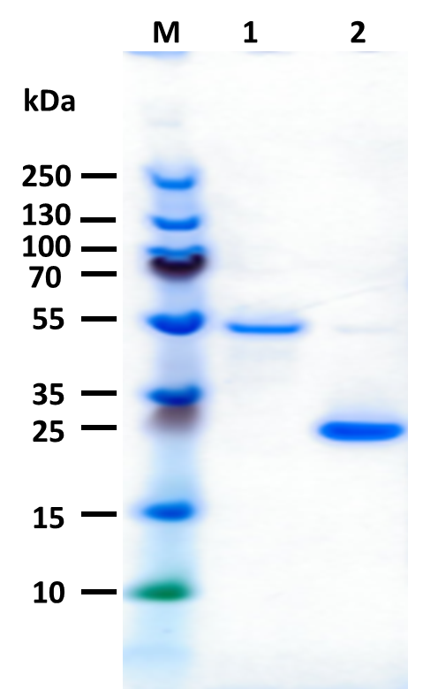

Fig. S1. Purified and refolded recombinant flagellin (lane 1) and IFNγ (lane 2). M, Thermo Scientific™ PageRuler™ Plus Prestained Protein Ladder, 10 to 250 kDa.

