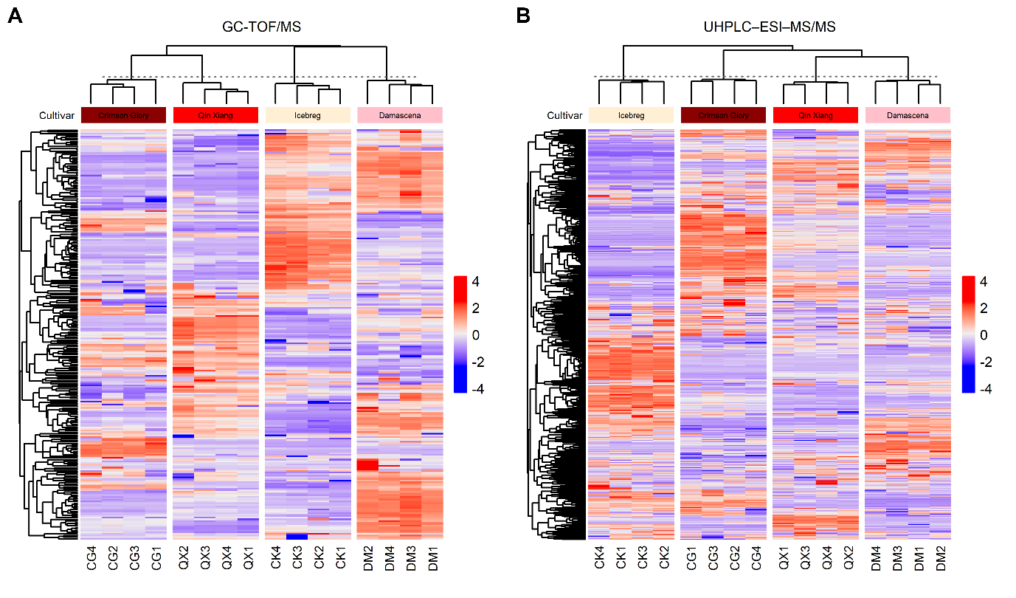
Supplementary Fig. S1. Heatmaps of the metabolomics data. (A) Non-target metabolomic analysis using gas chromatography-time-of-flight mass spectrometry (GC-TOF/MS). (B) Non-target metabolomic analysis using ultra-high-performance liquid chromatography/electrospray ionization-mass spectrometry (UHPLC–ESI–MS/MS).

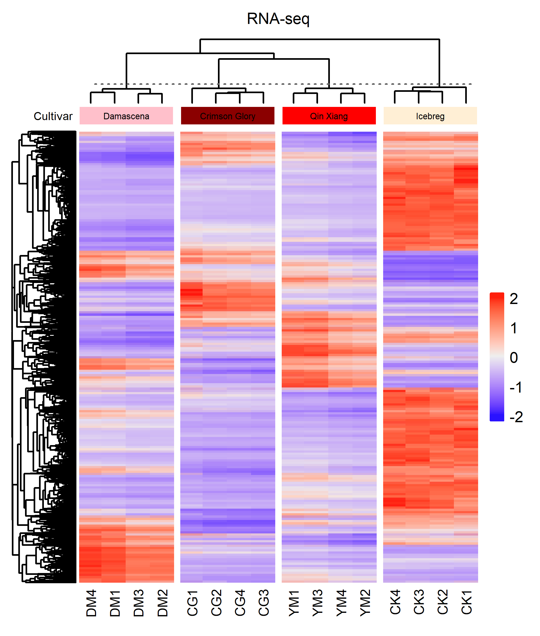
Supplementary Fig. S2. Heatmap of the transcriptome data.
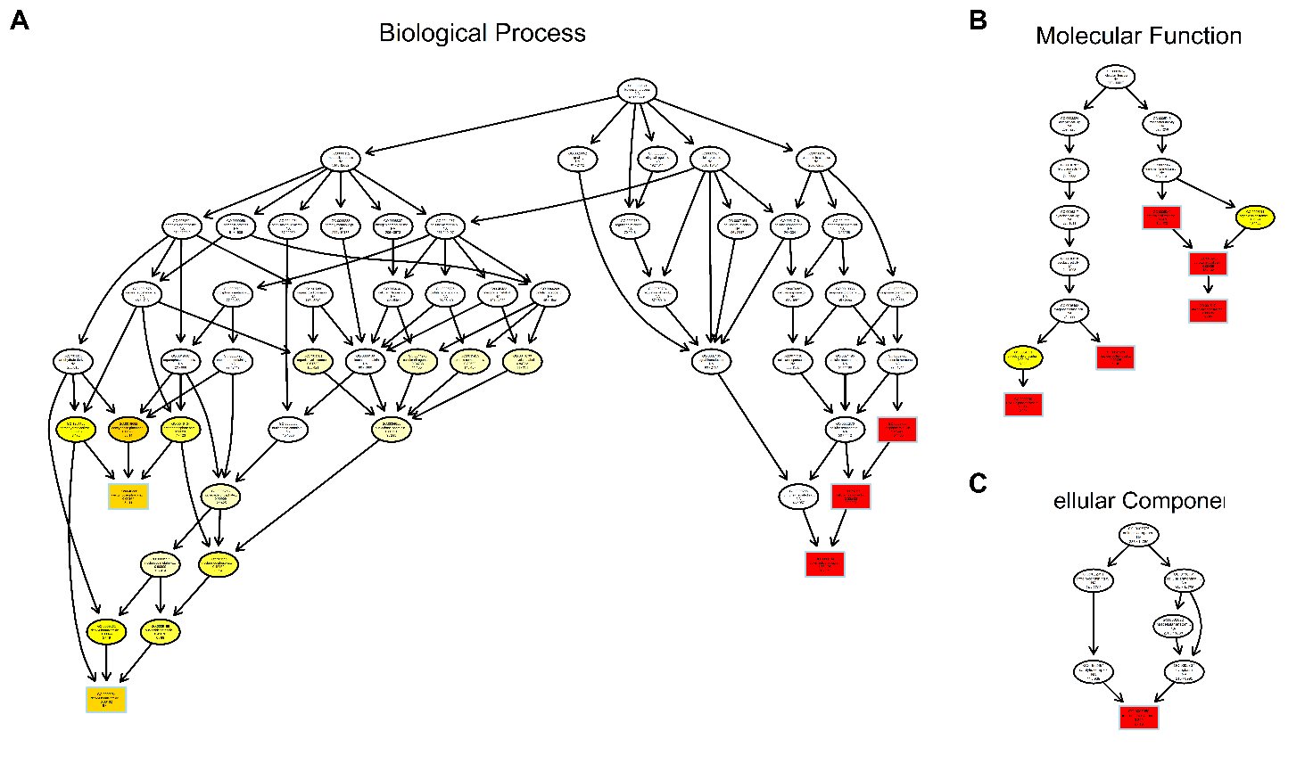
Supplementary Fig. S3. Directed acyclic graph (DAG) of the floral fragrance-correlated genes.

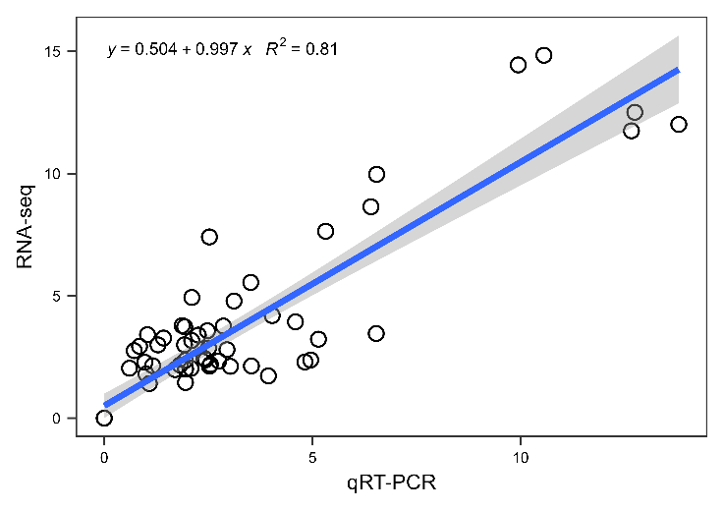
Supplementary Fig. S4. Linear fitting between RNA-seq and qRT-PCR data. Values were log2-transformed.

Supplementary Table S1. Primers for qRT-PCR.
Gene_ID | Symbol | Forward Primer | Reverse Primer
Housekeeping gene | UBC | GCCAGAGATTGCCCATATGTA | TCACAGAGTCCTAGCAGCACA
LOC112176785 | APRR1 | TCAAGTCTCCTCGGCAGGT | CGACATCACTAACCAAAGCAG
LOC112173416 | AS1 | GCTCCTCACAACACAATCCA | CCTCCCAAAGTCGGTCCAAG
LOC112188721 | AUX22 | GCCAAACTGCTCTGAAACTGA | ATACCCTCTTCTTCTCCTTGATTT
LOC112168975 | BZIP9 | GTCGCCAACCATTACCATTCA | CCAGCAACATTTCCGAGTCC
LOC112179289 | GPAT2 | AACAAGGGACAGAGAAAGAGATAGG | CTGGGCAAACCACAAGGTCT
LOC112200358 | HMT3 | ATGGATTTGGGAAGCGAGAAA | ACGAGGTGAGGAGAACTGAC
LOC112173536 | IAA11 | TGAGGCTAATGGACTTGCTCC | ACGATGGCTTCTCTGCTTCTC
LOC112189843 | LNK2 | TGCCAGATGTTGAGACCGAG | AACGGGCGATGAAAGAGCAA
LOC112200430 | NUDIX1 | GAAGCCAAACCATCGCAGTA | ATTGTCCCACTCATACCATCC
LOC112168752 | PAAS | CACAAGCCATCCTCAGCAC | AGCATTCCAAACCGAAACTAACT
LOC112189050 | PER25 | ACCCAACCATAAGCCAAGCA | CTGCGTTACCATCCCTCACA
LOC112201637 | PER47 | CCAACGGTAGAAAGGATGGGA | AAGCATTCAAGGTGGGAGCA
LOC112172154 | SDC | CGTCTTCGTGATGCTGGGAT | AAGCCAACTGCCACCTACG
LOC112198236 | SUS2 | AAGAGATTGCGGGAAGCCAG | AGCCCAGGAAGAGTGAAAGC
LOC112199816 | TPPA | GGGATAAAGGGAAGGCAGTCA | CATCTGTGCGGTCATCTCCA
LOC112179256 | TPPF | TGGTGATGATAGGACTGATGAAGA | ACCTCTGCTGGTTCCCTGA
LOC112165974 | TPS1 | GTCACAAGCCTCAAGCCAAG | TGCCCTACTATTCTTCCTAATCTCC

Supplementary Table S2. Statistics of transcriptome data for roses.
Sample | Clean  reads | Clean  base (Gb) | Q20  (%) | Q30  (%) | Total  mapped | Uniquely  mapped | RNA-seq Mapped Events
 |  |  |  |  |  |  | Mapped to  Gene | Mapped to  InterGene | Mapped to  Exon
CK1 | 41400648 | 6.25 | 98.02 | 94.29 | 36277779  (87.63%) | 34765314  (95.83%) | 34021863  (97.86%) | 743451  (2.14%) | 33312421  (97.91%)
CK2 | 41019378 | 6.19 | 97.87 | 93.87 | 35767739  (87.20%) | 34424691  (96.25%) | 33694954  (97.88%) | 729737  (2.12%) | 33009704  (97.97%)
CK3 | 41785874 | 6.31 | 97.70 | 93.49 | 36401571  (87.11%) | 35097841  (96.42%) | 34357737  (97.89%) | 740104  (2.11%) | 33678907  (98.02%)
CK4 | 41905624 | 6.33 | 97.75 | 93.61 | 36462849  (87.01%) | 35191542  (96.51%) | 34445070  (97.88%) | 746472  (2.12%) | 33755197  (98.00%)
QX1 | 43393186 | 6.55 | 97.84 | 93.91 | 38055344  (87.70%) | 36407514  (95.67%) | 35487875  (97.47%) | 919639  (2.53%) | 34787867  (98.03%)
QX2 | 37721600 | 5.70 | 97.85 | 93.83 | 33164847  (87.92%) | 31722865  (95.65%) | 30976122  (97.65%) | 746743  (2.35%) | 30448486  (98.30%)
QX3 | 43833390 | 6.62 | 97.69 | 93.54 | 38264308  (87.29%) | 36607067  (95.67%) | 35683716  (97.48%) | 923351  (2.52%) | 34992416  (98.06%)
QX4 | 39129902 | 5.91 | 97.81 | 93.77 | 34307217  (87.68%) | 32825494  (95.68%) | 32016174  (97.53%) | 809320  (2.47%) | 31427112  (98.16%)
DM1 | 50168144 | 7.58 | 97.76 | 93.68 | 41125598  (81.98%) | 39228199  (95.39%) | 38195322  (97.37%) | 1032877  (2.63%) | 37564442  (98.35%)
DM2 | 45287220 | 6.84 | 97.84 | 93.88 | 37274334  (82.31%) | 35525068  (95.31%) | 34609124  (97.42%) | 915944  (2.58%) | 34062169  (98.42%)
DM3 | 45453792 | 6.86 | 97.76 | 93.68 | 37393433  (82.27%) | 35667374  (95.38%) | 34754010  (97.44%) | 913364  (2.56%) | 34211603  (98.44%)
DM4 | 51610122 | 7.79 | 97.85 | 93.92 | 42457171  (82.27%) | 40502428  (95.40%) | 39466881  (97.44%) | 1035547  (2.56%) | 38843991  (98.42%)
CG1 | 47486562 | 7.17 | 98.05 | 94.38 | 41278761  (86.93%) | 39235429  (95.05%) | 38371193  (97.80%) | 864236  (2.20%) | 37788195  (98.48%)
CG2 | 43174880 | 6.52 | 97.77 | 93.68 | 37307813  (86.41%) | 35471144  (95.08%) | 34543725  (97.39%) | 927419  (2.61%) | 33805782  (97.86%)
CG3 | 41004884 | 6.19 | 97.95 | 94.14 | 35578259  (86.77%) | 33858754  (95.17%) | 32992300  (97.44%) | 866454  (2.56%) | 32303629  (97.91%)
CG4 | 41632466 | 6.29 | 97.84 | 93.83 | 36400831  (87.43%) | 34565031  (94.96%) | 33700474  (97.50%) | 864557  (2.50%) | 33034297  (98.02%)

