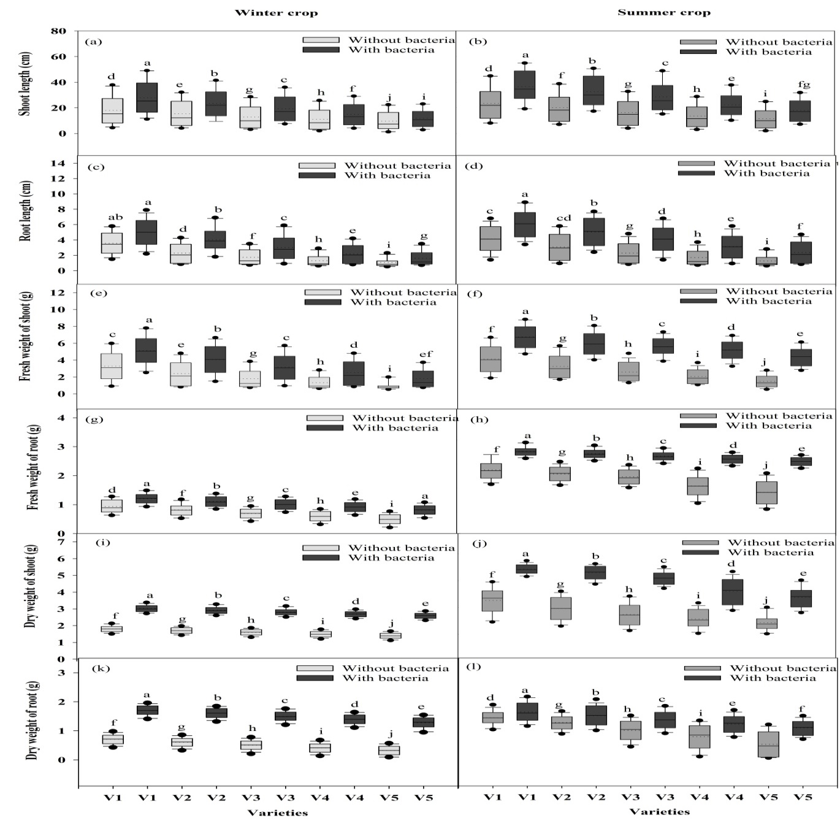
Supplementary figures

Figure S1: Showing the mean shoot length (a-b), root length (c-d), fresh weight of shoot (e-f), root (g-h), dry weight of shoot (i-j) and root (k-l) of mung bean plants across the five cultivars during mid harvest Inqelab mung (V1), NIFA-19 (V2), NIFA-17 (V3), Sona mung (V4) and Ramzan mung (V5) in winter and summer seasons. Bars indicate mean (±) standard error and different letter (s) exhibit significant differences from each other. Grey bars indicate the soil with NaCl treatment while black bars indicate NaCl treatment along with B. pseudomycoides inoculum.
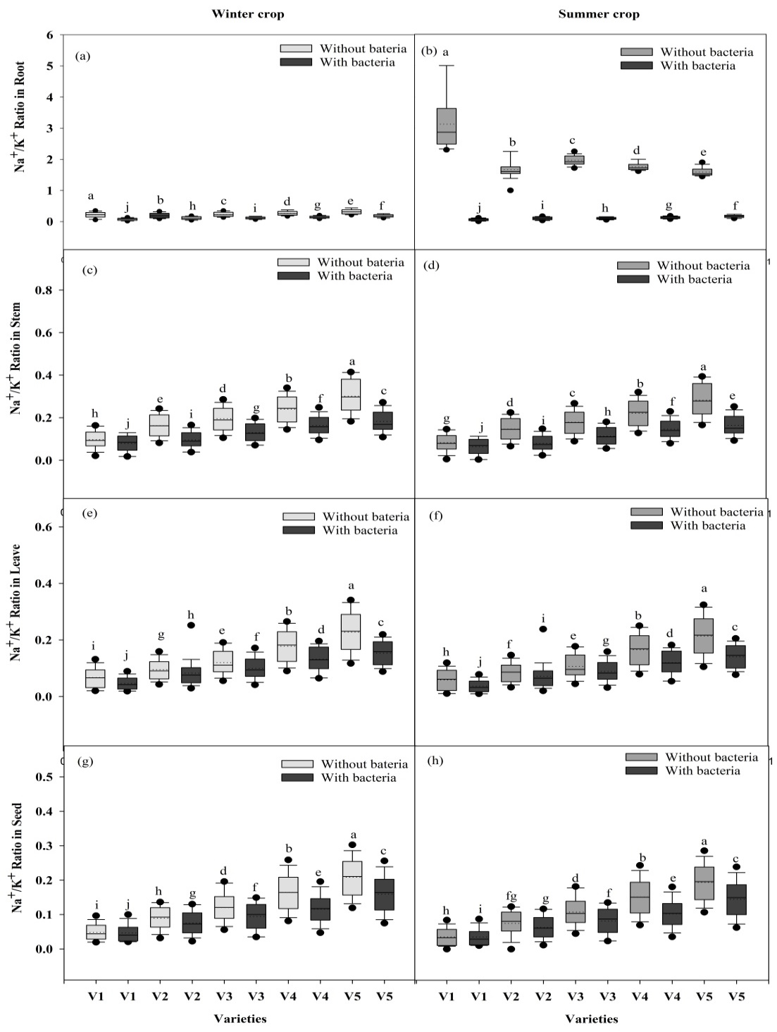

Figure S2: Showing the mean sodium potassium ratio in root (a-b), stem (c-d), leave (e-f) and seed (g-h) of mung bean plants across the five cultivars Inqelab mung (V1), NIFA-19 (V2), NIFA-17 (V3), Sona mung (V4) and Ramzan mung (V5) in winter and summer seasons. Bars indicate mean (±) standard error and different letter (s) exhibit significant differences from each other. Grey bars indicate the soil with NaCl treatment while black bars indicate NaCl treatment along with B. pseudomycoides inoculum.

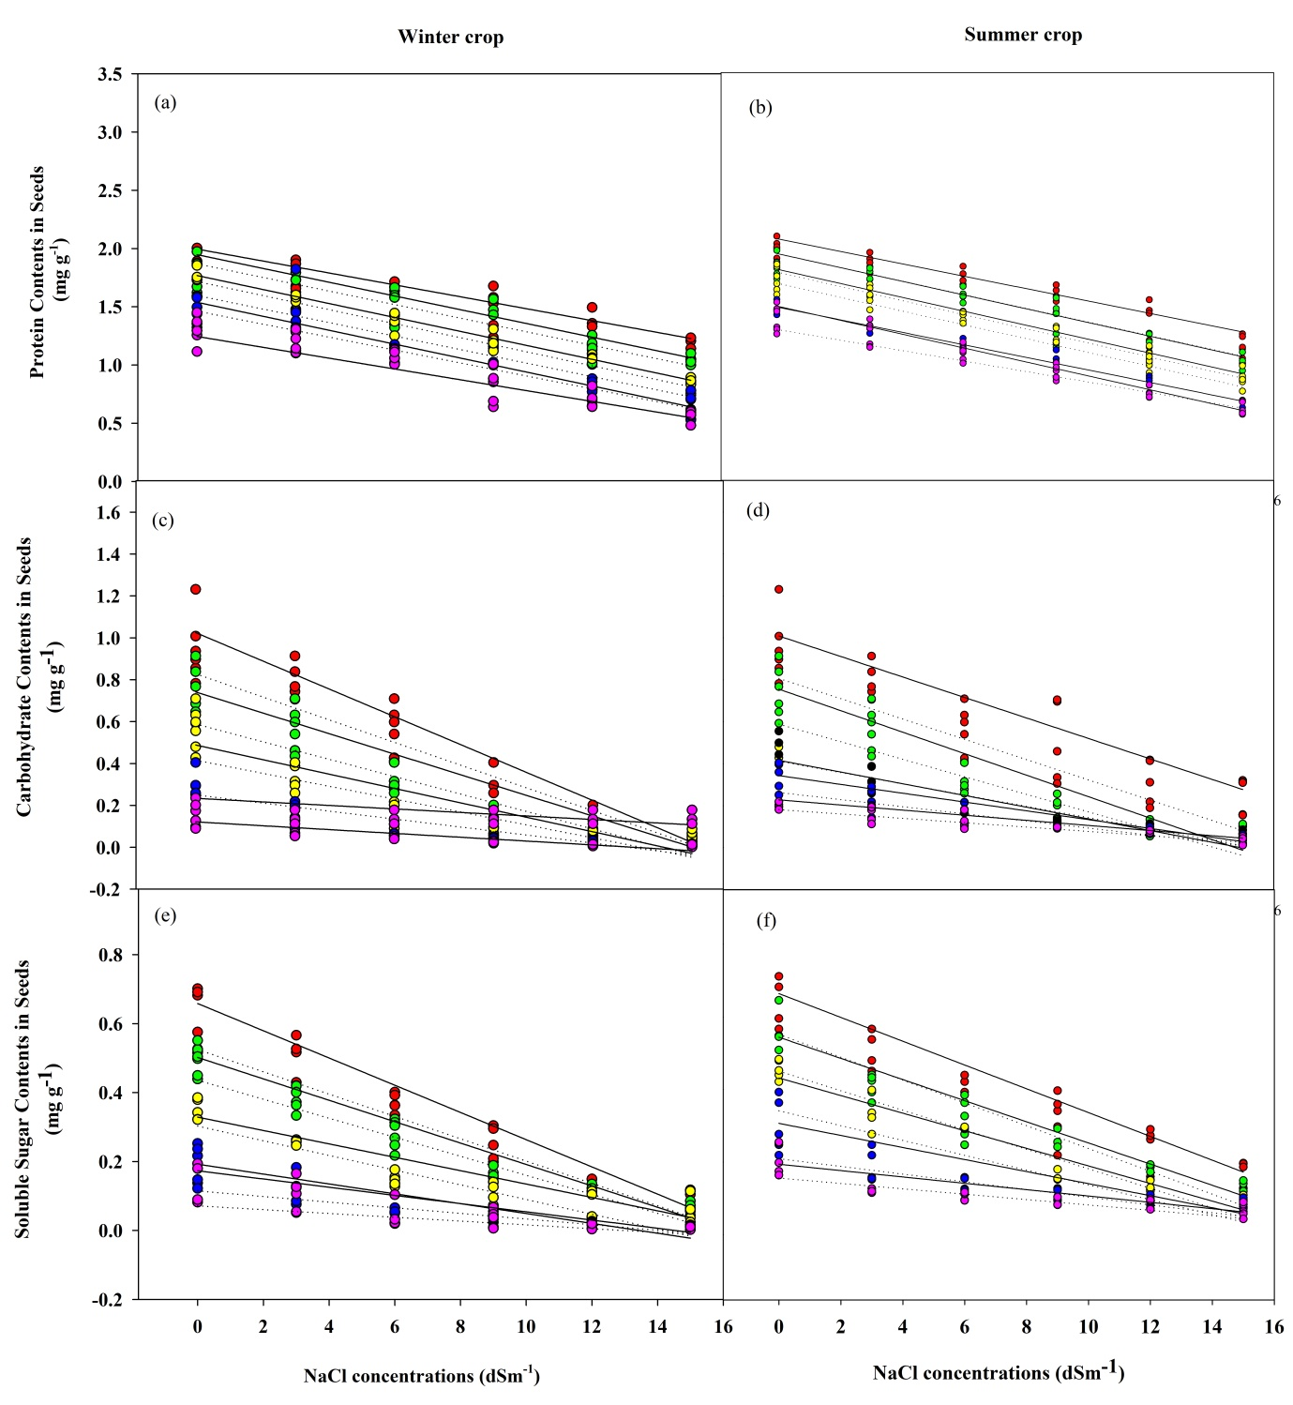
Figure S3: Relationship of Sodium concentrations from 0 dSm⁻¹ – 15 dSm⁻¹ across five cultivars of mung bean. Dotted lines indicate plant without inoculum of bacteria, while solid lines represent plants with inoculum of bacteria, Red dots=V1, Green dots= V2, Yellow dots= V3, Blue dots= V4, Purple dots= V5.

Tables
Table 1: Number of seeds plant⁻¹ of different V.radiata varities with “+” and without “-” Bacillus pseudomycoides inoculum under NaCl stress in summer (SC) and winter (WC)
Parameter | Varities |  | B. pseudomycoides inoculum | DF | SS | MS | F | P value
Number of seeds plant⁻¹ | V1 | SC | + | 5 | 35672.2 | 7134.4 | 430.28 | 0.0000
Number of seeds plant⁻¹ | V1 | SC | - | 5 | 66955.2 | 13391.0 | 2196.5 | 0.0000
Number of seeds plant⁻¹ | V1 | WC | + | 5 | 52251.6 | 10450.3 | 1605.5 | 0.0000
Number of seeds plant⁻¹ | V1 | WC | - | 5 | 22162.9 | 4432.59 | 240.71 | 0.0000
Number of seeds plant⁻¹ | V2 | SC | + | 5 | 35542.2 | 7108.4 | 1608.4 | 0.0000
Number of seeds plant⁻¹ | V2 | SC | - | 5 | 66753.2 | 13350.6 | 2124.5 | 0.0020
Number of seeds plant⁻¹ | V2 | WC | + | 5 | 56752.9 | 11350.6 | 1722.0 | 0.0000
Number of seeds plant⁻¹ | V2 | WC | - | 5 | 22199.3 | 4439.86 | 516.80 | 0.0000
Number of seeds plant⁻¹ | V3 | SC | + | 5 | 43077.3 | 8615.4 | 2026.3 | 0.0000
Number of seeds plant⁻¹ | V3 | SC | - | 5 | 73300.2 | 14660.0 | 2494.0 | 0.0000
Number of seeds plant⁻¹ | V3 | WC | + | 5 | 59149.6 | 11829.9 | 4087.8 | 0.0000
Number of seeds plant⁻¹ | V3 | WC | - | 5 | 20406.4 | 4081.28 | 2043.9 | 0.0000
Number of seeds plant⁻¹ | V4 | SC | + | 5 | 52976.8 | 10595.4 | 1169.0 | 0.0000
Number of seeds plant⁻¹ | V4 | SC | - | 5 | 79820.1 | 15964.0 | 2196.2 | 0.0000
Number of seeds plant⁻¹ | V4 | WC | + | 5 | 60408.6 | 12081.7 | 1464.3 | 0.0000
Number of seeds plant⁻¹ | V4 | WC | - | 5 | 24261.5 | 4852.30 | 1251.9 | 0.0000
Number of seeds plant⁻¹ | V5 | SC | + | 5 | 53048.2 | 10609.6 | 1166.6 | 0.0000
Number of seeds plant⁻¹ | V5 | SC | - | 5 | 75674.3 | 15134.9 | 1941.9 | 0.0310
Number of seeds plant⁻¹ | V5 | WC | + | 5 | 69305.4 | 13861.1 | 3011.9 | 0.0000
Number of seeds plant⁻¹ | V5 | WC | - | 5 | 24217.5 | 4843.49 | 1346.1 | 0.0000

Two-ANOVA model for interaction among number of seeds plant⁻¹, salt stress and Bacillus pseudomycoides that represent significance (p ≤ 0.05) level

Table 2: Weight of seeds plant⁻¹ of different V.radiata varities with “+” and without “-“ Bacillus pseudomycoides inoculum under NaCl stress in summer (SC) and winter (WC)
Parameter | Varities |  | B. pseudomycoides inoculum | DF | SS | MS | F | P value
Weight of seeds plant⁻¹ | V1 | SC | + | 5 | 5611.09 | 1122.22 | 89.85 | 0.0000
Weight of seeds plant⁻¹ | V1 | SC | - | 5 | 5753.52 | 1150.70 | 232.39 | 0.0000
Weight of seeds plant⁻¹ | V1 | WC | + | 5 | 5376.81 | 1075.36 | 143.28 | 0.0000
Weight of seeds plant⁻¹ | V1 | WC | - | 5 | 8893.08 | 1778.62 | 145.66 | 0.0000
Weight of seeds plant⁻¹ | V2 | SC | + | 5 | 4903.07 | 980.613 | 244.03 | 0.0000
Weight of seeds plant⁻¹ | V2 | SC | - | 5 | 5808.67 | 1161.73 | 145.32 | 0.0000
Weight of seeds plant⁻¹ | V2 | WC | + | 5 | 5483.96 | 1096.79 | 177.18 | 0.0000
Weight of seeds plant⁻¹ | V2 | WC | - | 5 | 8126.83 | 1625.37 | 349.19 | 0.0000
Weight of seeds plant⁻¹ | V3 | SC | + | 5 | 4774.37 | 954.873 | 447.47 | 0.0000
Weight of seeds plant⁻¹ | V3 | SC | - | 5 | 5531.76 | 1106.35 | 248.98 | 0.0000
Weight of seeds plant⁻¹ | V3 | WC | + | 5 | 4779.69 | 955.937 | 133.00 | 0.0000
Weight of seeds plant⁻¹ | V3 | WC | - | 5 | 7870.97 | 1574.19 | 303.84 | 0.0410
Weight of seeds plant⁻¹ | V4 | SC | + | 5 | 5204.03 | 1040.81 | 169.13 | 0.0000
Weight of seeds plant⁻¹ | V4 | SC | - | 5 | 5434.12 | 1086.82 | 125.14 | 0.0000
Weight of seeds plant⁻¹ | V4 | WC | + | 5 | 5400.26 | 1080.05 | 305.06 | 0.0000
Weight of seeds plant⁻¹ | V4 | WC | - | 5 | 7339.76 | 1467.95 | 473.55 | 0.0000
Weight of seeds plant⁻¹ | V5 | SC | + | 5 | 5714.78 | 1142.96 | 204.48 | 0.0000
Weight of seeds plant⁻¹ | V5 | SC | - | 5 | 6573.27 | 1314.65 | 251.62 | 0.0000
Weight of seeds plant⁻¹ | V5 | WC | + | 5 | 6393.69 | 1278.74 | 109.56 | 0.0000
Weight of seeds plant⁻¹ | V5 | WC | - | 5 | 5293.16 | 1058.63 | 277.62 | 0.0000

Two-ANOVA model for interaction among weight of seeds plant⁻¹, salt stress and Bacillus pseudomycoides that represent significance (p ≤ 0.05) level

