Supplementary Figures
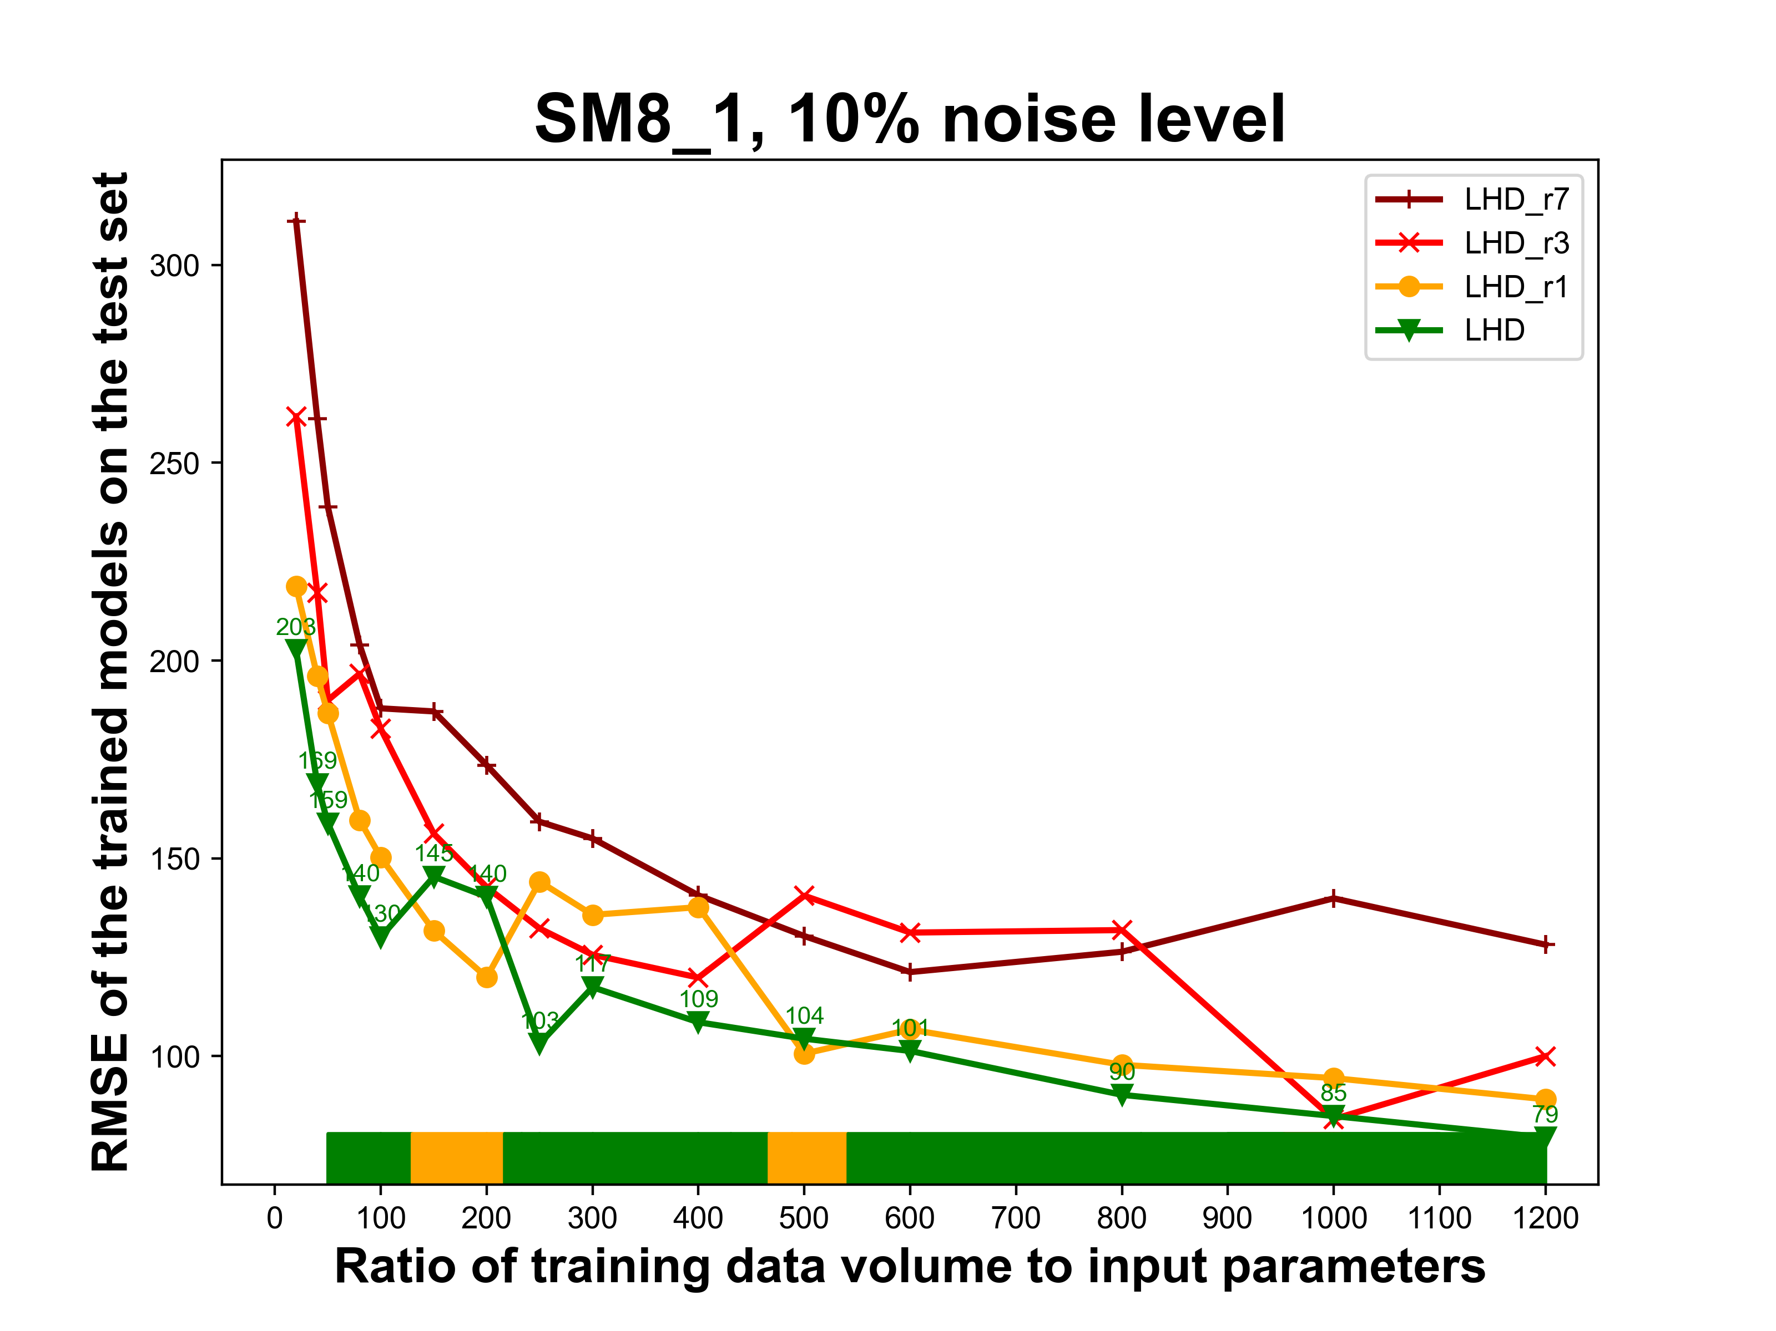
Supplementary Figure 1. Replication in data distribution versus only sampling with new data points, SM8_1, 10% noise level. The color bar illustrates the best performing DOE strategy.
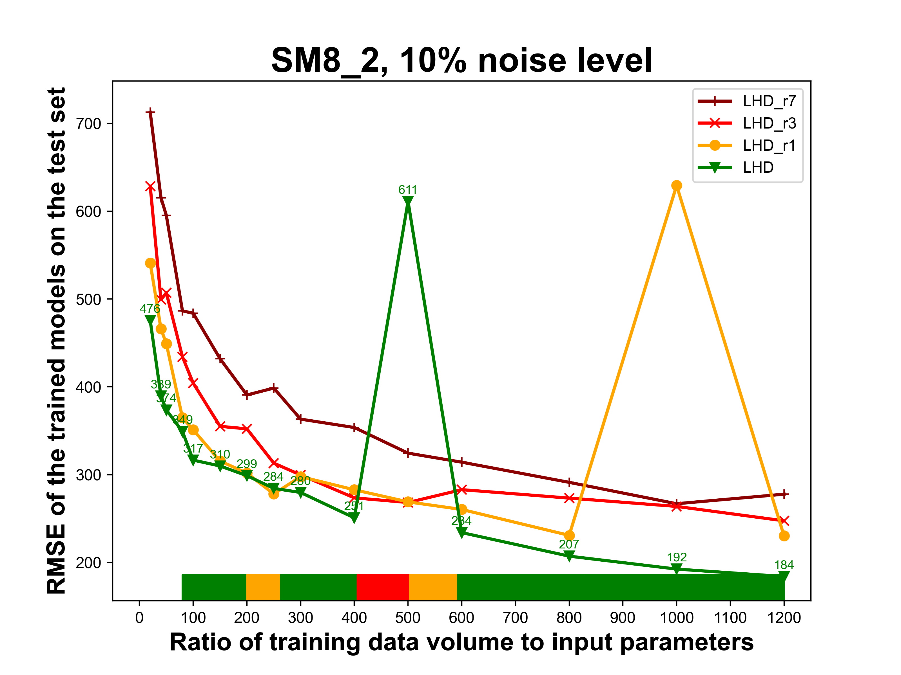
Supplementary Figure 2. Replication in data distribution versus only sampling with new data points, SM8_2, 10% noise level. The color bar illustrates the best performing DOE strategy.
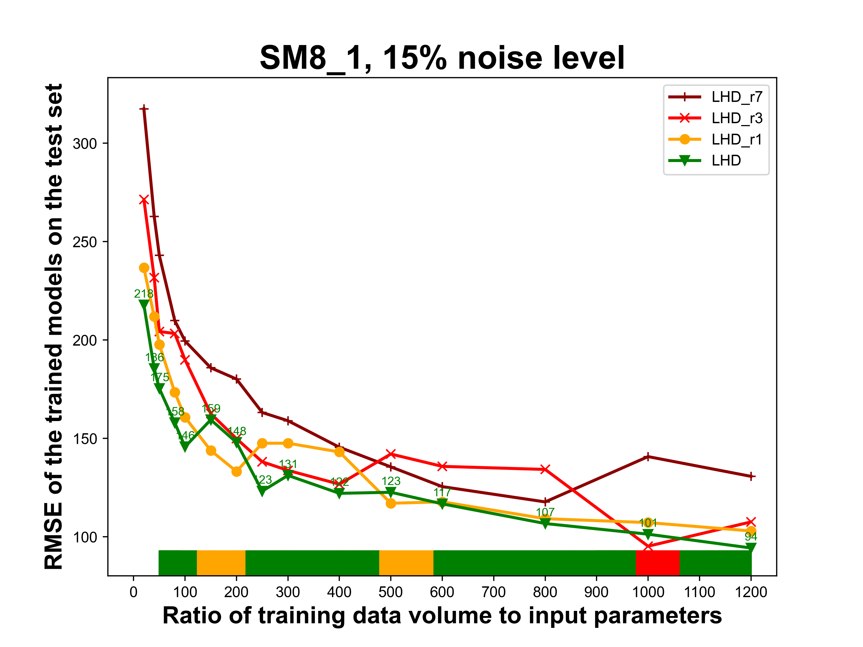
Supplementary Figure 3. Replication in data distribution versus only sampling with new data points, SM8_1, 15% noise level. The color bar illustrates the best performing DOE strategy.
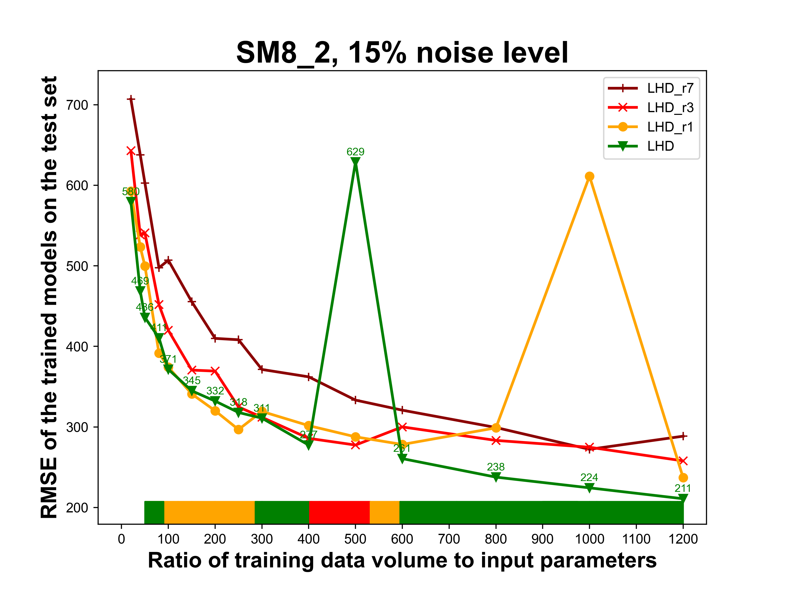
Supplementary Figure 4. Replication in data distribution versus only sampling with new data points, SM8_2, 15% noise level. The color bar illustrates the best performing DOE strategy.
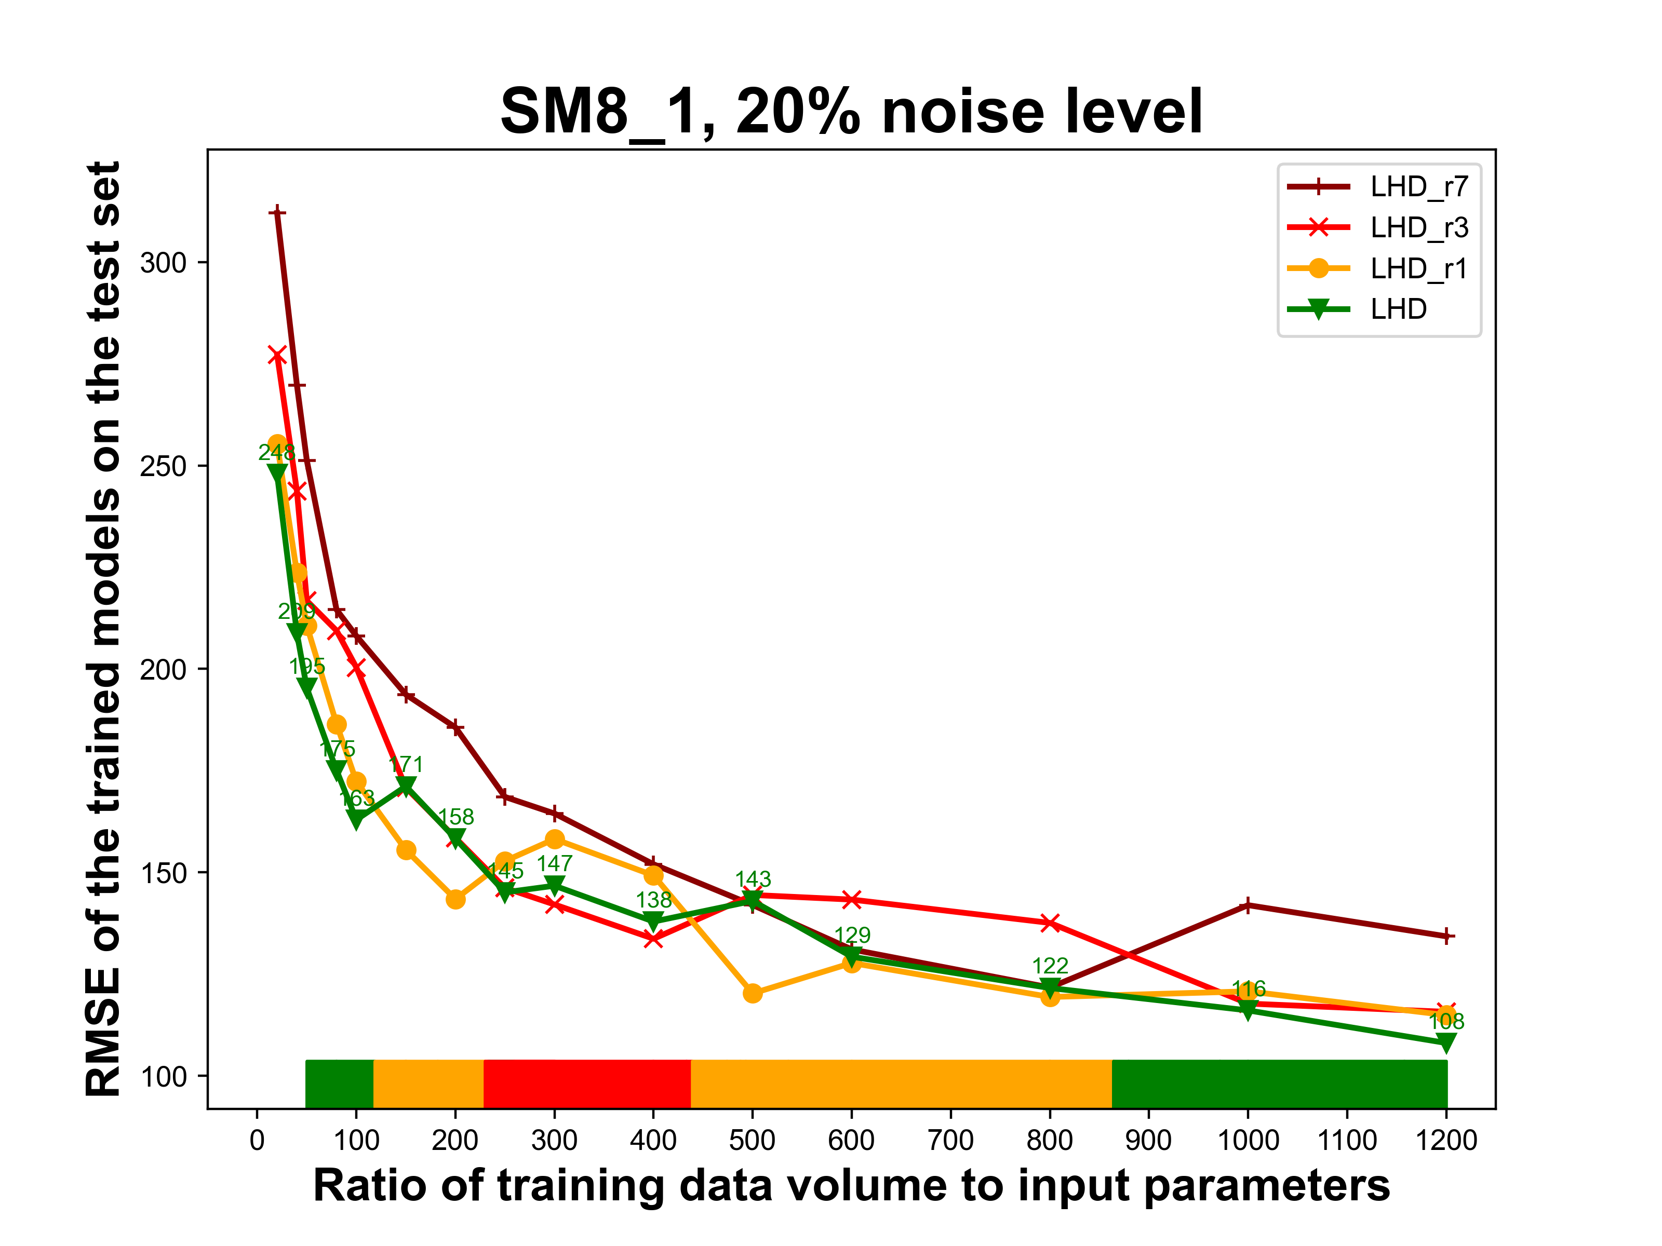
Supplementary Figure 5. Replication in data distribution versus only sampling with new data points, SM8_1, 20% noise level. The color bar illustrates the best performing DOE strategy.
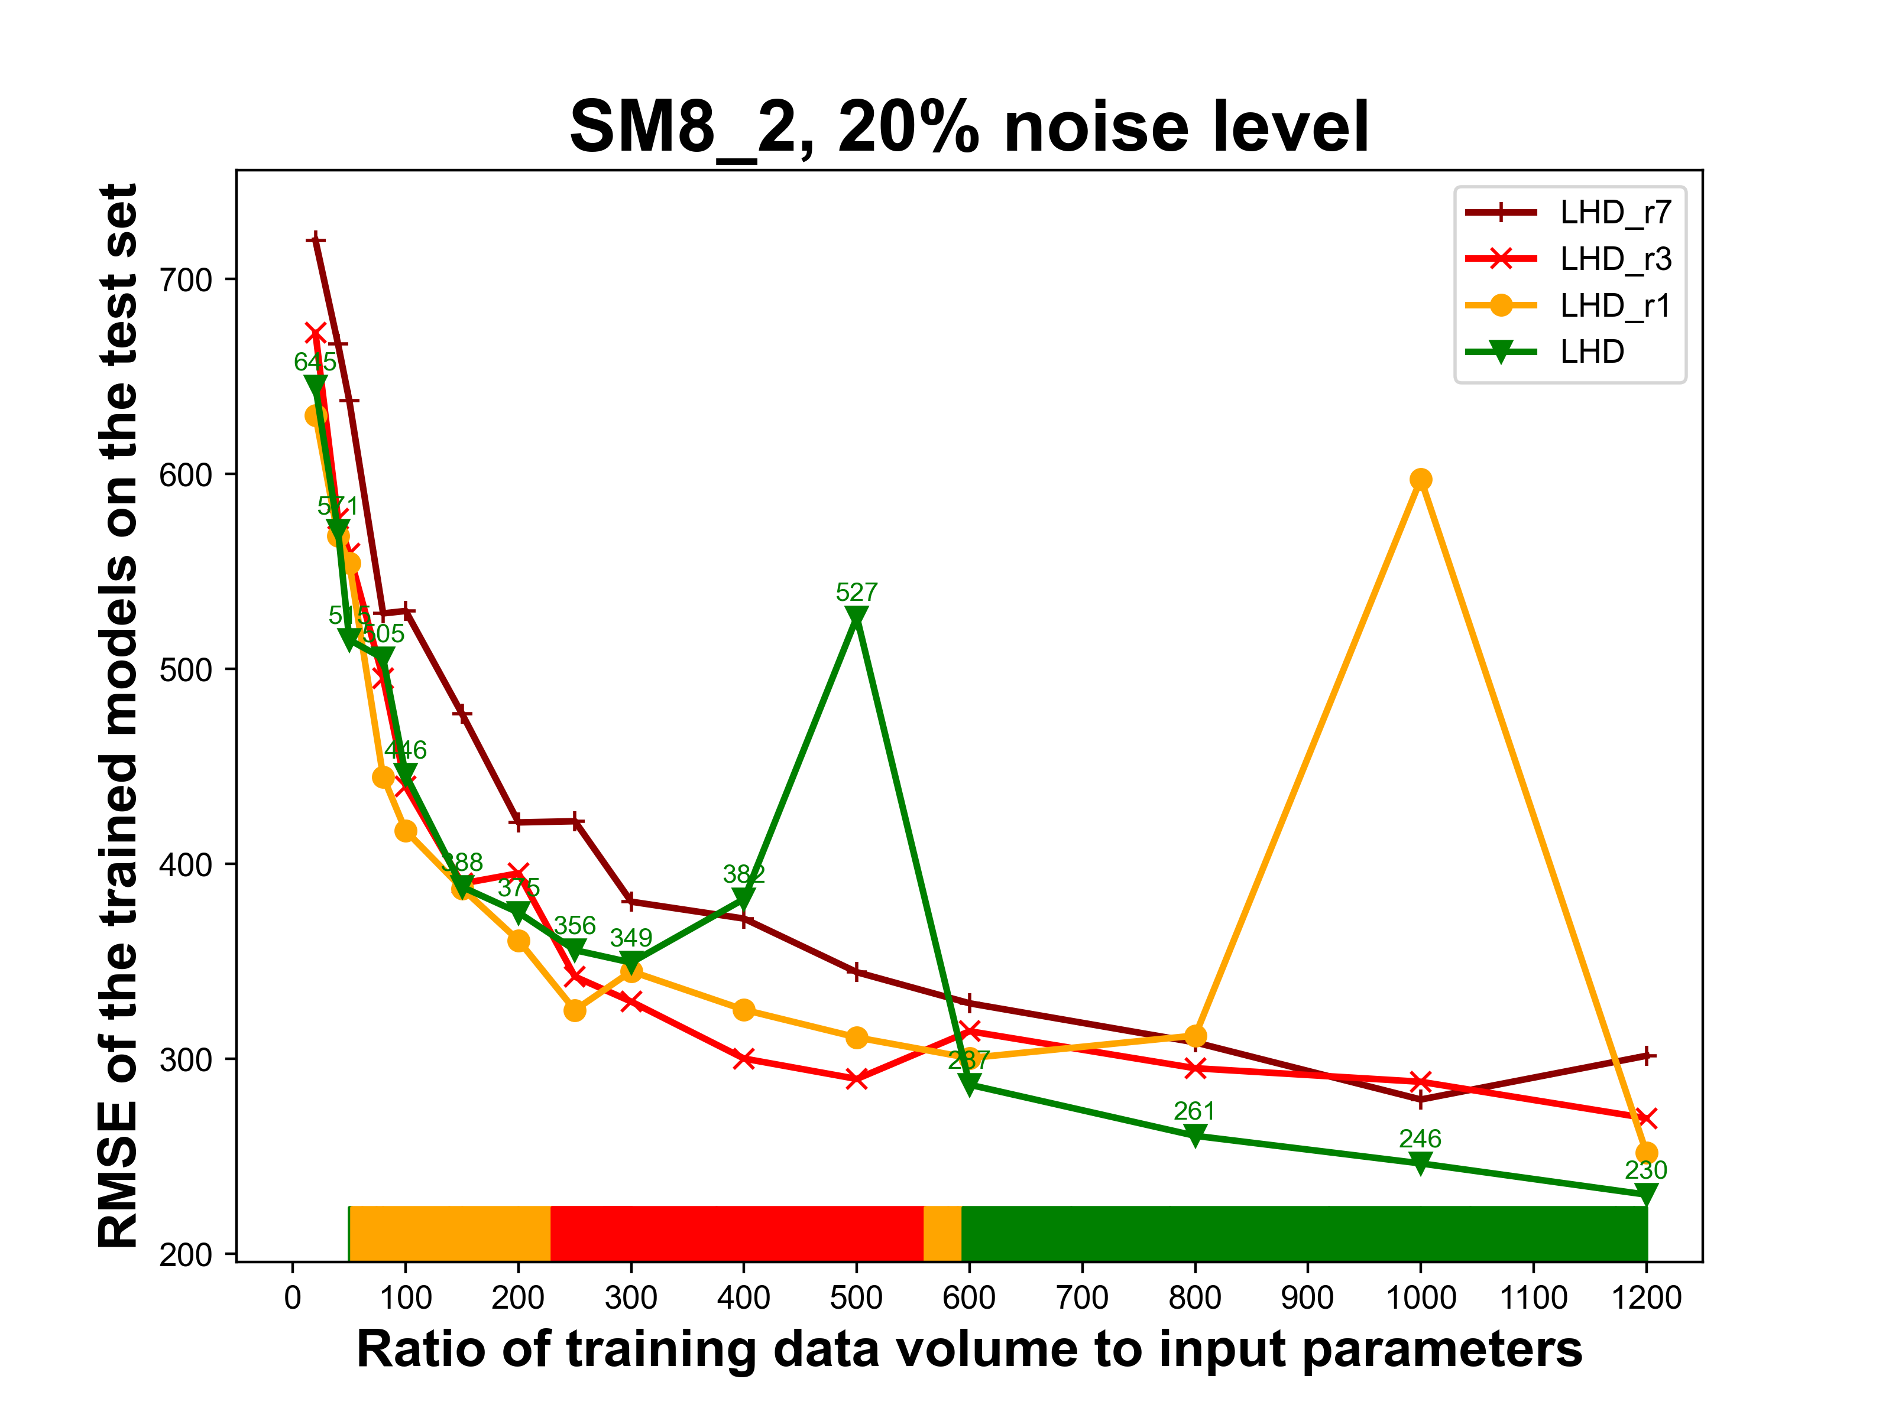
Supplementary Figure 6. Replication in data distribution versus only sampling with new data points, SM8_2, 20% noise level. The color bar illustrates the best performing DOE strategy.
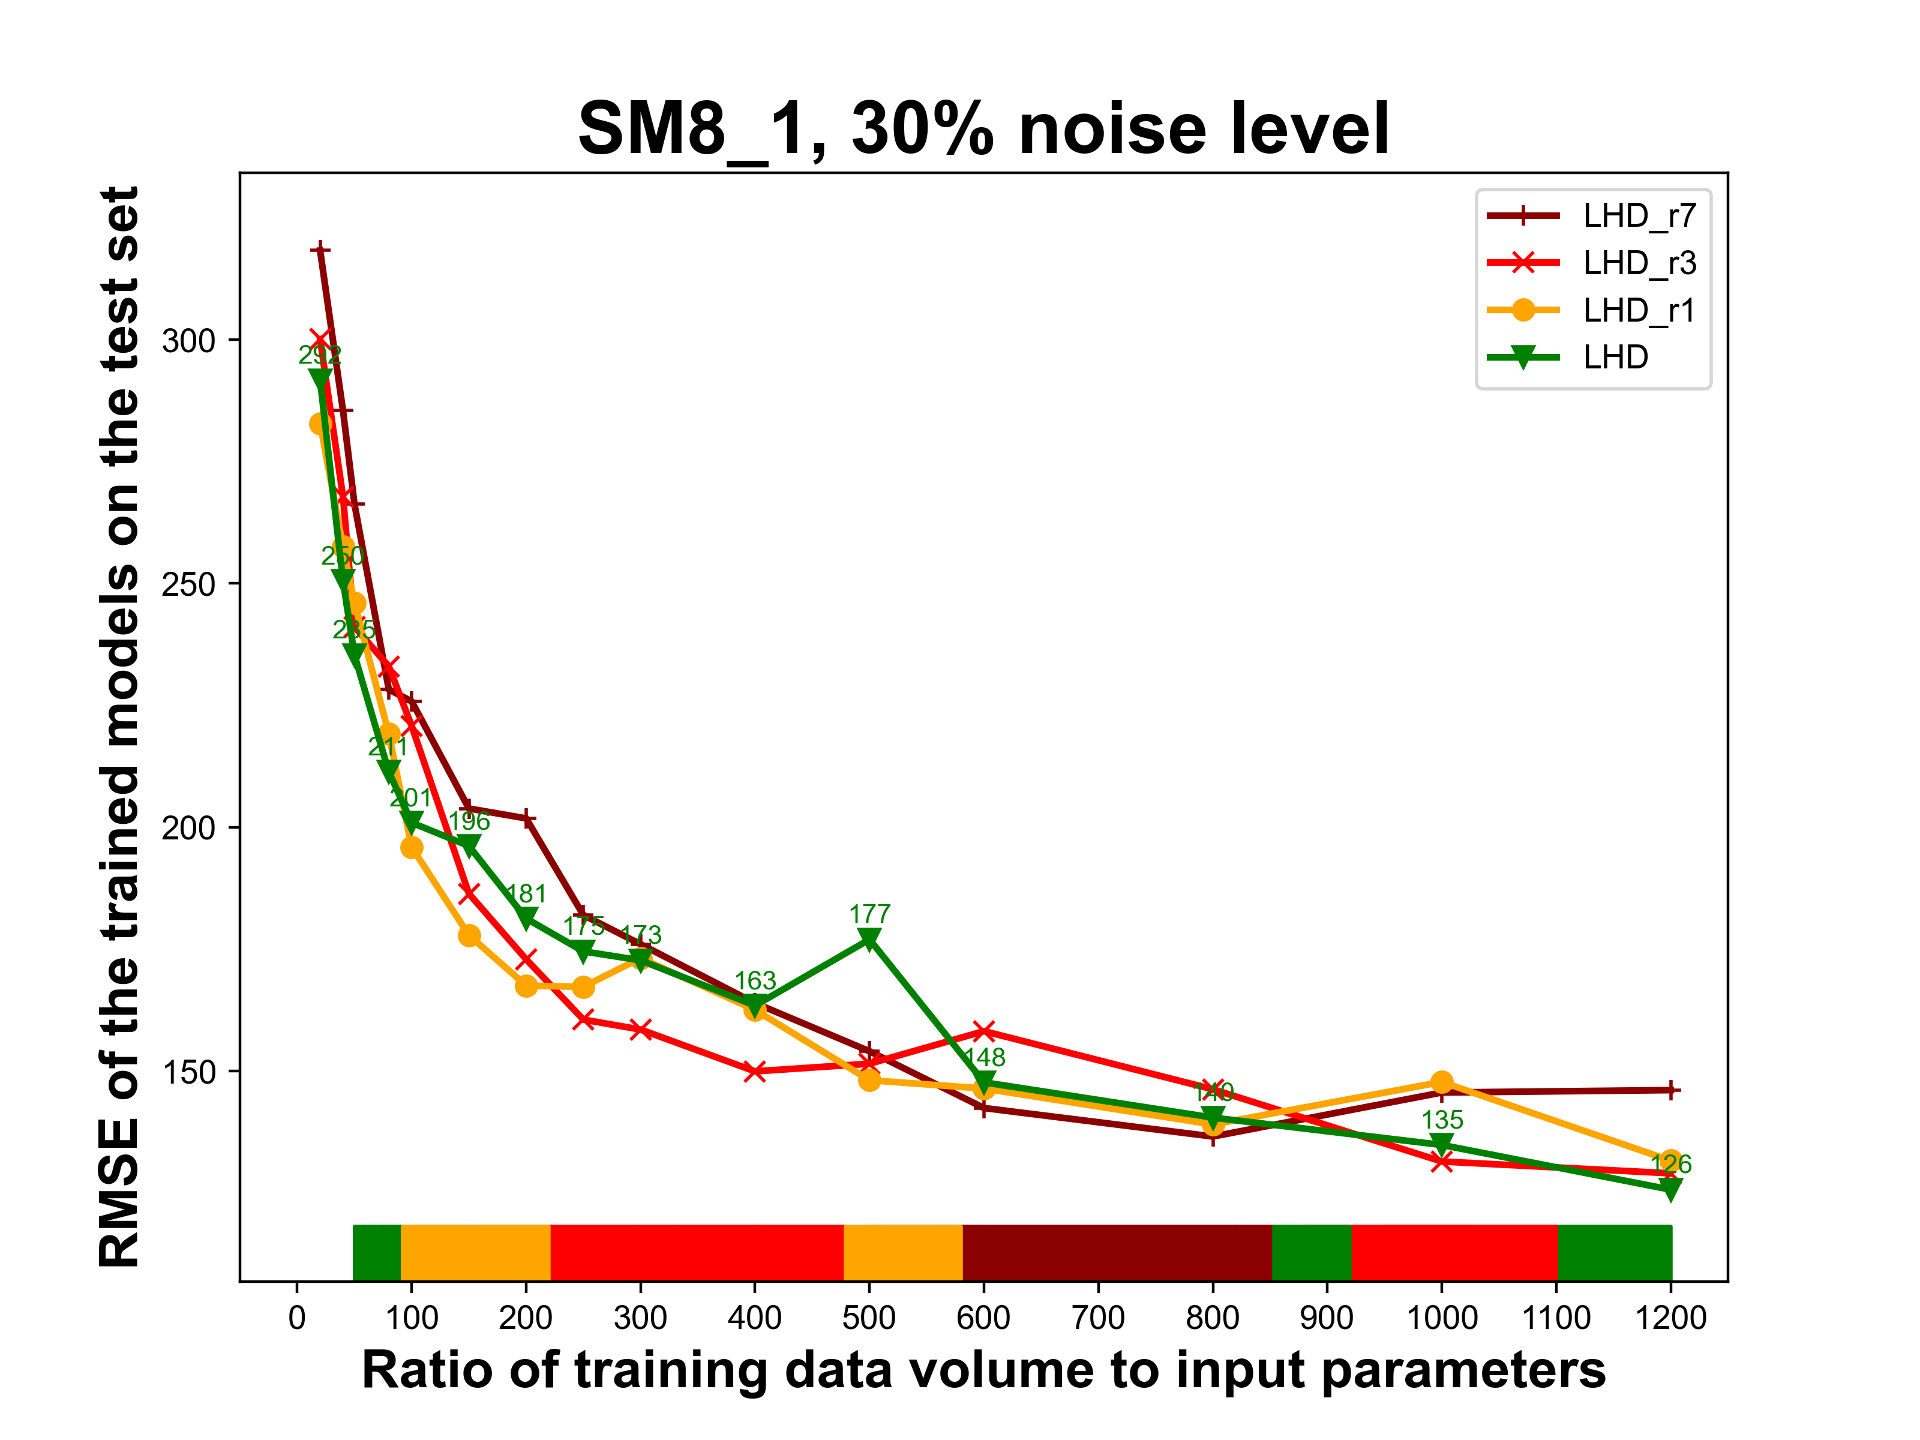
Supplementary Figure 7. Replication in data distribution versus only sampling with new data points, SM8_1, 30% noise level. The color bar illustrates the best performing DOE strategy.
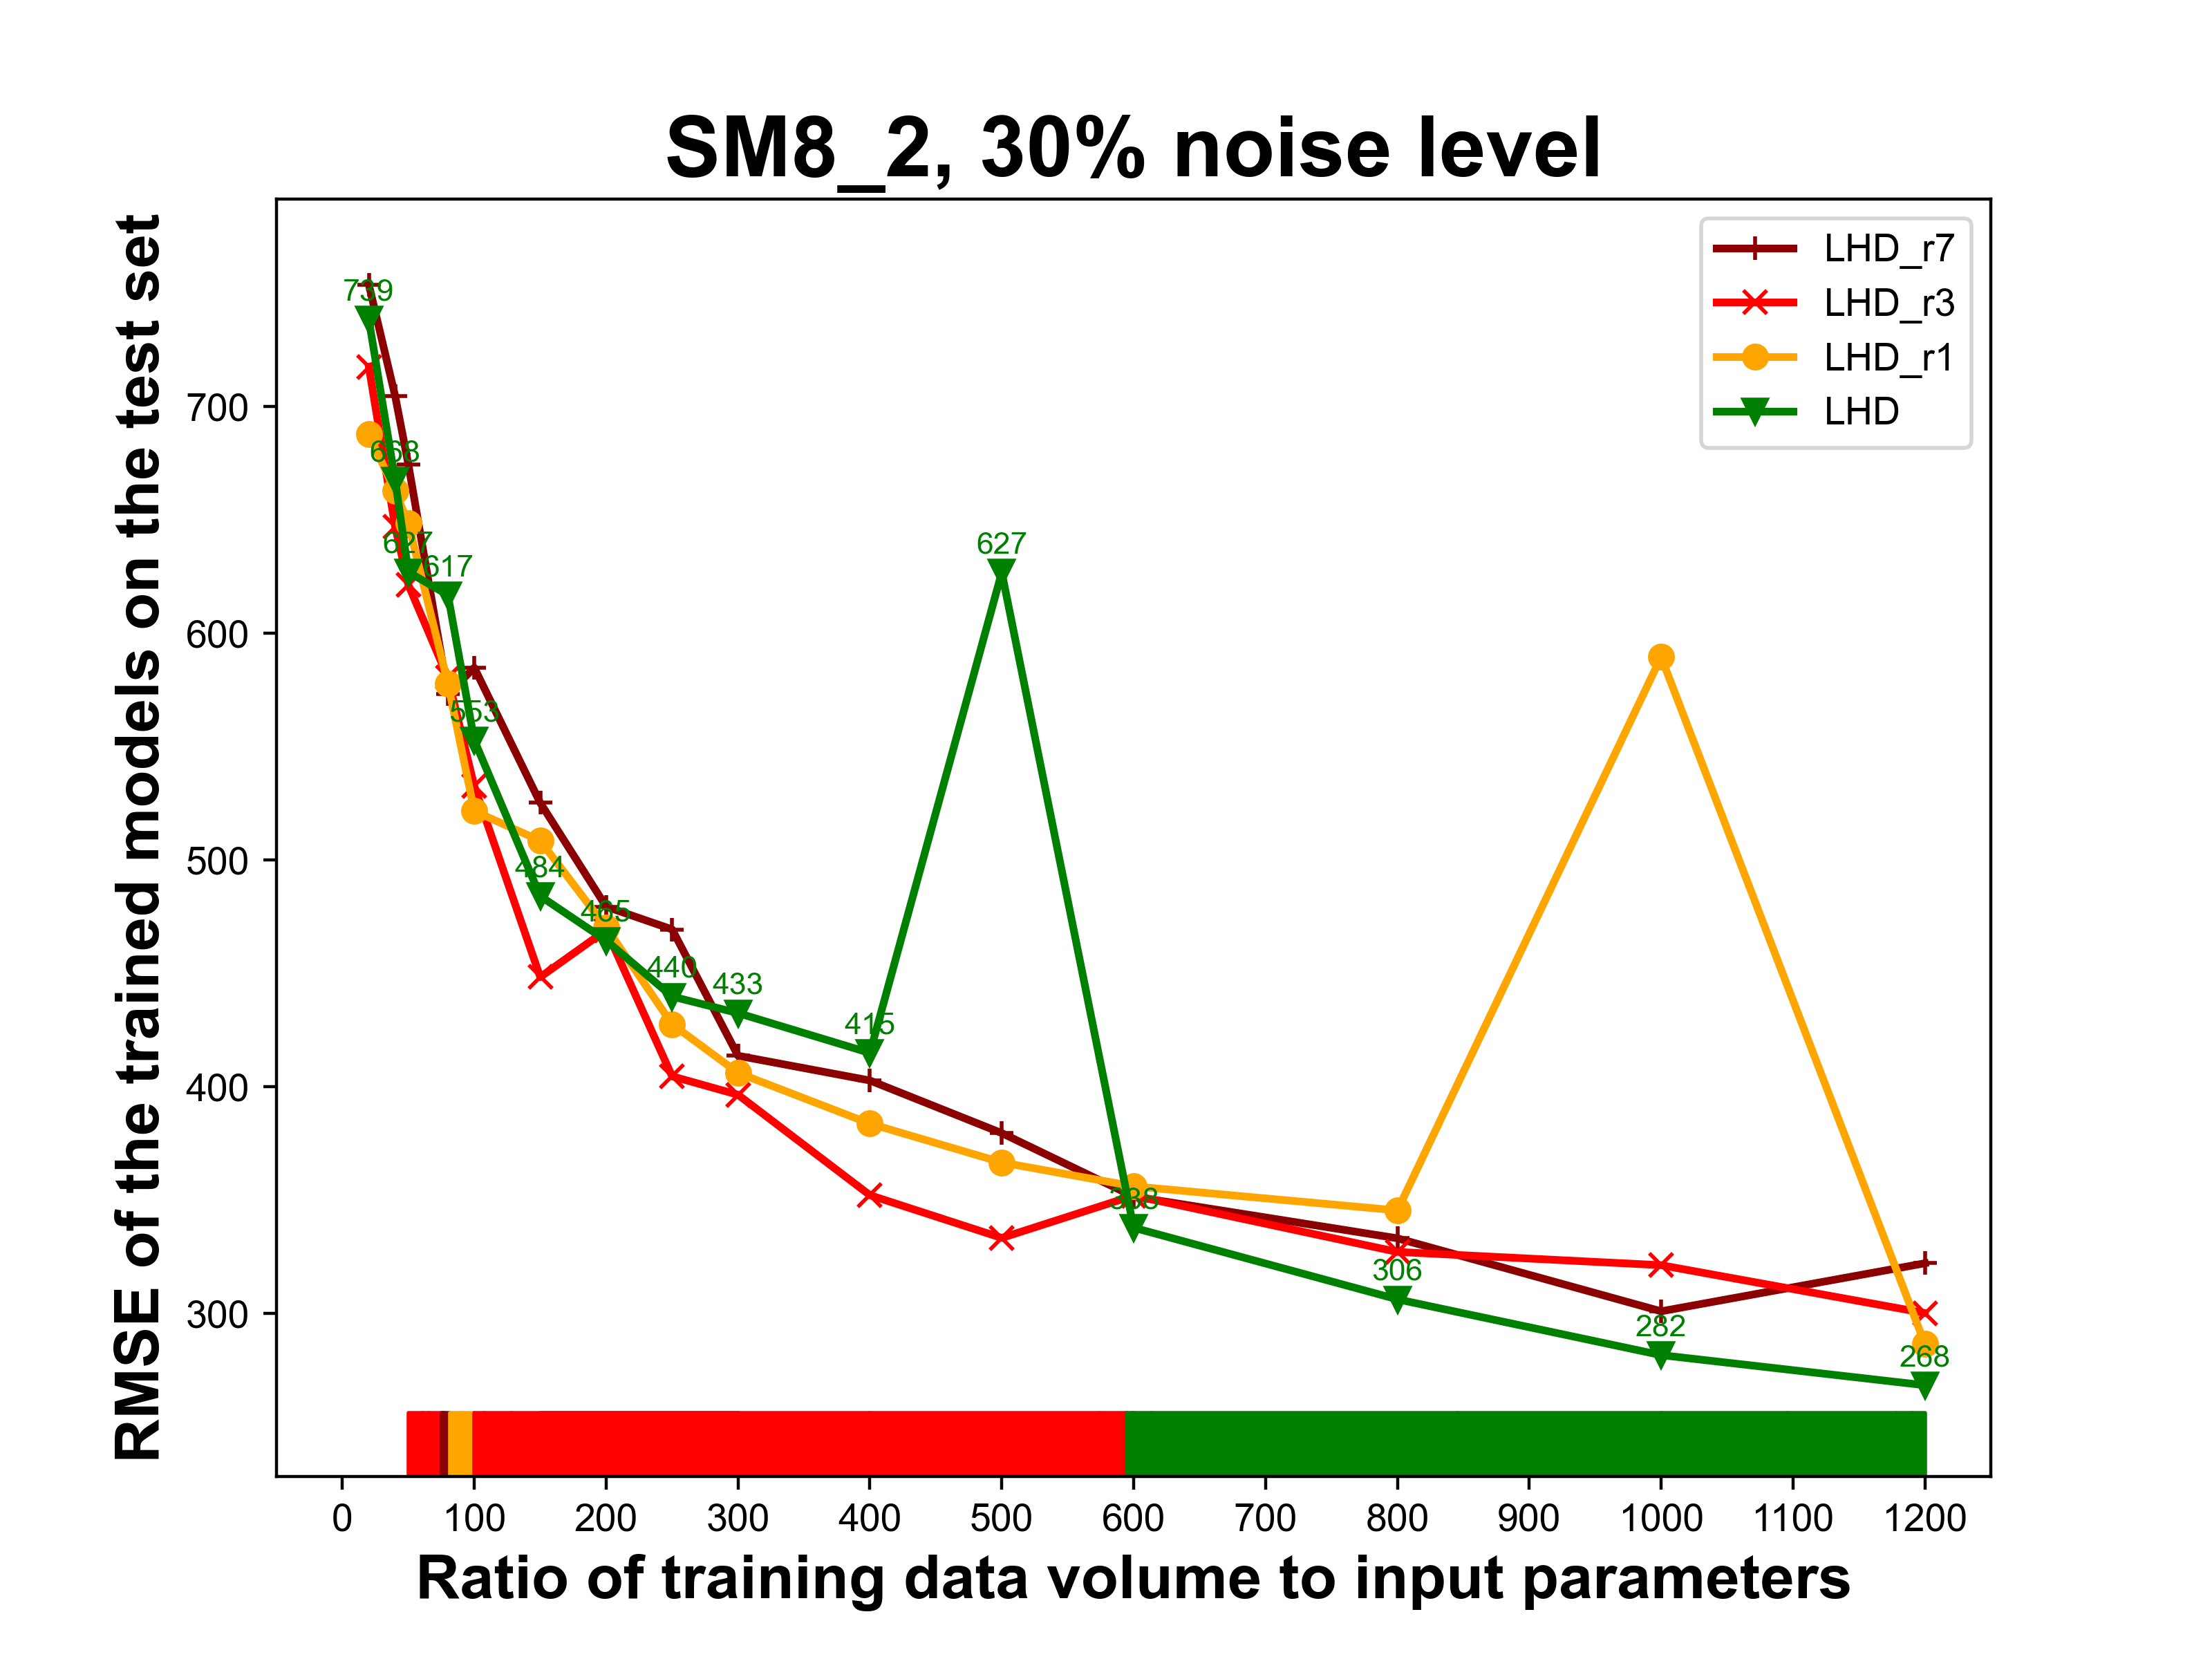
Supplementary Figure 8. Replication in data distribution versus only sampling with new data points, SM8_2, 30% noise level. The color bar illustrates the best performing DOE strategy.

